Supportive Graphs for Sub-group meta-analysis plot of the pooled prevalence of type-2 diabetes

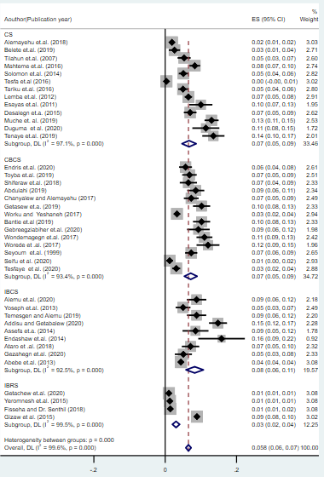
Fig A. Forest plot of prevalence of type-2 diabetes by study design

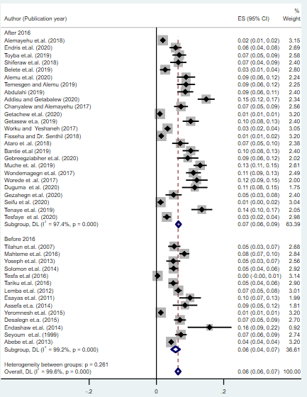
Fig B. Forest plot of prevalence of type-2 diabetes by study period

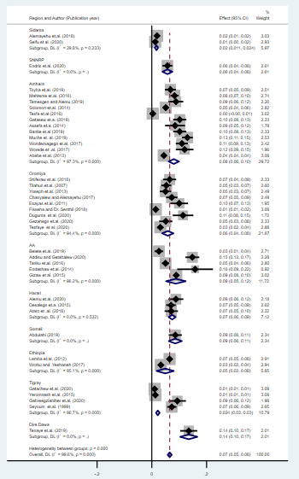
Fig C. Forest plot of plod prevalence of T2DM by region

