Dea Reviewers,
Thank you for your letter and the reviewers recommend reconsideration of our manuscript entitled “Efficacy of traditional Chinese medicine injections for treating idiopathic pulmonary fibrosis: a systematic review and network meta-analysis” (Manuscript Number: PONE-D-22-09987). These comments are all valuable and very helpful for revising and improving this paper, as well as the important guiding significance to our research. We revised it completely according to the suggestions of reviewers, and supplemented pictures, texts and references. We hope the revised manuscript could meet the reviewer’s comments and suitable for publication in PLOS ONE. Revised portions are marked in Red Font in the revised manuscript
Reviewer: 1
#1. In the discussion part, I would suggest the authors to explain the types of western medicines studied in randomized controlled trials selected for this study.
Response: Thank you for your suggestion. We performed a literature research, and added the types of western medicines studied in randomized controlled trials selected for this study. Please see below. Thanks again for your advice.
IPF is a progressive pulmonary interstitial inflammatory disease and a sequela of severe patients with novel coronavirus pneumonia in 2019 [69]. The prevalence of IPF is increasing significantly, and the treatment options for IPF are very limited and ineffective due to the pathogenesis of IPF is not clear. Researchers have proposed some effective methods to treat IPF. WM treatment of IPF mainly involved pharmacological treatment and non-pharmacological treatment (e.g. lung transplantation). However, the long-term use of high doses of glucocorticoids can cause more harm than good, with many irreversible side effects and adverse reactions that can cause irreversible damage to the body[70]. Nedanib and pirfenidone are the only two known drugs recommended by the US Food and Drug Administration for the treatment of IPF. Nonetheless, these drugs are not only expensive, but their clinical efficacy is uncertain and they often cause adverse side effects during clinical use, most commonly gastrointestinal disorders, including diarrhoea, nausea and vomiting[4]. Therefore, there is considerable debate in the medical community as to whether hormone therapy should be used long-term in patients with IPF. TCM has a long history in the treatment of IPF, and treatment is mainly based on syndrome differentiation [71]. Combinations of CMIs and WM have been widely used to treat IPF, increase CER, and improve patients’ quality of life. However, there is a lack of comprehensive and systematic evidence to support the beneficial effects of CMI in combination with WM in IPF.
In this study, NMA was used to systematically evaluate the efficacy of CMIs combined with WM in the treatment of IPF. Meanwhile, WM treatment of IPF mainly involves pharmacological treatment (e.g. glucocorticoids, anti-fibrotic drugs) and non-pharmacological treatment (e.g. oxygen and ventilators). Different outcome indicators such as CER, PaO2, PacO2, pulmonary function test (DLCO, FVC, TLC, FEV1%, and FEV1/FVC%), and molecular composition (IIIC and TGF)-associated fibrosis were analyzed to identify drugs with more efficacy advantages and provide a reference basis for the selection of CMIs for patients with IPF. A total of 63 RCTs involving 14 types of CMIs were eventually included in this NMA for data analysis. As shown in Table 3, the SUCRA of DH+WM in CER, PaO2, PaCO2, TLC, and TGF were 61.4 %, 83.7 %, 83.3 %, 89.0 %, and 85.7 %, respectively, ranking in the top 3. In addition, the SUCRA of SX+WM in CER, PaO2, PaCO2, FVC, FEV1%, and TGF were 75.5%, 71.7%, 99.8%, 86.2%, 85.9%, and 75.3%, ranking in the top 3. In terms of CER, SXN+WM, SXT+WM, SX+WM, DH+WM, and HQ+WM were the top five treatment strategies with the highest probability of being the best intervention. Furthermore, SXN combined with WM had the best performance in the CER (91.1%) and FVC (99.9%); HHS combined with WM had the best performance in the PaO2 (91.4%), FEV1/FVC% (93.0%), and IIIC (94.5%), all of which are important options for the treatment of IPF.
Reviewer: 2
#1. Authors must concentrate on the formatting, and use of symbols, etc., throughout the manuscript.
Response: Thank you so much for your comment. I had carefully checked the entire manuscript and made changes so that our manuscript meets PLOS ONE's style requirements which were marked in red in the paper.
#2. Abstract should be revised and it should be more focus on your aim and results. Introduction and last paragraph of the introduction section should be elaborated in detail for better understanding of your studied issue.
Response: Thank you for your suggestion. I have revised the abstract to better reflect the aims and findings of this study. In addition, I have added some expressions to highlight our studied issue in the introduction section. Details as follows.
Original | Revision
Background:  Idiopathic pulmonary fibrosis (IPF), acutely or slowly progressing into irreversible pulmonary disease, causes severe damage to patients' lung functions, as well as death. Chinese medicine injections (CMIs) may be effective and safe. However, there is a lack of comprehensive and systematic evidence to support the beneficial effects of CMI in combination with Western medicine (WM) on IPF. This study aimed to systematically evaluate the efficacy of CMI in combination with WM.  Material and Methods:  PubMed, Web of Science, Embase, Cochrane Library, MEDLINE, and Chinese databases, including the China National Knowledge Infrastructure, Wanfang Database, Scientific Journal Database, and China Biology Medicine Database were searched from inception to October 31, 2021. The inclusion criterion was randomized controlled trials (RCTs) on CMIs with WM for treating IPF. Reviewers independently screened the literature, extracted data, and evaluated the risk of bias in the included studies. RevMan 5.4 software and Stata software (version 16.0) were used for the data analysis. | Background:  Idiopathic pulmonary fibrosis (IPF), acutely or slowly progressing into irreversible pulmonary disease, causes severe damage to patients' lung functions, as well as death. In China, Chinese medicine injections (CMIs) have been generally combined with Western medicine (WM) to treat IPF, which are safe and effective. This study aimed to systematically compare the efficacy of 14 CMIs combined with WM in the treatment of IPF based on a systematic review and network meta-analysis (NMA).  Material and Methods:  PubMed, Web of Science, Embase, Cochrane Library, MEDLINE, and Chinese databases, including the China National Knowledge Infrastructure, Wanfang Database, Scientific Journal Database, and China Biology Medicine Database were searched from inception to October 31, 2021. The inclusion criterion was randomized controlled trials (RCTs) on CMIs with WM for treating IPF. Reviewers independently screened the literature, extracted data, and evaluated the risk of bias in the included studies. RevMan 5.4 software and Stata software (version 16.0) were used for the data analysis. NMA were carried out for calculating the odd ratios (ORs) with 95% confidence intervals (CI), the surface under cumulative ranking curve (SUCRA) and the probabilities of being the best.
Results:  A total of 63 eligible RCTs involving 14 CMIs were included in this network meta-analysis (NMA). More CMIs can significantly improve the clinical effectiveness rate (CER); Shuxuening injection (SXN)+WM, Shuxuetong injection (SXT)+WM, Shenxiong injection (SX)+WM, Danhong injection (DH)+WM, and Huangqi injection (HQ)+WM were the top five treatment strategies. In terms of improvement in the CER, PaO2, PaCO2, FVC, TLC, FEV1%, FEV1/FVC%, IIIC, and TGF, DH +WM ranked relatively high in the SUCRA value of the nine outcome indicators, which seems to indicate that DH+WM had the highest likelihood of being the best treatment. | Results:  A total of 63 eligible RCTs involving 14 CMIs were included in this NMA. More CMIs can significantly improve the clinical effectiveness rate (CER); Shuxuening injection (SXN)+WM (OR 8.91, 95% CI 3.81-20.83), Shuxuetong injection (SXT)+WM (OR 7.36, 95% CI 3.30-16.00), Shenxiong injection (SX)+WM (OR 5.42, 95% CI 2.90-10.13), Danhong injection (DH)+WM (OR 4.06, 95% CI 2.62-6.29), and Huangqi injection (HQ)+WM (OR 3.47, 95% CI 1.55-7.77) were the top five treatment strategies. Furthermore, DH +WM ranked relatively high in the SUCRA value of the nine outcome indicators, oxygen partial pressure (PaO2) (OR -13.39; 95% CI -14.90,-11.89; SUCRA 83.7%), carbon dioxide partial pressure (PaCO2) (OR -4.77; 95% CI -5.55,-3.99; SUCRA 83.3), orced vital capacity (FVC) (OR -1.42; 95% CI -2.47,-0.36; SUCRA 73.5%), total lung capacity (TLC) (OR 0.93; 95% CI 0.51,1.36; SUCRA 89.0%), forced expiratory volume 1/ forced vital capacity (FEV1/FVC%) (OR -10.30; 95% CI -12.98,-7.62; SUCRA 72.7%), type III collagen (IIIC) (OR 13.08; 95% CI 5.11,21.05; SUCRA 54.9%), and transforming growth factor (TGF) (OR -4.22; 95% CI -6.06,-2.37; SUCRA 85.7%) respectively, which seems to indicate that DH+WM had the highest likelihood of being the best treatment.
Conclusions:  The combined use of DH, SXN, SX, and safflower yellow sodium chloride injection with WM exerted a more positive effect in treating IPF than WM alone; however, the quality of evidence was low. We suggest that further studies should focus on the improvement of methodological quality and increase the follow-up period. | Conclusions:  This review specified several CMIs combined with WM in the treatment of IPF in China. In contrast to glucocorticoids or antioxidants, CMIs combined with WM delayed the decline in lung function, maintained oxygenation and quality of life in patients with IPF. The combined use of DH, SXN, SX, and safflower yellow sodium chloride injection (HHS) with WM exerted a more positive effect in treating IPF than WM alone. However, there were limitations to the conclusions of this study due to quality control differences in the included trials.
1 Introduction
Idiopathic pulmonary fibrosis (IPF) is a chronic, progressive and lethal fibrotic lung disease, characterized by diffuse alveolitis, profound changes in epithelial cell phenotype and fibroblast proliferation. The incidence of IPF is around 8/10 million-15/10 million, accounting 65% interstitial lung disease[1]. IPF mostly presents as a chronic disease, but patients have an average median survival of only 2-4 years after diagnosis. Because of its unclear pathogenesis, the treatments for IPF are limited and causing high rate of mortality[2].
Glucocorticoids can relieve IPF patients' symptoms, but it is ineffective in reversing the lung damage. Lung transplantation is the last treatment for IPF patients. More effective therapeutic ways are becoming available for IPF patients following the research progress on pathogenesis of IPF.[3]. Pirfenidone and nidanib are approved for the treatment of IPF because they can slow down the decline of lung function and disease progression; however, these two drugs have more adverse effects, and no reliable evidence has been found to confirm that they significantly improve patients' symptoms and quality of life. Moreover, the cost of both drugs is high, which places a heavy economic burden on patients and society [4]. Traditional Chinese medicine (TCM) has a long history of treating IPF, and treatment is based on syndrome differentiation, which has the advantages of low toxicity, multi-level and multi-target, and unique advantages in clinical application [5,6].
Clinical trials of TCM in the treatment of IPF are gradually increasing, but it is unclear whether they can slow down the progression of the disease. Based on the research method of evidence-based medicine, this study used NMA to compare the number of different CMIs combined with WM interventions under the same conditions to obtain more reliable evidence for clinical reference. NMA is a development of the traditional meta-analysis, which has the advantage of providing quantitative statistical analysis of different interventions for the same disease and ranking them in order of efficacy, thus providing evidence to support the clinical use of drugs. Therefore, This study aims to provide evidence-based clinical practice by collecting RCTs on the efficacy and safety of CMIs combined with WM in the treatment of IPF.
#3. More abbreviation makes difficult to understand the concept. Please revise it.
Response: Thank you so much for your comment. I have revised the abbreviation to better understand the concept. Details as follows.
HHS can promote fibrin degradation and fibrotic damage within lung tissue, and delay the decline of lung function by reducing the levels of hyaluronic acid (HA), laminin (LN), and type Ⅲ procollagen (PCIII).
The flavonoids in Ginkgo biloba extract can significantly increase blood oxygen concentration, which has an inhibitory effect on serum interleukin- 6 (IL6), IL8, and tumor necrosis factor-α (TNF-α) levels in patients with IPF.
#4. Framework figure is required. It will be useful to the readers for better understanding of the studied issue.
Response: Thank you so much for your comment. We have added this research framework of the study, which is shown in Fig. 1A.
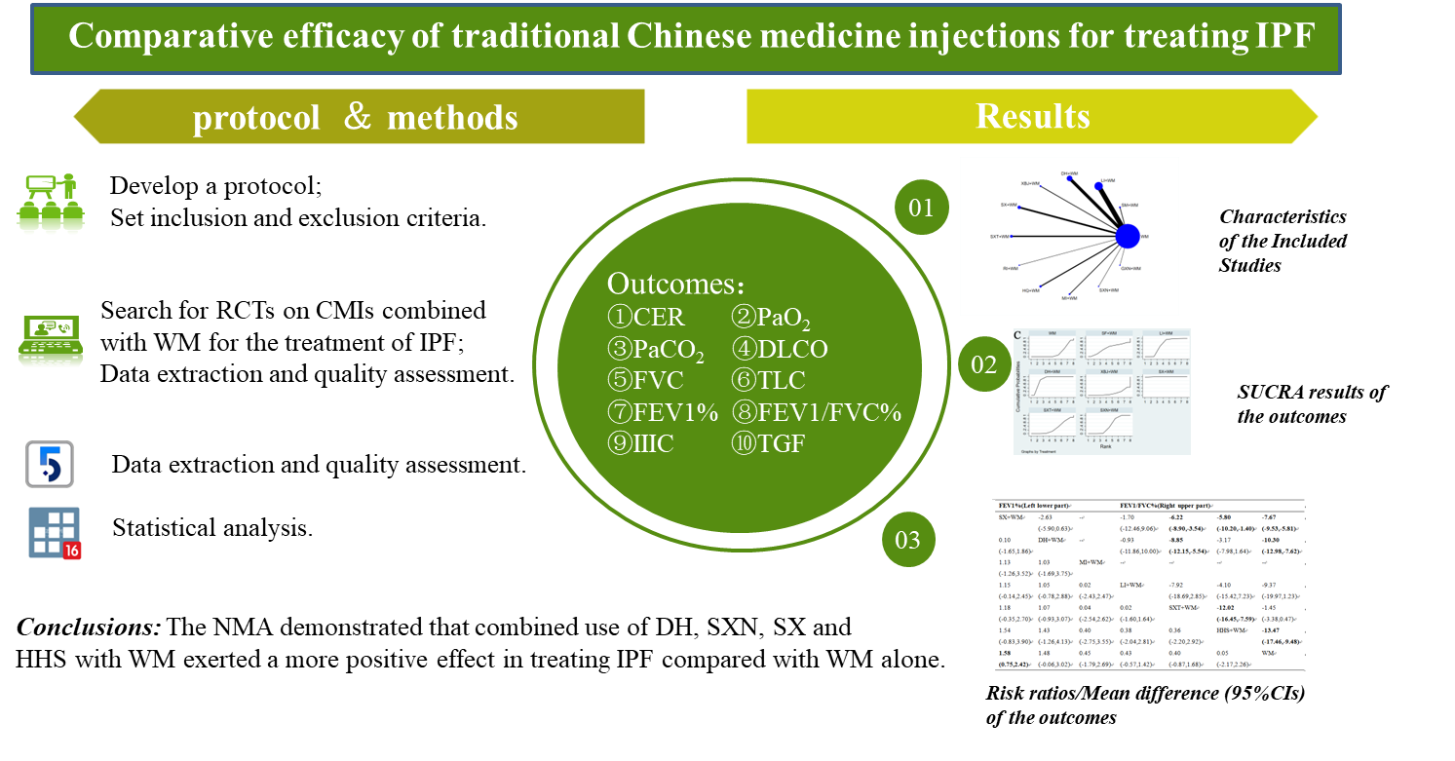
#5. In conclusion section authors should provide some future prospectus related to present study.
Response: Thank you so much for your comment. We have revised the conclusion section. Details as follows.
5. Conclusions
IPF is a slowly progressive lung disease with a high mortality rate and an unknown pathogenesis. There is no effective cure for IPF, and CMIs combined with WM is expected to be one of the future strategies for IPF treatment. This NMA confirms that the 14 treatment strategies used in this study improved the symptoms and clinical indicators of patients with IPF in different ways. The combined use of DH, SXN, SX, and HHS with WM exerted a more positive effect in treating IPF than that done by WM alone. However, it is worth noting that since different types of CMIs have different effects and functions in patients, patients’ conditions should also be considered while selecting the CMIs to play a better role in the treatment of IPF.
#6. Authors should clearly state the figure caption as well as description for ease of understanding of the readers.
Response: Thank you so much for your comment. We have revised the the figure caption. Details as follows. Further details were detailed in the full article.
Fig. 1A. The research framework of the study
Fig. 1B. Flow chart of the search for eligible studies.
Fig. 2. Network relationship diagram of each outcome index of CMIs combined with WM in the treatment of IPF. A, CER; B, PaO2; C, PaCO2; D, DLCO; E, FVC; F, TLC; G, FEV1%; H, FEV1/FVC%; I, IIIC; and J, TGF.
We greatly appreciate the efficient, professional and rapid processing of our paper by your work. If there is anything else we should do, please do not hesitate to let us know. Once again, thank you very much for your marvelous comments and suggestions.
Best regards,
Hongsheng Cui

