Indications and outcomes of enterovesical and colovesical fistulas: systematic review of the literature and meta-analysis of prevalence

Supplementary Materials
Index

- Table 4: diagnostic methods | 2
- Sensitivity analysis - Baujat plot | 3
- Funnel plot and p-curve analysis for complications | 4
- Funnel plot and p-curve analysis for mortality | 5
- Bubble plot of metaregression: years of publication | 6
- Word combination syntax | 7

- Table 4: diagnostic methods
Author | Year of publication | Diagnostic method
Author | Year of publication | CT (%) | Endoscopy (%) | Cystoscopy (%) | Cystography (%) | Barium enema (%) | Other
Pollard | 1987 |  | 62.1 | 60.6 | 7.5 | 80.3 | IV pyelography: 66.6%
McNamara | 1990 |  | 15.8 | 63.5 | 25.4 | 60.1 | IV pyelography: 69.8%; small-bowel series 63.5%
Holmes | 1992 | - | - | - | - | -
McBeath | 1994 | 42.1 | 35.5 | 55.2 | 35.5 | 76.3 | IV pyelography: 38.1%; oral charcoal 5.2%
Munoz | 1998 | 54.5 | 78.8 | 96.9 | 60.6 | 30.3 | IV pyelography: 39.4%
Vasilevsky | 1998 |  |  | 100 | 100 | 100
Yamamoto | 2000 | - | - | - | - | -
Walker | 2002 | 36.8 | 10.5 | 21 |  | 84.2
Menenakos | 2003 | - | - | - | - | -
Najjar | 2004 | 83 | 25 | 50 | 75 | 83 | IV pyelography: 58%
Kavanagh | 2005 | 50 | 36.6 | 53.3 | 3.3 | 33.3 | Oral charcoal 16.6%
Laurent | 2005 | 9.1 |  | 45.4 |  | 90.9
Ferguson | 2008 | 100 |  | 100
Melchior | 2009 | 83.7 | 95.9 | 100 | 61.2 | 85.7 | Poppy seed test: 75.5%; MR 10.2%
Lynn | 2012 | - | - | - | - | -
Niebling | 2013 | 90.3 | 83.9 | 54.8 |  | 74.2
Maciel | 2014 | - | - | - | - | -
Salgado-Nesme | 2016 | - | - | - | - | -
Taxonera | 2016 | 53.6 | 5.1 | 12.4 | 10.3 | 3 | MRI 59.8
Badic | 2017 | 46.4 | 61 | 18
El-Haddad | 2018 | 100 | 90 | 55 | 17.5 | 12.5
Nevo | 2019 | - | - | - | - | -

- Sensitivity analysis – Baujat plot
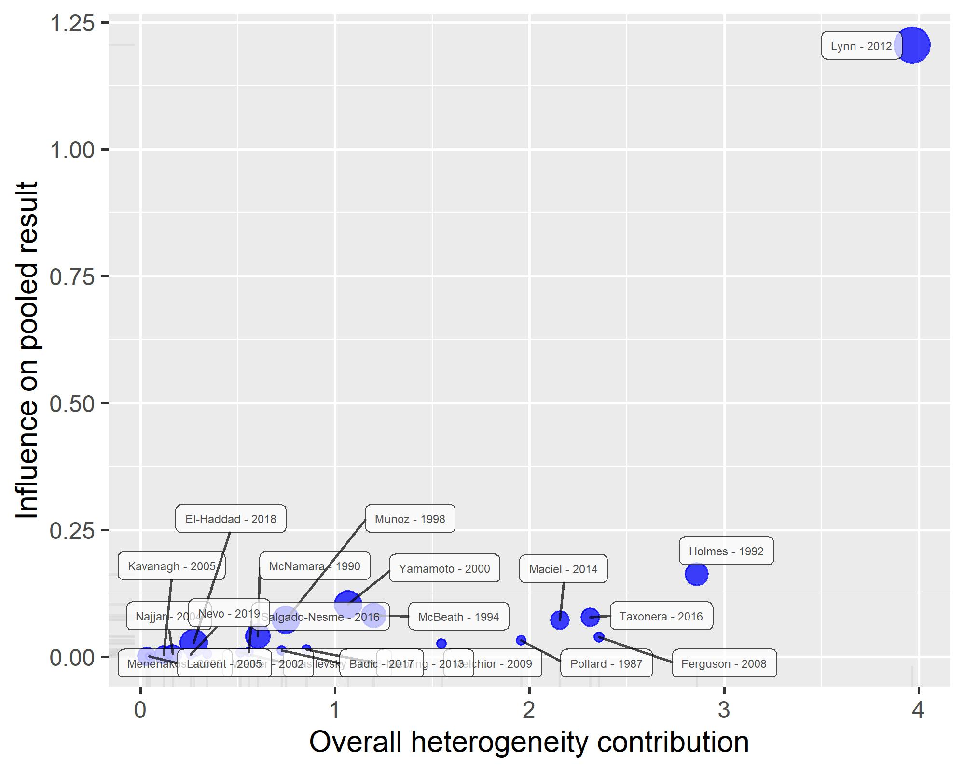

- Funnel plot and p-curve analysis for complications
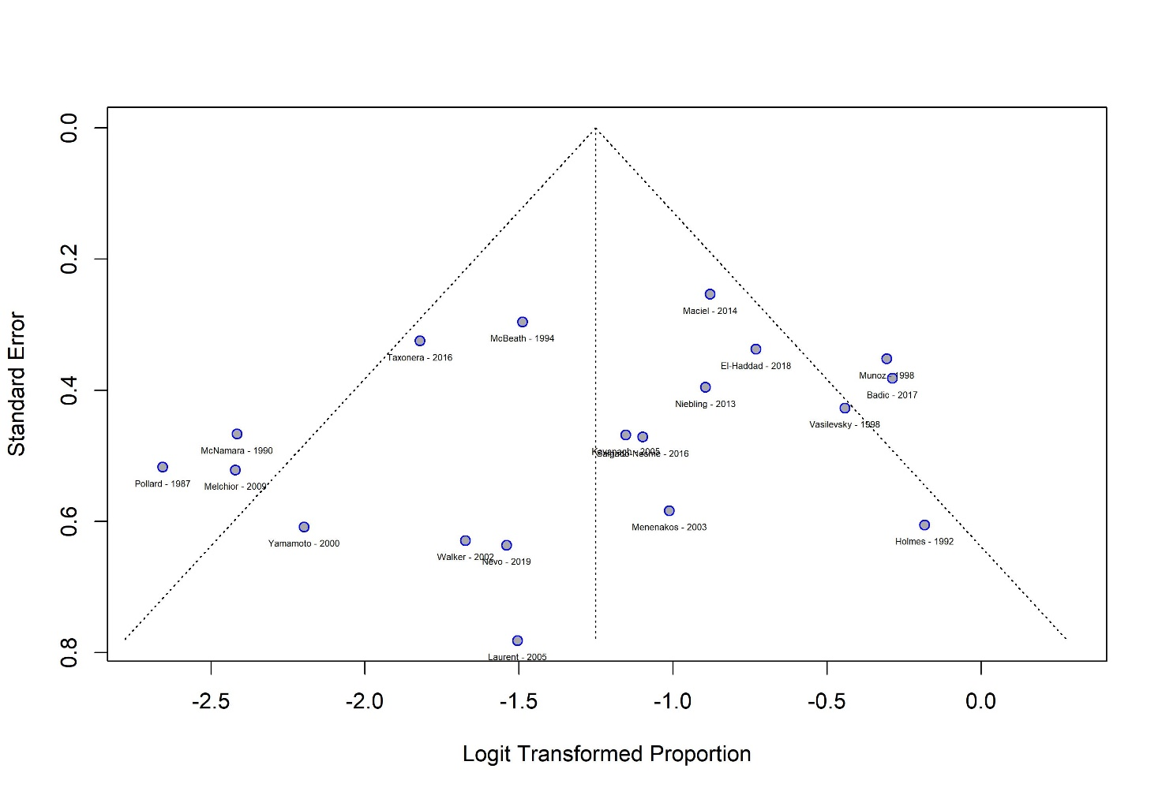
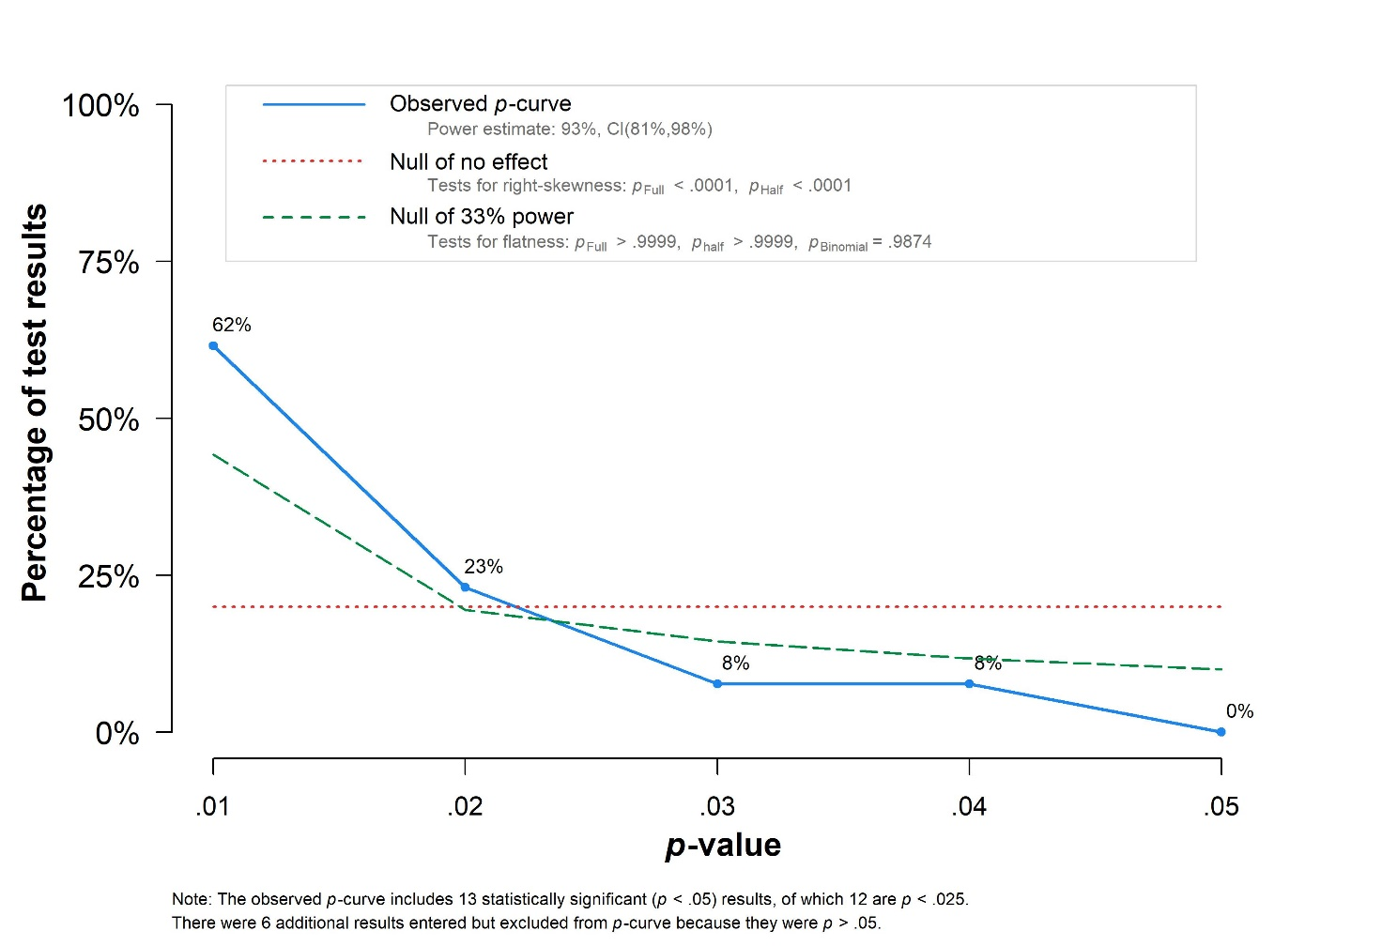
- Funnel plot and p-curve analysis for mortality
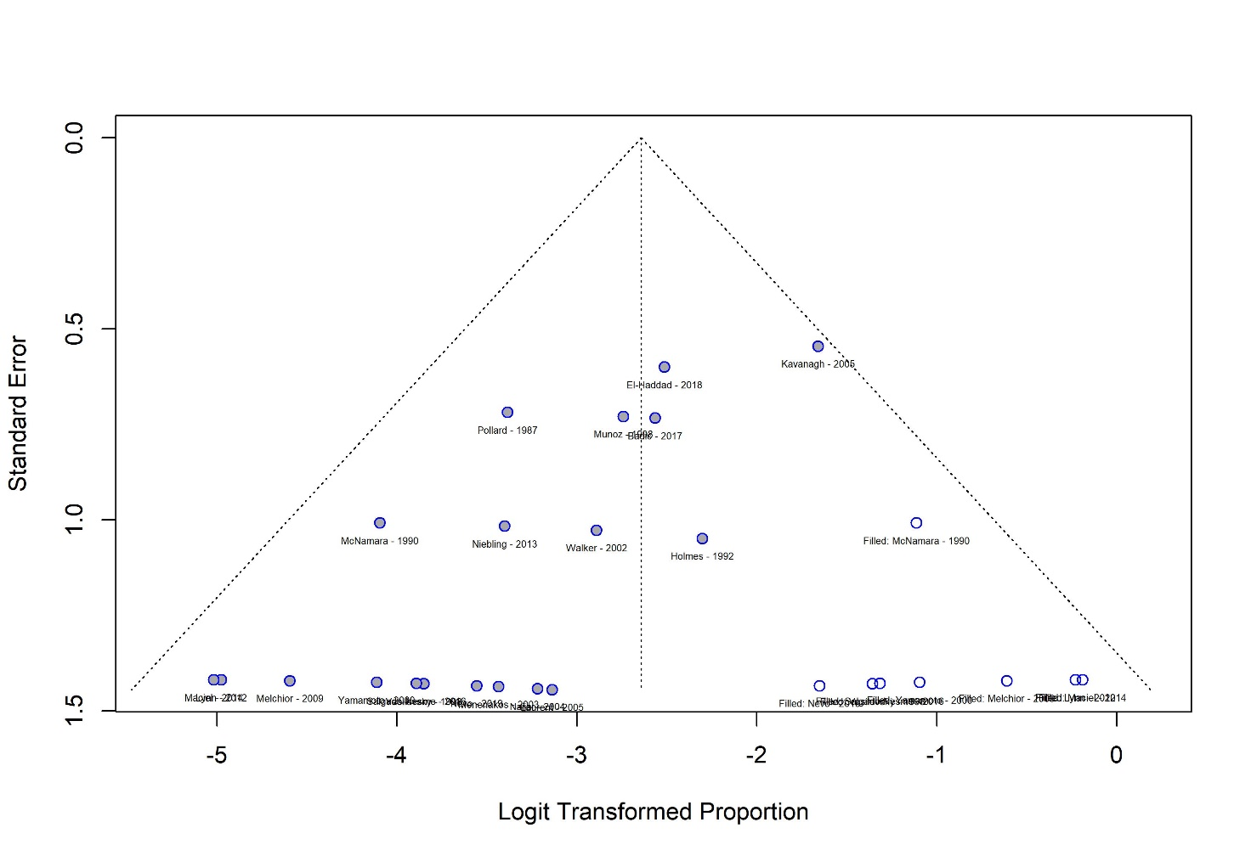
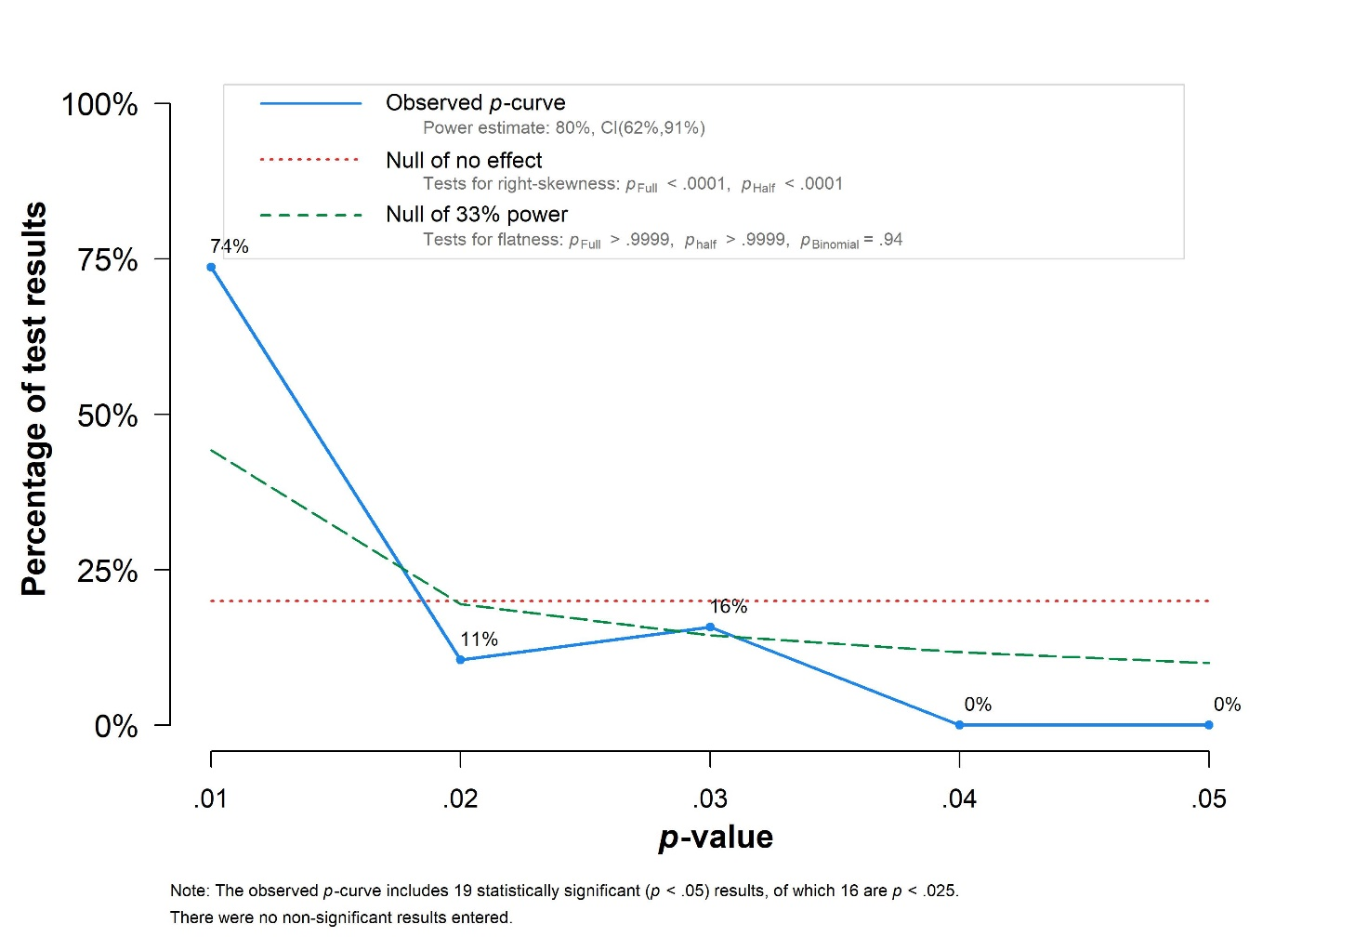
- Bubble plot of metaregression: years of publication
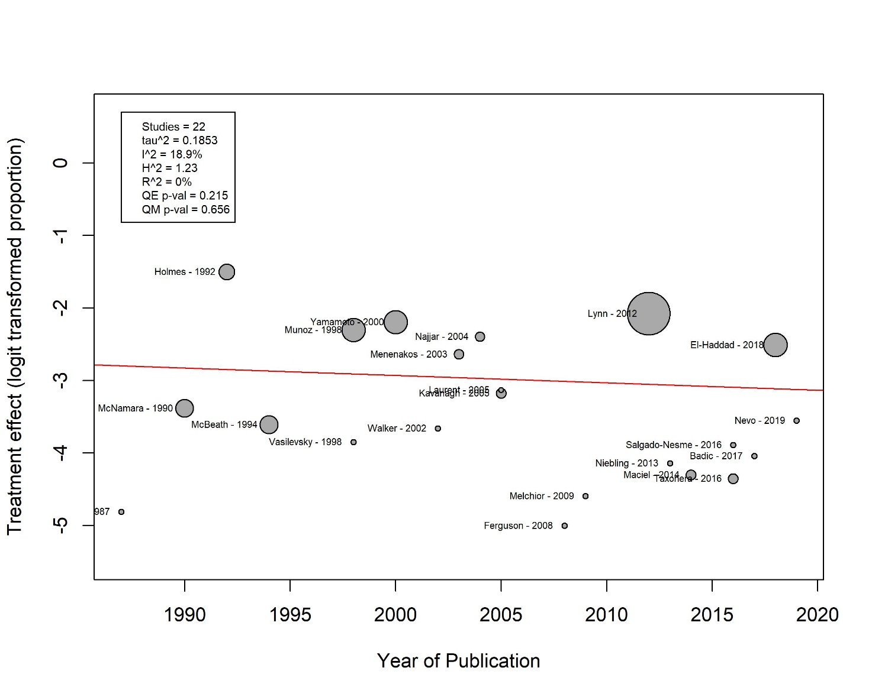
- Word combination syntax
Keywords used for database search: “colovesical fistula”, “enterovesical fistula”, “pelvic fistula”, “surgery”, “surgical treatment”, “surgical management”, “primary healing”, and “outcome”. The keywords “enterocutaneous”, “enteroatmospheric”, “anal fistula” and “wound healing” were set to be excluded from the search.
Search query: ((colovesical fistula) OR (enterovesical fistula) OR (pelvic fistula)) NOT (enterocutaneous) NOT (enteroatmospheric) NOT (anal fistula) AND ((surgery) OR (surgical treatment) OR (surgical management)) AND ((primary healing) OR (outcome)) NOT (wound healing)

