Supplement
S1 Fig. 1.

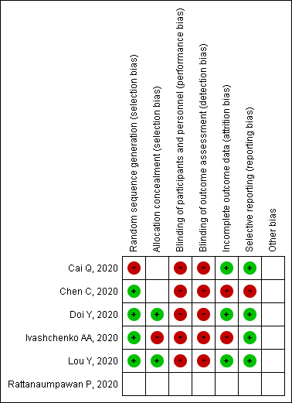

S2 Fig. 2.
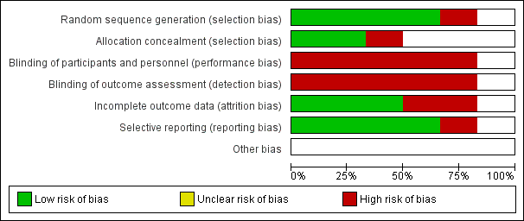

S3 Fig. S3
Proportion of Effect for viral clearance among comparators of favipiravir a. by day 7 and b. by day 14 from the initiation of treatment
a.
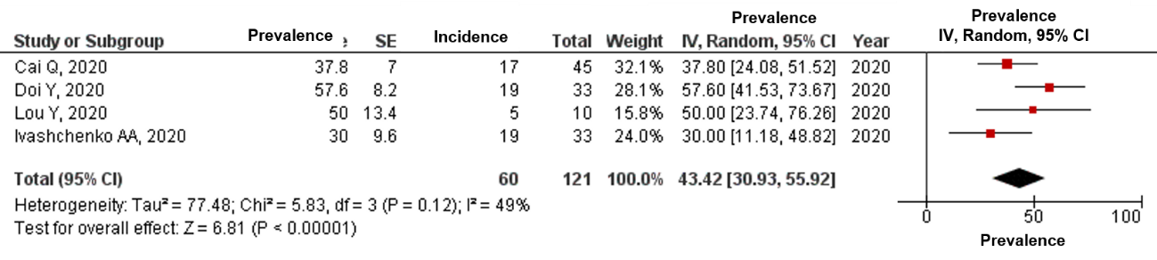
b.
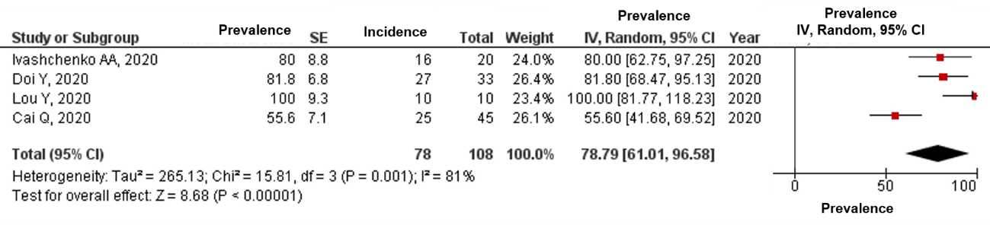

S4 Fig. S4
Proportion of Effect for clinical improvement among comparators of favipiravir a. by day 7 and b. by day 14 from the initiation of treatment
a.
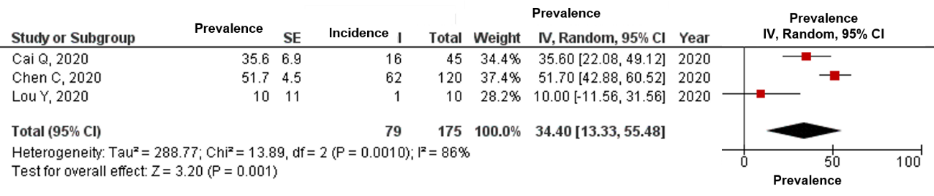

b.


