Supplementary Figures and Tables

Figure S1: Stringency indices of countries with depression data during the COVID-19 pandemic. Point indicates the start date of a study included in our meta-analysis.
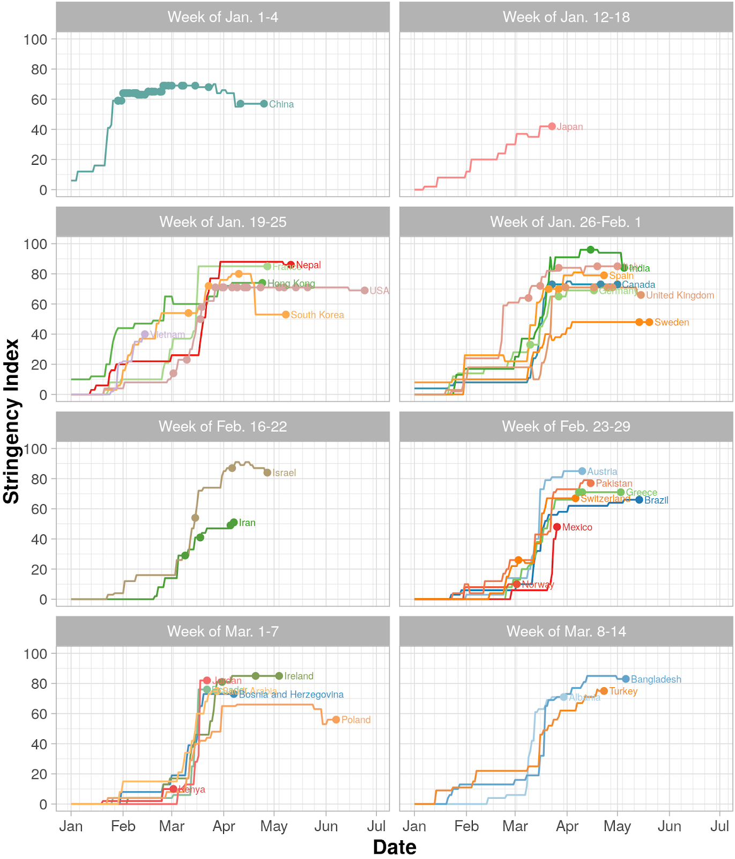

Figure S2. We conducted a sensitivity analysis excluding studies from China. Government response date significantly moderated depressive symptom prevalence (k=81, n=458,364; β=0.003, SE=0.001, Q_{M}=5.839, df=1, p=0.016; Q_{E}=10364.72, df=79, p<0.001; R²=5.97%).

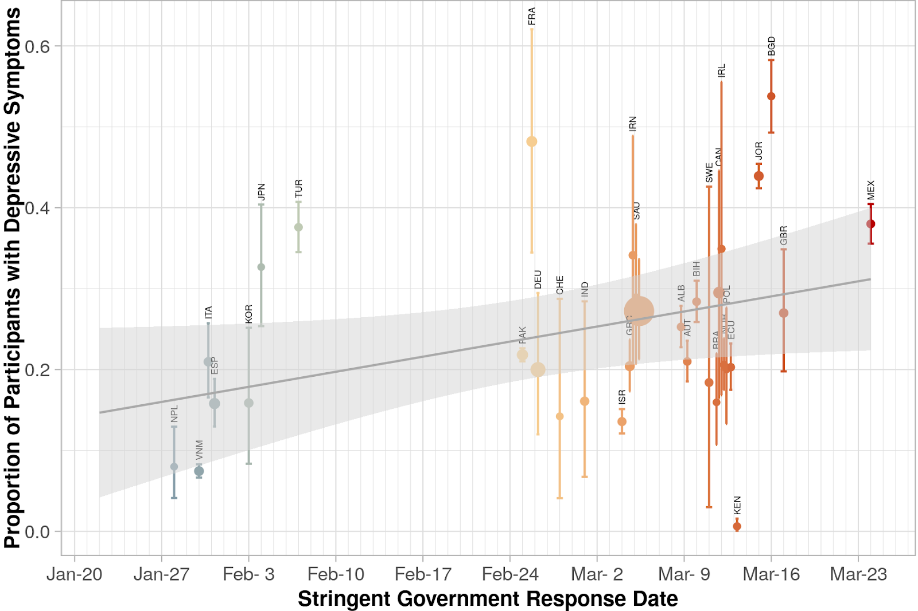
Figure S3: Funnel plot.
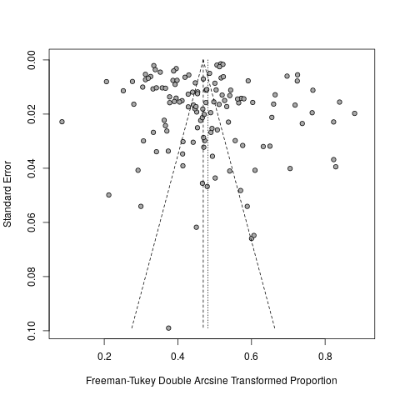

Table S1: Database search record.

 | Searches | Results
1 | Coronavirus Infections/ | 28265
2 | Severe Acute Respiratory Syndrome/ | 4943
3 | Pandemics/ | 28415
4 | ("COVID" or "COVID-19" or "coronavirus" or "SARS-CoV-2").tw,kf. | 65013
5 | exp *Mood Disorders/ | 94193
6 | depressi*.tw,kf. | 396019
7 | *Depressive Disorder, Major/cl [Classification] | 103
8 | *Depressive Disorder, Major/pp [Physiopathology] | 2115
9 | ("patient health questionnaire" or "PHQ").tw,kf. | 6897
10 | 1 or 2 or 3 or 4 | 75566
11 | 5 or 6 or 7 or 8 or 9 | 413532
12 | 10 and 11 | 879
13 | limit 12 to yr="2019 -Current" | 805

Table S2: Characteristics of included studies. Date of stringent policy implementation denotes the earliest calendar day on which the country met or exceeded a stringency index of 20. Stringency index (i.e., Oxford COVID-19 Government Response Index) assesses variations in the strictness of government policies across 180 countries. Indices range from 0 to 100; a higher value denotes a more stringent government response at a given time.

Abbreviations: N: study sample size; NR: not reported; PHQ:Patient Health Questionnaire.

Country | Date of Stringent Policy Implementation | Author | N | Study Period | Depression Metric | Cut-off Score | Full citation
Albania | 2020-03-09 | Mechili | 1112 | Mar 30 - Apr 9 | PHQ9 | 10 | ¹²²
Austria | 2020-03-09 | Pieh | 1005 | Apr 10 - Apr 30 | PHQ9 | 10 | ¹³³
Bangladesh | 2020-03-16 | Islam | 476 | May 6-12 | PHQ9 | 10 | ⁹⁸
Bosnia and Herzegovina | 2020-03-10 | Slijivo | 1201 | Apr 7-12 | PHQ9 | 10 | ¹⁴⁵
Brazil | 2020-03-12 | Civantos | 163 | May 14-31 | PHQ2 | 3 | ⁷⁵
Canada | 2020-03-12 | Mrklas | 8267 | Mar 23 - May 4 | PHQ9 | 10 | ¹²³
Canada | 2020-03-12 | Price | 2005 | Apr 21-28 | PHQ9 | 10 | ¹³⁴
Canada | 2020-03-12 | Schmitz | 1607 | May 1-6 | PHQ9 | 10 | ¹³⁹
China | 2020-01-22 | An | 1103 | Mar 15-20 | PHQ9 | 10 | ⁶²
China | 2020-01-22 | Cai | 2346 | Feb 11-26 | PHQ9 | 10 | ⁶⁹
China | 2020-01-22 | Chang | 3881 | Jan 31 - Feb 3 | PHQ9 | 10 | ⁷¹
China | 2020-01-22 | Chen | 902 | Feb 9-11 | PHQ9 | 10 | ⁷²
China | 2020-01-22 | Chi | 2038 | Feb 12-17 | PHQ9 | 10 | ⁷³
China | 2020-01-22 | Fu | 1242 | Feb 18-28 | PHQ9 | NR | ⁸⁴
China | 2020-01-22 | Hong | 4692 | Feb 8-14 | PHQ9 | 10 | ⁹²
China | 2020-01-22 | Hu | 85 | Mar 7-24 | PHQ9 | 10 | ⁹³
China | 2020-01-22 | Huang | 362 | Feb 23 - Mar 5 | PHQ9 | 10 | ⁹⁵
China | 2020-01-22 | Huang | 6261 | Feb 10-15 | PHQ9 | 10 | ⁹⁴
China | 2020-01-22 | Kang | 994 | Jan 29 - Feb 4 | PHQ9 | 10 | ¹⁰⁰
China | 2020-01-22 | Lai | 1257 | Jan 29 - Feb 3 | PHQ9 | 10 | ¹⁰⁶
China | 2020-01-22 | Lee | 3064 | Jan 29 - Feb 11 | PHQ9 | 10 | ¹⁰⁷
China | 2020-01-22 | Li | 4369 | Feb 8-15 | PHQ9 | 10 | ¹¹¹
China | 2020-01-22 | Li | 5033 | Feb 9-16 | PHQ9 | 10 | ¹¹⁰
China | 2020-01-22 | Li | 658 | Feb 16-19 | PHQ9 | 10 | ¹¹²
China | 2020-01-22 | Li | 398 | Apr 25 - May 9 | PHQ9 | 10 | ¹¹³
China | 2020-01-22 | Liang | 2003 | Feb 14 - Mar 29 | PHQ9 | 10 | ¹⁰⁹
China | 2020-01-22 | Lin | 5641 | Feb 5-23 | PHQ9 | 10 | ¹¹⁴
China | 2020-01-22 | Liu | 217 | Feb. 23 - Apr 2 | PHQ9 | 10 | ¹¹⁵
China | 2020-01-22 | Liu | 675 | Apr 11-22 | PHQ9 | 10 | ¹¹⁷
China | 2020-01-22 | Ma | 770 | Feb 24 - Mar 8 | PHQ9 | 10 | ¹¹⁸
China | 2020-01-22 | Ni | 1791 | Feb 18-24 | PHQ2 | 3 | ¹²⁶
China | 2020-01-22 | Que | 2285 | Feb 16-23 | PHQ9 | 10 | ¹³⁵
China | 2020-01-22 | Ran | 1770 | Feb 23 - Mar 2 | PHQ9 | 10 | ¹³⁶
China | 2020-01-22 | Shi | 56679 | Feb 28 - Mar 11 | PHQ9 | 10 | ¹⁴³
China | 2020-01-22 | Tang | 2485 | Feb 20-27 | PHQ9 | 10 | ¹⁴⁹
China | 2020-01-22 | Tu | 100 | Feb 7-25 | PHQ9 | NR | ¹⁵²
China | 2020-01-22 | Wang | 274 | Feb 26 - Mar 3 | PHQ9 | 10 | ¹⁵⁵
China | 2020-01-22 | Wang | 19372 | Feb 10-17 | PHQ9 | 10 | ¹⁵⁷
China | 2020-01-22 | Wang | 926 | Feb 25 - Mar 6 | PHQ2 | 3 | ¹⁵⁸
China | 2020-01-22 | Xiao | 933 | Feb 4-12 | PHQ9 | 10 | ¹⁶¹
China | 2020-01-22 | Xin | 24378 | Feb 1-10 | PHQ9 | 10 | ¹⁶²
China | 2020-01-22 | Xu | 8817 | Feb 14-23 | PHQ9 | 10 | ¹⁶³
China | 2020-01-22 | Zhang | 1563 | Jan 29 - Feb 3 | PHQ9 | 10 | ¹⁶⁶
China | 2020-01-22 | Zhang | 1342 | Feb 11-16 | PHQ9 | 10 | ¹⁶⁹
China | 2020-01-22 | Zhang | 2182 | Feb 19 - Mar 6 | PHQ2 | 3 | ¹⁶⁵
China | 2020-01-22 | Zhang | 205 | Feb 15-29 | PHQ9 | 10 | ¹⁶⁷
China | 2020-01-22 | Zhao | 220 | Feb 10-15 | PHQ9 | 10 | ¹⁷⁰
China | 2020-01-22 | Zhao | 281 | Mar 23 - Apr 20 | PHQ9 | 10 | ¹⁷¹
China | 2020-01-22 | Zhou | 8079 | Mar 8-15 | PHQ9 | 10 | ¹⁷²
Ecuador | 2020-03-13 | Paz | 759 | March 22 to April 18 | PHQ9 | 10 | ¹³¹
France | 2020-02-26 | Essadek | 8004 | Apr 27-30 | PHQ9 | 10 | ⁸¹
Germany | 2020-02-26 | Bauerle | 15037 | Mar 10 - May 5 | PHQ2 | 3 | ⁶⁵
Germany | 2020-02-26 | Benke | 4188 | Apr 17 - May 15 | PHQ9 | 10 | ⁶⁶
Germany | 2020-02-26 | Petzold | 6509 | Mar 27 - Apr 6 | PHQ2 | 3 | ¹³²
Germany | 2020-02-26 | Teufel | 12244 | Mar 10-24 | PHQ2 | NR | ¹⁵⁰
Greece | 2020-03-05 | Blekas | 270 | Apr 10-13 | PHQ9 | NR | ⁶⁷
Greece | 2020-03-05 | Papandreou | 839 | May 3-20 | PHQ9 | 10 | ¹²⁹
Greece | 2020-03-05 | Skapinakis | 3379 | Apr 8-12 | PHQ9 | 10 | ¹⁴⁴
Hong Kong Special Administrative Region of the People's Republic of China | 2020-01-22 | Choi | 500 | Apr 24 - May 3 | PHQ9 | 10 | ⁷⁴
India | 2020-03-01 | Khanna | 2355 | Apr 15-19 | PHQ9 | 10 | ¹⁰²
India | 2020-03-01 | Suryavanshi | 197 | May 5-16 | PHQ9 | 10 | ¹⁴⁷
Iran | 2020-03-05 | Pouralizadeh | 441 | Apr 7-12 | PHQ9 | 10 | ¹³⁰
Iran | 2020-03-05 | Vafaei | 246 | Mar 9-16 | PHQ9 | 10 | ¹⁵⁴
Iran | 2020-03-05 | Zhang | 304 | Apr 5-20 | PHQ2 | NR | ¹⁶⁸
Ireland | 2020-03-12 | Corbett | 240 | Apr 20 - May 5 | PHQ9 | NR | ⁷⁷
Ireland | 2020-03-12 | Karatzias | 184 | Mar 31 - Apr 5 | PHQ9 | 10 | ¹⁰¹
Ireland | 2020-03-12 | Maguire | 59 | May | PHQ2 | 3 | ¹¹⁹
Israel | 2020-03-04 | Barzilay | 424 | Apr 6-15 | PHQ2 | 3 | ⁶⁴
Israel | 2020-03-04 | Palgi | 1059 | Mar 15 - Apr 1 | PHQ9 | 10 | ¹²⁸
Israel | 2020-03-04 | Shapiro | 503 | "late April" | PHQ2 | 3 | ¹⁴¹
Italy | 2020-01-31 | Amerio | 131 | Mar 15- Apr 15 | PHQ9 | 10 | ⁶¹
Italy | 2020-01-31 | Gualano | 1486 | Apr 19 - May 3 | PHQ2 | 3 | ⁸⁸
Italy | 2020-01-31 | Martina | 349 | May 1-6 | PHQ2 | 3 | ¹²⁰
Italy | 2020-01-31 | Pakenham | 1035 | NR | PHQ9 | 10 | ¹²⁷
Japan | 2020-02-04 | Zhao | 150 | Mar 23 - Apr 20 | PHQ9 | 10 | ¹⁷¹
Jordan | 2020-03-15 | Naser | 4126 | Mar 22-28 | PHQ9 | 10 | ¹²⁴
Kenya | 2020-03-13 | Dyer | 479 | Mar | PHQ9 | 10 | ⁸⁰
Mexico | 2020-03-24 | Galindo-Vazquez | 1508 | Mar 26 - Apr 12 | PHQ9 | NR | ⁸⁶
Nepal | 2020-01-28 | Gupta | 150 | May 11 - Jun 10 | PHQ9 | 10 | ⁸⁹
Norway | 2020-03-12 | Havnen | 617 | Mar | PHQ9 | 10 | ⁹¹
Pakistan | 2020-02-25 | Imran | 10178 | Apr 15 - May | PHQ9 | 10 | ⁹⁷
Poland | 2020-03-12 | Szepietowski | 120 | NR - emailed author | PHQ9 | 10 | ¹⁴⁸
Saudi Arabia | 2020-03-05 | Almater | 107 | Mar 28 - Apr 4 | PHQ9 | 10 | ⁶⁰
South Korea | 2020-02-03 | Jung | 1925 | Mar 11-12 | PHQ9 | 10 | ⁹⁹
South Korea | 2020-02-03 | Kim | 550 | May 8 - 13 | PHQ9 | 10 | ¹⁰⁴
South Korea | 2020-02-03 | Yang | 65 | Apr 10 | PHQ9 | 10 | ¹⁶⁴
South Korea | 2020-02-03 | Zhao | 390 | Mar 23 - Apr 20 | PHQ9 | 10 | ¹⁷¹
Spain | 2020-01-31 | Fullana | 4399 | Mar 27 - Apr 14 (most of the responses collected Mar 27 - Apr 1) | PHQ9 | 10 | ⁸⁵
Spain | 2020-01-31 | Gonzalez-Sanguino | 3480 | Mar 21 - 28 | PHQ2 | NR | ⁸⁷
Spain | 2020-01-31 | Papandreou | 1002 | Apr 23 - May 18 | PHQ9 | 10 | ¹²⁹
Sweden | 2020-03-11 | Hakansson | 279 | May 20 - Jun 10 | PHQ9 | 10 | ⁹⁰
Sweden | 2020-03-11 | McCracken | 1212 | May 14 - Jun 11 | PHQ9 | 10 | ¹²¹
Switzerland | 2020-02-28 | Krammer | 85 | April 8-23 | PHQ9 | 10 | ¹⁰⁵
Switzerland | 2020-02-28 | Speth | 114 | Mar 3 - Apr 17 | PHQ2 | 3 | ¹⁴⁶
Turkey | 2020-02-07 | Sahin | 939 | Apr 23 - May 23 | PHQ9 | 10 | ¹³⁸
United Kingdom | 2020-03-17 | Dawson | 555 | May 15-21 | PHQ9 | 10 | ⁷⁹
United Kingdom | 2020-03-17 | Hyland | 1041 | Mar 31 - Apr 5 | PHQ9 | 10 | ⁹⁶
United Kingdom | 2020-03-17 | Rettie | 842 | Apr 17-26 | PHQ9 | 10 | ¹³⁷
United Kingdom | 2020-03-17 | Shah | 207 | Apr 25 - May 1 | PHQ2 | 3 | ¹⁴⁰
United Kingdom | 2020-03-17 | Willner | 244 | Apr 28 - Jun 5 | PHQ9 | 10 | ¹⁵⁹
United States | 2020-03-05 | Arnetz | 641 | May 7-29 | PHQ9 | 10 | ⁶³
United States | 2020-03-05 | Barzilay | 831 | Apr 6-15 | PHQ2 | 3 | ⁶⁴
United States | 2020-03-05 | Bruine de Bruin | 6666 | Mar 10 -31 | PHQ2 | 3 | ⁶⁸
United States | 2020-03-05 | Cardel | 250 | Apr 1-12 | PHQ2 | 3 | ⁷⁰
United States | 2020-03-05 | Civantos | 349 | Apr 14 - 25 | PHQ2 | 3 | ⁷⁶
United States | 2020-03-05 | Czeisler | 5470 | Jun 24-30 | PHQ2 | 3 | ⁷⁸
United States | 2020-03-05 | Ettman | 1441 | Mar 31 - Apr 13 | PHQ9 | 10 | ⁸²
United States | 2020-03-05 | Farewell | 25 | Mar - Apr | PHQ2 | 3 | ⁸³
United States | 2020-03-05 | Killgore | 1013 | Apr 9-10 | PHQ9 | NR | ¹⁰³
United States | 2020-03-05 | Lee | 453 | Apr 15 | PHQ2 | 3 | ¹⁰⁸
United States | 2020-03-05 | Liu | 898 | Apr 13 - May 19 | PHQ9 | 10 | ¹¹⁶
United States | 2020-03-05 | Raj | 2081 | Mar 19-27 | PHQ2 | 3 | ⁴⁹
United States | 2020-03-05 | Shechter | 657 | Apr 9-24 | PHQ2 | 3 | ¹⁴²
United States | 2020-03-05 | Thomaier | 374 | Mar 27 - Apr 10 | PHQ2 | 3 | ¹⁵¹
United States | 2020-03-05 | Twenge | 69316 | Apr 23 - May 5 | PHQ2 | 3 | ¹⁵³
United States | 2020-03-05 | Twenge | 119897 | May 14-19 | PHQ2 | 3 | ¹⁵³
United States | 2020-03-05 | Twenge | 90798 | May 21-26 | PHQ2 | 3 | ¹⁵³
United States | 2020-03-05 | Twenge | 39447 | May 7-12 | PHQ2 | 3 | ¹⁵³
United States | 2020-03-05 | Wang | 1994 | May 4-19 | PHQ9 | 10 | ¹⁵⁶
United States | 2020-03-05 | Wilson | 474 | Apr 6-12 | PHQ9 | 10 | ¹⁶⁰
Vietnam | 2020-01-30 | Nguyen | 3947 | Feb 14 - Mar 2 | PHQ9 | 10 | ¹²⁵

