Ambient particulate matter and household air pollution on early-life determinants of stunting – a systematic review and meta-analysis
Vivian C. Pun; Russell Dowling, Sumi Mehta
Supplementary

Figure S1. Number of publications on the association between ambient particulate pollution and household air pollution and stunting between 1999 and 2020.

Table S1. Characteristics of the studies included in the meta-analysis.

Article | Data Year | Country | Study design | Sample Size | Outcome | Outcome prevalence | Exposure Period | Exposure Measure | SES adjusted? | Smoking adjusted?
Ambient PM2.5 pollution
Melody et al., 2020 | 2012-2015 | Victoria, Australia | Retrospective cohort study | 285,594 | SGA | 8.9% | Entire pregnancy | PM2.5 | Yes | No
Huang et al., 2020 | 1996-2002 | Taiwan | Retrospective cohort study | 322,513 | SGA | 6.9% | Trimesters | PM10 | Yes | No
Tapia et al., 2020 | 2012-2016 | Lima, Peru | Retrospective cohort study | 123,028 | SGA | 5.7% | Entire pregnancy, trimesters | PM2.5 | Yes | No
Ottone et al., 2020 | 2012-2014 | Northern Italy | Retrospective cohort study | 23,708 | SGA | 5.7% | Entire pregnancy | PM2.5 | Yes | Yes
Guo et al., 2020 | 2014-2017 | Guangdong, China | Retrospective cohort study | 2,567,457 | SGA | 13.7% | Entire pregnancy, trimesters | PM2.5, PM10 | No | Yes
Lin et al., 2020 | 2014-2017 | Beijing, China | Prospective cohort study | 18,863 | SGA | 5.7% | Entire pregnancy | PM2.5, PM10 | Yes | No
Wang et al., 2019a | 2015-2017 | Guangzhou, China | Retrospective cohort study | 506,000 | SGA | 9.7% | Entire pregnancy, trimesters | PM2.5, PM10 | No | No
Percy et al., 2019 | 2007-2010 | Ohio, USA | Retrospective cohort study | 224,921 | SGA | 10.8% | Entire pregnancy, trimesters | PM2.5 | No | Yes
Nobles et al., 2019 | 2002-2010 | Utah, USA | Retrospective cohort study | 50,005 | SGA | 7.9% | Entire pregnancy, trimesters | PM2.5, PM10 | No | Yes
Hao et al., 2019 | 2017 | Huangshi, China | Cross-sectional study | 4,194 | SGA | 7.5% | Entire pregnancy, trimesters | PM2.5, PM10 | No | No
Choe et al., 2019a,b | 2002-2012 | Seoul, Korea | Retrospective cohort study | 824,011 | SGA | 11.2% | Entire pregnancy, trimesters | PM10 | Yes | No
Li et al., 2019 | 2013-2016 | Changzhou, China | Retrospective cohort study | 2,709 | SGA | 16.2% | Entire pregnancy | PM2.5 | No | No
Wang et al., 2019b | 2005-2012 | Shenzhen, China | Cross-sectional study | 1,206,158 | SGA | 7.8% | Entire pregnancy, trimesters | PM10 | Yes | No
Fong et al., 2019 | 2001-2012 | Massachusetts, USA | Retrospective cohort study | 725,919 | SGA | 9.1% | Entire pregnancy | PM2.5 | Yes | No
Smith et al., 2017 | 2006-2010 | London | Retrospective cohort study | 540,365 | SGA | 9.5% | Entire pregnancy | PM2.5, PM10 | Yes | Yes
Capobussi et al., 2016 | 2005-2012 | Italy | Retrospective cohort study | 27,128 | SGA | 10.2% | Entire pregnancy, trimesters | PM10 | Yes | No
Lavigne et al., 2016 | 2005-2012 | Canada | Retrospective cohort study | 818,400 | SGA | 9.3% | Entire pregnancy, trimester 2, trimester 3 | PM2.5 | Yes | Yes
Stieb et al., 2016 | 1999-2008 | Canada | Retrospective cohort study | 2,966,705 | SGA | 8.3% | Entire pregnancy, trimesters | PM2.5 | No | No
Pereira et al., 2016 | 1988-2008 | Connecticut, USA | Retrospective cohort study | 9,587 | SGA | na | Entire pregnancy, trimester 2 | PM10 | No | Yes
Qian et al., 2016 | 2010-2013 | Wuhan, China | Prospective cohort study/case-control study | 95,911 | IUGR | 8.8% | Entire pregnancy, trimester 1 | PM2.5, PM10 | Yes | Yes
Bijnens et al., 2016 | 2002-2013 | Belgium | Retrospective cohort study | 4,760 | SGA | 9.0% | Entire pregnancy, trimesters | PM10 | Yes | No
Winckelmans et al., 2015 | 1999-2009 | Belgium | Retrospective cohort study | 494,653 | SGA | 9.4% | Entire pregnancy, trimesters | PM10 | No | No
Hannam et al., 2014 | 2004-2008 | UK | Retrospective cohort study | 37,862 | SGA | 8.6% | Entire pregnancy | PM2.5 | Yes | Yes
Hyder et al., 2014 | 2000-2006 | Connecticut and Massachusetts, USA | Retrospective cohort study | 643,839 | SGA | 10.0% | Entire pregnancy, trimesters | PM2.5 | No | Yes
Gray et al., 2014 | 2002-2006 | North Carolina, USA | Retrospective cohort study | 457,642 | SGA | 9.3% | Entire pregnancy | PM2.5 | No | Yes
Lee et al., 2013 | 1997-2002 | Pennsylvania, USA | Retrospective cohort study | 34,705 | SGA | 8.5% | Trimester 1 | PM2.5, PM10 | No | Yes
Sathyanarayana et al., 2013 | 1997-2005 | USA | Retrospective cohort study | 298,835 | SGA | 10.2% | Trimester 1, trimester 3 | PM2.5 | Yes | Yes
Salihu et al., 2012 | 2000-2007 | USA | Retrospective cohort study | 12,356 | SGA | 12.9% | Entire pregnancy | PM2.5, PM10 | No | Yes
Le et al., 2012 | 1990-2001 | Michigan, USA | Retrospective cohort study | 24,248 | SGA | 8.3% | Trimesters | PM10 | No | Yes
Madsen et al., 2010 | 1999-2002 | Norway | Retrospective cohort study | 25,229 | SGA | 9.6% | Entire pregnancy | PM2.5, PM10 | No | Yes
Brauer et al., 2008 | 1999-2002 | Canada | Retrospective cohort study | 70,249 | SGA | 9.0% | Entire pregnancy | PM2.5, PM10 | Yes | Yes
Liu et al., 2007 | 1985-2000 | Canada | Retrospective cohort study | 386,202 | IUGR | 10.9% | Trimesters | PM2.5 | No | No
Hansen et al., 2007 | 2000-2003 | Australia | Retrospective cohort study | 26,617 | SGA | 7.1% | Trimesters | PM10 | Yes | No
Kim et al., 2007 | 2001-2004 | Seoul, Korea | Prospective cohort study | 1,514 | IUGR | 0.9% | Trimesters | PM10 | No | No
Household air pollution
Islam, et al. 2020 | 2015-2016 | India | Cross-sectional study | 80,070 | HAZ | 38.7% | Children < 5 year old | Use of polluted cooking fuel | Yes | No
Lamichhane, et al. 2019 | 2006, 2011, 2016 | Nepal | Cross-sectional study | 9,914 | HAZ | 45.0% | Children < 5 year old | Use of polluting fuel | Yes | Yes
Amare, et al. 2019 | 2016 | Ethiopia | Cross-sectional study | 3,579 | HAZ | 38.0% | Post-pregnancy (0-59 months) | Traditional vs modern fuel | Yes | No
Kim, et al. 2017 | 2005-2014 | South Asia (pooled) | Cross-sectional study | 18,586 | HAZ | 38.40% | Post-pregnancy (6-23 months) | Use of solid fuel | Yes | No
Dadras, et al. 2017 | 2011 | Nepal | Cross-sectional study | 900 | HAZ | 39.8% | Post-pregnancy (0-59 months) | Unclean vs cleaned cooking | Yes | No
Machisa, et al. 2013 | 2006-2007 | Swaziland | Cross-sectional study | 1,150 | HAZ | 27.60% | Post-pregnancy (6-36 months) | Use of biomass fuel | Yes | No
Fenske, et al. 2013 | 2005-2006 | India | Cross-sectional study | 12,176 | HAZ | 36.8%; 17.1% | Post-pregnancy (0-24 months) | Use of diff cooking fuels | No | No
Rohner, et al. 2013 | 2010 | Philippines | Cross-sectional study | 477 | HAZ | 26.8% | Post-pregnancy (6-23 months) | Unclean vs cleaned cooking | Yes | No
Tielsch, et al. 2009 | 1998-2000 | India | Prospective cohort study | 10,437 | HAZ; SGA | 89.4%; 57.5% | Post-pregnancy (0-6 months) | Use of wood/dung fuel | No | Yes
Kyu, et al. 2009 | 2005-2007 | Cambodia, DR, Haiti, Jordan, Moldova, Namibia, Nepal | Cross-sectional study | 28,439 | HAZ | 14.8%; 8% | Post-pregnancy (0-59 months) | Exposure to biofuel smoke | Yes | No
Hong, et al. 2006 | 2004 | Bangladesh | Cross-sectional study | 2,570 | HAZ | 43.0% | Post-pregnancy (0-59 months) | Unclean vs cleaned cooking | Yes | No

Figure S2. Pooled estimates of the effect on SGA (all outcome definitions) associated with a 10 μg/m³ increase in ambient PM_{2.5} concentration during entire pregnancy
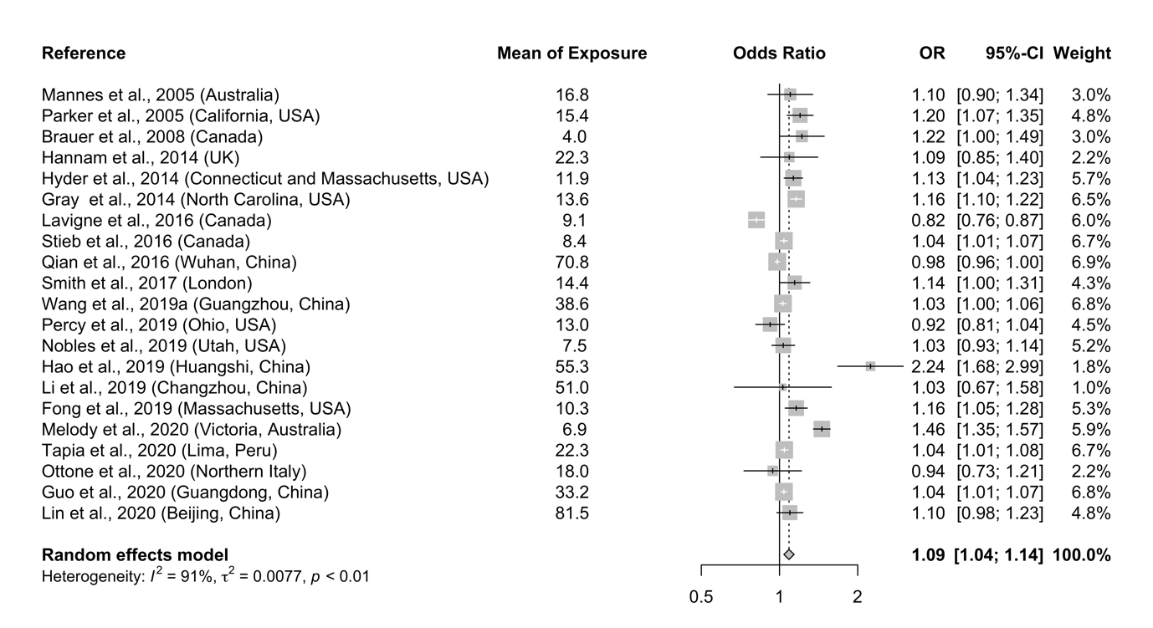

Figure S3. Pooled estimates of the effect on SGA associated with a 10 μg/m³ increase in PM₁₀ concentration during entire pregnancy and three trimesters
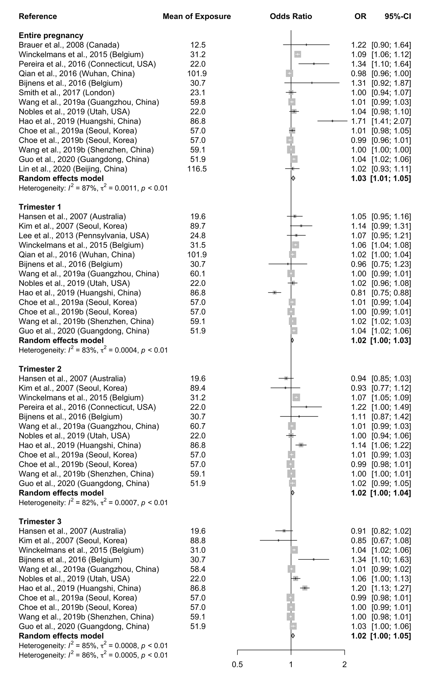
Figure S4. Pooled estimates of the effect on severe stunting (HAZ <-3) associated with exposure to household air pollution from solid fuel use compared with cleaner fuels


