The impact of mitigation measures on perinatal outcomes during the first nine months of the COVID-19 pandemic: a systematic review with meta-analysis - SUPPLEMENTARY MATERIAL
Table S.1: Risk of bias assessment (ROBIN-I)
Author | Bias due to confounding | Bias in selection of participants | Bias in classification of interventions | Bias due to deviations from intended interventions | Bias due to missing data | Bias in measurement of outcomes | Bias in selection of the reported result | Overall Bias judgement
Arnaez et al.¹
Been et al.²
Berghella et al.³
Briozzo et al.⁴
Caniglia et al.⁵
De Curtis et al.⁶
Dell’Utri et al.⁷
Duryea et al.³⁶
Friedrich et al.⁸
Greene et al.⁹
Gu et al.¹⁰
Handley et al.¹¹
Harvey et al.¹²
Hedermann et al.¹³
Janevic et al.¹⁴
Justman et al.¹⁵
Kasuga et al.¹⁶
Kc et al.¹⁷
Khalil et al.¹⁸
Kirchengast et al.¹⁹
Kugelman et al.²⁰
Kumar et al.²¹
Kumari et al.²²
Lemon et al.³⁵
Li et al.²³
Maeda et al.²⁴
Main et al.²⁵
Matheson et al.²⁶
McDonnell et al.²⁷
Meyer et al.²⁸
Mor et al.²⁹
Pasternak et al.³⁰
Philip et al.³¹
Richter et al.⁴⁸
Simpson et al.³²
Stowe et al.³³
Sun et al.³⁴
Wood et al.³⁵

ROBINS-I Risk of Bias Key
Low risk of bias
Moderate risk of bias
Serious risk of bias
Critical risk of bias

Table S.2: Study methodology
Author | Primary outcome(s) | Inclusion criteria | Exclusion criteria | Analysis methodology | Data Source | Adjustment for variables
Arnaez et al.¹ | ﻿Preterm birth and stillbirths | All births, >23 weeks | Nil | ﻿Join point regression analysis with ﻿Multivariate binomial logistic regression models | Hospital records | Yes
Been et al.² | Preterm birth | Singletons | Multiple births, <24 weeks, >41+6 weeks, stillbirth/neonatal death prior to bloodspot screening | ﻿Difference-in-regression-discontinuity analysis | National Institute for Public Health and the Environment | Yes
Berghella et al.³ | Preterm birth incidence | All births, >20 weeks | Nil | Multivariable logistic regression | Hospital records | Yes
Briozzo et al.⁴ | Perinatal results | All births | Nil | Cross-sectional cohort study | Hospital records | No
Caniglia et al.⁵ | Stillbirth, preterm birth, small gestational age, neonatal death | Singleton baby, >24 weeks | <24 weeks | Difference in differences analysis | Hospital records for exposure cohort and Tsepamo study for control cohort | Yes
De Curtis et al.⁶ | Preterm birth rate and stillbirth rate | Singleton | Late termination for fetal abnormality | ﻿z-test of two proportions (protest STATA command) | Hospital discharge database | No
Dell’Utri et al.⁷ | Reason for hospital presentation | All patients presenting as an emergency | Nil | Chi-squared test | Hospital records | No
Duryea et al.³⁶ | Placental abruption, stillbirth and NICU admission in a full-term infant and umbilical cord pH<7.0 | All deliveries of infants >500g | Nil | Pearson X² analysis, unpaired t-test and Mantel-Haenszel test | Obstetric research database | Yes
Friedrich et al.⁸ | Haematological impact of wear face masks | Women admitted for delivery | Nil | Comparative descriptors and logistic regression analysis | Hospital records | Yes
Greene et al.⁹ | Effect of service change on obstetric outcomes | All deliveries | Nil | t-test, Wilcoxon test, Chi-squared | Hospital records | Yes
Gu et al.¹⁰ | Prevention of hospital acquired COVID-19 | All births | Nil | Comparative descriptors | Hospital records | No
Handley et al.¹¹ | ﻿Preterm birth, spontaneous PTB, medically indicated PTB, and stillbirth rates | Singleton, >20 weeks | Multiple pregnancy | ﻿Fisher exact test with ﻿marginal effects models | Geobirth database | ﻿Yes
Harvey et al.¹² | Preterm birth rate | All births between 17 and 47 weeks | <17 and >47 weeks gestation | Comparative descriptors and logistic regression analysis | Tennessee birth records | Yes
Hedermann et al.¹³ | Preterm birth rate | Singleton | Multiple pregnancy | Logistic regression analysis | Danish Neonatal Screening Biobank | No
Janevic et al.¹⁴ | Racial/ethnic differences in Preterm birth | All births | Nil | Log binomial regression for difference-in-differences analysis | Hospital records | Yes
Justman et al.¹⁵ | Changes to antenatal care and mode of delivery | All patients registered at hospital | Nil | Comparative descriptors, univariant analysis | Hospital records | No
Kasuga et al.¹⁶ | Perinatal complications | All births | Positive COVID-19 test, multiple pregnancies, transfer of care from another hospital | Comparative descriptors (meta-analysis data deduced from percentages) | Hospital records | No
Kc et al.¹⁷ | Preterm birth, institutional stillbirth and neonatal mortality | Institutional births, >22 weeks,  singleton, fetal heart beat present on admission | Multiple pregnancies, births out with hospital | ﻿Generalised linear model with Poisson distribution and log-link function | within REFINE and SUSTAIN studies | Yes
Khalil et al.¹⁸ | Preterm birth rate and stillbirth rate | Singleton and multiple pregnancies,  >24 weeks | Late termination for fetal abnormality | Comparative descriptors with Mann-Whitney and Fisher exact tests | Hospital records | No
Kirchengast et al.¹⁹ | Preterm birth and low birth weight | Singleton live births | Stillbirth, COVID-19 infection | Comparative descriptors and logistic regression analysis | Hospital records | No
Kugelman et al.²⁰ | Hospital admission rates | Acute presentations, >20 weeks | Attendance for routine care, Missing data | Chi squared, t-test, logistic regression analysis | Hospital records | Yes
Kumar et al.²¹ | Stillbirth rate | All stillbirths, >20 weeks | Nil | ﻿Analytical case-control study | Hospital records | No
Kumari et al.²² | Rates of hospitalisation in labour | Women admitted to hospital | Nil | Retrospective analysis | Hospital records | No
Lemon et al.³⁵ | Rate of preterm birth | Singleton deliveries > or equal to 20 weeks | Missing gestational age data, ‘self-paying’ women, stillbirth | Person chi-square and t-tests | Hospital records | No
Li et al.²³ | ﻿Indications for caesarean delivery and the birth weight | All births | <28 weeks, stillbirth | ﻿Chi-square test, t-test and Fisher’s exact probability method | Hospital records | No
Maeda et al.²⁴ | Preterm birth rates and NICU admission | Live births at caesarean section, before 37 weeks, neonates requiring resuscitation or care in NICU or growing care unit | Spontaneous vaginal deliveries | Difference in differences analysis | Hospital records | Yes
Main et al.²⁵ | Preterm birth rates | All births | Nil | Logistic regression analysis | California Centre for Health Statistics | Yes
Matheson et al.²⁶ | Preterm birth rate | All births | Termination of pregnancy, stillbirth | ﻿Interrupted time series analysis with auto-regressive integrated moving average model | Hospital records | Yes
McDonnell et al.²⁷ | Maternal and neonatal outcomes | All births | Nil | Pearsons correlation co-efficient, Chi squared/Fishers test | Hospital records | No
Meyer et al.²⁸ | Preterm birth | Singleton | Multiple pregnancy | Multivariant regression analysis | Hospital records | Yes
Mor et al.²⁹ | Fetal death | Singleton, admitted to hospital | <24 weeks, multiple pregnancies, termination of pregnancy | Comparative descriptors with mean with SD, Chi squared/Fisher's exact test, t-test | Hospital records | No
Pasternak et al.³⁰ | Preterm birth and stillbirth | Singleton births | Multiple pregnancy, stillbirth | Multinomial logistic regression | Swedish Pregnancy Register | Yes
Philip et al.³¹ | Birthweight | VLBW and ELBW, >22 weeks | ﻿Congenital anomalies, multiple pregnancies or inconsistencies around the accuracy of gestational age estimation | ﻿Poisson regression | Hospital records | No
Richter et al.⁴⁸ | Preterm birth and NICU admission | Singleton births | Multiple births, primary residence outwith NYC, no registered ZIP code, covid positive during pregnancy, no gestational age, late term (>41+6 weeks). | quasi-experimental difference-in-difference logistic regression | Hospital records | No
Simpson et al.³² | Preterm birth and stillbirth | In hospital births >20 weeks | Nil | Univariable and multivariable logistic regression models; generalised estimating equation approach and | Hospital records | Yes
Stowe et al.³³ | Stillbirth rates | ﻿Hospitalization with stillbirth >24 weeks | Nil | ﻿Incidence rate ratio with a Fisher exact test | Hospital Episode Statistics data, Secondary Uses Service, and Office for National Statistics civil deaths registrations | No
Sun et al.³⁴ | Time to delivery from arrival in hospital | All births in hospital | Nil | Comparative descriptors | Hospital records | No
Wood et al.³⁵ | Preterm birth rate | Singleton, 20-37 weeks | <20 weeks, >37 weeks | ﻿Wilcoxon rank-sum | Hospital records | No

Table S.3: Pooled analysis of for odds of low birth weight or NICU admission during the COVID-19 pandemic versus pre-pandemic period.
Subgroup analysis | Very low birth weight |  |  | Extremely low birth weight |  |  | NICU admission
 | Number of studies | Total sample size | Odds ratio (95% Confidence interval) | Number of studies | Total sample size | Odds ratio (95% Confidence interval) | Number of studies | Total sample size | Odds ratio (95% Confidence interval)
All (unadjusted) | 4 | 119917 | 0.91 (95% CI 0.57-1.45) | 3 | 70397 | 0.83 (95% CI 0.17-4.13) | 11 | 568878 | 0.96 (95% CI 0.86-1.08)
High stringency index score (>mean) | 2 | 59977 | 1.09 (95% CI 0.69 to 1.74) | 1 | - | - | 6 | 130478 | 0.87 (95% CI 0.78 to 0.97)
Low stringency index score (<mean) | 2 | 59940 | 0.53 (95% CI 0.14 to 2.01) | 2 | 60180 | 0.41 (95% CI 0.08 to 2.16) | 5 | 428435 | 0.99 (95% CI 0.91 to 1.08)
Singletons only | 1 | - | - | 1 | - | - | 4 | 139063 | 0.92 (95% CI 0.66-1.30)
Singletons and multiples | 3 | 90442 | 0.87 (95% CI 0.47-1.61) | 2 | 40922 | 0.66 (95% CI 0.02-20.68) | 7 | 429515 | 1.02 (0.99-1.04)
Single centre studies | 2 | 59940 | 0.53 (95% CI 0.14-2.01) | 2 | 60180 | 0.41 (95% CI 0.08-2.16) | 9 | 147292 | 0.95 (95% CI 0.79-1.13)
Multicentre studies | 2 | 59977 | 1.09 (95% CI 0.69-1.74) | 1 | - | - | 2 | 421286 | 0.99 (95% CI 0.89-1.10)
Middle income settings | 0 | - | - | 0 | - | - | 1 | - | -
High income settings | 4 | - | - | 3 | - | - | 10 | 567996 | 0.97 (95% CI 0.87-1.09)

S1. Forest plots for odds of preterm birth less than 37 weeks.

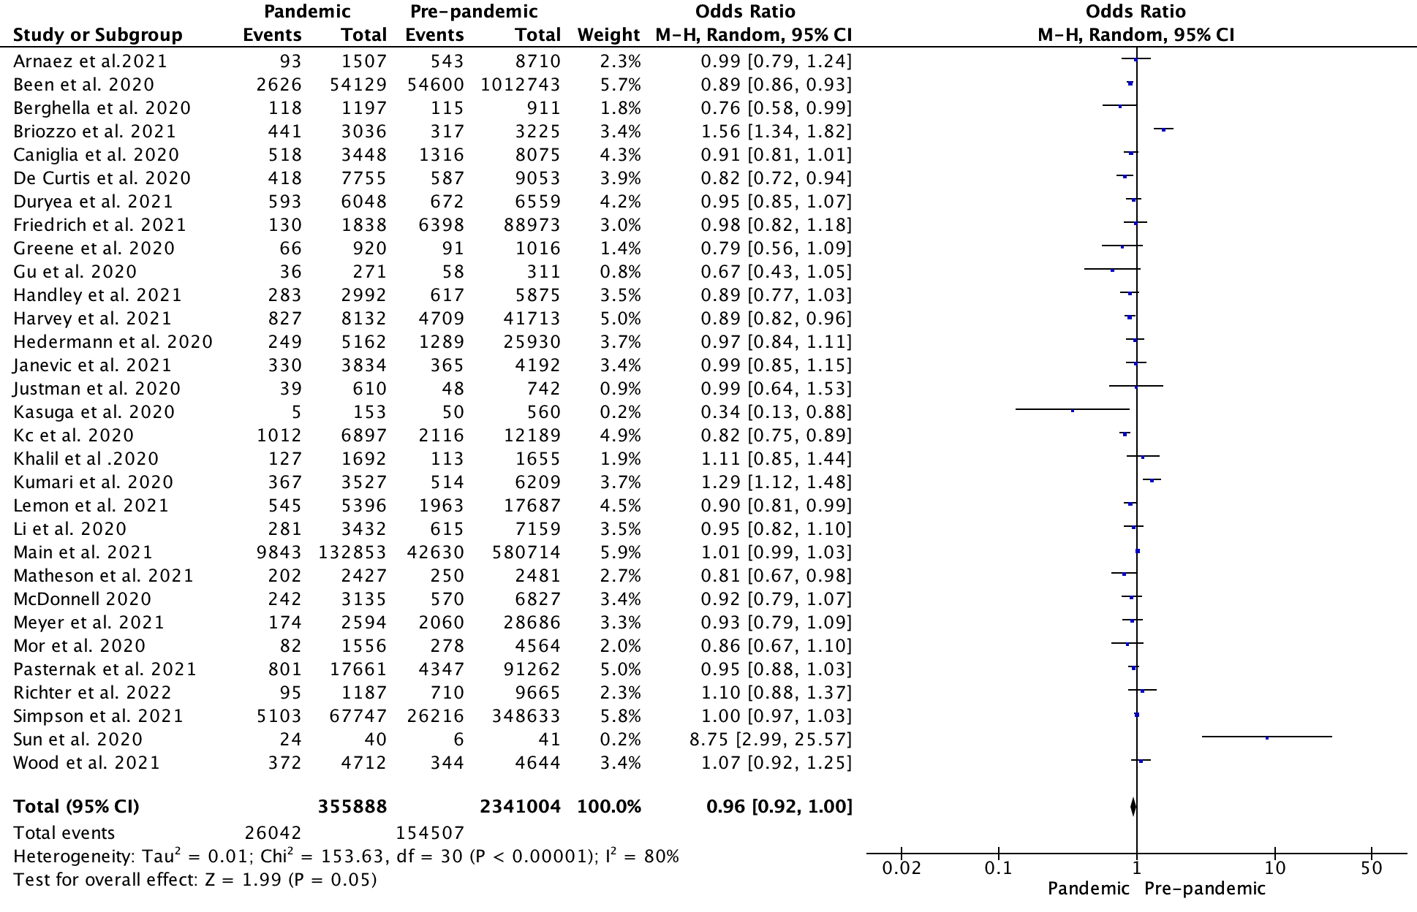
Figure S1.1: Forest plot for odds of preterm birth at less than 37 weeks gestation (unadjusted results)

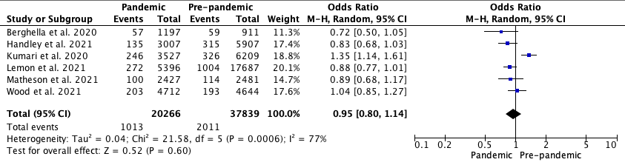
Figure S1.2: Forest plot for odds of spontaneous preterm birth at less than 37 weeks gestation (unadjusted results)

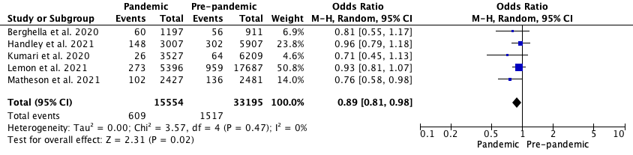
Figure S1.3: Forest plot for odds of iatrogenic preterm birth at less than 37 weeks gestation (unadjusted results)

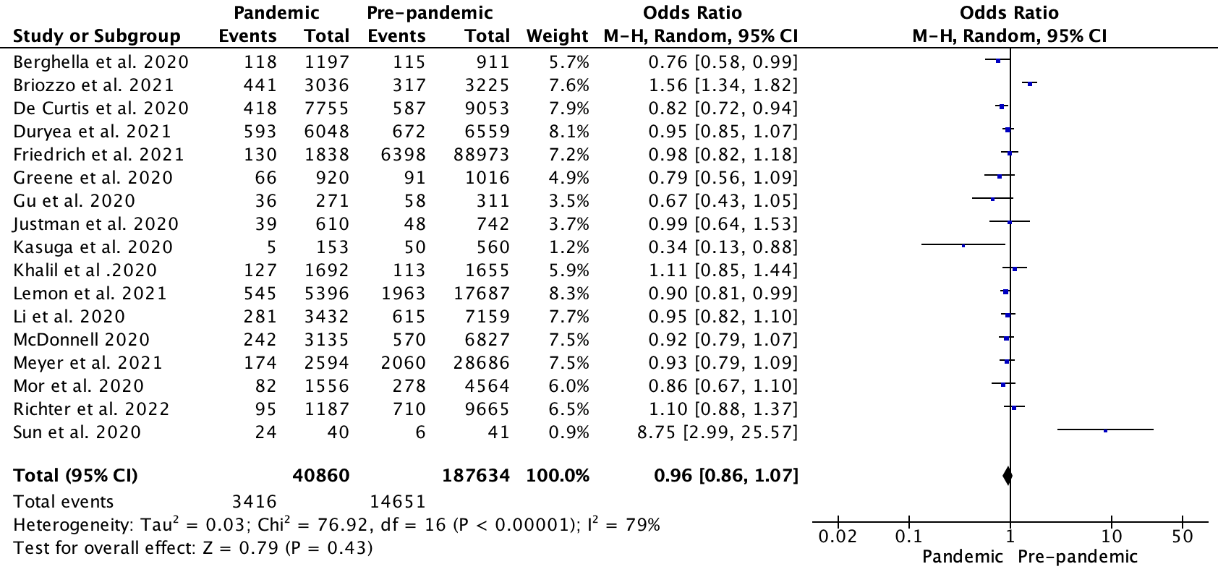
Figure S1.4: Forest plot for odds of preterm birth at less than 37 weeks gestation in single centre studies during the COVID-19 pandemic lockdown versus pre-pandemic period.

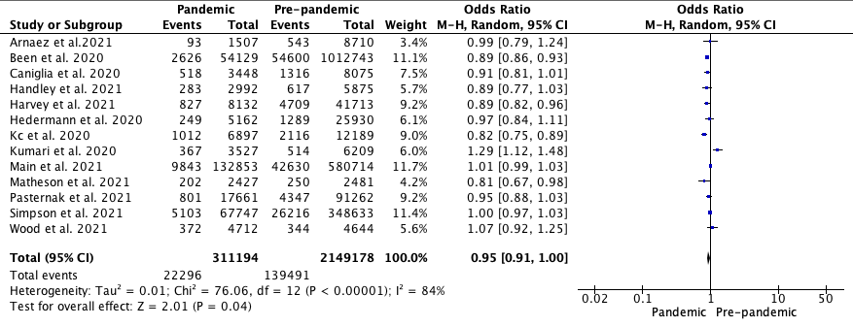
Figure S1.5: Forest plot for odds of preterm birth at less than 37 weeks gestation in multicentre studies during the COVID-19 pandemic lockdown versus pre-pandemic period.

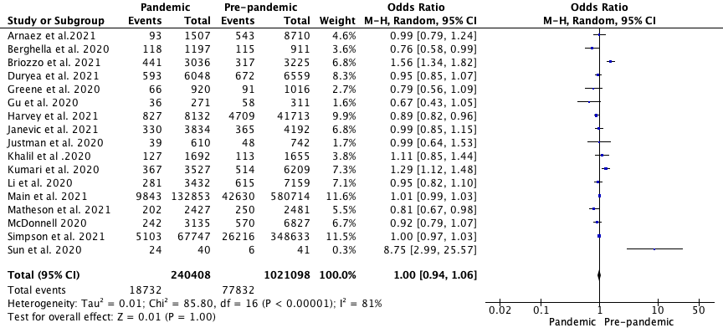
Figure S1.6: Forest plot for odds of preterm birth at less than 37 weeks gestation including singleton and multiples pregnancies during the COVID-19 pandemic lockdown versus pre-pandemic period.

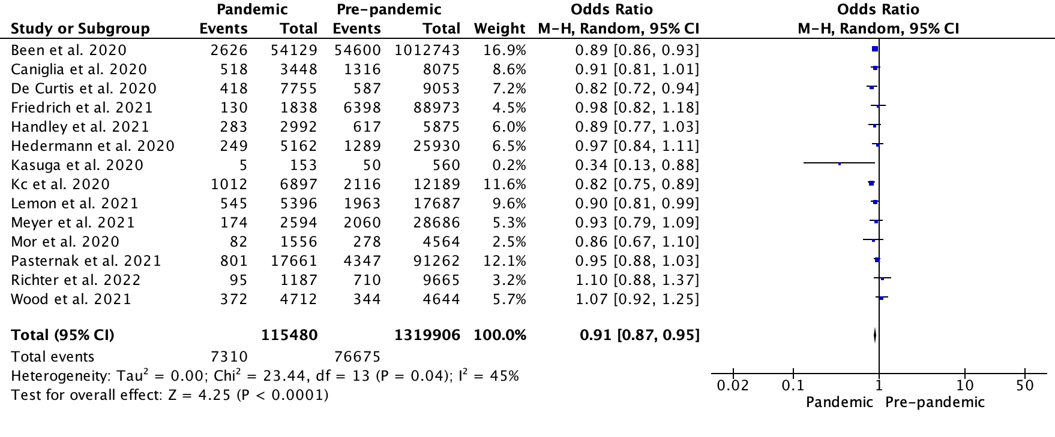
Figure S1.7: Forest plot for odds of preterm birth at less than 37 weeks gestation including only singleton pregnancies during the COVID-19 pandemic lockdown versus pre-pandemic period.

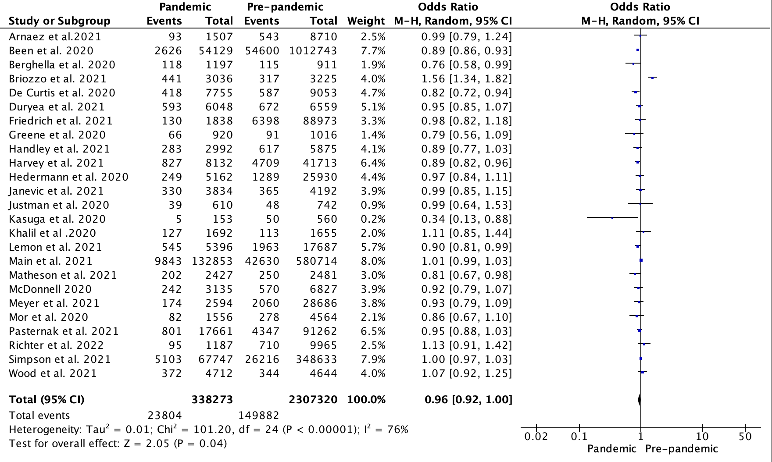
Figure S1.8: Forest plot for odds of preterm birth at less than 37 weeks gestation in high income settings.

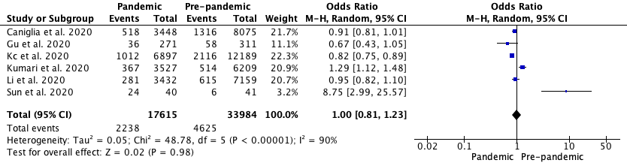
Figure S1.9: Forest plot for odds of preterm birth at less than 37 weeks gestation in middle income settings.

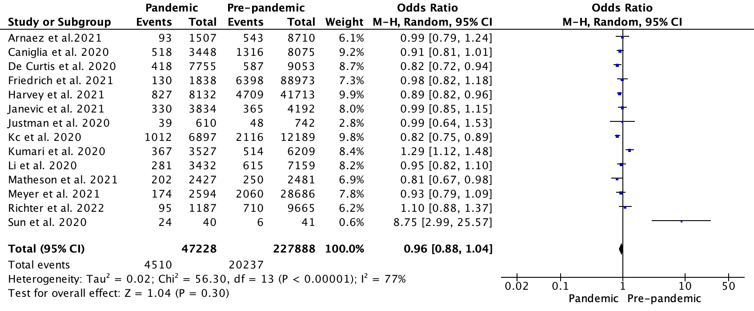
Figure S1.10: Forest plot for odds of preterm birth at less than 37 weeks gestation in studies conducted with stringency index scores greater than the median.

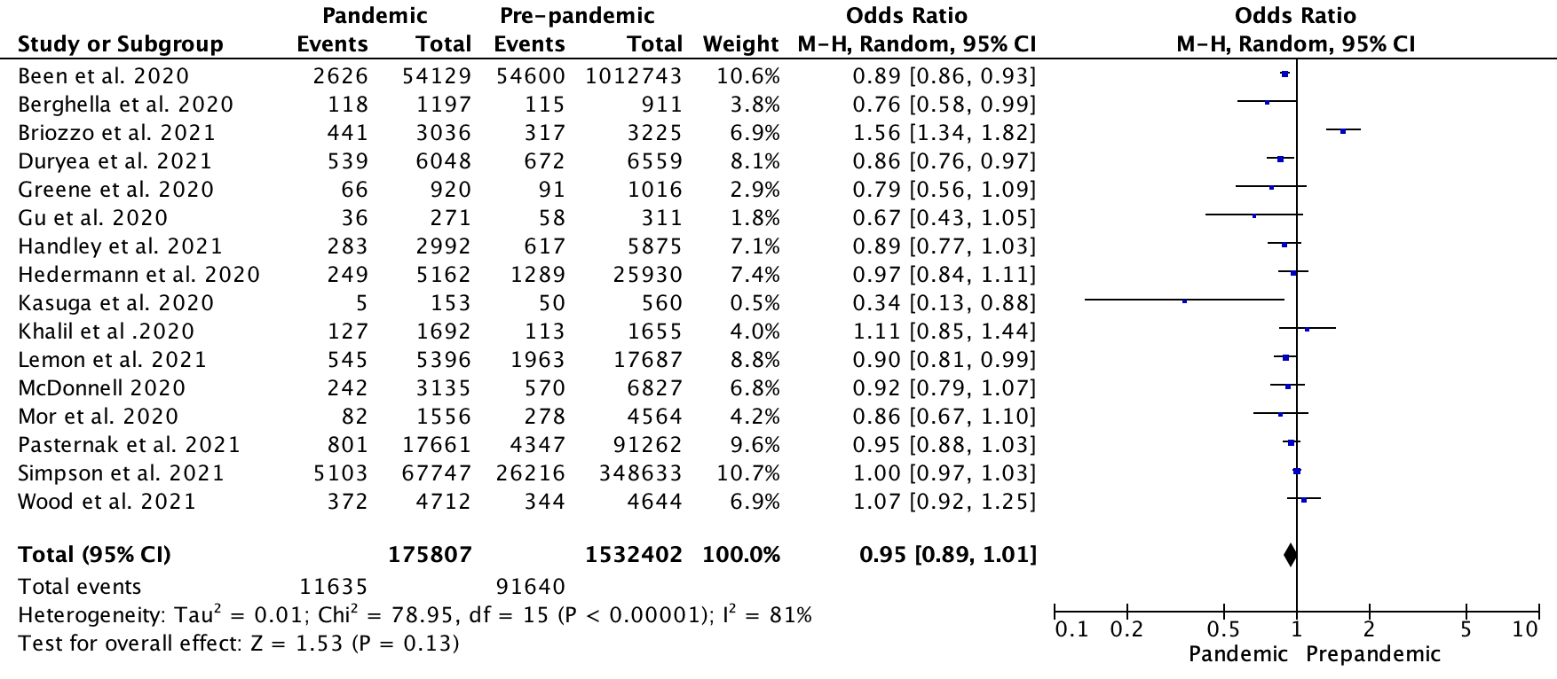
Figure S1.11: Forest plot for odds of preterm birth at less than 37 weeks gestation in studies conducted with stringency index scores less than the median.

S2. Forest plots for odds of preterm birth less than 34 weeks.

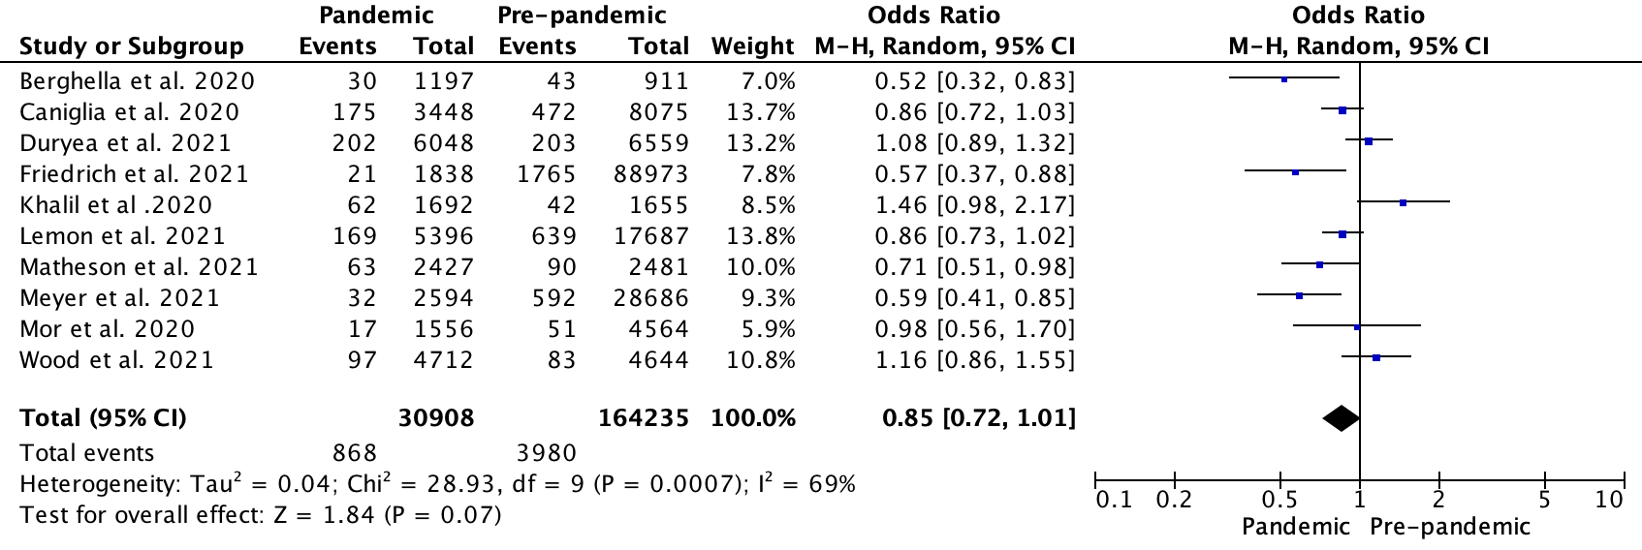
Figure S2.1: Forest plot for odds of preterm birth at less than 34 weeks gestation (unadjusted results)

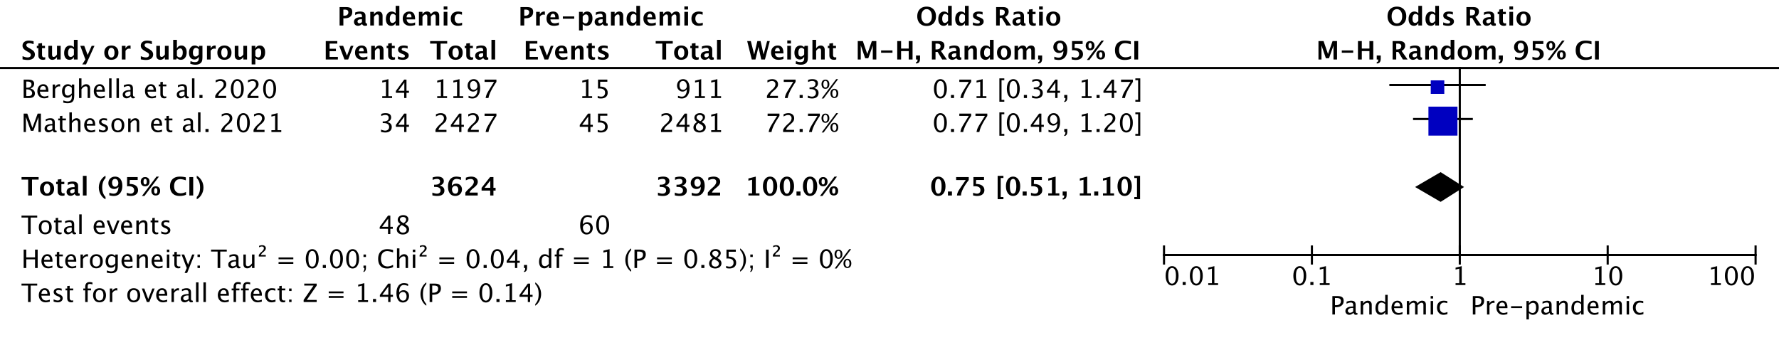
Figure S2.2: Forest plot for odds of spontaneous preterm birth at less than 34 weeks gestation (unadjusted results)

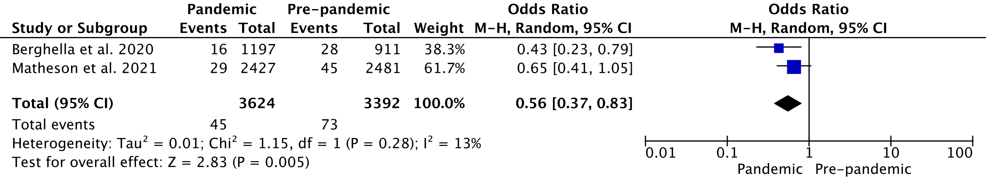
Figure S2.3: Forest plot for odds of iatrogenic preterm birth at less than 34 weeks gestation (unadjusted results)

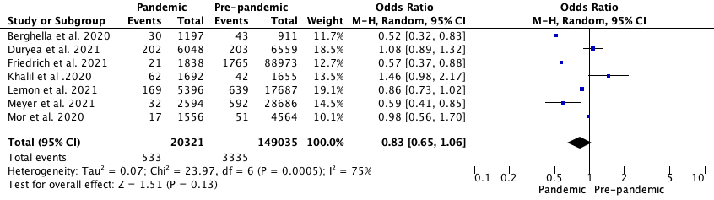
Figure S2.4: Forest plot for odds of preterm birth at less than 34 weeks gestation in single centre studies during the COVID-19 pandemic lockdown versus pre-pandemic period.

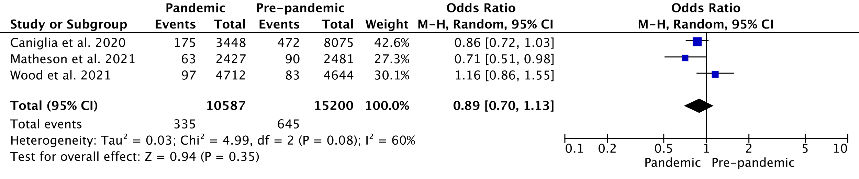
Figure S2.5: Forest plot for odds of preterm birth at less than 34 weeks gestation in multicentre studies during the COVID-19 pandemic lockdown versus pre-pandemic period.

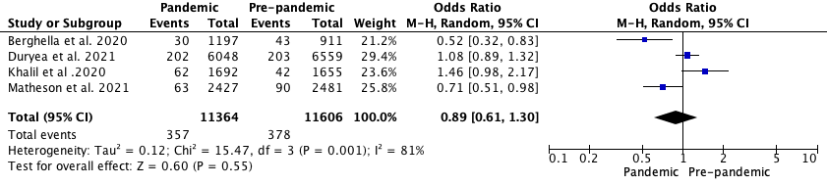
Figure S2.6: Forest plot for odds of preterm birth at less than 34 weeks gestation including singleton and multiples pregnancies during the COVID-19 pandemic lockdown versus pre-pandemic period.

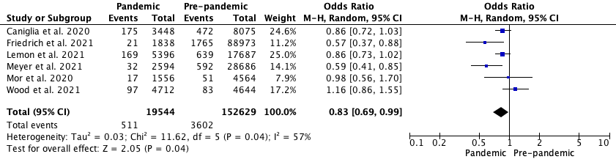
Figure S2.7: Forest plot for odds of preterm birth at less than 34 weeks gestation including only singleton pregnancies during the COVID-19 pandemic lockdown versus pre-pandemic period.

Figure S2.8: Forest plot for odds of preterm birth at less than 34 weeks gestation in high income settings.
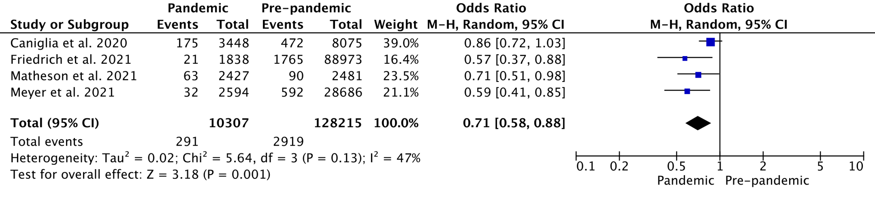
Figure S2.9: Forest plot for odds of preterm birth at less than 34 weeks gestation in studies conducted with stringency index scores greater than the median.

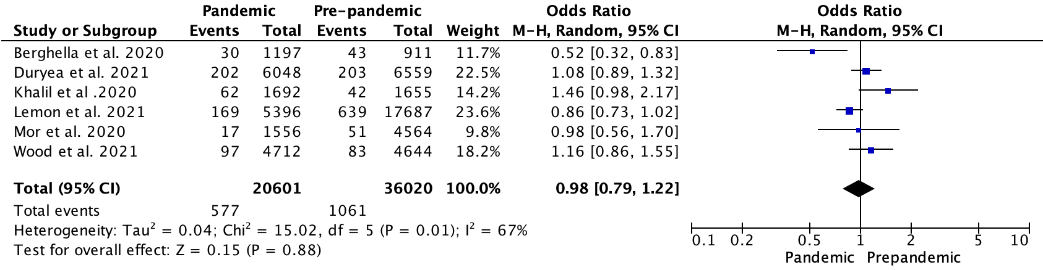
Figure S2.10: Forest plot for odds of preterm birth at less than 34 weeks gestation in studies conducted with stringency index scores less than the median.

S3. Forest plots for odds of preterm birth less than 32 weeks.

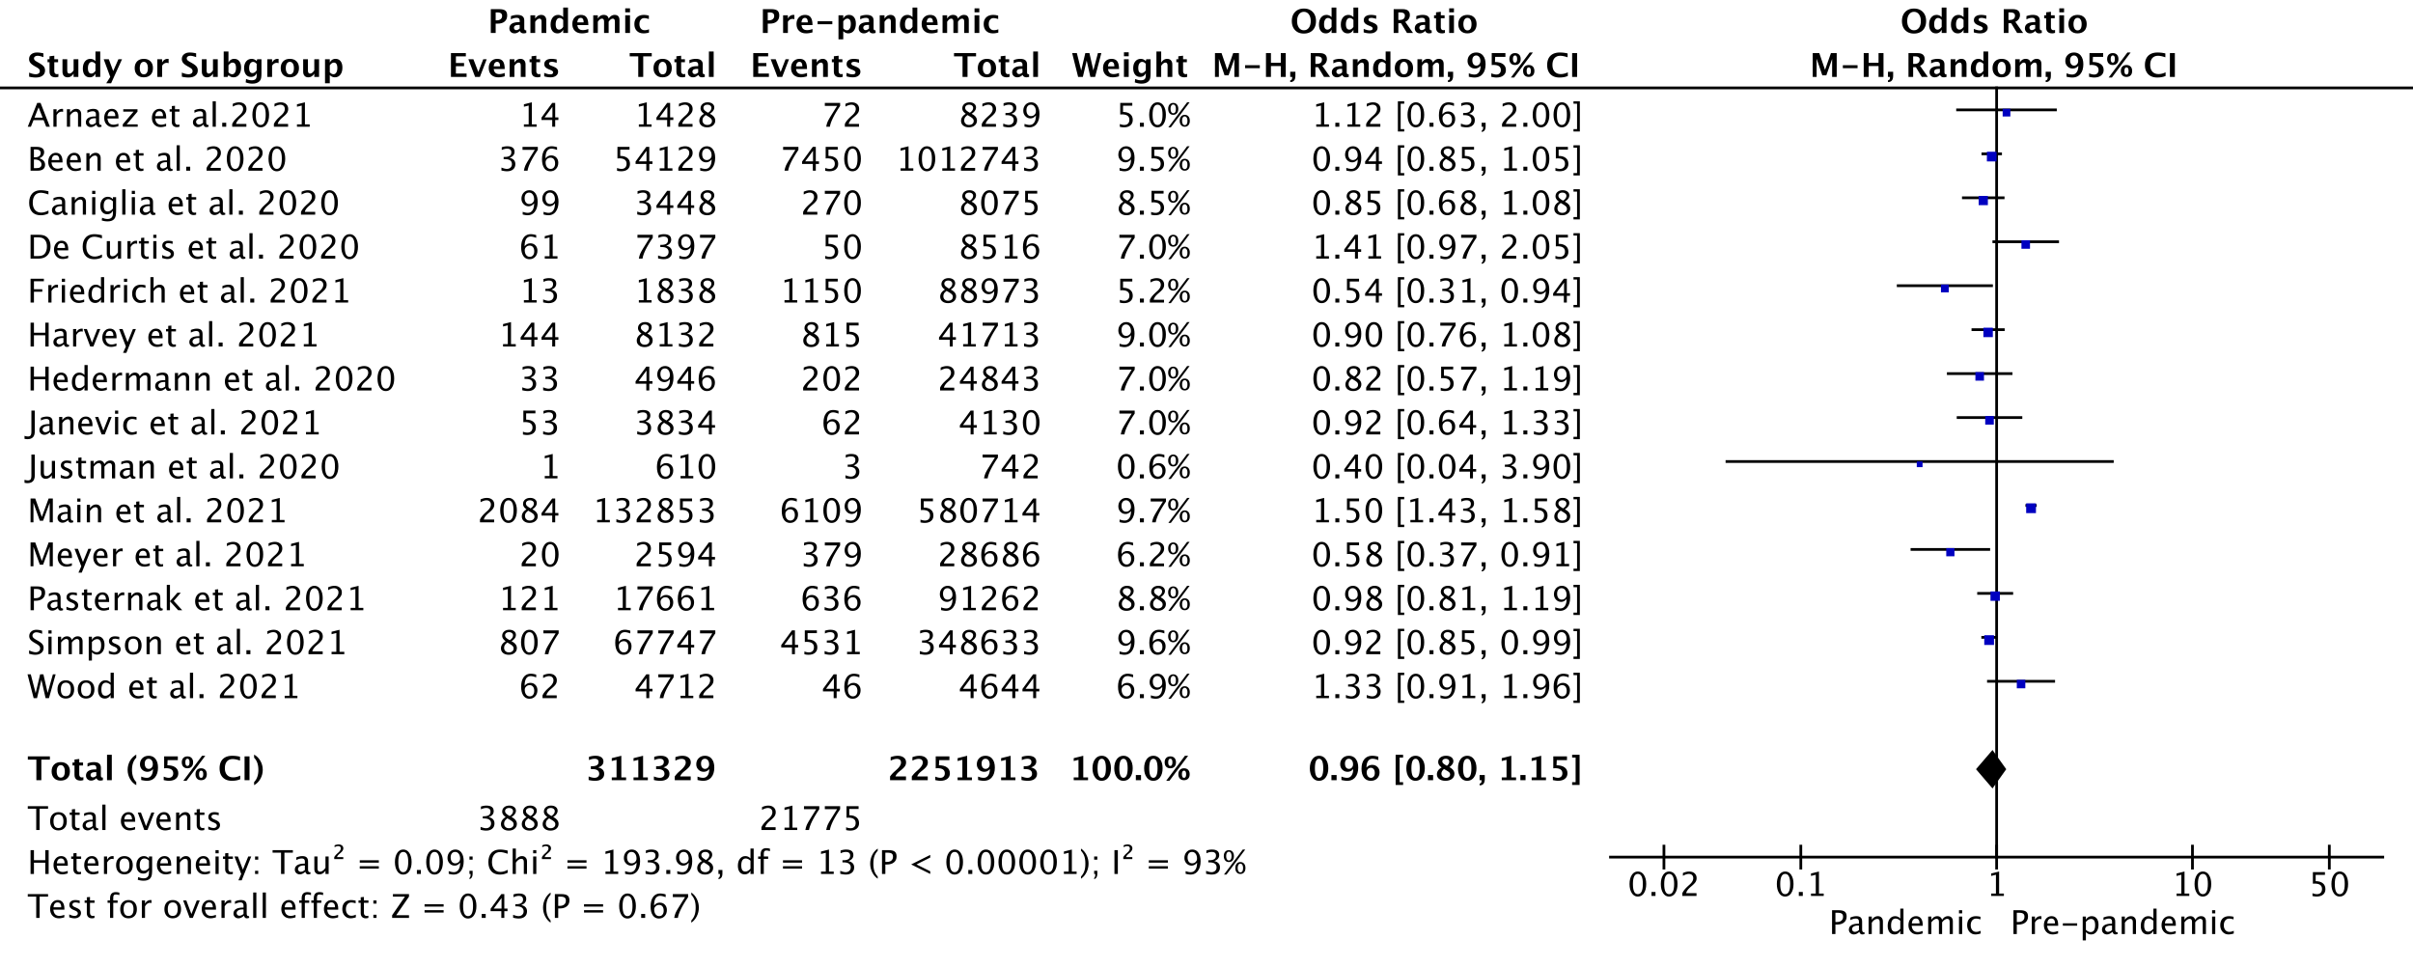
Figure S3.1: Forest plot for odds of preterm birth at less than 32 weeks gestation (unadjusted results)

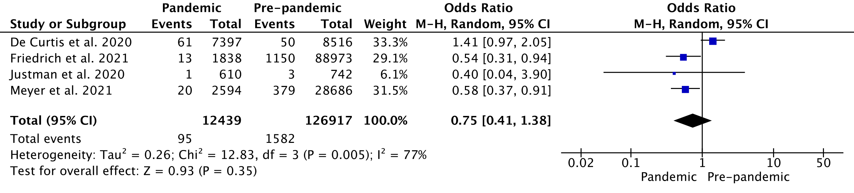
Figure S3.2: Forest plot for odds of preterm birth at less than 32 weeks gestation in single centre studies during the COVID-19 pandemic lockdown versus pre-pandemic period.

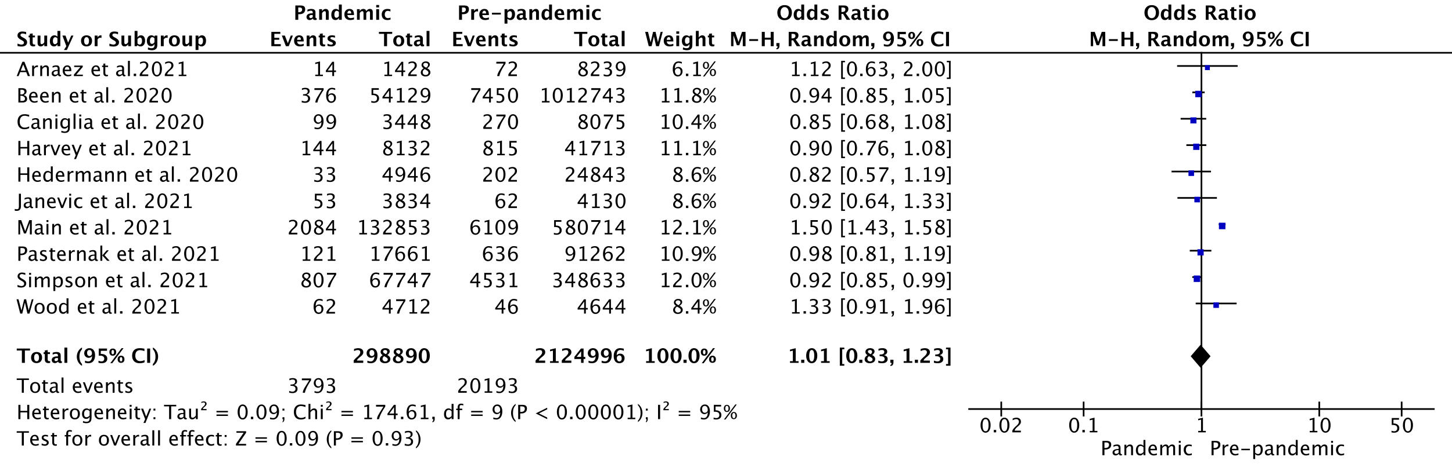
Figure S3.3: Forest plot for odds of preterm birth at less than 32 weeks gestation in multicentre studies during the COVID-19 pandemic lockdown versus pre-pandemic period.

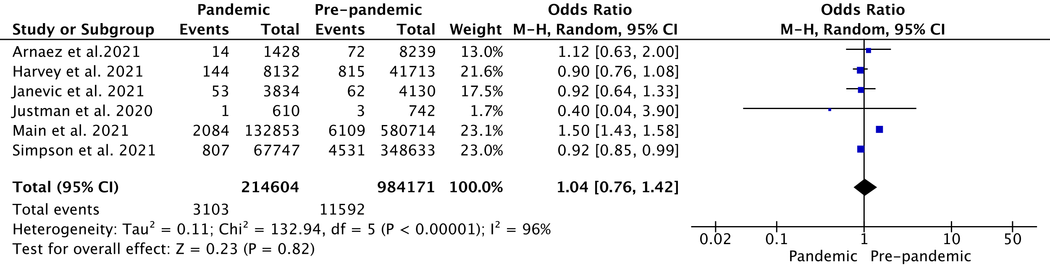
Figure S3.4: Forest plot for odds of preterm birth at less than 32 weeks gestation including singleton and multiples pregnancies during the COVID-19 pandemic lockdown versus pre-pandemic period.

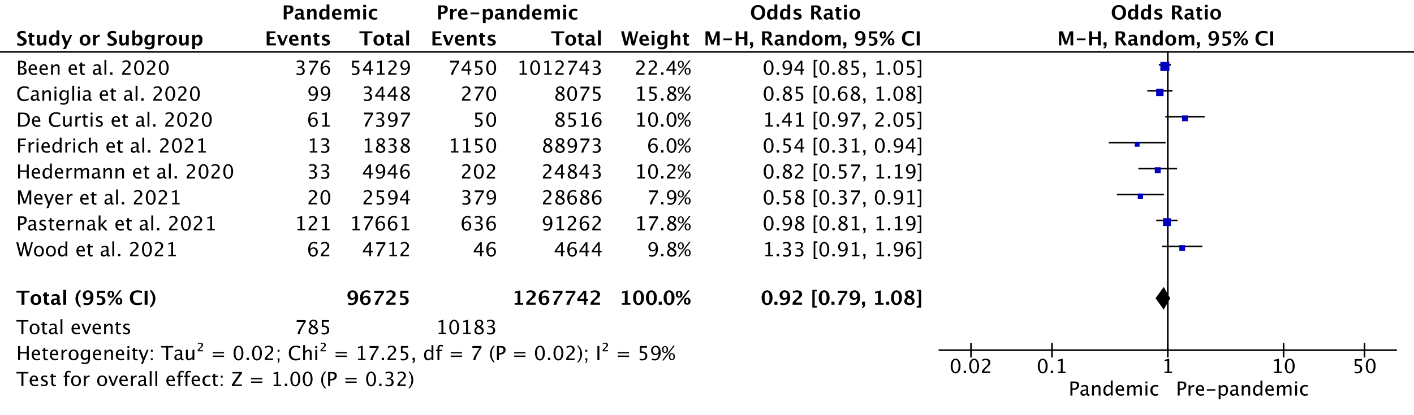
Figure S3.5: Forest plot for odds of preterm birth at less than 32 weeks gestation including only singleton pregnancies during the COVID-19 pandemic lockdown versus pre-pandemic period.

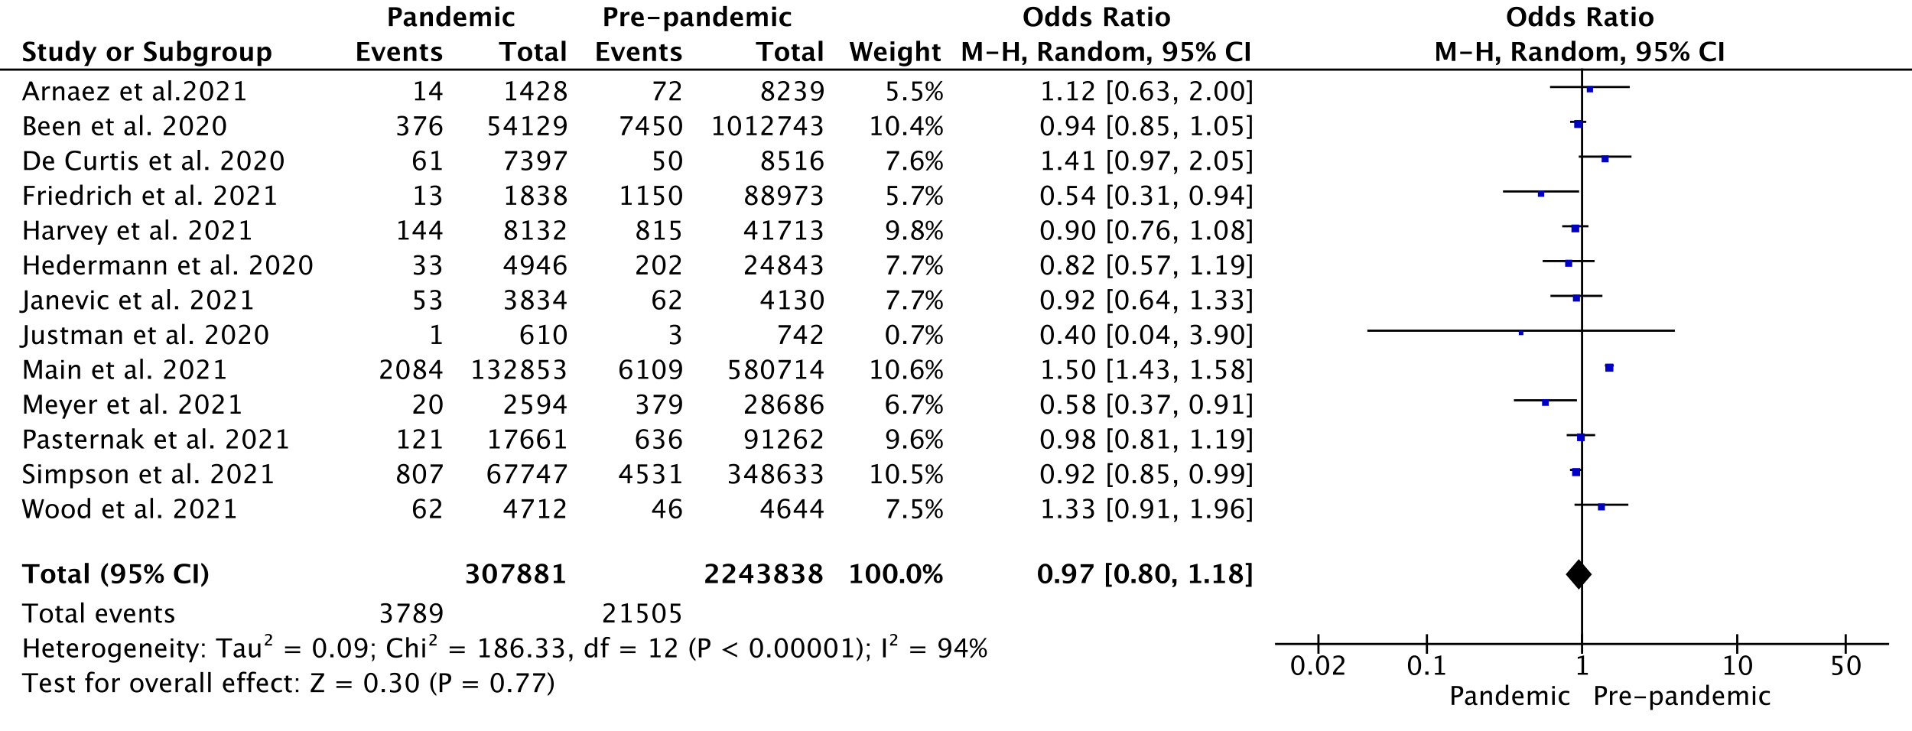
Figure S3.6: Forest plot for odds of preterm birth at less than 32 weeks gestation in high income settings.

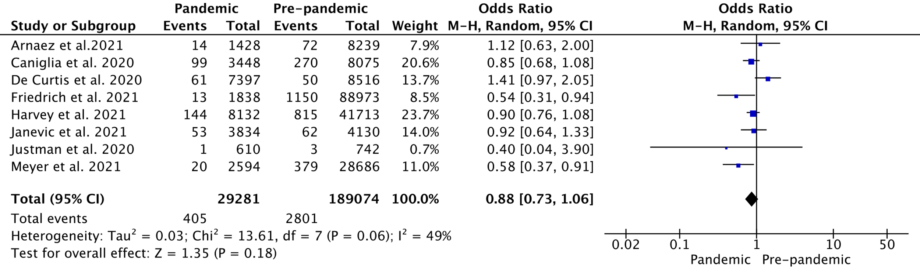
Figure S3.7: Forest plot for odds of preterm birth at less than 32 weeks gestation in studies conducted with stringency index scores greater than the median.

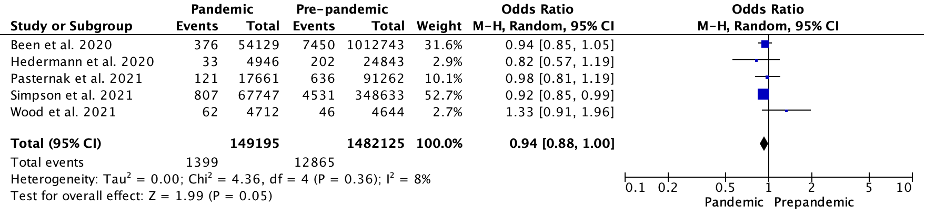
Figure S3.8: Forest plot for odds of preterm birth at less than 32 weeks gestation in studies conducted with stringency index scores less than the median.

S4. Forest plots for odds of preterm birth less than 28 weeks.

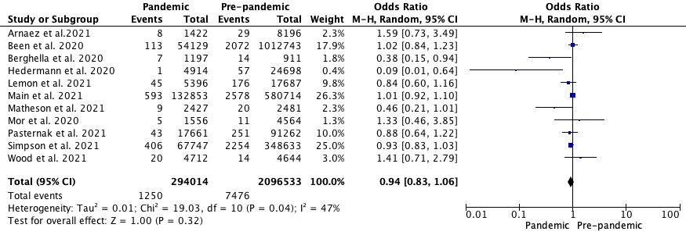
Figure S4.1: Forest plot for odds of preterm birth at less than 28 weeks gestation (unadjusted results)

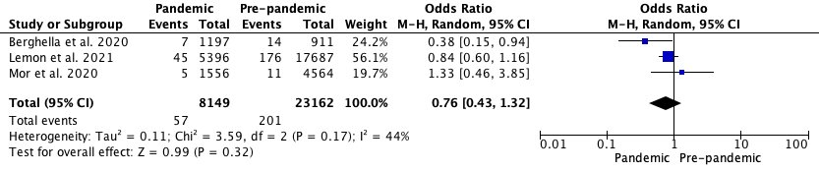
Figure S4.2: Forest plot for odds of preterm birth at less than 28 weeks gestation in single centre studies during the COVID-19 pandemic lockdown versus pre-pandemic period.

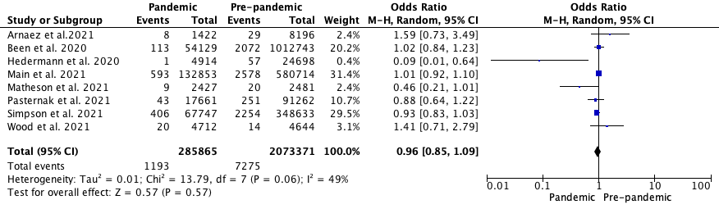
Figure S4.3: Forest plot for odds of preterm birth at less than 28 weeks gestation in multicentre studies during the COVID-19 pandemic lockdown versus pre-pandemic period.

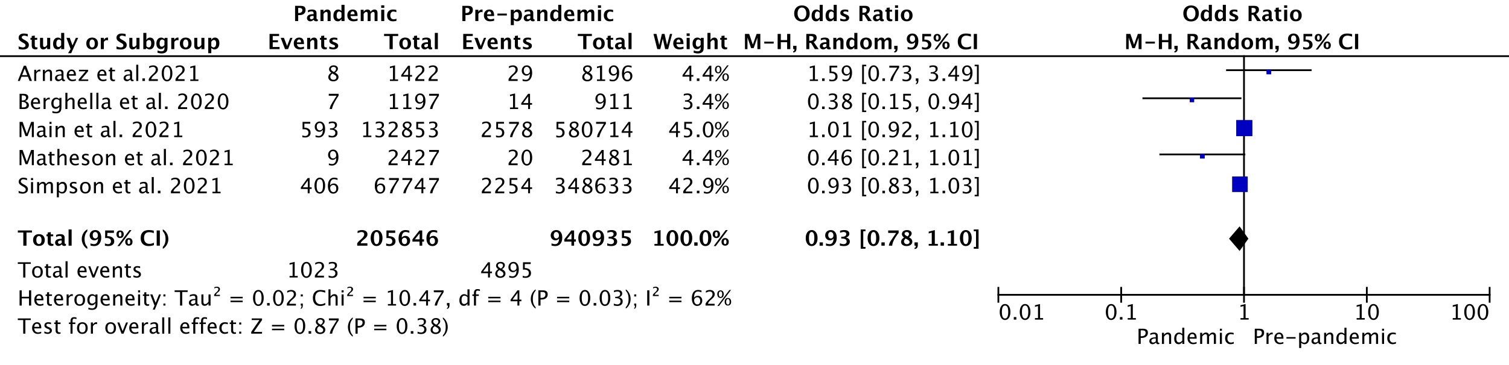
Figure S4.4: Forest plot for odds of preterm birth at less than 28 weeks gestation including singleton and multiples pregnancies during the COVID-19 pandemic lockdown versus pre-pandemic period.

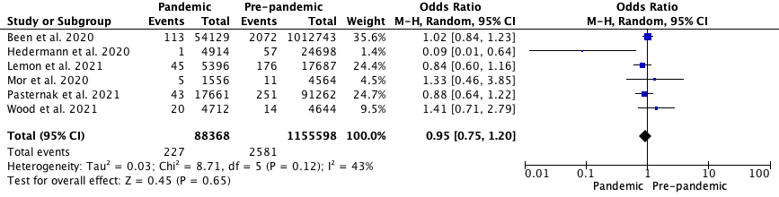
Figure S4.5: Forest plot for odds of preterm birth at less than 28 weeks gestation including only singleton pregnancies during the COVID-19 pandemic lockdown versus pre-pandemic period.

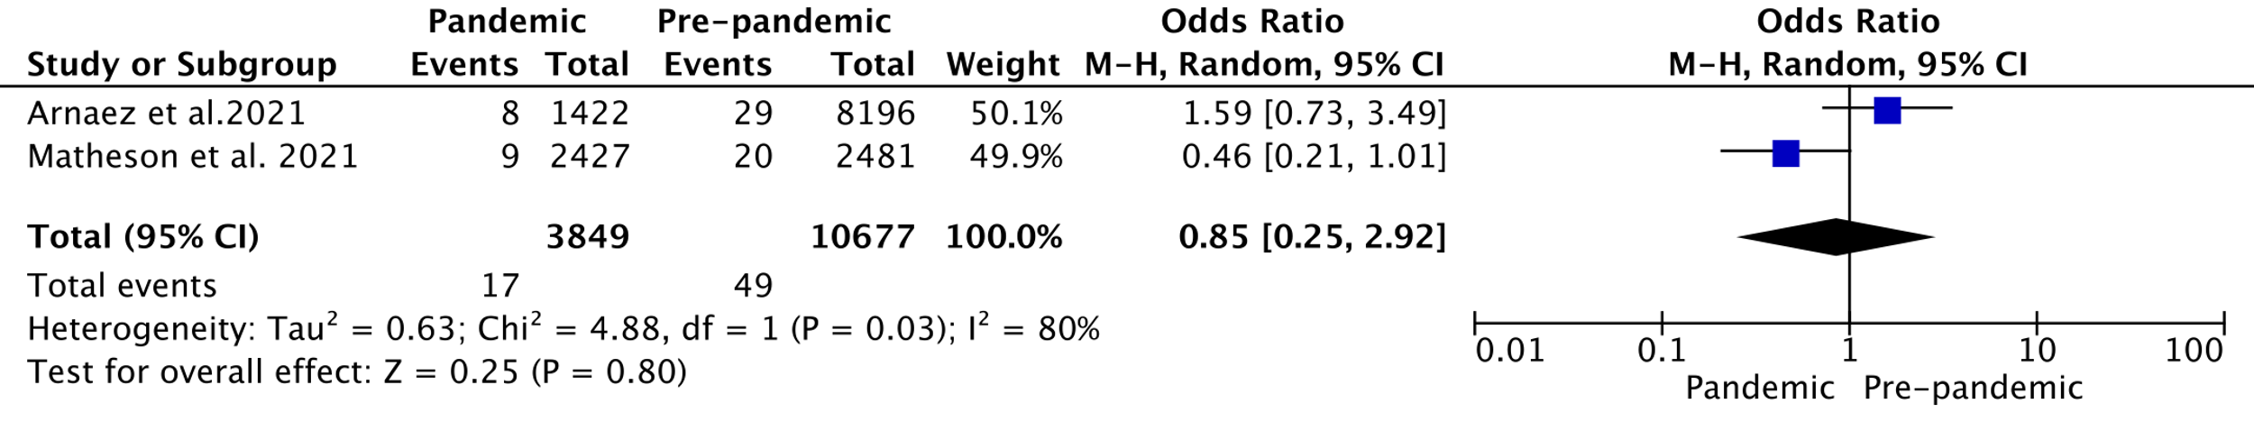
Figure S4.6: Forest plot for odds of preterm birth at less than 28 weeks gestation in studies conducted with stringency index scores greater than the median.

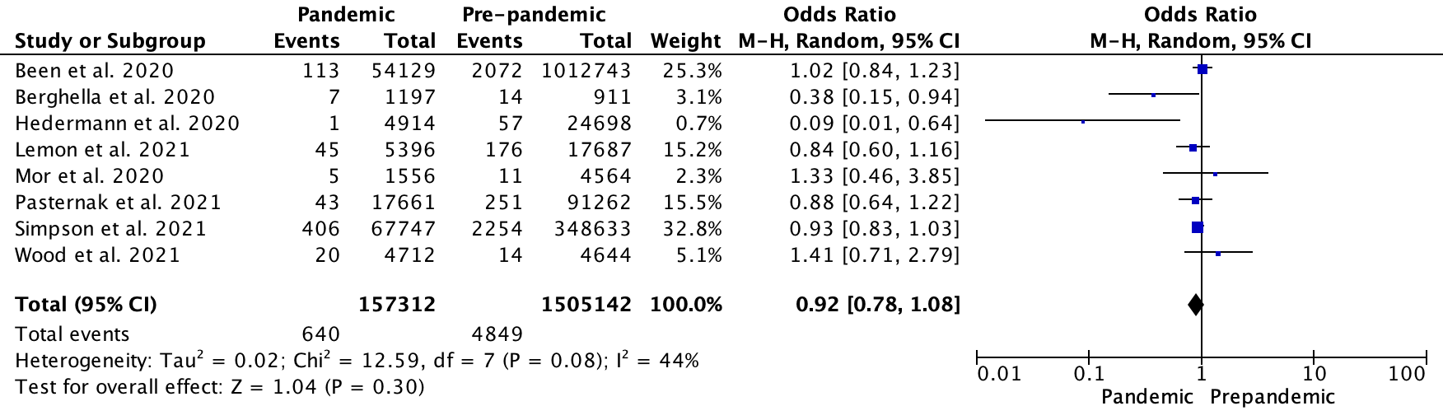
Figure S4.7: Forest plot for odds of preterm birth at less than 28 weeks gestation in studies conducted with stringency index scores less than the median.

S5. Forest plots for odds of stillbirth

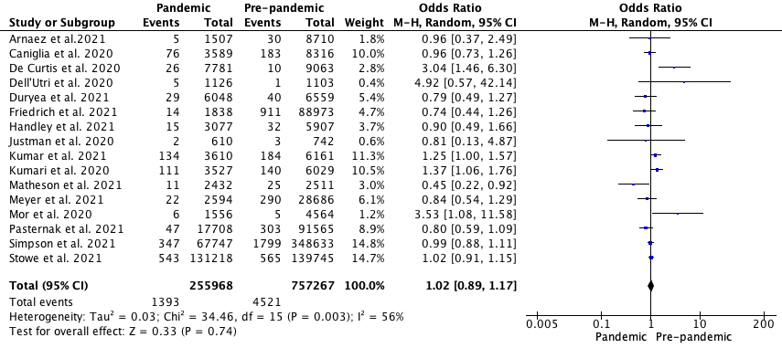
Figure S5.1: Forest plot for odds of stillbirth (unadjusted results)

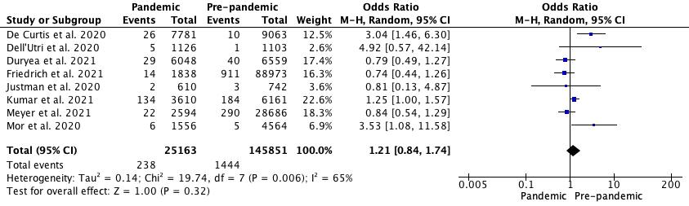
Figure S5.2: Forest plot for odds of stillbirth in single centre studies during the COVID-19 pandemic lockdown versus pre-pandemic period.

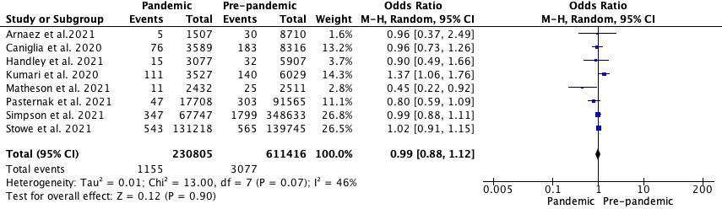
Figure S5.3: Forest plot for odds of stillbirth in multicentre studies during the COVID-19 pandemic lockdown versus pre-pandemic period.

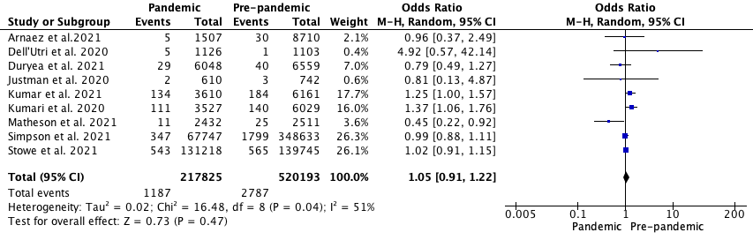
Figure S5.4: Forest plot for odds of stillbirth including singleton and multiples pregnancies during the COVID-19 pandemic lockdown versus pre-pandemic period.

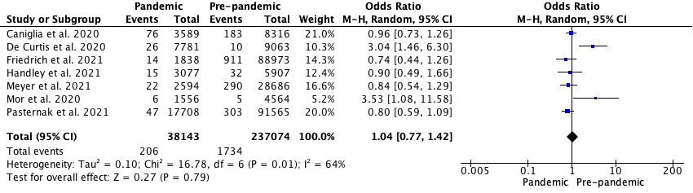
Figure S5.5: Forest plot for odds of stillbirth including only singleton pregnancies during the COVID-19 pandemic lockdown versus pre-pandemic period.

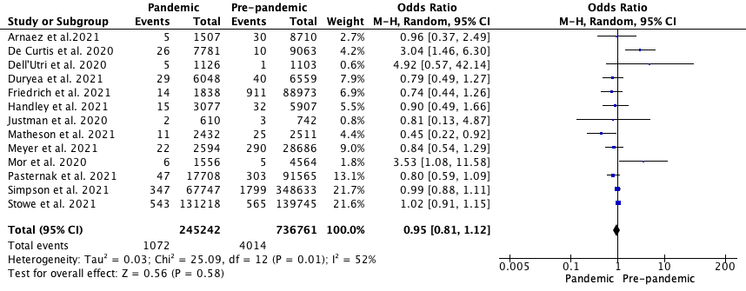
Figure S5.6: Forest plot for odds of stillbirth in high income settings.

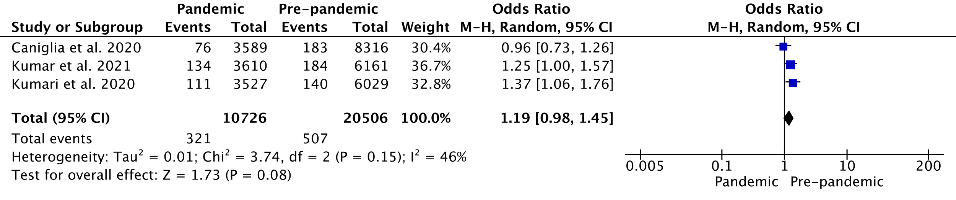
Figure S5.7: Forest plot for odds of stillbirth in middle income settings.

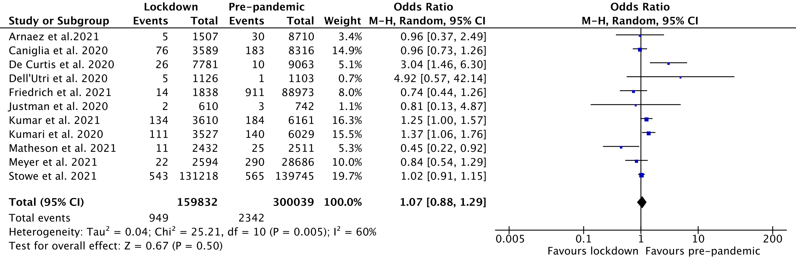
Figure S5.8: Forest plot for odds of stillbirth in studies conducted with stringency index scores greater than the median.

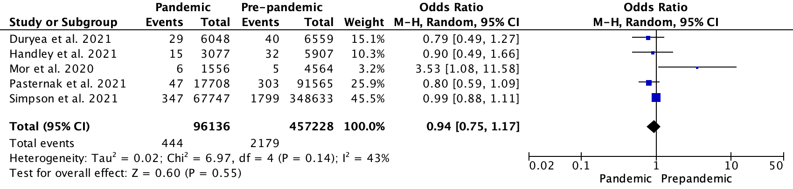
Figure S5.9: Forest plot for odds of stillbirth in studies conducted with stringency index scores less than the median.

S6. Forest plots for odds of very low birth weight

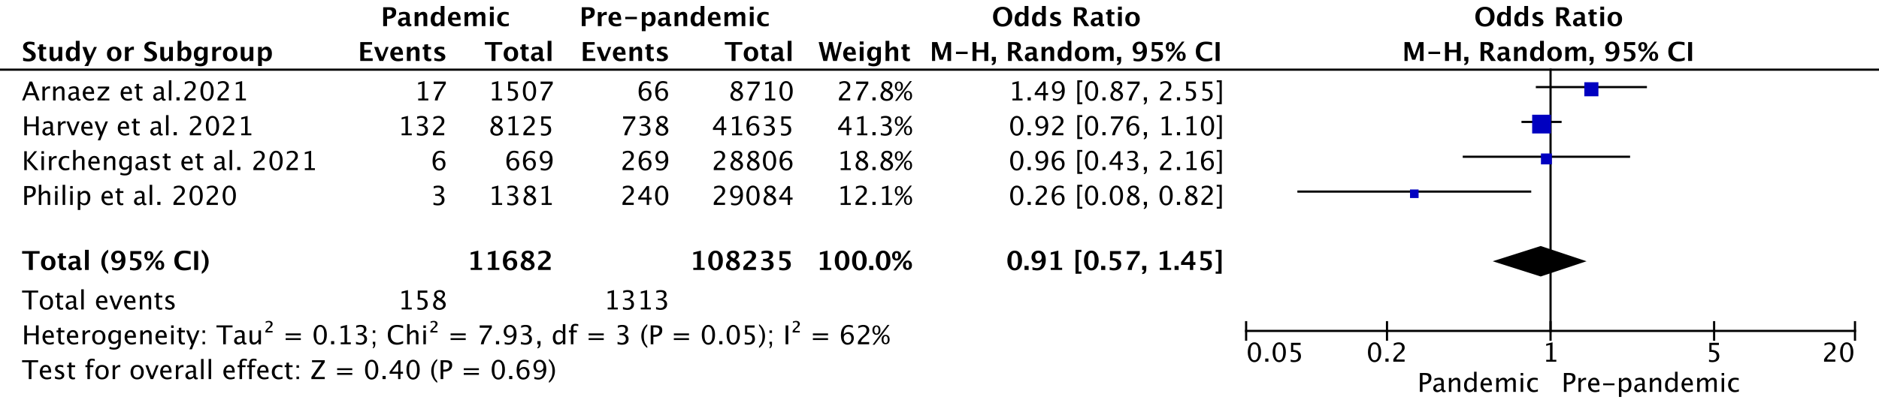
Figure S6.1: Forest plot for odds of very low birth weight (unadjusted results)

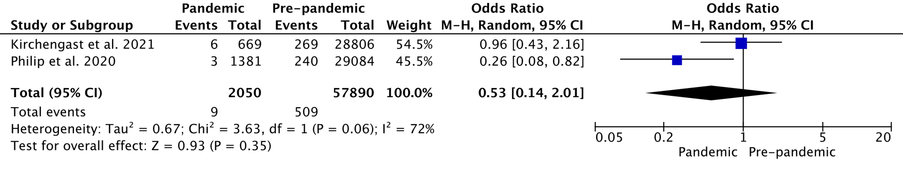
Figure S6.2: Forest plot for odds of very low birth weight in single centre studies during the COVID-19 pandemic lockdown versus pre-pandemic period.

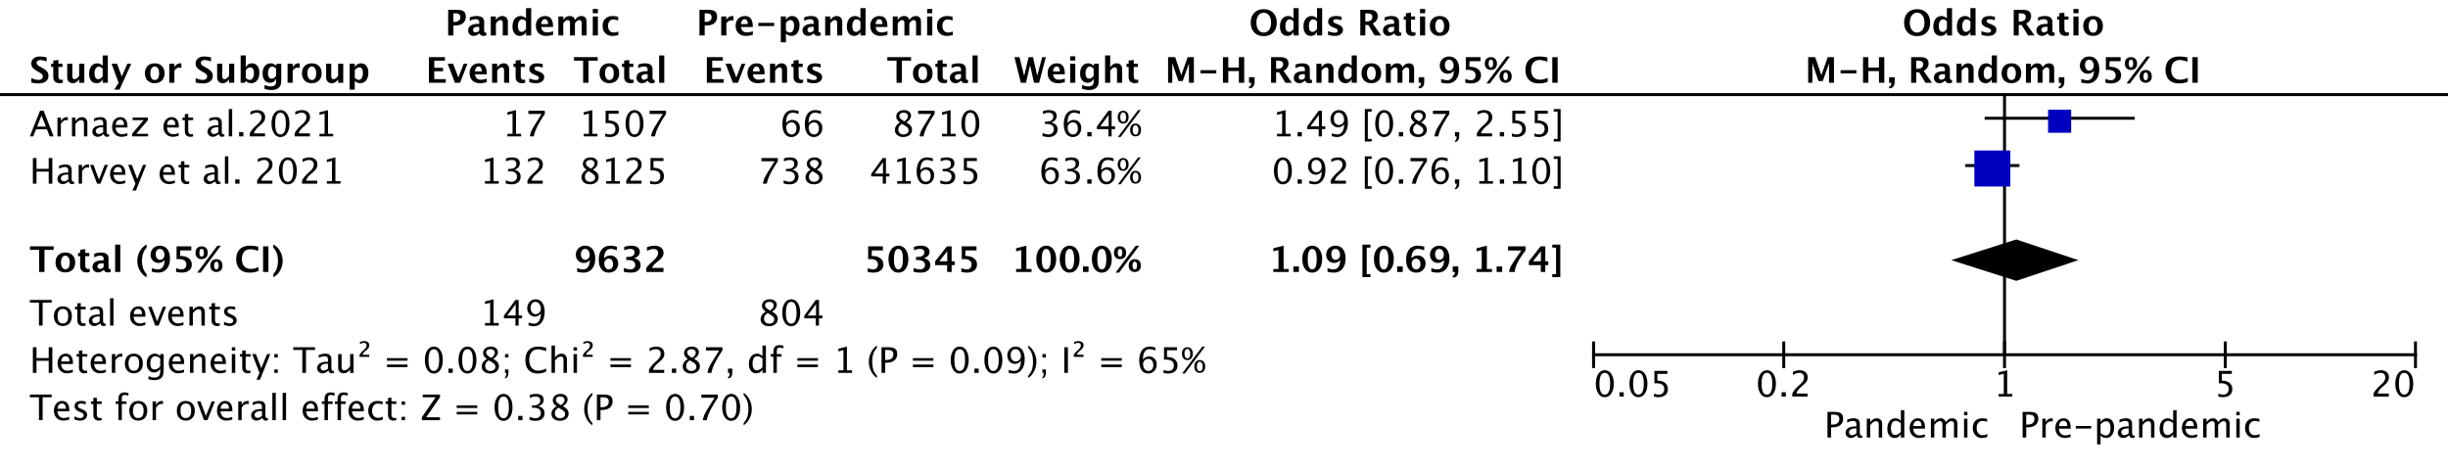
Figure S6.3: Forest plot for odds of very low birth weight in multicentre studies during the COVID-19 pandemic lockdown versus pre-pandemic period.

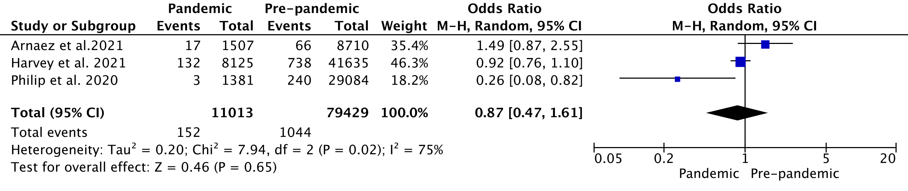
Figure S6.4: Forest plot for odds of very low birth weight including singleton and multiples pregnancies during the COVID-19 pandemic lockdown versus pre-pandemic period.

Figure S6.5: Forest plot for odds of very low birth weight in studies conducted with stringency index scores greater than the median.

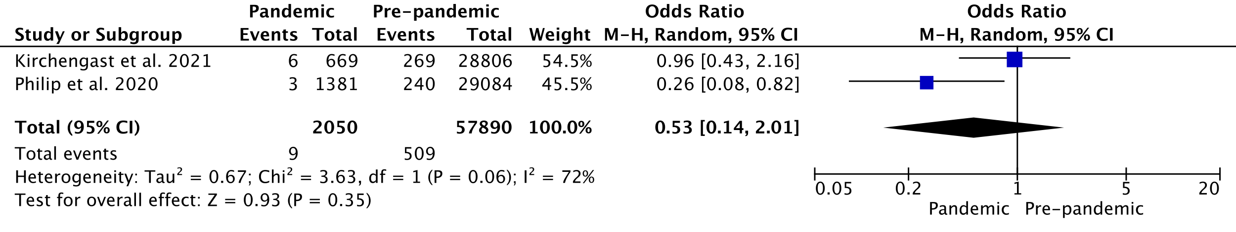
Figure S6.6: Forest plot for odds of very low birth weight in studies conducted with stringency index scores less than the median.

S7. Forest plots for odds of extremely low birth weight

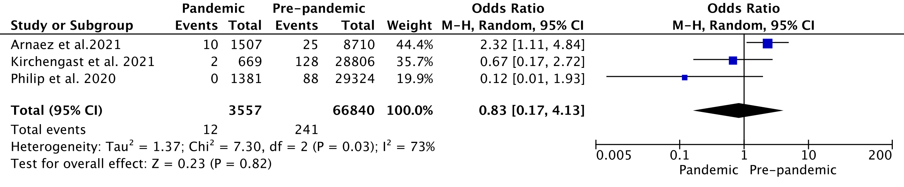
Figure S7.1: Forest plot for odds of extremely low birth weight (unadjusted results)

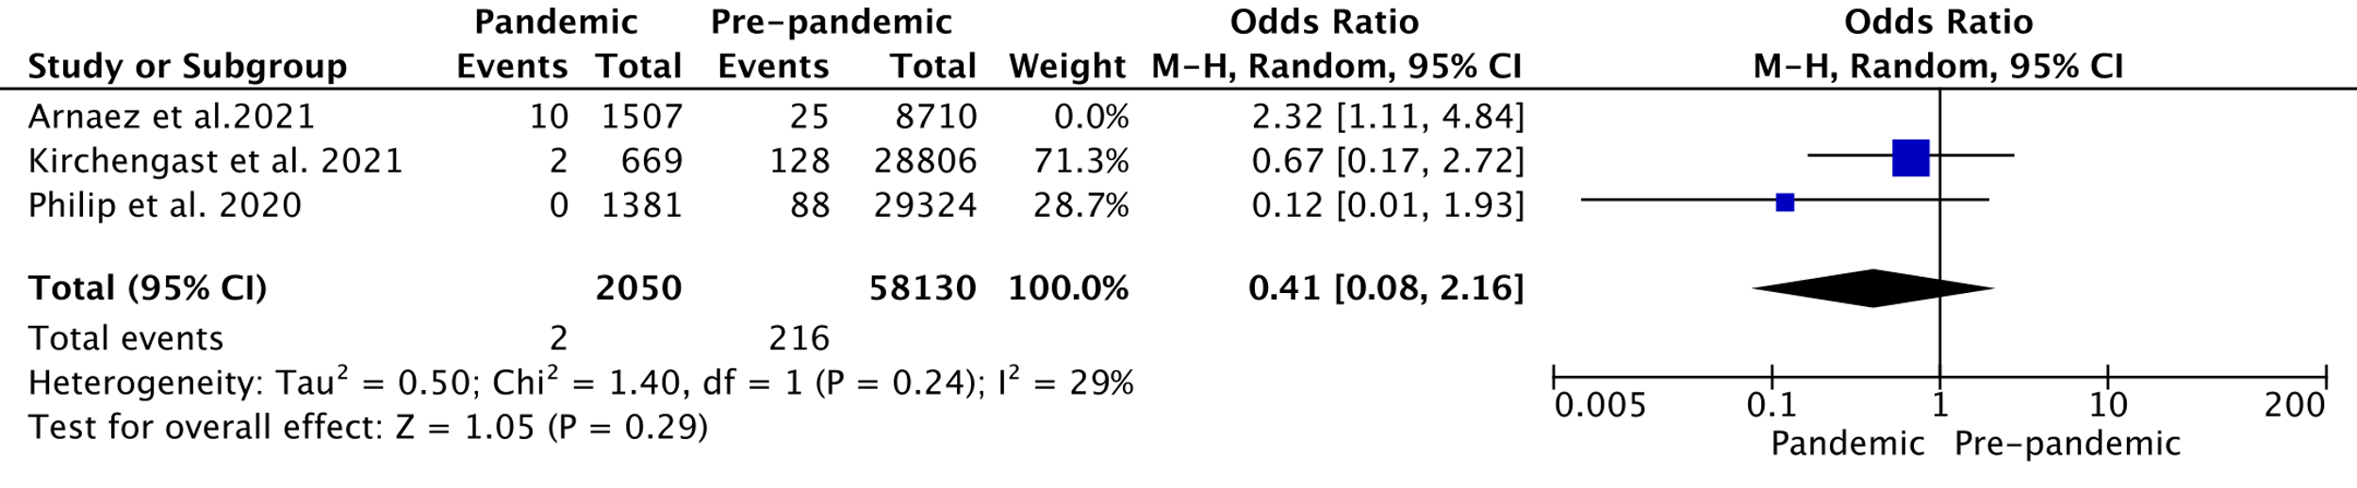
Figure S7.2: Forest plot for odds of extremely low birth weight in single centre studies during the COVID-19 pandemic lockdown versus pre-pandemic period.

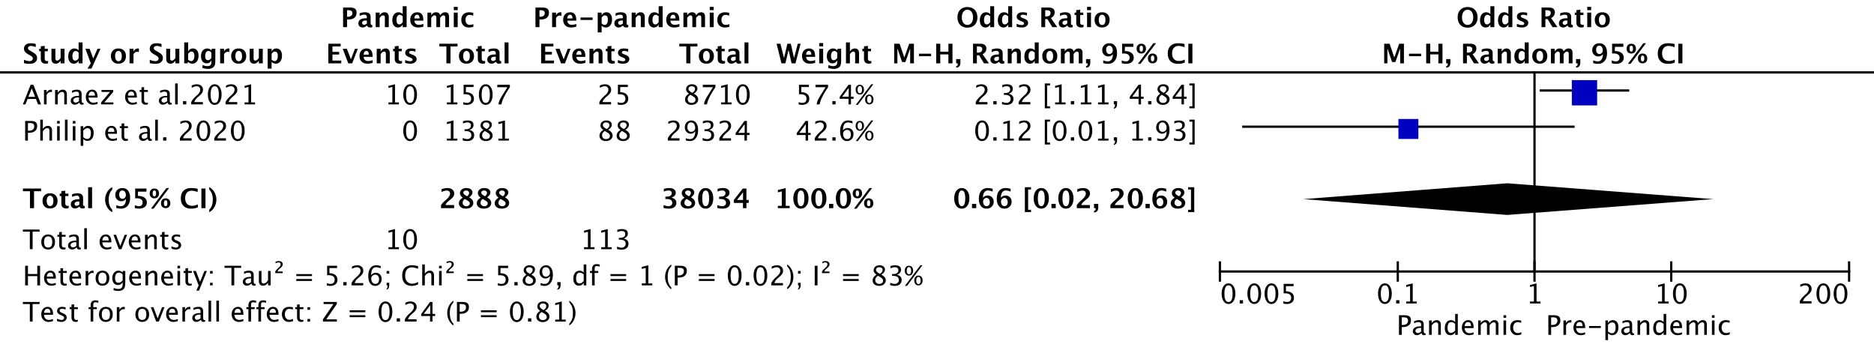
Figure S7.3: Forest plot for odds of extremely low birth weight including singleton and multiples pregnancies during the COVID-19 pandemic lockdown versus pre-pandemic period.

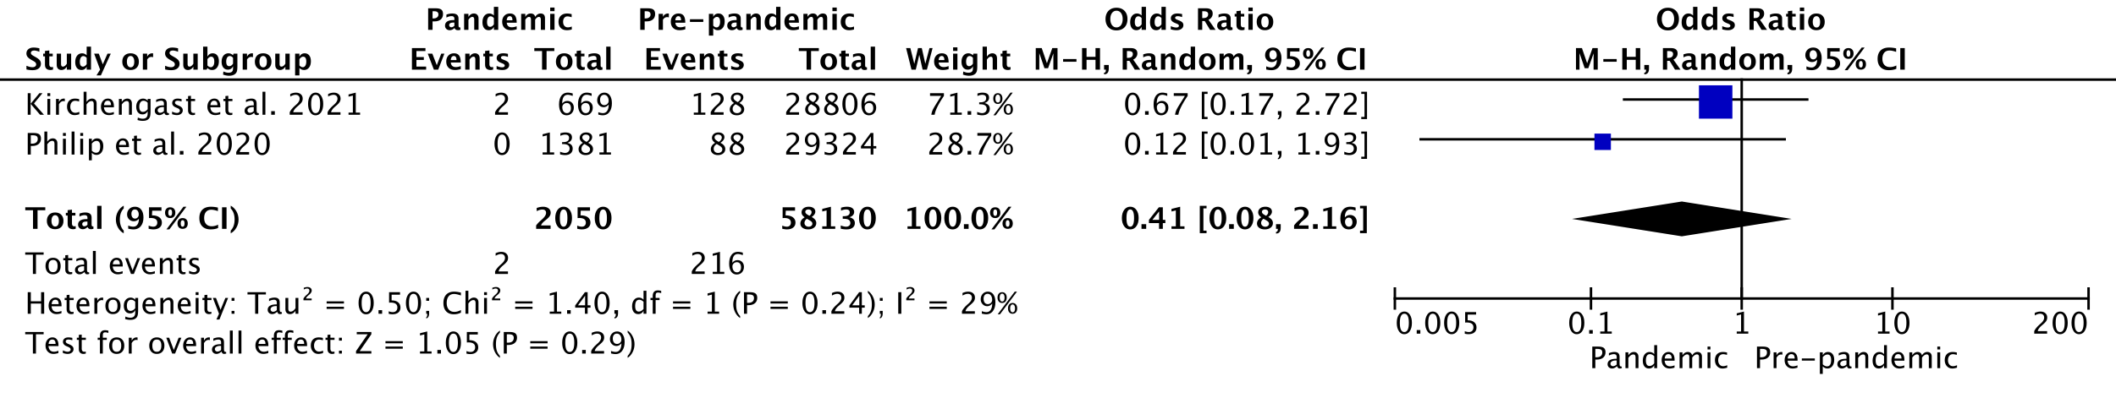
Figure S7.4: Forest plot for odds of extremely low birth weight in studies conducted with stringency index scores less than the median.

S8. Forest plots for odds of NICU admission
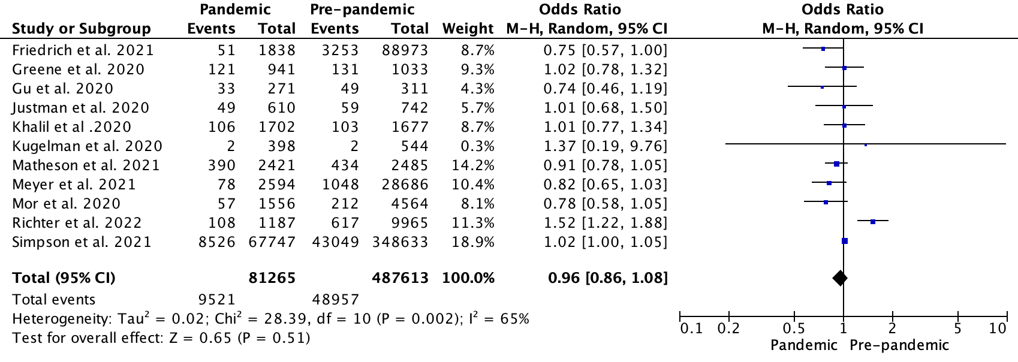
Figure S8.1: Forest plot for odds of NICU admission (unadjusted results)

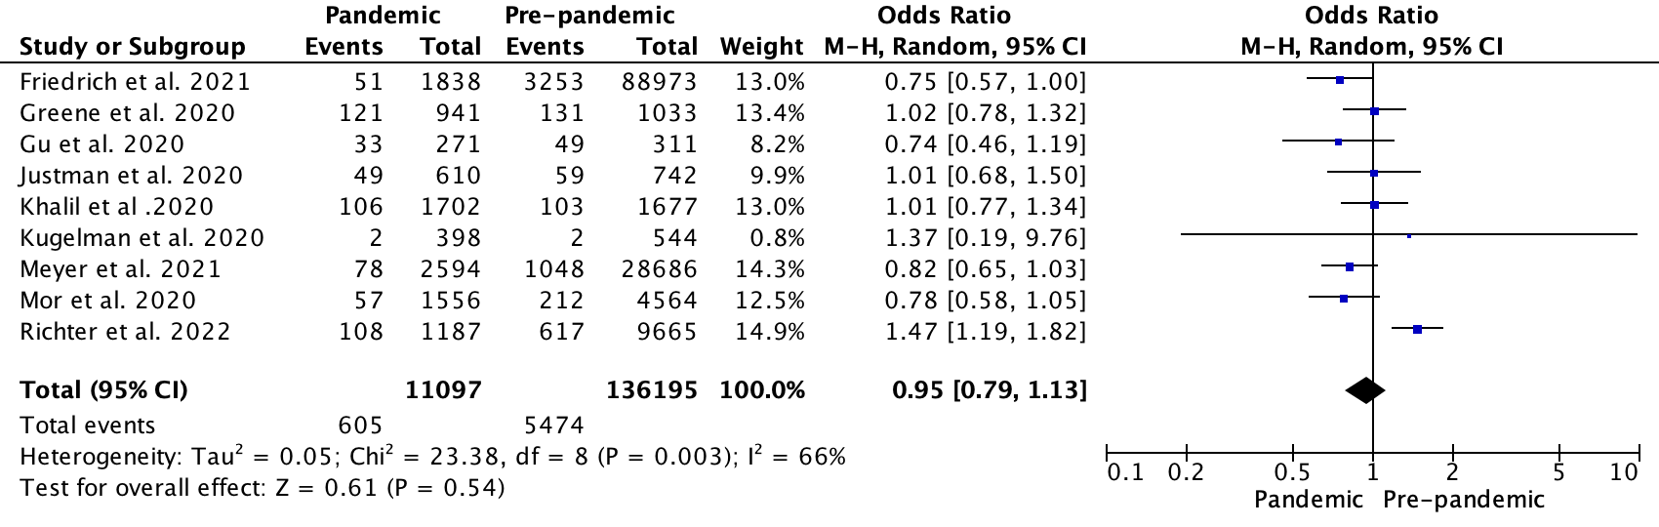
Figure S8.2: Forest plot for odds of NICU admission in single centre studies during the COVID-19 pandemic lockdown versus pre-pandemic period.

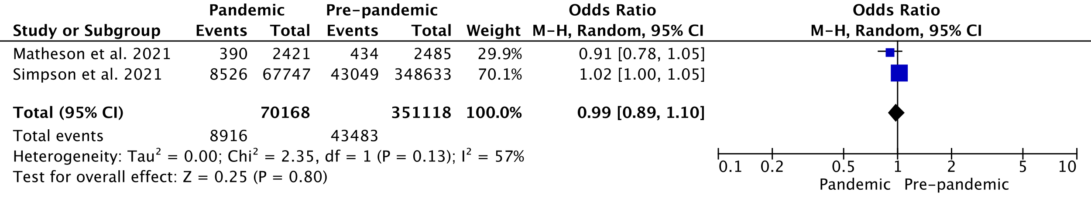
Figure S8.3: Forest plot for odds of NICU admission in multicentre studies during the COVID-19 pandemic lockdown versus pre-pandemic period.

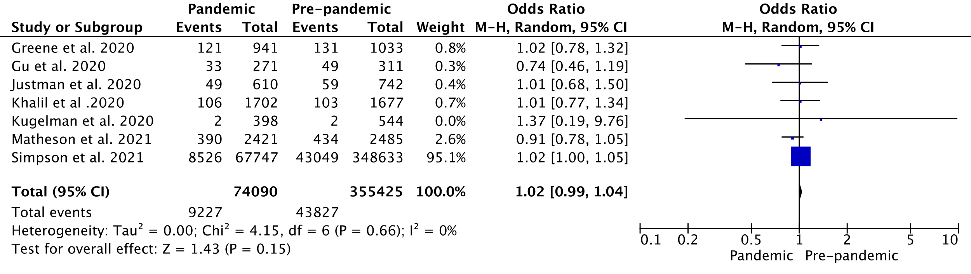
Figure S8.4: Forest plot for odds of NICU admission including singleton and multiples pregnancies during the COVID-19 pandemic lockdown versus pre-pandemic period.

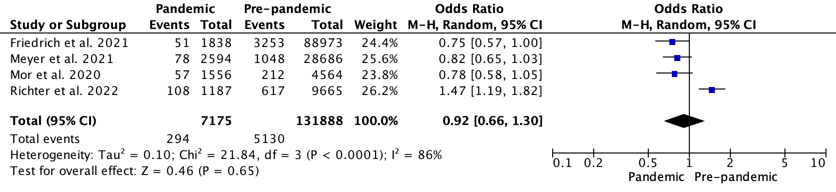
Figure S8.5: Forest plot for odds of NICU admission including only singleton pregnancies during the COVID-19 pandemic lockdown versus pre-pandemic period.

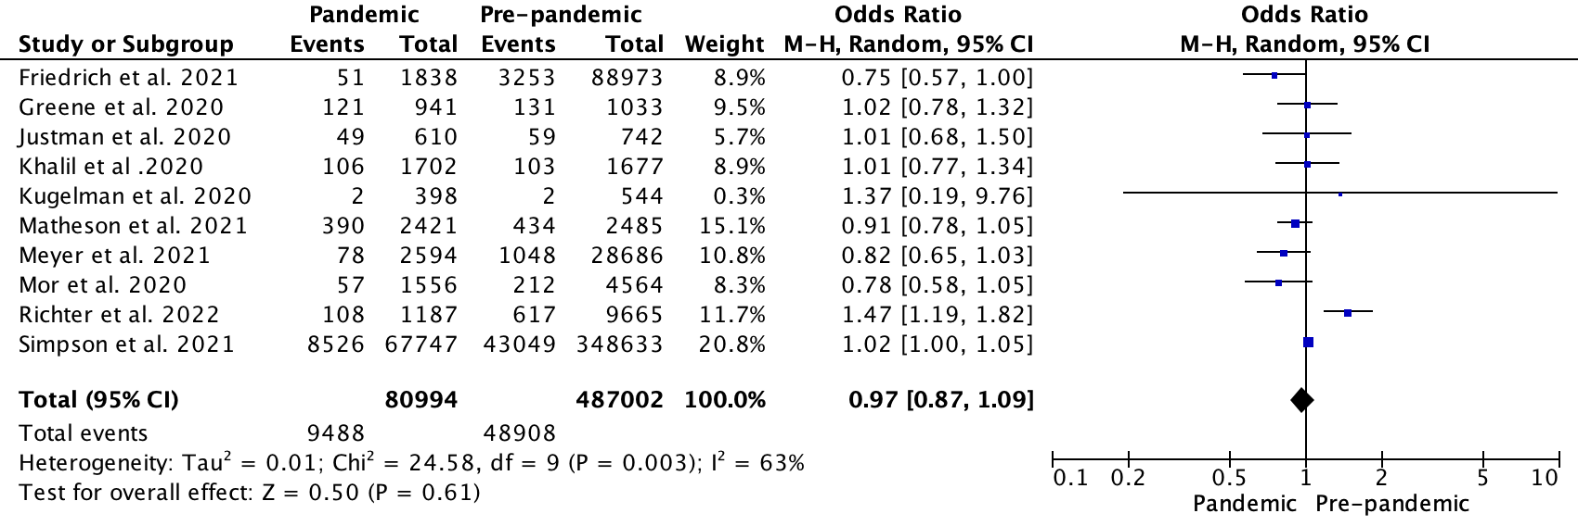
Figure S8.6: Forest plot for odds of NICU admission in high income settings.

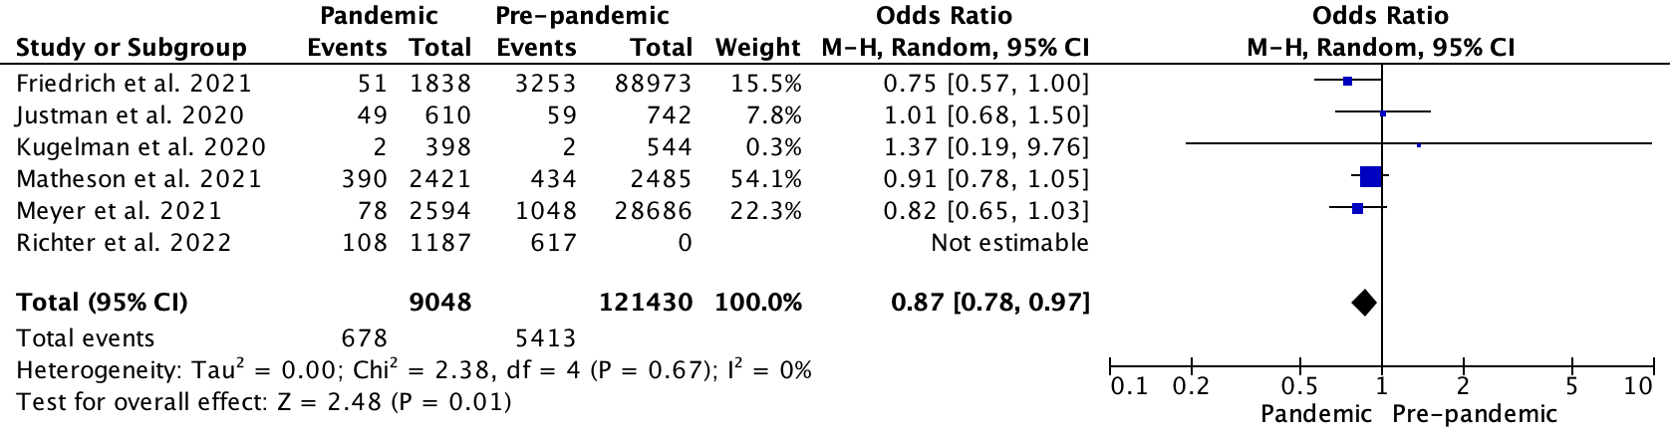
Figure S8.7: Forest plot for odds of NICU admission in studies conducted with stringency index scores greater than the median.

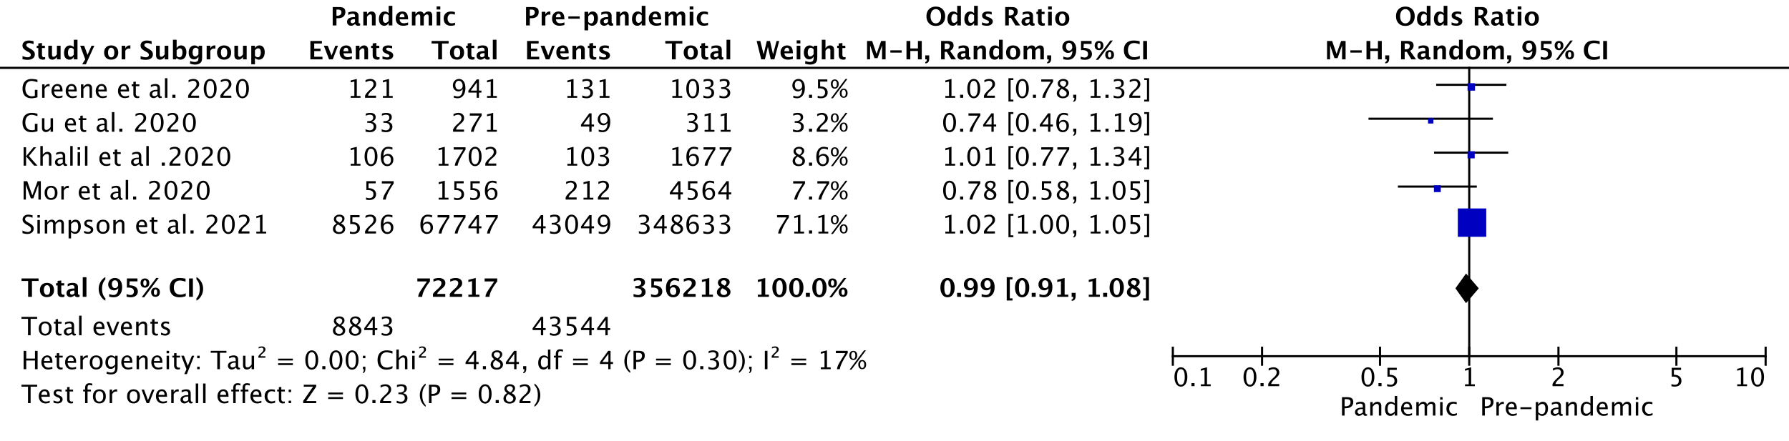
Figure S8.8: Forest plot for odds of NICU admission in studies conducted with stringency index scores less than the median.

S9. Funnel plots
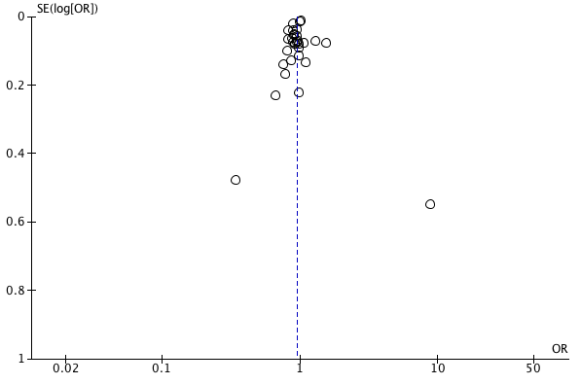
Figure S9.1: Funnel plot for pandemic versus pre-pandemic odds of preterm birth at less than 37 weeks gestation (unadjusted results)

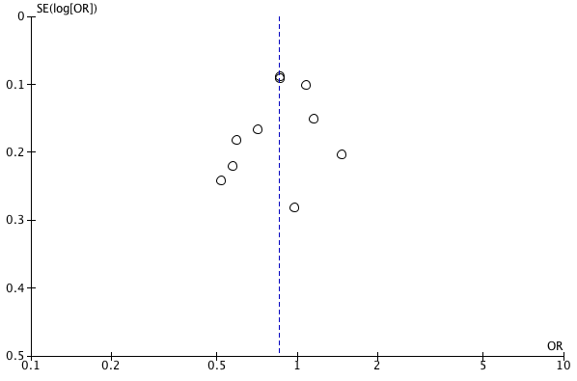
Figure S9.2: Funnel plot for pandemic versus pre-pandemic odds of preterm birth at less than 34 weeks gestation (unadjusted results)

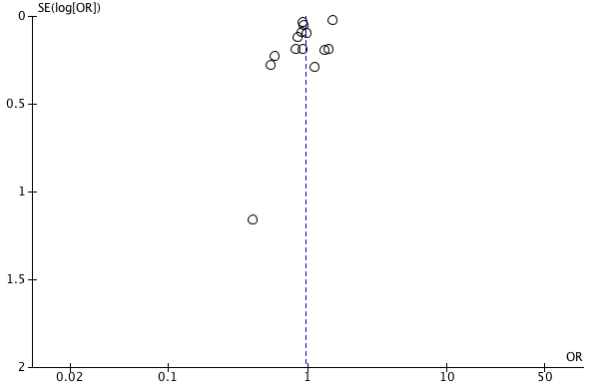
Figure S9.3: Funnel plot for pandemic versus pre-pandemic odds of preterm birth at less than 32 weeks gestation (unadjusted results)

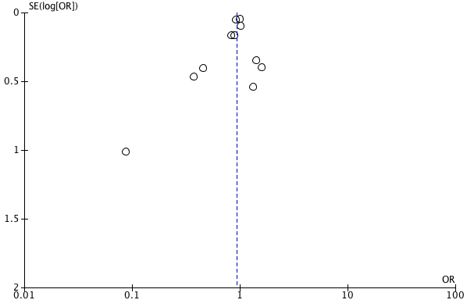
Figure S9.4: Funnel plot for pandemic versus pre-pandemic odds of preterm birth at less than 28 weeks gestation (unadjusted results)

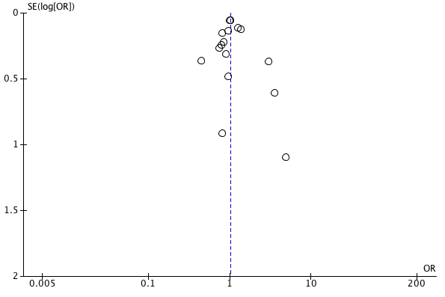
Figure S9.5: Funnel plot for pandemic versus pre-pandemic odds of stillbirth (unadjusted results)

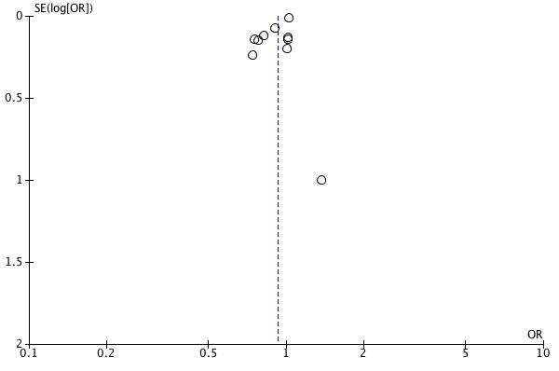
Figure S9.6: Funnel plot for pandemic versus pre-pandemic odds of NICU admission (unadjusted results)

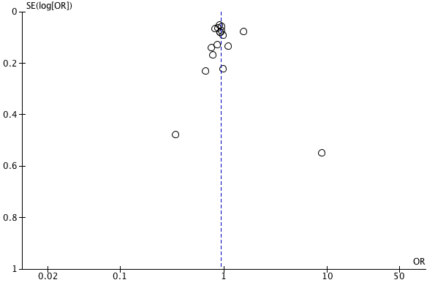
Figure S9.7: Funnel plot for pandemic versus pre-pandemic odds of preterm birth at less than 37 weeks gestation in single centre studies.

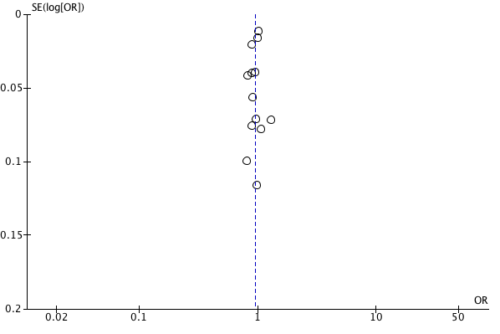
Figure S9.8: Funnel plot for pandemic versus pre-pandemic odds of preterm birth at less than 37 weeks gestation in multicentre studies.

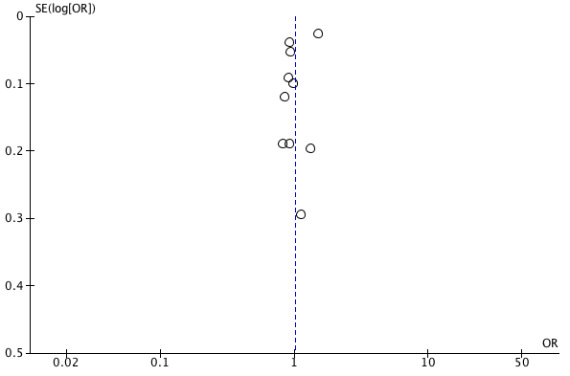
Figure S9.9: Funnel plot for pandemic versus pre-pandemic odds of preterm birth at less than 32 weeks gestation in multicentre studies.

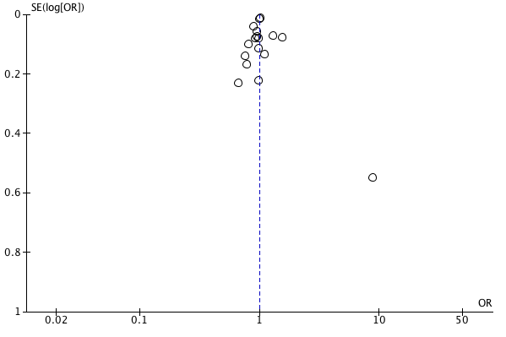
Figure S9.10: Funnel plot for pandemic versus pre-pandemic odds of preterm birth at less than 37 weeks gestation in singleton and multiples pregnancies

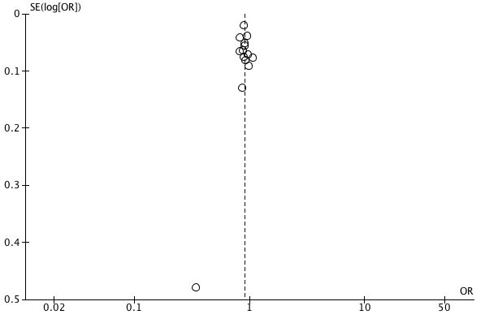
Figure S9.11: Funnel plot for pandemic versus pre-pandemic odds of preterm birth at less than 37 weeks gestation in singleton pregnancies

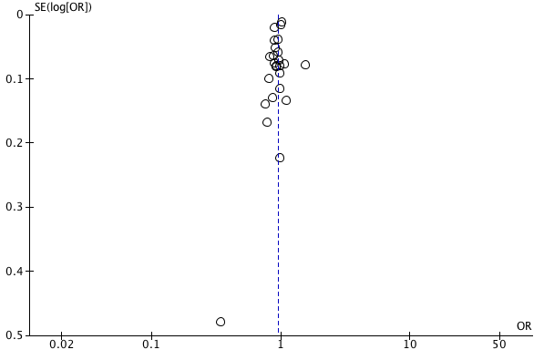
Figure S9.12: Funnel plot for pandemic versus pre-pandemic odds of preterm birth at less than 37 weeks gestation in high income settings.

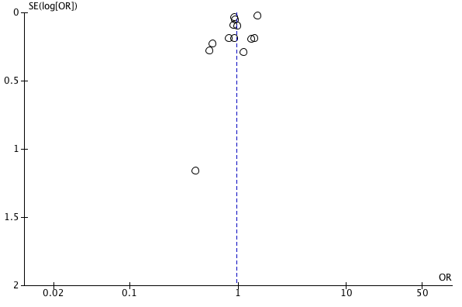
Figure S9.13: Funnel plot for pandemic versus pre-pandemic odds of preterm birth at less than 32 weeks gestation in high income settings.

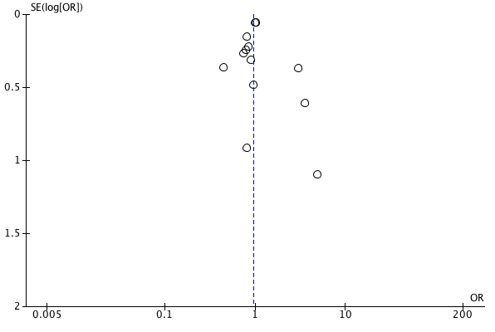
Figure S9.14: Funnel plot for pandemic versus pre-pandemic odds of stillbirth in high income settings.

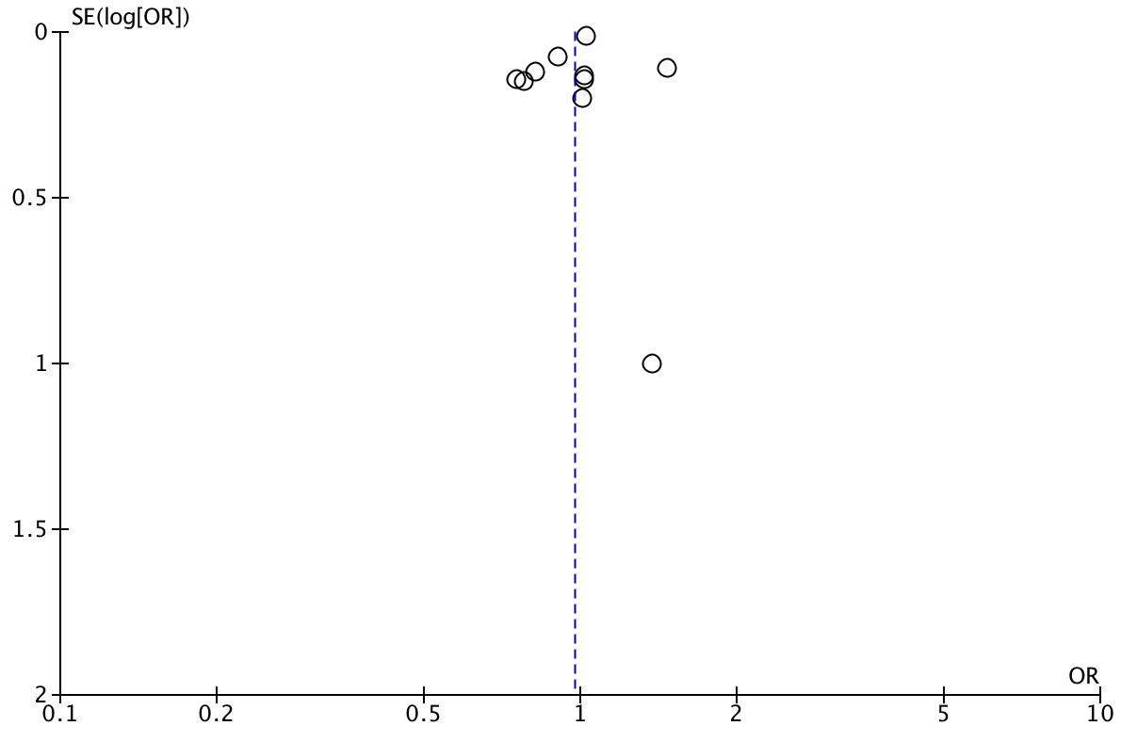
Figure S9.15: Funnel plot for pandemic versus pre-pandemic odds of NICU admission in high income settings.

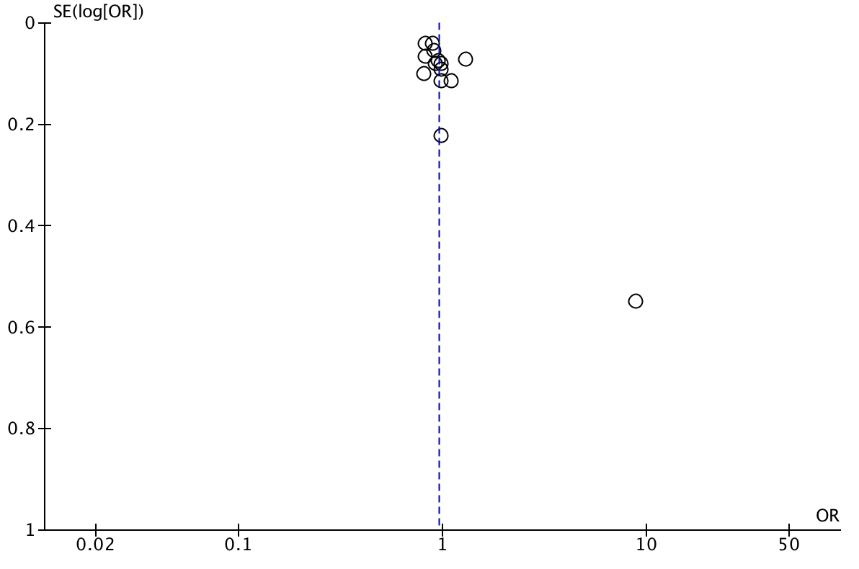
Figure S9.16: Funnel plot for pandemic versus pre-pandemic odds of preterm birth at less than 37 weeks gestation in studies conducted with stringency index scores greater than the median.

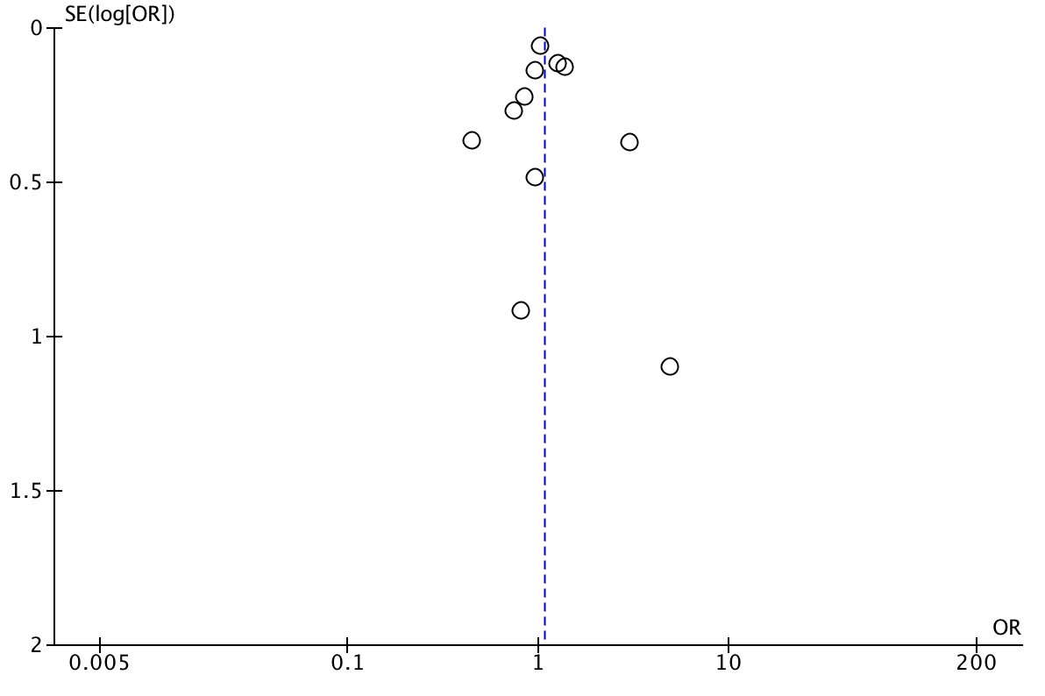
Figure S9.17: Funnel plot for pandemic versus pre-pandemic odds of stillbirth in studies conducted with stringency index scores greater than the median.

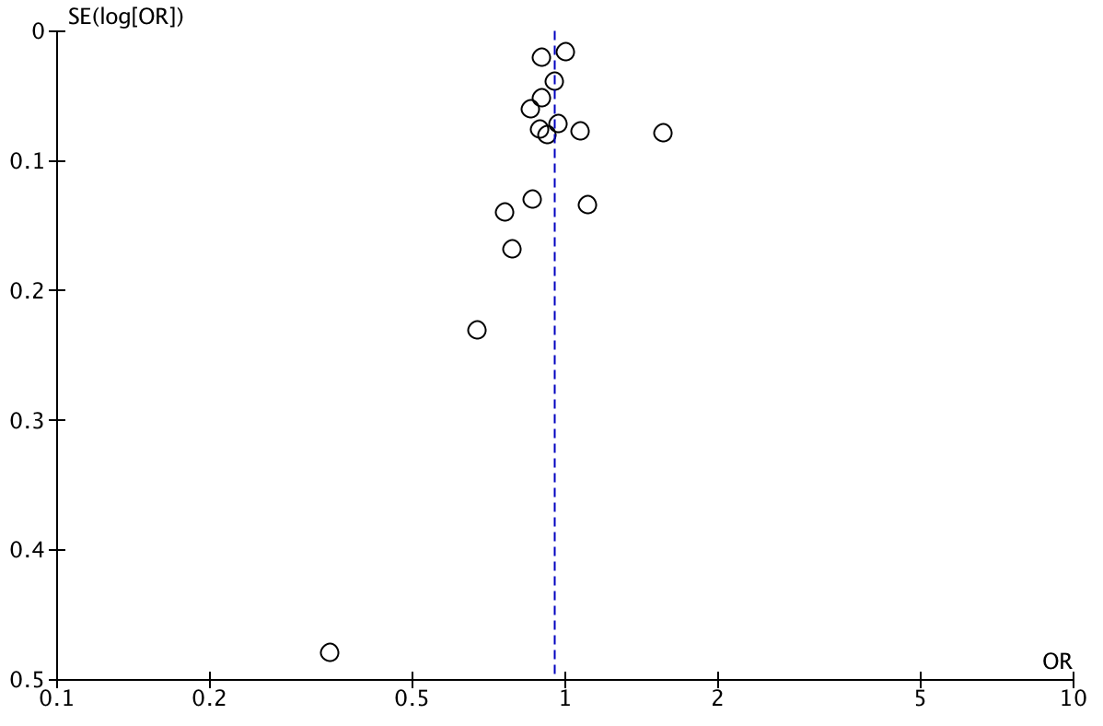
Figure S9.18: Funnel plot for pandemic versus pre-pandemic odds of preterm birth at less than 37 weeks gestation in studies conducted with stringency index scores less than the median.

