APPENDIX A Frequencies for the most commonly utilized dependent variables (according to the number of articles)
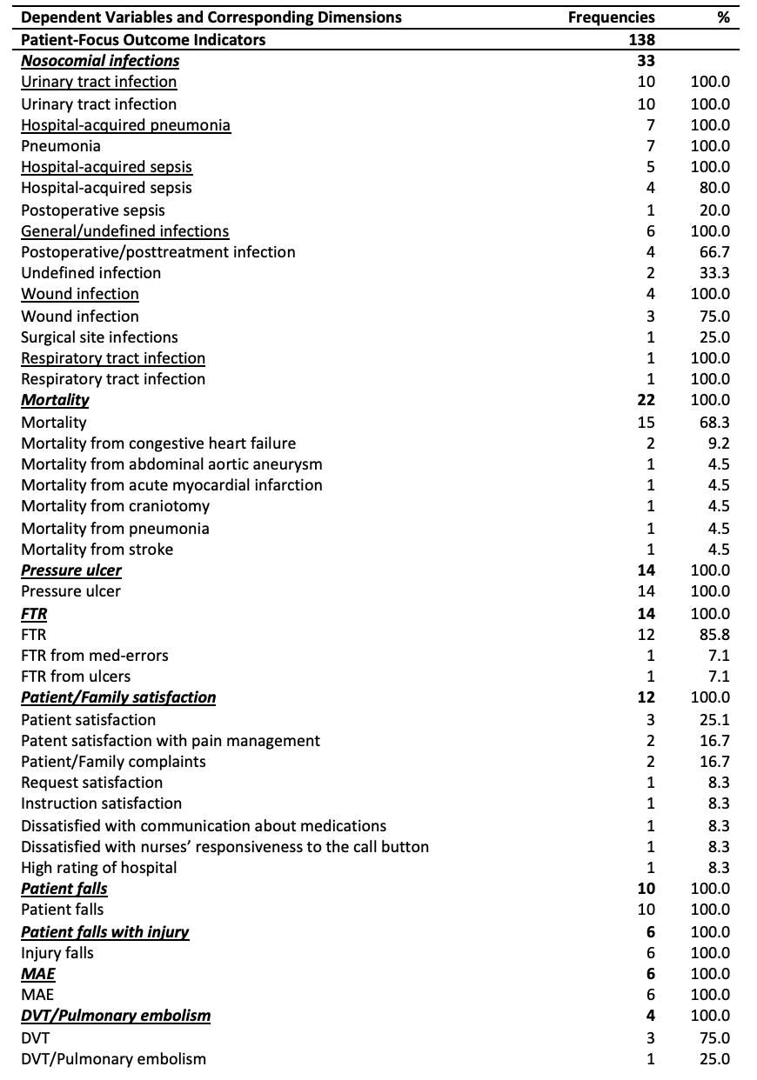
APPENDIX A (Cont.) Frequencies for the most commonly utilized dependent variables (according to the number of articles)
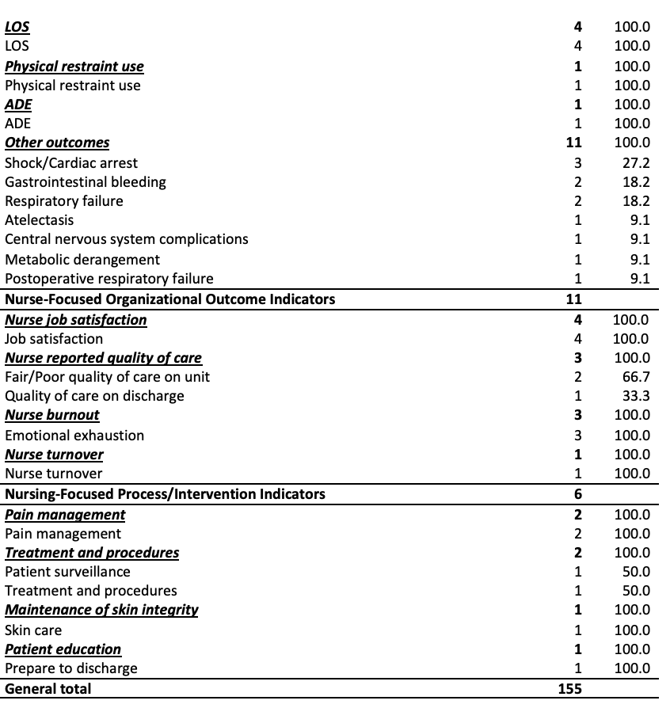

APPENDIX B Frequencies for the most commonly utilized independent variables (according to the number of articles)
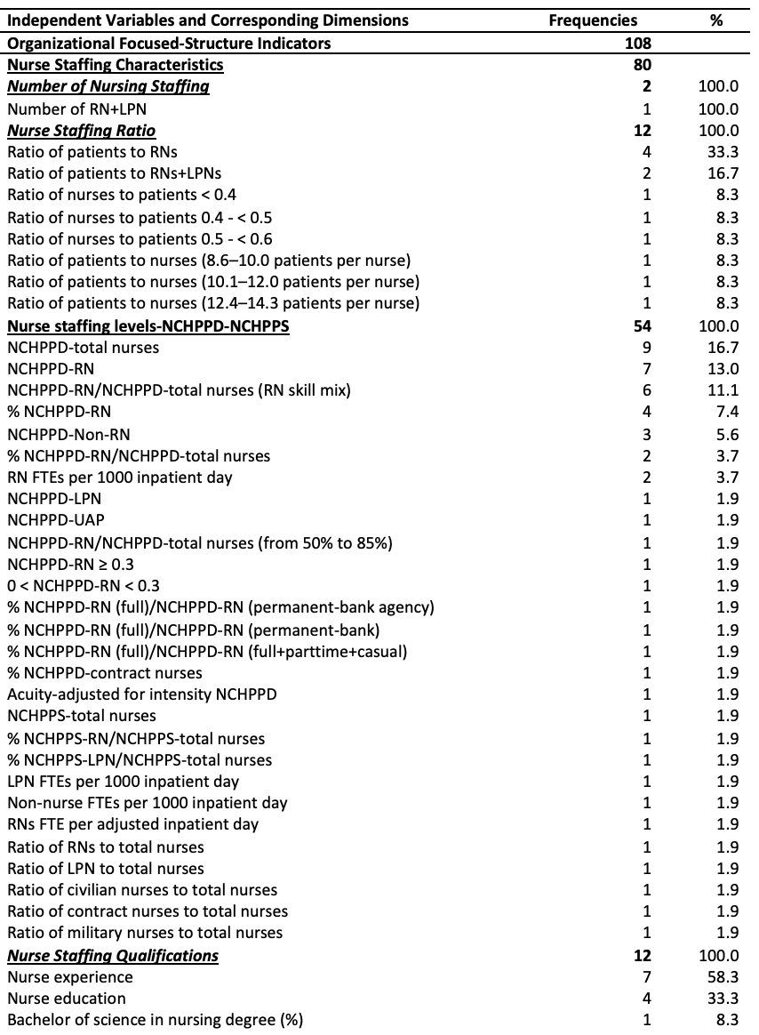
APPENDIX B (Cont.) Frequencies for the most commonly utilized independent variables (according to the number of articles)
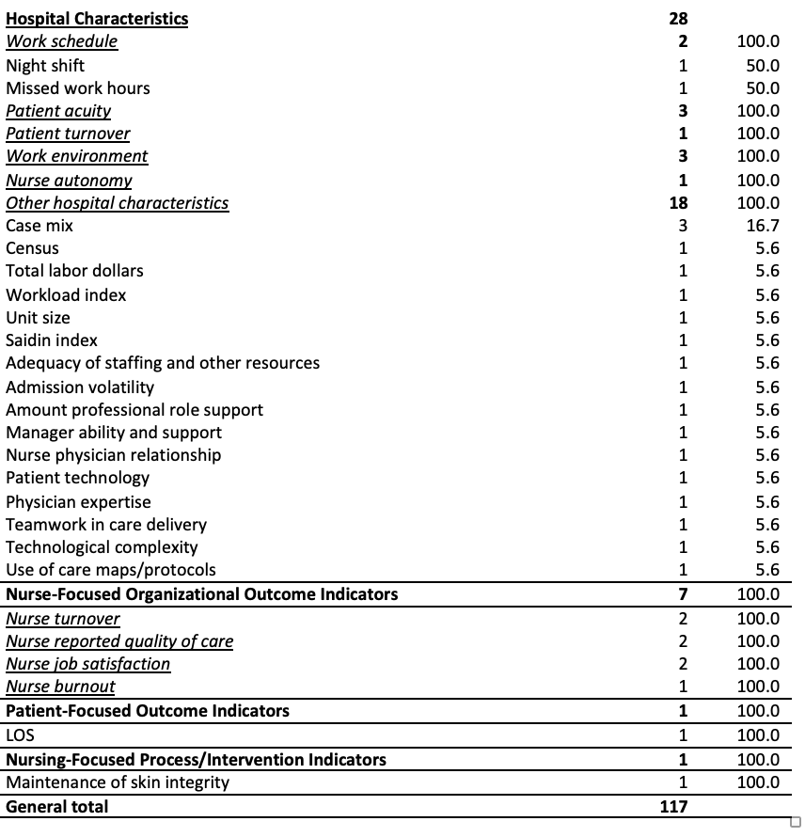
In Appendix A and B, some indicators were categorized. Nurse staffing levels refer to ratio of total nursing staff, and nursing care hours per patient days (NCHPPDs), nursing care hour per patient shifts (NCHPPSs), and their proportions.
Ratio of total nursing staff refer to ratio of RNs to total nurses, ratio of LPNs to total nurses, ratio of civilian nurses to total nurses, ratio of contract nurses to total nurses, ratio of military nurses to total nurses.
NCHPPDs-NCHPPSs refer to NCHPPD-total nurses, NCHPPD-RN, NCHPPD-RN/NCHPPD-total nurses(RN proportion), %NCHPPD-RN, NCHPPD-Non-RN, %NCHPPD-RN/NCHPPD-total nurses, RN FTEs per 1000 inpatient day, NCHPPD-LPN, NCHPPD-UAP, NCHPPD-RN/NCHPPD-total nurses(from 50 % to 85 %), NCHPPD-RN≥0.3, 0<NCHPPD-RN<0.3, %NCHPPD-RN(full)/NCHPPD-RN(permanent-bank-agency), %NCHPPD-RN(full)/NCHPPD-RN(permanent-bank), %NCHPPD-RN(full)/NCHPPD-RN(full+parttime+casual), %NCHPPD-contract nurses, Acuity-adjusted for intensity NCHPPD, NCHPPS-total nurses, %NCHPPS-RN/NCHPPS-total nurses, %NCHPPS-LPN/NCHPPS-total nurses, LPN FTEs per 1000 inpatient day, Non-nurse FTEs per 1000 inpatient day, RNs FTE per adjusted inpatient day.
Nurse staffing ratio refer to ratio of patients to RNs, ratio of patients to RNs+LPNs, ratio of nurses to patients<0.4, ratio of nurses to patients 0.4-<0.5, ratio of nurses to patients 0.5-<0.6, ratio of patients to nurses (8.6–10.0 patients per nurse), ratio of patients to nurses (10.1–12.0 patients per nurse), ratio of patients to nurses (12.4–14.3 patients per nurse).
Nurse staffing qualifications refer to nurse experience, education, and bachelor of science in nursing degree (%).
Work schedule refer to long work hours, off shift and weekends, weekly burden, lack of time away, mandatory overtime, working while sick, required on call, insufficient work breaks, night shift, missed work hours.
Other hospital characteristics refer to census, technological complexity, nurse physician relationship, manager ability and support, teamwork in care delivery, amount professional role support, use of care maps/protocols, physician expertise, unit size, patient technology, admission volatility, workload index, case mix, total labor dollars, saidin index, adequacy of staffing and other resources.
Other outcomes refer to shock/cardiac arrest, gastrointestinal bleeding, respiratory failure, atelectasis, central nervous system complications, metabolic derangement, postoperative respiratory failure.

APPENDIX C Reporting quality and risk of bias assessment of 39 publications (The National Institutes of Health (NIH) Quality Assessment Tool for Observational Cohort and Cross-Sectional Studies)

Author, Year, Country | 1 |  | 2 |  | 3 |  | 4 |  | 5 |  | 6 |  | 7 |  | 8 |  | 9 |  | 10 |  | 11 |  | 12 |  | 13 |  | 14 |  | Quality Rating
 | R1 | R2 | R1 | R2 | R1 | R2 | R1 | R2 | R1 | R2 | R1 | R2 | R1 | R2 | R1 | R2 | R1 | R2 | R1 | R2 | R1 | R2 | R1 | R2 | R1 | R2 | R1 | R2 | R1 | R2
Aiken et al. (2002), USA | Y | Y | Y | Y | Y | Y | Y | Y | Y | Y | N | N | N | N | Y | Y | Y | Y | NA | NA | Y | Y | NA | NA | NA | NA | Y | Y | G | G
Aiken et al. (2003), USA | Y | Y | Y | Y | Y | Y | Y | Y | Y | Y | N | N | N | N | Y | Y | Y | Y | NA | NA | Y | Y | NA | NA | NA | NA | Y | Y | G | G
Aiken et al. (2011), USA | Y | Y | Y | Y | Y | Y | Y | Y | Y | Y | N | N | N | N | NA | NA | Y | Y | NA | NA | Y | Y | NA | NA | NA | NA | Y | Y | G | G
Bae et al. (2014), USA | NR | Y | Y | Y | Y | Y | Y | Y | Y | Y | Y | Y | Y | Y | Y | Y | Y | Y | NA | NA | Y | Y | NA | NA | NA | NA | Y | Y | F | G
Blegen & Vaughn (1998), USA | Y | Y | Y | Y | Y | Y | NR | Y | Y | Y | Y | Y | Y | Y | Y | Y | Y | Y | NA | NA | Y | Y | NA | NA | NA | NA | Y | Y | F | G
Blegen et al. (1998), USA | Y | Y | Y | Y | Y | Y | NR | Y | Y | Y | N | N | N | N | Y | Y | Y | Y | NA | NA | Y | Y | NA | NA | NA | NA | Y | Y | F | G
Blegen et al. (2011), USA | Y | Y | Y | Y | Y | Y | NR | Y | Y | Y | N | N | N | N | NA | NA | Y | Y | NA | NA | Y | Y | NA | NA | NA | NA | Y | Y | F | G
Bond et al. (1999), USA | Y | Y | Y | Y | Y | Y | NR | Y | Y | Y | N | N | N | N | Y | Y | Y | Y | NA | NA | Y | Y | NA | NA | NA | NA | Y | Y | F | G
Cho et al. (2003), USA | Y | Y | Y | Y | Y | Y | Y | Y | Y | Y | N | N | N | N | Y | Y | Y | Y | NA | NA | Y | Y | NA | NA | NA | NA | Y | Y | G | G
Cho et al. (2016), South Korea | Y | Y | Y | Y | Y | Y | Y | Y | Y | Y | N | N | N | N | Y | Y | Y | Y | NA | NA | Y | Y | NA | NA | NA | NA | Y | Y | G | G
Dunton et al. (2004), USA | Y | Y | Y | Y | Y | Y | NR | Y | Y | Y | N | N | N | N | Y | Y | Y | Y | NA | NA | Y | Y | NA | NA | NA | NA | Y | Y | F | G
Halm et al. (2005), USA | Y | Y | Y | Y | Y | Y | Y | Y | Y | Y | N | N | N | N | Y | Y | Y | Y | NA | NA | Y | Y | NA | NA | NA | NA | Y | Y | G | G
Harless & Mark (2010), USA | Y | Y | Y | Y | Y | Y | NR | Y | Y | Y | Y | Y | Y | Y | Y | Y | Y | Y | NA | NA | Y | Y | NA | NA | NA | NA | Y | Y | F | G
Kovner & Gergen (1998), USA | Y | Y | Y | Y | Y | Y | NR | Y | Y | Y | N | N | N | N | NA | NA | Y | Y | NA | NA | Y | Y | NA | NA | NA | NA | Y | Y | F | G
Lichtig et al. (1999), USA | Y | Y | Y | Y | Y | Y | Y | Y | Y | Y | Y | Y | Y | Y | NA | NA | Y | Y | NA | NA | Y | Y | NA | NA | NA | NA | Y | Y | G | G
Mark et al. (2003), USA | Y | Y | Y | Y | Y | Y | NR | Y | Y | Y | N | N | N | N | NA | NA | Y | Y | NA | NA | Y | Y | NA | NA | NA | NA | Y | Y | F | G
Mark et al. (2004), USA | Y | Y | Y | Y | Y | Y | NR | Y | Y | Y | Y | Y | Y | Y | Y | Y | Y | Y | NA | NA | Y | Y | NA | NA | NA | NA | Y | Y | F | G
McGills Hall et al. (2004), Canada | Y | Y | NR | Y | Y | Y | NR | NR | Y | Y | N | N | N | N | Y | Y | Y | Y | NA | NA | Y | Y | NA | NA | NA | NA | Y | Y | F | F
McHugh & Stimpfel (2012), USA | Y | Y | Y | Y | Y | Y | NR | Y | Y | Y | N | N | N | N | Y | Y | Y | Y | NA | NA | Y | Y | NA | NA | NA | NA | Y | Y | F | G
Moore et al. (1999), USA | Y | Y | NR | Y | Y | Y | NR | Y | Y | Y | N | N | N | N | Y | Y | Y | Y | NA | NA | Y | Y | NA | NA | NA | NA | Y | Y | F | G
Needleman et al. (2002), USA | Y | Y | Y | Y | Y | Y | NR | Y | Y | Y | N | N | N | N | Y | Y | Y | Y | NA | NA | Y | Y | NA | NA | NA | NA | Y | Y | F | G
Needleman et al. (2011), USA | Y | Y | Y | Y | Y | Y | Y | Y | Y | Y | Y | Y | Y | Y | Y | Y | Y | Y | NA | NA | Y | Y | NA | NA | NA | NA | Y | Y | G | G
Park et al. (2012), USA | Y | Y | Y | Y | Y | Y | NR | Y | Y | Y | N | N | N | N | Y | Y | Y | Y | NA | NA | Y | Y | NA | NA | NA | NA | Y | Y | F | G
Park et al. (2014), USA | Y | Y | Y | Y | Y | Y | NR | Y | Y | Y | Y | Y | Y | Y | Y | Y | Y | Y | NA | NA | Y | Y | NA | NA | NA | NA | Y | Y | F | G
Patrician et al. (2011), USA | Y | Y | Y | Y | Y | Y | NR | Y | Y | Y | Y | Y | Y | Y | NA | NA | Y | Y | NA | NA | Y | Y | NA | NA | NA | NA | Y | Y | F | G
Potter et al. (2003), USA | Y | Y | Y | Y | Y | Y | NR | Y | Y | Y | N | N | N | N | Y | Y | Y | Y | NA | NA | Y | Y | NA | NA | NA | NA | Y | Y | F | G
Raffertya et al. (2007), UK | Y | Y | Y | Y | Y | Y | Y | Y | Y | Y | N | N | N | N | Y | Y | Y | Y | NA | NA | Y | Y | NA | NA | NA | NA | Y | Y | G | G
Rao et al. (2017), USA | Y | Y | Y | Y | Y | Y | NR | Y | Y | Y | N | N | N | N | Y | Y | Y | Y | NA | NA | Y | Y | NA | NA | NA | NA | Y | Y | F | G
Sasichay-Akkadechanunt et al. (2003), Tailand | Y | Y | Y | Y | Y | Y | Y | Y | Y | Y | N | N | N | N | NA | NA | Y | Y | NA | NA | Y | Y | NA | NA | NA | NA | Y | Y | G | G
Seago et al. (2006), USA | Y | Y | Y | Y | Y | Y | NR | Y | Y | Y | Y | Y | Y | Y | Y | Y | Y | Y | NA | NA | Y | Y | NA | NA | NA | NA | Y | Y | F | G
Shuldham et al. (2009), UK | Y | Y | NR | Y | Y | Y | NR | Y | Y | Y | N | N | N | N | Y | Y | Y | Y | NA | NA | Y | Y | NA | NA | NA | NA | Y | Y | F | G
Sovie & Javad (2001), USA | Y | Y | Y | Y | Y | Y | Y | Y | Y | Y | N | N | N | N | Y | Y | Y | Y | NA | NA | Y | Y | NA | NA | NA | NA | Y | Y | G | G
Tourangeau et al. (2002), Canada | Y | Y | Y | Y | Y | Y | NR | Y | Y | Y | N | N | N | N | Y | Y | Y | Y | NA | NA | Y | Y | NA | NA | NA | NA | Y | Y | F | G
Tourangeau et al. (2006), Canada | Y | Y | Y | Y | Y | Y | Y | Y | Y | Y | N | N | N | N | Y | Y | Y | Y | NA | NA | Y | Y | NA | NA | NA | NA | Y | Y | G | G
Trinkoff et al. (2011), USA | Y | Y | Y | Y | Y | Y | Y | Y | Y | Y | N | N | N | N | Y | Y | Y | Y | NA | NA | Y | Y | NA | NA | NA | NA | Y | Y | G | G
Unruh (2003), USA | Y | Y | Y | Y | Y | Y | NR | Y | Y | Y | Y | Y | Y | Y | Y | Y | Y | Y | NA | NA | Y | Y | NA | NA | NA | NA | Y | Y | F | G
Van den Heede et al. (2009), Belgian | Y | Y | Y | Y | Y | Y | Y | Y | Y | Y | N | N | N | N | NA | NA | Y | Y | NA | NA | Y | Y | NA | NA | NA | NA | Y | Y | G | G
Yang (2003), Taiwan | Y | Y | Y | Y | Y | Y | NR | Y | Y | Y | N | N | N | N | NA | NA | Y | Y | NA | NA | Y | Y | NA | NA | NA | NA | Y | Y | F | G
Zhu et al. (2012), China | Y | Y | Y | Y | Y | Y | Y | Y | Y | Y | N | N | N | N | Y | Y | Y | Y | NA | NA | Y | Y | NA | NA | NA | NA | Y | Y | G | G
G:Good, F:Fair, N:No, NA:Not Applicable, NR:Not Reported, Y:Yes, R1:Rater #1, R2:Rater #2, Rater #1 Initials:NO, Rater #2 Initials:BO

APPENDIX D Number of explored relationships in 39 articles based on the facility types, unit types, dependent variables, independent variables and analytical approaches.

Authors, Year, Country | Facility Type | Unit Type | Dependent Variable | Independent Variable | Analytical Approach | Relationships
Aiken et al. (2002), USA | 1 | 1 | 4 | 1 | 1 | 4
Aiken et al. (2003), USA | 1 | 1 | 2 | 3 | 1 | 6
Aiken et al. (2011), USA | 1 | 1 | 2 | 3 | 1 | 6
Bae et al. (2014), USA | 1 | 1 | 3 | 7 | 2 | 28
Blegen & Vaughn (1998), USA | 1 | 1 | 1 | 2 | 1 | 2
Blegen et al. (1998), USA | 1 | 1 | 6 | 3 | 1 | 18
Blegen et al. (2011), USA | 1 | 2 | 6 | 3 | 1 | 24
Cho et al. (2003), USA | 1 | 1 | 7 | 3 | 1 | 21
Cho et al. (2016), South Korea | 1 | 1 | 3 | 3 | 1 | 9
Dunton et al. (2004), USA | 1 | 4 | 2 | 4 | 1 | 24
Halm et al. (2005), USA | 1 | 1 | 4 | 2 | 1 | 4
Harless & Mark (2010), USA | 1 | 1 | 2 | 1 | 1 | 2
Kovner & Gergen (1998), USA | 1 | 1 | 3 | 1 | 1 | 3
Lichtig et al. (1999), USA | 1 | 1 | 5 | 1 | 1 | 5
Mark et al. (2003), USA | 1 | 1 | 5 | 6 | 1 | 9
Mark et al. (2004), USA | 1 | 1 | 4 | 3 | 1 | 12
McGills Hall et al. (2004), Canada | 1 | 1 | 4 | 3 | 1 | 12
McHugh & Stimpfel (2012), USA | 1 | 1 | 4 | 1 | 1 | 5
Moore et al. (1999), USA | 1 | 1 | 4 | 3 | 1 | 5
Needleman et al. (2002), USA | 1 | 2 | 14 | 2 | 1 | 44
Park et al. (2012), USA | 1 | 2 | 1 | 5 | 1 | 10
Park et al. (2014), USA | 1 | 1 | 1 | 4 | 1 | 4
Patrician et al. (2011), USA | 1 | 3 | 3 | 9 | 1 | 81
Potter et al. (2003), USA | 1 | 1 | 1 | 1 | 1 | 1
Raffertya et al. (2007), UK | 1 | 1 | 6 | 3 | 1 | 18
Rao et al. (2017), USA | 1 | 1 | 2 | 1 | 1 | 2
Sasichay-Akkadechanunt et al. (2003), Tailand | 1 | 1 | 1 | 4 | 1 | 4
Seago et al. (2006), USA | 1 | 1 | 5 | 6 | 1 | 40
Shuldham et al. (2009), UK | 1 | 2 | 7 | 3 | 1 | 42
Sovie & Javad (2001), USA | 1 | 1 | 3 | 2 | 1 | 3
Tourangeau et al. (2002), Canada | 4 | 1 | 1 | 3 | 1 | 7
Tourangeau et al. (2006), Canada | 1 | 1 | 1 | 18 | 1 | 18
Trinkoff et al. (2011), USA | 1 | 1 | 6 | 10 | 1 | 60
Unruh (2003), USA | 1 | 1 | 6 | 2 | 1 | 12
Van den Heede et al. (2009), Belgian | 1 | 1 | 10 | 2 | 1 | 20
Yang (2003), Taiwan | 1 | 1 | 5 | 4 | 1 | 20
Zhu et al. (2012), China | 1 | 1 | 13 | 5 | 1 | 39
Sum | 40 | 46 | 157 | 137 | 38 | 624

APPENDIX E Features of 39 publications
Authors, Years, Countries | Study Designs | Samples | Focus Area | Leading Independent Variables | Leading Dependent Variables | Leading Results
Aiken et al. (2002), USA | Cross-sectional | 232342 discharged patients-10184 nurses-168 hospitals | Patient, Nurse | Nurse staffing ratio | Mortality, FTR, nurse Staff Satisfaction, Nurse Burnout | After adjusting for patient and hospital characteristics (size, teaching status, and technology), each additional patient per nurse was associated with a 7% (odds ratio [OR], 1.07; 95% confidence interval [CI], 1.03-1.12) increase in the likelihood of dying within 30 days of admission and a 7% (OR, 1.07; 95% CI, 1.02-1.11) increase in the odds of failure-to-rescue. After adjusting for nurse and hospital characteristics, each additional patient per nurse was associated with a 23% (OR, 1.23; 95% CI, 1.13-1.34) increase in the odds of burnout and a 15% (OR, 1.15; 95% CI, 1.07-1.25) increase in the odds of job dissatisfaction.
Aiken et al. (2003), USA | Cross-sectional | 232342 discharged patients-10185 nurses-168 hospitals | Patient | Nurse staffing ratio, nurse staffing qualifications | Mortality, FTR | The proportion of hospital RNs holding a bachelor’s degree or higher ranged from 0% to 77% across the hospitals. After adjusting for patient characteristics and hospital structural characteristics (size, teaching status, level of technology), as well as for nurse staffing, nurse experience, and whether the patient’s surgeon was board certified, a 10% increase in the proportion of nurses holding a bachelor’s degree was associated with a 5%decrease in both the likelihood of patients dying within 30 days of admission and the odds of failure to rescue (odds ratio, 0.95; 95% confidence interval, 0.91-0.99 in both cases).
Aiken et al. (2011), USA | Cross-sectional | 1262120 patients’ outcomes-39038 nurses-665 hospitals | Patient | Nurse staffing ratio, nurse staffing qualifications, hospital characteristics | Mortality, FTR | The effect of decreasing workloads by one patient/nurse on deaths and failure-to rescue is virtually null in hospitals with poor work environments, but decreases the odds on both deaths and failures in hospitals with average environments by 4%, and in hospitals with the best environments by 9 and 10% respectively. The effect of 10% more BSN nurses decreases the odds on both outcomes in all hospitals, regardless of their work environment, by roughly 4%.
Bae et al. (2014), USA | Longitudinal | 6 hospitals | Patient | Nurse staffing levels, nurse turnover | Patient falls, patient falls with injury, pressure ulcer | Rates of patient falls and injury falls were found to be greater with higher temporary registered nurse staffing levels but decreased with greater levels of licensed practical nursing care hours per patient day. Pressure ulcers were not related to any staffing characteristics.
Blegen & Vaughn (1998), USA | Longitudinal | 11 hospitals | Patient | Nurse staffing levels | MAE | This study was the "non-linear" relationship between the proportion of RNs in the staff mix and MAEs. As the proportion of RNs on a unit increased from 50% to 85% "the rate of MAEs declined, but as the RN proportion increased from 85% to 100% the rate of MAEs increased."
Blegen et al. (1998), USA | Cross-sectional | 21783 dischargers-1074 nurses- 1 hospital | Patient | Nurse staffing levels, hospital characteristics | Nosocomial infections, mortality, patient falls, pressure ulcer, MAE, patient/family satisfaction | Units with higher average patient acuity had lower rates of medication errors and patient falls but higher rates of the other adverse outcomes. With average patient acuity on the unit controlled, the proportion of hours of care delivered by RNs was inversely related to the unit rates of medication errors, decubiti, and patient complaints. Total hours of care from all nursing personnel were associated directly with the rates of decubiti, complaints, and mortality. An unexpected finding was that the relationship between RN proportion of care was curvilinear; as the RN proportion increased, rates of adverse outcomes decreased up to 87.5%. Above the level, as RN proportion increased, the adverse outcome rates also increased.
Blegen et al. (2011), USA | Cross-sectional | 1.1 million discharged patients-54 hospitals | Patient | Nurse staffing levels | Nosocomial infections, mortality, pressure ulcer, FTR, LOS | "TotHPD in general units was associated with lower rates of congestive heart failure mortality (P<0.05), failure to rescue (P<0.10), infections (P<0.01), and prolonged length of stay (P<0.01). RN skill mix in general units was associated with reduced failure to rescue (P<0.01) and infections (P<0.05). TotHPD in intensive care units was associated with fewer infections (P<0.05) and decubitus ulcers (P<0.10). RN skill mix was associated with fewer cases of sepsis (P<0.01) and failure to rescue (P<0.05). Safety-net status was associated with higher rates of congestive heart failure mortality, decubitus ulcers, and failure to rescue."
Bond et al. (1999), USA | Cross-sectional | 3763 hospitals | Patient | Nurse staffing ratio | Mortality | Hospital characteristics associated with lower mortality were occupancy rate and private nonprofit and private for-profit ownership. Mortality rates decreased as staffing level per occupied bed increased for medical residents, registered nurses, registered pharmacists, medical technologists, and total hospital personnel. Mortality rates increased as staffing level per occupied bed increased for hospital administrators and licensed practical-vocational nurses.
Cho et al. (2003), USA | Cross-sectional | 124204 patients-232 hospitals | Patient | Nurse staffing levels | Nosocomial infections, patient falls with injury, pressure ulcer, ADE | Three statistically significant relationships were found between nurse staffing and adverse events. An increase of 1 hour worked by registered nurses (RN) per patient day was associated with an 8.9% decrease in the odds of pneumonia. Similarly, a 10% increase in RN Proportion was associated with a 9.5% decrease in the odds of pneumonia. Providing a greater number of nursing hours per patient day was associated with a higher probability of pressure ulcers. The occurrence of each adverse event was associated with a significantly prolonged length of stay and increased medical costs. Patients who had pneumonia, wound infection or sepsis had a greater probability of death during hospitalization.
Cho et al. (2016), South Korea | Cross-sectional | 113426 patients-4,864 nurses-58 hospitals | Patient | Nurse staffing ratio, hospital characteristics | Patient falls with injury, pressure ulcer, MAE | A larger number of patients per nurse was significantly associated with a greater incidence of administration of the wrong medication or dose (odds ratio [OR] = 1.01, 95% confidence interval [CI] = 1.007–1.016), pressure ulcer (OR = 1.01, 95% CI = 1.007–1.016), and patient falls with injury (OR = 1.02, 95% CI = 1.013–1.022). A better work environment had a significant inverse relationship with adverse events; the odds of reporting a higher incidence of adverse events were 45% lower for administration of the wrong medication or dose (OR = 0.55, 95% CI = 0.400–0.758), followed by 39% lower for pressure ulcer (OR = 0.61, 95% CI = 0.449 0.834) and 32% lower for falls with injury after admission (OR = 0.68, 95% CI = 0.490–0.939).
Dunton et al. (2004), USA | Cross-sectional | 282 hospitals | Patient | Nurse staffing levels | Patient falls, patient falls with injury | Higher fall rates were associated with fewer nursing hours per patient day and a lower percentage of registered nurses, although the relationship varied by unit type. Smaller hospitals also had higher fall rates.
Halm et al. (2005), USA | Cross-sectional | 2709 patients-140 nurses-1 hospital | Patient, Nurse | Nurse staffing levels, nurse staffing qualifications | Mortality, FTR, nurse job satisfaction, nurse burnout | Staffing was not a significant predictor of mortality or failure-to-rescue, nor did clinical specialty predict emotional exhaustion or job dissatisfaction.
Harless & Mark (2010), USA | Longitudinal | 11945276 patient-283 hospitals | Patient | Nurse staffing levels | Mortality, FTR | At 2.97 RN full-time equivalents per 1000 inpatient days, a 1-unit increase in staffing was associated with a 0.043 decrease in the mortality ratio (P < 0.05), and the estimated effect was smaller at hospitals with higher staffing levels. Estimates for failure to rescue ratio were statistically significant only at higher staffing levels.
Kovner & Gergen (1998), USA | Cross-sectional | 589 hospitals | Patient | Nurse staffing levels | Nosocomial infections, DVT-pulmonary embolism, other outcomes | A large and significant inverse relationship was found between full-time-equivalent RNs per adjusted inpatient day (RNAPD) and urinary tract infections after major surgery (p<.0001) as well as pneumonia after major surgery (p<.001). A significant but less robust inverse relationship was found between RNAPD and thrombosis after major surgery (p<.01), as well as pulmonary compromise after major surgery (p<.05).
Lichtig et al. (1999), USA | Longitudinal | 691 hospitals | Patient | Nurse staffing levels | Nosocomial infections, pressure ulcer, LOS | Both higher nurse staffing and higher proportion of RNs were significantly related to shorter lengths of stay. Lower adverse outcome rates were more consistently related to a higher proportion of RNs.
Mark et al. (2003), USA | Cross-sectional | 1682 RNs-1326 patients-64 hospitals | Patient, Nurse | Nurse staffing levels, nurse staffing qualifications, hospital characteristics | Patient falls, patient/family satisfaction, LOS, nurse job satisfaction, nurse turnover | We found that professional nursing practice had consistent effects across model levels on nursing satisfaction, but very limited effects on other outcomes. Important differences in the hospital- and nursing unit level models support continued use of multilevel modeling techniques in the study of organizational and patient outcomes.
Mark et al. (2004), USA | Longitudinal | 244-256 hospitals by years-11 states | Patient | Nurse staffing levels | Nosocomial infections, mortality, pressure ulcer | Increasing registered nurse staffing had a diminishing marginal effect on reducing mortality ratio, but had no consistent effect on any of the complications. Selected hospital characteristics, market characteristics, and financial performance had other independent effects on quality measures.
McGills Hall et al. (2004), Canada | Cross-sectional | 19 hospitals | Patient | Nurse staffing levels, nurse staffing qualifications, LOS | Nosocomial infections, patient falls, MAE | The lower the proportion of professional nursing staff employed on a unit, the higher the number of medication errors and wound infections. The less experienced the nurse, the higher the number of wound infections. Nurse staffing models that included a lower proportion of professional nursing staff in the mix used more nursing hours in this study.
McHugh & Stimpfel (2012), USA | Cross-sectional | 16241 nurses-396 hospitals | Patient | Nurse reported quality of care | Mortality, FTR, patient/family satisfaction | We found that a 10% increment in the proportion of nurses reporting excellent quality of care was associated with lower odds of mortality and failure to rescue; greater patient satisfaction; and higher composite process of care scores for acute myocardial infarction, pneumonia, and surgical patients. Nurse reported quality of care is a useful indicator of hospital performance
Moore et al. (1999), USA | Cross-sectional | 1500 patients-300 nurses-1 hospital | Patient | Nurse staffing levels, maintenance of skin integrity, nurse job satisfaction | Nosocomial infection, patient falls with injury, patient/family satisfaction | The most consistent predictor of outcome indicators was the percentage of RNs of the total staff.
Needleman et al. (2002), USA | Cross-sectional | 799 hospitals | Patient | Nurse staffing levels | Nosocomial infection, mortality, pressure ulcer, FTR, LOS, DVT-pulmonary embolism, other outcomes | Among medical patients, a higher proportion of hours of care per day provided by registered nurses and a greater absolute number of hours of care per day provided by registered nurses were associated with a shorter length of stay (P=0.01 and P<0.001, respectively) and lower rates of both urinary tract infections (P<0.001 and P=0.003, respectively) and upper gastrointestinal bleeding (P=0.03 and P=0.007, respectively). A higher proportion of hours of care provided by registered nurses was also associated with lower rates of pneumonia (P=0.001), shock or cardiac arrest (P=0.007), and “failure to rescue,” which was defined as death from pneumonia, shock or cardiac arrest, upper gastrointestinal bleeding, sepsis, or deep venous thrombosis (P=0.05). Among surgical patients, a higher proportion of care provided by registered nurses was associated with lower rates of urinary tract infections (P=0.04), and a greater number of hours of care per day provided by registered nurses was associated with lower rates of “failure to rescue” (P=0.008).
Needleman et al. (2011), USA | Longitudinal | 1 medical center | Patient | Nurse staffing levels, patient turnover | Mortality | There was a significant association between increased mortality and increased exposure to unit shifts during which staffing by RNs was 8 hours or more below the target level (hazard ratio per shift 8 hours or more below target, 1.02; 95% confidence interval [CI], 1.01 to 1.03; P<0.001). The association between increased mortality and high patient turnover was also significant (hazard ratio per high-turnover shift, 1.04; 95% CI, 1.02 to 1.06; P<0.001).
Park et al. (2012), USA | Cross-sectional | 1000000 patient-42 hospitals | Patient | Nurse staffing levels, hospital characteristics, patient turnover | FTR | Higher RN staffing was associated with lower FTR. When patient turnover increased from 48.6% to 60.7% on non-intensive units (non-ICUs), the beneficial effect of non-ICU RN staffing on FTR was reduced by 11.5%.
Park et al. (2014), USA | Longitudinal | 10935 observations-465 hospitals | Patient | Nurse staffing levels, hospital characteristics, nurse turnover | Pressure ulcer | The lagged effect of RN turnover on unit acquired pressure ulcers was significant, while there was no concurrent effect. For every 10 percentage-point increase in RN turnover in a quarter, the odds of a patient having a pressure ulcer increased by 4 percent in the next quarter. Higher RN turnover in a quarter was associated with lower RN staffing in the current and subsequent quarters. Higher RN staffing was associated with lower pressure ulcer rates, but it did not mediate the relationship between turnover and pressure ulcers.
Patrician et al. (2011), USA | Longitudinal | 13 hospitals | Patient | Nurse staffing levels, hospital characteristics | Patient falls, patient falls with injury, MAE | RN skill mix, total nursing care hours, and experience, measured by a proxy variable, were associated with shift-level adverse events.
Potter et al. (2003), USA | Cross-sectional | 1 hospital | Patient | Nurse staffing levels | Patient/Family satisfaction, pain management | The study revealed a inverse correlation as predicted between percentage of RN hours and patients' perception of pain. In addition, a positive correlation was found between the percentage of RN hours and patients' perceptions of satisfaction.
Raffertya et al. (2007), UK | Cross-sectional | 118752 patient-3984 nurses-30 trusts | Patient, Nurse | Nurse staffing ratio | Mortality, FTR, nurse reported quality of care, nurse job satisfaction, nurse burnout | Patients and nurses in the quartile of hospitals with the most favorable staffing levels (the lowest patient-to-nurse ratios) had consistently better outcomes than those in hospitals with less favorable staffing. Patients in the hospitals with the highest patient to nurse ratios had 26% higher mortality (95% CI: 12–49%); the nurses in those hospitals were approximately twice as likely to be dissatisfied with their jobs, to show high burnout levels, and to report low or deteriorating quality of care on their wards and hospitals.
Rao et al. (2017), USA | Cross-sectional | 1222870 patients-20684 nurses-570 hospitals | Patient | Hospital characteristics | Mortality, FTR | Greater nurse autonomy at the hospital level was significantly associated with lower odds of 30-day mortality and FTR for surgical patients even after accounting for patient risk and structural hospital characteristics. Each additional point on the nurse autonomy scale was associated with approximately 19% lower odds of 30-day mortality (p <.001) and 17% lower odds of failure to rescue (p <.01).
Sasichay-Akkadechanunt et al. (2003), Tailand | Cross-sectional | 2531 patients-1 hospital | Patient | Nurse staffing levels, nurse staffing ratio, Nurse staffing qualifications | Mortality | The findings of this study revealed that the ratio of total nurse staffing to patients was significantly related to in-hospital mortality in both partial and marginal analyses, controlling for patient characteristics. In addition, the ratio of total nursing staff to patients was found to be the best predictor of in hospital mortality among the four nurse staffing variables, controlling for patient characteristics.
Seago et al. (2006), USA | Longitudinal | 1 hospital | Patient | Nurse staffing levels, hospital characteristics | FTR, patient/family satisfaction | Accounting for total dollars and case mix, all patient satisfaction measures increased as total hours of care per patient day increased, and as the skill mix became richer (more RN hours/total hours) there was a higher satisfaction with pain management and physical care requests. There was an increase in FTR from medication error as the non-RN (Other) hours of care per patient day increased and there was an increase in FTR from decubitus ulcers as patient severity increased.
Shuldham et al. (2009), UK | Cross-sectional | 25507 patients-2 hospitals | Patient | Nurse staffing levels, | Nosocomial infection, patient falls, pressure ulcer, DVT-pulmonary embolism, other outcomes | In the lower dependency category wards there was only a weak association demonstrated between nurse staffing and the majority of the outcomes. The results from the high dependency critical care areas showed few significant results with only the rate of sepsis being significantly reduced as the ratio of permanent staff hours increased.
Sovie & Javad (2001), USA | Cross-sectional | 29 hospitals-8 Census Regions | Patient | Nurse staffing levels | Nosocomial infection, patient falls, patient/family satisfaction | Outcomes were affected by registered nurse hours worked per patient/day and hours worked per patient day by all staff and their interactions with processes. Increased registered nurse hours worked per patient/day were associated with lower fall rates and higher patient satisfaction levels with pain management. Increased hours worked per patient day by all staff were associated with lower urinary tract infection rates
Tourangeau et al. (2002), Canada | Cross-sectional | 49941 patients-3998 nurses-75 hospitals | Patient | Nurse staffing levels, Nurse staffing qualifications, number of nursing staff | Mortality | These findings support a relationship between lower 30-day mortality and 3 predictors: a richer registered nurse skill mix, more years of experience on the clinical unit, and reported larger number of shifts missed.
Tourangeau et al. (2006), Canada | Cross-sectional | 46993 patients-5980 nurses-75 hospitals | Patient | Nurse staffing levels, Nurse staffing qualifications, hospital characteristics, nurse reported quality of care, nurse job satisfaction, nurse burnout | Mortality | Using backward regression, 45% of variance in risk-adjusted 30-day mortality rates was explained by eight predictors. Lower 30-day mortality rates were associated with hospitals that had a higher percentage of Registered Nurse staff, a higher percentage of baccalaureate-prepared nurses, a lower dose or amount of all categories of nursing staff per weighted patient case, higher nurse-reported adequacy of staffing and resources, higher use of care maps or protocols to guide patient care, higher nurse-reported care quality, lower nurse-reported adequacy of manager ability and support, and higher nurse burnout.
Trinkoff et al. (2011), USA | Cross-sectional | 633 nurses-71 hospitals | Patient | Nurse staffing levels, hospital characteristics | Mortality | Work schedule was related significantly to mortality when staffing levels and hospital characteristics were controlled. Pneumonia deaths were significantly more likely in hospitals where nurses reported schedules with long work hours (odds ratio [OR] = 1.42, 95% confidence interval [CI] = 1.17-1.73, p<.01) and lack of time away from work (OR = 1.24, 95% CI = 1.03-1.50, p<.05). Abdominal aortic aneurysm was also associated significantly with the lack of time away (OR = 1.39, 95% CI = 1.11-1.73, p<.01). For patients with congestive heart failure, mortality was associated with working while sick (OR = 1.39, 95% CI = 1.13-1.72, p<.01), whereas acute myocardial infarction was associated significantly with weekly burden (hours per week; days in a row) for nurses (OR = 1.33, 95% CI = 1.09-1.63, p<.01).
Unruh (2003), USA | Longitudinal | 211 hospitals | Patient | Nurse staffing levels, number of nursing staff | Nosocomial infection, patient falls, pressure ulcer, other outcomes | Greater incidence of nearly all adverse events occurred in hospitals with fewer licensed nurses. Greater incidence of decubitus ulcers and pneumonia occurred in hospitals with a lower proportion of licensed nurses.
Van den Heede et al. (2009), Belgian | Cross-sectional | 260923 patient-115 hospitals | Patient | Nurse staffing levels, nurse staffing qualifications | Nosocomial infection, pressure ulcer, DVT-pulmonary embolism, other outcomes | The mean acuity-adjusted Nursing Hours per Patient Day in Belgian hospitals was 2.62 (S.D.=0.29). The variability in patient outcome rates between hospitals is considerable. The inter-quartile ranges for the 10 patient outcomes go from 0.35 for Deep Venous Thrombosis to 3.77 for failure to-rescue.
Yang (2003), Taiwan | Cross-sectional | 1 medical center | Patient | Nurse staffing levels, nurse staffing ratio, hospital characteristics | Nosocomial infection, patient falls, pressure ulcer, patient/family satisfaction | Results showed that workload of nurses is the most powerful predictor of nosocomial infections and hours of care best predicted the five adverse patient outcome indices. Lower adverse outcome rates were more consistently related to a higher proportion of N3 level of RNs. Patients could fare better when N3s play a significant role in the staffing mix. The findings provide further empirical support for the context of implications that patient outcomes are correlated to organizational structure. It obviously illustrates the relationships between nurse staffing and the quality of nursing practice.
Zhu et al. (2012), China | Cross-sectional | 5430 patient-7802 nurse-181 hospitals | Patient, Nursing, Nurse | Nurse staffing ratio | Nosocomial infection, pressure ulcer, MAE, patient/family satisfaction, physical restraint use nurse reported quality of care, pain management, treatment and procedures, maintenance of skin integrity, patient education | More nursing staff per patient had statistically significant positive effects on all necessary nursing care, nurses’ reports of quality of care, their confidence on patients’ self-care ability on discharge from the hospital, patient adverse events, as well as patients’ report of satisfaction. When the nurse-to-patient ratio (total number of nurses on all shifts on the unit divided by total number of patients who stay on the unit) increased to the 0.5–<0.6 category, most patient outcomes were significantly improved, considering hospital and patient factors and nurse skill mix in the logistic regression models.

