Supplementary Table 1: Odds ratio of selective studies for meta-analysis
 | Eyal et al | Arthur et al | Markos et al | Kenneth et al | Ling et al | Qingxian et al | Mark et al | Jennifer et al | Christopher et al
Overweight | 1.1(0.5-2.3) | 1.69(0.52-5.48) | 2.27(0.59-8.83) | --- | 0.65(0.19-2.23) | 1.74(1.03-2.93) | 1.32(1.09-1.60) | 1.1(0.8-1.7) | 1.38(1.03-1.85)
Obese | 5.1(2.3-11.1) | 7.36(1.63-33.14) | 5.39(1.13-25.64) | 6.32(1.16-34.54) | 2.86(0.79-10.31) | 2.69(1.31-5.52) | 1.97(1.61-2.42) | 1.5(0.9-2.3) | 1.73(1.03-2.90)
*Reference: Person with a normal BMI (18.5-24.9 wt/m²)

Supplementary figures:

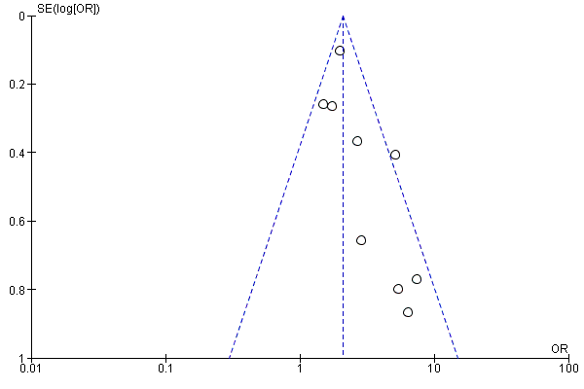
Figure 1: Funnel plot for obesity (Fixed effect model)
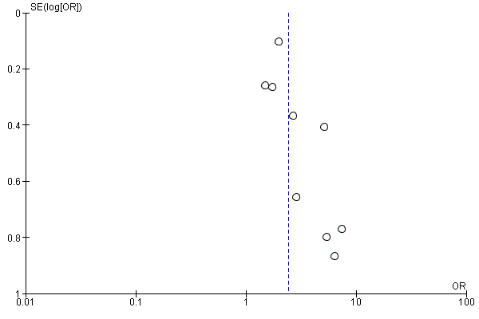
Figure 2: Funnel plot for obesity (Random effect model)

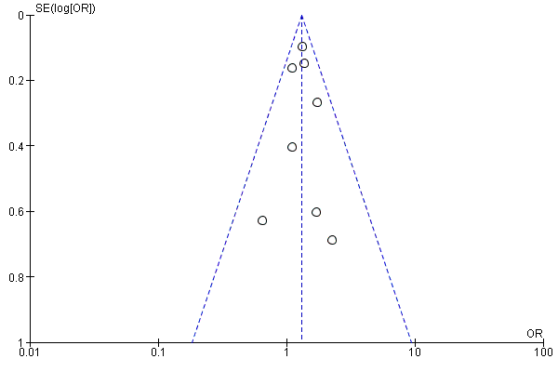
Figure 3: Funnel plot for overweight (Fixed effect model)
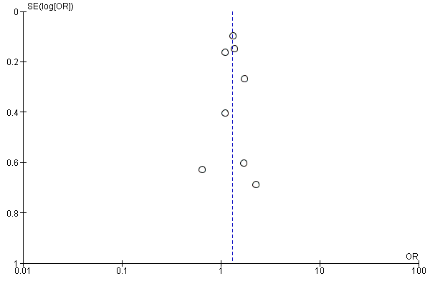
Figure 4: Funnel plot for overweight (Random effect model)

