Risk of Bias using ROBINS-I for Non-Randomized Studies of Interventions (NRSI) studies (Quasi- experimental and obdervational):
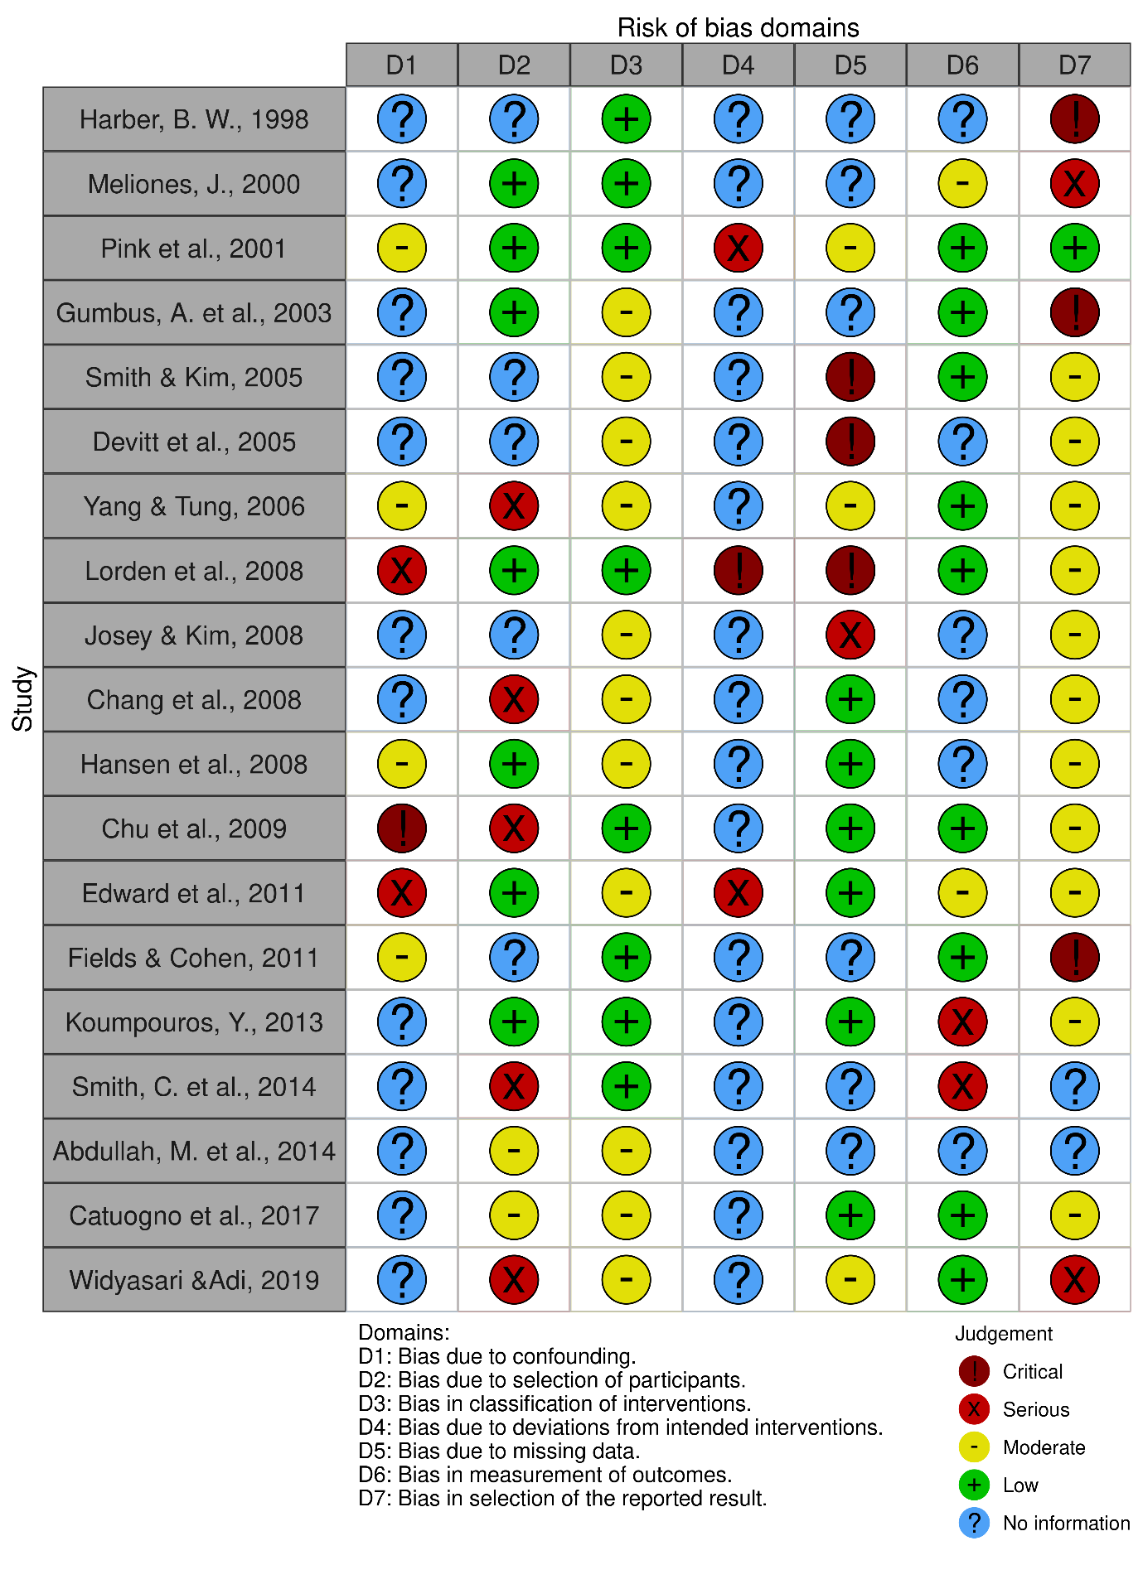
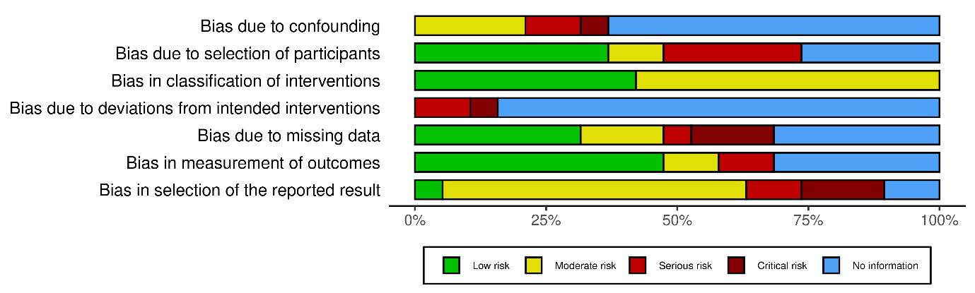

Risk of bias using ROB 2 for Randomized Controlled Trials (RCT) studies:


