SUPPLEMENTARY MATERIAL
“Hybrid Coronary Revascularization versus Percutaneous Coronary Intervention:
A Systematic Review and Meta-Analysis”

Jef Van den Eynde, BSc, Michel Pompeu B.O. Sá, MD, MSc, PhD,
Senne De Groote, BSc, Andrea Amabile, MD, Serge Sicouri, MD,
Basel Ramlawi, MD, FACS, FACC, Gianluca Torregrossa, MD, MEBCTS,
Wouter Oosterlinck, MD, PhD.

Supplementary Methods – page 2
Supplementary Tables – page 3

Supplementary Methods
Search strategy.
PubMed/MEDLINE (n=213 on 19/04/2021)
("hybrid coronary revascularization" OR "hybrid myocardial revascularization" OR "integrated myocardial revascularization" OR "hybrid revascularization" OR "HCR") AND ("percutaneous coronary intervention"[Mesh] OR "PCI" OR "stent*")

Embase (n=518 on 19/04/2021)
('hybrid coronary revascularization' OR 'hybrid myocardial revascularization' OR 'integrated myocardial revascularization' OR 'hybrid revascularization' OR 'hcr') AND ('percutaneous coronary intervention'/exp OR 'pci' OR 'stent'/exp OR 'stent*')

Scopus (n=259 on 19/04/2021)
(TITLE-ABS-KEY ("hybrid coronary revascularization" OR "hybrid myocardial revascularization" OR "integrated myocardial revascularization" OR "hybrid revascularization" OR "HCR") AND TITLE-ABS-KEY ("percutaneous coronary intervention" OR "PCI" OR "stent*") )

Cochrane Controlled Trials Register (CENTRAL/CCTR) (n=28 on 19/04/2021)
("hybrid coronary revascularization" OR "hybrid myocardial revascularization" OR "integrated myocardial revascularization" OR "hybrid revascularization" OR "HCR") AND ("percutaneous coronary intervention"[Mesh] OR "PCI" OR "stent*")

Supplementary Tables
Table S1. Risk of bias assessment of observational studies using the ROBINS-I tool.
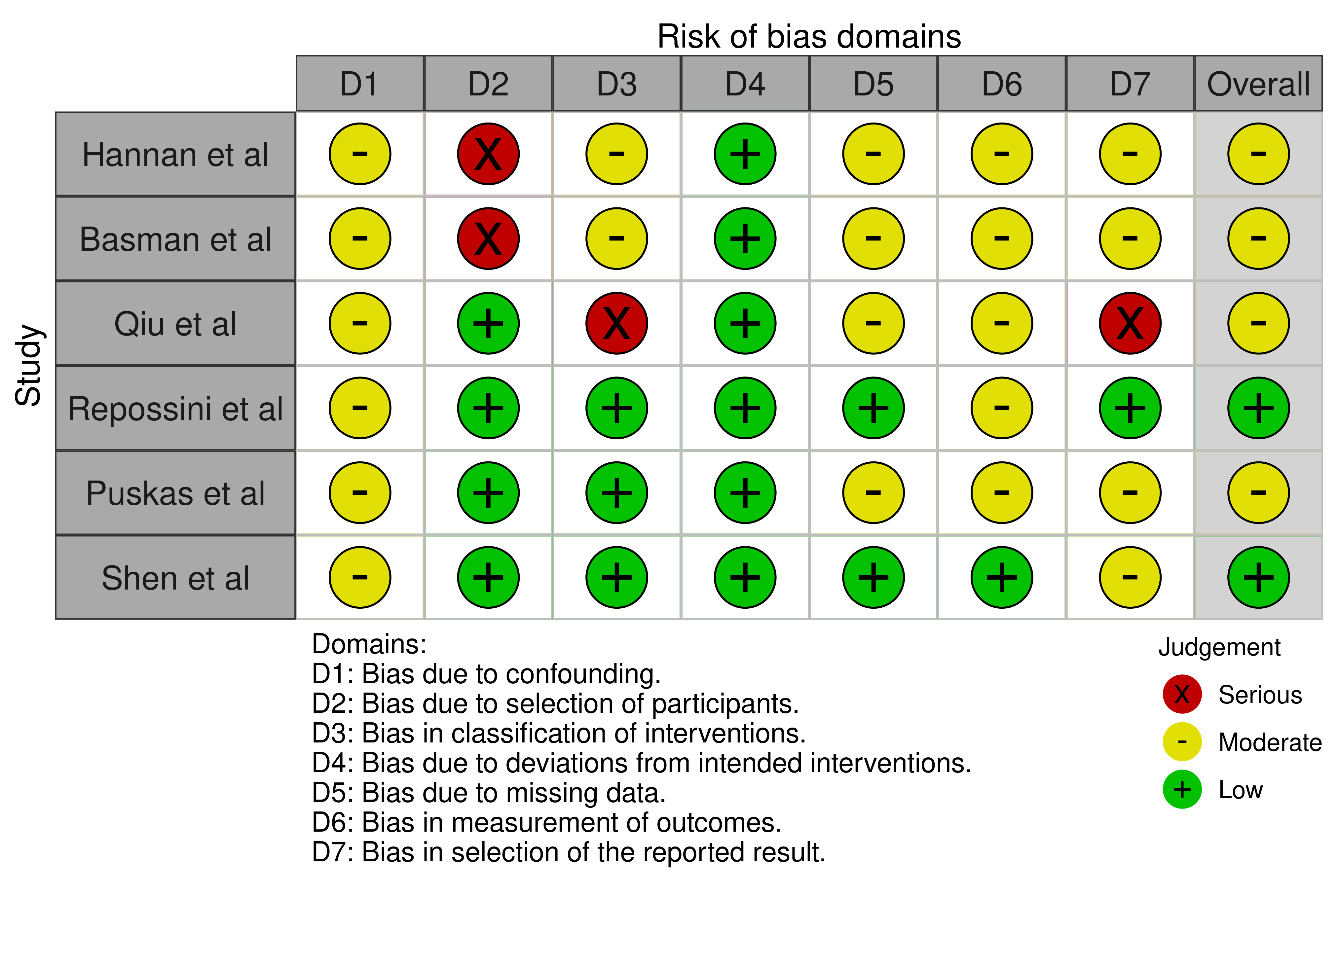
Table S2. Risk of bias assessment of randomized controlled trials using the RoB 2 tool.


