Supplementary Material

Supplementary Data
Cumulative Index to Nursing and Allied Health (CINAHL)
Updated to June 2021
Filters: Language english; Year of publication (1990-2021).
Results: 87
Keywords and Boolean operators: ("blood flow restriction" OR "vascular occlusion" OR "Kaatsu") AND ("resistance training" OR "strength training" OR "resistance exercise" OR "weightlifting" OR "weight-lifting" OR "weight lifting") AND ("metabolic stress" OR "lactate" OR "fatigue" OR "muscle activation" OR "torque" OR "maximal voluntary isometric contraction" OR "maximal voluntary contraction")
PubMed®
Updated to June 2021
Filters: Language english; Species Humans.
Results: 134
Keywords and Boolean operators: ("blood flow restriction" OR "vascular occlusion" OR "Kaatsu") AND ("resistance training" OR "strength training" OR "resistance exercise" OR "weightlifting" OR "weight-lifting" OR "weight lifting") AND ("metabolic stress" OR "lactate" OR "fatigue" OR "muscle activation" OR "torque" OR "maximal voluntary isometric contraction" OR "maximal voluntary contraction")
Scopus
Updated to June 2021
Filters: Language english; Articles.
Results: 166
Keywords and Boolean operators: ("blood flow restriction" OR "vascular occlusion" OR "Kaatsu") AND ("resistance training" OR "strength training" OR "resistance exercise" OR "weightlifting" OR "weight-lifting" OR "weight lifting") AND ("metabolic stress" OR "lactate" OR "fatigue" OR "muscle activation" OR "torque" OR "maximal voluntary isometric contraction" OR "maximal voluntary contraction")

SPORTDiscus
Updated to June 2021
Filters: Language english.
Results: 126
Keywords and Boolean operators: ("blood flow restriction" OR "vascular occlusion" OR "Kaatsu") AND ("resistance training" OR "strength training" OR "resistance exercise" OR "weightlifting" OR "weight-lifting" OR "weight lifting") AND ("metabolic stress" OR "lactate" OR "fatigue" OR "muscle activation" OR "torque" OR "maximal voluntary isometric contraction" OR "maximal voluntary contraction")
Web of Science
Updated to June 2021
Filters: Language English; Articles; Year of publication (1990-2021).
Results: 246
Keywords and Boolean operators: ("blood flow restriction" OR "vascular occlusion" OR "Kaatsu") AND ("resistance training" OR "strength training" OR "resistance exercise" OR "weightlifting" OR "weight-lifting" OR "weight lifting") AND ("metabolic stress" OR "lactate" OR "fatigue" OR "muscle activation" OR "torque" OR "maximal voluntary isometric contraction" OR "maximal voluntary contraction")

Supplementary Figures and Tables

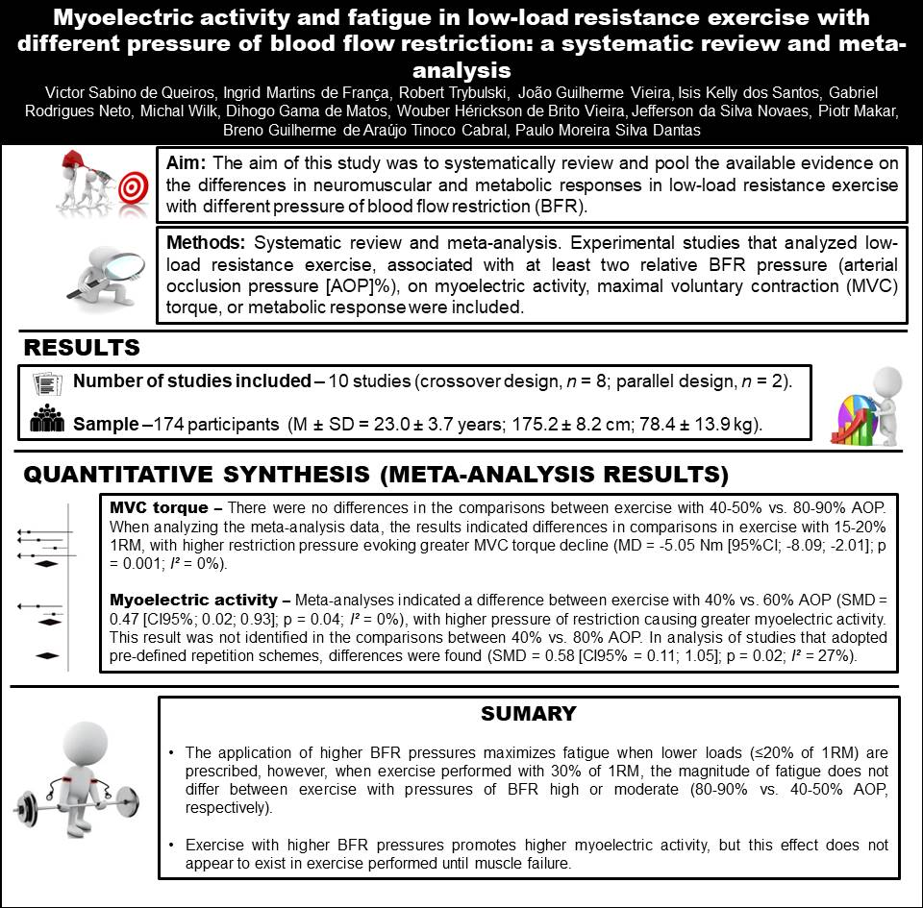
Supplementary Figures

Supplementary Figure 1. Graphic abstract.

