Supplementary data
eFigure 1. Comparative meta-analysis of the healing rate of superficial second degree burn wounds.
eFigure 2. Comparative meta-analysis of the healing rate of deep second degree burn wounds.
eFigure 3. Comparative meta-analysis of the infection rate of superficial second degree burn wounds.
eFigure 4. Comparative meta-analysis of the infection rate of deep second degree burn wounds.
eFigure 5. Comparative meta-analysis of the adverse reaction of deep second degree burn wounds.
eFigure 6. Comparative meta-analysis of the healing rate of trauma and surgical wounds.
eFigure 7. Comparative meta-analysis of adverse reaction of trauma and surgical wounds.

eFigure 1. Comparative meta-analysis of the healing rate of superficial second degree burn wound.
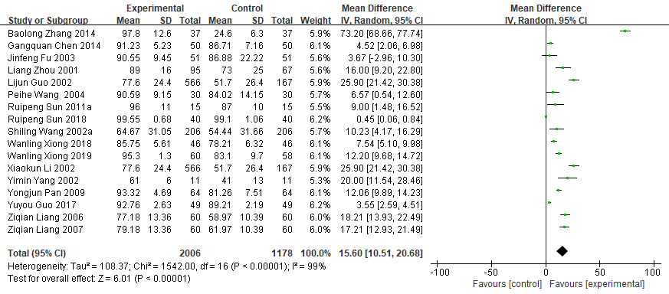

eFigure 2. Comparative meta-analysis of the healing rate of deep second degree burn wound.
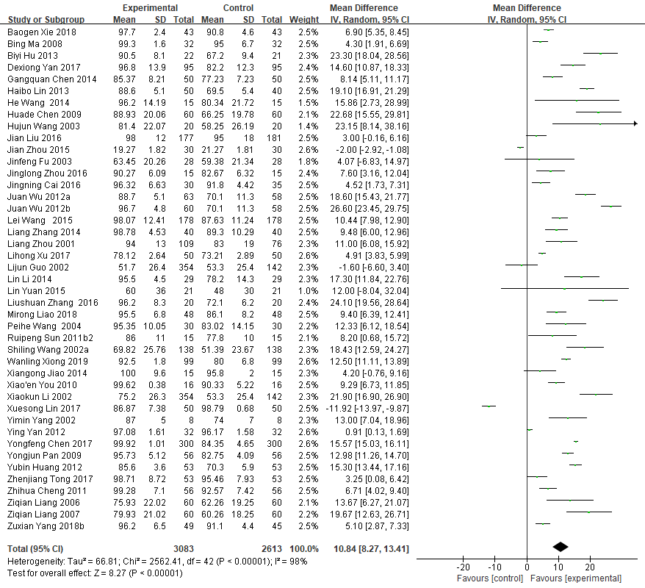

eFigure 3. Comparative meta-analysis of the infection rate of superficial second degree burn wounds.
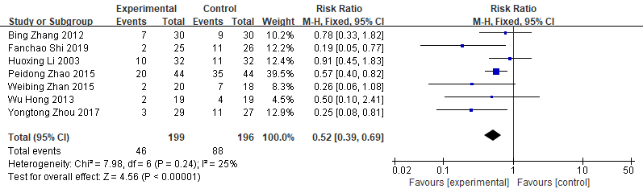

eFigure 4. Comparative meta-analysis of the infection rate of deep second degree burn wounds.
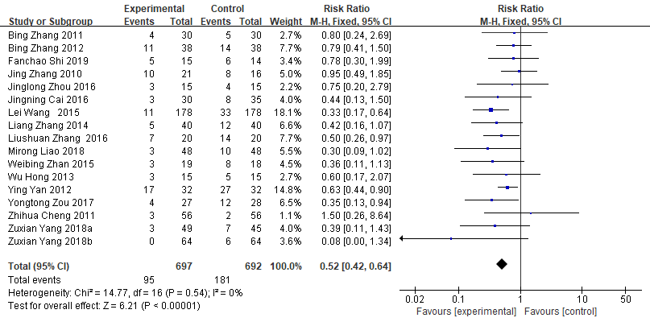

eFigure 5. Comparative meta-analysis of the adverse reaction of deep second degree burn wounds.
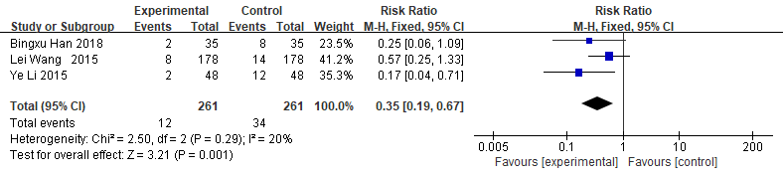

eFigure 6. Comparative meta-analysis of the healing rate of trauma and surgical wounds.
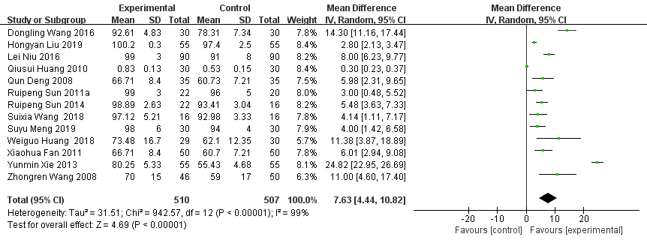

eFigure 7. Comparative meta-analysis of adverse reaction of trauma and surgical wounds.


