Additional file 1

Figures:
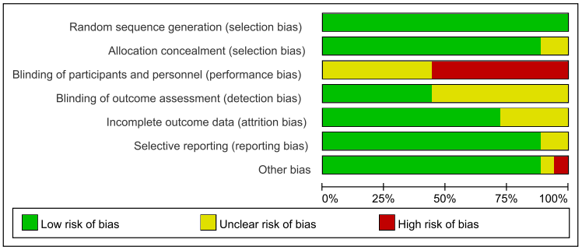
Supplementary Figure 1. Risk of bias graph
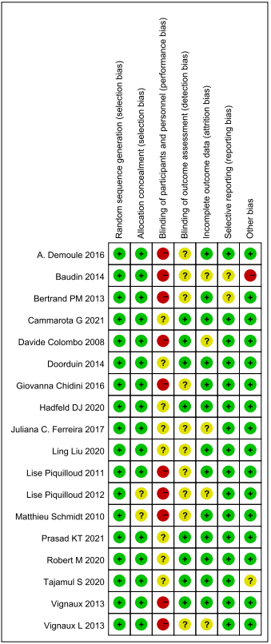
Supplementary Figure 2. Risk of bias summary

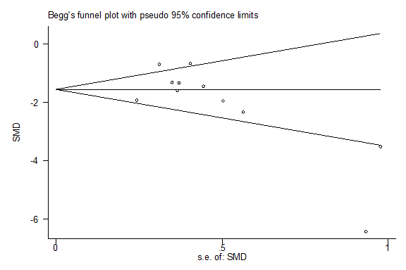
Supplementary Figure 3. Funnel plot of publication bias

Supplementary Figure 4. Sensitivity analyses for AI

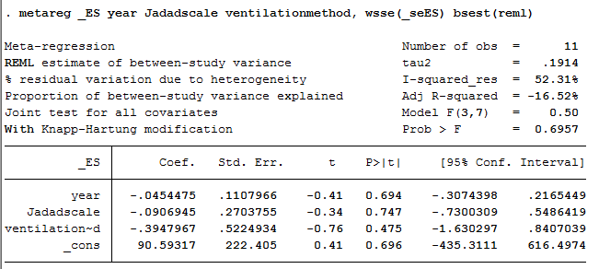
Supplementary Figure 5. Meta regression for AI

Supplementary Figure 6. Sensitivity analyses for duration of MV

