SUPPLEMENTARY FILE
Supplementary Table 1: Publication Bias via Egger’s test
Figure 2: Funnel Plot for PCI
Figure 1: Funnel Plot for chest pain

Variables | Intercept | t value | p value
Hypertension | 1.1876 | -1.650 | 0.125
Diabetes Mellitus | -0.2260 | -0.297 | 0.773
Dyslipidemia | -0.9340 | -0.480 | 0.646
Pre-existing CAD | -0.4860 | -0.210 | 0.840
Chest Pain | 1.9260 | 2.413 | 0.039
Fever | 1.1690 | 2.258 | 0.065
Dyspnea | 1.0630 | 1.954 | 0.082
Smoking | -0.3400 | -0.433 | 0.680
Obstructive CAD | 1.2230 | 1.195 | 0.260
Non-obstructive CAD | 1.3370 | 2.497 | 0.067
PCI | 2.2290 | 2.283 | 0.046
Mortality | 1.53 | 1.704 | 0.119

Supplementary Table 1: Publication Bias via Egger’s test

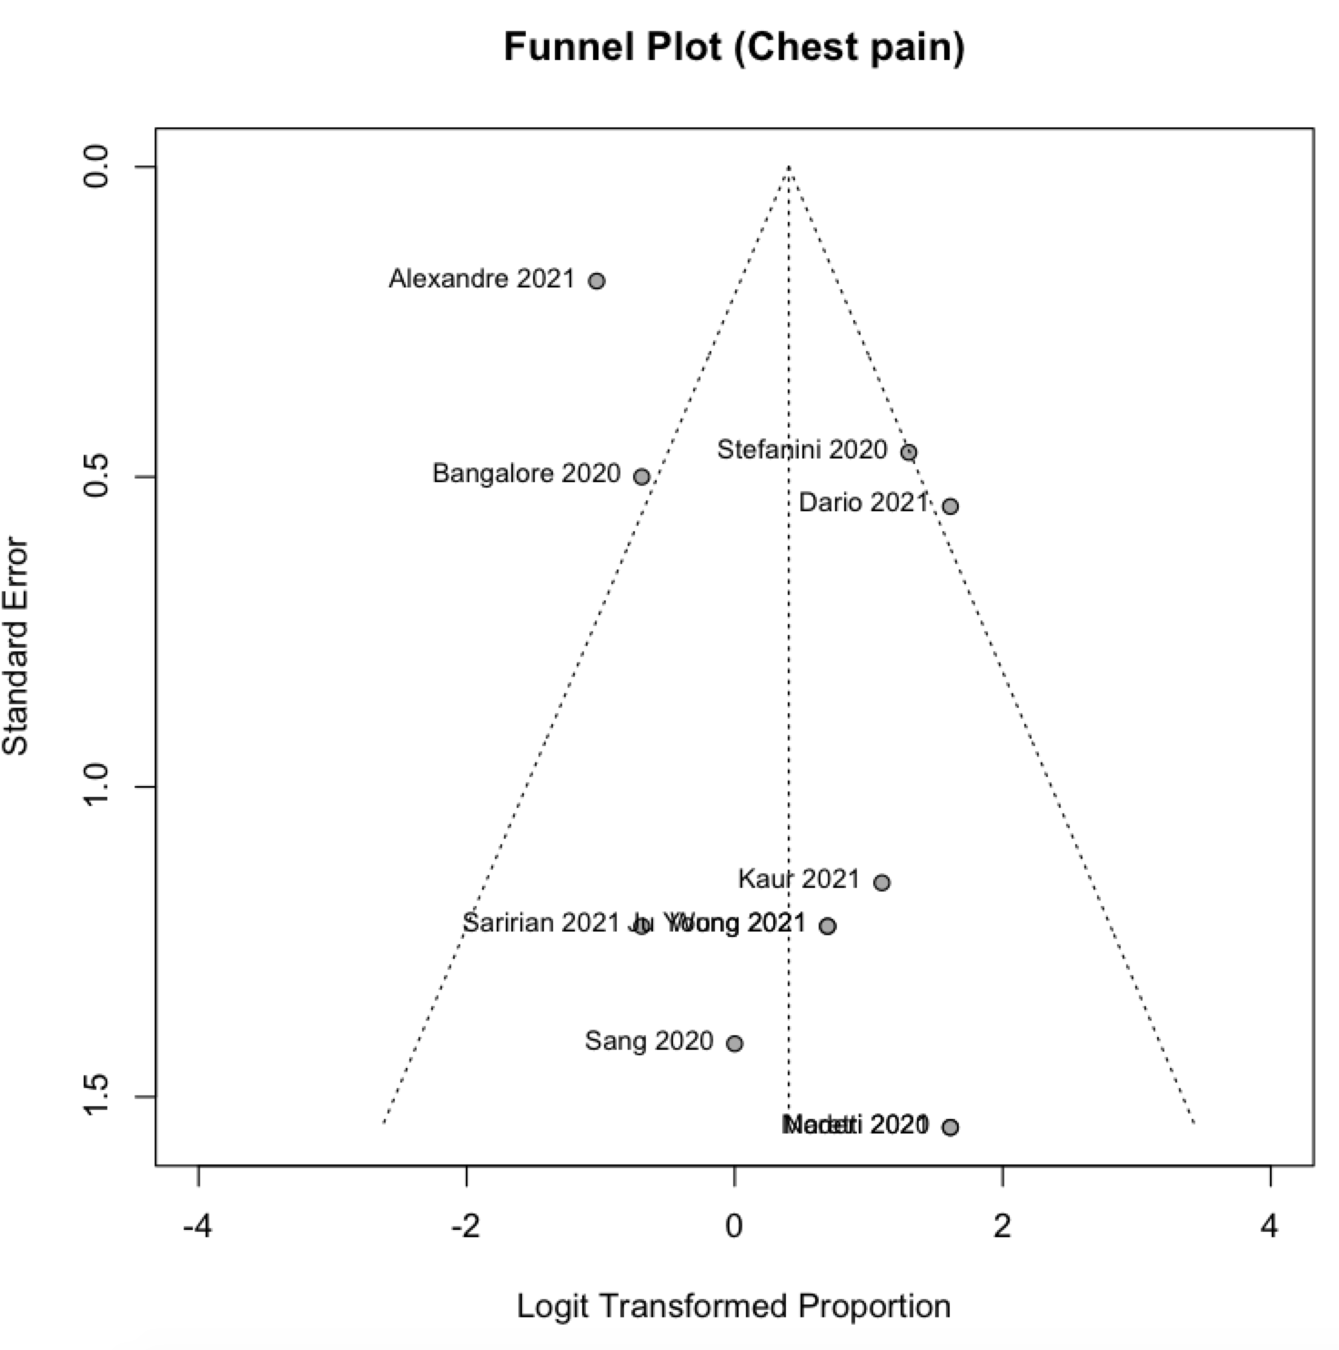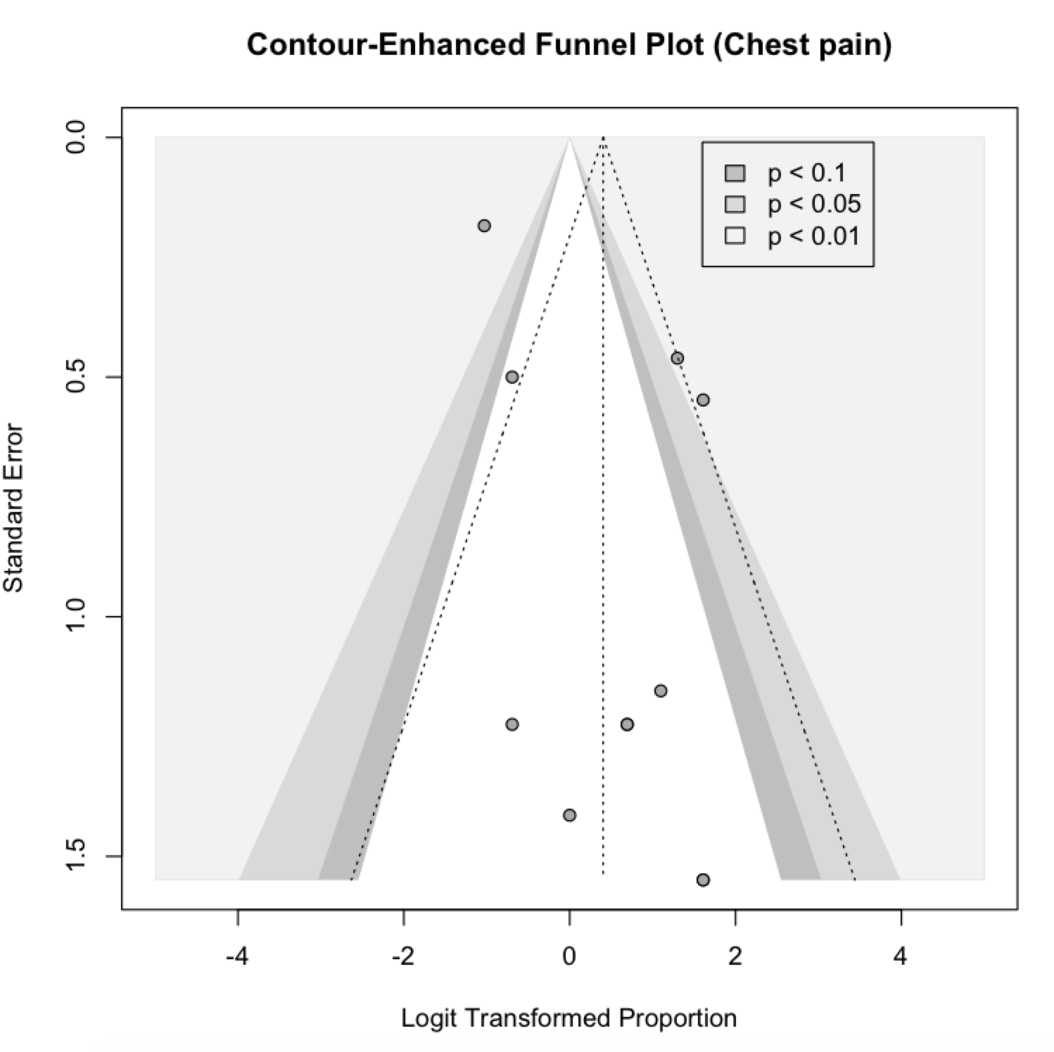
Figure 1: Funnel Plot for chest pain

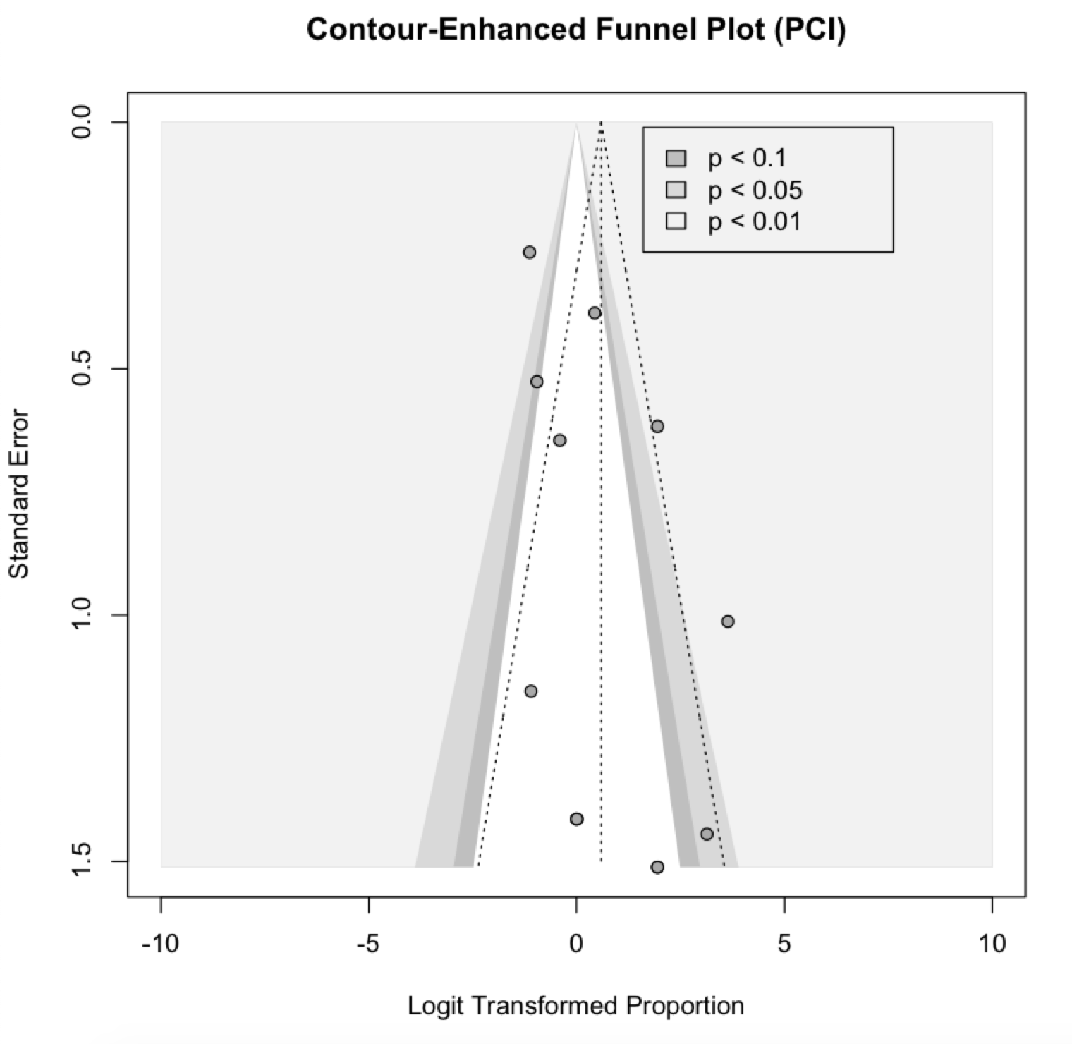

Figure 2: Funnel Plot for PCI

