Appendix 5: Funnel Plots
Funnel Plot for 3 months with at least one app
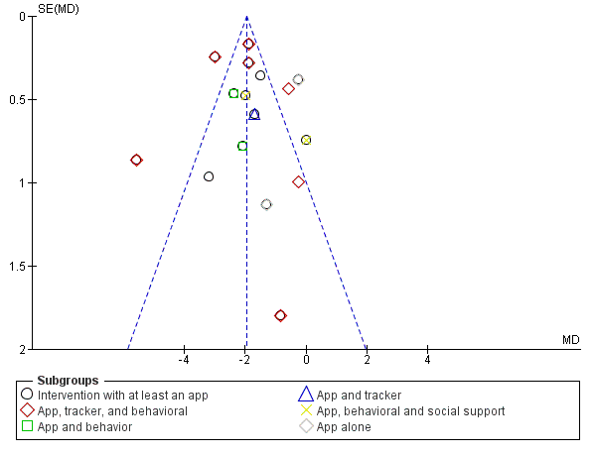
Funnel Plot for 6 months with at least one app


