Supplementary materials
Supplementary Table 1. The difference in values before and after the intervention.
Study | Blood pressure |  | BMI | WC | NO | QOL
Study | I | C | BMI | WC | NO | PF | RP | GH | BP | VT | SF | RE | MH
Wang XB | SBP: -26.28; DBP: -17.04 | SBP: -40.66; DBP: -26.4 | NA | NA | NA | NA | NA | NA | NA | NA | NA | NA | NA
Ma CH | SBP: -4.69; DBP: -6.21 | SBP: 1.55; DBP: -1.56 | I: -1.78; C: -3.51 | I: -2.65; C: -1.35 | NA | I: 2.15; C: 0.32 | I: 11.6; C: -1.19 | I: 4.72; C: 1.08 | I: 5.28; C: 0.6 | I: 6.17; C: 1.47 | I: 0.91; C: 0.14 | I: 3.40; C: 1.54 | I: 6.39; C: 1.49
Chan AKW | SBP: -12.81; DBP: -5.28 | SBP: -0.23; DBP: 1.02 | NA | NA | NA | NA | NA | NA | NA | NA | NA | NA | NA
Shou XL | SBP: -12.74; DBP: -6.92 | SBP: 0.01; DBP: 0.89 | I: -0.88; C: -0.04 | NA | NA | I:12.3 C:4.8 | I: 11.6; C: 0.5 | I: 16.5; C: 3.1 | I: 15.2; C: 4.8 | I: 8.7; C: -1.8 | I: 19.5; C: 0.7 | I: 16.2; C: 1.0 | I: 15.9; C: 1.3
Liu T | SBP: -22.07; DBP: -11.40 | SBP: -17.29; DBP: -8.44 | NA | NA | NA | I:13.0 C:2.2 | I: 16.7; C: 1.1 | I: 16.0; C: 1.4 | I: 15.6; C: 0.3 | I: 9.6; C: -1.0 | I: 18.2; C: 1.3 | I: 16.4; C: 1.3 | I: 13.8; C: 2.1
Xiao YK | SBP: -26.1; DBP: -12.9 | SBP: -14.6; DBP: -4.3 | NA | NA | I: 22.8; C: 5.1 | I: 27.9; C: 15.6 | I: 23.4; C: 12.3 | I: 21.9; C: 14.5 | I: 1.7; C: 2.4 | I: 24.0; C: 14.1 | I: 2.3; C: 4.8 | I: 2.9; C: 1.4 | I: 24.6; C: 14.7
Shi ZB | SBP: -10.43; DBP: -6.90 | SBP: -2.33; DBP: 2.34 | NA | NA | NA | NA | NA | NA | NA | NA | NA | NA | NA
Zhang DL | SBP: -10.75; DBP: -2.53 | SBP: -1.76; DBP: -0.84 | I: -0.1; C: 0.4 | NA | NA | NA | NA | NA | NA | NA | NA | NA | NA
Kim SW | SBP: -6.9; DBP: -15.5 | SBP: 0.1; DBP: -0.95 | NA | NA | NA | NA | NA | NA | NA | NA | NA | NA | NA
Sun J | SBP: -10.43; DBP: -6.90 | SBP: -2.33; DBP: -2.34 | I: -1.13; C: -0.34 | I: -0.33; C: -0.33 | NA | I: -0.69; C: -0.92 | I: 11.31; C: 0.79 | I: 4.01; C: 3.66 | I: 11.35; C: 1.79 | I: 9.77; C: 6.22 | I: 2.54; C: 1.18 | I: 3.54; C: 2.18 | I: 3.87; C: 2.37
Qi DL | SBP: -25.5; DBP: -9.06 | SBP: -0.7; DBP: -0.8 | NA | NA | NA | NA | NA | NA | NA | NA | NA | NA | NA
Zheng YC | SBP: -40.03; DBP: -25.79 | SBP: -24.98; DBP: -14.69 | NA | NA | NA | NA | NA | NA | NA | NA | NA | NA | NA
Wei YH | SBP: -16.8; DBP: -13.1 | SBP: 7; DBP: 5.1 | NA | NA | NA | NA | NA | NA | NA | NA | NA | NA | NA
Kim JH | SBP: -0.83; DBP: -1.34 | SBP: 0.5; DBP: 0.17 | NA | NA | NA | NA | NA | NA | NA | NA | NA | NA | NA
Xie HJ | SBP: -12.66; DBP: -14.19 | SBP: -1.16; DBP: 1.23 | NA | NA | I: 7.69; C: -0.66 | NA | NA | NA | NA | NA | NA | NA | NA
Chen FZ | SBP: -12.9; DBP: -7.5 | SBP: -1.3; DBP: -1.8 | NA | NA | NA | NA | NA | NA | NA | NA | NA | NA | NA
Wang XJ | SBP: -13.9; DBP: -8.13 | SBP: -0.93; DBP: -0.93 | NA | NA | NA | NA | NA | NA | NA | NA | NA | NA | NA
Sun QQ | SBP: -13.90; DBP: -8.13 | SBP: -0.93; DBP: -0.93 | NA | NA | NA | I: 6.09; C: -1.1 | I: 21.09; C: 2.34 | I: 14.72; C: 1.22 | I: 7.69; C: 1.00 | I: 7.18; C: 1.88 | I: 7.64; C: 1.39 | I: 16.67; C: -5.21 | I: 3.18; C: -0.87
Han QY | SBP: -35.2; DBP: -26.8 | SBP: -24.7; DBP: -13.1 | NA | NA | NA | I: 12.2; C: -9.9 | I: 12.8; C: -6.9 | I: 14.8; C: -4.0 | I: 13.5; C: -3.7 | I: 8.0; C: -5.1 | I: 18.5; C: -3.3 | I: 18.4; C: -2.6 | I: 17.9; C: -1.9
Tang QH | SBP: -10.29; DBP: -0.94 | SBP: 3.09; DBP: -0.19 | I: -1.94; C: -0.36 | I: -4.18; C: 0.15 | NA | NA | NA | NA | NA | NA | NA | NA | NA
Zhou SW | SBP: -24.2; DBP: -11.0 | SBP: -6.0; DBP: -4.1 | NA | NA | NA | NA | NA | NA | NA | NA | NA | NA | NA
Luo H | SBP: -33.14; DBP: -7.91 | SBP: -20.21; DBP: -5.22 | NA | NA | NA | NA | NA | NA | NA | NA | NA | NA | NA
Tsai JC | SBP: -15.6; DBP: -8.8 | SBP: 6.4; DBP: 3.4 | I: -0.2; C: -0.2 | NA | NA | NA | NA | NA | NA | NA | NA | NA | NA
Young DR | SBP: -7.0; DBP: -2.4 | SBP: -8.4; DBP: -3.2 | NA | NA | NA | NA | NA | NA | NA | NA | NA | NA | NA
SBP, systolic blood pressure; DBP, diastolic blood pressure; BMI, body mass index; WC, waist circumference; NO, nitric oxide content; QOL, quality of life;
PF, physical functioning; RP, role limitations due to physical health; BP, bodily pain; GH, general health perceptions; VT, vitality; SF, social functioning;RE,
role limitations due to emotional problems; MH, mental health; I, intervention group; C, control group.

Supplementary Table 2. Multivariate Meta Regression Analysis of Studies
valuating Systolic Blood Pressure in Patients with Hypertension doing Tai Chi.
 | Coef | Std. Err | t | P | [95%CI]
Research objects | 0.333 | 0.759 | 0.44 | 0.666 | -1.251,1.917
Research quality | -0.266 | 0.342 | -0.78 | 0.446 | -0.978,0.447
Intervention cycle | -0.145 | 0.331 | -0.44 | 0.667 | -0.835,0.546
Coef, coefficient; Std.Err, Standard error; CI, confidence intervals.

Supplementary Table 3. Multivariate Meta Regression Analysis of Studies
Evaluating Diastolic Blood Pressure in Patients with Hypertension doing Tai Chi.
 | Coef | Std.Err | t | P | [95%CI]
Research objects | -1.034 | 1.089 | -0.95 | 0.354 | -3.306,1.238
Research quality | -0.353 | 0.478 | -0.74 | 0.468 | -1.349,0.643
Intervention cycle | -0.232 | 0.462 | -0.5 | 0.621 | -1.196,0.732
Coef, coefficient; Std.Err, Standard error; CI, confidence intervals.

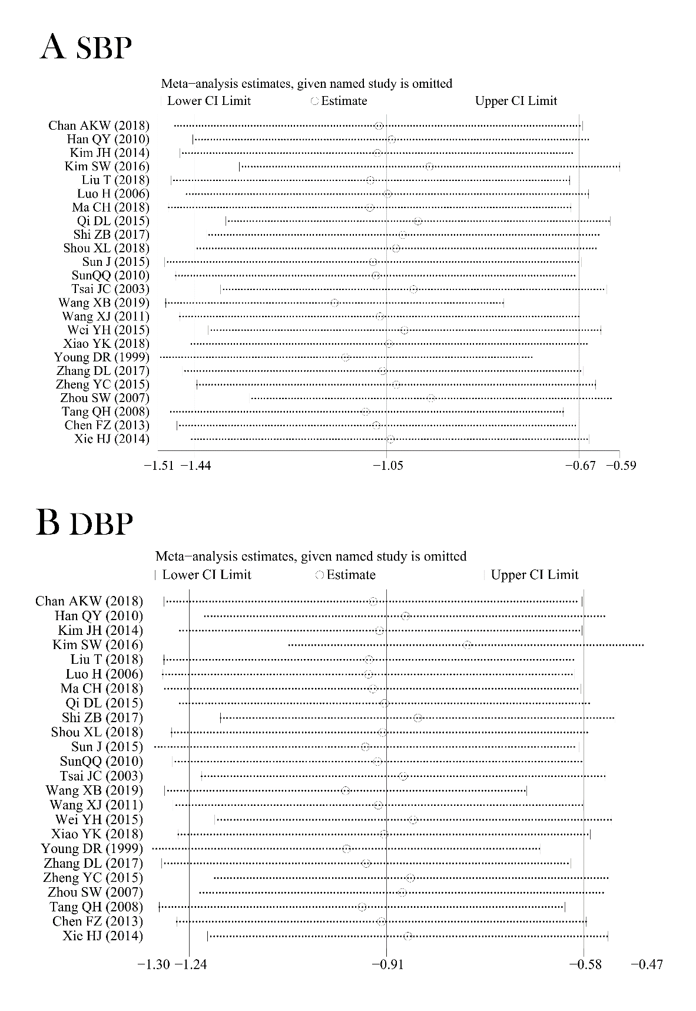
Supplementary Figure 1. Influence Analysis of Studies Assessing SBP (A) and DBP (B) in Patients with Hypertension by Tai Chi.( SBP, systolic blood pressure; DBP, diastolic blood pressure。）
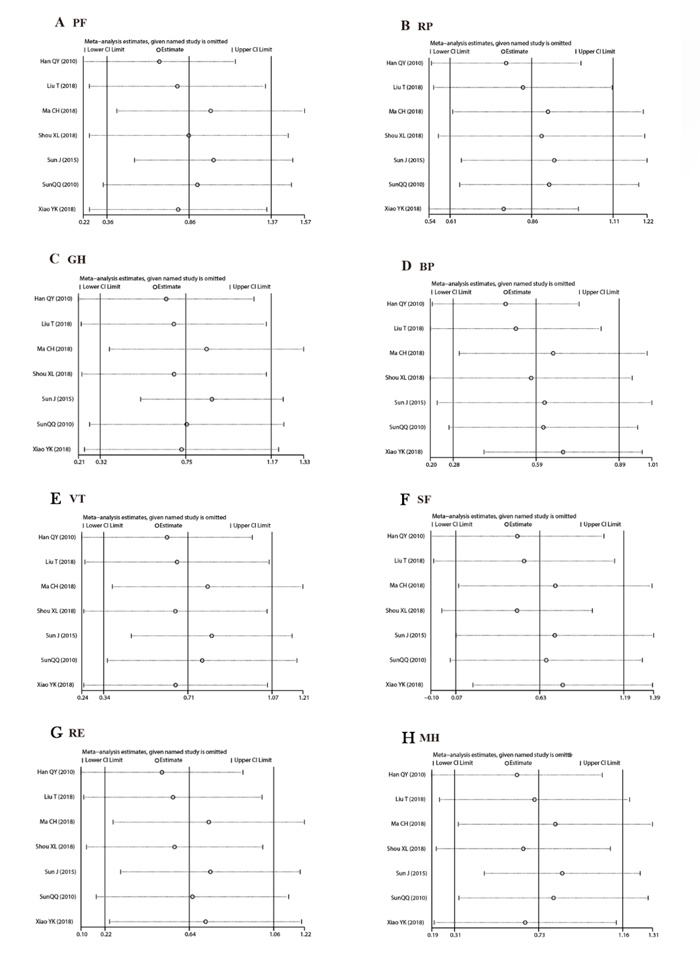Supplementary Figure 2. Influence Analysis of Studies Assessing PF (A), RP (B), GH (C), and BP (D), VT (E), SF (F), RE (G) and MH (H) in Patients with Hypertension by Tai Chi. (PF, physical functioning; RP, role limitations due to physical health; BP, bodily pain; GH, general health perceptions; VT, vitality; SF, social functioning; RE, role limitations due to emotional problems; MH, mental health.)

