Figure 4 Forestplot of Subgroup analysis of the association between AAD and the severity of COVID-19 based on disease ( 4A:AR,4B: asthma)
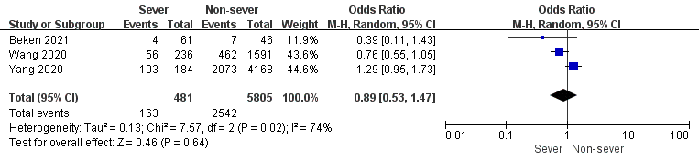
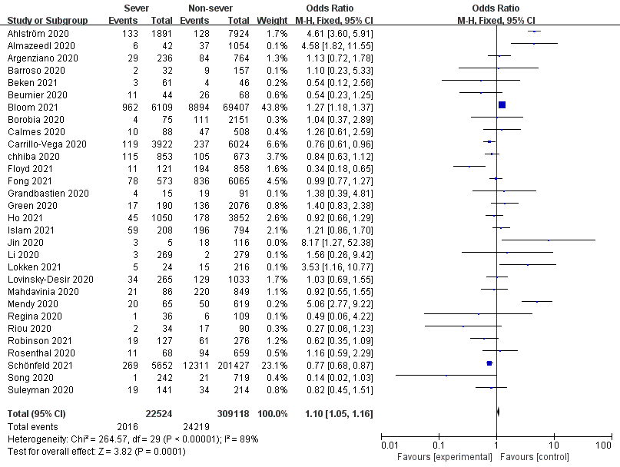
4A
4B

Figure 5 Forestplot of Subgroup analysis of the association between AAD and the severity of COVID-19 based on the definition of severity ( 5A:Hospitalization; 5B: ICU; 5C:Mechanical vetilation)
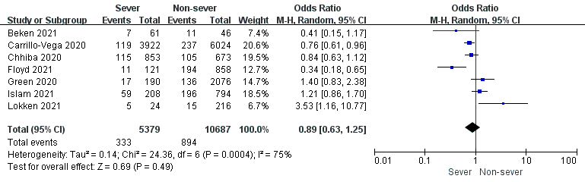
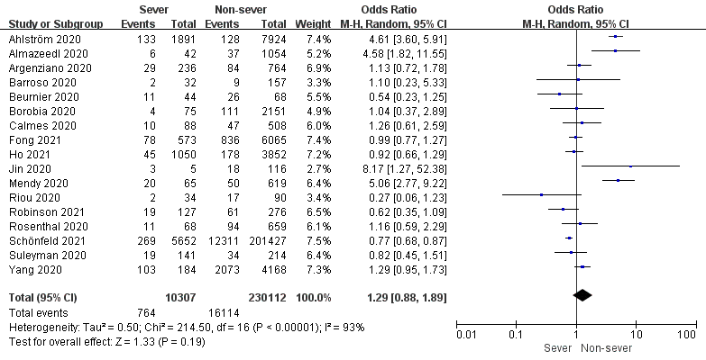
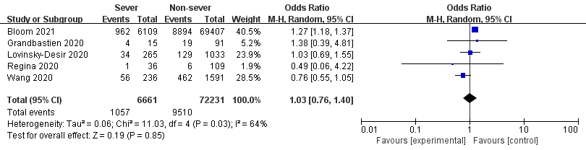
5A
5B
5C

Figure 6 Forestplot of Subgroup analysis of the association between AAD and the severity of COVID-19 based on based on countries or regions ( 6A:America; 6B: Asia; 6C:Europe)
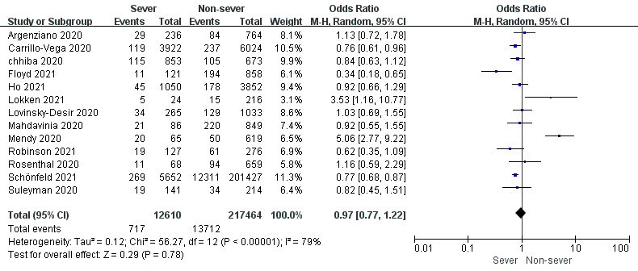
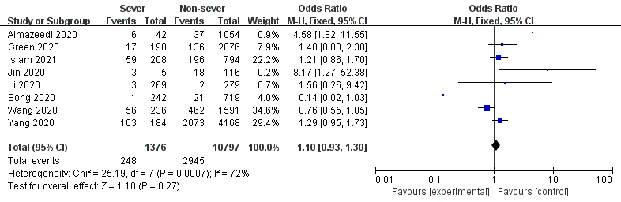
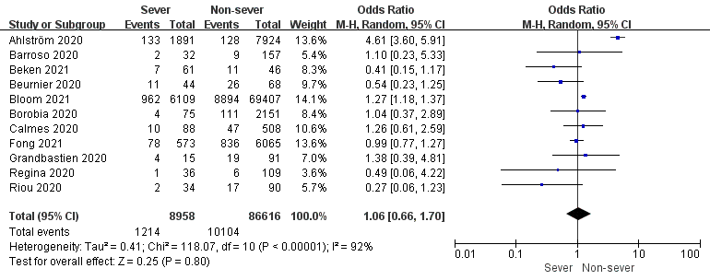
6A
6B
6C

Figure 7 Forestplot of Subgroup analysis of the association between AAD and the mortality of COVID-19 based on countries or regions ( 7A:America; 7B: Asia; 7C:Europe)
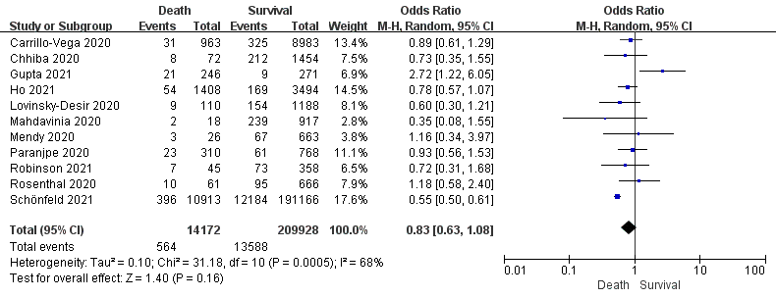
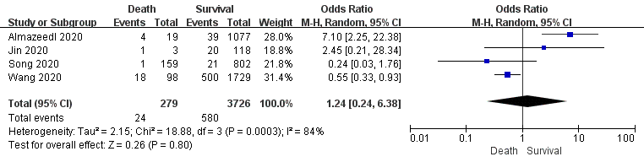
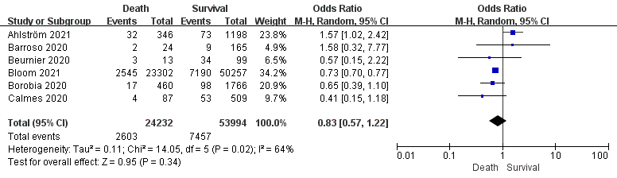
7A
7B
7C

