Supplementary file 4. Sensitivity analyses of outcomes

Tumor weight
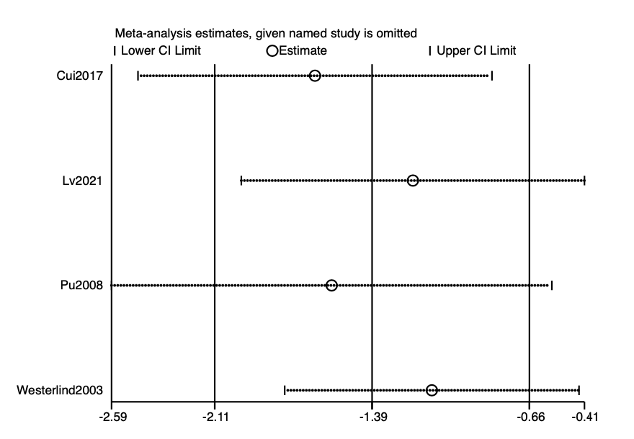
Tumor number
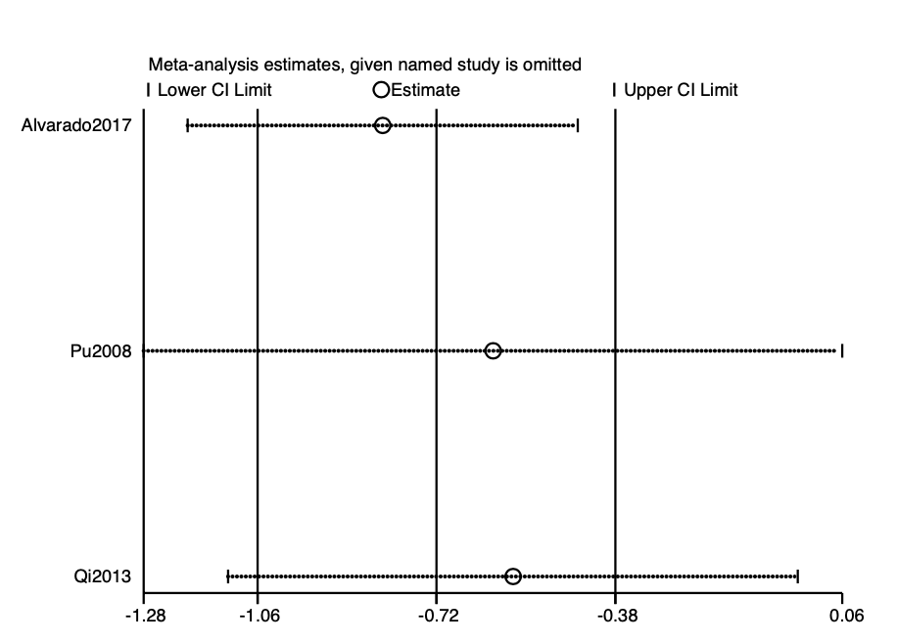
Tumor incidence (motorized wheel/high-intensity)
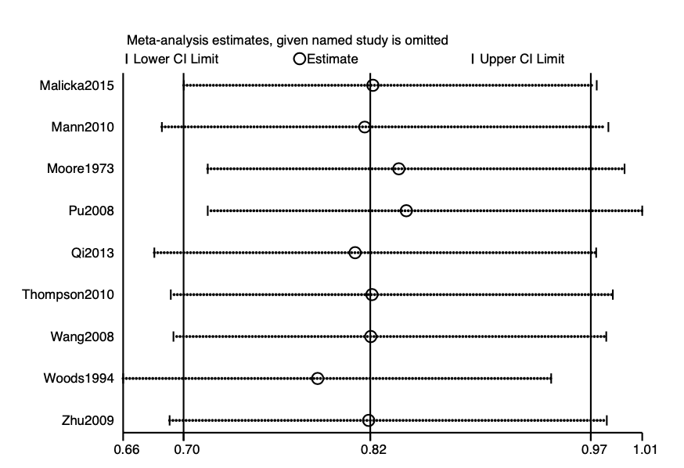
Tumor incidence (ree wheel/low-intensity)


