Supplementary Table 1: Algorithm for study search to identify published articles on the knowledge, attitude and practice of COVID-19 among Bangladeshi residents
Search function | Search term
Any of | "Knowledge" OR "Attitude" OR "Perception" OR "Practice"
AND Any of | "corona virus" OR "novel corona virus" OR "Covid- 19" OR "severe acute respiratory syndrome"
AND | "Bangladesh"

Supplementary Table 2: Data that were extracted from the selected articles
Category | Data to be collected
General | Name of the first author
General | Year of publication
General | No. of participants
General | Mean age of the participants
General | Gender (percentage of male/female participants)
General | Sampling date
General | Focus group
General | Questionnaire administration
Knowledge
Knowledge about Covid-19 Symptoms | Symptoms of Covid
Knowledge about Covid-19 Symptoms | Fever
Knowledge about Covid-19 Symptoms | Dry cough
Knowledge about Covid-19 Symptoms | Respiratory sign
Knowledge about Covid-19 Symptoms | Weakness
Knowledge about Covid-19 Symptoms | Diarrhea
Knowledge about Covid-19 Symptoms | Headache
Knowledge about Covid-19 Transmission | Spread through respiratory droplet
Knowledge about Covid-19 Treatment | No-specific treatment available
Attitude | COVID-19 will be successfully controlled
Attitude | Bangladesh can win the battle against the COVID-19
Practice | Wash hand regularly
Practice | Maintain social distance
Practice | Avoid crowded place
Practice | Always wear mask when go outside

Supplement Table 3:Study quality assessment questions
Risk of bias items
External Validity |  | Internal Validity
1 | Was the study's target population a close representation of the national population in relation to relevant variables, e.g. age, sex, occupation? | 5 | Were data collected directly from the subjects?
2 | Was the sampling frame a true or close representation of the target population? | 6 | Was the research purpose and study design reasonable?
3 | Was some form of random selection used to select the sample, OR, was a census undertaken? | 7 | Was the study instrument that measured the parameter of interest shown to have reliability and validity?
4 | Was the likelihood of Non-response rate reported? | 8 | Was the same mode of data collection used for all subjects?
 |  | 9 | Was the length of the shortest prevalence period for the parameter of interest appropriate?
 |  | 10 | Were the numerator( s) and denominato r(s) for the parameter of interest appropriate?

Supplement Table 4:Study quality assessment scores
Risk of bias items | External Validity |  |  |  | Internal Validity |  |  |  |  |  | Overall risk of study bias
Risk of bias items | 1 | 2 | 3 | 4 | 5 | 6 | 7 | 8 | 9 | 10
Rahman MM, 2021 [21] | No | Yes | Yes | No | Yes | Yes | Yes | Yes | Yes | Yes | Low
Hossain I, 2020 [30] | No | Yes | Yes | No | Yes | Yes | No | Yes | Yes | Yes | Low
Pervez S, 2021 [22] | No | No | Yes | No | Yes | Yes | Yes | Yes | Yes | Yes | Low
Ahmed S, 2021 [31] | No | No | Yes | No | Yes | Yes | Yes | Yes | Yes | Yes | Low
Roy D, 2020 [32] | No | No | No | No | Yes | Yes | Yes | Yes | Yes | Yes | Moderate
Akram A, 2021 [33] | No | No | No | Yes | Yes | Yes | Yes | Yes | Yes | Yes | Low
Rahman MM, 2021 [2] | No | Yes | Yes | No | Yes | Yes | Yes | Yes | Yes | Yes | Low
Hossain MJ, 2021 [23] | No | Yes | Yes | No | Yes | Yes | Yes | No | Yes | Yes | Low
Rahman M, 2020 [24] | No | Yes | Yes | No | Yes | Yes | Yes | Yes | Yes | Yes | Low
Islam S, 2020 [25] | No | Yes | No | No | Yes | Yes | Yes | Yes | Yes | Yes | Low
Anwar S, 2020 [9] | No | Yes | No | Yes | Yes | Yes | Yes | No | Yes | Yes | Low
Hossain MB, 2020 [26] | No | Yes | Yes | Yes | Yes | Yes | Yes | Yes | Yes | Yes | Low
Paul A, 2020 [27] | No | Yes | Yes | No | Yes | Yes | Yes | Yes | Yes | Yes | Low
Hossain MA, 2020 [8] | No | Yes | Yes | No | Yes | Yes | Yes | Yes | Yes | Yes | Low
Ahmed I, 2020 [28] | No | Yes | No | No | Yes | Yes | No | Yes | Yes | Yes | Moderate
Ferdous MZ, 2020 [6] | No | Yes | Yes | Yes | Yes | Yes | No | Yes | Yes | Yes | Low
Wadood MA, 2021 [1] | No | No | No | No | Yes | Yes | Yes | Yes | Yes | Yes | Moderate
Ahmad M, 2020 [29] | No | Yes | Yes | No | Yes | Yes | No | Yes | Yes | Yes | Low

Supplementary Table 5: Subgroup analysis of Covid-19 knowledge
Knowledge |  | No of study | Sample size | Percentage (%) | 95% CI | I²  (%) | P-value
Knowledge about Covid-19 Symptoms
Symptoms of Covid
Study Design | CBCS | 5 | 6438 | 68.74 | 50.40-82.64 | 99.3 | < 0.01
Study Design | IBCS | 4 | 1579 | 98.40 | 85.25-99.85 | 95.4 | < 0.01
Fever
Gender | Male | 3 | 521 | 89.64 | 86.71-91.98 | 15.7 | 0.31
Gender | Female | 3 | 400 | 91.93 | 86.52-95.29 | 65.8 | 0.05
Study Design | CBCS | 4 | 3297 | 94.28 | 90.42-96.64 | 93.5 | < 0.01
Study Design | IBCS | 2 | 505 | 91.49 | 88.71-93.62 | 0 | 0.75
Dry cough
Gender | Male | 3 | 521 | 82.05 | 77.37-85.94 | 61.3 | 0.08
Gender | Female | 3 | 400 | 77.14 | 68.48-83.99 | 79.6 | < 0.01
Study Design | CBCS | 4 | 3297 | 88.12 | 78.95-93.61 | 97.0 | < 0.01
Study Design | IBCS | 2 | 505 | 79.21 | 75.45-82.53 | 51.5 | 0.15
Respiratory sign
Gender | Male | 3 | 521 | 79.36 | 55.29-92.28 | 97.3 | < 0.01
Gender | Female | 3 | 400 | 88.61 | 42.69-98.78 | 97.8 | < 0.01
Study Design | CBCS | 4 | 3297 | 84.71 | 59.12-95.50 | 99.3 | < 0.01
Study Design | IBCS | 2 | 505 | 88.01 | 72.36-95.37 | 95.0 | < 0.01
Weakness
Gender | Male | 3 | 521 | 46.12 | 20.47-74.00 | 98.1 | < 0.01
Gender | Female | 3 | 400 | 33.14 | 7.24-75.89 | 97.7 | < 0.01
Study Design | CBCS | 4 | 3297 | 46.42 | 21.81-72.91 | 99.0 | < 0.01
Study Design | IBCS | 1 | 200 | 60.50 | 53.56-67.04
Diarrhea
Gender | Male | 3 | 521 | 37.24 | 13.60-69.12 | 97.9 | < 0.01
Gender | Female | 3 | 400 | 26.26 | 4.98-70.77 | 97.0 | < 0.01
Study Design | CBCS | 4 | 3297 | 42.43 | 16.09- 73.90 | 99.2 | < 0.01
Study Design | IBCS | 2 | 505 | 33.06 | 11.99-64.16 | 98.7 | < 0.01
Headache
Study Design | CBCS | 2 | 1371 | 56.57 | 47.36- 65.36 | 94.1 | < 0.01
Study Design | IBCS | 1 | 305 | 55.08 | 49.46-60.58
Sore throat
Study Design | CBCS | 3 | 2982 | 78.88 | 44.61-94.54 | 99.6 | < 0.01
Study Design | IBCS | 1 | 305 | 49.84 | 44.25-55.43
Knowledge about Covid-19 Transmission
Spread through respiratory droplet
Gender | Male | 3 | 1554 | 85.67 | 65.11-95.04 | 95.6 | < 0.01
Gender | Female | 3 | 1069 | 85.69 | 61.45-95.74 | 94.7 | < 0.01
Study Design | CBCS | 5 | 1945 | 85.82 | 66.41-94.88 | 86.6 | < 0.01
Study Design |  | 5 | 6588 | 95.82 | 92.50- 97.70 | 99.4 | < 0.01
Knowledge about Covid-19 Treatment
No-specific treatment available
Gender | Male | 1 | 1206 | 80.18 | 77.84-82.34
Gender | Female | 2 | 2624 | 82.36 | 80.85-83.77 | 0.00 | 0.38
Study Design | CBCS | 8 | 11007 | 74.01 | 65.83-80.80 | 98.2 | < 0.01
Study Design | IBCS | 3 | 627 | 95.84 | 11.58-99.98 | 97.4 | < 0.01

Supplementary Table 6: Subgroup analysis of Covid-19 attitude
Attitude |  | No of study | Sample size | Percentage (%) | 95% CI | I²  ^{(%)} | P-value
COVID-19 will be successfully controlled
Study Design | CBCS | 3 | 4634 | 58.47 | 44.22-71.44 | 98.8 | < 0.01
Study Design | IBCS | 2 | 1062 | 63.06 | 45.87-77.48 | 94.8 | < 0.01
Bangladesh can win the battle against the COVID-19
Gender | Male | 1 | 1166 | 41.77 | 38.97-44.62
Gender | Female | 2 | 2804 | 40.91 | 39.10-42.74 | 0.00 | 0.36
Study Design | CBCS | 3 | 4586 | 39.71 | 36.92-42.57 | 74.9 | 0.02
Study Design | IBCS | 2 | 1062 | 53.12 | 35.37-70.12 | 95.9 | < 0.01

Supplementary Table 7: Subgroup analysis of Covid-19 practice
Practice |  | No of study | Sample size | Percentage (%) | 95% CI | I²  ^{(%)} | P-value
Wash hand regularly
Gender | Male | 3 | 1554 | 91.30 | 78.96-96.71 | 96.0 | < 0.01
Gender | Female | 3 | 1069 | 90.53 | 75.53- 96.74 | 98.0 | < 0.01
Study Design | CBCS | 7 | 7354 | 91.71 | 81.28- 96.57 | 98.0 | < 0.01
Study Design | IBCS | 5 | 1945 | 96.17 | 85.54-99.07 | 48.3 | < 0.01
Maintain social distance
Gender | Male | 3 | 1554 | 87.13 | 85.37- 88.71 | 27.7 | 0.25
Gender | Female | 3 | 1069 | 91.93 | 83.60-96.22 | 94.3 | < 0.01
Study Design | CBCS | 5 | 5615 | 87.29 | 75.28 - 93.94 | 99.5 | < 0.01
Study Design | IBCS | 4 | 1401 | 77.17 | 59.92 -88.43 | 95.5 | < 0.01
Avoid crowded place
Gender | Male | 1 | 1166 | 70.15 | 67.46- 72.71
Gender | Female | 1 | 991 | 81.53 | 78.99-83.83
Study Design | CBCS | 5 | 6604 | 91.86 | 77.86-97.31 | 98.3 | < 0.01
Study Design | IBCS | 4 | 1745 | 92.10 | 37.38-99.56 | 94.6 | < 0.01
Always wear mask when go outside
Gender | Male | 3 | 1514 | 90.54 | 80.39-95.71 | 88.0 | < 0.01
Gender | Female | 3 | 1249 | 85.19 | 75.85 - 91.33 | 87.2 | < 0.01
Study Design | CBCS | 7 | 9371 | 86.40 | 78.03- 91.91 | 98.6 | < 0.01
Study Design | IBCS | 5 | 1945 | 93.78 | 65.43- 99.18 | 98.0 | < 0.01

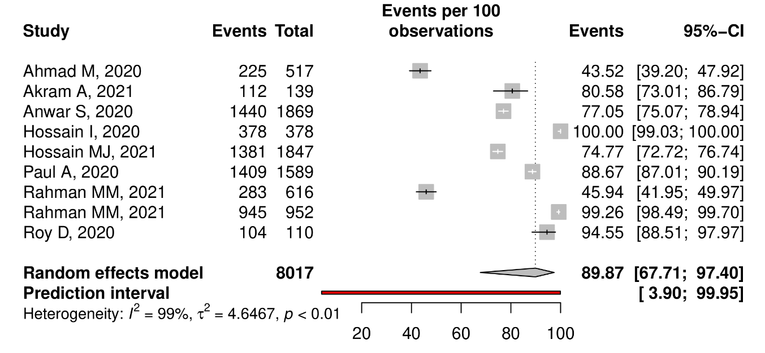
Supplementary Figure 1: Knowledge of Participants on overall COVID-19 symptoms

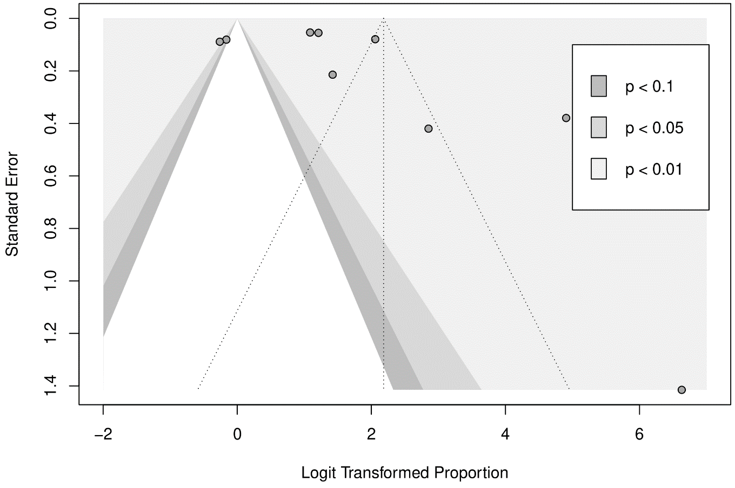
Supplementary Figure 2: Funnel plot of Knowledge of Participants on overall COVID-19 symptoms

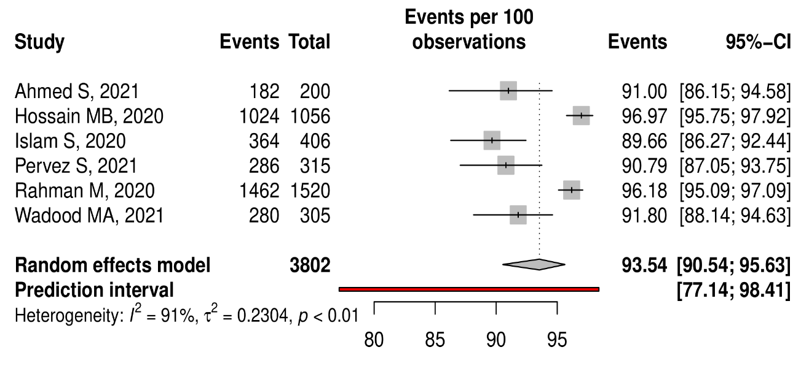
Supplementary Figure 3: Knowledge of participants about Fever as a symptom of Covid-19
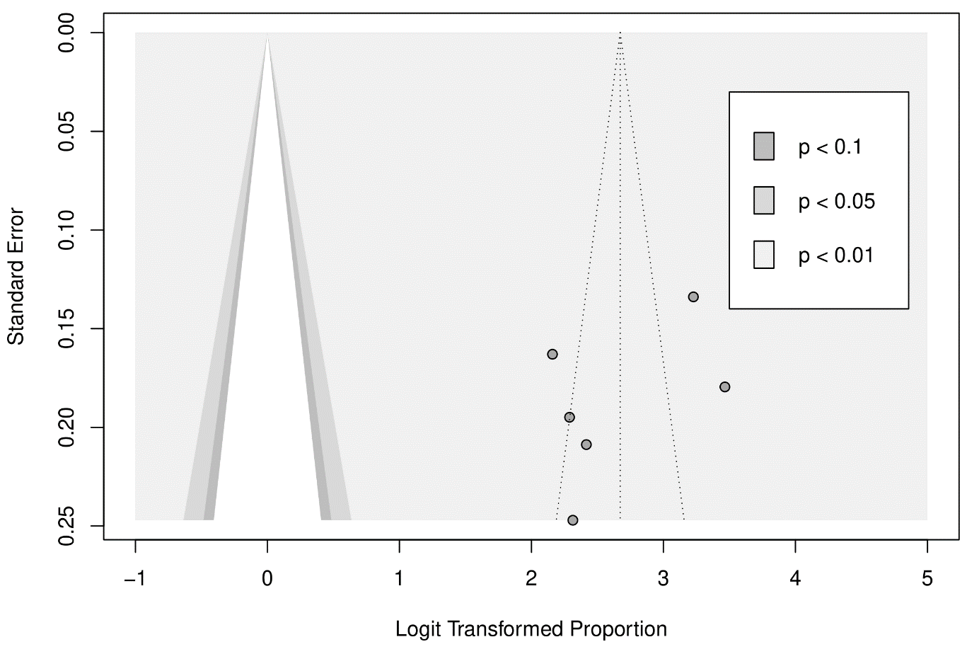
Supplementary Figure 4: Funnel plot of Knowledge of participants about Fever as a symptom of Covid-19

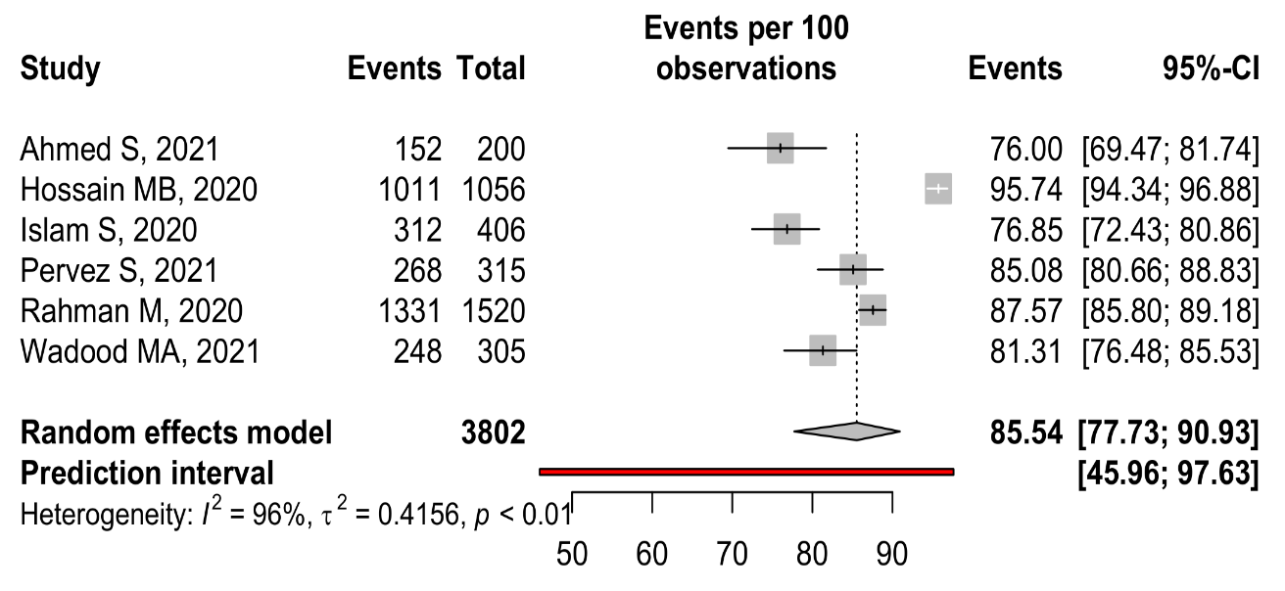
Supplementary Figure 5: Knowledge of participants about Dry cough as a symptom of Covid-19

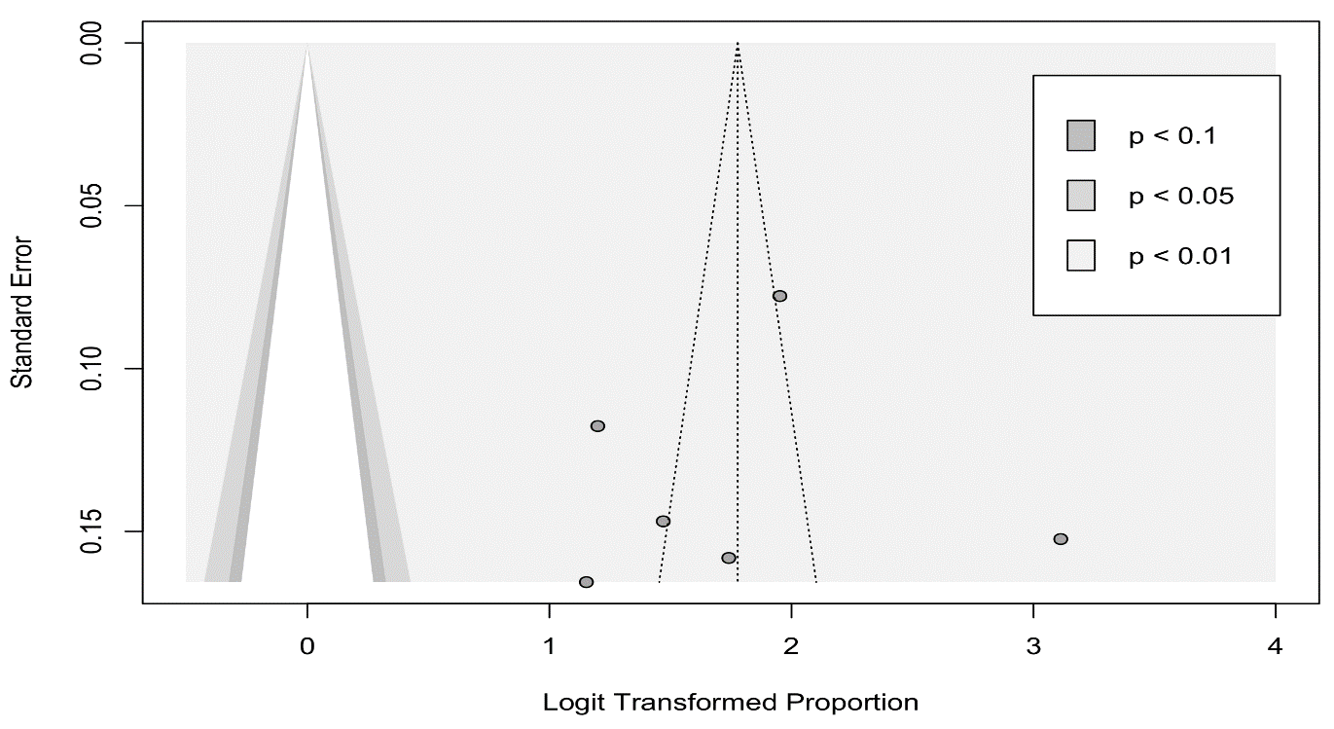
Supplementary Figure 6: Funnel plot of Knowledge of participants about Dry cough as a symptom of Covid-19

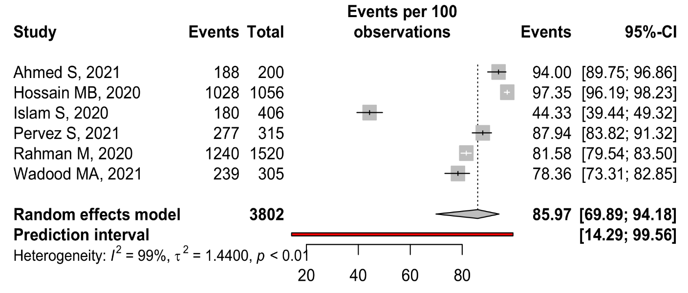
Supplementary Figure 7: Knowledge of participants about Respiratory signs as a symptom of Covid-19

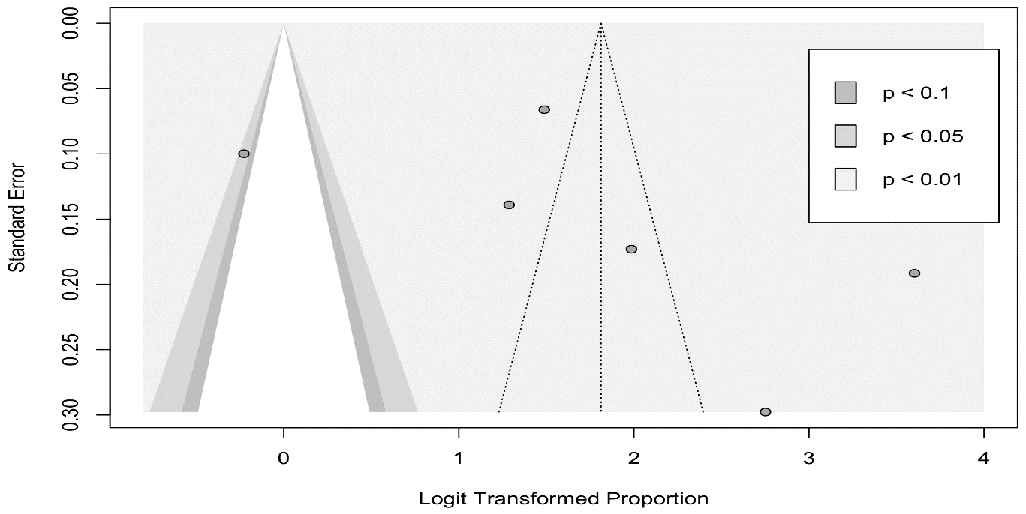
Supplementary Figure 8: Funnel plot of Knowledge of participants about Respiratory signs as a symptom of Covid-19

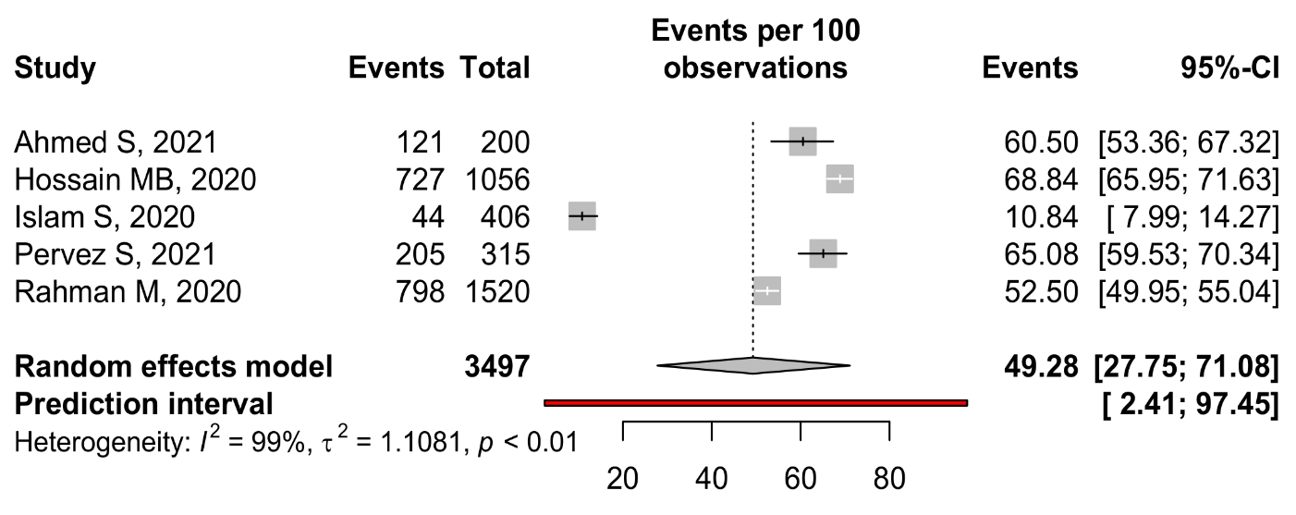
Supplementary Figure 9: Knowledge of participants about weakness as a symptom of Covid-19

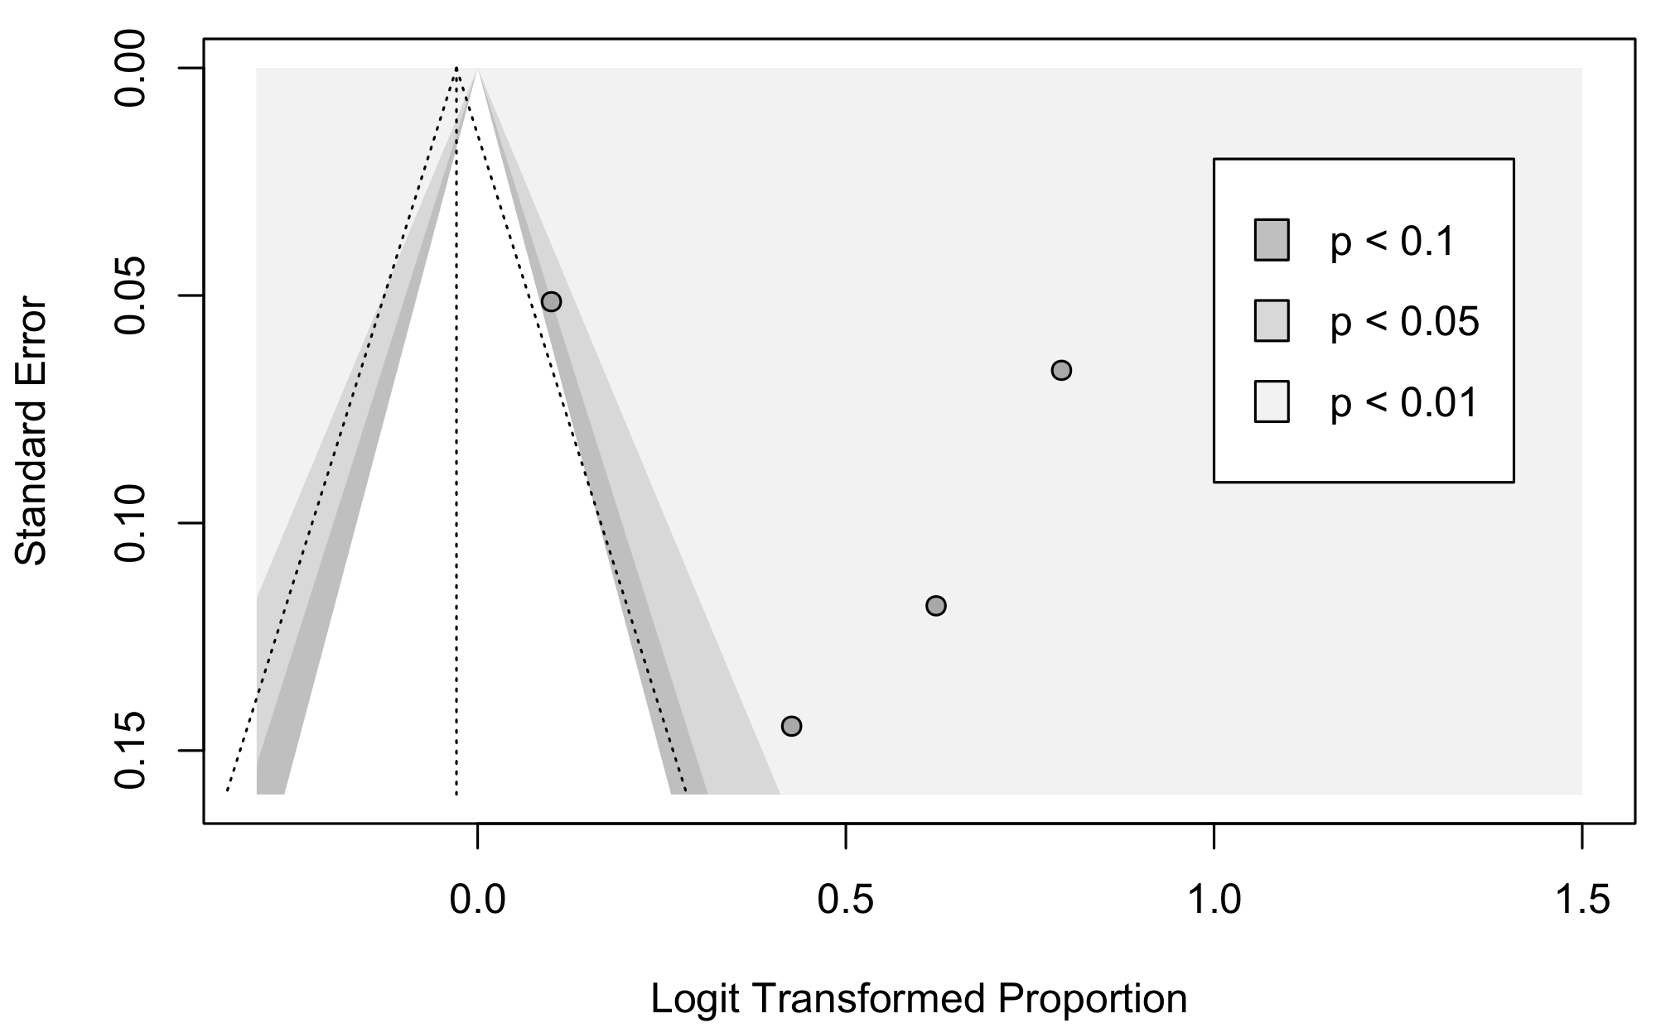
Supplementary Figure 10: Funnel plot of Knowledge of participants about weakness as a symptom of Covid-19

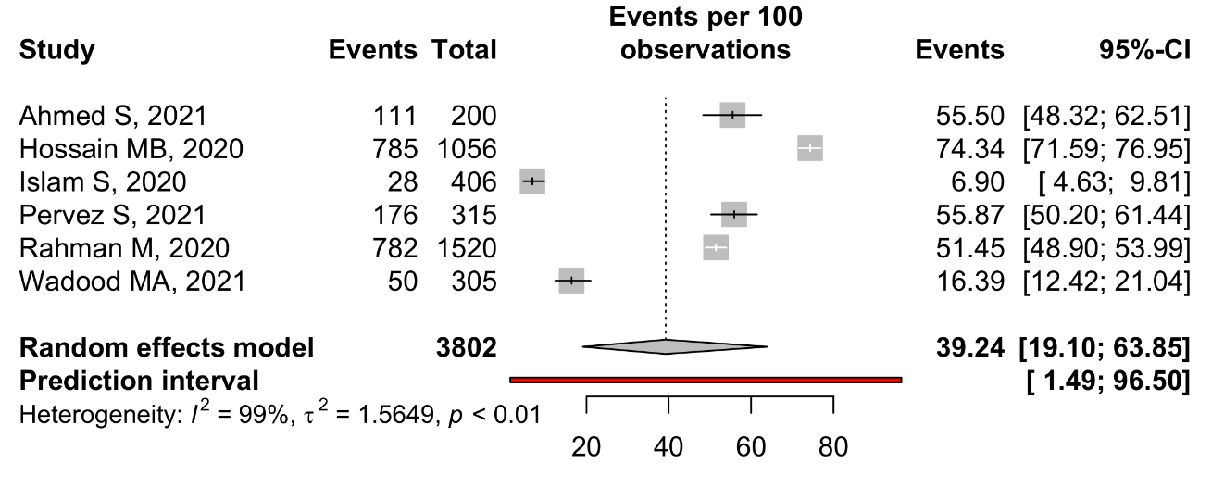
Supplementary Figure 11: Knowledge of participants about Diarrhea as a symptom of Covid-19
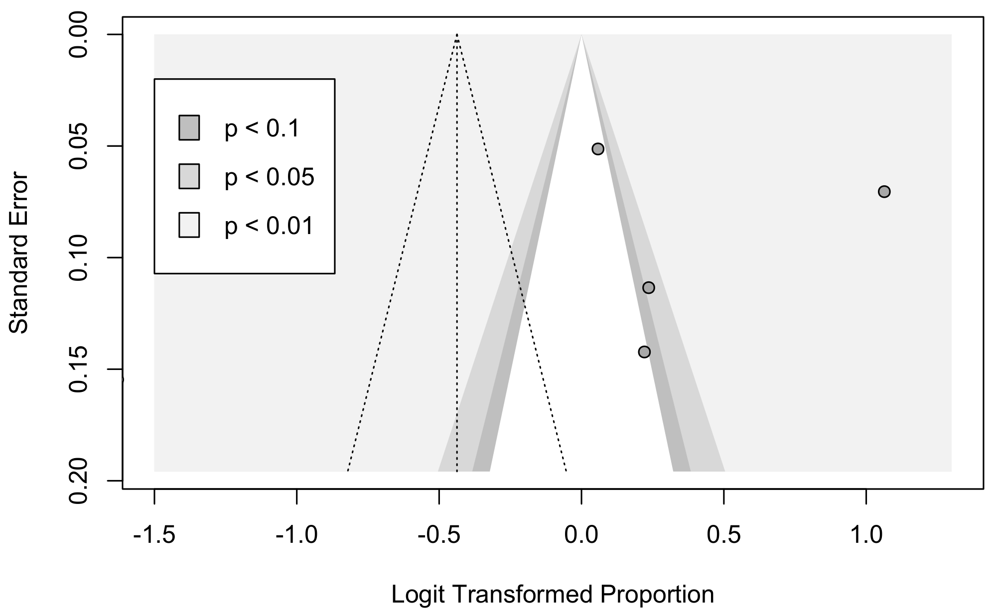
Supplementary Figure 12: Funnel plot of Knowledge of participants about Diarrhea as a symptom of Covid-19

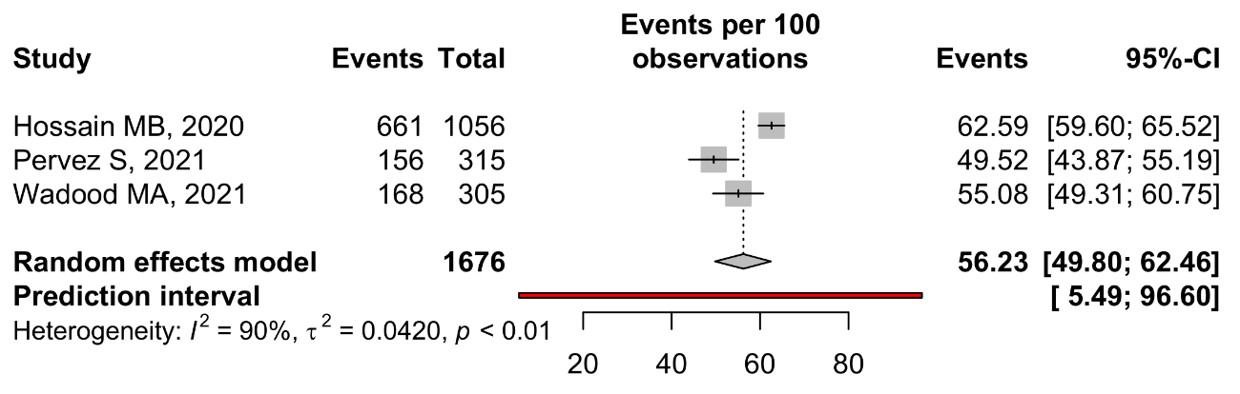
Supplementary Figure 13: Knowledge of participants about Headache as a symptom of Covid-19
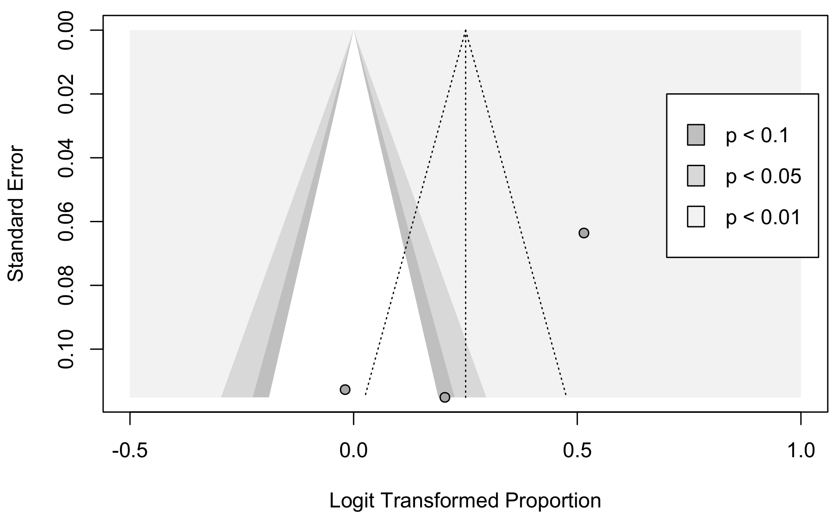
Supplementary Figure 14: Funnel plot of Knowledge of participants about Headache as a symptom of Covid-19

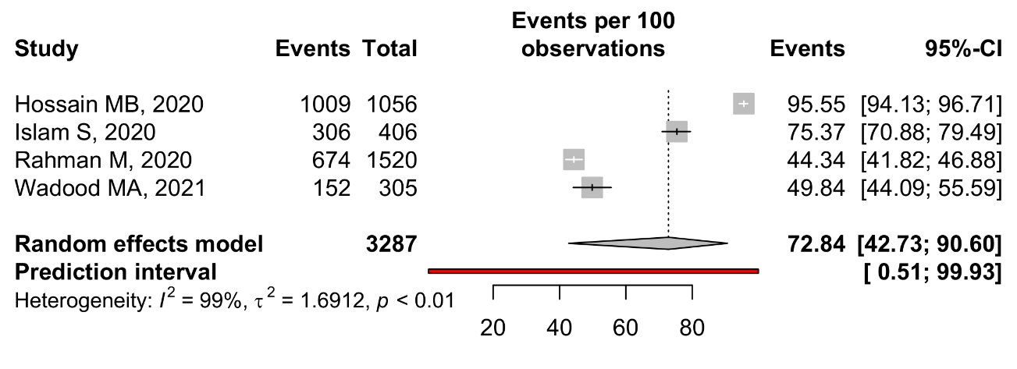
Supplementary Figure 15: Knowledge of participants about Sore throat as a symptom of Covid-19
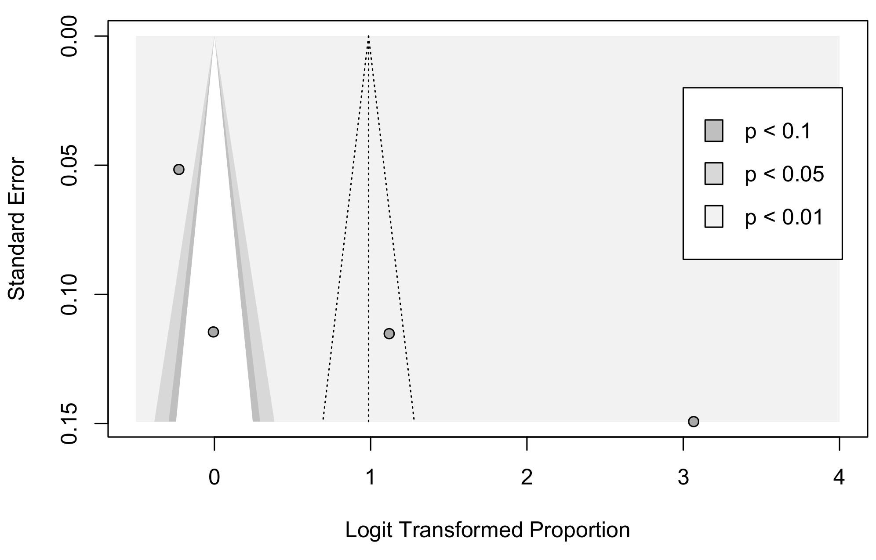
Supplementary Figure 16: Funnel plot of Knowledge of participants about Sore throat as a symptom of Covid-19

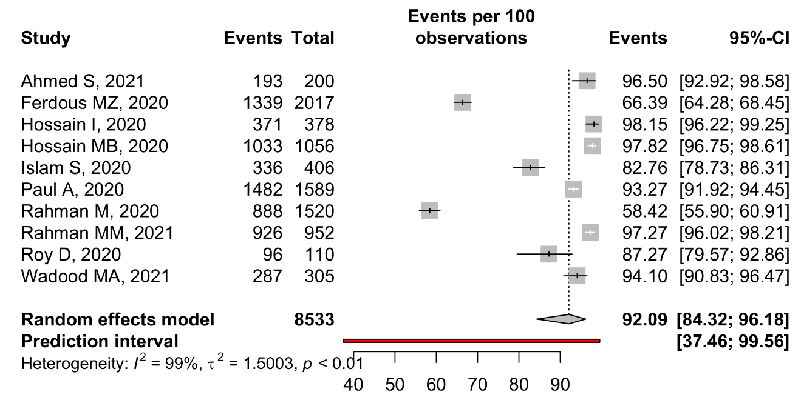
Fig Supplementary Figure 17: Knowledge of participants about transmission of Covid-19

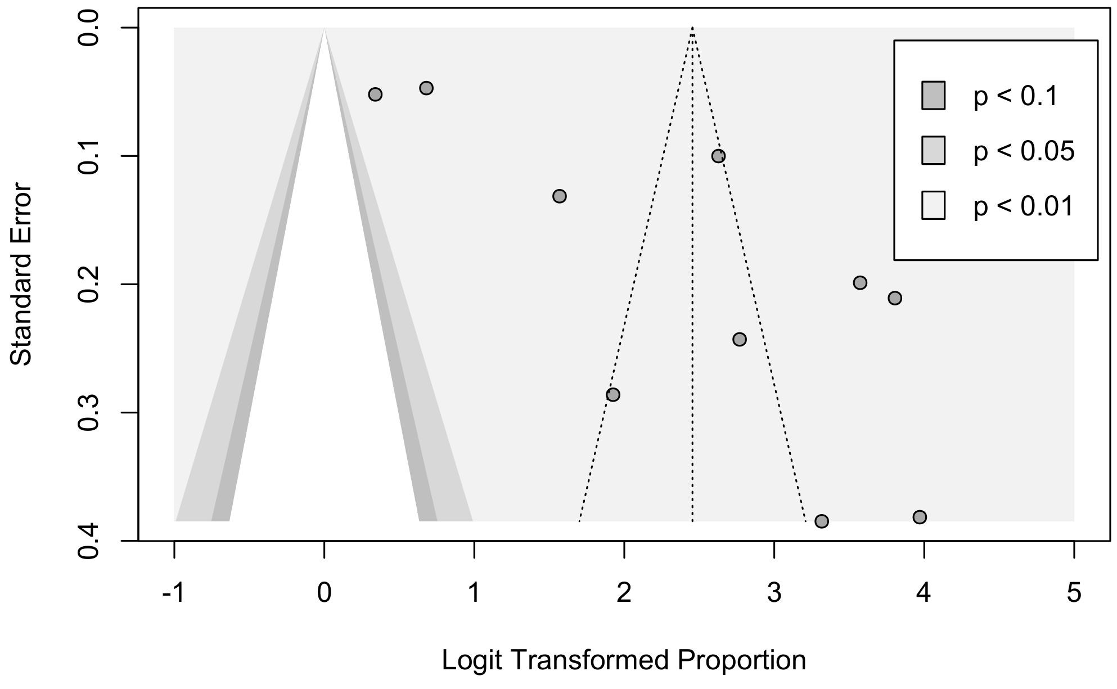
Supplementary Figure 18: Funnel plot of Knowledge of participants about transmission of Covid-19

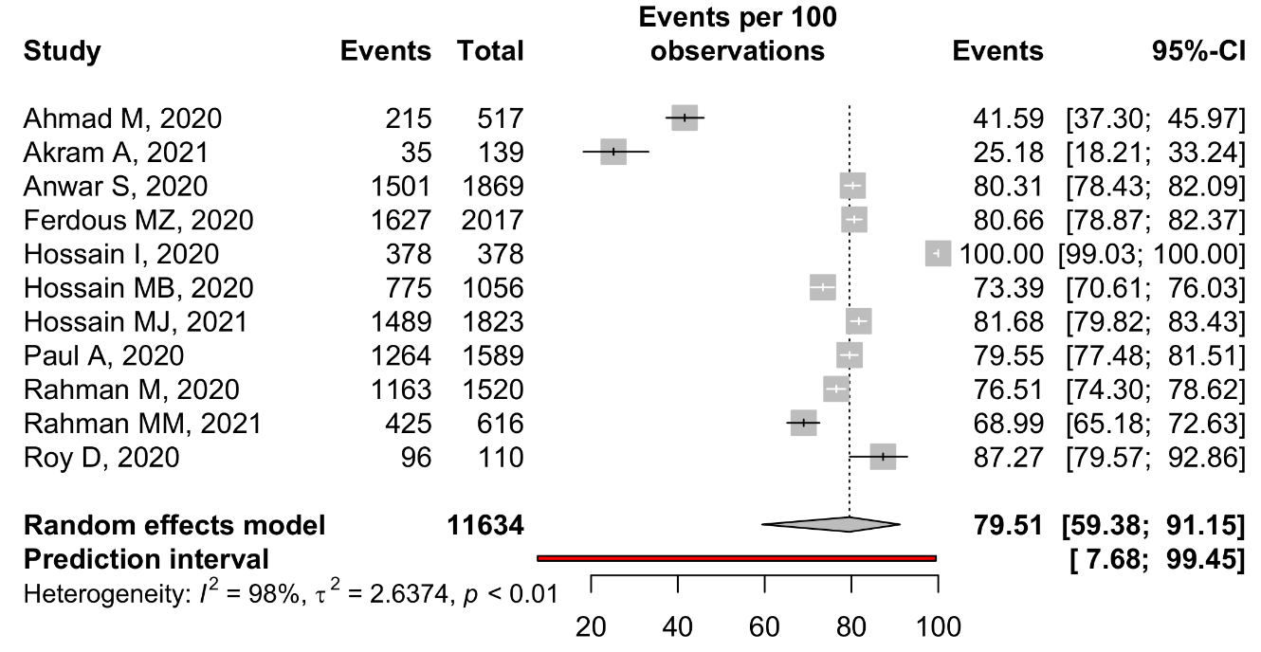
Supplementary Figure 19: Knowledge of participants about Treatments of Covid-19
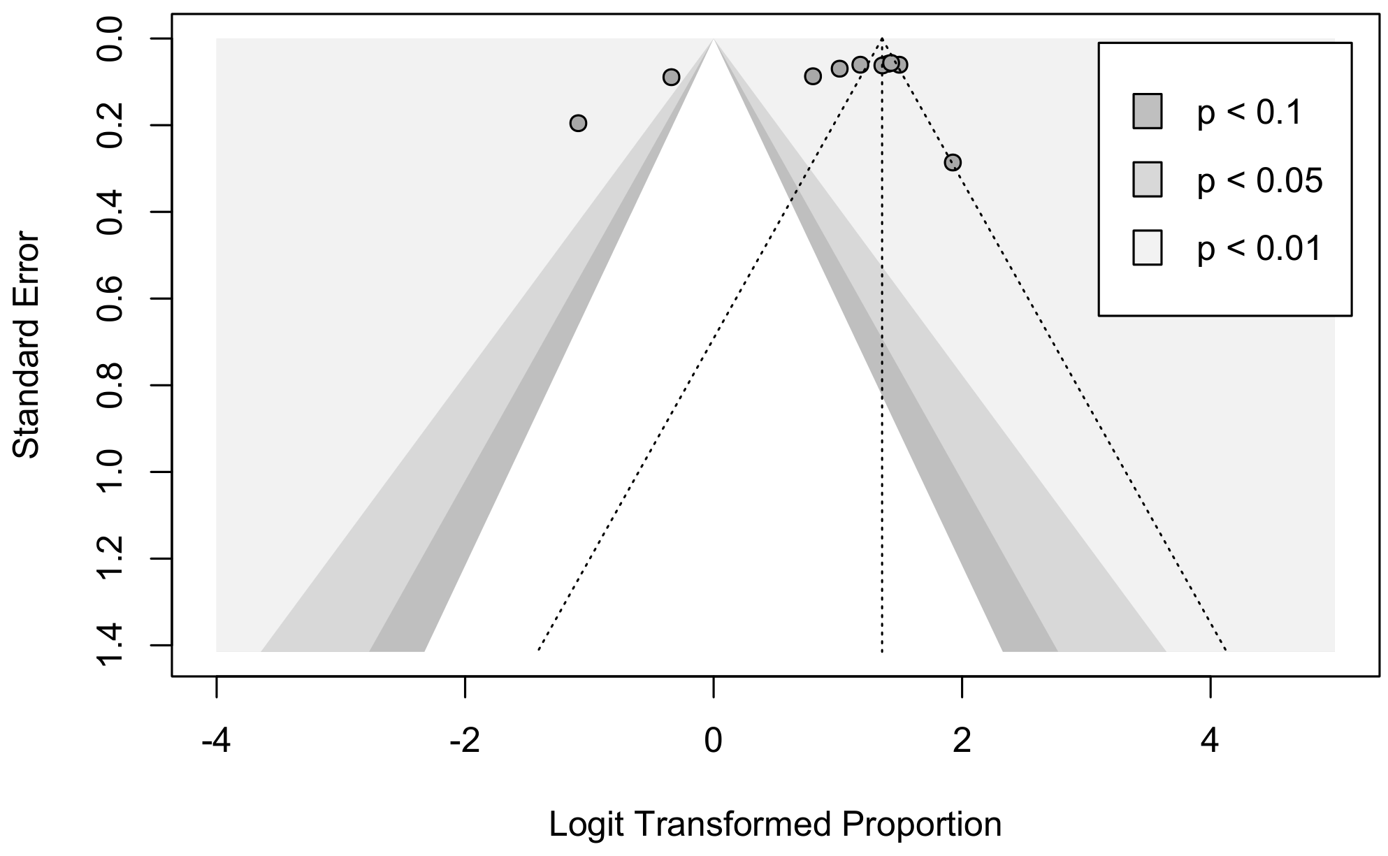
Supplementary Figure 20: Funnel plot of Knowledge of participants about Treatments of Covid-19

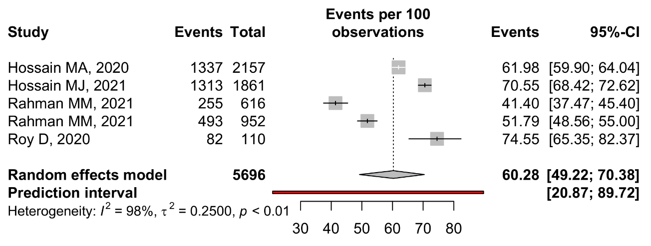
Supplementary Figure 21: Attitude of participants about successful control of covid-19 in Bangladesh
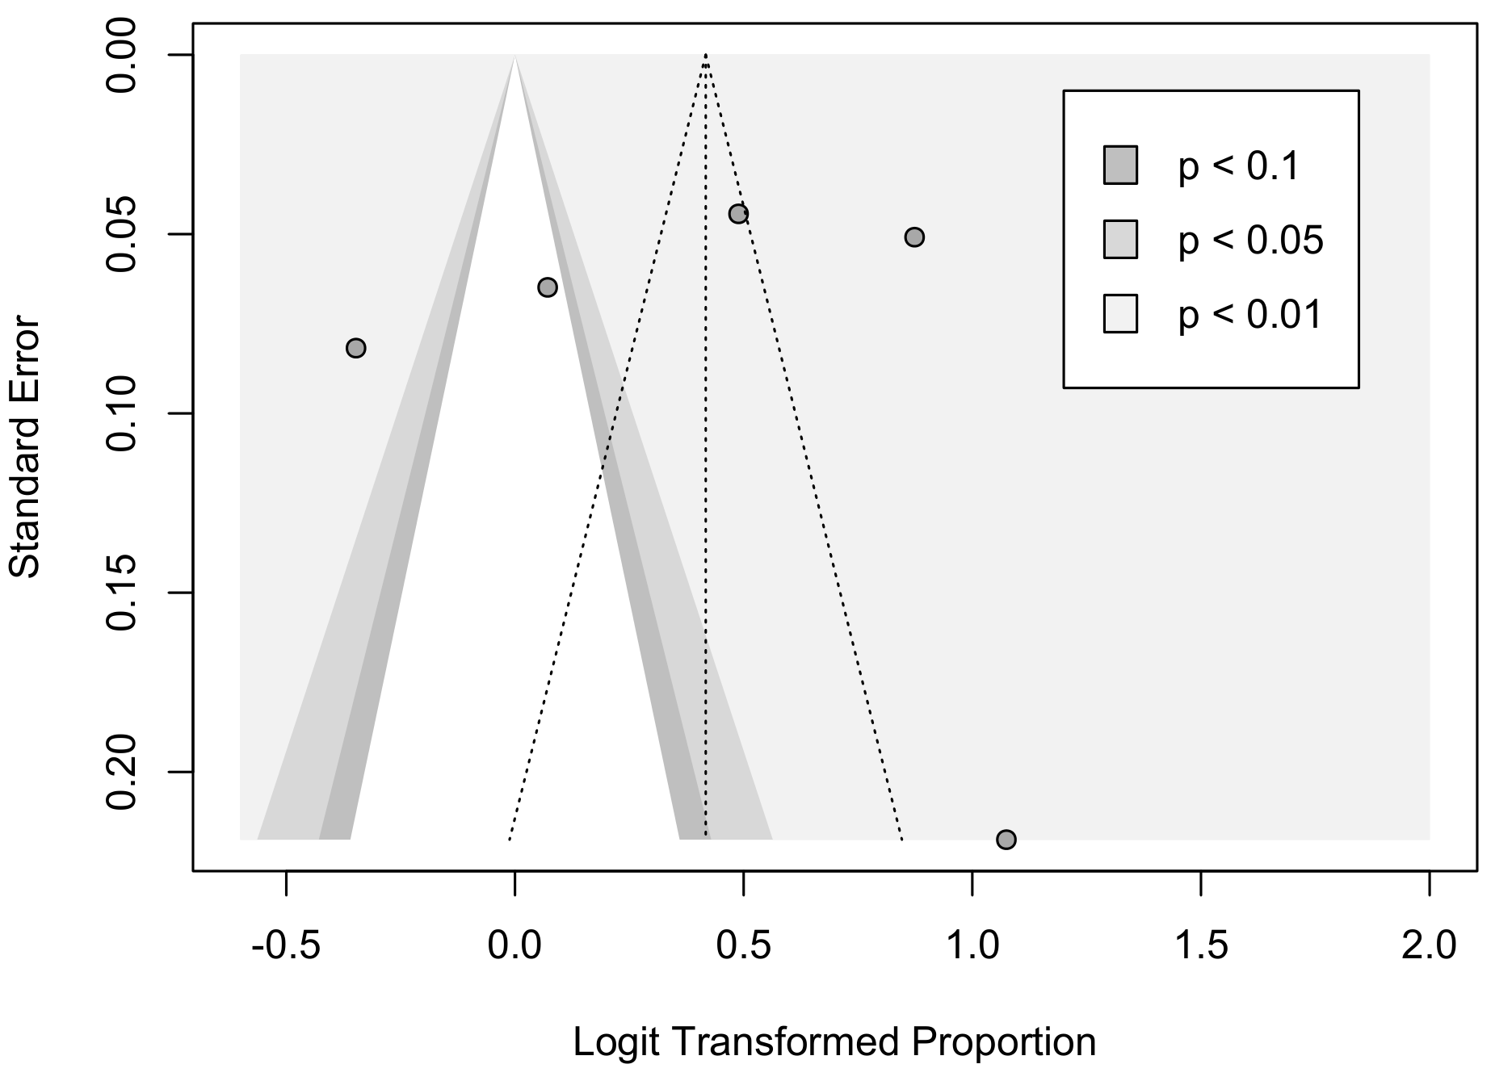
Supplementary Figure 22: Funnel plot of Attitude of participants about successful control of covid-19 in Bangladesh

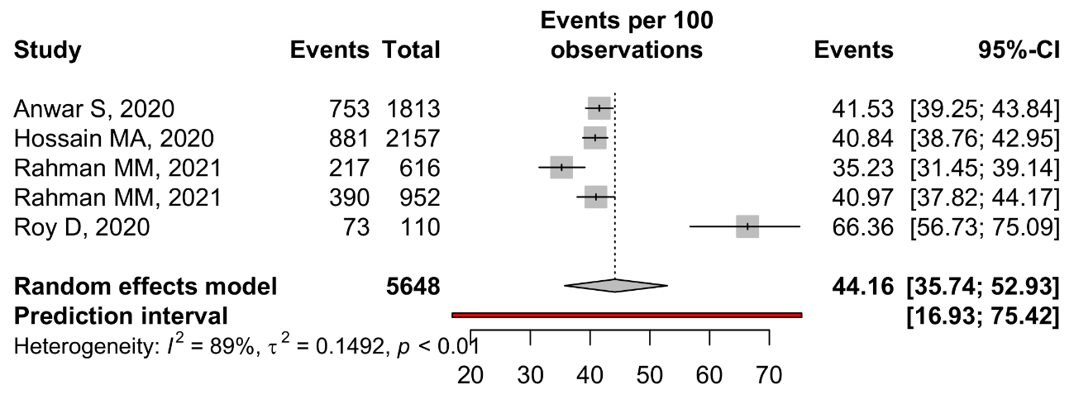
Supplementary Figure 23: Attitude of participants about win of Battle against covid-19 in Bangladesh

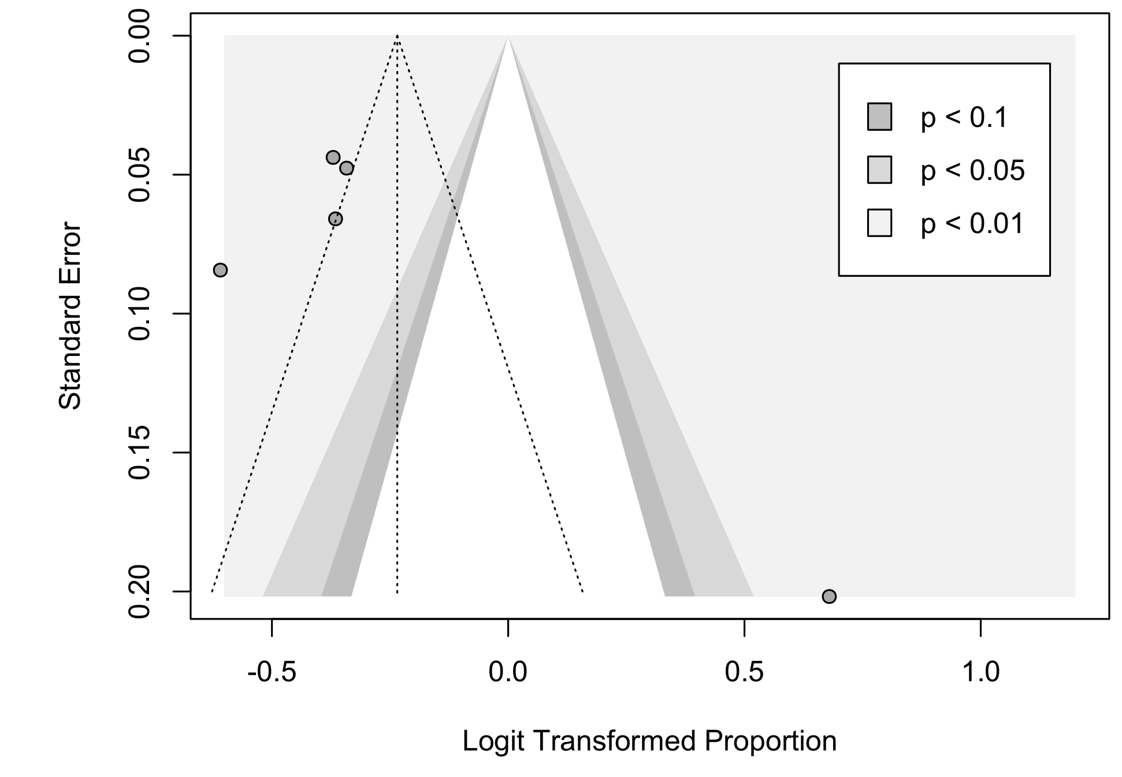
Supplementary Figure 23: Funnel plot of Attitude of participants about win of Battle against covid-19 in Bangladesh

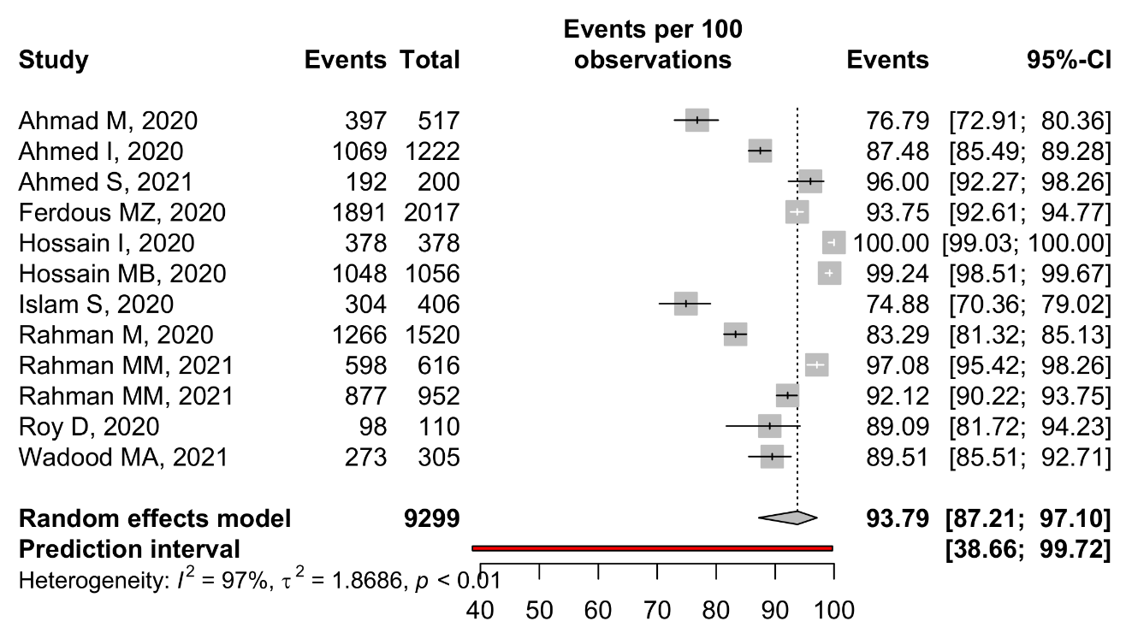
Supplementary Figure 23: Practice level of participants about washing hand regularly

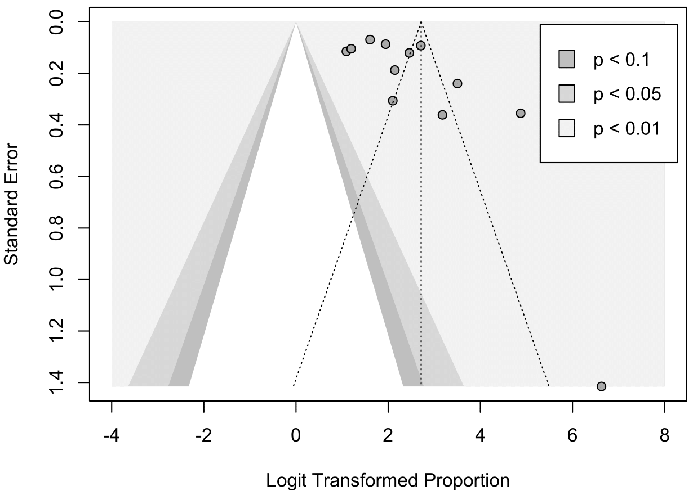
Supplementary Figure 24: Funnel plot of Practice level of participants about washing hand regularly

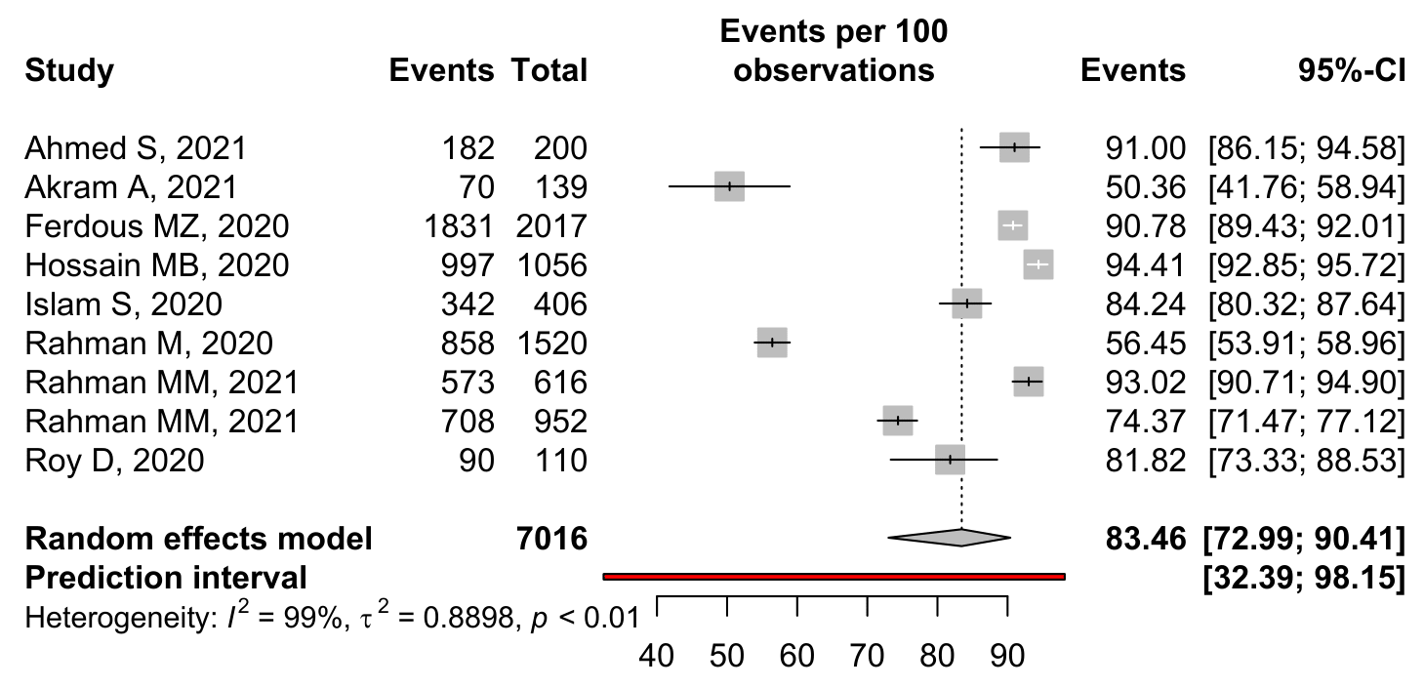
Supplementary Figure 25: Practice level of participants about maintaining Social distance

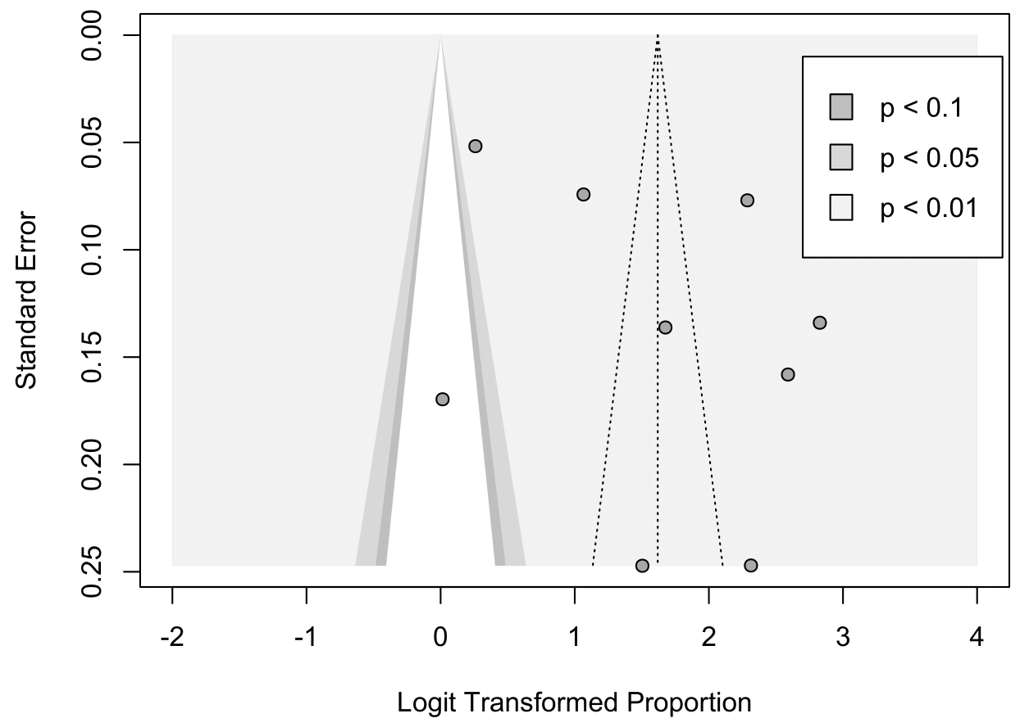
Supplementary Figure 26: Funnel plot of Practice level of participants about maintaining social distance

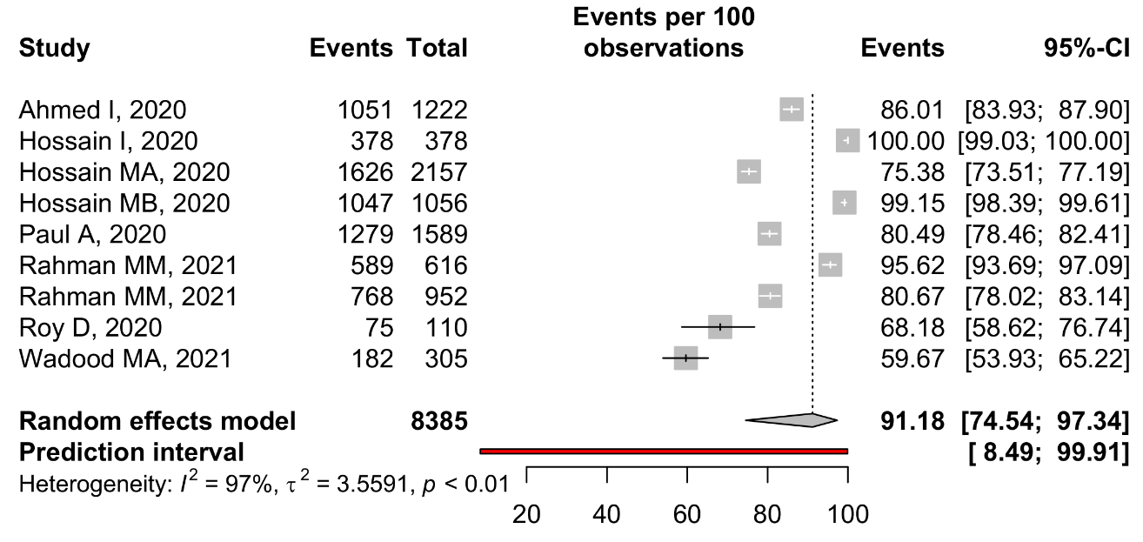
Supplementary Figure 27: Practice level of participants about Avoidance of crowded place

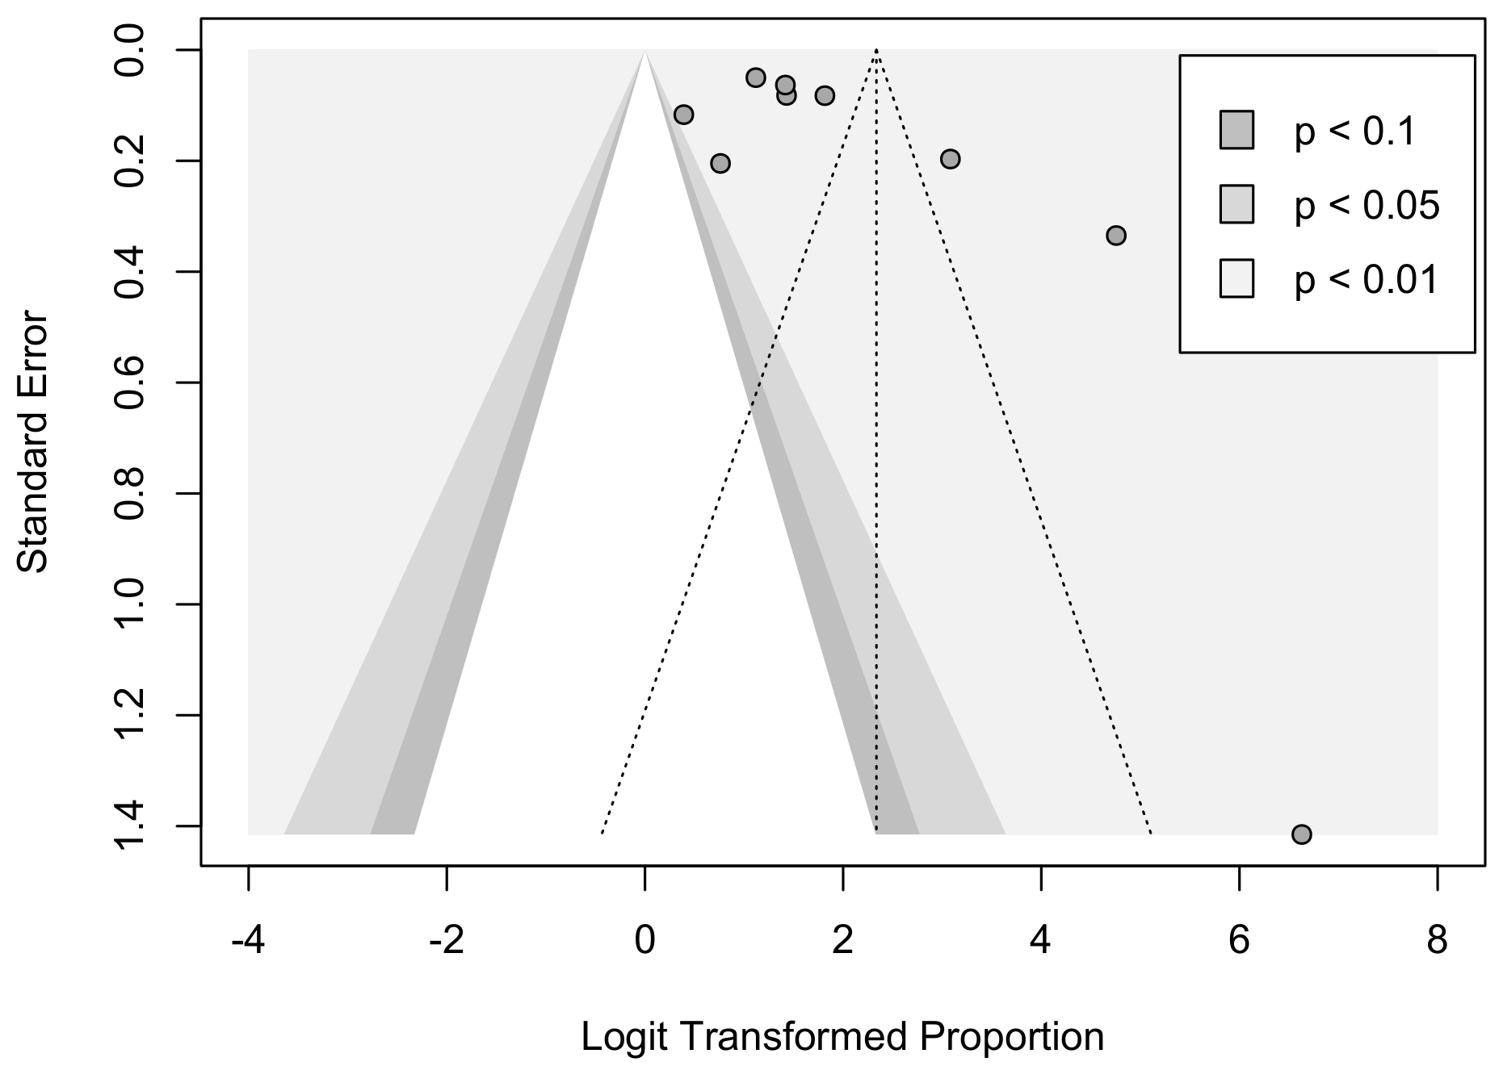
Supplementary Figure 28: Funnel plot of Practice level of participants about Avoidance of crowded place

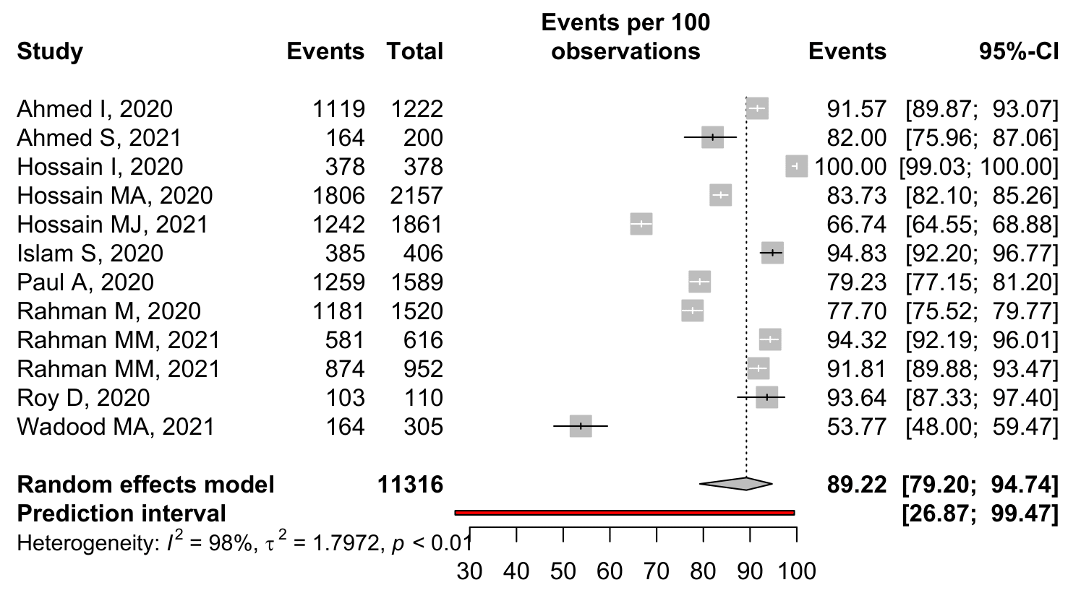
Supplementary Figure 29: Practice level of participants about wearing mask

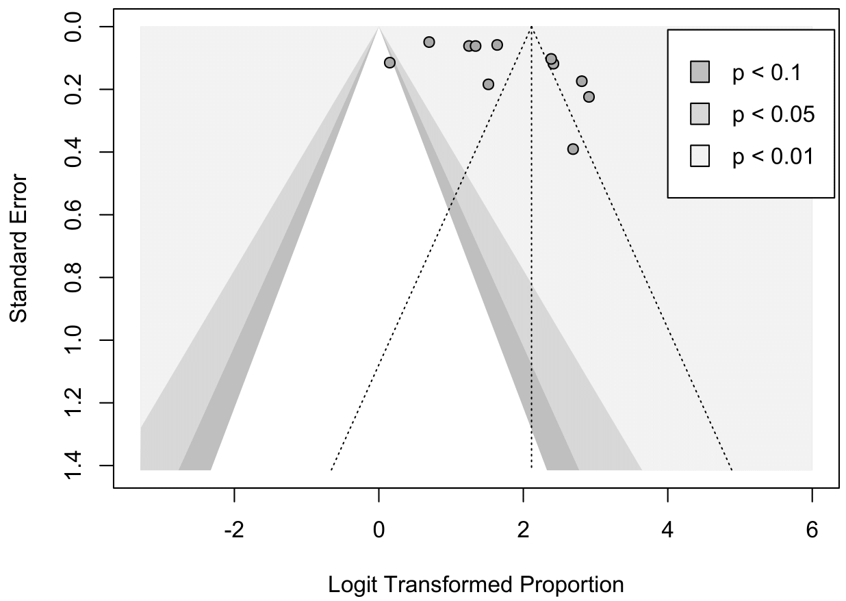

Supplementary Figure 30: Funnel plot of Practice level of participants about wearing mask

