Supplementary Figure 1: Venn diagram of the studies included on the meta-analysis. Each circle represents a particular combination of predefined variables. The variables have been coded numerically and the specific combination for each circle is represented by the small-sized numbers within the circle. The large number within each circle indicates the frequency of composite outcomes for each variable combination. The colour-delimited areas represent the frequency of composite outcomes for all the combinations including a particular variable.
Supplementary Figure 2: Upset plot of the studies included on the meta-analysis. The frequency of composite outcomes (red bars) discriminated by individual combinations of predefined variables reported in the studies. Black dots represent individual variables.
Supplementary Figure 3: “Funnel Plot” representing the mean for composite outcomes against the corresponding standard error for these values (n=43).
Supplementary Figure 4: Sensitivity analysis: the plot shows N-1 frequencies of composite outcomes where N-1 represents the total number of studies included in the meta-analysis minus one(n=43).
Supplementary Figure 5: Subgroup analysis: frequency of composite outcomes and 95% confidence intervals for outcome subgroups reporting a particular number of predefined variables (G - number of variables) against all the other outcomes (n=43): (A) Outcome subgroup reporting two variables versus the rest; (B) Outcome subgroup reporting three variables versus the rest; (C) Outcome subgroup reporting four variables versus the rest; (D) Outcome subgroup reporting five variables versus the rest. (E) Outcome subgroup reporting six variables versus the rest.
Supplementary Figure 6: Subgroup analysis: frequency of composite outcomes and corresponding 95% confidence interval according to the presence of individual predefined variables reported in the outcome (n=43): (A) Subgroups determined by the presence or absence of the variable “Biologics”; (B) Subgroups determined by the presence or absence of the variable “Biomarkers”; (C) Subgroups determined by the presence or absence of the variable “Clinical Evaluation”; (D) Subgroups determined by the presence or absence of the variable “Endoscopic Assessment”;(E) Subgroups determined by the presence or absence of the variable “Events”; (F) Subgroups determined by the presence or absence of the variable “Therapy Modification”.
Supplementary Figure 7: Each row from top to bottom: variables that present a statistically significant increase of composite outcome frequency, when included in the outcome, in the subgroup analysis determined by the presence or absence of each variable; variables with no statistically significant increase of composite outcome frequency in the subgroup analysis determined by the presence or absence of each variable; frequency of composite outcome according to the number of variables.

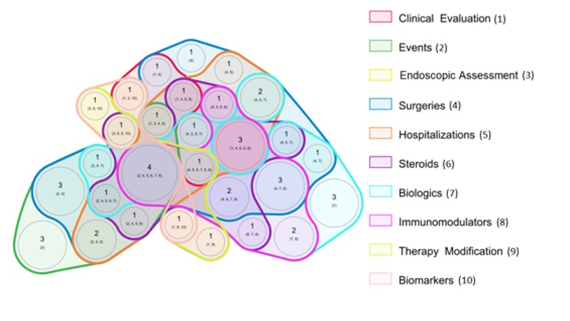
Supplementary Figure 1: Venn diagram of the studies included on the meta-analysis. Each circle represents a particular combination of predefined variables. The variables have been coded numerically and the specific combination for each circle is represented by the small-sized numbers within the circle. The large number within each circle indicates the frequency of composite outcomes for each variable combination. The colour-delimited areas represent the frequency of composite outcomes for all the combinations including a particular variable.

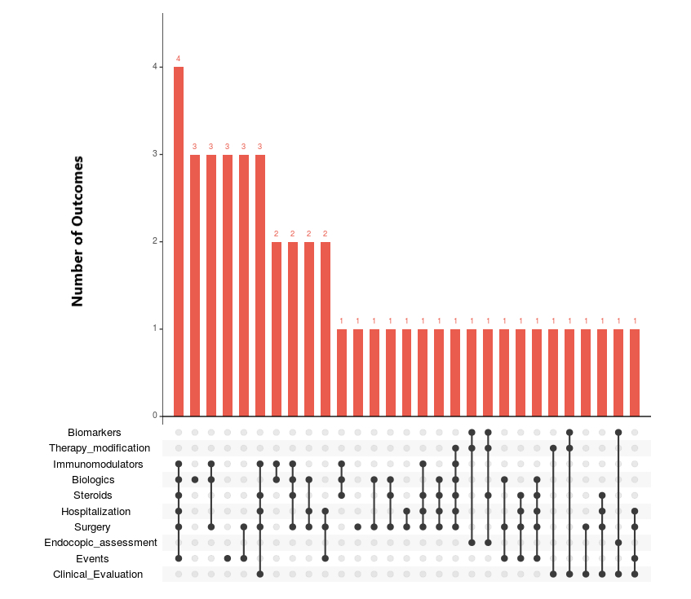
Supplementary Figure 2: Upset plot of the studies included on the meta-analysis. The frequency of composite outcomes (red bars) discriminated by individual combinations of predefined variables reported in the studies. Black dots represent individual variables.

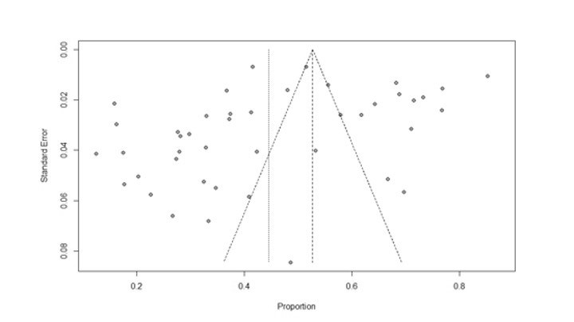
Supplementary Figure 3: “Funnel Plot” representing the mean for composite outcomes against the corresponding standard error for these values (n=43).

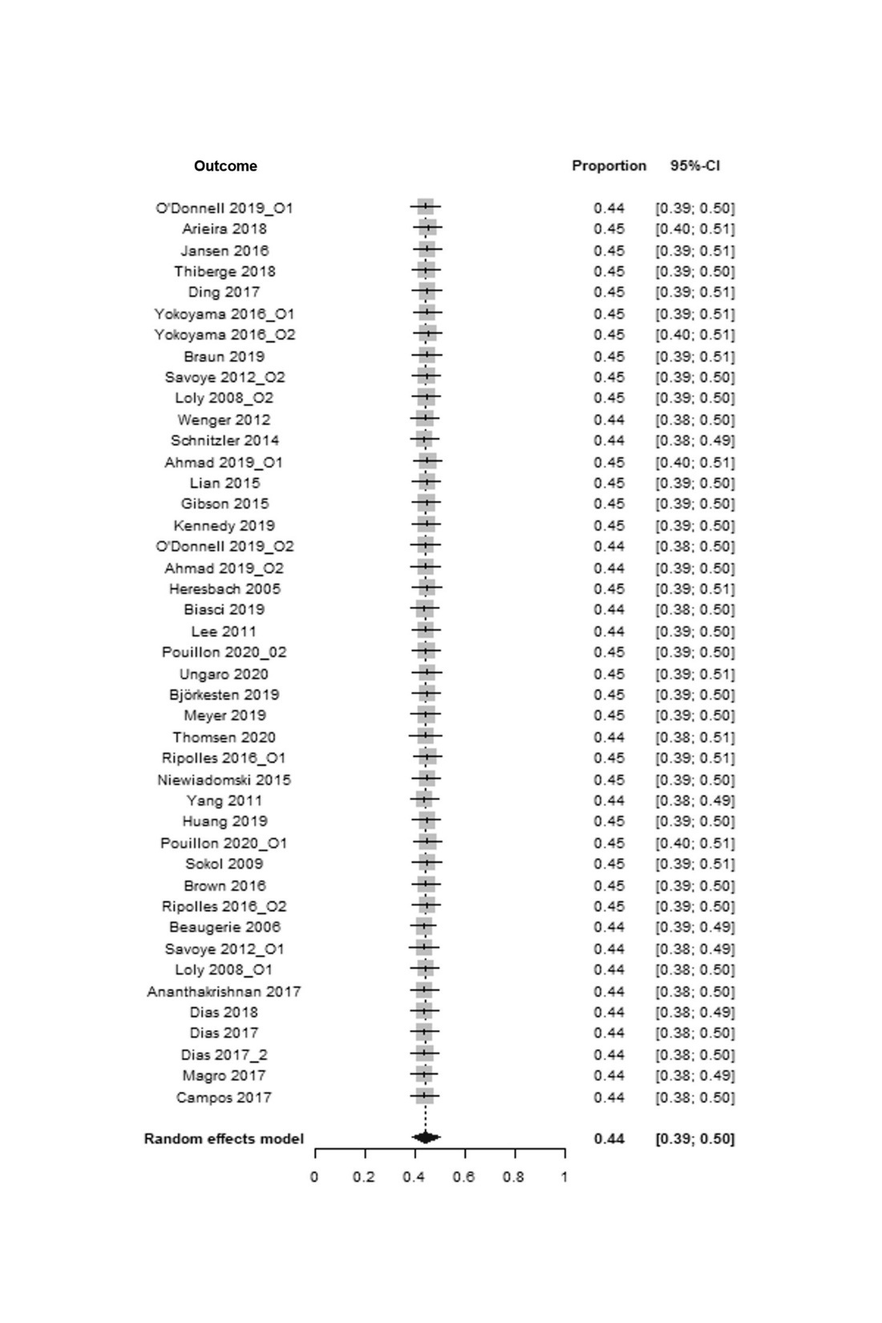
Supplementary Figure 4: Sensitivity analysis: the plot shows N-1 frequencies of composite outcomes where N-1 represents the total number of studies included in the meta-analysis minus one(n=43).

Supplementary Figure 5: Subgroup analysis: frequency of composite outcomes and 95% confidence intervals for outcome subgroups reporting a particular number of predefined variables (G - number of variables) against all the other outcomes (n=43): (A) Outcome subgroup reporting two variables versus the rest; (B) Outcome subgroup reporting three variables versus the rest; (C) Outcome subgroup reporting four variables versus the rest; (D) Outcome subgroup reporting five variables versus the rest. (E) Outcome subgroup reporting six variables versus the rest.
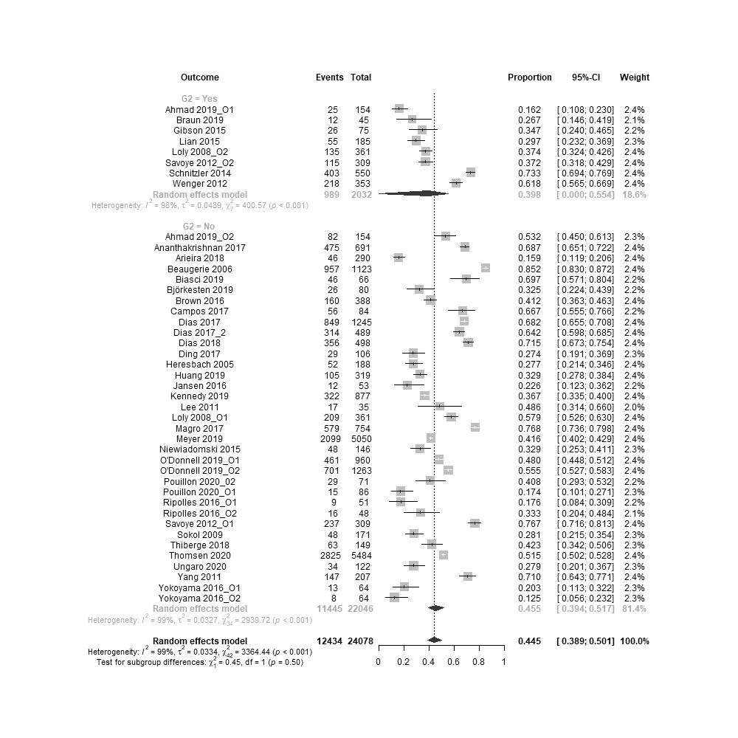
(A)

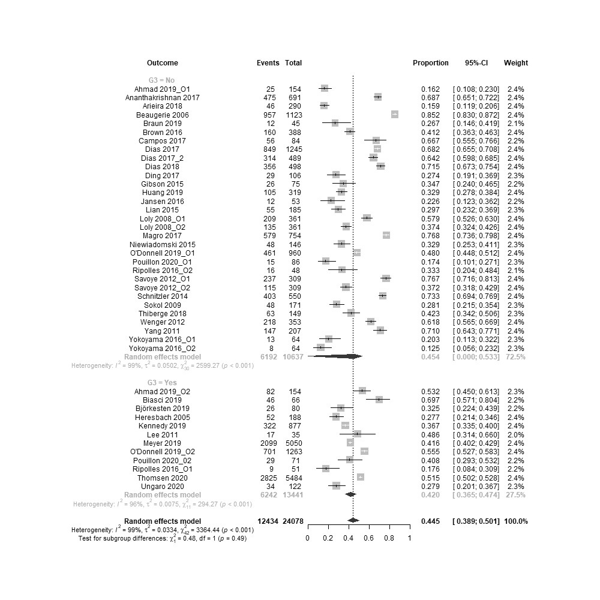
(B)
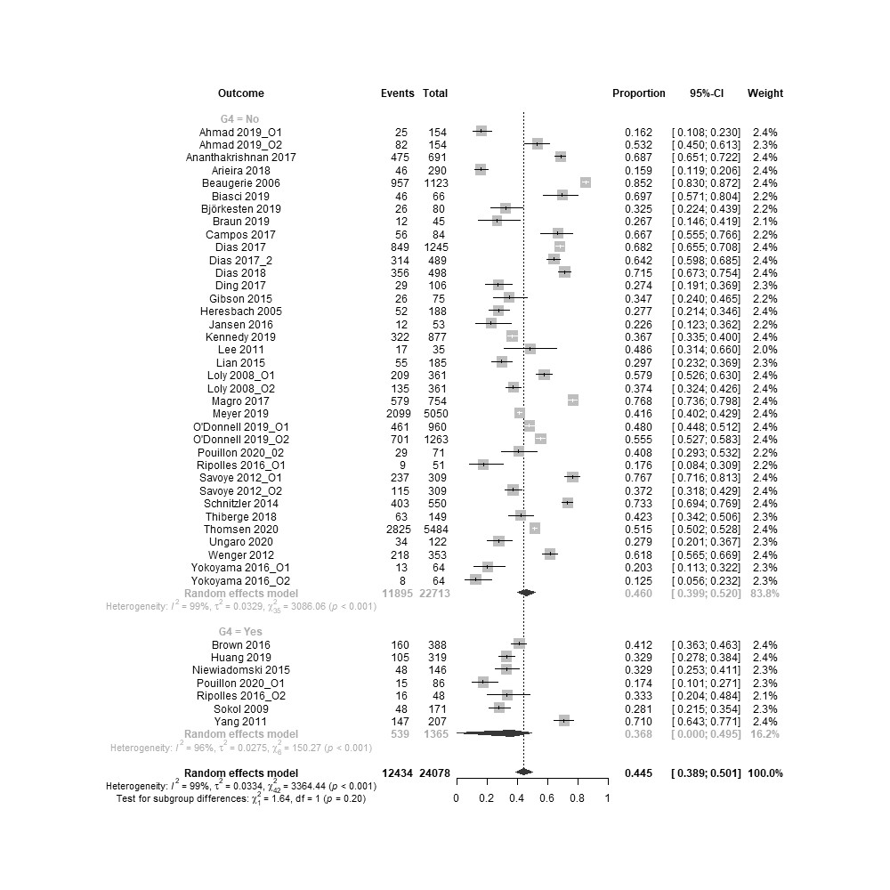
(C)
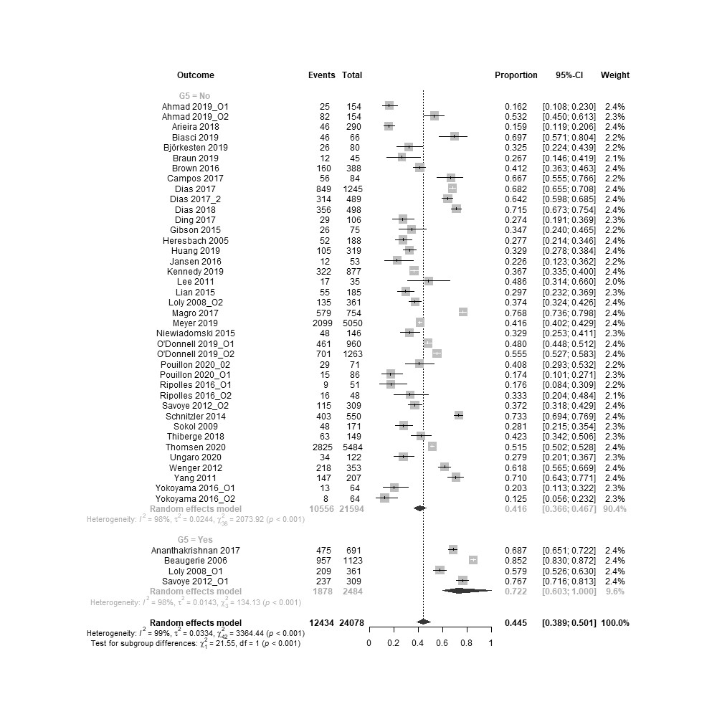
(D)
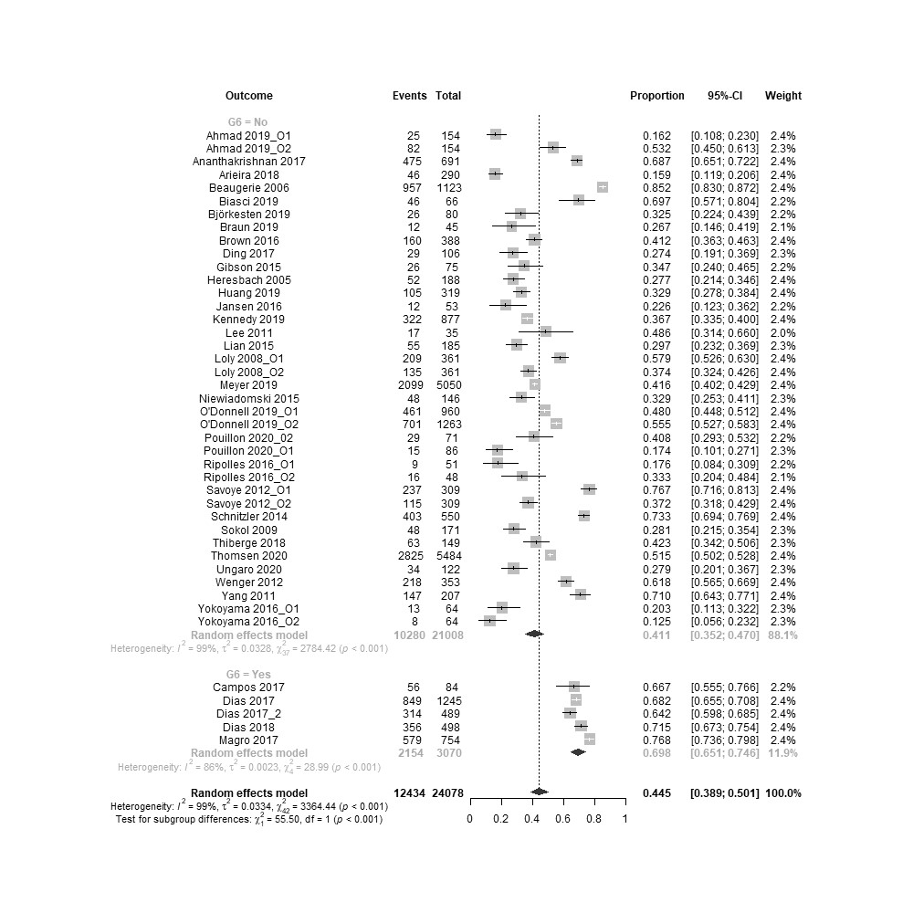
(E)
Supplementary Figure 6: Subgroup analysis: frequency of composite outcomes and corresponding 95% confidence interval according to the presence of individual predefined variables reported in the outcome (n=43): (A) Subgroups determined by the presence or absence of the variable “Biologics”; (B) Subgroups determined by the presence or absence of the variable “Biomarkers”; (C) Subgroups determined by the presence or absence of the variable “Clinical Evaluation”; (D) Subgroups determined by the presence or absence of the variable “Endoscopic Assessment”;(E) Subgroups determined by the presence or absence of the variable “Events”; (F) Subgroups determined by the presence or absence of the variable “Therapy Modification”.
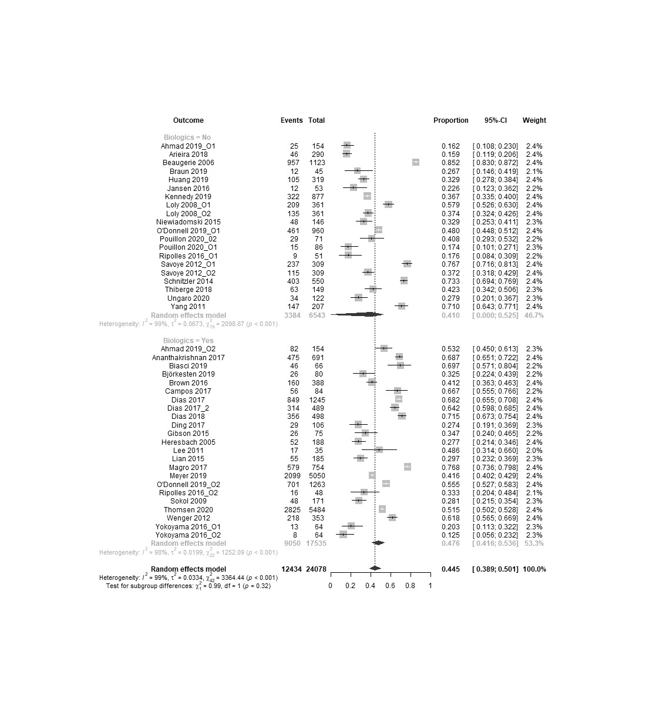
(A)

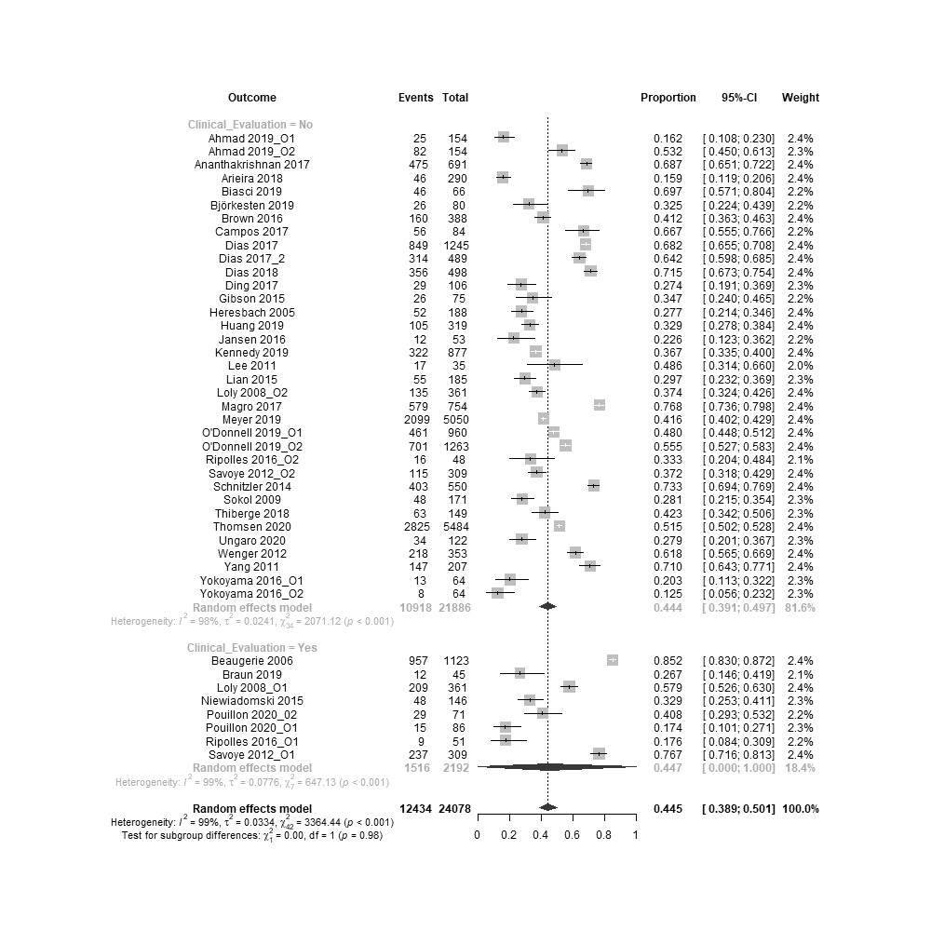
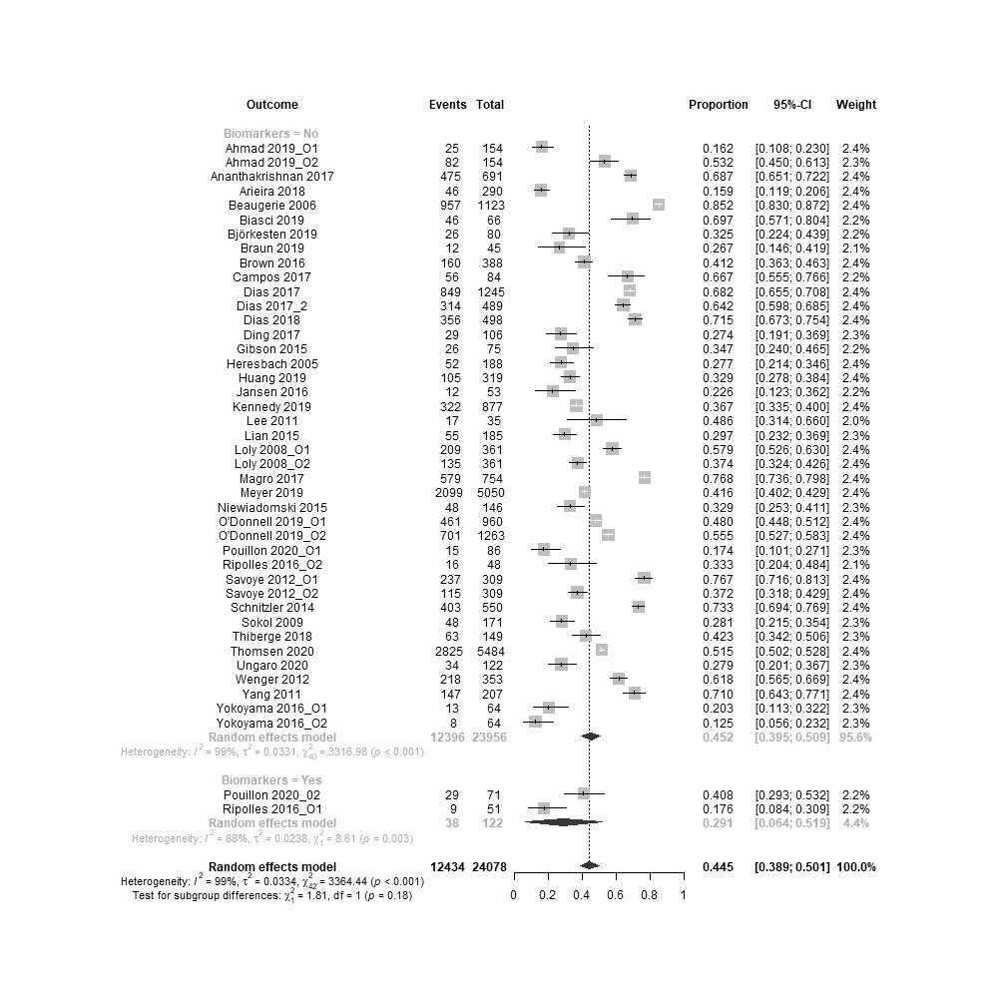
(B)
(C)
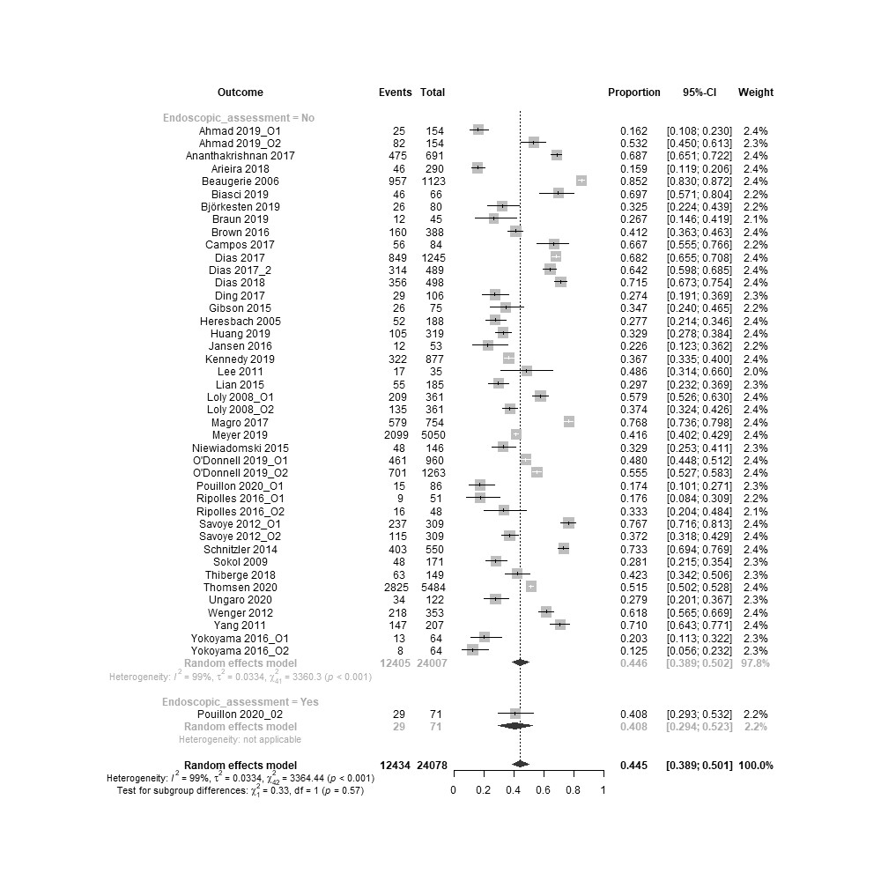
(D)
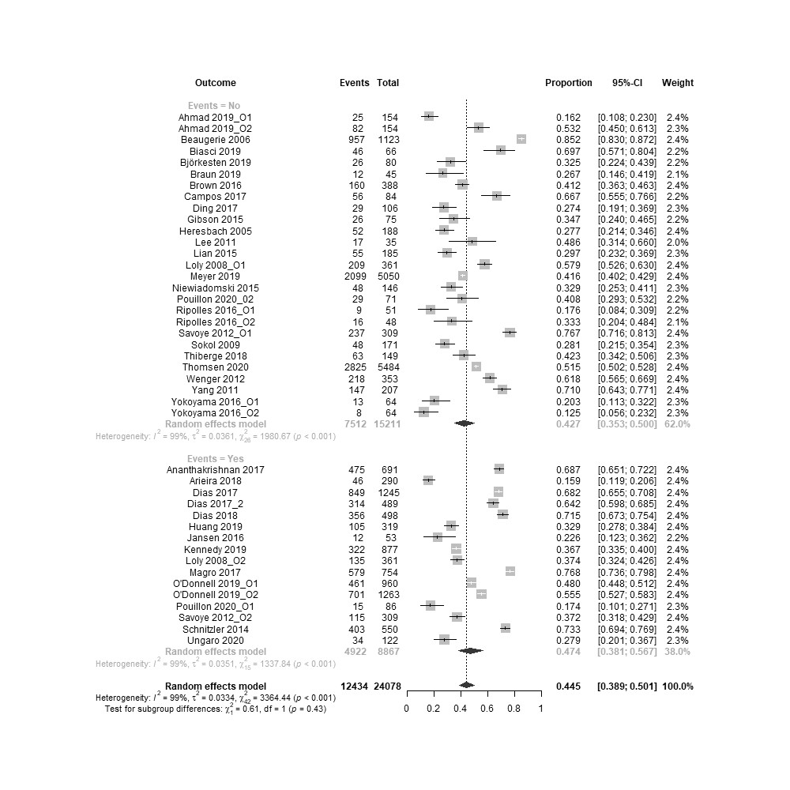
(E)
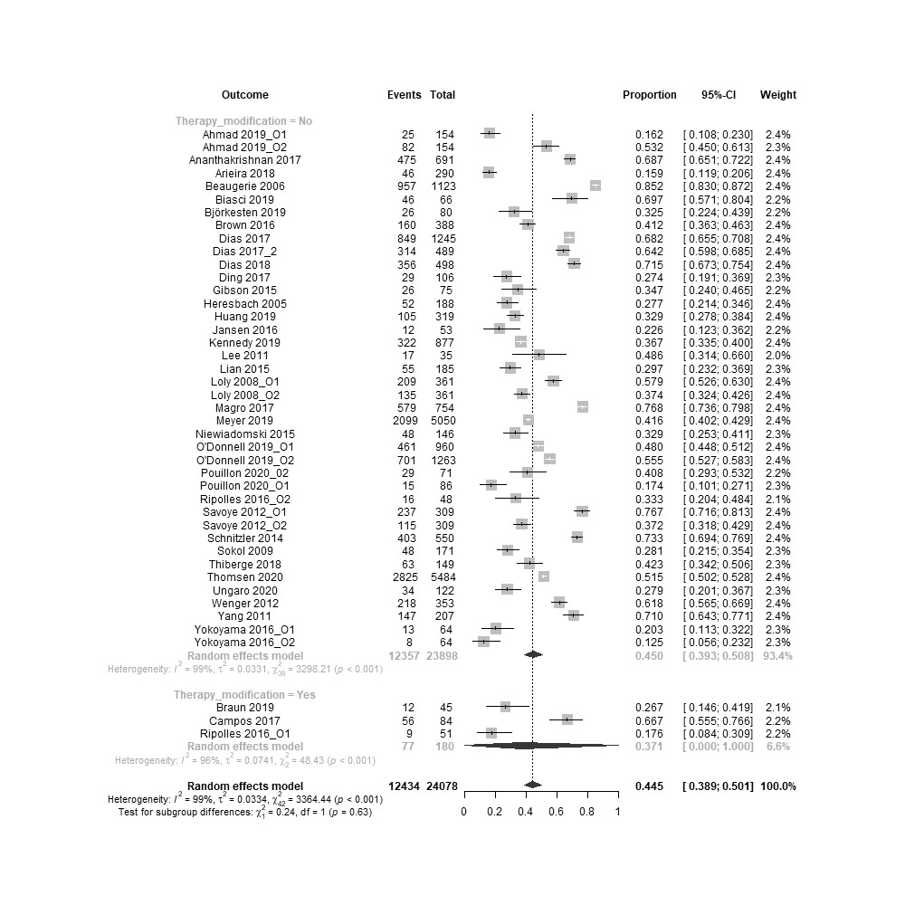
(F)

Supplementary Figure 7: Each row from top to bottom: variables that present a statistically significant increase of composite outcome frequency, when included in the outcome, in the subgroup analysis determined by the presence or absence of each variable; variables with no statistically significant increase of composite outcome frequency in the subgroup analysis determined by the presence or absence of each variable; frequency of composite outcome according to the number of variables.


