Supplementary Table 1. Evaluation obtained with CASP Checklists for cohort studies.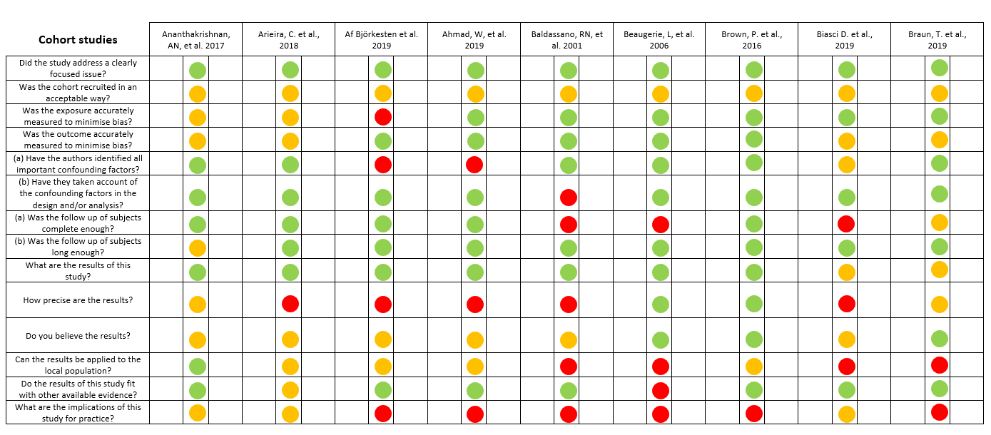

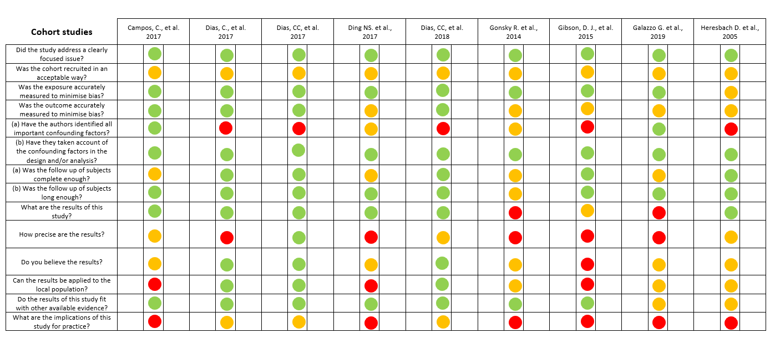

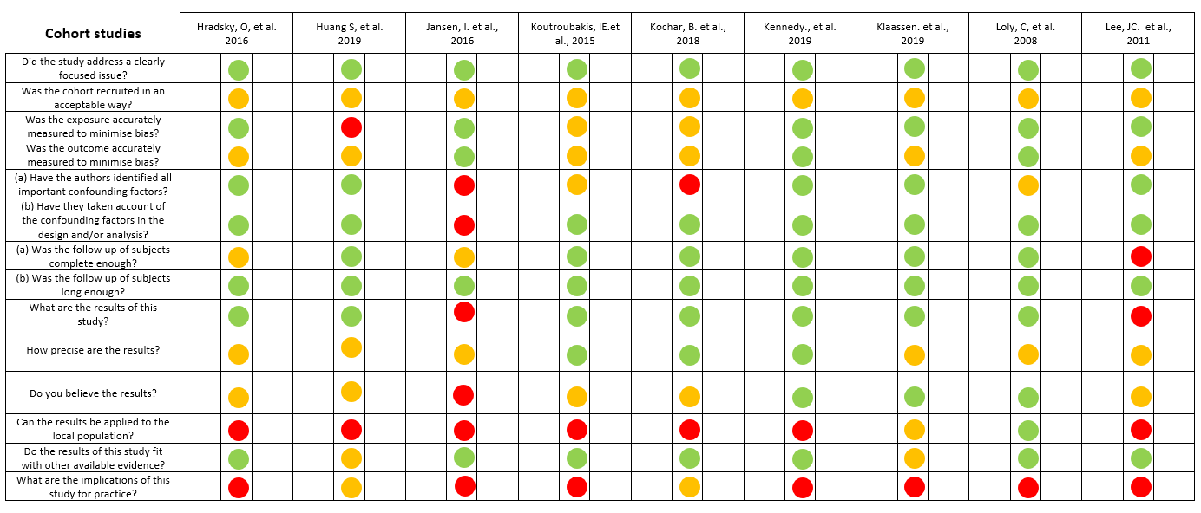

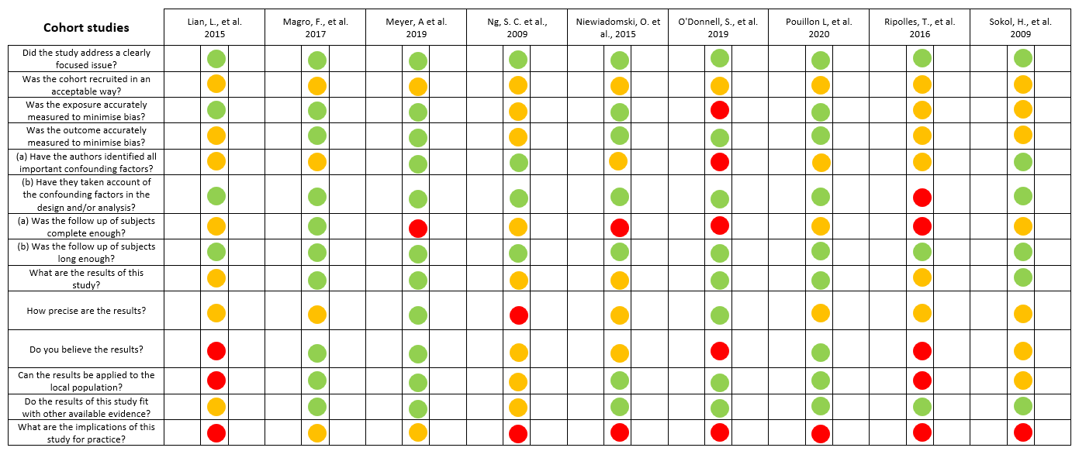

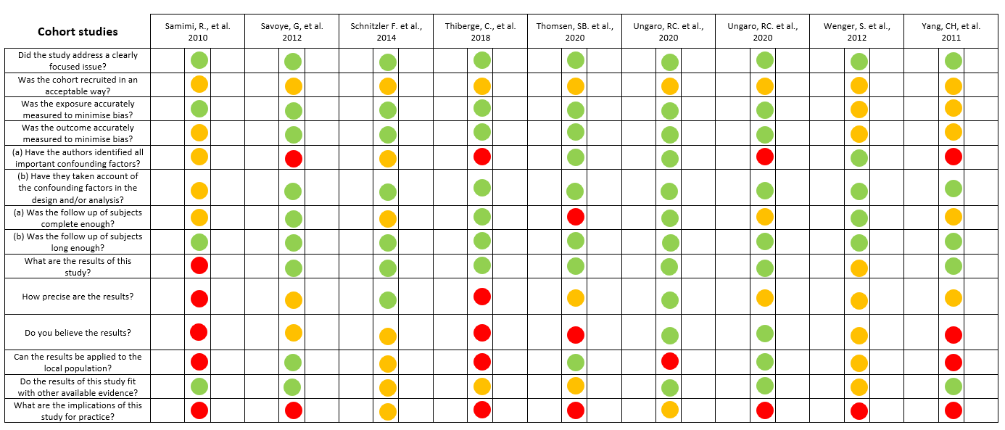

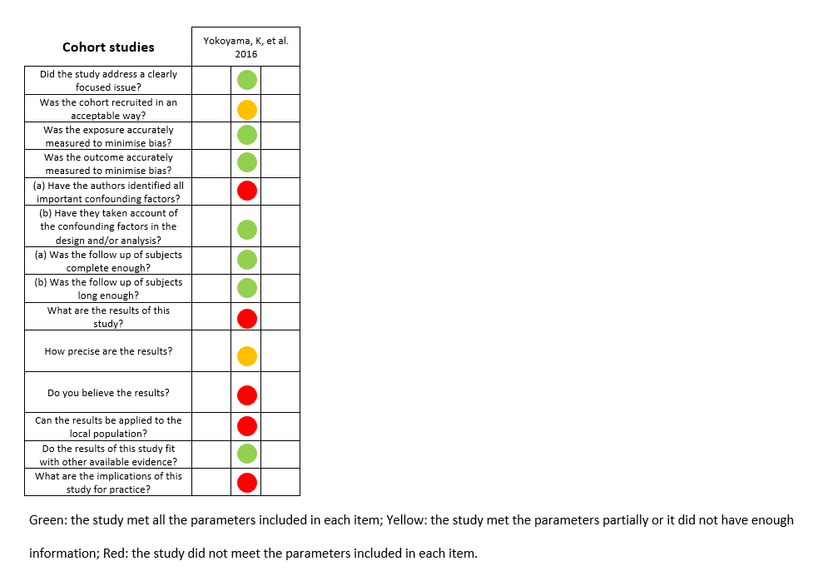
Supplementary Table 2: Characteristics of the studies included in the systematic review. When a scientific article includes more than one cohort, characteristics are discriminated by cohort.
Study | Country | Study design | Observation period | CD | UC | IBD (sample size) | Disease location | Exposure | Comparison | Outcome | Outcome definition | Composite | Aggregate | Variables
Ananthakrishnan NA. et al., 2017⁵⁷ | USA | Multicentric  Prospective cohort | 365 ± 45ª days | Yes | Yes | 871, adults  CD: 707  UC: 164 | L1^{c}: 17.0% (CT), 21.0.0% (M)  L2^{c}: 17.0%, 19.0%  L3^{c}: 66.0%, 59.0% | Combination therapy  (anti-TNF and immunomodulator) | Monotherapy  (anti-TNF) | Effectiveness | New surgery or hospitalizations (IBD-related), penetrating complications (new abscess or fistula), need for corticosteroids or change in biological therapy | Yes | No | Events  Surgery  Hospitalization  Steroids  Biologics
Arieira, C. et al.,  2018⁵⁶ | Portugal | Unicentric  Retrospective and prospective cohort | 113.0 ± 74.7ª months | Yes | Yes | 290 | L1^{c}: 47.6%  L2^{c}: 4.8%  L3^{c}: 47.6%  L4^{c}: 14.8% | NA | NA | Complicated disease | Stricturing (intestinal narrowing not passed by the endoscope or a luminal narrowing with pre-stenotic dilation) or penetrating abdominal disease (fistula or abscess) | Yes | No | Events
Af Björkesten et al.,  2019⁵⁵ | Finland | Multicentric  Retrospective chart review | FC: 1183.36 days^{e}  Non-FC: 1325.14 days^{e} | Yes | No | 186, adults | L1^{c}: 18.8%  L2^{c}: 25.3%  L3^{c}: 55.9% | Normal FC  (FC < 100) | Elevated FC  (>250mg/g) | Composite event | Surgery (ostomy, resection, and fistula discision), corticosteroid initiation (or re-initiation), biological therapy failure (drug discontinuation due to inefficacy or adverse events), increase of administered dose or shortening of the administration interval of biological therapy | Yes | No | Surgery  Steroids  Biologics
Ahmad W. et al.,  2019⁵⁴ | USA | Unicentric  Retrospective cohort | 30 days^{d} | Yes | Yes | 268  CD: 154  UC: 114 | L1^{c}: 12.0% (CSE), 21.0% (GGPs)  L2^{c}: 34.0%, 24.0%  L3^{c}: 53.0%, 52.0%  L4^{c}: 0.0%, 3.0% | GPPs | CSE | Disease course | IBD-related hospitalization, surgery, or emergency department visit | Yes | No | Surgery  Hospitalization
Ahmad W. et al.,  2019⁵⁴ | USA | Unicentric  Retrospective cohort | NA |  |  |  |  |  |  | Treatment modification | Change in corticosteroids, immunomodulators or biologics | Yes | No | Steroids  Biologics  Immunomodulators
Baldassano RN. et al.,  2001⁵³ | USA | Unicentric  Retrospective cohort | 4.3 ± 3.78ª years | Yes | No | 79, paediatric | Colon: 8.0  Small intestine and colon: 16.0  Ileocecal: 39.0  Small intestine only: 4.0 | NA | NA | Postoperative recurrence | Increase in the PCDAI of 30 points over baseline and: radiological, histological, or endoscopic confirmation of recurrent CD, or a response to escalation in medical therapy | No | Yes | Clinical evaluation  Endoscopic assessment  Therapy modification
Beaugerie L. et al.,  2006⁵² | France | Unicentric  Retrospective and prospective cohort | 5 years^{d} | Yes | No | 1188 | Small bowel: 44.6% (ND), 32.8% (D)  Small bowel and colon: 25.9%, 39.4%  Colon: 29.5%, 27.8% | NA | NA | Disabling disease | More than two steroid courses or dependence on steroids, hospitalization (for flare-up or CD complication), disabling chronic symptoms (diarrhea with nocturnal and/or urgent stools, intense abdominal pain because of intestinal obstruction, fever, fatigue attributable to the disease, joint pain, painful uveitis or pyoderma gangrenosum), need for immunosuppressive therapy, or surgery (for perianal disease or intestinal resection) | Yes | No | Clinical evaluation  Surgery  Hospitalization  Steroids  Immunomodulators
Brown, P. et al.,  2016⁵¹ | UK | Unicentric  Retrospective cohort | 12 months^{d} | Yes | No | 388 | L1^{c}: 11.6%  L2^{c}: 22.0%  L3^{c}: 66.4% | NA | NA | Loss of response | Dose escalation of infliximab to 10 mg/kg body weight or shortening duration of maintenance infusions, switching to an alternative agent, need for a course of steroids for a flare of the disease (as determined by the treating physician), hospitalization (CD-related, excluding the current admission), surgery (CD-related) | Yes | No | Surgery  Hospitalization  Steroids  Biologics
Biasci D. et al.,  2019⁵⁰ | UK | Unicentric  Prospective cohort | IBD1: 4.9 (3.6–7.4)^{b} years  IBD2: 5.3 (4.3–8.3)^{b} years | Yes | Yes | 118, adults  CD: 66  UC: 51 | L1^{c}: 27.3% (IBD1), 39.4% (IBD2)  L2^{c}: 33.3%, 27.3%  L3^{c}: 39.4%, 33.3%  L4^{c}: 6.1%, 9.1% | IBD1 | IBD2 | Aggressive disease | Escalate treatment with immunomodulators, biologics or surgery | Yes | No | Surgery  Biologics  Immunomodulators
Braun, T. et al.,  2019⁴⁹ | Israel | Prospective cohort | 2 years^{d} | Yes | No | 62, adults  Quiescent CD: 45  Active CD: 17 | L2^{c}: 7.0% (quiescent CD), 12.0% (active CD) | NA | NA | Clinical flare | Increase of >70 points on the CDAI from baseline and a CDAI of >150, or the need for rescue medication for CD necessitated by disease worsening as determined by PGA | Yes | No | Clinical evaluation  Therapy modification
Campos, C. et al.,  2017⁴⁸ | France | Unicentric  Retrospective cohort | 60 months^{d} | Yes | No | 84, adults | L1^{c}: 39.3%  L2^{c}: 11.9%  L3^{c}: 48.8%  L4^{c}: 5.9% | NA | NA | Treatment failure | Symptomatic stricture leading to: surgery (including stricturoplasty), endoscopic dilation, hospitalization, treatment discontinuation (i.e. 5-ASA, steroids including budesonide, thiopurines, methotrexate, anti-TNF agents, ustekinumab or vedolizumab), additional concomitant therapy or death  Symptomatic stricture was defined as obstructive symptoms (pain occurring or increasing after a meal, and improving with abdominal sounds and/or gas emission per the anus), subocclusive episodes (gas blockade with abdominal bloating, nausea and vomiting resolved by fast with no hospitalization) or occlusion requiring hospitalization | Yes | No | Surgery  Hospitalization  Steroids  Biologics  Immunomodulators  Therapy modification
Dias CC. et al.,  2017⁴⁷ | Portugal | Multicentric  Retrospective cohort | NA | Yes | No | 1547, adults  DC: 1245  V: 302 | L1^{c}: 44.0% (DC), 40.0% (V)  L2^{c}: 16.0%, 15.0%  L3^{c}: 40.0%, 46.0%  L4^{c}: 12.0%, 9.0% | NA | NA | Disabling disease | One or more abdominal surgeries, or two hospitalizations, steroid dependence or refractoriness, change in the first immunosuppressive drug or anti-TNF-a agent, or appearance of other clinical events (stenosis, anal disease or penetrating disease)  Steroid dependence was defined as the inability to reduce steroids (<10 mg per day), prednisolone within 3 months of starting steroids without recurrent active disease, or disease relapse within 3 months of stopping steroids; Steroid resistance was defined as the presence of active disease despite a prednisolone dose of up to 0.75 mg kg−1 per day over a period of 4 weeks | Yes | No | Surgery  Hospitalization  Steroids  Biologics  Immunomodulators  Therapy modification
Dias C. et al.,  2017⁴⁶ | Portugal | Multicentric  Retrospective and prospective cohort | 9 (6–14)^{b} years | Yes | No | 618, adults  DC: 489  V: 129 | L1^{c}: 47.0% (DC), 50.0% (V)  L2^{c}: 9.0%, 10.0%  L3^{c}: 43.0%, 40.0%  L4^{c}: 11.0%, 12.0% | I, S_{I} | S₀ | Disabling disease | Surgery (at least one in the first five years after diagnosis ou more than one during follow-up), more than two hospitalizations, at least two steroid course requirements per year, steroid dependency and steroid refractoriness, need to change in immunosuppression (AZA or MTX) and anti-TNF drugs (IFX or ADA), or new events (stenosis, penetrating disease or anal disease) | Yes | No | Events  Surgery  Hospitalization  Steroids  Biologics  Immunomodulators
Ding NS. et al.,  2017⁴⁵ | UK | Unicentric  Retrospective cohort | NA | Yes | No | 106 | L1^{c}: 6.6%  L2^{c}: 15.1%  L3^{c}: 82.1%  L4^{c}: 0.0% | NA | NA | Loss of response | Recurrence of patient’s symptoms with subsequent need for cessation or switch of anti-TNF therapy | Yes | No | Biologics
Dias CC. et al.,  2018⁴⁴ | Portugal | Multicentric  Retrospective cohort | 16 years (11–25)^{b} | Yes | No | 498, adults | L1^{c}: 54.0%  L2^{c}: 7.0%  L3^{c}: 39.0%  L4^{c}: 10.0% | NA | NA | Disabling disease | One or more abdominal surgeries, or two hospitalization; steroid dependence or refractoriness; change in the first immunosuppressive drug or anti-TNF-a agent; or appearance of other clinical events (stenosis, anal disease or penetrating disease)  Steroid dependence was defined as the inability to reduce steroids (<10 mg per day), prednisolone within 3 months of starting steroids without recurrent active disease, or disease relapse within 3 months of stopping steroids; Steroid resistance was defined as the presence of active disease despite a prednisolone dose of up to 0.75 mg kg−1 per day over a period of 4 weeks | Yes | No | Events  Surgery  Hospitalization  Steroids  Biologics  Immunomodulators
Gonsky R. et al.,  2014⁴³ | USA | Unicentric  Retrospective cohort | NA | Yes | Yes | NA | NA | T allele | C allele | Complicated disease | Stricturing or penetrating phenotype | Yes | No | Events
Gibson, D. J. et al.,  2015⁴² | Ireland | Unicentric  Retrospective cohort | 16.7 (9.0–30.1)ª months | Yes | No | 75 | L1^{c}: 45.0%  L2^{c}: 0.0%  L3^{c}: 55.0% | NA | NA | Treatment failure | Surgery (CD-related), anti-TNF discontinuation (due to lack of efficacy, loss of response or failure to respond to dose escalation or intolerance), anti-TNF switched to other agent (due to inadequate response/loss of response) | Yes | No | Surgery  Biologics
Galazzo G. et al.,  2019⁴¹ | Netherlands | Retrospective and prospective cohort | 5 years^{d} | Yes | No | 57, adults | L1^{c}: 34.3% (RR), 31.8% (RA)  L2^{c}: 22.9%, 31.8%  L3^{c}: 42.9%, 36.4% | NA | NA | Disease activity | Active disease on endoscopy or imaging, hospitalization due to an exacerbation, surgery for active IBD, or treatment adjustment for increased symptoms | Yes | No | Clinical evaluation  Endoscopic assessment  Surgery  Hospitalization  Therapy modification
Heresbach D. et al.,  2005⁴⁰ | France | Inception cohort | 67.3 (0.1–92.8)^{b} months  12 months^{d} | Yes | No | 188  Granulomas: 69  No granulomas: 119 | NA | Granulomas | No granulomas | Aggressive clinical course | Time to immunosuppressive treatment (azathioprine or methotrexate or infliximab) or surgery (bowel resection) | Yes | No | Surgery  Biologics  Immunomodulators
Hradsky O. et al.,  2016³⁹ | Czech Republic | Unicentric  Retrospective cohort | 12 months^{d} | Yes | No | 65, paediatric | L1^{c}: 28.0%  L2^{c}: 17.0%  L3^{c}: 55.0%  L4^{c}: 55.0% | AZA and CS | AZA and EEN | Relapse | Time to increase in disease activity with the need for additional reinduction therapy (CS, EEN, anti-TNF therapy, or surgery) | Yes | No | Surgery  Steroids  Biologics
Huang, S. et al.,  2019³⁸ | China | Retrospective cohort | 42.4 (24.7–60.0)^{b} months | Yes | No | 319 | L1^{c}: 24.1%  L2^{c}: 9.7%  L3^{c}: 66.1%  L4^{c}: 21.3% | MH | No MH | Disabling disease | One or more bowel surgeries (resection of the colon or small intestine) or perianal surgeries (perianal abscess drainage, setons placement, fistulectomy, or fistulotomy) after the initial 6 months, hospitalization (at least 3 for disease flare or disease complication), steroid dependency, or new disease complication events (such as intestinal stenosis, penetrating disease or perianal disease)  Steroid dependency was defined as being unable to reduce steroids below the equivalent of prednisone 10 mg per day within 3 months of starting steroids, without recurrent active disease, or having disease relapse within 3 months of stopping steroids; intestinal stenosis was defined as intestinal obstruction observed by CTE/MRE/radiography or the inability to pass the scope in a colonoscopy; penetrating disease was defined as intestinal fistula | Yes | No | Events  Surgery  Hospitalization  Steroids
Jansen, I. et al.,  2016³⁷ | Germany | Unicentric  Prospective cohort | 6 months^{d} | Yes | No | 55, adults | L1^{c}: 18.1%  L2^{c}: 36.4%  L3^{c}: 29.1%  L4^{c}: 3.6%  L4+^{c}: 12.7% | NA | NA | Complications | New stenosis, fistula or abscess | Yes | No | Events
Koutroubakis, IE.et al.,  2015³⁶ | USA | Unicentric  Prospective cohort | 5 years^{d} | Yes | Yes | 410  CD: 245  UC: 165 | L1^{c}: 23.7%  L2^{c}: 20.0%  L3^{c}: 53.9%  L4^{c}: 2.4% | Anemia for 1-2 years  Anemia for > 3 years | No anemia | Complicated disease | Stricturing or penetrating | Yes | No | Events
Kochar, B. et al.,  2018³⁵ | USA | Multicentric  Prospective cohort | 22 ± 10ª months | Yes | Yes | 4314, adults  CD: 2798  UC: 1516 | Ileal: 23.0%  Colonic: 21.0%  Ileo-colonic: 56.0%  Upper GI: 6.0% | Depression | No depression | Aggressive disease | Time to surgery or hospitalization | Yes | No | Surgery  Hospitalization
Kennedy, NA. et al.,  2019²⁶ | UK | Unicentric  Retrospective cohort | 50.6 (32.8–76.0)^{b} months | Yes | No | 918 | L1 +/- L4^{c}: 31.7%  L2 +/- L4^{c}: 36.0%  L3 +/- L4^{c}: 31.6%  L4^{c}: 0.7% | NA | NA | Disease progression | Progression from B1 to B2/B3 or B2 to B3^{c}, hospitalization for flare, or resection surgery | Yes | No | Events  Surgery  Hospitalization
Klaassen, M.A.Y. et al.,  2019³⁰ | Netherlands | Unicentric  Retrospective cohort | 6 months^{d} | Yes | No | 196 | NA | NA | NA | Exacerbation | Increase in the occurrence of IBD-associated gastrointestinal complaints that could not be attributed to other concurrent GI diseases (severe abdominal pain and cramping, increase in stool frequency, decrease in stool consistency, bloody diarrhoea, and/or malaise necessitating consecutive CD treatment adjustment or intensification); and interpretation by the treating physician: unplanned visits to the outpatient clinic due to typical patient complaints, changes in IBD-associated biomarkers (calprotectin >200 μg/g faeces, CRP >5 mg/L) in a patient with typical complaints that could not be explained otherwise, necessity of increasing dose and/or type of anti-IBD medication, active inflammation seen during endoscopy, active inflammation confirmed in a pathology report of gut biopsies | No | Yes | Endoscopic assessment  Therapy modification  Biomarkers
Loly, C. et al.,  2008³⁴ | Belgium | Unicentric  Retrospective cohort | 5 years^{d} | Yes | No | 361, adults | Small bowel: 32.9% (ND), 29.2% (D)  Small bowel and colon: 33.8%, 50.0%  Colon: 33.3%, 20.8% | NA | NA | Disabling disease | More than two steroid courses required or dependence on steroids, hospitalization (for flare-up or CD complications), disabling chronic symptoms (diarrhoea with nocturnal and/ or urgent stools, intense abdominal pain because of intestinal obstruction, joint pain, painful uveitis or pyoderma gangrenosum), need for immunosuppressive therapy or surgery (intestinal resection or for perianal disease) | Yes | No | Clinical evaluation  Surgery  Hospitalization  Steroids  Immunomodulators
 |  |  |  |  |  |  |  |  |  | Severe disease | Development of a complex perianal disease, or surgery (any colonic resection, two or more small-bowel resections, or one small-bowel resection measuring more than 50 cm in length, or the construction of a definite stoma) | Yes | No | Events  Surgery
Lee, JC. et al.,  2011³³ | UK | Unicentric  Prospective cohort | IBD1: 526 days (476–647)^{b}  IBD2: 531 days (428–659)^{b} | Yes | Yes | 67  CD: 35  UC: 32 | L1^{c}: 17.0% (IBD1), 22.0% (IBD2)  L2^{c}: 33.0%, 22.0%  L3^{c}: 50.0%, 57.0%  L4^{c}: 0.0%, 9.0% | IBD1 | IBD2 | Disease course | Immunomodulators, biologics or surgery | Yes | No | Surgery  Biologics  Immunomodulators
Lian, L. et al.,  2015³² | USA | Unicentric  Retrospective chart review | 3.9 ± 2.9ª years | Yes | No | 185 | NA | NA | NA | Escalation of medical therapy | Need immunomodulators or biologics after EBD (use of increased dosage of the same drug or use of a higher class of CD medication) | Yes | No | Biologics  Immunomodulators
Magro, F. et al.,  2017³¹ | Portugal | Multicentric  Retrospective cohort | 11 (3–65)^{b} years | Yes | No | 754, adults | L1^{c}: 47.0%  L2^{c}: 6.0%  L3^{c}: 47.0%  L4^{c}: 12.0% | Early syrgery  (before immunosuppression) | Immunossupression  (before surgery) | Disabling disease | More than one abdominal surgery or two hospital admissions, more than two courses of steroids per year, steroid dependence or steroid refractoriness, change in the initial immunosuppressor or anti-TNFa, appearance of new clinical events after the index episode (fistula, abscess, stenosis, perforation, or anal disease)  Steroid dependence was defined as the inability to reduce steroids below the equivalent of 10 mg/d prednisolone within 3 months of starting steroids without recurrent active disease, or disease relapse within 3 months of stopping steroids; steroid resistance was defined as the presence of active disease despite a prednisolone dose of up to 0.75 mg/kg/d over a period of 4weeks | Yes | No | Events  Surgery  Hospitalization  Steroids  Biologics  Immunomodulators
Meyer A. et al.,  2019²⁹ | France | Multicentric  Equivalence cohort | RP: 366 (195-605)^{b} days  CT-P13: 286 (184-432)^{b} days | Yes | No | 5050, adults  CT-P13: 2499  RP: 2551 | Colon: 14.3%  Small bowel: 23.7%  Colon and small bowel: 25.2% | CT-P13 | Infliximab (RP) | Effectiveness | Death, surgery (CD-related including bowel resection, stricturoplasty, new intestinal stoma, and surgery for anorectal abscess or fistula), hospitalization for at least one night (all cause except childbirth), and reimbursement of another biologic therapy (adalimumab, vedolizumab, or ustekinumab) | Yes | No | Surgery  Hospitalization  Biologics
Ng, S. C. et al.,  2009²⁸ | UK | Retrospective cohort | 1 year^{d} | Yes | No | 99 | L1^{c}: 36.0%  L2^{c}: 13.0%  L3^{c}: 51.0% | NA | NA | Clinical recurrence | Presence of symptoms related to CD, associated with radiologic, endoscopic, or laboratory findings (increase in CRP), considered severe enough to require steroid treatment or an increase of existing treatment | No | Yes | Endoscopic assessment  Steroids  Therapy modification  Biomarkers
Niewiadomski, O. et al.,  2015²⁷ | Australia | Multicentric  Retrospective and prospective cohort | 18 (12–82)^{b} months  12 months^{d} | Yes | Yes | 252  CD: 146  UC: 96  Undifferentiated: 10 | L1^{c}: 32.0%  L2^{c}: 30.0%  L3^{c}: 38.0%  L4^{c}: 12.0% | NA | NA | Disabling disease | More than two courses of steroids, further hospitalization after diagnosis, ongoing active disease, surgery (intestinal resection and perianal surgery) | Yes | No | Clinical evaluation  Surgery  Hospitalization  Steroids
O'Donnell, S. et al.,  2019²⁵ | Canada | Unicentric  Retrospective cohort | Indolent: 18.7 yearsª  Progressive: 11.5 yearsª  5 years^{d} | Yes | No | 1495 | Small bowel: 79.0% | NA | NA | Disease progression | Stricturing or penetrating disease behavior (B2/B3)^{c}  B2 was defined as the occurrence of constant luminal narrowing demonstrated by radiologic, endoscopic, or surgical examination combined with prestenotic dilation and/or obstructive signs or symptoms but without evidence of penetrating disease; B3 was defined as the occurrence of bowel perforation, intra-abdominal fistulas, inflammatory masses, and/or abscesses at any time in the course of the disease and not secondary to a postoperative intra-abdominal complication | Yes | No | Events
 |  |  |  |  |  |  |  |  |  | Progressive phenotype | Stricturing or penetrating disease or abdominal surgery or biologic therapy within 5 years of diagnosis  Stricturing disease was defined as the occurrence of constant luminal narrowing demonstrated by radiologic, endoscopic, or surgical examination combined with prestenotic dilation and/or obstructive signs or symptoms but without evidence of penetrating disease; penetrating disease was defined as the occurrence of bowel perforation, intra-abdominal fistulas, inflammatory masses, and/or abscesses at any time in the course of the disease and not secondary to a postoperative intra-abdominal complication: abdominal surgery included any surgery for the treatment of CD (bowel resection or stricturoplasty) | Yes | No | Events  Surgery  Biologics
Pouillon L. et al.,  2021²⁴ | France and Belgium | Multicentric  Retrospective cohort | 3.5 (1.6–5.3)^{b} years  1 year^{d} | Yes | No | 86, adults | L1^{c}: 65.1%  L2^{c}: 2.3%  L3^{c}: 32.6%  L4^{c}: 2.3% | NA | NA | Postoperative recurrence | Clinical recurrence (new or worsening IBD-related abdominal pain and/or diarrhea), hospitalization (IBD-related), occurrence of bowel damage (new intra-abdominal fistulae, abscesses and/or strictures), need for endoscopic balloon dilatation of the anastomosis, and need to repeat the surgery | Yes | No | Clinical evaluation  Events  Surgery  Hospitalization
 |  |  |  |  |  |  |  |  |  | Mucosal disease progression | Endoscopic disease progression (i.e. evolution to Rutgeerts’ Score > i1), elevation of fecal biomarker (FC level >250µg/g), and disease activity on MRI (i.e. segmental Nancy score at the neoterminal ileum >2) | Yes | No | Clinical evaluation  Endoscopic assessment  Biomarkers
Ripolles, T. et al.,  2016²³ | Spain | Multicentric  Prospective cohort | 16 (12.2–32)^{b} months  1 year^{d} | Yes | No | 51, adults | L1^{c}: 57.0%  L2^{c}: 21.5%  L3^{c}: 21.5% | NA | NA | Lack of response | HBI or CRP increased or did not change or when other treatments had to be administered to control the disease | Yes | No | Clinical evaluation  Biomarkers  Therapy modification
 |  |  |  |  |  |  |  |  |  | Change in medication | Medication changes (corticosteroids or immunomodulators), intensification of biological therapy or surgery (bowel resection) | Yes | No | Surgery  Steroids  Biologics  Immunomodulators
Sokol, H. et al.,  2009²² | France | Unicentric  Retrospective cohort | 51.9 ± 2.6ª months  2 years^{d} | Yes | No | 171 | L1^{c}: 77.2%  L2^{c}: 0.0%  L3^{c}: 22.8%  L4^{c}: 6.4% | NA | NA | Postoperative recurrence | Reappearance of CD clinical manifestations requiring a specific treatment (5-ASA, corticosteroid, immunomodulators, biological agents or surgery) | Yes | No | Surgery  Steroids  Biologics  Immunomodulators
Samimi, R. et al.,  2010²¹ | USA | Unicentric  Retrospective cohort | 30 days^{d} | Yes | No | 53, adults | Ileal: 38.0%  Ileocolonic: 68.0%  Colon: 2.0% | NA | NA | Clinical relapse or surgery | Time to HBI score greater than or equal to 5 or an increase in total score of 3 points or more from baseline, recurrent abscess, recurrent fistula drainage, or recurrent obstructive symptoms, or surgery | Yes | No | Clinical evaluation  Events  Surgery
Savoye, G. et al.,  2012²⁰ | France | Multicentric  Restrospective cohort | 8 (7–12)^{b} years | Yes | No | 309, paediatric | L1^{c}: 13.0%  L2^{c}: 14.0%  L3^{c}: 62.0%  L4^{c}: 24.0% | NA | NA | Disabling disease | More than two steroid courses or dependency, further hospitalization (for flare-up or complications), presence of disabling chronic symptoms, need for immunosuppressive therapy or surgery (intestinal resection, or perianal), accordingly to Beaugerie et al | Yes | No | Clinical evaluation  Surgery  Hospitalization  Steroids  Immunomodulators
 |  |  |  |  |  |  |  |  |  |  | Development of complex perianal disease, or surgery (colonic resection, more than one small-bowel resection or definite stoma), accordingly to Loly et al | Yes | No | Events  Surgery
 |  |  |  |  |  |  |  |  |  |  | Growth failure at maximal-follow-up defined by a BMI or weight or height less than -2 SD Z scores and at least one suregry (intestinal resection or two perianal surgeries within 5 years after diagnosis) | No | Yes | Clinical evaluation  Surgery
Schnitzler F. et al.,  2014¹⁹ | Germany | Multicentric  Retrospective cohort | Mild: 45.6 months^{e}  Aggressive: 49.8 months^{e} | Yes | No | 550 | NA | FOXO3 SNP | NOD2 SNP | Aggressive clinical course | Stricturing (B2)^{c} or penetrating disease behaviour (B3)^{c} or surgery (CD-related) | Yes | No | Events  Surgery
Thiberge, C. et al.,  2018¹⁸ | France | Unicentric  Retrospective cohort | 6 months^{d} | Yes | No | 149 | Ileal: 25.5%  Colonic: 15.9%  Ileocolic: 44.1%  Isolated upper disease: 0.0%  Upper disease + ileal: 4.1%  Upper disease + colonic: 1.4%  Upper disease + ileocolic: 9.0% | NA | NA | Adverse outcome | Death or need for surgery (stricturoplasty, bowel resection, stoma without resection, perianal or abdominal abscess drainage, and viscerolysis) | Yes | No | Surgery
Thomsen, SB. et al.,  2020¹⁷ | Denmark | Multicentric  Retrospective cohort | 24,714 person-years^{e} | Yes | Yes | 10367, adults  CD: 5484  UC: 4883 | NA | Thiopurines  and allopurinol | Thiopurines  alone | Treatment effect | Need for anti-TNFa treatment (initiation of infliximab or adalimumab) or hospitalization (for a primary diagnosis of IBD or a secondary diagnosis of IBD and a primary diagnosis of gastrointestinal related symptoms), major surgery (including colectomy, intestinal resections and other major surgical procedures) or death | Yes | No | Surgery  Hospitalization  Biologics
Ungaro, RC. et al.,  2020¹⁶ | USA | Multicentric  Retrospective cohort | 3.02 (0.05–6.26)^{b} years | Yes | No | 122, adults | L1^{c}: 15.5%  L2^{c}: 55.0%  L3^{c}: 29.5% | Remission | No remission | Disease progression | New internal fistula/abscess, stricture (obstructive symptoms and bowel narrowing on imaging or endoscopy), perianal fistula/abscess, hospitalization (CD-related), or surgery (CD-related) | Yes | No | Events  Surgery  Hospitalization
Ungaro, RC. et al.,  2020¹⁵ | USA  Denmark | Multicentric  Retrospective cohort | USA: 325 (163–642)^{b} days, continue; 296 (166–558)^{b} days, stopped  Denmark: 199 (101–410)^{b} days;  142 (82–336)^{b} days | Yes | No | 3178  US: 2960  Denish: 218 | NA | Continued  mesalamine | Discontinued  mesalamine | Adverse clinical event | New corticosteroid use, or hospitalization (any admission with CD as the primary or secondary diagnosis) or surgery | Yes | No | Surgery  Hospitalization  Steroids
Wenger, S. et al.,  2012¹⁴ | Germany | Multicentric  Retrospective cohort | NA | Yes | No | 353 | Colon: 25.9%  Ileum and colon: 51.7%  Ileum: 21.9%  Upper GI tract: 9.1% | NA | NA | Progressive disease course | Immunossupressive therapy served as a surrogate parameter of a progressive disease course in CD patients, and included thiopurines, methotrexate, anti-TNF-α antibodies, cyclophosphamide, and tacrolimus | Yes | No | Biologics  Immunomodulators
Yang, CH. et al.,  2011¹³ | China | Multicentric  Retrospective cohort | 2 years^{d} | Yes | No | 207 | Small bowel: 32.9%  Colon: 17.4%  Small bowel and colon: 49.8% | NA | NA | Disabling disease | At least two steroid courses or steroid dependence, need for immunosuppressive therapy, intestinal resection or surgery for perianal disease, or hospitalization (due to acute exacerbation or CD complications) | Yes | No | Surgery  Hospitalization  Steroids  Immunomodulators
Yokoyama, K., et al.,  2016¹² | Japan | Multicentric  Retrospective cohort | Induction:18.4 ± 9.7ª months  Maintenance: 18.6 ± 9.6ª months  12 months^{d} | Yes | No | 133, adults  ADA: 53  IFX: 80 | NA | ADA | IFX | Treatment failure | Switch, or discontinuation of ADA or IFX in the maintenance phase  Switch was defined as at least one prescription of ADA within 2 weeks following an IFX prescription among patients initiating maintenance treatment with IFX, or vice versa; discontinuation was assumed to occur if no prescription renewal occurred within 2 weeks following the expected date of renewal and there was no infection justifying the delay to prescription renewal | Yes | No | Biologics
 |  |  |  |  |  |  |  |  |  | Dose escalation | Increase in maintenance therapy dosage or a reduction in the interval between maintenance therapy prescriptions  For IFX: (1) at least two successive prescriptions with a number of vials exceeding by 2 the number previously prescribed, or at least two successive intervals between injections of less than 6 weeks; for ADA: 1) at least two successive prescriptions which showed an increase in maintenance therapy dosage, or (2) at least two successive reductions in the frequency of prescriptions (an increase in the number of prescribed syringes per prescribed duration) | Yes | No | Biologics

ADA: Adalimumab. AZA: Azathioprine. CD: Crohn's disease. CDAI: Crohn's Disease Activity Index. CRP: C-reactive protein. CSE: Conventional stool evaluation. CTE: Computed tomography enterography. D: Disabling. DC: Derivation cohort. EBD: Endoscopic balloon dilation. EEN: Exclusive Enteral Diet. FC: Faecal calprotectin. GI: Gastrointestinal. GPP: Gastrointestinal pathogen panel. HBI: Harvey-Bradshaw Index. IBD: Inflammatory bowel disease. IBD1: Low T cell exhaustion. IBD2: High T cell exhaustion. IFX: Infliximab. L1: Ileal location. L2: Colonic location. L3: Ileocolonic location. L4: Isolated upper disease. MH: Mucosal healing. MRI: Magnetic Resonance Imaging. MTX: methotrexate. NA: Not available. ND: Non disabling. PCDAI: Paediatric Crohn Disease Activity Index. PGA: Physician Global Assessment. RA: Had a subsequent exacerbation. RP: Reference product. RR: Maintained remission. UC: Ulcerative colitis. V: Validation cohort. ª: mean. ^{b}: median. ^{c}: Montreal classification. ^{d}: time of occurrence of the outcome. ^{e}: duration of follow-up.

Supplementary Table 3: Results of the meta-analysis discriminated by study.
Study | Outcome | Clinical evaluation | Events | Endoscopic assessment | Surgery | Hospitalization | Steroids | Immunomodulators | Biologics | Therapy modification | Biomarkers | Proportion of patients with composite outcome | N | Composite | Aggregate
Ananthakrishnan NA. et al., 2017⁵⁷ | Effectiveness | No | Yes | No | Yes | Yes | Yes | No | Yes | No | No | 475/691 | 691 | Yes | No
Arieira, C. et al.,  2018⁵⁶ | Complicated disease | No | Yes | No | No | No | No | No | No | No | No | 46/290 | 290 | Yes | No
Af Björkesten et al.,  2019⁵⁵ | Events | No | No | No | Yes | No | Yes | No | Yes | No | No | 26/80 | 80 | Yes | No
Ahmad W. et al.,  2019⁵⁴ | Disease course | No | No | No | Yes | Yes | No | No | No | No | No | CSE: 11/79  GPP: 14/75 | CSE: 79  GPP: 75 | Yes | No
Ahmad W. et al.,  2019⁵⁴ | Treatment modification | No | No | No | No | No | Yes | Yes | Yes | No | No | CSE: 52/79  GPP: 30/75 | CSE: 79  GPP: 75 | Yes | No
Baldassano RN. et al.,  2001⁵³ | Postoperative recurrence | Yes | No | Yes | No | No | No | No | No | Yes | No | NA |  | No | Yes
Beaugerie L. et al.,  2006⁵² | Disabling disease | Yes | No | No | Yes | Yes | Yes | Yes | No | No | No | 957/1123 | 1123 | Yes | No
Brown, P. et al.,  2016⁵¹ | Loss of response | No | No | No | Yes | Yes | Yes | No | Yes | No | No | 160/388 | 388 | Yes | No
Biasci D. et al.,  2019⁵⁰ | Aggressive disease | No | No | No | Yes | No | No | Yes | Yes | No | No | BD1: 27/33  IBD2: 19/33 | IBD1: 33  IBD2: 33 | Yes | No
Braun, T. et al.,  2019⁴⁹ | Clinical flare | Yes | No | No | No | No | No | No | No | Yes | No | 12/45 | 45 | Yes | No
Campos, C. et al.,  2017⁴⁸ | Treatment failure | No | No | No | Yes | Yes | Yes | Yes | Yes | Yes | No | 56/84 | 84 | Yes | No
Dias CC. et al.,  2017⁴⁷ | Disabling disease | No | Yes | No | Yes | Yes | Yes | Yes | Yes | No | No | DC: 849/1245  V: 206/302 | DC: 1245  V: 302 | Yes | No
Dias C. et al.,  2017⁴⁶ | Disabling disease | No | Yes | No | Yes | Yes | Yes | Yes | Yes | No | No | DC: 314/489  V: 78/129 | DC: 489  V: 129 | Yes | No
Ding NS. et al.,  2017⁴⁵ | Loss of response | No | No | No | No | No | No | No | Yes | No | No | 29/106 | 106 | Yes | No
Dias CC. et al.,  2018⁴⁴ | Disabling disease | No | Yes | No | Yes | Yes | Yes | Yes | Yes | No | No | 356/498 | 498 | Yes | No
Gonsky R. et al.,  2014⁴³ | Complicated disease | No | Yes | No | No | No | No | No | No | No | No | NA | NA | Yes | No
Gibson, D. J. et al.,  2015⁴² | Treatment failure | No | No | No | Yes | No | No | No | Yes | No | No | 26/75 | 75 | Yes | No
Galazzo G. et al.,  2019⁴¹ | Disease activity | Yes | No | Yes | Yes | Yes | No | No | No | Yes | No | NA | NA | Yes | No
Heresbach D. et al.,  2005⁴⁰ | Aggressive clinical course | No | No | No | Yes | No | No | Yes | Yes | No | No | 52/188 | 188 | Yes | No
Hradsky O. et al.,  2016³⁹ | Relapse | No | No | No | Yes | No | Yes | No | Yes | No | No | NA | NA | Yes | No
Huang, S. et al.,  2019³⁸ | Disabling disease | No | Yes | No | Yes | Yes | Yes | No | No | No | No | 105/319 | 319 | Yes | No
Jansen, I. et al.,  2016³⁷ | Complications | No | Yes | No | No | No | No | No | No | No | No | 12/53 | 53 | Yes | No
Koutroubakis, IE.et al.,  2015³⁶ | Complicated disease | No | Yes | No | No | No | No | No | No | No | No | NA | NA | Yes | No
Kochar, B. et al.,  2018³⁵ | Aggressive disease | No | No | No | Yes | Yes | No | No | No | No | No | NA | NA | Yes | No
Kennedy, N.A. et al.,  2019²⁶ | Disease progression | No | Yes | No | Yes | Yes | No | No | No | No | No | 322/877 | 877 | Yes | No
Klaassen, M.A.Y.. et al.,  2019³⁰ | Exacerbation | No | No | Yes | No | No | No | No | No | Yes | Yes | 15/196 | 196 | No | Yes
Loly, C. et al.,  2008³⁴ | Disabling disease | Yes | No | No | Yes | Yes | Yes | Yes | No | No | No | 209/361 | 361 | Yes | No
Loly, C. et al.,  2008³⁴ | Severe disease | No | Yes | No | Yes | No | No | No | No | No | No | 135/361 | 361 | Yes | No
Lee, JC. et al.,  2011³³ | Disease course | No | No | No | Yes | No | No | Yes | Yes | No | No | 17/35 | 35 | Yes | No
Lian, L. et al.,  2015³² | Escalation of medical therapy | No | No | No | No | No | No | Yes | Yes | No | No | 55/185 | 185 | Yes | No
Magro, F. et al.,  2017³¹ | Disabling disease | No | Yes | No | Yes | Yes | Yes | Yes | Yes | No | No | 579/754  Group S: 190/244  Group I: 389/510 | 754 | Yes | No
Meyer A. et al.,  2019²⁹ | Effectiveness | No | No | No | Yes | Yes | No | No | Yes | No | No | 2099/5050 | 5050 | Yes | No
Ng, S. C. et al.,  2009²⁸ | Clinical recurrence | No | No | Yes | No | No | Yes | No | No | Yes | Yes | 21/99 | 99 | No | Yes
Niewiadomski, O. et al.,  2015²⁷ | Disabling disease | Yes | No | No | Yes | Yes | Yes | No | No | No | No | 48/146 | 146 | Yes | No
O'Donnell, S. et al.,  2019²⁵ | Disease progression | No | Yes | No | No | No | No | No | No | No | No | 461/960 | 960 | Yes | No
O'Donnell, S. et al.,  2019²⁵ | Progressive phenotype | No | Yes | No | Yes | No | No | No | Yes | No | No | 701/1263 | 1263 | Yes | No
Pouillon L. et al.,  2021²⁴ | Postoperative recurrence | Yes | Yes | No | Yes | Yes | No | No | No | No | No | 15/86 | 86 | Yes | No
Pouillon L. et al.,  2021²⁴ | Mucosal disease progression | Yes | No | Yes | No | No | No | No | No | No | Yes | 29/71 | 71 | Yes | No
Ripolles, T. et al.,  2016²³ | Lack of response | Yes | No | No | No | No | No | No | No | Yes | Yes | 9/51 | 51 | Yes | No
Ripolles, T. et al.,  2016²³ | Change in medication | No | No | No | Yes | No | Yes | Yes | Yes | No | No | 16/48 | 48 | Yes | No
Sokol, H. et al.,  2009²² | Postoperative recurrence | No | No | No | Yes | No | Yes | Yes | Yes | No | No | 48/171 | 171 | Yes | No
Samimi, R. et al.,  2010²¹ | Clinical relapse or surgery | Yes | Yes | No | Yes | No | No | No | No | No | No | NA | NA | Yes | No
Savoye, G. et al.,  2012²⁰ | Disabling disease | Yes | No | No | Yes | Yes | Yes | Yes | No | No | No | 237/309 | 309 | Yes | No
Savoye, G. et al.,  2012²⁰ | Disabling disease | No | Yes | No | Yes | No | No | No | No | No | No | 115/309 | 309 | Yes | No
Savoye, G. et al.,  2012²⁰ | Disabling disease | Yes | No | No | Yes | No | No | No | No | No | No | 47/309 | 309 | No | Yes
Schnitzler F. et al.,  2014¹⁹ | Aggressive clinical course | No | Yes | No | Yes | No | No | No | No | No | No | 403/550 | 550 | Yes | No
Thiberge, C. et al.,  2018¹⁸ | Adverse outcome | No | No | No | Yes | No | No | No | No | No | No | 63/149 | 149 | Yes | No
Thomsen, SB. et al.,  2020¹⁷ | Treatment effect | No | No | No | Yes | Yes | No | No | Yes | No | No | 2825/5484 | 5484 | Yes | No
Ungaro, RC. et al.,  2020¹⁶ | Disease progression | No | Yes | No | Yes | Yes | No | No | No | No | No | 34/122 | 122 | Yes | No
Ungaro, RC. et al.,  2020¹⁵ | Adverse clinical event | No | No | No | Yes | Yes | Yes | No | No | No | No | NA | NA | Yes | No
Wenger, S. et al.,  2012¹⁴ | Progressive disease course | No | No | No | No | No | No | Yes | Yes | No | No | 218/353 |  | Yes | No
Yang, CH. et al.,  2011¹³ | Disabling disease | No | No | No | Yes | Yes | Yes | Yes | No | No | No | 2 years: 147/207  5 years: 166/207 | 207 | Yes | No
Yokoyama, K., et al.,  2016¹² | Treatment failure | No | No | No | No | No | No | No | Yes | No | No | 13/64 | 133 | Yes | No
Yokoyama, K., et al.,  2016¹² | Dose escalation | No | No | No | No | No | No | No | Yes | No | No | 8/64 | 64 | Yes | No
CSE: Conventional stool evaluation. DC: Derivation cohort. GPP: Gastrointestinal pathogen panel. IBD1: Low T cell exhaustion. IBD2: High T cell exhaustion. NA: Not available. V: Validation cohort.

