Appendix
MEDLINE
- Exp General Surgery/
- surgery.mp.
- opertation.mp
- opera$.mp
- surg$.mp
- or/1-5
- exp Tissue Adhesions/
- adhesion.mp
- adhesive.mp
- adhesi$.ab,ti.
- or/7-10
- 6 and 11
- exp Methylene Blue/
- Methylthionin$.mp
- Urolene.mp
- Urelene.mp
- Provayblue.mp
- Proveblue.mp
- Swiss Blue.mp
- CI 52015.mp
- basic blue 9.mp
- or/13-21
- 12 and 22

EMBASE
- 'general surgery'/exp
- surgery
- operation
- surg$
- operat$
- #1 OR #2 OR #3 OR #4 OR #5
- #1 OR #2 OR #3 OR #4 OR #5 AND [embase]/lim
- 'adhesion'/exp
- Adhesion
- 'adhesion barrier'/exp
- adhesi$.
- #8 OR #9 OR #10 OR #11
- #7 AND #12
- ‘Methylene Blue’/ exp
- Methylthionin$
- Urolene
- Urelene
- Provayblue
- Proveblue
- Swiss AND Blue
- CI 52015.mp
- Basic AND blue AND 9
- #14 OR #15 OR #16 OR #17 OR #18 OR #19 OR #20 OR #21 OR #22
- #13 AND #23

Figure legend for supplementary figure
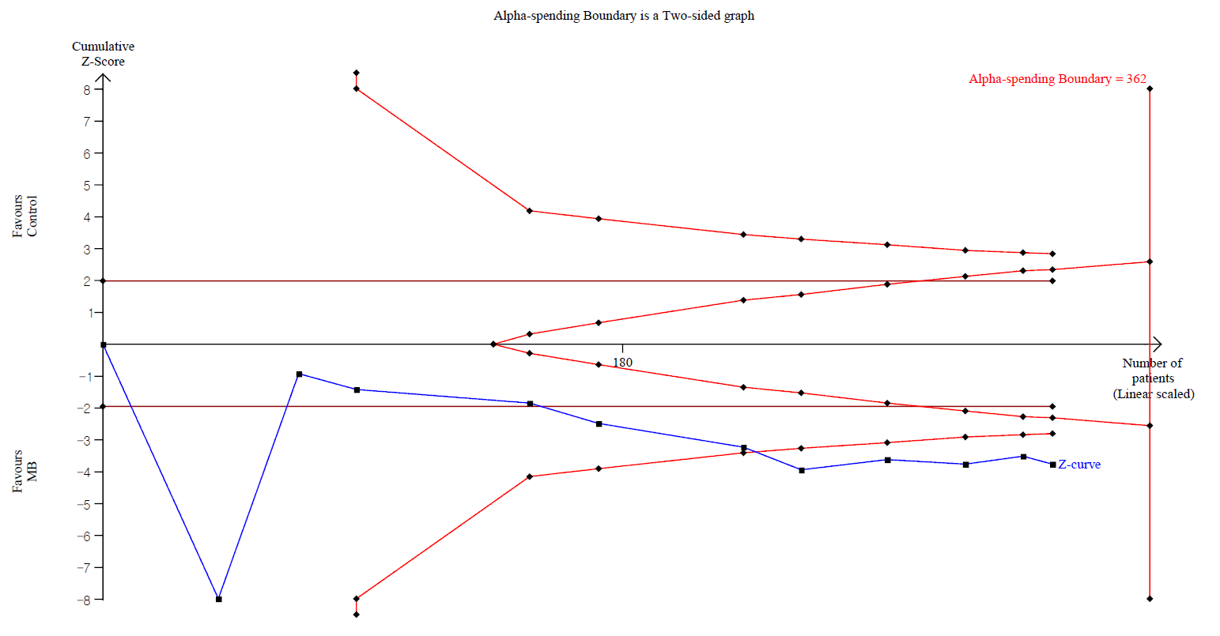
Supplementary figure 1. Trial sequence analysis for macroscopic adhesion score. The cumulative Z curve (complete blue curve, ) crossed both the conventional test boundary (etched red line, ) and the trial sequential monitoring boundary (complete red curve, )

