Supporting information

S.1 PRISMA flow diagram
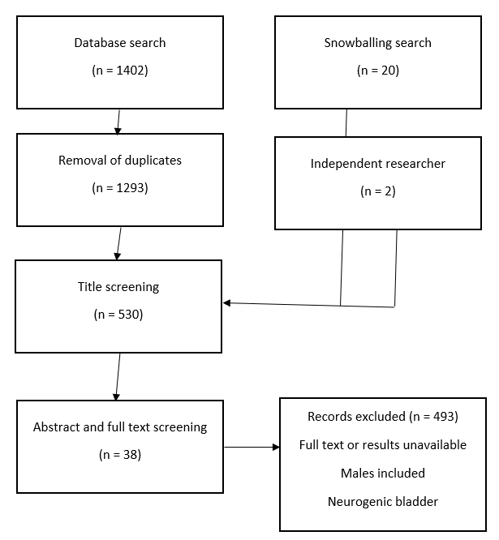

Figure 1: PRISMA flow diagram showing the process of data collection and narrowing of the search.
Trials were excluded if they did not meet the inclusion criteria of idiopathic OAB, pharmacological management and female participants.

