Multimedia Appendix 4
Effect estimates were transformed to a standardized regression coefficient (B). The following transformation were made:
Log Odds —> d —> r
b ---> B
r = B
Where: d = standardised mean difference; r = correlation coefficient; b = Unstandardised regression coefficient; B = standardised coefficient.
The table below details the equations used for the transformations.
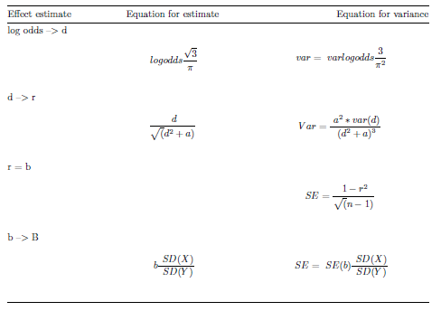
When SEs were missing they were calculated using the following formulas:

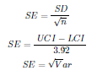

Where: SE = Standard error; d = Standardized mean difference; r = Correlation coefficient; b =
Standardized regression coefficient; B = Standardized regression coefficient; var = Variance; SD =
Standard deviation; UCI = Upper confidence interval; LCI = Lower confidence interval

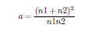
n1 = Sample size for group 1 n2 = Sample size for group 2
For studies where only a p-value was provided and no measure of variability, the p-value was used
to approximate the variance [1]. If an exact p-value was not provided (e.g. Ma and Lewis) and only
p<0.001 or p<0.01 was reported, a p-value of 0.0009 or 0.009, respectively, was assumed.

Three studies included in the meta-analysis assessed the relationship between physical activity and engagement by comparing the change in moderate to vigorous physical activity from baseline to follow-up. For these studies the difference was standardized using the baseline standard deviation rather than the standard deviation of change as recommended (1).

References
1. Morris SB, DeShon RP. Combining effect size estimates in meta-analysis with repeated measures and independent-groups designs. Psychological Methods. 2002;7(1):105-25.

