Supplementary Table 1. Embase search strategy used in the study.
Dilation
Query((((’esophagus achalasia’/exp) OR (’cardiospasm’:ab,ti OR ’achalasia’:ab,ti OR ’megaesophagus’:ab,ti OR ’mega
esophagus’:ab,ti OR ’megaoesophagus’:ab,ti OR ’mega oesophagus’:ab,ti)) AND ((’balloon dilatation’/exp) OR (dilation
OR dilatation:ab,ti)) AND [humans]/lim AND [english]/lim AND ([embase]/lim OR [embase classic]/lim)) NOT ’case
report’) NOT ((((’esophagus achalasia’/exp) OR (’cardiospasm’:ab,ti OR ’achalasia’:ab,ti OR ’megaesophagus’:ab,ti OR
’mega esophagus’:ab,ti OR ’megaoesophagus’:ab,ti OR ’mega oesophagus’:ab,ti)) AND ((’balloon dilatation’/exp) OR (dilation
OR dilatation:ab,ti)) AND [humans]/lim AND [english]/lim AND ([embase]/lim OR [embase classic]/lim)) NOT ’case
report’) AND ([editorial]/lim OR [letter]/lim OR [note]/lim)

Myotomy
Query((((’esophagus achalasia’/exp) OR (’cardiospasm’:ab,ti OR ’achalasia’:ab,ti OR ’megaesophagus’:ab,ti OR ’mega
esophagus’:ab,ti OR ’megaoesophagus’:ab,ti OR ’mega oesophagus’:ab,ti)) AND ((’myotomy’/exp) OR (myotomy OR heller
OR peroral OR (per AND oral) OR poem OR lhm)) AND [humans]/lim AND [english]/lim AND ([embase]/lim OR [embase
classic]/lim)) NOT ’case report’) NOT (((’esophagus achalasia’/exp) OR (’cardiospasm’:ab,ti OR ’achalasia’:ab,ti OR
’megaesophagus’:ab,ti OR ’mega esophagus’:ab,ti OR ’megaoesophagus’:ab,ti OR ’mega oesophagus’:ab,ti)) AND ((’myotomy’/
exp) OR (myotomy OR heller OR peroral OR (per AND oral) OR poem OR lhm)) AND [humans]/lim AND [english]/
lim AND ([embase]/lim OR [embase classic]/lim)) NOT ’case report’ AND ([editorial]/lim OR [letter]/lim OR [note]/lim)

Reference: Khashab MA, Vela MF, Thosani N, Agrawal D, Buxbaum JL, Abbas Fehmi SM, Fishman DS, Gurudu SR, Jamil LH, Jue TL, Kannadath BS, Law JK, Lee JK, Naveed M, Qumseya BJ, Sawhney MS, Yang J, Wani S. ASGE guideline on the management of achalasia. Gastrointest Endosc. 2020;91(2):213–227.

Supplementary Table 2. GRADE (Grading of Recommendations, Assessment, Development and Evaluation) categories of quality of evidence

GRADE Quality of Evidence | Meaning | Interpretation
High | We are very confident that the true effect lies close to that of the estimate of the effect. | Further research is VERY UNLIKELY to change our confidence in the estimate of effect
Moderate | We are moderately confident in the estimate of the effect; the true effect is likely to be close to the estimate of the effect, but there is a possibility that it is substantially different. | Further research is LIKELY to have an impact on our confidence in the estimate of effect and MAY change the estimate
Low | Our confidence in the estimate of the effect is limited; the true effect may be substantially different from the estimate of the effect. | Further research is VERY LIKELY to have an impact on our confidence in estimate of effect and is LIKELY to change the estimate
Very Low | We have very little confidence in the estimate of the effect; the true effect is likely to be substantially different from the estimate of the effect. | Any estimate of effect is very uncertain

Supplementary Table 3. Demographical and clinical characteristics of patients enrolled in the included randomized controlled trials comparing different interventions for management of achalasia.
Study, Year | Age | Gender male | Body Mass Index | Baseline Eckardt Score | Baseline LES pressure (mmHg) | Patient Questionnaire
Laparoscopic Heller Myotomy vs. Pneumatic Dilation
Boeckxstaens, 2011 | Intervention: 45.5 (42.8-48.3)  Control: 46.4 (43.2-49.6) | Intervention: 57 (53.7%)  Control: 60 (63.1%) | Intervention: 25 (24-26)  Control: 24.6 (23.8-25.4) | Intervention: 7.4 (7-7.8)  Control: 7 (6.7-7.4) | Intervention: 31 (28-33)  Control: 33 (30-37) | Intervention: QLQ-OES24 39 (36-42)  Control: QLQ-OES24 36 (34-39)
Borges, 2014 | Intervention: 45.8 (18-74)  Control: 52.8 (26-75) | Intervention: 16 (36.4%)  Control: 26 (52%) | NR | NR | Intervention: 29.9 (9.8-56.2)  Control: 27.8 (5-62.2) | NR
Hamdy, 2015 | Intervention: 32  Control: 30.8 | Intervention: 8 (32%)  Control: 5 (20%) | NR | Severe dysphagia in 4 patients in each group | Intervention: 39.8  Control: 37.4 | NR
Kostic, 2007 | Intervention: 43±14  Control: 45±18 | Intervention: 11 (44%)  Control: 13 (50%) | Intervention: Weight 68 Kg±13  Control: Weight 68 Kg±12 | NR | Intervention: 17.9±7.2  Control: 23.9±14.8 | Intervention: GSRS: 2.5±1.4  Control: GSRS 3.4±1.6
POEM vs. Pneumatic Dilation

Ponds, 2019 | Intervention: 47 (37-56)  Control: 50 (32-62) | Intervention: 33 (52%)  Control: 40 (61%) | Intervention: 23.2±3.7)  Control: 23.4±4.1 | Intervention: 8 (6-9)  Control: 7 (6-9) | Intervention: 31 (25-45)  Control: 32.8 (24-45) | Intervention: DSQoL 25 (22-27)  Control: DSQoL 24 (22-26)
POEM vs. Laparoscopic Heller Myotomy

Werner, 2019 | Intervention: 48.6 ± 14.9  Control: 48.6±14.6 | Intervention: 68 (60.7%)  Control: 60 (55%) | Intervention: 24.8±4.6  Control: 24.5±4.5 | Intervention: 6.8±2  Control: 6.7±2 | Intervention: 26.8±11.4  Control: 26±10.9 | Intervention: GQoL 89.2±23.1  Control: GQoL 90.4±18.1
[Abbreviations: LES-Lower Esophageal Sphincter; NR-Not reported, POEM- Peroral Endoscopic Myotomy]

Supplementary Table 4. GRADE Summary of Findings reporting the comparative efficacy of different treatment for achalasia. Quality of the evidence was rated based on GRADE methodology. RCTs of direct comparison were rated down for presence of any of the following factors – risk of bias in literature, inconsistency, indirectness, imprecision and publication bias.

 | 1-year treatment success
 | Relative risk (95% CI) | Quality of Evidence
All treatments vs. pneumatic dilation
LHM | 1.18 (0.96-1.44) | Low
POEM | 1.29 (0.99-1.69) | Low
vs. Laparoscopic Heller myotomy
POEM | 1.09 (0.86-1.39) | Very Low
Abbreviations: LHM-Laparoscopic Heller Myotomy; POEM-Per Oral Endoscopic Myotomy

Supplementary Table 5. Physiological outcomes reported at 1 year
 |  | Baseline |  |  | Post-Treatment |  |  | Mean difference
Variable | Treatment | No. of Cohorts | No. of patients | Mean mmHg (standard deviation) | No. of Cohorts | No. of patients | Mean mmHg (standard deviation) | No. of Cohorts | No. of patients | Mean mmHg (standard deviation)
Baseline LES basal pressure | PD | 5 | 260 | 30.9±4.6 | 3 | 186 | 11.4±2.3 | 3 | 186 | - 18.5 ±2.3
Baseline LES basal pressure | LHM | 5 | 309 | 28.9±7.1 | 2 | 131 | 10±3.1 | 2 | 131 | -18.9±4
Baseline LES basal pressure | POEM | 2 | 176 | 28.9±2.1 | 1 | 64 | 11.8±6.7 | 1 | 64 | -17.1 ±4.5
IRP | PD | 2 | 91 | 21.3±7.2 | 1 | 66 | 11±2.3 | 1 | 66 | -10.3±4.9
IRP | LHM | 2 | 134 | 26.8±6.4 | 1 | 109 | 11.5±0.8 | 1 | 109 | -15.3±5.6
IRP | POEM | 2 | 176 | 26.6±4 | 2 | 176 | 10.3±3 | 2 | 176 | -16.3±1
 |  | Baseline |  |  | 1 year after treatment |  |  | 2 years after treatment
 |  | No. of Cohorts | No. of patients | Median cm (IQR) | No. of Cohorts | No. of patients | Median cm (IQR) | No. of Cohorts | No. of patients | Median cm (IQR)
Height of barium contrast | PD | 2 | 161 | 9.35 (3-10.1) | 2 | 151 | 0 (0 to 1.5) | 2 | 119 | 1.84 (0-8.8)
Height of barium contrast | LHM | 1 | 106 | 12 (8.1-18) | 1 | 98 | 0 (0 to 0.65) | 1 | 97 | 1.9 (0-6.8)
Height of barium contrast | POEM | 1 | 64 | 7.2 (4.5-9.2) | 1 | 64 | 1.7 (0-3.3) | 1 | 58 | 2.3 (0-3.7)
Abbreviations: IQR, Interquartile Range; IRP, Integrated Relaxation Pressure; LES, Lower Esophageal Sfincter; LHM, Laparoscopic Heller Myotomy; NR, Not Reported; PD, Pneumatic Dilation; POEM, Per-Oral Endoscopic Myotomy

Supplementary Table 6. Serious adverse events reported in the randomized controlled trials comparing different interventions for management of achalasia.

Study | Adverse Events in the Intervention Group | Adverse Events in the Control Group
Laparoscopic Heller Myotomy vs. Pneumatic Dilation

Boeckxstaens, 2011 | Mucosal tear 12%  Conversion to open surgery: 0.9% | Perforation: 4%
Borges, 2014 | None | Perforation: 4%
Hamdy, 2015 | Mucosal injury: 12%  Perforation: 4% | Perforation: 8%
Kostic, 2007 | None | Perforation: 7.7%
Peroral Endoscopic Myotomy vs. Pneumatic Dilation
Ponds, 2019 | None | Perforation: 1.5%  Severe Pain: 1.5%
Peroral Endoscopic Myotomy vs. Laparoscopic Heller Myotomy
Werner, 2019 | Mucosal Leakage: 0.9%  Aspiration: 0.9%  Pneumothorax: 0.9% | Perforation: 2.7%  Severe Pain: 1.8%  Pneumothorax: 1.8%  Aspiration: 0.9%  Hiatal Stenosis: 0.9%

Supplementary Figure 1. Risk of bias summary of the included randomized-controlled trials

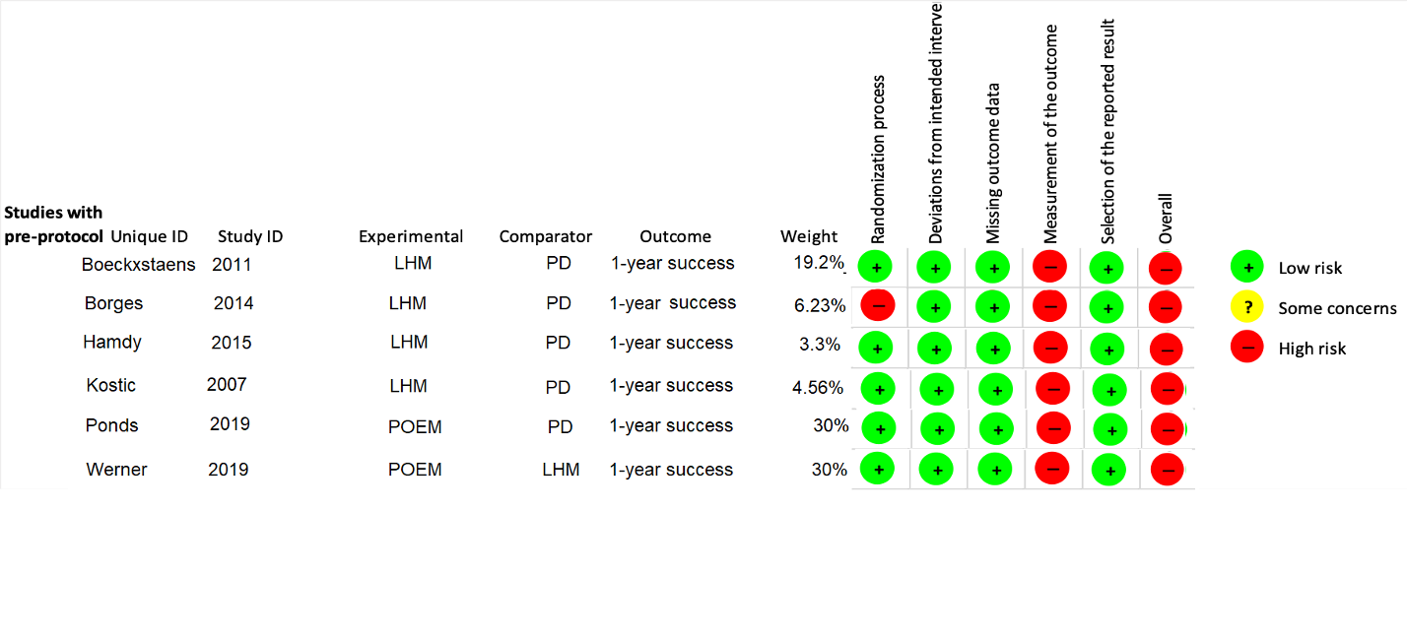

Supplementary Figure 2. Direct meta-analysis for 2-year treatment success rate



