Supplement
The Efficacy and Safety of Hydroxychloroquine in COVID-19 Patients: A Systematic Review and Meta-Analysis of Randomized Controlled Trials
Zakariya Kashour¹, MD, Tarek Kashour², MBChB, Dana Gerberi³, MLIS, Imad M. Tleyjeh⁴⁻⁷, MD, MSc,

Search strategies for the article appendix:
All EBM Reviews via Ovid (Cochrane Database of Systematic Reviews (2005+), ACP Journal Club (1991+), Cochrane Central Register of Controlled Trials (CCTR, 1991+), Cochrane Clinical Answers (CCA), Cochrane Methodology Register (2012+), Database of Abstracts of Reviews of Effects (DARE, 2016+), Health Technology Assessment Database (HTA, 2016+), National Health Service Economic Evaluation Databases (NHSEED, 2016+)):
((((corona-vir* or coronavir* or covid* or ncov* or hcov* or cov19 or cov-19 or cov2019 or cov-2019) adj5 ("19" or "2019" or novel or new or nuevo or nouveau or wuhan or hubei or china or chinese or pneumon* or pandemic* or outbreak* or quarantin* or shut-down* or shutdown* or lockdown* or lock-down* or "stay at home" or "stay-at-home" or "shelter-in-place")).ab,hw,kw,ti. or (corona-virinae19 or corona-virinae2019 or corona-virus19 or corona-virus2019 or coronavirinae19 or coronavirinae2019 or coronavirus19 or coronavirus2019 or covid19 or covid2019 or ncov19 or ncov2019 or hcov19 or hcov2019).ab,hw,kw,ti. or (sars* adj1 (corona-vir* or coronavir* or covid* or cov or hcov)).ab,hw,kw,ti. or (severe-acute-respiratory-syndrome adj1 (corona-vir* or coronavir* or covid* or cov* or hcov* or ncov*)).ab,hw,kw,ti. or (betacoronavirus or sarscov*).ab,hw,kw,ti.) AND (HCQ* or chloroquin* or chlorochin* or chloroquin* or hydroxychlorochin* or hydrochloroquin* or hydrocloroquin* or antimalaria* or anti-malaria* or antirheumati* or anti-rheumati* or amokin or anoclor or aralen* or arechin* or arequin* or arthrochin* or arthroquin* or artrichin* or artriquin* or avloclor or avoclor or bemaphat* or bemasulph or bipiquin or cadiquin or chemochin* or chingamin* or chlorofoz or chloroquinesulphate or choloquin* or choroquin* or cidanchin or clo-kit or clorichin* or cloriquin* or delagil or delagyl or dichinalex or diclokin or diquinalex or diroquine or emquin or ercoquin or genocin or gontochin* or gontoquin* or heliopar or imagon or iroquine or khingamin* or klorokin* or klorokinfosfat or lagaquin or malaquin or malarex or malarivon or malaviron or maliaquine or maquine or mesylith or mexaquin or mirquin or nivachine or nivaquin* or oxychlorochin* or plaquenil or p-roquine or quensyl or quinachlor or quingamine or repal or resochen* or resochin* or resochinon or resoquin* or reumachlor or roquine or sanoquin* or silbesan or siragan or sirajan or solprin* or tresochin* or tresoquin* or trochin* or troquin*).ab,hw,ti.) AND ((random* or RCT* or ((superiority or pragmatic or non-inferiority or noninferiority or equivalence) adj2 (trial or study or studies))).ab,hw,kw,ti.

Embase via Ovid (1974+):
((exp coronavirinae/ or ((corona-vir* or coronavir* or covid* or ncov* or hcov* or cov19 or cov-19 or cov2019 or cov-2019) adj5 ("19" or "2019" or novel or new or nuevo or nouveau or wuhan or hubei or china or chinese or pneumon* or pandemic* or outbreak* or quarantin* or shut-down* or shutdown* or lockdown* or lock-down* or "stay at home" or "stay-at-home" or "shelter-in-place")).ab,hw,kw,ti. or (corona-virinae19 or corona-virinae2019 or corona-virus19 or corona-virus2019 or coronavirinae19 or coronavirinae2019 or coronavirus19 or coronavirus2019 or covid19 or covid2019 or ncov19 or ncov2019 or hcov19 or hcov2019).ab,hw,kw,ti. or (sars* adj1 (corona-vir* or coronavir* or covid* or cov or hcov)).ab,hw,kw,ti,tw. or (severe-acute-respiratory-syndrome adj1 (corona-vir* or coronavir* or covid* or cov* or hcov* or ncov*)).ab,hw,kw,ti. or (betacoronavirus or sarscov*).ab,hw,kw,ti.) AND (chloroquine/ or HCQ* or hydroxychloroquine/ or (chloroquin* or chlorochin* or chloroquin* or hydroxychlorochin* or hydrochloroquin* or hydrocloroquin* or antimalaria* or anti-malaria* or antirheumati* or anti-rheumati* or amokin or anoclor or aralen* or arechin* or arequin* or arthrochin* or arthroquin* or artrichin* or artriquin* or avloclor or avoclor or bemaphat* or bemasulph or bipiquin or cadiquin or chemochin* or chingamin* or chlorofoz or chloroquinesulphate or choloquin* or choroquin* or cidanchin or clo-kit or clorichin* or cloriquin* or delagil or delagyl or dichinalex or diclokin or diquinalex or diroquine or emquin or ercoquin or genocin or gontochin* or gontoquin* or heliopar or imagon or iroquine or khingamin* or klorokin* or klorokinfosfat or lagaquin or malaquin or malarex or malarivon or malaviron or maliaquine or maquine or mesylith or mexaquin or mirquin or nivachine or nivaquin* or oxychlorochin* or plaquenil or p-roquine or quensyl or quinachlor or quingamine or repal or resochen* or resochin* or resochinon or resoquin* or reumachlor or roquine or sanoquin* or silbesan or siragan or sirajan or solprin* or tresochin* or tresoquin* or trochin* or troquin*).ab,du,dy,hw,kw,ti,tn.) AND (exp randomized controlled trial/ or (random* or RCT* or ((superiority or pragmatic or non-inferiority or noninferiority or equivalence) adj2 (trial or study or studies))).ab,hw,kw,ti.) NOT (exp animal/ not exp human/, (editorial or note or review or survey).pt.) Limit to 2019+

MEDLINE via Ovid (1946+ and Epub Ahead of Print, In-Process & Other Non-Indexed Citations and Ovid MEDLINE(R) Daily):
((exp Coronavirus/ or exp Coronavirus Infections/ or ((corona-vir* or coronavir* or covid* or ncov* or hcov* or cov19 or cov-19 or cov2019 or cov-2019) adj5 ("19" or "2019" or novel or new or nuevo or nouveau or wuhan or hubei or china or chinese or pneumon* or pandemic* or outbreak* or quarantin* or shut-down* or shutdown* or lockdown* or lock-down* or "stay at home" or "stay-at-home" or "shelter-in-place")).ab,hw,kw,ti. or (corona-virinae19 or corona-virinae2019 or corona-virus19 or corona-virus2019 or coronavirinae19 or coronavirinae2019 or coronavirus19 or coronavirus2019 or covid19 or covid2019 or ncov19 or ncov2019 or hcov19 or hcov2019).ab,hw,kw,ti. or (sars* adj1 (corona-vir* or coronavir* or covid* or cov or hcov)).ab,hw,kw,ti. or (severe-acute-respiratory-syndrome adj1 (corona-vir* or coronavir* or covid* or cov* or hcov* or ncov*)).ab,hw,kw,ti. or (betacoronavirus or sarscov*).ab,hw,kw,ti.) AND (exp Chloroquine/ or (HCQ* or chloroquin* or chlorochin* or chloroquin* or hydroxychlorochin* or hydrochloroquin* or hydrocloroquin* or antimalaria* or anti-malaria* or antirheumati* or anti-rheumati* or amokin or anoclor or aralen* or arechin* or arequin* or arthrochin* or arthroquin* or artrichin* or artriquin* or avloclor or avoclor or bemaphat* or bemasulph or bipiquin or cadiquin or chemochin* or chingamin* or chlorofoz or chloroquinesulphate or choloquin* or choroquin* or cidanchin or clo-kit or clorichin* or cloriquin* or delagil or delagyl or dichinalex or diclokin or diquinalex or diroquine or emquin or ercoquin or genocin or gontochin* or gontoquin* or heliopar or imagon or iroquine or khingamin* or klorokin* or klorokinfosfat or lagaquin or malaquin or malarex or malarivon or malaviron or maliaquine or maquine or mesylith or mexaquin or mirquin or nivachine or nivaquin* or oxychlorochin* or plaquenil or p-roquine or quensyl or quinachlor or quingamine or repal or resochen* or resochin* or resochinon or resoquin* or reumachlor or roquine or sanoquin* or silbesan or siragan or sirajan or solprin* or tresochin* or tresoquin* or trochin* or troquin*).ab,kw,rn,ti,nm.) AND (exp randomized controlled trial/ or (random* or RCT* or ((superiority or pragmatic or non-inferiority or noninferiority or equivalence) adj2 (trial or study or studies))).ab,hw,kw,ti.)) NOT (exp Animals/ not Humans/, (editorial or note or review or survey).pt.) Limit to 2019+

PubMed.gov (1946+)
(Covid-19 PubMed filter from the Canadian Agency for Drugs and Technologies in Health – CADTH - used below)
((((((Coronavirus[mh:noexp] OR Betacoronavirus[mh:noexp] OR Coronavirus Infections[mh:noexp]) AND (Disease Outbreaks[mh:noexp] OR Epidemics[mh:noexp] OR Pandemics[mh])) OR COVID-19 diagnostic testing [Supplementary Concept] OR COVID-19 drug treatment [Supplementary Concept] OR COVID-19 serotherapy [Supplementary Concept] OR COVID-19 vaccine [Supplementary Concept] OR spike glycoprotein, COVID-19 virus [Supplementary Concept] OR COVID-19 [Supplementary Concept] OR severe acute respiratory syndrome coronavirus 2 [Supplementary Concept] OR nCoV[tiab] OR nCoV[tt] OR 2019nCoV[tiab] OR 2019nCoV[tt] OR 19nCoV[tiab] OR 19nCoV[tt] OR COVID19*[tiab] OR COVID19*[tt] OR COVID[tiab] OR COVID[tt] OR SARS-CoV-2[tiab] OR SARS-CoV-2[tt] OR SARSCOV-2[tiab] OR SARSCOV-2[tt] OR SARSCOV2[tiab] OR SARSCOV2[tt] OR Severe Acute Respiratory Syndrome Coronavirus 2[tiab] OR Severe Acute Respiratory Syndrome Coronavirus 2[tt] OR ((severe acute respiratory syndrome[tiab] OR severe acute respiratory syndrome[tt]) AND (corona virus 2[tiab] OR corona virus 2[tt])) OR new coronavirus[tiab] OR (new[tt] AND coronavirus[tt]) OR novel coronavirus[tiab] OR novel coronavirus[tt] OR novel corona virus[tiab] OR (novel[tt] AND corona virus[tt]) OR novel CoV[tiab] OR (novel[tt] AND CoV[tt]) OR novel HCoV[tiab] OR (novel[tt] AND HCoV[tt]) OR (("19″[tiab] OR "19"[tt] OR "2019"[tiab] OR "2019"[tt] OR Wuhan[tiab] OR Wuhan[tt] OR Hubei[tiab] OR Hubei[tt]) AND (coronavirus*[tiab] OR coronavirus*[tt] OR corona virus*[tiab] OR corona virus*[tt] OR CoV[tiab] OR CoV[tt] OR HCoV[tiab] OR HCoV[tt])) OR ((coronavirus*[tiab] OR coronavirus*[tt] OR corona virus*[tiab] OR corona virus*[tt] OR betacoronavirus*[tiab] OR betacoronavirus*[tt]) AND (outbreak*[tiab] OR outbreak*[tt] OR epidemic*[tiab] OR epidemic*[tt] OR pandemic*[tiab] OR pandemic*[tt] OR crisis[tiab] OR crisis[tt])) OR ((Wuhan[tiab] OR Wuhan[tt] OR Hubei[tiab] OR Hubei[tt]) AND (pneumonia[tiab] OR pneumonia[tt]))) AND (2019/10/31:3000/12/31[Date – Publication])) AND (("Chloroquine"[Mesh]) or ((HCQ* or chloroquin* or chlorochin* or chloroquin* or hydroxychlorochin* or hydrochloroquin* or hydrocloroquin* or antimalaria* or anti-malaria* or antirheumati* or anti-rheumati* or amokin or anoclor or aralen* or arechin* or arequin* or arthrochin* or arthroquin* or artrichin* or artriquin* or avloclor or avoclor or bemaphat* or bemasulph or bipiquin or cadiquin or chemochin* or chingamin* or chlorofoz or chloroquinesulphate or choloquin* or choroquin* or cidanchin or clo-kit or clorichin* or cloriquin* or delagil or delagyl or dichinalex or diclokin or diquinalex or diroquine or emquin or ercoquin or genocin or gontochin* or gontoquin* or heliopar or imagon or iroquine or khingamin* or klorokin* or klorokinfosfat or lagaquin or malaquin or malarex or malarivon or malaviron or maliaquine or maquine or mesylith or mexaquin or mirquin or nivachine or nivaquin* or oxychlorochin* or plaquenil or p-roquine or quensyl or quinachlor or quingamine or repal or resochen* or resochin* or resochinon or resoquin* or reumachlor or roquine or sanoquin* or silbesan or siragan or sirajan or solprin* or tresochin* or tresoquin* or trochin* or troquin*))) AND (("Randomized Controlled Trial" [Publication Type]) or (random* or RCT* or ((superiority or pragmatic or non-inferiority or noninferiority or equivalence) AND (trial* or study or studies))))) NOT (editorial[PT] OR note[PT] or review[PT] or survey[PT]))

Scopus via Elsevier (1970+):
( ( ( TITLE-ABS-KEY ( ( corona-vir* OR coronavir* OR covid OR ncov OR hcov OR cov19 OR cov-19 OR cov2019 OR cov-2019 ) W/5 ( 19 OR 2019 OR novel OR new OR nuevo OR nouveau OR wuhan OR hubei OR china OR chinese OR pneumon* OR pandemic* OR outbreak* OR quarantin* OR shut-down* OR shutdown* OR lockdown* OR lock-down* OR "stay at home" OR "stay-at-home" OR "shelter-in-place" ) ) ) OR ( TITLE-ABS-KEY ( corona-virinae19 OR corona-virinae2019 OR corona-virus19 OR corona-virus2019 OR coronavirinae19 OR coronavirinae2019 OR coronavirus19 OR coronavirus2019 OR covid19 OR covid2019 OR ncov19 OR ncov2019 OR hcov19 OR hcov2019 ) ) OR ( TITLE-ABS-KEY ( sars* W/1 ( corona-vir* OR coronavir* OR covid* OR cov OR hcov ) ) ) OR ( TITLE-ABS-KEY ( severe-acute-respiratory-syndrome W/1 ( corona-vir* OR coronavir* OR covid* OR cov* OR hcov* OR ncov* ) ) ) OR ( TITLE-ABS-KEY ( betacoronavirus OR sarscov* ) ) ) AND ( TITLE-ABS-KEY ( hcq* OR chloroquin* OR chlorochin* OR chloroquin* OR hydroxychlorochin* OR hydrochloroquin* OR hydrocloroquin* OR antimalaria* OR anti-malaria* OR antirheumati* OR anti-rheumati* OR amokin OR anoclor OR aralen* OR arechin* OR arequin* OR arthrochin* OR arthroquin* OR artrichin* OR artriquin* OR avloclor OR avoclor OR bemaphat* OR bemasulph OR bipiquin OR cadiquin OR chemochin* OR chingamin* OR chlorofoz OR chloroquinesulphate OR choloquin* OR choroquin* OR cidanchin OR clo-kit OR clorichin* OR cloriquin* OR delagil OR delagyl OR dichinalex OR diclokin OR diquinalex OR diroquine OR emquin OR ercoquin OR genocin OR gontochin* OR gontoquin* OR heliopar OR imagon OR iroquine OR khingamin* OR klorokin* OR klorokinfosfat OR lagaquin OR malaquin OR malarex OR malarivon OR malaviron OR maliaquine OR maquine OR mesylith OR mexaquin OR mirquin OR nivachine OR nivaquin* OR oxychlorochin* OR plaquenil OR p-roquine OR quensyl OR quinachlor OR quingamine OR repal OR resochen* OR resochin* OR resochinon OR resoquin* OR reumachlor OR roquine OR sanoquin* OR silbesan OR siragan OR sirajan OR solprin* OR tresochin* OR tresoquin* OR trochin* OR troquin* ) ) ) AND ( ( TITLE-ABS-KEY ( random* OR rct* ) OR TITLE-ABS-KEY ( ( superiority OR pragmatic OR non-inferiority OR noninferiority OR equivalence ) W/2 ( trial OR study OR studies ) ) ) ) AND ( LIMIT-TO ( PUBYEAR , 2020 ) OR LIMIT-TO ( PUBYEAR , 2019 ) ) AND ( LIMIT-TO ( DOCTYPE , "ar" ) OR LIMIT-TO ( DOCTYPE , "le" ) OR LIMIT-TO ( DOCTYPE , "er" ) )

Web of Science Core Collection via Clarivate Analytics (1975+):
(TS=((corona-vir* or coronavir* or covid or ncov or hcov or cov19 or cov-19 or cov2019 or cov-2019) NEAR/5 ("19" or "2019" or novel or new or nuevo or nouveau or wuhan or hubei or china or chinese or pneumon* or pandemic* or outbreak* or quarantin* or shut-down* or shutdown* or lockdown* or lock-down* or "stay at home" or "stay-at-home" or "shelter-in-place") ) OR TS=(corona-virinae19 or corona-virinae2019 or corona-virus19 or corona-virus2019 or coronavirinae19 or coronavirinae2019 or coronavirus19 or coronavirus2019 or covid19 or covid2019 or ncov19 or ncov2019 or hcov19 or hcov2019) OR TS=(sars* NEAR/1 (corona-vir* or coronavir* or covid* or cov or hcov) ) OR TS=(severe-acute-respiratory-syndrome NEAR/1 (corona-vir* or coronavir* or covid* or cov* or hcov* or ncov*) ) OR TS=(betacoronavirus or sarscov*)) AND TS=(HCQ* or chloroquin* or chlorochin* or chloroquin* or hydroxychlorochin* or hydrochloroquin* or hydrocloroquin* or antimalaria* or anti-malaria* or antirheumati* or anti-rheumati* or amokin or anoclor or aralen* or arechin* or arequin* or arthrochin* or arthroquin* or artrichin* or artriquin* or avloclor or avoclor or bemaphat* or bemasulph or bipiquin or cadiquin or chemochin* or chingamin* or chlorofoz or chloroquinesulphate or choloquin* or choroquin* or cidanchin or clo-kit or clorichin* or cloriquin* or delagil or delagyl or dichinalex or diclokin or diquinalex or diroquine or emquin or ercoquin or genocin or gontochin* or gontoquin* or heliopar or imagon or iroquine or khingamin* or klorokin* or klorokinfosfat or lagaquin or malaquin or malarex or malarivon or malaviron or maliaquine or maquine or mesylith or mexaquin or mirquin or nivachine or nivaquin* or oxychlorochin* or plaquenil or p-roquine or quensyl or quinachlor or quingamine or repal or resochen* or resochin* or resochinon or resoquin* or reumachlor or roquine or sanoquin* or silbesan or siragan or sirajan or solprin* or tresochin* or tresoquin* or trochin* or troquin*) AND TS=(random* or RCT*) or ((superiority or pragmatic or non-inferiority or noninferiority or equivalence) NEAR/2 (trial or study or studies))) Limit to 2019+, article or letter

Table S1 Study characteristics
Treatment RCTs
Study/ year | Country/ Setting | Study Population | Randomization | Intervention | Control | Primary Outcome
Abd-Elsalam et al. 2020 | Egypt | Patients admitted with suspected or confirmed COVID-19 | Patients were randomized using a computerized random number generator using simple randomization with an equal allocation ratio | HCQ 400 mg twice on day 1 followed by 200 mg twice daily for 15 days | SOC | Percentage of recovery
Cavalcanti et al. 2020 | Brazil/ Inpatient | Patients hospitalized with suspected or confirmed COVID-19 infection | Participants were randomly assigned 1:1:1 to SOC, SOC+ HCQ or SOC + HCQ + AZ | HCQ 400mg BID x 7 days or HCQ 400mg BID x 7 days + AZ 500 mg x 7 days | SOC | Clinical status at 15  days, evaluated with the use of a seven-level ordinal scale
Chen C et al. 2020 | Taiwan/ Inpatient | Patients admitted with RT-PCR confirmed Covid-19 infection | Patients were randomized 2:1 to either HCQ + SOC or SOC alone | HCQ 800 mg on day 1 followed by 400 mg. for 6 days | SOC | time to viral clearance
Chen J et al. 2020 | China/ Inpatient | Patients admitted with confirmed Covid-19 infection | Participants were randomly assigned to either treatment or control group  in a 1:1 ratio | HCQ | Conventional therapy | viral clearance by day 7 or death
Chen L et al. 2020 | China/ Inpatient | RT-PCR confirmed infection or lung changes characteristic of COVID-19 | Patients were assigned to 1 of 3 groups using a computer-generated randomization number | HCQ or CQ | SOC | Time to clinical recovery Secondary outcome: time to SARS-CoV-2 RNA negativity
Chen Z et al. 2020 | China/Inpatients | Laboratory (RT-PCR) positive of  SARS-CoV-2 | Randomized COVID-19 positive patients | HCQ 400 mg for 5 days | SOC | Time to clinical recovery
Dabbous et al. 2020 | Egypt | Patients with RT-PCR confirmed COVID-19 with mild to moderate disease | Computer based block- randomization with a 1:1 allocation ratio | HCQ 400 mg twice for 1 day then 200 mg twice daily between days 2 and 10 | Favipiravir 1600 mg twice for 1 day then 600 mg twice daily between days 2 and 10 | Viral clearance at days three,  seven and 14
Horby et al. 2020 | UK/Inpatient | Suspected or confirmed COVID-19 cases | Random assignment to HCQ or SOC | HCQ 800mg every 6 hours for 2 doses followed by 400mg after 6 hours. Then 400mg twice daily for 9 days | SOC | 28-day mortality
Karman et al. 2020 | Pakistan/ Inpatient | RT-PCR confirmed COVID-19 patients with mild illness | Patients who did not give consent for treatment or had contraindication for treatment | HCQ 800 mg on day 1 followed by 400 mg. for 4 days | Vitamin C, oral Zinc, oral Vitamin D | Disease progression Secondary outcome: Viral clearance at 7 and 14 days
Lychenbakken et al. 2002 | Norway | PCR-confirmed COVID-19 | Computer generated randomization sequence with a 1:1 allocation | HCQ 400 mg twice daily for seven days | SOC | The rate of decline in viral load in the oropharynx from baseline through the first 96 hours after randomization
Pan et al. | 30 countries | Patients hospitalized with a diagnosis of COVID-19 | Online based ranodomization system with a 1:1 ratio | HCQ 400 mg twice daily for 10 days | Local SOC | In-hospital mortality
Skipper et al. 2020 | USA and Canada/ Outpatient | Non-hospitalized adults with <4 days of symptoms and either PCR-confirmed COVID-19 infection or compatible symptoms after a high-risk exposure within the past 14 days | block randomization sequence using differently sized blocks in a 1:1 allocation | 800 mg then 600 mg 6 to 8 hours later, followed by 600 mg for 4 days | Lactose or folic acid placebo | Ordinal scale by day 14 of not hospitalized, hospitalized, ICU admission or death
Tang W et al. 2020 | China/Inpatient | PCR-confirmed COVID-19 | Random assignment with stratification | HCQ loading dose of 1200mg followed by 200mg 3 times day for up to 3 weeks | SOC | Negative conversion by 28 days and clinical improvement within 28 days in patients with severe infection
Ulrich et al. 2020 | United States | patients hospitalized with laboratory confirmed COVID-19 | 1:1 ratio | HCQ 800mg on day 1 then 400 mgs for 4 days | calcium citrate 200mg tablets | The proportion of subjects meeting a severe COVID-19 progression composite endpoint (death, ICU admission, mechanical ventilation, ECMO, and/or vasopressor use) at day 14.
Prevention RCTs
Abella et al. 2020 | USA | Health care workers who worked ≥ 20 hours per week in hospital-based units, had no known history of SARS-CoV-2 infection, and did not have symptoms suggestive of COVID-19 | Participants were randomized in a 1:1 ratio to receive either treatment or placebo in blocks of 8 | HCQ, 600 mg, daily | Placebo | The rate of conversion to SARS-CoV-2–positive status via NP swab in enrolled participants during the 8 weeks
Boulware et al. 2020 | USA and Canada/ Outpatient | Adults within 4 days of household or occupational exposure to someone with confirmed COVID-19 | Participants were randomly assigned to either treatment or control group  in a 1:1 ratio | HCQ 800 mg followed by 600 mg in 6 to 8 hours, followed by 600 mg  daily for 4 days | Placebo | Incidence of Lab confirmed COVID-19 or illness compatible with COVID-19 within 14 days
Lofgren et al. 2020 | USA and Canada/ Outpatient | Known exposure to a PCR-confirmed COVID-19 case within four days | Random assignment to HCQ or SOC | HCQ 800mg, followed by 600mg in 6-8 hours, then 600mg daily for 5 days | Placebo | Adverse events only
Mitja et al. 2020 | Spain/ Outpatient | Close contact with PCR-confirmed COVID-19 cases and signs and asymptomatic for the previous 2 weeks | Cluster-randomization 1:1 to HCQ or usual care | HCQ 800mg on the first day followed by 400 mg daily for 6 days | Usual care | Onset of a confirmed Covid-19 episode
Pujol et al. 2020 | Spain | Healthcare workers working at least 3 days a week in a trial hospital with a negative result  PCR assay within four days before enrolment. | Sequentially numbered sealed envelopes of  identical appearance containing either hydroxychloroquine or placebo. | HCQ 400 mg daily for 4 days followed by 400 mg weekly during the study period, | Placebo treatment with the same schedule as HCQ | the incidence of COVID-19 confirmed cases (defined by compatible symptoms with COVID-19 with seroconversion or a positive PCR for SARS-CoV-2)
Rajasingham et al. 2020 | USA/ Canada | Healthcare workers with ongoing exposure to persons with Covid-19 | Randomly assigned in a 2:2:1:1 ratio to hcq or once or twice a week or placebo once or twice a week | hydroxychloroquine 400mg once weekly or twice weekly for 12 weeks | Placebo | Covid-19–free survival time by laboratory-confirmed or probable compatible illness

AZ: Azithromycin; CQ: Chloroquine; HCQ: Hydroxychloroquine; ICU: Intensive care unit; NR: Not reported; SOC: Standard of care

Table S2 PRISMA checklist
Section/topic | # | Checklist item | Reported on page #
TITLE
Title | 1 | Identify the report as a systematic review, meta-analysis, or both. | 1
ABSTRACT
Structured summary | 2 | Provide a structured summary including, as applicable: background; objectives; data sources; study eligibility criteria, participants, and interventions; study appraisal and synthesis methods; results; limitations; conclusions and implications of key findings; systematic review registration number. | 2
INTRODUCTION
Rationale | 3 | Describe the rationale for the review in the context of what is already known. | 3
Objectives | 4 | Provide an explicit statement of questions being addressed with reference to participants, interventions, comparisons, outcomes, and study design (PICOS). | 3
METHODS
Protocol and registration | 5 | Indicate if a review protocol exists, if and where it can be accessed (e.g., Web address), and, if available, provide registration information including registration number. | NA
Eligibility criteria | 6 | Specify study characteristics (e.g., PICOS, length of follow-up) and report characteristics (e.g., years considered, language, publication status) used as criteria for eligibility, giving rationale. | 3-4
Information sources | 7 | Describe all information sources (e.g., databases with dates of coverage, contact with study authors to identify additional studies) in the search and date last searched. | 4
Search | 8 | Present full electronic search strategy for at least one database, including any limits used, such that it could be repeated. | S1
Study selection | 9 | State the process for selecting studies (i.e., screening, eligibility, included in systematic review, and, if applicable, included in the meta-analysis). | 3-4
Data collection process | 10 | Describe method of data extraction from reports (e.g., piloted forms, independently, in duplicate) and any processes for obtaining and confirming data from investigators. | 4
Data items | 11 | List and define all variables for which data were sought (e.g., PICOS, funding sources) and any assumptions and simplifications made. | 4-5
Risk of bias in individual studies | 12 | Describe methods used for assessing risk of bias of individual studies (including specification of whether this was done at the study or outcome level), and how this information is to be used in any data synthesis. | 5
Summary measures | 13 | State the principal summary measures (e.g., risk ratio, difference in means). | 5-6
Synthesis of results | 14 | Describe the methods of handling data and combining results of studies, if done, including measures of consistency (e.g., I²) for each meta-analysis. | 5-6
Risk of bias across studies | 15 | Specify any assessment of risk of bias that may affect the cumulative evidence (e.g., publication bias, selective reporting within studies). | 6
Additional analyses | 16 | Describe methods of additional analyses (e.g., sensitivity or subgroup analyses, meta-regression), if done, indicating which were pre-specified. | NA
RESULTS
Study selection | 17 | Give numbers of studies screened, assessed for eligibility, and included in the review, with reasons for exclusions at each stage, ideally with a flow diagram. | 6
Study characteristics | 18 | For each study, present characteristics for which data were extracted (e.g., study size, PICOS, follow-up period) and provide the citations. | 6
Risk of bias within studies | 19 | Present data on risk of bias of each study and, if available, any outcome level assessment (see item 12). | 6
Results of individual studies | 20 | For all outcomes considered (benefits or harms), present, for each study: (a) simple summary data for each intervention group (b) effect estimates and confidence intervals, ideally with a forest plot. | 7-11
Synthesis of results | 21 | Present results of each meta-analysis done, including confidence intervals and measures of consistency. | 7-11
Risk of bias across studies | 22 | Present results of any assessment of risk of bias across studies (see Item 15). | S7
Additional analysis | 23 | Give results of additional analyses, if done (e.g., sensitivity or subgroup analyses, meta-regression [see Item 16]). | 8
DISCUSSION
Summary of evidence | 24 | Summarize the main findings including the strength of evidence for each main outcome; consider their relevance to key groups (e.g., healthcare providers, users, and policy makers). | 11
Limitations | 25 | Discuss limitations at study and outcome level (e.g., risk of bias), and at review-level (e.g., incomplete retrieval of identified research, reporting bias). | 11-12
Conclusions | 26 | Provide a general interpretation of the results in the context of other evidence, and implications for future research. | 12
FUNDING
Funding | 27 | Describe sources of funding for the systematic review and other support (e.g., supply of data); role of funders for the systematic review. | 1

Figure S1 Cochrane ROB2 quality assessment of the included trials
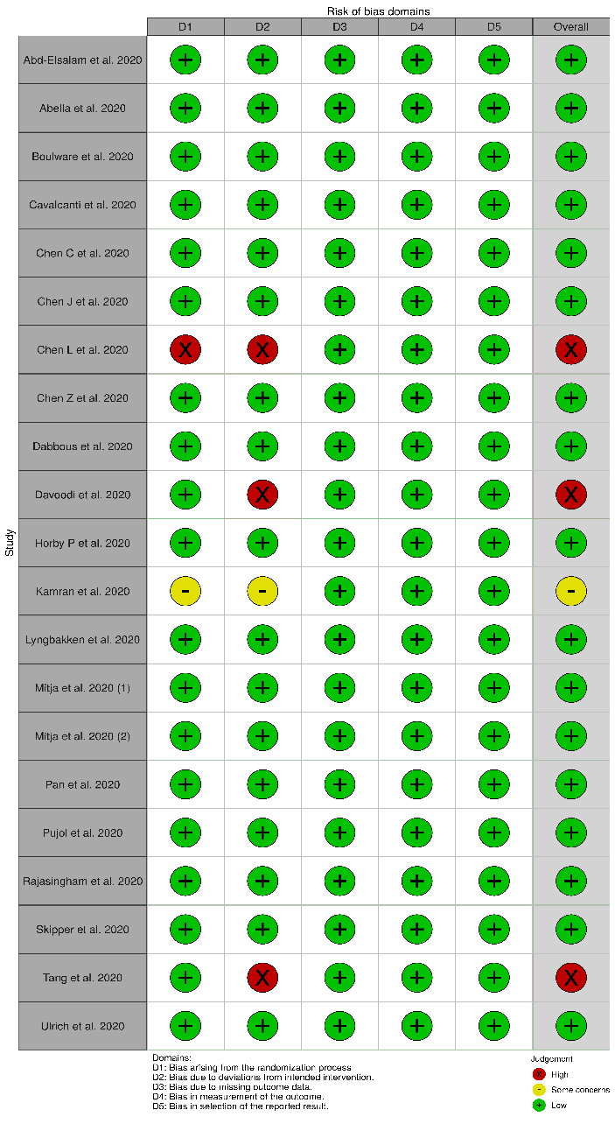
Figure S2: Effect of HCQ on short-term mortality in COVID-19 patients: Fixed effect model forest plot (risk ratio)
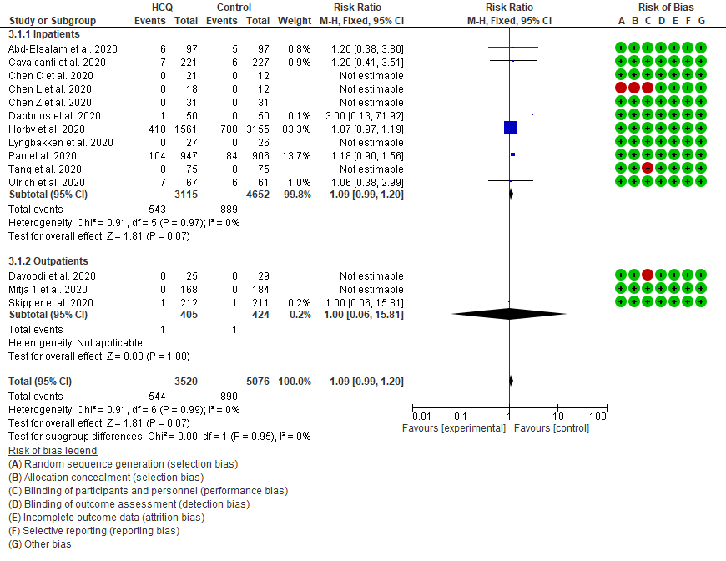

Figure S3: Funnel plot for the studies that were included in the mortality meta-analysis
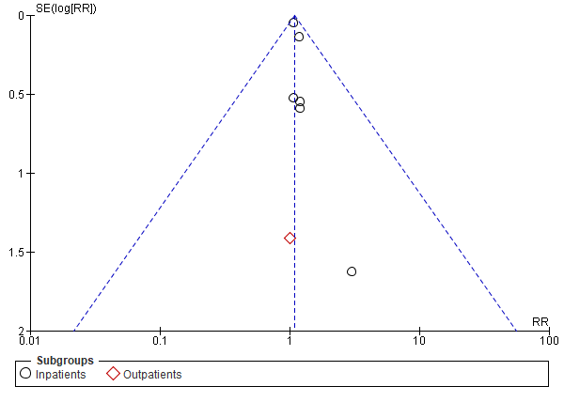

Figure S4 A: Effect of HCQ on short-term mortality (sensitivity analysis-1), included the HCQ/azithromycin arm of Cavalcanti et al. Random effect model forest plot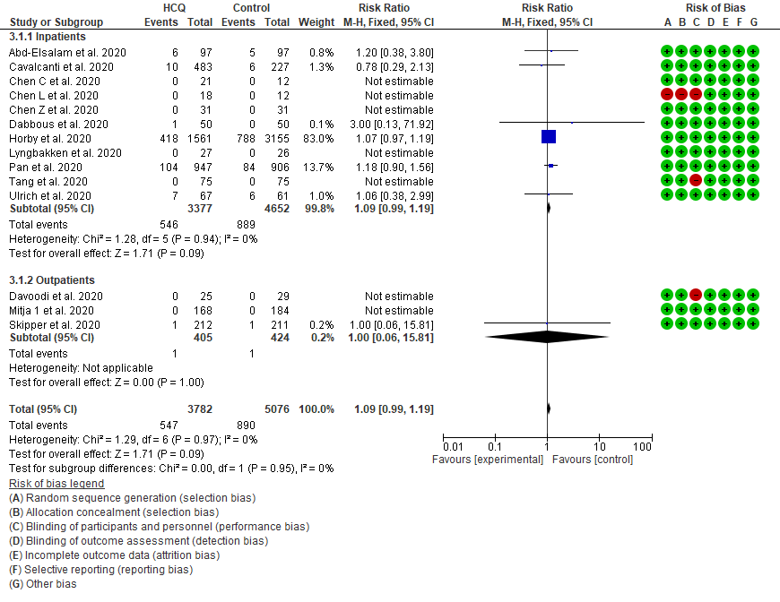
Figure S4 B: Effect of HCQ on short-term mortality (sensitivity analysis-2), excluding studies at high risk of bias: Random effect model forest plot 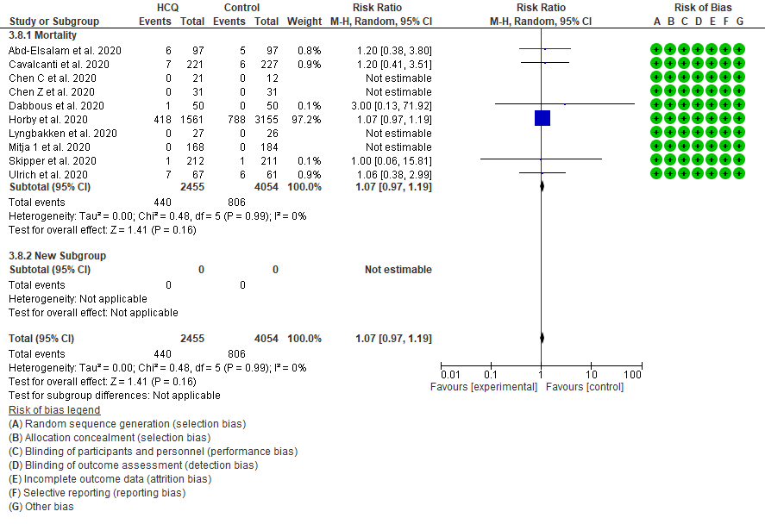
Figure S5 A: Effect of HCQ on viral clearance at 7 days (sensitivity analysis), excluding studies at high risk of bias: Random effect model forest plot
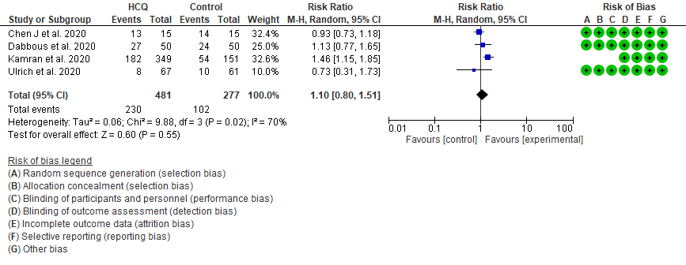
Figure S5 B: Effect of HCQ on viral clearance at 14 days (sensitivity analysis), excluding studies at high risk of bias: Random effect model forest plot
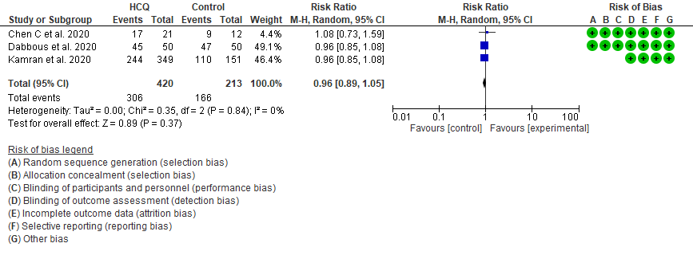
Figure S6: Effect of HCQ on symptom resolution (sensitivity analysis), excluding studies at high risk of bias: Random effect model forest plot
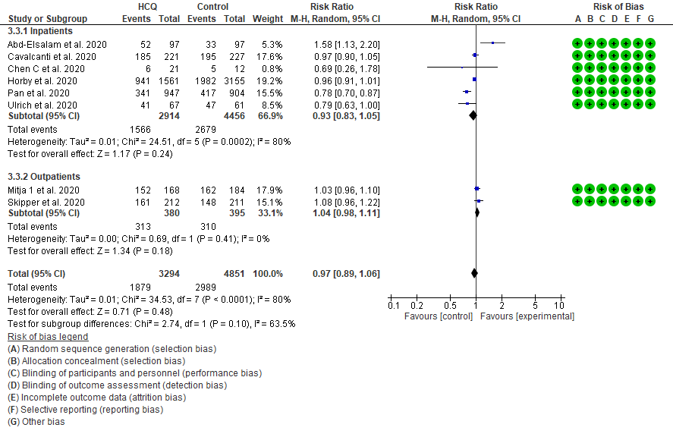
Figure S7 A: HCQ associated any adverse events expressed as risk difference: Random effect model forest plot 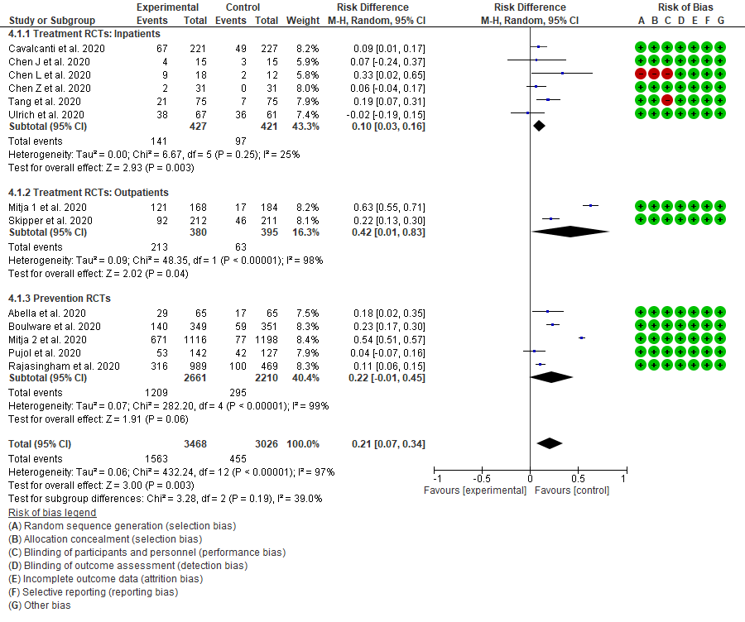
Figure S7 B: HCQ associated any adverse events expressed as risk ratio: Random effect model forest plot
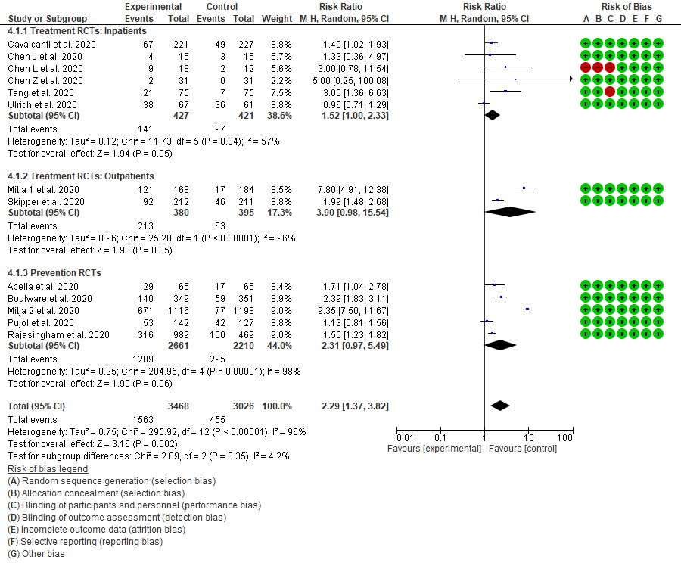
Figure S8: HCQ associated arrhythmias expressed as risk ratios: Fixed effect model forest plot
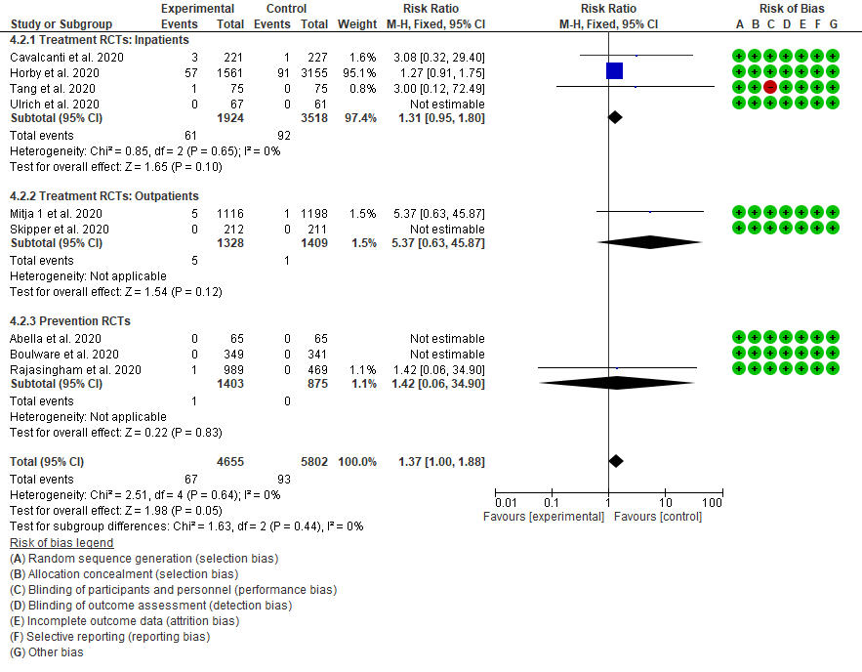
Figure S9: HCQ associated GI side effects expressed as risk ratio: Random effect model forest plot
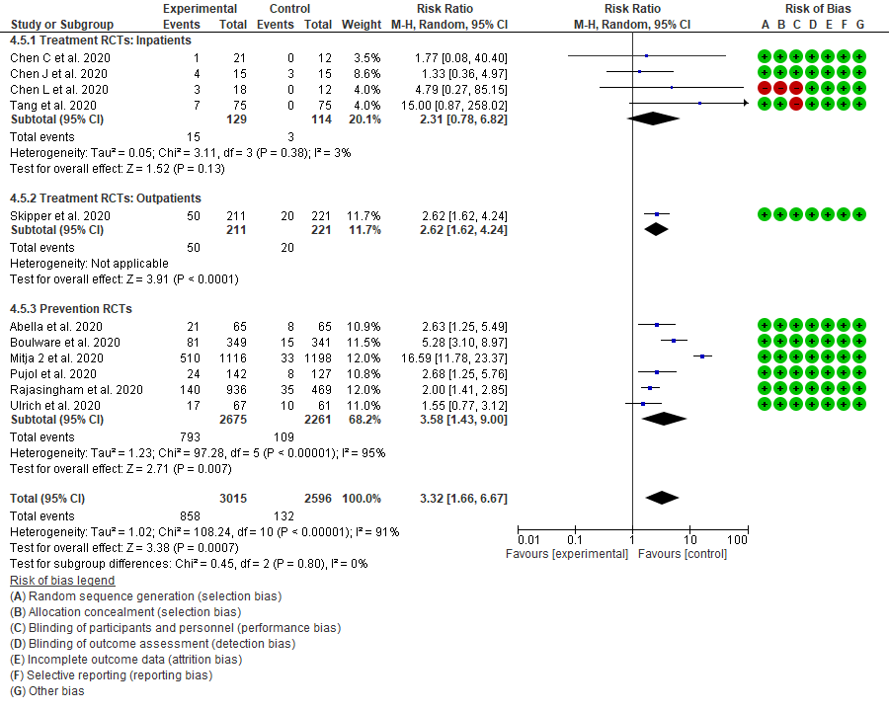
Figure S10: HCQ associated headaches expressed as risk ratio: Fixed effect model forest plot
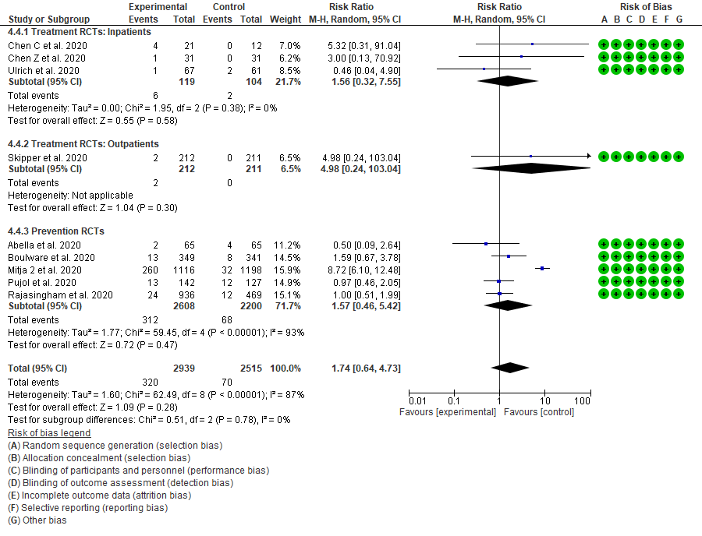
Figure S11: HCQ associated LFT elevation expressed as risk ratio: Fixed effect model forest plot
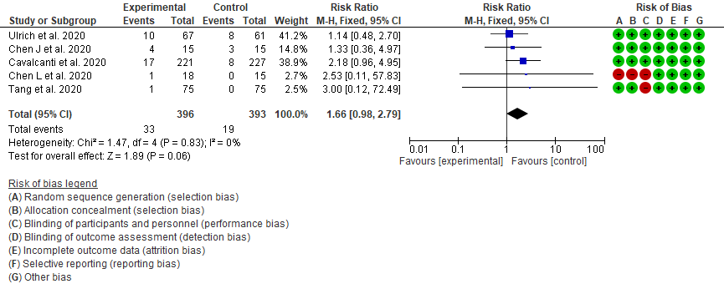

Figure S12: HCQ associated Neurologic symptoms expressed as risk ratio: Random effect model forest plot
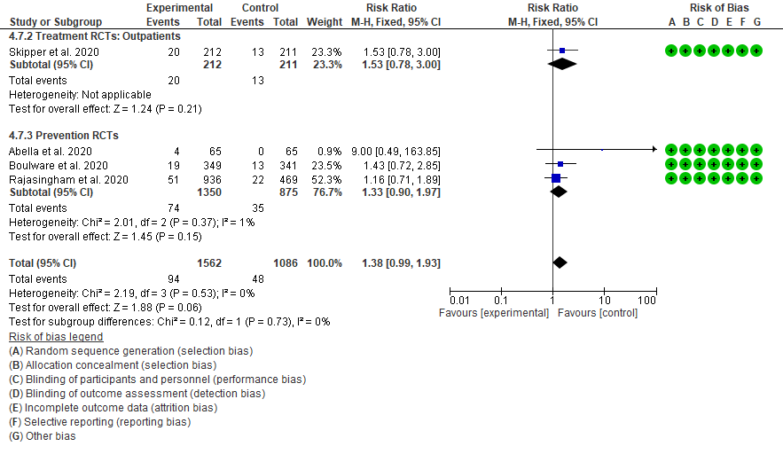

Figure S13: HCQ associated skin rash expressed as risk ratio: Fixed effect model forest plot 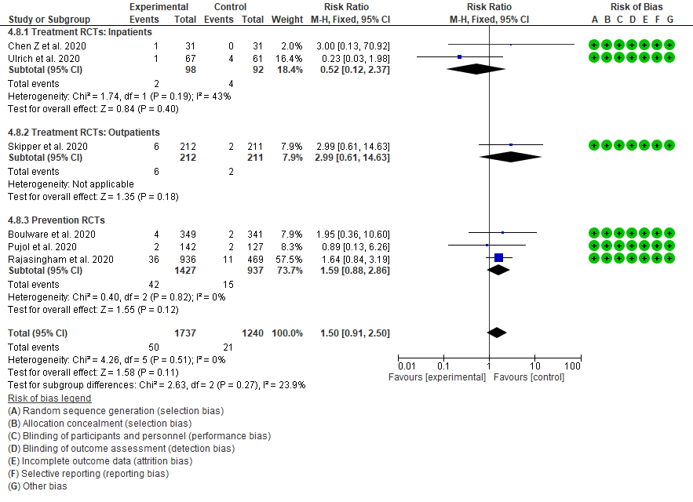
Figure S14: HCQ associated visual symptoms expressed as risk ratio: Fixed effect model forest plot


