Supplemental 3
Figure S1. Trial sequential analysis of MACEs
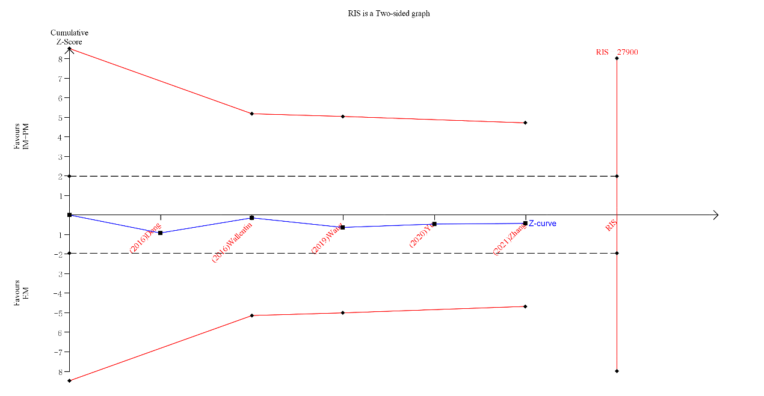
Figure S2. Trial sequential analysis of stoke
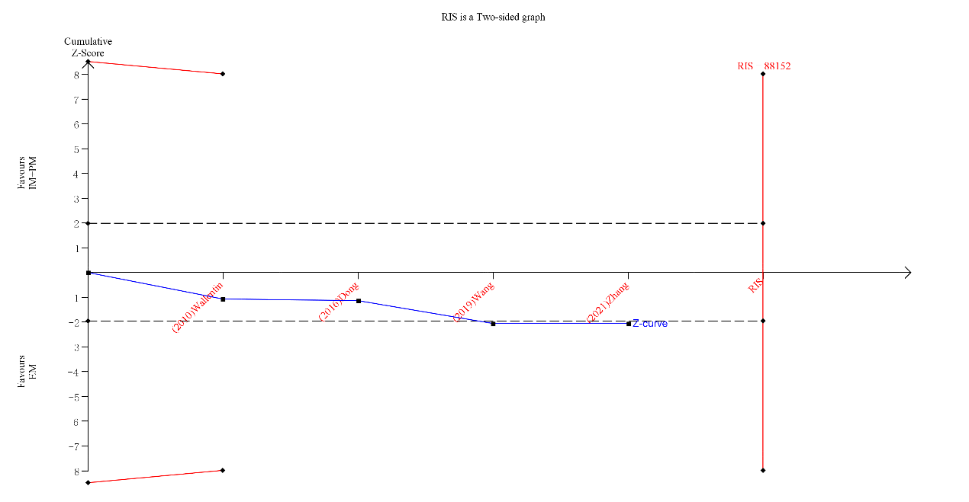
Figure S3. Trial sequential analysis of the bleeding events of Asian subgroup
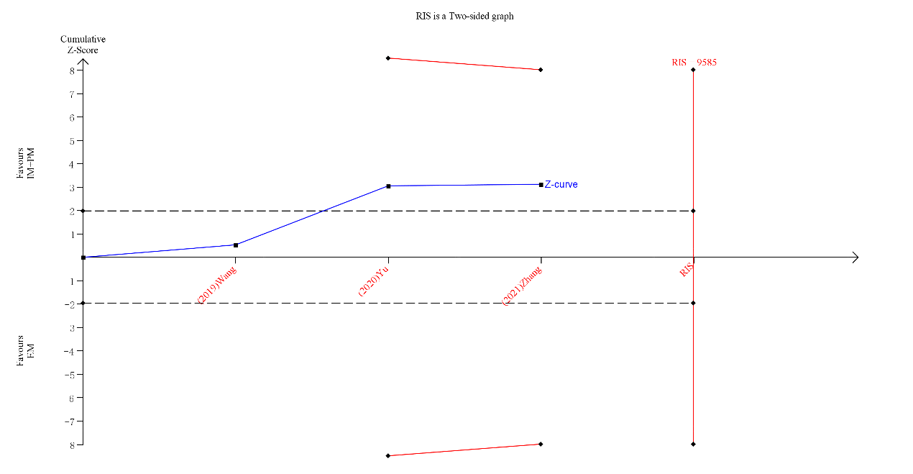
Figure S4. Trial sequential analysis of the bleeding events
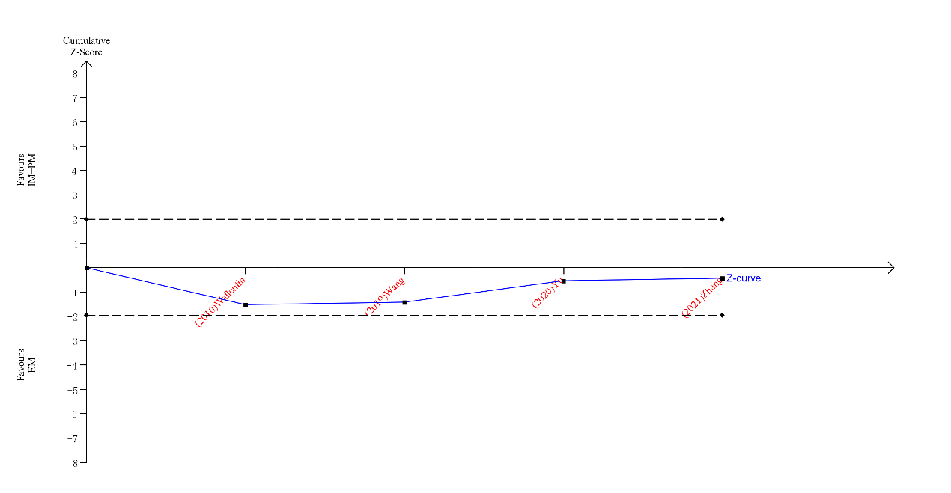

Figure S5. Trial sequential analysis of MI
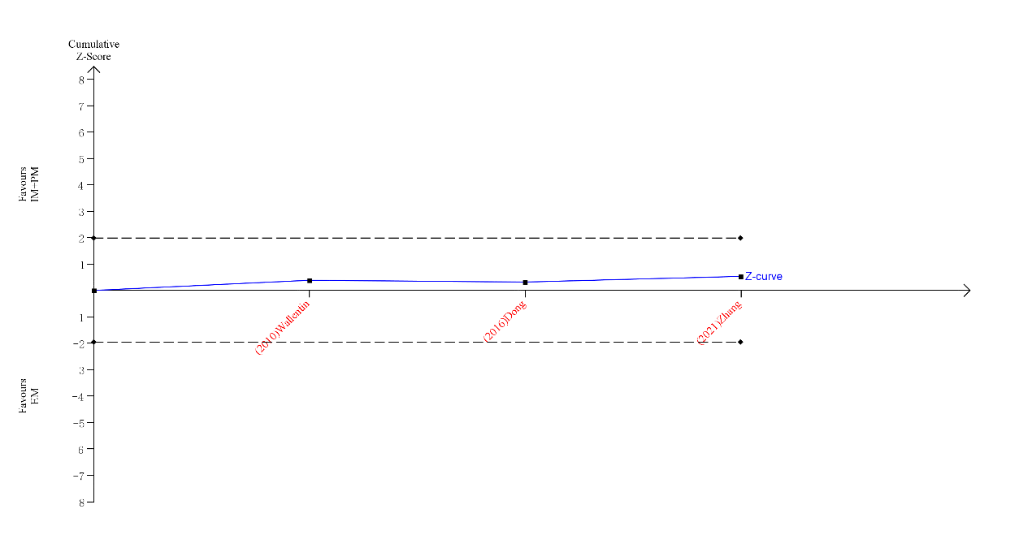

Figure S6. Trial sequential analysis of definite stent thrombosis
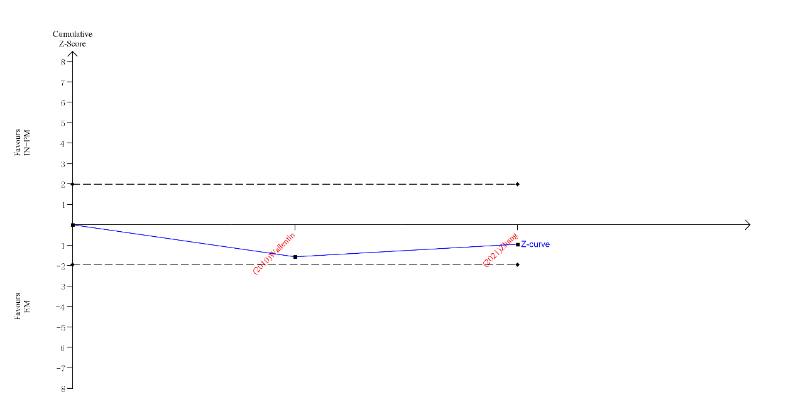

Figure S7. Trial sequential analysis of revascularization
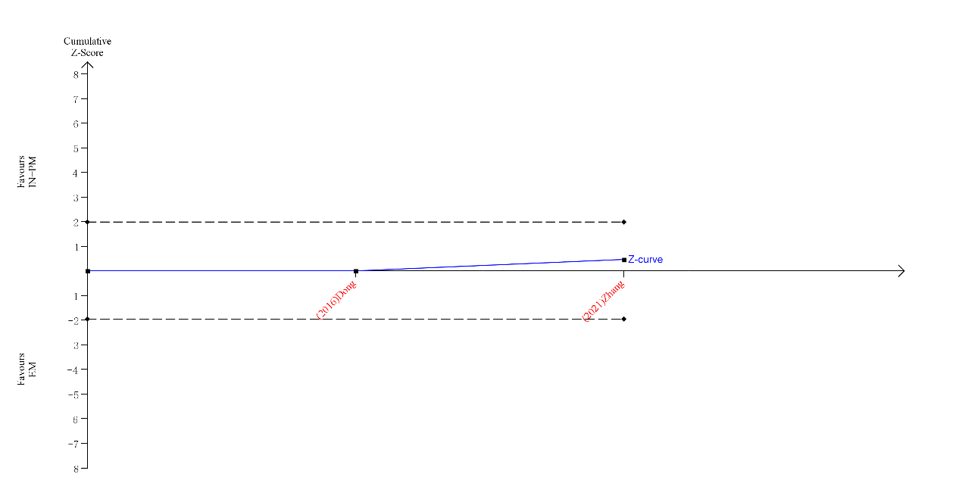
Annotation of all these figures:
TSA for a relative risk improvement of 20%. The continuous blue line represents the Z line (cumulative effect size), red lines represent the trial sequential monitoring boundaries, and required information size (RIS, the estimated optimal sample size adjusted to sample size and repeated analysis). The black dashed lines represent the conventional CIs.

