ADDITIONAL FILE

Additional file 1: Table S1: Research strategy
("colitis, ulcerative"[MeSH Terms] OR "inflammatory bowel disease"[All Fields] OR "ulcerative colitis"[All Fields])
AND
("mucosal healing"[All Fields] OR "endoscopic remission"[All Fields] OR "endoscopic healing"[All Fields] OR "Mayo endoscopic score"[All Fields] OR "Mayo 0"[All Fields] OR "Mayo 1"[All Fields])

Additional file 1: Table S2: Clinical Outcomes and Measures
Reference (Country) | Study design |  | Outcome |  | Colonoscope technology
 |  | Clinical Relapse | Colectomy | Hospitalization
Barreiro-de Acosta  2016  (Spain) | Prospective | Recatal bleeding AND  Therapy to induce remission  or any treatment escalation | Yes | No | n.a.
Narang 2018  (India) | Prospective | Simple Clinical Colitis Activity Index > 2 | No | No | n.a.
Ponte 2017  (Portugal) | Retrospective | Therapy to induce remission  Partial Mayo score ≥2 | No | No | n.a.
Boal Carvalho 2016  (Portugal) | Retrospective | Therapy to induce remission  Any treatment escalation | Yes | Yes | n.a.
Yokoyama 2013  (Japan) | Retrospective | Any treatment escalation | No | No | High magnification colonoscope
Kim 2016  (South Korea) | Retrospective | Partial Mayo score ≥3 | Yes | No | n.a.
Yoshino 2016  (Japan) | Retrospective | Any treatment escalation | No | No | n.a.
Lόpez-Palacios 2011  (Spain) | Prospective | Truelove and Witt’s criteria | Yes | No | n.a.
Yamamoto 2018  (Japan) | Prospective | Worsening of stool frequency and/or rectal bleeding with MES ≥2 | No | No | n.a.
Frieri 2017  (Italy) | Prospective | Treatment escalation (Steroid, Immunomodulator, biological drugs) | Yes | Yes | n.a.
Lobatόn 2018  (Belgium, Spain) | Prospective | Partial Mayo score ≥3  Any treatment escalation | Yes | Yes | Chromoendoscopy or narrow-banding imaging
Osterman 2020  (USA) | Prospective | Partial Mayo score ≥2  Any treatment escalation | No | No | n.a.
Inoue 2013  (Japan) | Retrospective (Abstract) | Recatal bleeding AND increase in bowel movement at two consecutive visits | No | No | n.a.
Sakemi 2016  (Japan) | Retrospective (Abstract) | Lichtiger Clinical activity Index (CAI) score ≥5 | No | No | n.a.
Kanazawa 2019  (Japan) | Retrospective | Rachmilewitz Clinical Activity Index (RCA)I ≥5 | No | No | n.a.

Additional file 1: Table S3: Baseline characteristics of the included studies
Reference  (Country) | Study design | Follow-up  (months) | Population | Baseline therapy | MES 0 or 1 | Outcome
Barreiro-de Acosta  2016  (Spain) | Prospective | 12 | 187 | None, Mesalamine, IMM†, anti-TNFα‡ | 187  Mayo 0= 126 (67.3%)  Mayo 1= 61 (32.7%) | Clinical relapse, Colectomy
Narang 2018  (India) | Prospective | 12 | 76 | Mesalamine, IMM† | 46  Mayo 0= 36 (78.3%)  Mayo 1= 10 (21.7%) | Clinical relapse
Ponte 2017  (Portugal) | Retrospective | 46-72 | 82 | Mesalamine, IMM† | 60  Mayo 0= 32 (53.3%)  Mayo 1= 28 (46.7%) | Clinical relapse
Boal Carvalho 2016  (Portugal) | Retrospective | 12 | 138 | Mesalamine, IMM†, anti-TNFα‡ | 138  Mayo 0= 61 (44.2%)  Mayo 1= 77 (55.8%) | Clinical relapse, Colectomy, Hospitalization
Yokoyama 2013  (Japan) | Retrospective | 60 | 38 | None, Mesalamine, IMM† | 24  Mayo 0= 9 (37.5%)  Mayo 1= 15 (62.5%) | Clinical relapse
Kim 2016  (South Korea) | Retrospective | 80 | 215 | Mesalamine, IMM†, anti-TNFα‡ | 200  Mayo 0= 113 (56.5%)  Mayo 1= 87 (43.5%) | Clinical relapse, Colectomy
Yoshino 2016  (Japan) | Retrospective | 16 | 298 | Mesalamine, IMM†, anti-TNFα‡, GMAA§, none | 88  Mayo 0= 43 (48.9%)  Mayo 1= 45 (51.1%) | Clinical relapse
Lόpez-Palacios 2011  (Spain) | Prospective | 27 | 20 | IMM† | 13  Mayo 0= 10 (76.9%)  Mayo 1= 3 (23.1%) | Clinical relapse, Colectomy
Yamamoto 2018  (Japan) | Prospective | 12 | 164 | Mesalamine | 164  Mayo 0=84 (51%)  Mayo 1= 80 (49%) | Clinical relapse
Frieri 2017  (Italy) | Prospective | 36 | 52 | Mesalamine | 46  Mayo 0=29 (63%)  Mayo 1= 17 (37%) | Clinical relapse, Colectomy, Hospitalization
Lobatόn 2018  (Belgium, Spain) | Prospective | 12 | 96 | Mesalamine, IMM†, anti-TNFα‡ | 96  Mayo 0= 63 (66%)  Mayo 1= 33 (34%) | Clinical relapse, Colectomy, Hospitalization
Osterman 2020  (USA) | Prospective | 12 | 100 | Mesalamine, IMM†, anti-TNFα‡ | 61  Mayo 0= 5 (8.2%)  Mayo 1= 56 (91.8%) | Clinical relapse
Inoue 2013  (Japan) | Retrospective  (Abstract) | 39 | 331 | n.a.¶ | 254  Mayo 0= 176 (69%)  Mayo 1= 78 (31%) | Clinical relapse
Sakemi 2016  (Japan) | Retrospective (Abstract) | 36 | 74 | Mesalamine, IMM† | 74  Mayo 0= 23 (31%)  Mayo 1= 51 (69%) | Clinical relapse
Kanazawa 2019  (Japan) | Retrospective | 24 | 166 | Mesalamine | 166  Mayo 0= 91 (%)  Mayo 1= 75 (%) | Clinical relapse
†IMM: Azathioprine or 6-mercaptopurine; ‡TNF: tumor necrosis factor; §GMAA: granulocyte monocyte adsorption apheresis.
¶n.a.: not available.

Additional file 1: Table S4: Quality Assessment of Studies by Newcastle-Ottawa Scale
Reference  (Country) | Study design
 |  | Selection | Comparability | Outcome | Total Score  Average
Barreiro-de Acosta  2016 (Spain) | Prospective | **** | ** | *** | 9
Narang 2018  (India) | Prospective | **** | - | ** | 6
Ponte 2017  (Portugal) | Retrospective | **** | - | *** | 7
Boal Carvalho 2016  (Portugal) | Retrospective | **** | ** | *** | 9
Yokoyama 2013  (Japan) | Retrospective | **** | - | *** | 7
Kim 2016  (South Korea) | Retrospective | **** | - | ** | 6
Yoshino 2016  (Japan) | Retrospective | *** | ** | *** | 8
Lόpez-Palacios 2011  (Spain) | Prospective | *** | - | *** | 6
Yamamoto 2018  (Japan) | Prospective | ** | - | *** | 5
Frieri 2017  (Italy) | Prospective | *** | - | *** | 6
Lobatόn 2017  (Belgium, Spain) | Prospective | **** | - | ** | 6
Osterman 2020  (USA) | Prospective | **** | - | *** | 7
Inoue 2013  (Japan) | Retrospective (Abstract) | *** | * | ** | 6
Sakemi 2016  (Japan) | Retrospective (Abstract) | ** | * | ** | 5
Kanazawa 2019  (Japan) | Retrospective | **** | ** | ** | 8

NOS CRITERIA:
(a) selection (score 0–4)
- patients in steroid-free clinical remission with MES 0 or MES 1 at baseline (drawn from the same representative UC population);
- MES ascertained in the same manner for those with MES 0 or MES 1.
(b) comparability (score 0–2)
- comparability of MES 0 and 1 population characteristics at baseline (percent of pancolitis, smokers, years from diagnosis).
(c) outcome (score 0–3)
- defined by clinical relapse evaluated with a clinical score, steroid use, or any treatment escalation;
- colectomy and hospitalization with appropriate follow-up to assess these outcomes (≥12 months);
- adequacy of accounting for subjects.

Additional file 1: Table S5: Full text excluded
n. | Study | Reasons
1 | Uchiyama, 2017 | Steroid use
2 | Ikeya, 2015 | Steroid use
3 | Naganuma, 2019 | Steroid use
4 | Fukuda, 2019 | No MES 0 patients
5 | Shi, 2015 | No clinical relapse evaluation
6 | Nakarai, 2016 | Steroid use
7 | Nakarai, 2018 | No MES 1 patients
8 | Pouillon, 2018 | No separate evaluation of MES0/1
9 | Molander, 2014 | No separate evaluation of MES0/1
10 | Calafat, 2017 | No separate evaluation of MES0/1
11 | Arai, 2016 | No MES score used (UCEIS)
12 | Fukaura, 2019 | No separate evaluation of MES0/1
13 | Theede, 2016 | No clinical relapse evaluation
14 | D’Haenf, 2012 | No separate evaluation of MES0/1
15 | Rosenberg, 2013 | No separate evaluation of MES0/1
16 | Langhorst, 2013 | No MES score used
17 | Feagins, 2013 | Histological evaluation only
18 | Miyoshi, 2013 | No separate evaluation of MES0/1
19 | Prantera, 2009 | No MES score used (UCDAI)
20 | Yamamoto, 2015 | No MES score used (UCDAI)
21 | Bessissow, 2012 | No MES 1 patients
22 | Barreiro-de Acosta, 2009 | Steroid use; No colonoscopic evaluation at baseline
23 | Bortlik, 2016 | No separate evaluation of MES0/1
24 | Colombel, 2011 | No patients in clinical remission only
25 | Bokemeyer, 2012 | No separate evaluation of MES0/1
26 | Azad, 2011 | No separate evaluation of MES0/1
27 | Nakarai, 2014 | Steroid use; No clinical relapse evaluation
28 | Farkas, 2014 | No patients in clinical remission only; No separate evaluation MES 0/1
29 | Takenaka, 2019 | No clinical relapse evaluation available
30 | Bosuyt, 2017 | No patients in clinical remission only
31 | Ikeya, 2016 | Steroid use
32 | Andreoli, 1993 | No MES score used (Endoscopic grading scale)
33 | Dai, 2014 | Evaluation of clinical relapse after discontinuation of therapy
34 | Ozaki, 2019 | Steroid use
35 | Takahashi, 2016 | No clinical relapse evaluation available
36 | Lahaire, 2013 | Steroid use

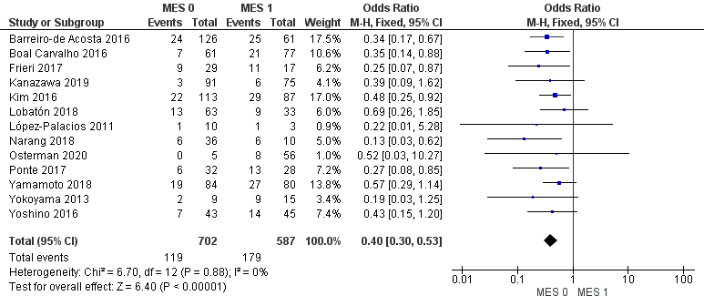
Additional file 1: Figure S1: Sensitivity analysis after abstract exclusion

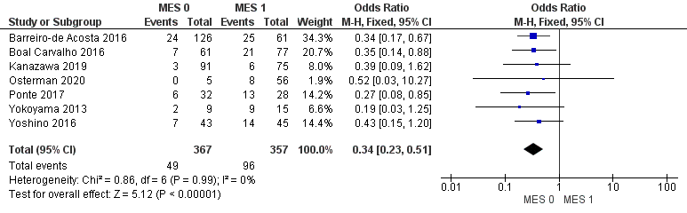
Additional file 1: Figure S2: Sensitivity analysis after low-moderate quality studies exclusion

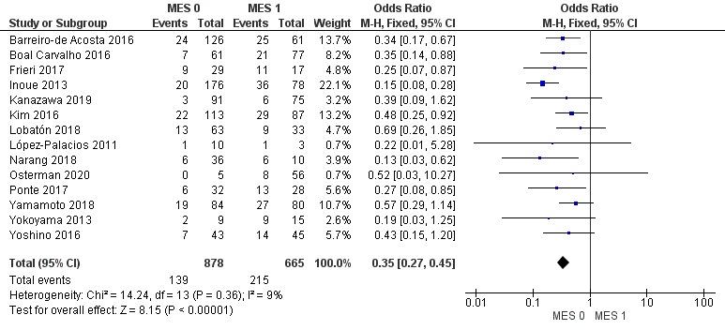
Additional file 1: Figure S3: Sensitivity analysis after abstract³⁸ exclusion

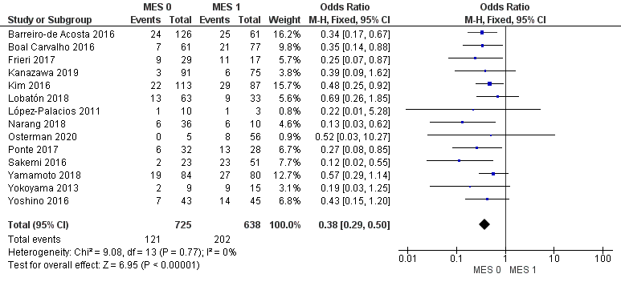
Additional file 1: Figure S4: Sensitivity analysis after abstract⁴¹ exclusion

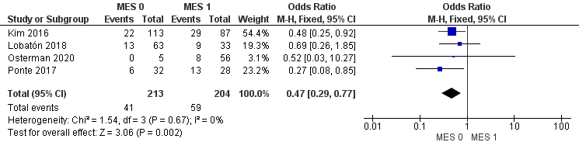
Additional file 1: Figure S5: Sensitivity analysis including studies with clinical relapse assessed with partial Mayo score evaluation

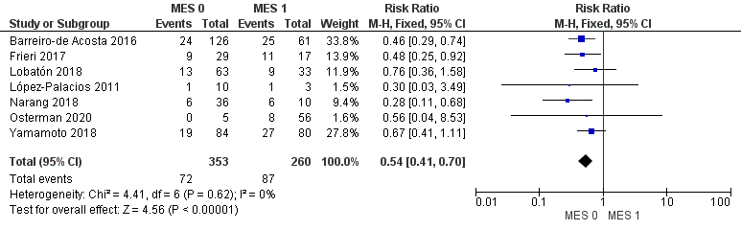
Additional file 1: Figure S6: Sensitivity analysis after retrospective studies exclusion

Additional file 1: Figure S7: Funnel plot for clinical relapse (N: 15 studies, 1617 patients); Egger’s test: p= 0.47

