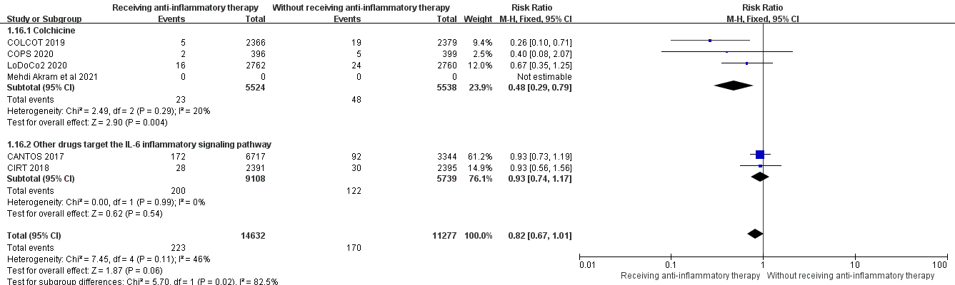
Supplementary Figure 1. Subgroup analysis of colchicine and other drugs targeting the central IL-6 inflammatory signaling pathway.
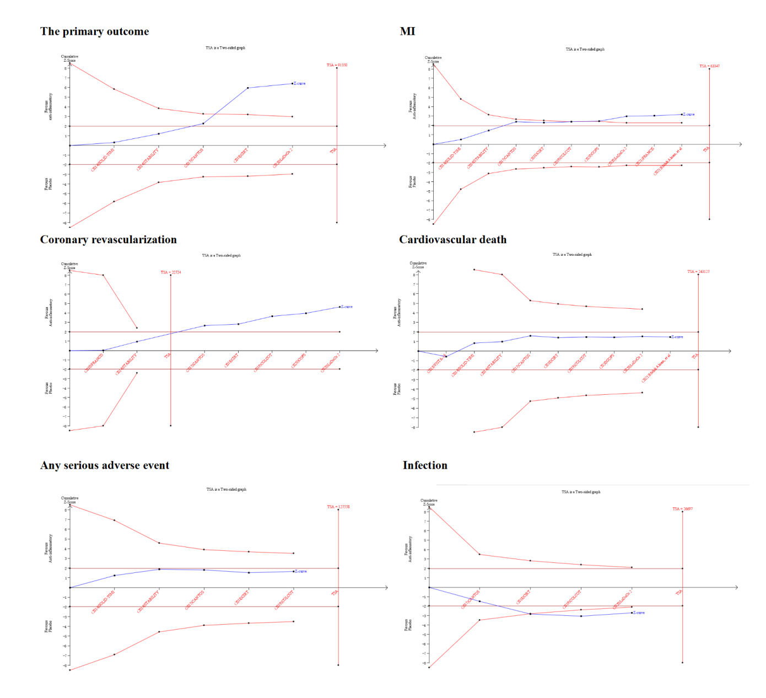
Supplementary Figure 2. Size of information required for each outcome.

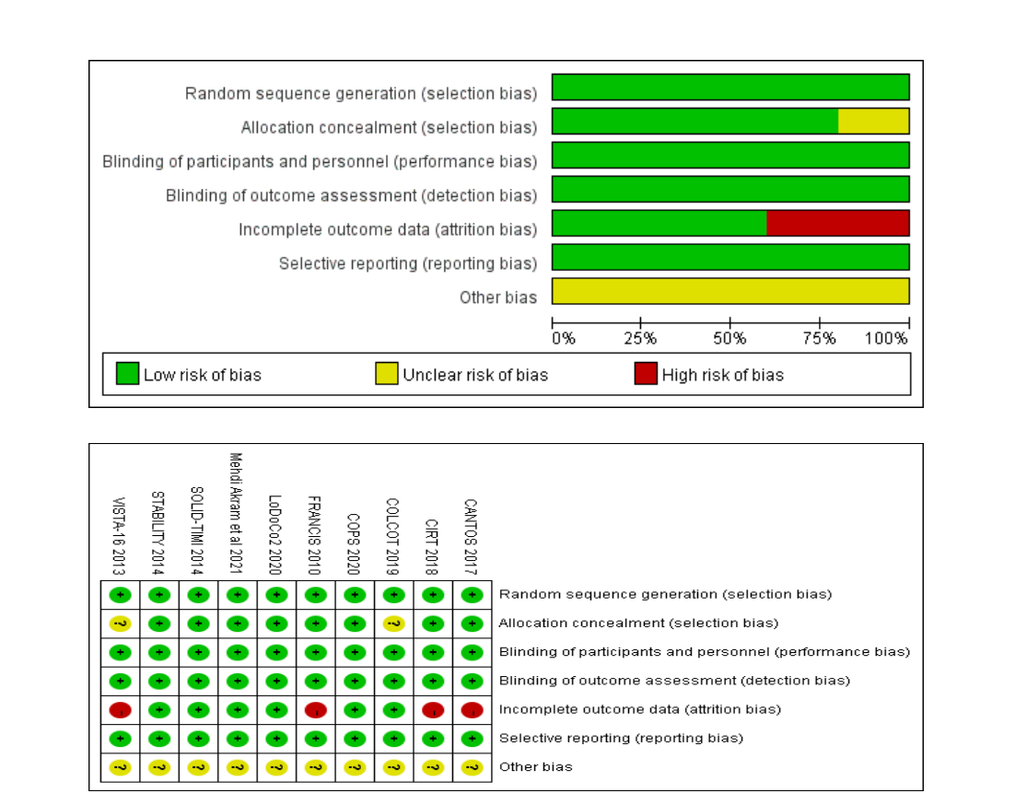
Supplementary Figure 3. Assessment for the risk of bias in each randomized controlled trial included.

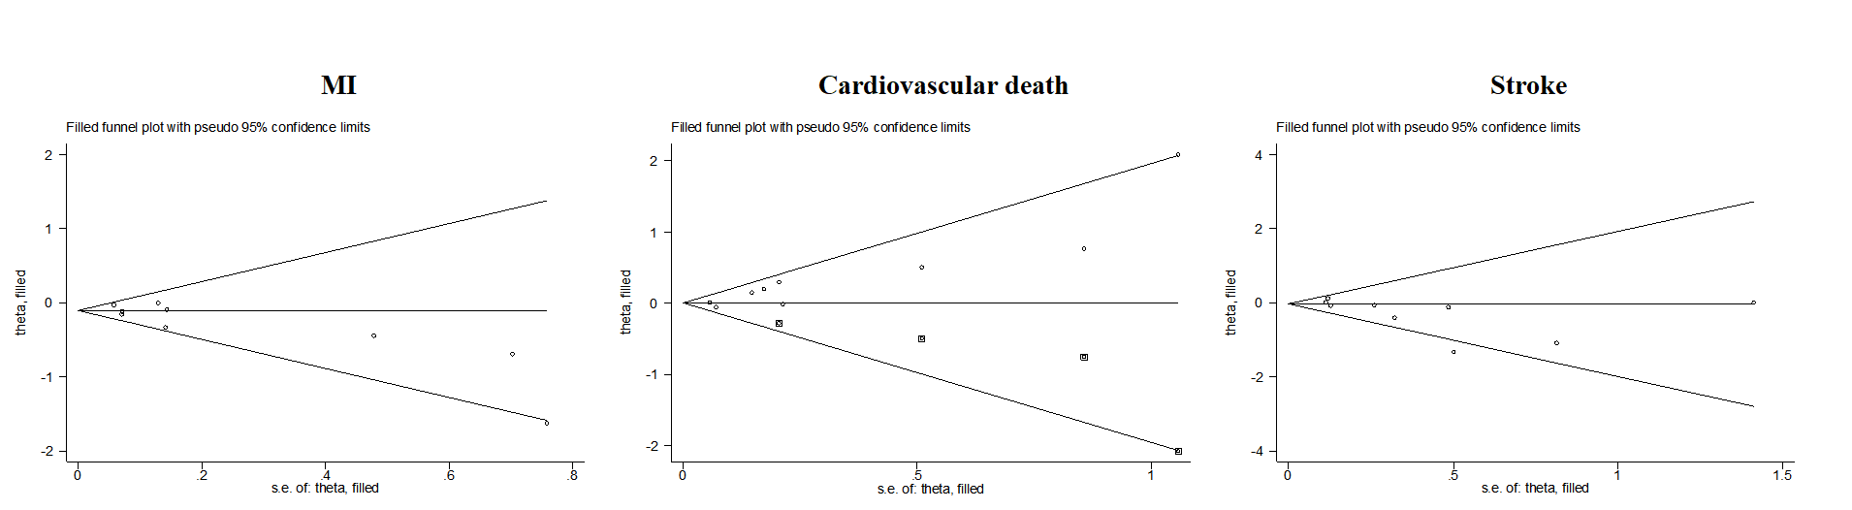
Supplementary Figure 4. The trim and fill method of MI, cardiovascular death, and stroke.

