Supplemental document

Pulse consumption improves indices of glycemic control in adults with and without type 2 diabetes: a systematic review and meta-analysis of acute and long-term randomized controlled trials

Maryam S. Hafiz^{1,2}, Matthew D. Campbell^{3,4,5}, Lauren L. O’Mahoney³, Melvin Holmes¹, Caroline Orfila¹, Christine Boesch¹*

¹School of Food Science and Nutrition, University of Leeds, Leeds, United Kingdom; ²Faculty of Applied Medical Sciences, Department of Clinical Nutrition, King Abdul-Aziz University, Jeddah, Saudi Arabia; ³Faculty of Health Sciences and Wellbeing, University of Sunderland; ⁴Wellcome-MRC Institute of Metabolic Science, University of Cambridge; ⁵Leeds Institute of Cardiovascular and Metabolic Medicine, University of Leeds; ⁶Leicester Diabetes Centre, University of Leicester.

*Corresponding author: C Boesch, School of Food Science and Nutrition, University of Leeds, Leeds, LS2 9JT, United Kingdom. Tel +44 113 3430268. Email: c.bosch@leeds.ac.uk

Supplemental Table 1. Predetermined search terms
Search category | Search terms used
- Population | (normoglycaemic) OR (normoglycaemia) OR (normoglycemia) OR (healthy) OR (normal) OR (diabetic) OR (diabetes) OR (T2DM) OR (T2D) OR (NIDDM) OR (adults)
- Intervention | (pulses) OR (pulse) OR (legumes) OR (leguminous) OR (legume) OR (beans) OR (bean) OR (peas) OR (pea) OR (chickpeas) OR (chickpea) OR (lentils) OR (lentil) OR (gram)
- Outcomes | (glucose) OR (FPG) OR (PPG) OR (glycemic) OR (glycaemia) OR (glycemia) OR (insulin) OR (post-prandial) OR (postprandial) OR (PPGR) OR (OGTT) OR (insulinemic) OR (insulinaemic) OR (HOMA) OR (Homeostatic Model Assessment of Insulin Resistance ) OR insulin resistance) OR (IR) OR (glycated hemoglobin) OR (HbA1c) OR (A1C) OR (A1c) OR (glycated haemoglobin) OR (glycosylated haemoglobin)
- Combined search | - AND (2) AND (3)

Supplemental Table 2. Risk of bias assessment
Study | Risk of bias assessment
Study | Domain |  |  |  |  | Overall
Study | Randomization process | Deviation from intended intervention | Missing outcome data | Measurement of the outcome | Selection of the reported results | Overall
abete, 2008 | some concerns | low risk | low risk | low risk | some concerns | some concerns
Abete, 2009 | some concerns | low risk | low risk | low risk | some concerns | some concerns
Abeysekara, 2012 | low risk | low risk | some concerns | low risk | low risk | some concerns
Agustia, 2019 | some concerns | low risk | some concerns | low risk | some concerns | some concerns
Akhtar, 2019 | some concerns | low risk | some concerns | low risk | some concerns | some concerns
Alizadeh, 2014 | some concerns | low risk | low risk | low risk | some concerns | some concerns
Anderson, 1984 | some concerns | low risk | some concerns | low risk | some concerns | high risk
Anderson, 2014 | some concerns | low risk | low risk | low risk | some concerns | some concerns
Anguah, 2014 | some concerns | low risk | low risk | low risk | low risk | some concerns
Augustin, 2016 | some concerns | low risk | low risk | low risk | some concerns | some concerns
Boers, 2017 | low risk | low risk | low risk | low risk | low risk | low risk
Bornet, 1987 | low risk | low risk | low risk | low risk | some concerns | some concerns
Bornet, 1989 | some concerns | low risk | some concerns | low risk | some concerns | high risk
Cryne, 2012 | some concerns | low risk | low risk | low risk | some concerns | some concerns
Dandachy, 2018 | some concerns | low risk | low risk | low risk | some concerns | some concerns
Dilwari, 1981 | some concerns | low risk | some concerns | low risk | some concerns | high risk
Gravel, 2010 | low risk | low risk | low risk | low risk | some concerns | some concerns
Greffeuil, 2015 | some concerns | low risk | low risk | low risk | some concerns | some concerns
Hassanzadeh-Rostami, 2019 | low risk | low risk | low risk | low risk | some concerns | some concerns
Hosseinpour-Niazi, 2015 | low risk | low risk | low risk | low risk | some concerns | some concerns
Islam, 2015 | some concerns | low risk | low risk | low risk | some concerns | some concerns
Jang, 2001 | some concerns | low risk | low risk | low risk | some concerns | some concerns
Jenkins, 1980 | some concerns | low risk | some concerns | low risk | some concerns | high risk
Jenkins, 1980 | some concerns | low risk | some concerns | low risk | some concerns | high risk
Jenkins, 1982 | some concerns | low risk | low risk | low risk | some concerns | high risk
Jenkins, 2012 | low risk | low risk | low risk | low risk | some concerns | some concerns
Jimenez-Cruz, 2003 | some concerns | low risk | low risk | low risk | some concerns | some concerns
Jimenez-Cruz, 2004 | some concerns | low risk | low risk | low risk | some concerns | some concerns
Johnson, 2005 | some concerns | low risk | low risk | low risk | some concerns | some concerns
Kang, 2014 | some concerns | low risk | low risk | low risk | some concerns | some concerns
Kim, 2014 | low risk | low risk | low risk | low risk | some concerns | some concerns
Kim, 2016 | low risk | low risk | low risk | low risk | some concerns | some concerns
Kim, 2017 | some concerns | low risk | low risk | low risk | some concerns | some concerns
Liu, 2018 | low risk | low risk | low risk | low risk | some concerns | some concerns
Mani, 1992 | some concerns | low risk | some concerns | low risk | some concerns | high risk
Marinangeli, 2009 | some concerns | low risk | low risk | low risk | some concerns | some concerns
Marinangeli, 2011 | some concerns | low risk | low risk | low risk | some concerns | some concerns
Mehio, 1997 | some concerns | low risk | low risk | low risk | some concerns | some concerns
Mollard, 2011 | low risk | low risk | low risk | low risk | some concerns | some concerns
Moravek, 2018 | some concerns | low risk | low risk | low risk | some concerns | some concerns
Nestel, 2004 | some concerns | low risk | low risk | low risk | some concerns | some concerns
Olmedilla-Alonso, 2013 | some concerns | low risk | low risk | low risk | some concerns | some concerns
Onyechi, 1998 | some concerns | low risk | some concerns | low risk | some concerns | high risk
Pittaway, 2007 | some concerns | low risk | low risk | low risk | some concerns | some concerns
Potter, 1981 | low risk | low risk | some concerns | low risk | low risk | some concerns
Ramdath, 2017 | some concerns | low risk | low risk | low risk | some concerns | some concerns
Ramdath, 2018 | some concerns | low risk | low risk | low risk | some concerns | some concerns
Reverri, 2015 | some concerns | low risk | low risk | low risk | some concerns | some concerns
Saraf-Bank, 2016 | some concerns | low risk | low risk | low risk | some concerns | some concerns
Schafer, 2003 | some concerns | low risk | low risk | low risk | some concerns | some concerns
Tappy, 1986 | some concerns | low risk | some concerns | low risk | some concerns | high risk
Thompson, 2012 | low risk | low risk | low risk | low risk | some concerns | some concerns
Tonstad, 2014 | some concerns | low risk | low risk | low risk | some concerns | some concerns
Torsdottir, 1989 | some concerns | low risk | some concerns | low risk | some concerns | high risk
Tovar, 2014 | low risk | low risk | low risk | low risk | some concerns | some concerns
Traianedes, 1986 | some concerns | low risk | some concerns | low risk | some concerns | high risk
Venn, 2010 | some concerns | low risk | some concerns | low risk | some concerns | high risk
Winham, 2007 | low risk | low risk | low risk | low risk | some concerns | some concerns
Winham, 2007 | low risk | low risk | low risk | low risk | some concerns | some concerns
Winham, 2017 | some concerns | low risk | low risk | low risk | some concerns | some concerns
Wong, 2009 | low risk | low risk | low risk | low risk | some concerns | some concerns
Yoshimoto, 2020 | low risk | low risk | low risk | low risk | some concerns | some concerns
Zafar, 2015 | some concerns | low risk | low risk | low risk | some concerns | some concerns
Zhu, 2019 | low risk | low risk | low risk | low risk | some concerns | some concerns
Zurbau, 2019 | low risk | low risk | low risk | low risk | some concerns | some concerns

Supplemental Table 3. GRADE assessment
- Due to high unexplained heterogeneity
- Due to differences in control
- Due to substantial differences in interventions and comparisons
- The 95% CI included benefits as well as no effect
- The 95% CI included benefits and harms
Outcome | No. of trials | No. of participants | Certainty assessment |  |  |  |  | Effect estimate | Grade
Outcome | No. of trials | No. of participants | Risk of bias | Inconsistency | Indirectness | Imprecision | Other considerations | Effect estimate | Grade
PPGR in normoglycemia | 27 | 690 | Not serious | Serious ª | Serious ^{b} | Not serious | none | -1.23 [-1.59, -0.88] | Low
PPGR in T2DM | 6 | 136 | Not serious | Serious ª | Serious ^{b} | Not serious | none | -2.89 [-4.61, -1.18] | Low
Fasting glucose healthy | 16 | 1037 | Not serious | Not serious | Very serious ^{c} | Serious ^{d} | none | -0.06 [-0.12, 0.00] | Very low
Fasting glucose DM | 11 | 808 | Not serious | Serious ª | Very serious ^{c} | Not serious | none | -0.51 [-0.79, -0.24] | Very low
Hba1c DM | 7 | 524 | Not serious | Serious ª | Very serious ^{c} | Very serious ^{e} | None | -0.20 [-0.36, -0.05] | Very low
HOMA | 5 | 431 | Not serious | Serious ª | Very serious ^{c} | Not serious | none | -0.47 [-0.80, -0.14] | Very low

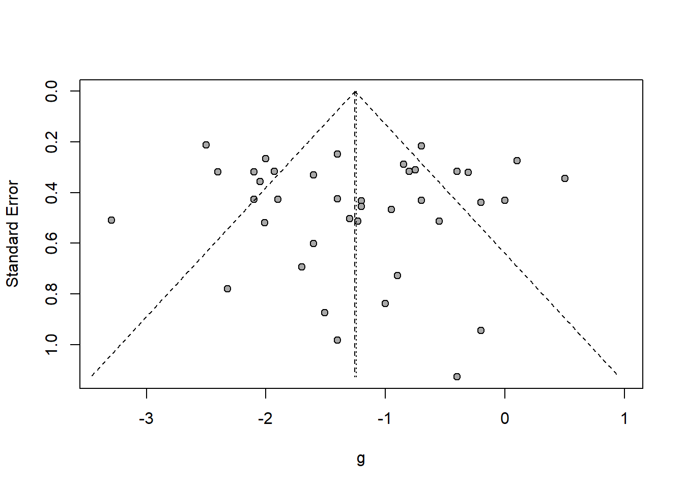
Supplemental Figure 1. funnel plot of acute studies included in meta-analysis investigating acute glucose response after pulse consumption in adults without T2DM
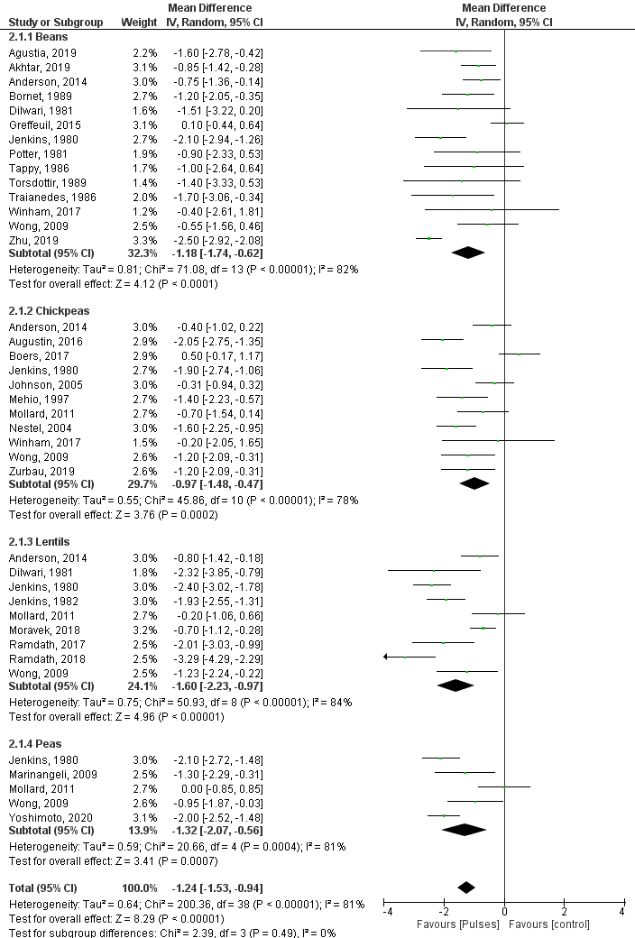
Supplemental Figure 2. Subgroup analysis by pulse type on acute studies investigating acute glucose response after pulse consumption in adults without T2DM
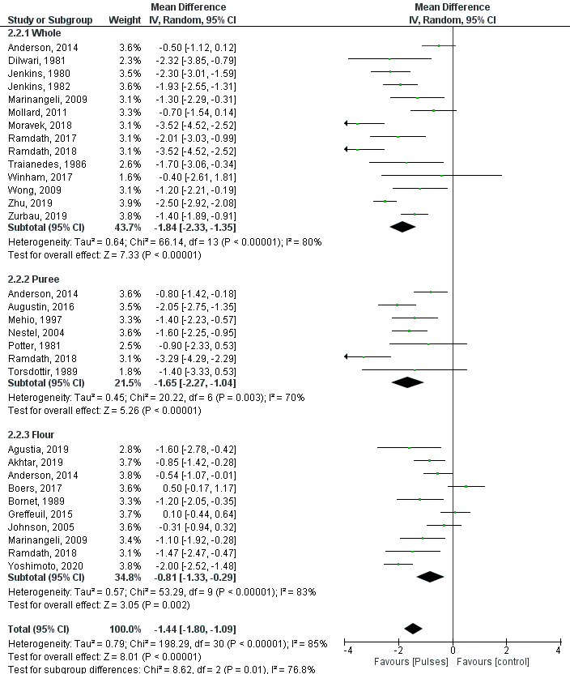
Supplemental Figure 3. Subgroup analysis by physical form of pulse on acute studies investigating acute glucose response after pulse consumption in adults without T2DM
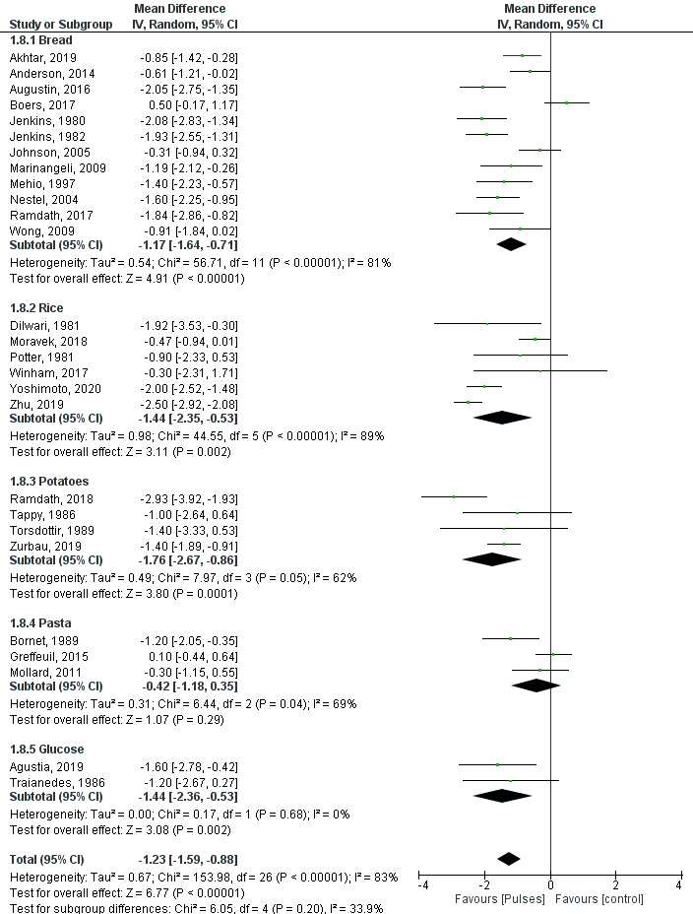
Supplemental Figure 4. Subgroup analysis by control group on acute studies investigating acute glucose response after pulse consumption in adults without T2DM

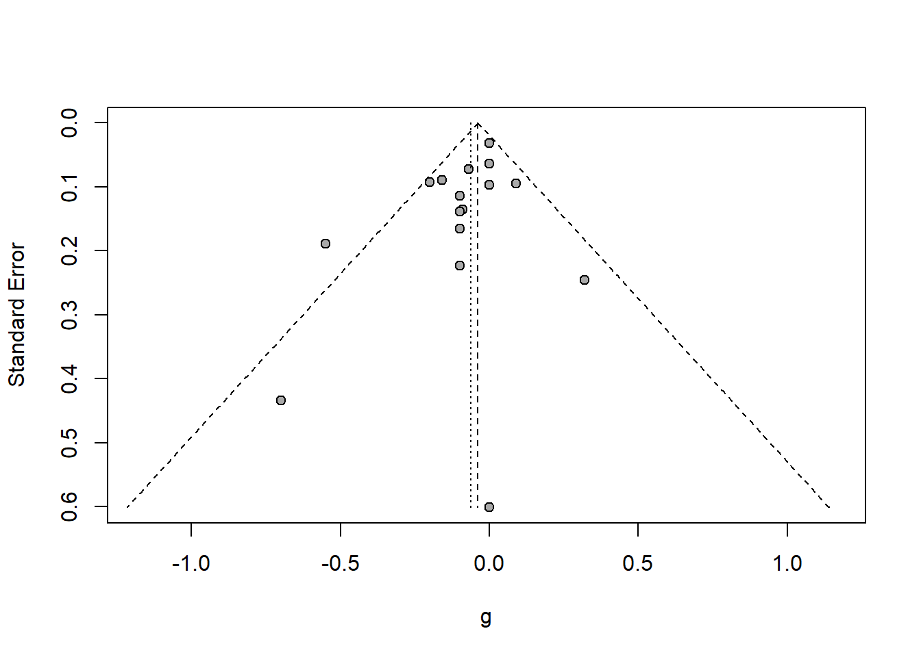
Supplemental Figure 6. Funnel plot of long-term trials included in meta-analysis investigating affect of pulse consumption in adults with T2DM
Supplemental Figure 5. Funnel plot of long-term trials included in meta-analysis investigating affect of pulse consumption in adults without T2DM
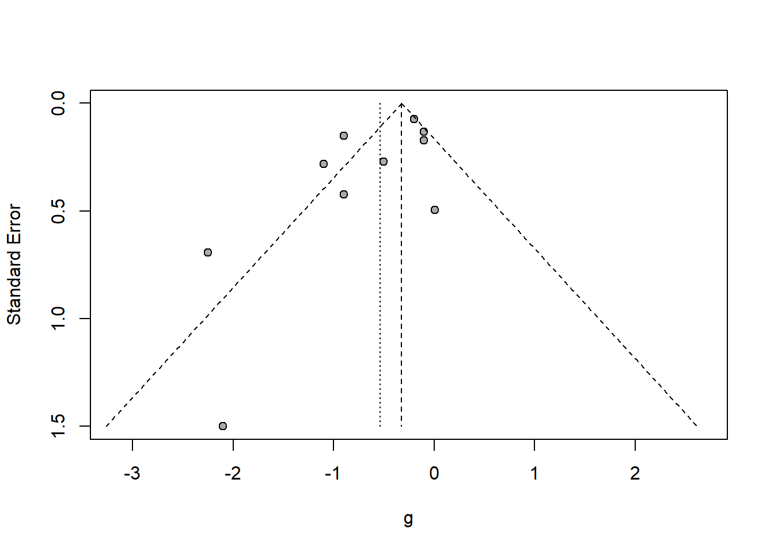
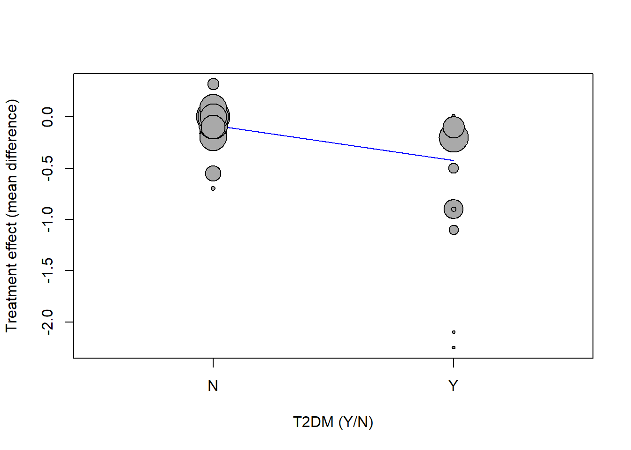
Supplemental Figure 7. Comparison of effect size in long-term trials between adults with and without T2DM
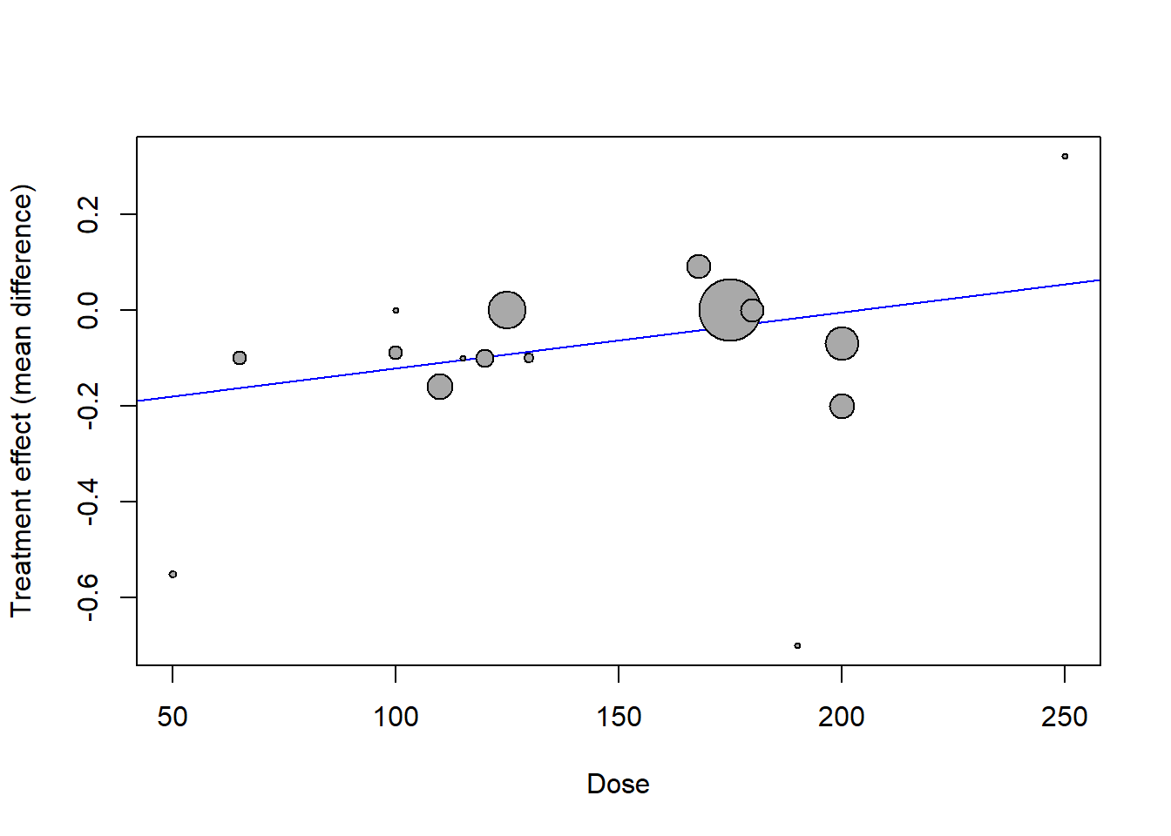

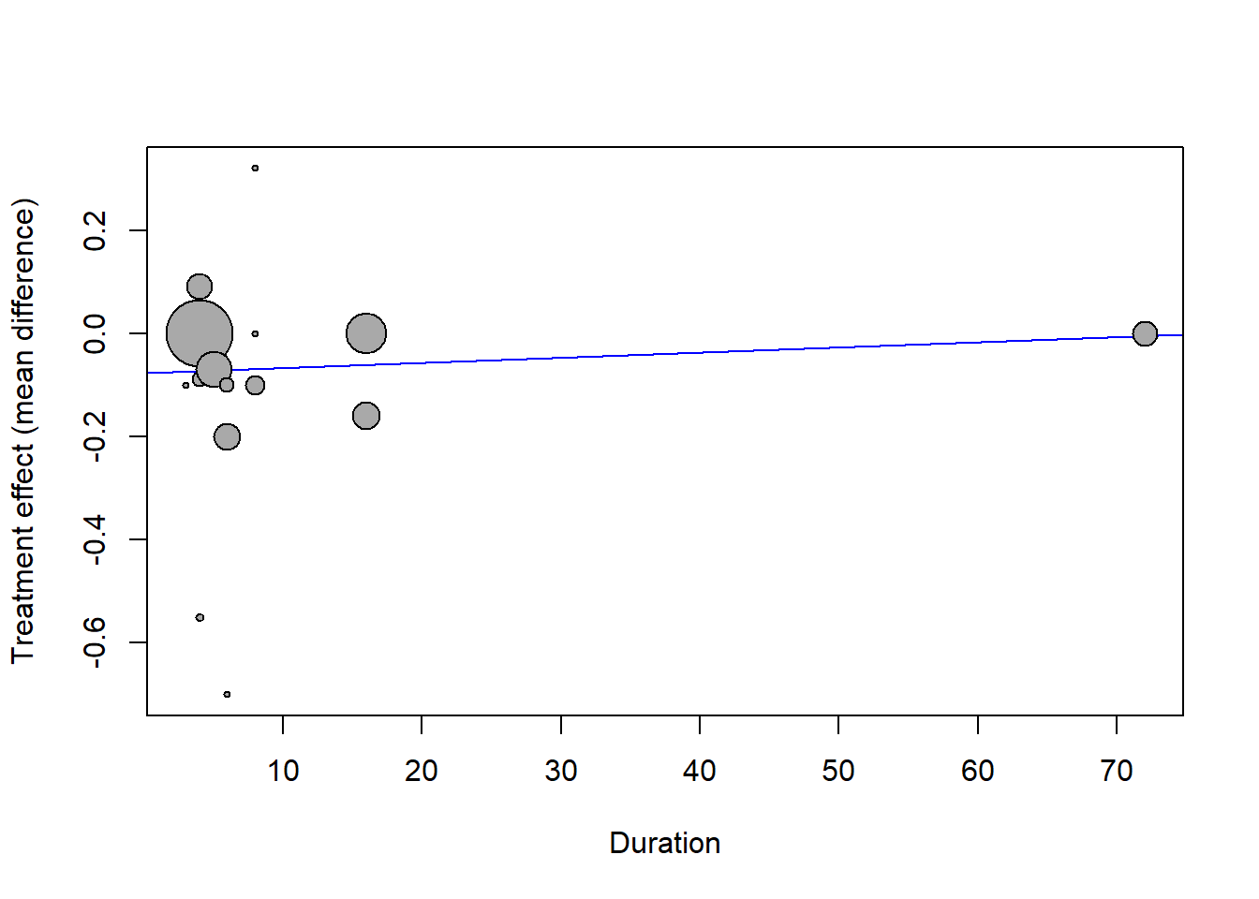

Supplemental Figure 8. Meta-regression of affect of dose and duration on modifying effect size in long-term trials on normoglycaemic adults
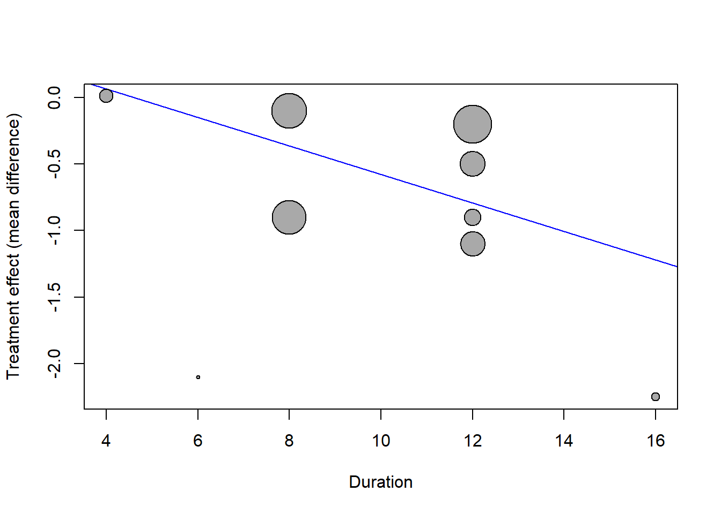
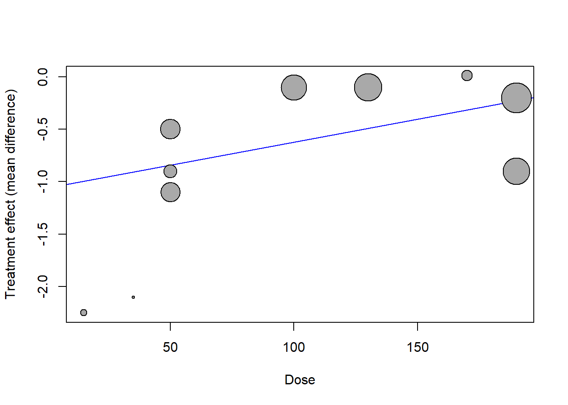
Supplemental Figure 9. Meta-regression of affect of dose and duration on modifying effect size in long-term trials on T2DM adults

