Supplementary Appendix

This appendix has been provided by the authors to give readers additional information about this work.
Clinical characteristics and outcome of COVID-19 infection in patients with solid-organ transplants: a systematic review and meta-analysis

Wen An, Ms¹, Qiuyang Wang, Ms², Ju-Seop Kang, MD, PhD¹, Tae-Eun Kim, MD, PhD^{3*}

- Department of Pharmacology & Clinical Pharmacology, College of Medicine, Hanyang University Seoul, Korea, anwen@hanyang.ac.kr
2.Department of Central China Research Institute of Health, Xinxiang Medical University, Xinxiang, China, qiuyangwang0907@gmail.com.
3.Department of Clinical Pharmacology, Konkuk University Hospital, Seoul, Korea, tekim@kuh.ac.kr

*Correspondence
Ju-Seop Kang, MD, PhD
jskang@hanyang.ac.kr
Department of Pharmacology & Clinical Pharmacology, College of Medicine, Hanyang University Seoul, Korea

Table of contents
Supplementary Table 3
Table S 1. Systematic reviews and Meta-analyses (PRISMA) standard for this study. 3

Supplementary Table
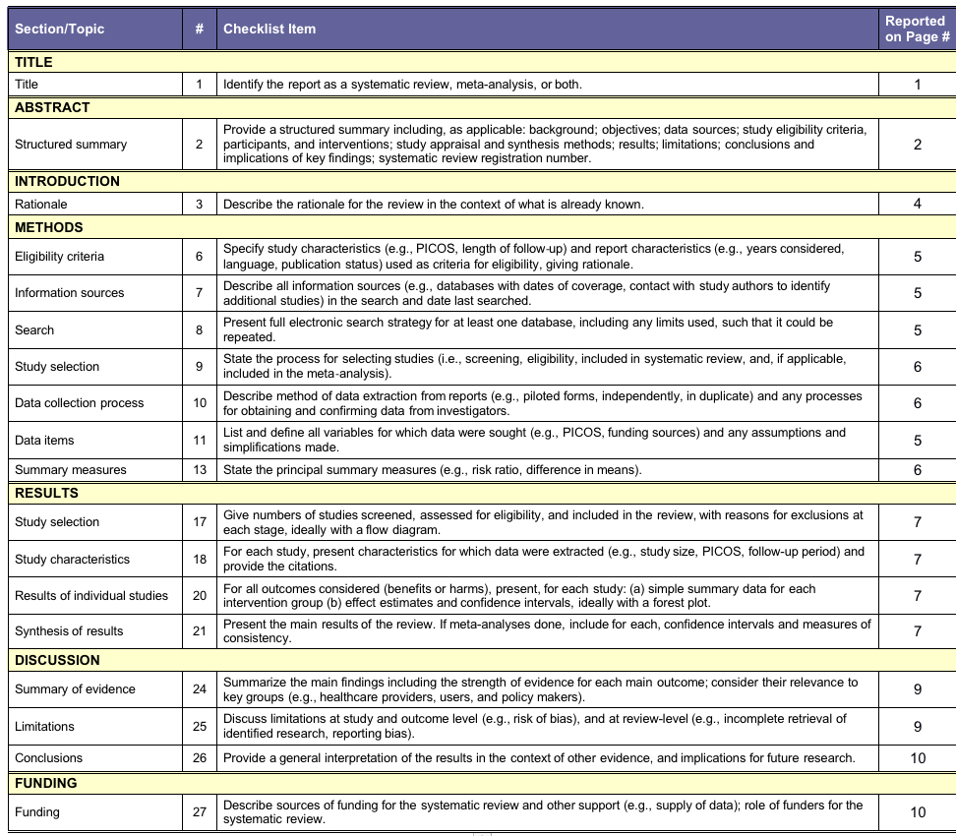
.
Table S 1. Systematic reviews and Meta-analyses (PRISMA) standard for this study.

