APPENDIX

In general

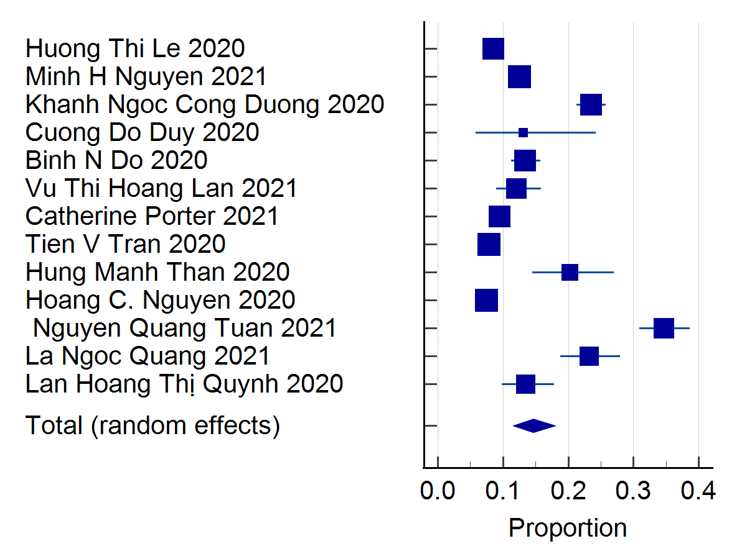
Test for heterogeneity
Q | 595.2208
DF | 12
Significance level | P < 0.0001
I² (inconsistency) | 97.98%
95% CI for I² | 97.39 to 98.44

Publication bias
Egger's test
Intercept | 5.7385
95% CI | -1.2902 to 12.7673
Significance level | P = 0.0998
Begg’s test
Kendall's Tau | 0.2051
Significance level | P = 0.3290

In health worker

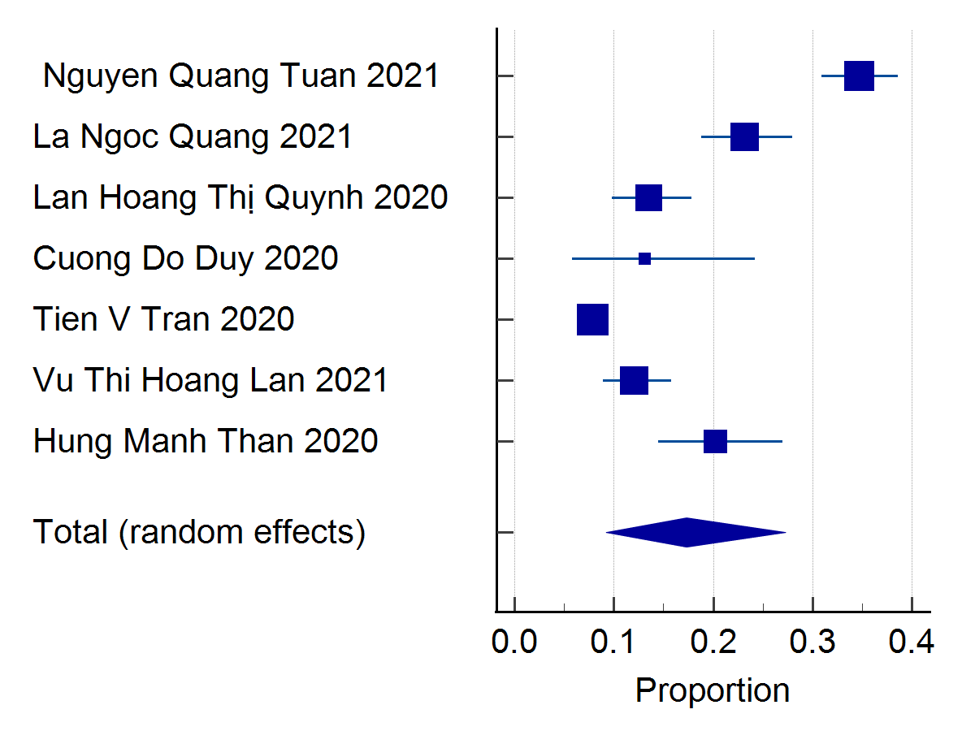
Test for heterogeneity
Q | 337.7929
DF | 6
Significance level | P < 0.0001
I² (inconsistency) | 98.22%
95% CI for I² | 97.48 to 98.75

Publication bias
Egger's test
Intercept | 6.9031
95% CI | -1.9109 to 15.7171
Significance level | P = 0.1002
Begg’s test
Kendall's Tau | -0.04762

In non-health worker

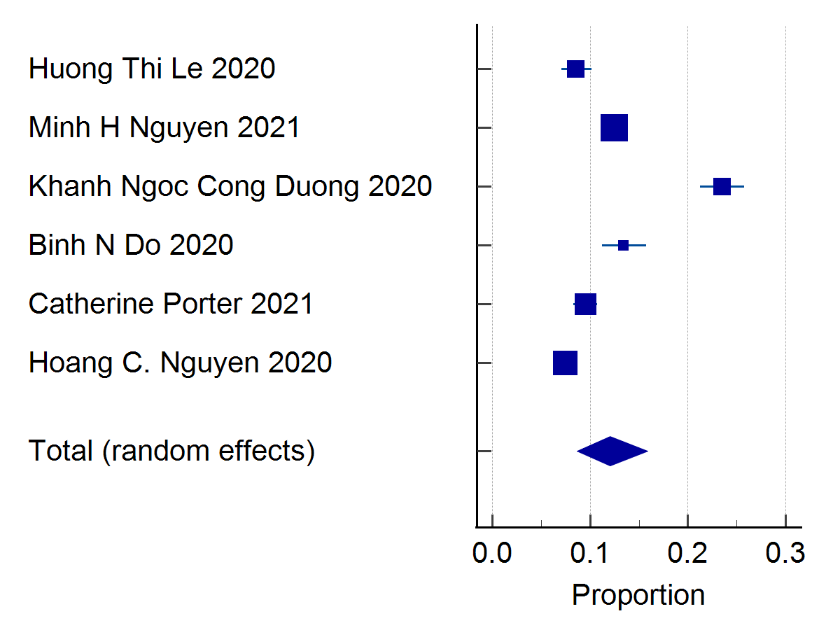
Test for heterogeneity
Q | 250.6216
DF | 5
Significance level | P < 0.0001
I² (inconsistency) | 98.00%
95% CI for I² | 97.04 to 98.66

Publication bias
Egger's test
Intercept | 2.8550
95% CI | -20.7807 to 26.4907
Significance level | P = 0.7542
Begg’s test
Kendall's Tau | 0.06667
Significance level | P = 0.8510

Publication Bias
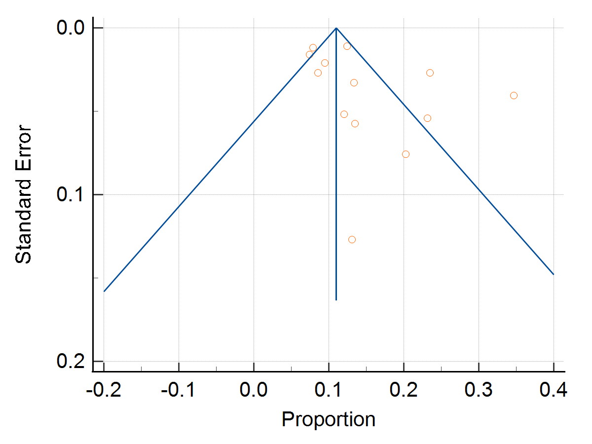

For general
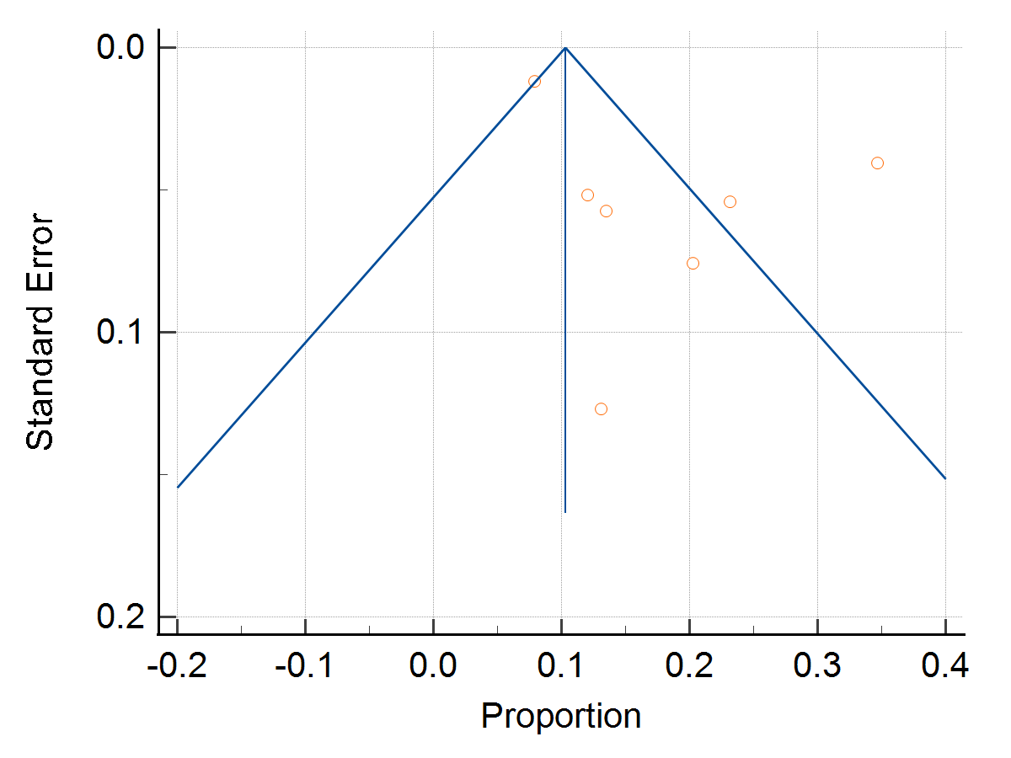

In health worker
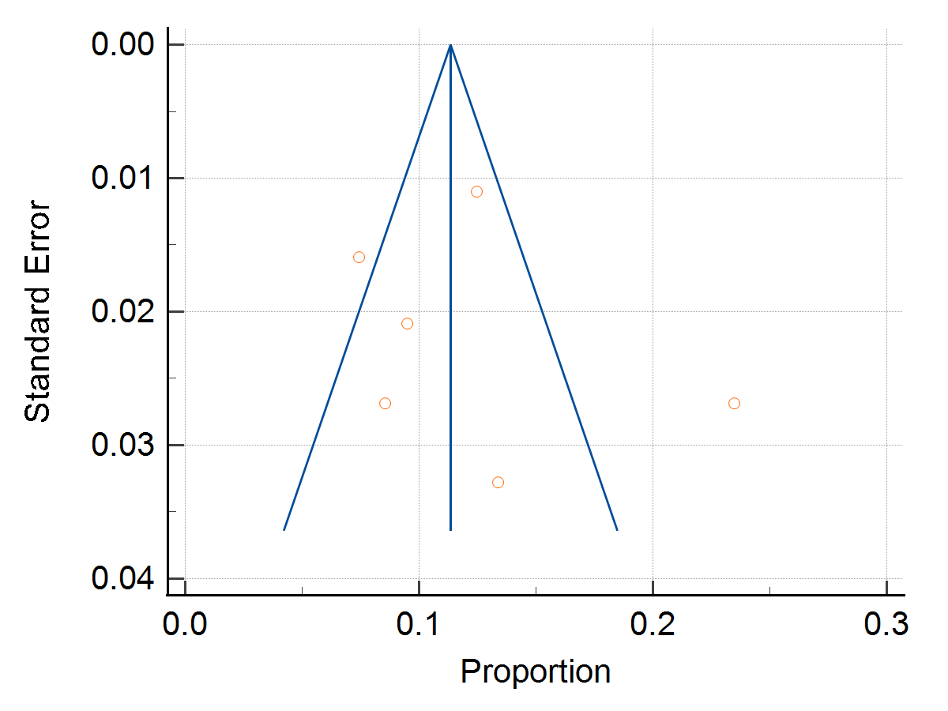

In non-health worker

