SUPPLEMENTARY MATERIAL 8. FUNNEL PLOTS.

8.A: Funnel plot of Time To Intubation according to device used
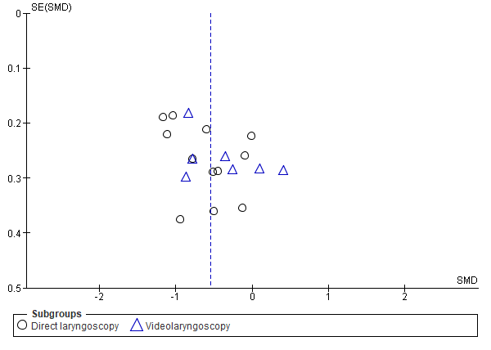
8.B: Funnel plot of Time To Intubation according to participants’ experience in airways
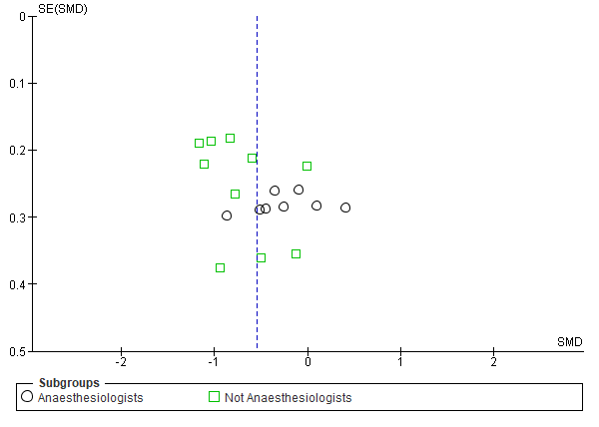

8.C: Funnel plot of Success Rate according to device used

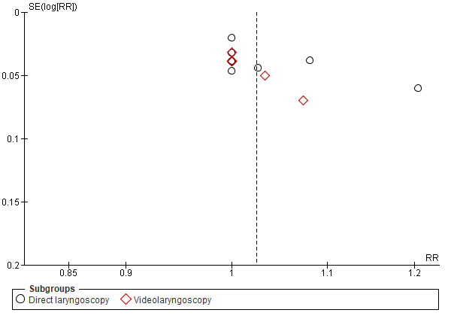

8.D: Funnel plot of Success Rate according to participants’ experience in airways


