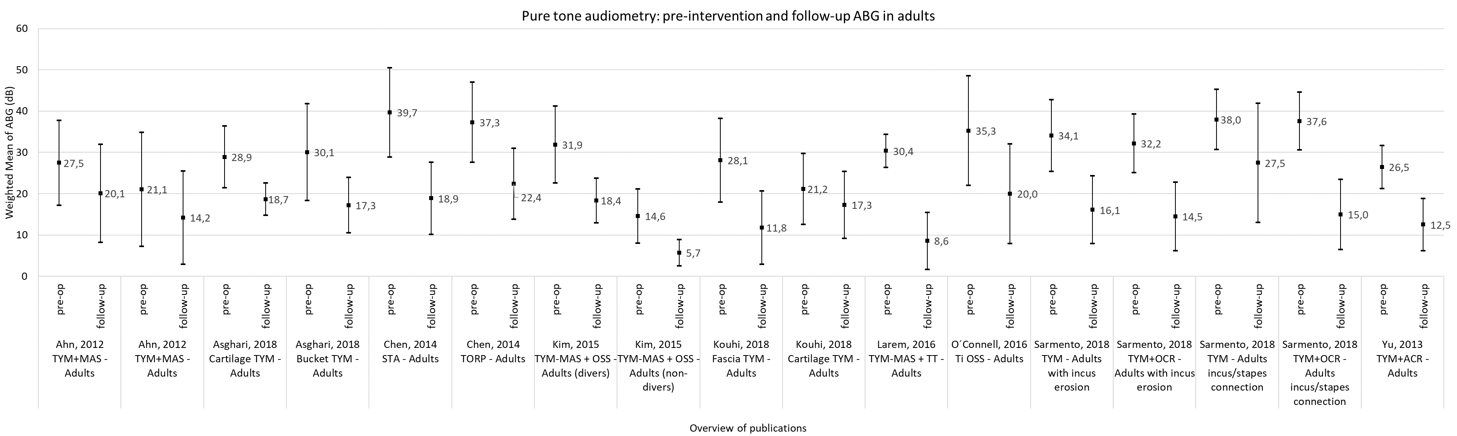

Supplementary Figure 1. Mean ABG data for adult patients. Pre-op and follow-up ABG in adult patient groups by intervention type. The mean pre-intervention ABG is 30.3 ±6.9 dB and post-intervention is 16.4 ±5.3 dB. TYM = tympanoplasty, MAS = mastoidectomy; OSS = ossiculoplasty; OCR = ossicular chain replacement; TORP = total ossicular replacement prosthesis; TT = tympanostomy tube; ACR = auditory canal reconstruction.

