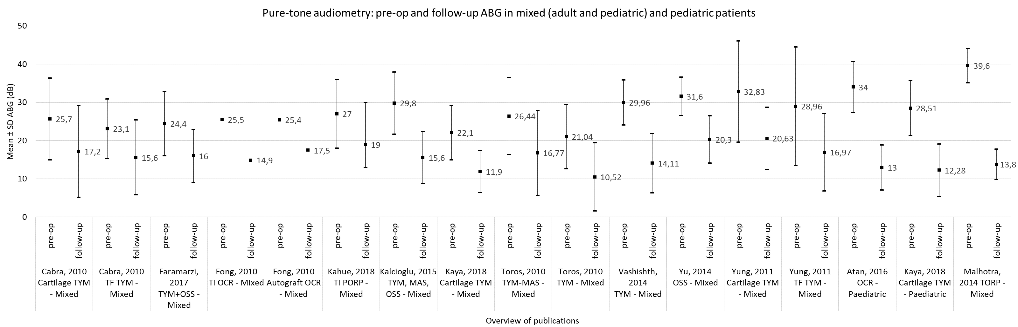
Supplementary Figure 2. Mean ABG data for mixed (adult with pediatric) and pediatric patients. Pre-op and follow-up ABG in the mixed and pediatric patient groups by intervention type. The mean pre-intervention ABG is 28.0 ±3.7 dB and post-intervention is 15.7 ±2.9 dB. TYM = tympanoplasty, MAS = mastoidectomy; OSS = ossiculoplasty; OCR = ossicular chain replacement; PORP = partial ossicular replacement prosthesis; TF = temporalis fascia.

