Dokumentasjon av litteratursøk.

Informasjon om søket.

Tittel på litteratursøk. | Svimmelhet (PPPD) og muskelskjelettsmerter.
Hvem har bestilt litteratursøket? | Navn: Unni Moen  E-post: unni.moen@hvl.no
Bibliotekar som har utført litteratursøket. | Navn: Gøril Tvedten Jorem  Arbeidssted: HVL, Biblioteket Bergen  E-post: goril.tvedten.jorem@hvl.no  Tlf: 55 58 78 09

Systematiske oversikter

Database/kilde | Cochrane
Dato for søk | 28.04.2020
Søkehistorie eller fremgangsmåte | 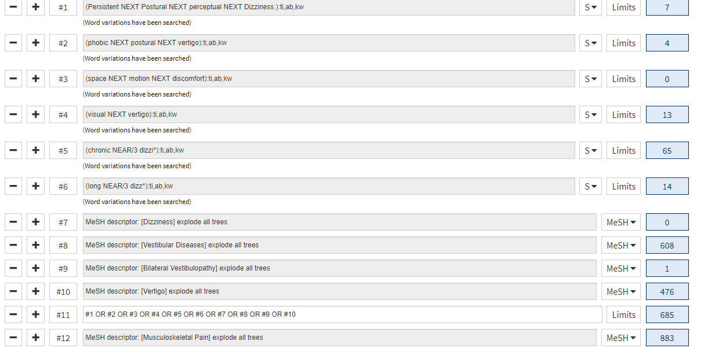  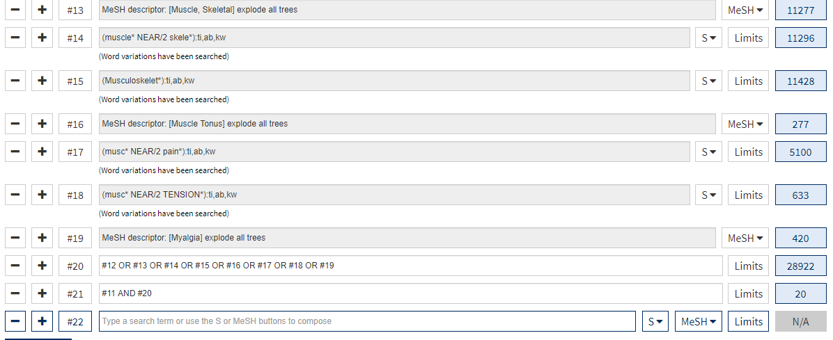
Antall treff | 20
Kommentarer

Primærstudier

Database/kilde | Medline
Dato for søk | 28.04.2020
Søkehistorie eller fremgangsmåte | Database: Ovid MEDLINE(R) and Epub Ahead of Print, In-Process & Other Non-Indexed Citations and Daily <1946 to April 24, 2020>  Search Strategy:  --------------------------------------------------------------------------------  1 pppd.ti,ab,kw. (433)  2 Persistent Postural perceptual Dizziness.ti,ab,kw. (58)  3 (phobic adj postural adj vertigo).ti,ab,kw. (60)  4 (space adj motion adj discomfort).ti,ab,kw. (3)  5 (visual adj vertigo).ti,ab,kw. (58)  6 (chronic adj subjective adj dizziness).ti,ab,kw. (44)  7 (chronic adj dizzi*).ti,ab,kw. (164)  8 (chronic adj1 functional adj1 dizziness).ti,ab,kw. (1)  9 (long adj3 dizz*).ti,ab,kw. (39)  10 exp Dizziness/ (5261)  11 vestibular diseases/ or bilateral vestibulopathy/ or vertigo/ (13693)  12 or/1-11 (17997)  13 exp Musculoskeletal Pain/ (4914)  14 exp Muscle, Skeletal/ (264579)  15 (muscle* adj2 skele*).ti,ab,kw. (113823)  16 Musculoskelet*.ti,ab,kw. (50685)  17 exp Muscle Tonus/ (6711)  18 (musc* adj2 (pain* or tension*)).ti,ab,tw. (17089)  19 exp Myalgia/ (1655)  20 or/13-19 (386236)  21 12 and 20 (321)  22 exp Anxiety/ (83635)  23 anxiet*.ti,ab,kw. (189532)  24 stress*.ti,ab,kw. (821107)  25 22 or 23 or 24 (995599)  26 21 not 25 (298)  ***************************
Antall treff | 298
Kommentarer

Database/kilde | Embase
Dato for søk | 28.04.2020
Søkehistorie eller fremgangsmåte | Database: Embase <1980 to 2020 Week 17>  Search Strategy:  --------------------------------------------------------------------------------  1 (Persistent adj Postural adj perceptual adj Dizziness).ti,ab,kw. (68)  2 (phobic adj postural adj vertigo).ti,ab,kw. (110)  3 (space adj motion adj discomfort).ti,ab,kw. (3)  4 (visual adj vertigo).ti,ab,kw. (84)  5 (chronic adj3 dizzi*).ti,ab,kw. (375)  6 (long adj3 dizz*).ti,ab,kw. (63)  7 *dizziness/ (2126)  8 *vestibular disorder/ (4522)  9 *bilateral vestibulopathy/ (124)  10 *vertigo/ (10061)  11 or/1-10 (16115)  12 *skeletal muscle/ (42526)  13 *musculoskeletal pain/ (2852)  14 (muscle* adj2 skele*).ti,ab,kw. (132503)  15 Musculoskelet*.ti,ab,kw. (70848)  16 *muscle tone/ (2346)  17 *myalgia/ (4046)  18 (musc* adj2 (pain* or tension*)).ti,ab,tw. (23685)  19 or/12-18 (232887)  20 11 and 19 (229)  21 exp anxiety/ (197979)  22 anxiet*.ti,ab,kw. (269242)  23 exp stress/ (290495)  24 anxiet*.ti,ab,kw. (269242)  25 or/21-24 (570211)  26 20 not 25 (209)
Antall treff | 209
Kommentarer

Database/kilde | Amed
Dato for søk | 29.04.2020
Søkehistorie eller fremgangsmåte | Database: AMED (Allied and Complementary Medicine) <1985 to April 2020>  Search Strategy:  --------------------------------------------------------------------------------  1 pppd.ti,ab. (0)  2 Persistent Postural perceptual Dizziness.ti,ab. (0)  3 (phobic adj postural adj vertigo).ti,ab. (0)  4 (space adj motion adj discomfort).ti,ab. (0)  5 (visual adj vertigo).ti,ab. (2)  6 (chronic adj3 dizziness).ti,ab. (14)  7 (long adj3 dizz*).ti,ab. (5)  8 exp Dizziness/ (187)  9 exp Vestibular disease/ (313)  10 (bilateral adj vestibulopath*).ti,ab. (2)  11 exp Vertigo/ (164)  12 or/1-11 (451)  13 exp Musculoskeletal Pain/ (234)  14 exp Muscle skeletal/ (6523)  15 (muscle* adj2 skele*).ti,ab. (1221)  16 Musculoskelet*.ti,ab. (4084)  17 exp Muscle tonus/ (150)  18 (musc* adj2 (pain* or tension*)).ti,ab. (1770)  19 or/13-18 (11919)  20 12 and 19 (10)  ***************************
Antall treff | 10
Kommentarer

Database/kilde | Google Scholar
Dato for søk | 29.04.2020
Søkehistorie eller fremgangsmåte | "Persistent Postural perceptual Dizziness" "Musculoskeletal Pain"  "Persistent Postural perceptual Dizziness" ""muscle pain"  "Persistent Postural perceptual Dizziness" "muscle tension”  "pppd" "muscle tension"  "pppd" "muscle pain”  “pppd” “Musculoskeletal Pain”  "long* dizziness" “Musculoskeletal Pain”  "long* dizziness" “Muscle Pain”  "phobic postural vertigo" “Muscle pain”  "phobic postural vertigo" “Muscle tension”  "phobic postural vertigo" “Musculoskeletal Pain”  "space motion discomfort" “Musculoskeletal Pain”  "space motion discomfort" “muscle pain”  "space motion discomfort" “muscle tension*  "chronic subjective dizziness" “muscle tension”  "chronic subjective dizziness" “muscle pain"  "chronic subjective dizziness" “Musculoskeletal Pain”  "chronic dizziness" “muscle pain”  "chronic dizziness" “muscle tension"  "chronic dizziness" “Musculoskeletal Pain”
Antall treff | 322
Kommentarer

Database/kilde | SveMed+
Dato for søk | 28.04.2020
Søkehistorie eller fremgangsmåte | 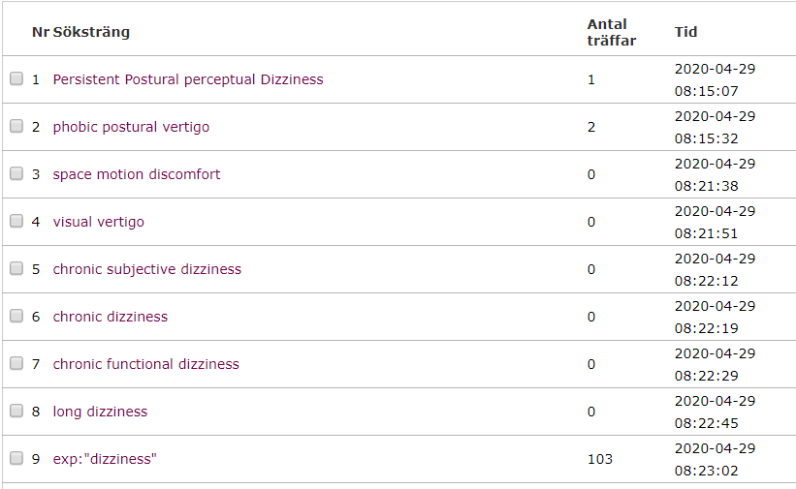  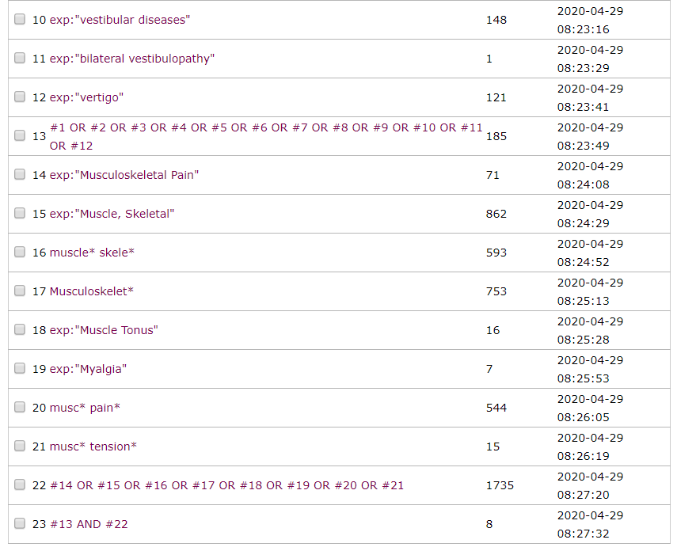
Antall treff | 8
Kommentarer

Database/kilde | Web of Science
Dato for søk | 28.04.2020
Søkehistorie eller fremgangsmåte | 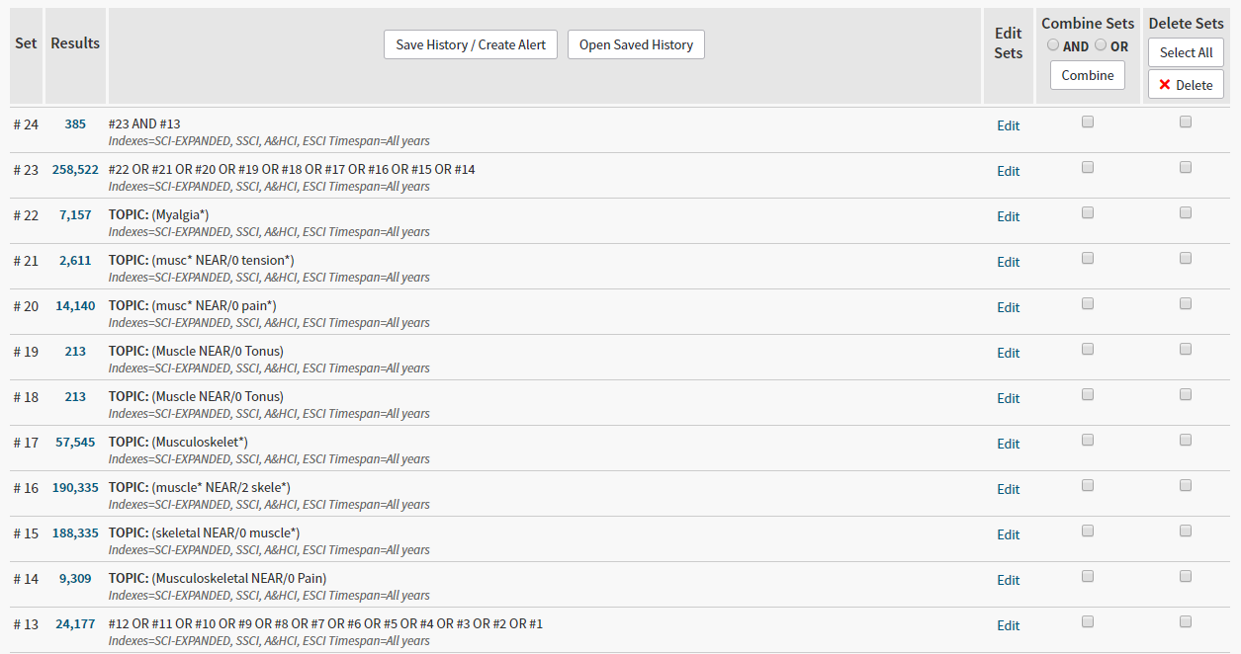  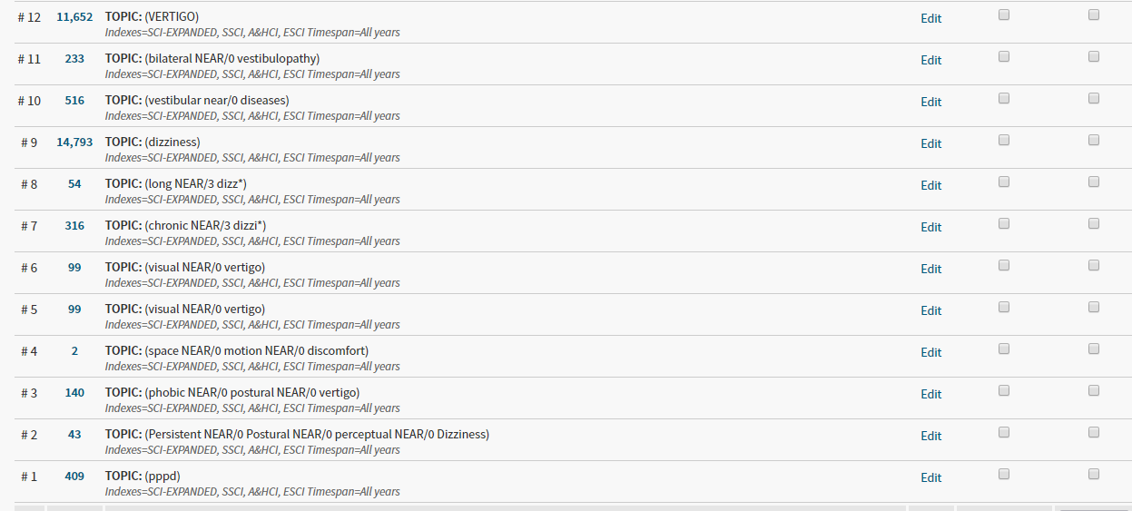
Antall treff | 385
Kommentarer | ikke mulig å fjerne stress og anxiety (ikke mulig å NOT’e).

