Supplementary File: The Effects of Nitrate Ingestion on High-Intensity Endurance Time-Trial Performance: A Systematic Review and Meta-Analysis

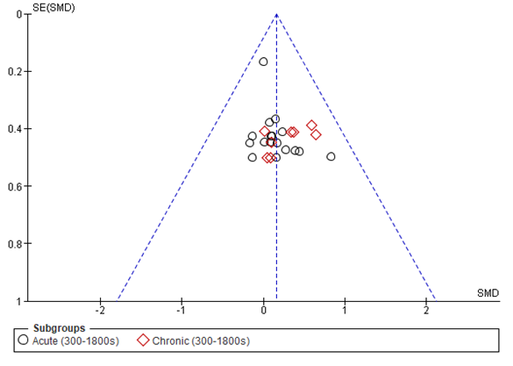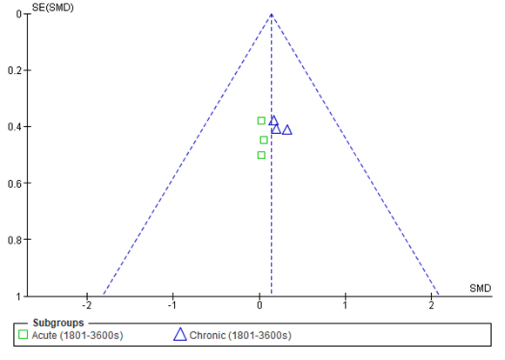
- (b)
Figure S1. Publication bias was assessed using funnel plot (a) 300-1800s exercise, (b)1801-3600s exercise of the standard error (SE) and standardized effect for each study. Visual inspection of the funnel plot shows that all studies are within 95% CI.

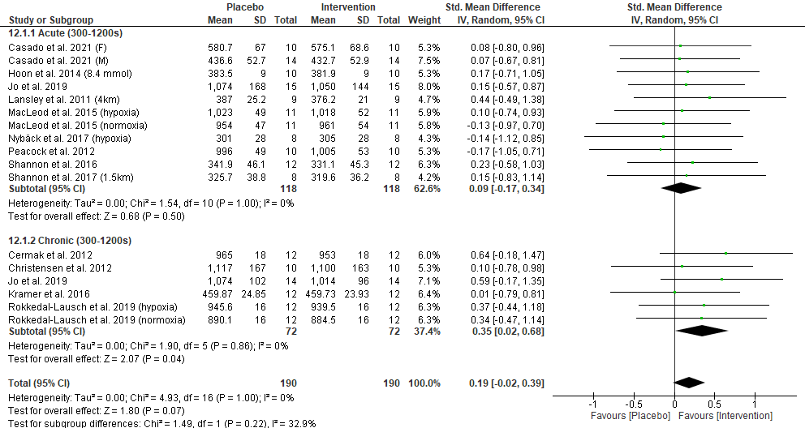
Figure S2. Forest plot showing effects of acute and chronic nitrate supplementation on time-trial performance ranging from 5 to 20 minutes, with low dose studies (<6 mmol) excluded.

