Supplementary Material1. Search formulas
PubMed
Search: (("Spondylolisthesis"[Mesh]) OR (((((Spondylolistheses[Title/Abstract]) OR (Spondylisthesis[Title/Abstract])) OR (Spondylistheses[Title/Abstract])) OR (Olisthesis[Title/Abstract])) OR (Olistheses[Title/Abstract]))) AND ((((((((oblique lateral interbody fusion[Title/Abstract]) OR (oblique lumbar interbody fusion[Title/Abstract])) OR (oblique lateral lumbar interbody fusion[Title/Abstract])) OR (retroperitoneal lumbar interbody fusion[Title/Abstract])) OR (pre-psoas lateral interbody fusion[Title/Abstract])) OR (anterior to psoas lumbar interbody fusion[Title/Abstract])) OR (anterolateral approach to lumbar interbody fusion[Title/Abstract])) OR (OLIF[Title/Abstract]))

Embase
Session Results
No. | Query Results | Results
#5. | #3 AND #4 | 93
#4. | 'oblique lateral interbody fusion':ab,ti OR 'oblique lumbar interbody fusion':ab,ti OR 'oblique lateral lumbar interbody fusion':ab,ti OR 'retroperitoneal lumbar interbody fusion':ab,ti OR 'pre-psoas lateral interbody fusion':ab,ti OR 'anterior to psoas lumbar interbody fusion':ab,ti OR 'anterolateral approach to lumbar interbody fusion':ab,ti OR olif:ab,ti | 354
#3. | #1 OR #2 | 10,289
#2. | 'slipped vertebra':ab,ti OR 'slipped vertebrae':ab,ti OR 'spondylo listhesis':ab,ti OR spondylolysthesis:ab,ti OR 'vertebral sliding':ab,ti OR spondylolistheses:ab,ti OR spondylisthesis:ab,ti OR spondylistheses:ab,ti OR olisthesis:ab,ti OR olistheses:ab,ti | 313
#1. | 'spondylolisthesis'/exp | 10,200

Scopus
( TITLE-ABS-KEY ( "Spondylolisthesis" OR "Spondylolistheses" OR "Spondylisthesis" OR "Spondylistheses" OR "Olisthesis" OR "Olistheses" OR "slipped vertebra" OR "slipped vertebrae" OR "spondylo-listhesis" OR "spondylolysthesis" OR "vertebral sliding" ) ) AND ( TITLE-ABS-KEY ( "oblique lateral interbody fusion" OR "oblique lumbar interbody fusion" OR "oblique lateral lumbar interbody fusion" OR "retroperitoneal lumbar interbody fusion" OR "pre-psoas lateral interbody fusion" OR "anterior to psoas lumbar interbody fusion" OR "anterolateral approach to lumbar interbody fusion" OR "OLIF" ) )

Web of Science
Set | Results | Save History / Create Alert Open Saved History
#3 | 182 | #2 AND #1  Indexes=WOS, KJD, MEDLINE, RSCI, SCIELO Timespan=All years
#2 | 907 | (oblique lateral interbody fusion or oblique lumbar interbody fusion or oblique lateral lumbar interbody fusion or retroperitoneal lumbar interbody fusion or pre-psoas lateral interbody fusion or anterior to psoas lumbar interbody fusion or anterolateral approach to lumbar interbody fusion or OLIF)  Indexes=WOS, KJD, MEDLINE, RSCI, SCIELO Timespan=All years
#1 | 10151 | TS=(Spondylolisthesis or Spondylolistheses or Spondylisthesis or Spondylistheses or Olisthesis or Olistheses or slipped vertebra or slipped vertebrae or spondylo-listhesis or spondylolysthesis or vertebral sliding )  Indexes=WOS, KJD, MEDLINE, RSCI, SCIELO Timespan=All years

OVID
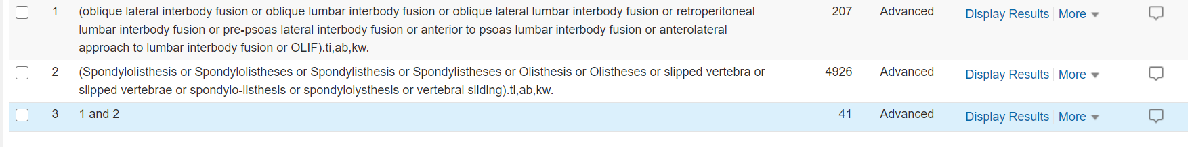

Cochrane


