Effect of physical activity promotion on adiponectin, leptin and other inflammatory markers in prediabetes – A systematic review and meta-analysis of randomized controlled trials
Journal: Acta Diabetologica
Authors: Radhika Aditya Jadhav, Dr. Arun G Maiya*, Aditi Hombali, Dr. Shashikiran U, Dr. Shivashankar K N,
Corresponding author: Dr. Arun G Maiya*
Centre for diabetic foot care and research, Department of Physiotherapy, Manipal College of Health Professions, Manipal academy of Higher Education, Manipal- 576104, Karnataka, India
Email: arun.maiya@manipal.edu

Electronic Supplementary file 4: Summary of risk of bias assessment
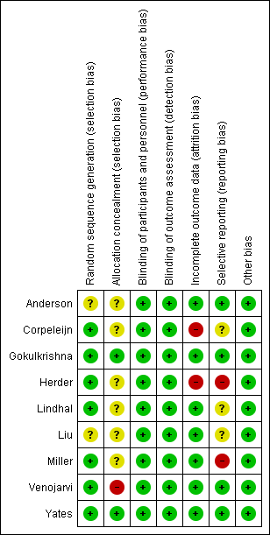

Fig.1: Review authors' judgements about each risk of bias item for each included study

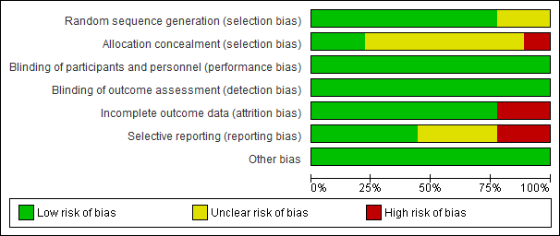
Fig.2: Risk of bias graph: review authors' judgements about each risk of bias item presented as percentages across all included studies.

