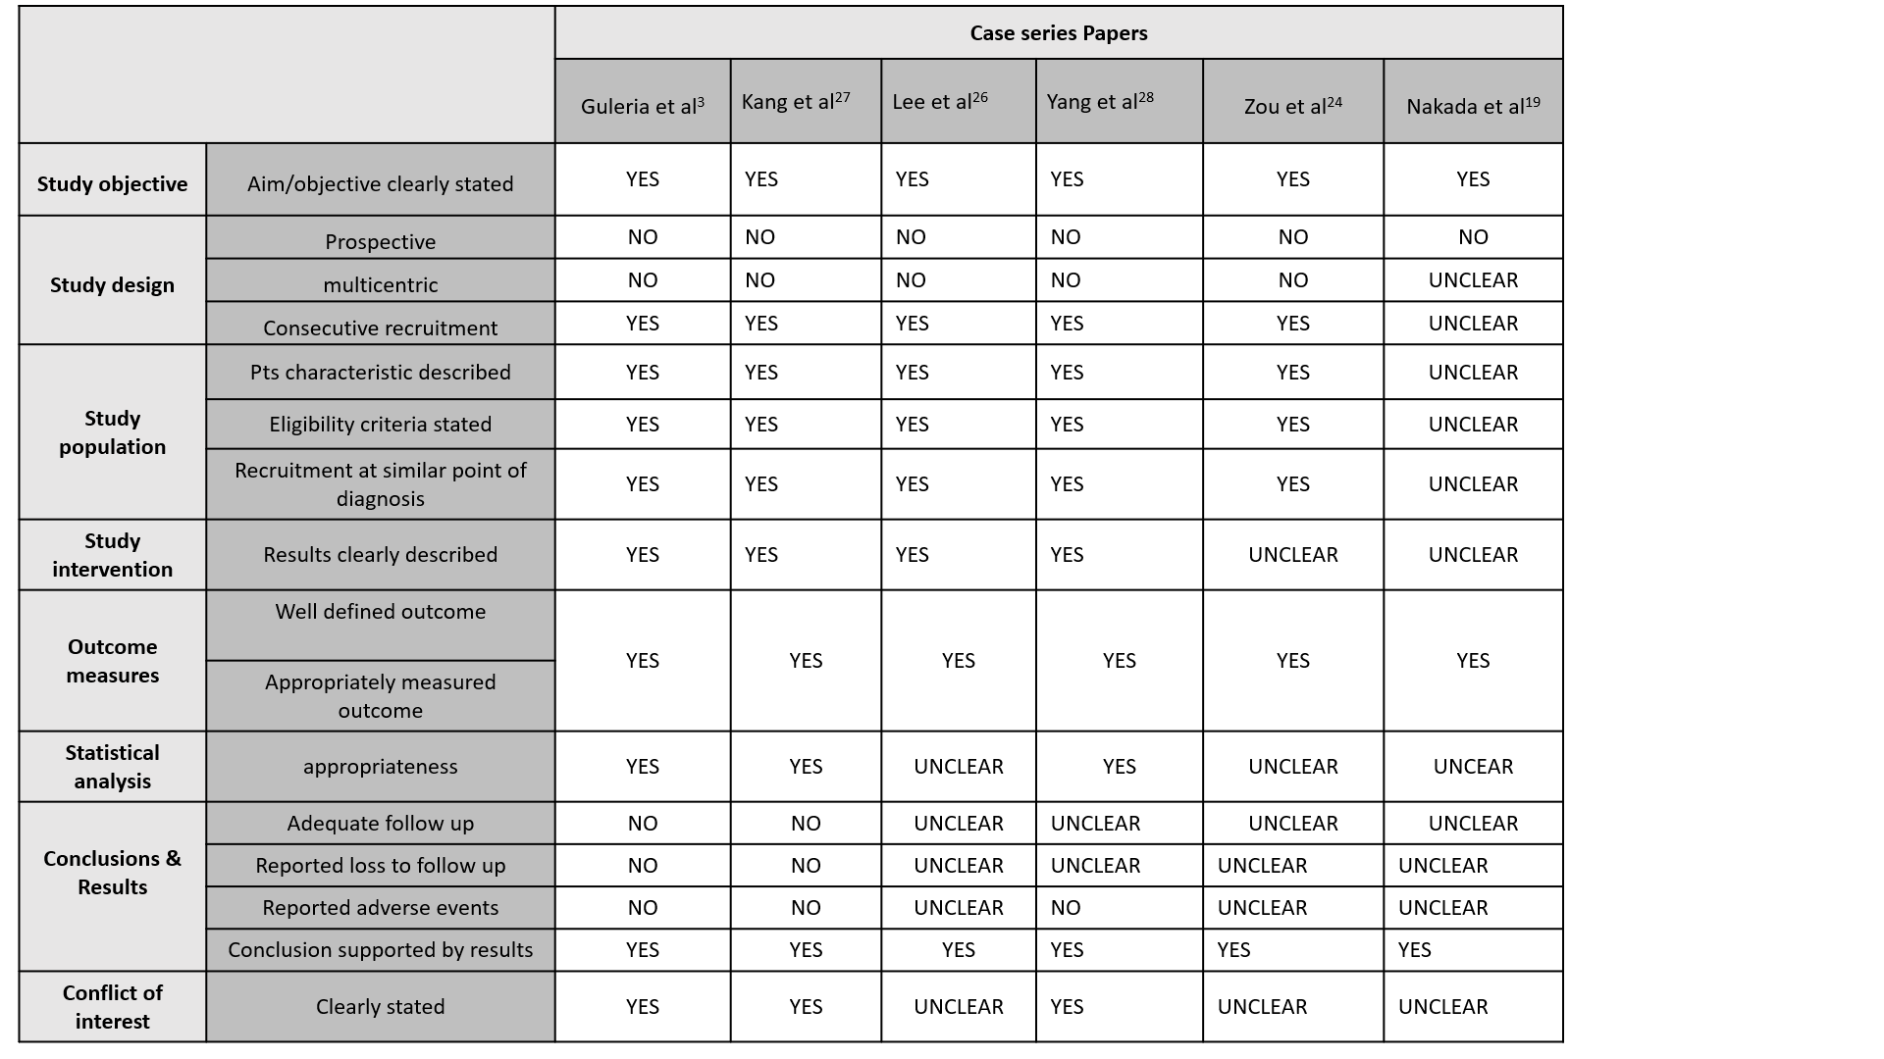
Supplemental materials. Table 1 - Quality Appraisal Checklist for Case Series Studies of IHE.
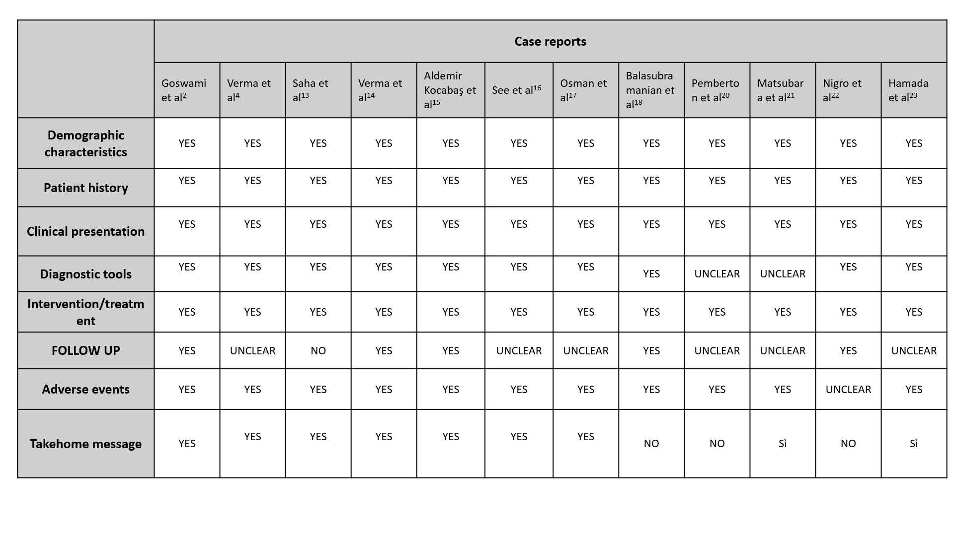
Supplemental materials. Table 2 - Checklist for Case Reports of The Joanna Briggs Institute Critical Appraisal tools.

