Supplementary Online Content

e-Table 1: PRISMA checklist

e-Table 2: Individual study risk of bias

e-Table 3: Summary of findings table (additional outcomes)

e-Table 4: Rate of superinfections

Sample Search Strategy

ICEMAN tool for subgroup effects

Systematic review protocol

TSA settings

e-Figure 1: Search results flowchart

e-Figure 2: Effect of corticosteroids on mortality. Studies are grouped by steroid subtype. Df = degrees of freedom.

e-Figure 3: Effect of corticosteroids on mortality. Studies are grouped by steroid initiation time. Df = degrees of freedom.

e-Figure 4: Effect of corticosteroids on mortality. Studies are grouped by steroid dosage. Df = degrees of freedom.

e-Figure 5: Effect of corticosteroids on mortality. Studies are grouped by ROB. Df = degrees of freedom.

e-Figure 6: Metaregression for mortality based on average daily steroid dose. CI = confidence interval

e-Figure 7: Effect of corticosteroids on mortality. Studies are grouped by COVID status and a sensitivity analysis removing studies that do not report 28 day mortality is done. Df = degrees of freedom.

e-Figure 8: ICU mortality. Df = degrees of freedom

e-Figure 9: Hospital mortality. Df = degrees of freedom

e-Figure 10: Hospital length of stay. Df = degrees of freedom

e-Figure 11: ICU length of stay. Df = degrees of freedom

e-Figure 12: Rates of neuromuscular weakness. Df = degrees of freedom

e-Figure 13: Rates of gastrointestinal bleeding. Df = degrees of freedom

e-Figure 14: Rates of hyperglycemia. Df = degrees of freedom

e-Figure 15: Effect of corticosteroids on mortality. Studies are grouped by publication date. Df = degrees of freedom

e-Figure 16: Effect of corticosteroids on mortality. Studies are grouped by presence of placebo. Df = degrees of freedom

e-Figure 17: Effect of corticosteroids on mortality with sensitivity analysis removing studies that initiated corticosteroids late . Df = degrees of freedom.

e-Figure 18: Effect of corticosteroids on duration of mechanical ventilation. Df = degrees of freedom.

e-Figure 19: Effect of corticosteroids on mortality. Studies are grouped by ARDS defintion. Df = degrees of freedom

 | # | Checklist item | Reported on page #
TITLE
Title | 1 | Identify the report as a systematic review, meta-analysis, or both. | 1
ABSTRACT
Structured summary | 2 | Provide a structured summary including, as applicable: background; objectives; data sources; study eligibility criteria, participants, and interventions; study appraisal and synthesis methods; results; limitations; conclusions and implications of key findings; systematic review registration number. | 4
INTRODUCTION
Rationale | 3 | Describe the rationale for the review in the context of what is already known. | 6
Objectives | 4 | Provide an explicit statement of questions being addressed with reference to participants, interventions, comparisons, outcomes, and study design (PICOS). | 7
METHODS
Protocol and registration | 5 | Indicate if a review protocol exists, if and where it can be accessed (e.g., Web address), and, if available, provide registration information including registration number. | 7
Eligibility criteria | 6 | Specify study characteristics (e.g., PICOS, length of follow-up) and report characteristics (e.g., years considered, language, publication status) used as criteria for eligibility, giving rationale. | 8
Information sources | 7 | Describe all information sources (e.g., databases with dates of coverage, contact with study authors to identify additional studies) in the search and date last searched. | 7
Search | 8 | Present full electronic search strategy for at least one database, including any limits used, such that it could be repeated. | 7, Supplementary materials
Study selection | 9 | State the process for selecting studies (i.e., screening, eligibility, included in systematic review, and, if applicable, included in the meta-analysis). | 8
Data collection process | 10 | Describe method of data extraction from reports (e.g., piloted forms, independently, in duplicate) and any processes for obtaining and confirming data from investigators. | 9
Data items | 11 | List and define all variables for which data were sought (e.g., PICOS, funding sources) and any assumptions and simplifications made. | 8
Risk of bias in individual studies | 12 | Describe methods used for assessing risk of bias of individual studies (including specification of whether this was done at the study or outcome level), and how this information is to be used in any data synthesis. | 9
Summary measures | 13 | State the principal summary measures (e.g., risk ratio, difference in means). | 9
Synthesis of results | 14 | Describe the methods of handling data and combining results of studies, if done, including measures of consistency (e.g., I²) for each meta-analysis. | 9

e-Table 2: Individual Study Risk of Bias

Study | Randomization process | Deviations from intended interventions | Missing outcome data | Measurement of the outcome | Selection of the reported result | Overall Bias for the outcome of Mortality
Steinberg, 2006 | Low | Low | Low | Low | Low | Low
Meduri, 2007 | Low | Low | Low | Low | Low | Low
Liu, 2012 | Some concerns | Low | Low | Low | Low | Some concerns
Rezk, 2013 | High | Low | Low | Low | Low | High
Tongyoo, 2016 | Low | Low | Low | Low | Low | Low
Villar, 2020 | Low | Low | Low | Low | Low | Low
Meduri, 1998 | Low | Some concerns | Low | Low | Low | Some concerns
Annane, 2006 | Low | Low | Low | Low | Low | Low
Zhou, 2014 | Some concerns | Some concerns | Low | Low | Some concerns | High
Zhifang, 2016 | Some concerns | Some concerns | Low | Low | Some concerns | High
Horby, 2020 | Low | Low | Low | Low | Low | Low
Tomazini, 2020 | Low | Low | Low | Low | Low | Low
DEXA-COVID19 | Low | Low | Low | Low | Low | Low
COVID STEROID | Low | Low | Low | Low | Low | Low
Steroids-SARI | Some concerns | Low | Low | Low | Low | Some concerns
Jeronimo, 2020 | Low | Low | Low | Low | Low | Low
Dequin, 2020 | Low | Low | Low | Low | Low | Low
Derek, 2020 | Low | Low | Low | Low | Low | Low

e-Table 3: Summary of Findings Table (Additional Outcomes)
Question: Corticosteroids compared to control for Acute Respiratory Distress Syndrome
Setting: ICU

Certainty assessment |  |  |  |  |  |  | № of patients |  | Effect |  | Certainty | Importance
№ of studies | Study design | Risk of bias | Inconsistency | Indirectness | Imprecision | Other considerations | Corticosteroids | control | Relative  (95% CI) | Absolute  (95% CI) | Certainty | Importance
ICU mortality
4 ^{f} | randomised trials | not serious | not serious ^{e} | serious^{v} | serious^{u} | none | 92/303 (30.4%) | 127/266 (47.7%) | RR 0.61  (0.38 to 0.99) | 186 fewer per 1,000  (from 296 fewer to 5 fewer) | ⨁⨁◯◯  LOW | CRITICAL
Hospital mortality
4 ^{g} | randomised trials | not serious | not serious ^{e} | serious^{v} | not serious | none | 104/303 (34.3%) | 134/266 (50.4%) | RR 0.67  (0.46 to 0.96) | 166 fewer per 1,000  (from 272 fewer to 20 fewer) | ⨁⨁⨁◯  MODERATE | CRITICAL

Explanations
e. High isquared, however, all studies favour corticosteroids
f. Annane 2006, Meduri 1998, Meduri 2007, Villar 2020
g. Annane 2006, Meduri 1998, Meduri 2007, Villar 2020
u. Wide confidence interval doesn’t exclude no effect.
v. Not all included studies had ARDS as inclusion criteria (COVID-19 studies, Annane 2006 – septic shock)

e-Table 4: Superinfection rates

 | Corticosteroid | Control
Steinberg, 2006 | 25 | 43
Meduri, 2007 | 40 | 40
Liu, 2012 | 2 | 1
Rezk, 2013 | 0 | 3
Zhao, 2014 | 7 | 4
Tongyoo, 2016 | 17 | 19
Villar, 2020 | 33 | 35
Meduri, 1998 | 24 | 10
Annane, 2006 | 12 | 12
Dequin, 2020 | 28 | 30
Tomazini, 2020 | 33 | 43
COVID-Steroid, 2020 | 0 | 0
Total | 221 | 244

Sample Search Strategy

Database: OVID Medline Epub Ahead of Print, In-Process & Other Non-Indexed Citations, Ovid MEDLINE(R) Daily and Ovid MEDLINE(R) 1946 to Present
Search Strategy:
--------------------------------------------------------------------------------
1 exp Adrenal Cortex Hormones/ (395664)
2 (steroid* or corticosteroid* or glucocorticoid* or hydroxycorticosteroid* or methylpredniso* or hydrocortison*).mp. [mp=title, abstract, original title, name of substance word, subject heading word, floating sub-heading word, keyword heading word, organism supplementary concept word, protocol supplementary concept word, rare disease supplementary concept word, unique identifier, synonyms] (565475)
3 1 or 2 (729535)
4 Respiratory Distress Syndrome, Adult/ (19463)
5 Acute Lung Injury/ (6223)
6 (((acute or adult or severe) and (respiratory adj1 distress)) or ards).mp. [mp=title, abstract, original title, name of substance word, subject heading word, floating sub-heading word, keyword heading word, organism supplementary concept word, protocol supplementary concept word, rare disease supplementary concept word, unique identifier, synonyms] (40178)
7 ((acute adj1 lung* adj1 injur*) or (shock adj1 lung*)).mp. [mp=title, abstract, original title, name of substance word, subject heading word, floating sub-heading word, keyword heading word, organism supplementary concept word, protocol supplementary concept word, rare disease supplementary concept word, unique identifier, synonyms] (15464)
8 exp Respiratory Insufficiency/ (62472)
9 ((respirat* or ventilat*) adj3 (insufficienc* or failure or depression or disturbance or dysfunction)).mp. [mp=title, abstract, original title, name of substance word, subject heading word, floating sub-heading word, keyword heading word, organism supplementary concept word, protocol supplementary concept word, rare disease supplementary concept word, unique identifier, synonyms] (70024)
10 or/4-9 (142363)
11 3 and 10 (8071)
12 limit 11 to ed=20200215-20200716 (120)
13 randomized controlled trial.pt. (509616)
14 controlled clinical trial.pt. (93756)
15 random*.ab. (1111037)
16 placebo.ab. (209324)
17 drug therapy.fs. (2219725)
18 trial.ab. (512235)
19 groups.ab. (2068241)
20 clinical trials as topic.sh. (192082)
21 random allocation.sh. (103195)
22 or/13-21 (5052577)
23 exp animals/ not humans.sh. (4717992)
24 22 not 23 (4383019)
25 12 and 24 (70)

Instrument for assessing the Credibility of Effect Modification Analyses (ICEMAN)

in meta-analyses of randomized controlled trials Version 1.0

Quick instructions
- Synonyms for effect modification include subgroup effect, interaction, and moderation
- The instrument applies to a single proposed effect modification at a time; complete one form per each outcome, time-point, effect measure, and effect modifier
- Response options on the left indicate definitely or probably reduced, response options on the right probably or definitely increased credibility
- Completely unclear goes under probably reduced credibility
- It is helpful to provide a supporting comment or quotation under each question
- Whether an effect modification is patient-important is not part of the credibility assessment
- The manual provides more detailed instructions and examples

Preliminary considerations
Study reference(s): Corticosteroids in COVID-19 and non-COVID-19 ARDS: a systematic review and meta-analysis
If available, protocol reference(s):
State a single outcome and, if applicable, time-point of interest (e.g., mortality at 1 year follow-up): Mortality
State a single effect measure of interest (e.g., relative or absolute risk difference): Relative risk
State a single potential effect modifier of interest (e.g., age or comorbidity): Duration of corticosteroids
Was the potential effect modifier measured before or at randomization? [ X] yes, continue [ ] no, stop here and refer to manual for further instructions

Credibility assessment
1: Is the analysis of effect modification based on comparison within rather than between trials?
[X] Completely between | [ ] Mostly between or unclear | [ ] Mostly within | [ ] Completely within
Subgroup analysis or meta-regression comparing overall effects of each individual trial. This is typical for aggregate data meta-analysis. | Subgroup analysis or meta-regression with most information coming from overall effects, but some trials providing within-trial subgroup information | Most trials providing within-trial subgroup information; or individual participant data analysis that combines within and between trial information | All trials providing within-trial subgroup information or individual participant data; and the analysis separates within from between trial information, e.g., meta-analysis of interactions
Comment:
2: For within-trial comparisons, is the effect modification similar from trial to trial? [X] Not applicable: no or one within-RCT comparison
[ ] Definitely not similar | [ ] Probably not similar or unclear | [ ] Mostly similar | [ ] Definitely similar
Effect modification reported for two or more trials and clearly different directions | Effect modification not reported for individual trials or too imprecise to tell | Effect modification reported for two or more trials, mostly similar in direction, but considerable differences in magnitude | Effect modification reported for two or more trials, similar in direction, only some differences in magnitude
Comment:
3: For between-trial comparisons, is the number of trials large? [ ] Not applicable: no between RCT comparison
[ ] Very small | [ ] Rather small or unclear | [X] Rather large | [ ] Large
1 or 2 or in smallest subgroup; 5 or less in continuous meta-regression | 3-4 in smallest subgroup; 6-10 in continuous meta-regression | 5-9 in smallest subgroup; 11 to 15 in continuous meta-regression | 10 or more in smallest subgroup; more than 15 in continuous meta-regression
Comment:
4: Was the direction of effect modification correctly hypothesized a priori?
[ ] Definitely no | [ ] Probably no or unclear | [ ] Probably yes | [ X ] Definitely yes
Clearly post-hoc or results inconsistent with hypothesized direction or biologically very implausible | Vague hypothesis or hypothesized direction unclear | No prior protocol available but unequivocal statement of a priori hypothesis with correct direction of effect modification | Prior protocol available and includes correct specification of direction of effect modification, e.g., based on a biologic rationale
Comment:
5: Does a test for interaction suggest that chance is an unlikely explanation of the apparent effect modification? (consider irrespective of number of effect modifiers)
[ ] Chance a very likely explanation | [ X ] Chance a likely explanation or unclear | [ ] Chance may not explain | [ ] Chance an unlikely explanation
Interaction or meta-regression p-value >0.05 | Interaction or meta-regression p-value ≤0.05 and >0.01, or no test of interaction reported and not computable | Interaction or meta-regression p-value ≤0.01 and >0.005 | Interaction or meta-regression p-value ≤0.005
Comment:
6: Did the authors test only a small number of effect modifiers or consider the number in their statistical analysis?
[ ] Definitely no | [ X ] Probably no or unclear | [ ] Probably yes | [ ] Definitely yes
Explicitly exploratory analysis or large number of effect modifiers tested (e.g., greater than 10) and multiplicity not considered in analysis | No mention of number or 4-10 effect modifiers tested and number not considered in analysis | No protocol available but unequivocal statement of 3 or fewer effect modifiers tested | Protocol available and 3 or fewer effect modifiers tested or number considered in analysis
Comment:
7: Did the authors use a random effects model?
[ ] Definitely no | [ ] Probably no or unclear | [ ] Probably yes | [ X ] Definitely yes
Fixed (or common) effect or fixed effects model explicitly stated | Probably fixed effect(s) model | Probably random (or mixed) effects | Random (or mixed) effects explicitly stated
Comment:
8: If the effect modifier is a continuous variable, were arbitrary cut points avoided? [ X ] not applicable: not continuous
[ ] Definitely no | [ ] Probably no or unclear | [ ] Probably yes | [ ] Definitely yes
Analysis based on exploratory cut point(s), e.g., picking cut point associated with highest interaction p-value | Analysis based on cut point(s) of unclear origin | Analysis based on pre-specified cut point(s), e.g., suggested by prior RCT | Analysis based on the full continuum, e.g., assuming a linear or logarithmic relationship
Comment:
9 Optional: Are there any additional considerations that may increase or decrease credibility? (manual section 3.9) [X ] not applicable
 | [ ] Yes, probably decrease | [ ] Yes, probably increase
Comment:
10: How would you rate the overall credibility of the proposed effect modification?
The overall rating should be driven by the items that decrease credibility. The following provides a sensible strategy:
- All responses definitely or probably decrease credibility or unclear very low
- Two or more responses definitely decrease credibility maximum usually low even if all other responses satisfy credibility criteria
- One response definitely decreases credibility maximum usually moderate even if all other responses satisfy credibility criteria
- Two responses probably decrease credibility maximum usually moderate even if all other responses satisfy credibility criteria
- No response options definitely or probably decrease credibility high very likely

Place a mark on the continuous line (or type “x” in editable version)
 | X
 | Very low credibility | Low credibility | Moderate credibility | High credibility
 | Very likely no effect modification  Use overall effect for each subgroup | Likely no effect modification  Use overall effect for each subgroup but note remaining uncertainty | Likely effect modification  Use separate effects for each subgroup but note remaining uncertainty | Very likely effect modification  Use separate effects for each subgroup
Comment: Two responses probably decrease credibility

Review Protocol

Steroids In ARDS

Objective
This systematic review and meta-analysis will examine the role of steroid therapy in acute respiratory distress syndrome (ARDS). This work is important to determine whether patient with diagnosed ARDS should receive glucorticoid therapy to reduce their overall mortality and ventilator free days. While previous MA have been conducted on the topic, a new randomized control trial including almost 25% of the previous MA analysis population has been recently published.

Review Question

In adult patients with known ARDS, does the use of glucocorticoids reduce mortality or increase ventilator free days.
Population – Adult patients (>18 years) with ARDS, as defined by Berlin criteria
Intervention – glucocorticoid use (any type and any duration)
Control – usual therapy
Outcome – At least one of hospital mortality, ICU mortality, mechanical ventilator free days, duration of mechanical ventilation, ICU length of stay, hospital length of stay, prevalence of nosocomial infections, neuromuscular weakness, reintubation rate and ICU readmission rate.

Search Strategy
Databases
We will search MEDLINE, EMBASE, Web of Science and Cochrane database for all relevant trials using the search strategy below. We will also manually search conference proceedings from critical care conferences and search the bibliographies of all included articles and prior meta-analyses on the topic. We will also consult experts in the field to ensure that we have not missed key studies.

Full Search Strategy
We will search the aforementioned databases using the keywords “acute lung injury,” “acute respiratory distress syndrome,” “acute respiratory failure,” “pneumonia,” “steroids,” “glucocorticoids,” and ”corticosteroids.” We will include only randomized control trials (RCTs) on the topic, and exclude all case series, case studies, cohort studies, case reports and other observational studies. We will include all RCTs that compare glucocorticoid use to placebo in adult patients with ARDS. Our outcomes of interest will be mortality, mechanical ventilator free days, duration of mechanical ventilation, ICU length of stay, hospital length of stay, prevalence of opportunistic infections, muscle weakness, reintubation rate and ICU readmission rate. We will also collect data on baseline variables including age, gender, SOFA score and APACHE II score.

Data Extraction
Two reviewers will screen citations independently and in duplicate from our initial search in two stages; first we will screen the title and abstract and then, we will screen the full text of potentially relevant abstracts. We will capture reasons for study exclusion at the full text review stage. A third author will adjudicate disagreements where required.

Study Quality Assessment
We will assess each study for risk of bias (ROB) using the modified Cochrane ROB 2 tool. We will use the GRADE methodology to assess the overall certainty of our outcomes.

Data Synthesis
We will use the DerSimonnian-Laird random effects model with inverse-variance weighting to generate pooled treatment effects across studies. Heterogeneity between trials will be assessed using a combination of the Chi² test, the I² statistic, and visual inspection of the forest plots. We will present results of dichotomous outcomes using relative risk (RR) and continuous outcomes as mean difference (MD) both with 95% confidence intervals (CIs). We will also provide absolute differences with 95% CIs.

We will plan for five a priori subgroup analysis for this study: methylprednisolone vs dexamethasone, early steroid initiation (<72 hours) vs late steroid initiation (>72 hours) including and excluding patients randomized > day 13 of ARDS, duration of steroid therapy (<7 days vs >7 days), low dose steroid use (below median dose of included trials) vs moderate-high dose steroid use (above median dose of included trials), high risk of bias studies vs low risk of bias studies.

TSA Settings

80% Power

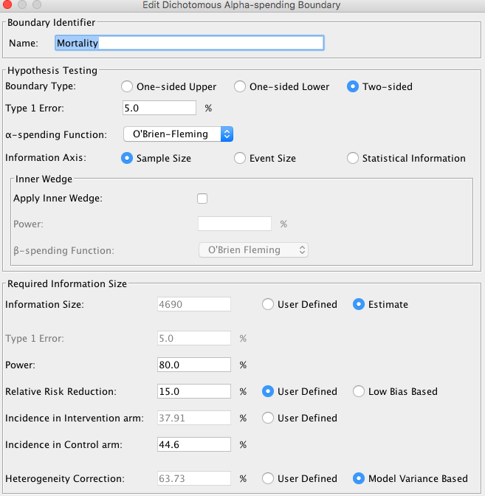

90% Power

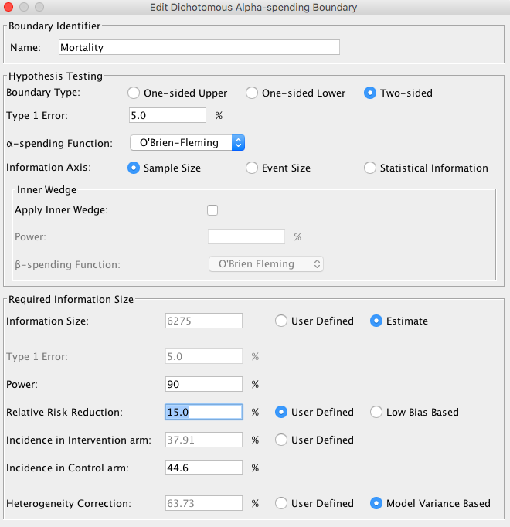

e-Figure 1: Search results flowchart

e-Figure 2: Effect of corticosteroids on mortality. Studies are grouped by steroid subtype. Df = degrees of freedom.

e-Figure 3: Effect of corticosteroids on mortality. Studies are grouped by steroid initiation time. Df = degrees of freedom.

e-Figure 4: Effect of corticosteroids on mortality. Studies are grouped by steroid dosage. Df = degrees of freedom.

e-Figure 5: Effect of corticosteroids on mortality. Studies are grouped by ROB. Df = degrees of freedom.

e-Figure 6: Metaregression for mortality based on average daily steroid dose. CI = confidence interval

e-Figure 7: Effect of corticosteroids on mortality. Studies are grouped by COVID status and a sensitivity analysis removing studies that do not report 28 day mortality is done. Df = degrees of freedom.

e-Figure 8: ICU mortality. Df = degrees of freedom

e-Figure 9: Hospital mortality. Df = degrees of freedom

e-Figure 10: Hospital length of stay. Df = degrees of freedom

e-Figure 11: ICU length of stay. Df = degrees of freedom

e-Figure 12: Rates of neuromuscular weakness. Df = degrees of freedom

e-Figure 13: Rates of gastrointestinal bleeding. Df = degrees of freedom

e-Figure 14: Rates of hyperglycemia. Df = degrees of freedom

e-Figure 15: Effect of corticosteroids on mortality. Studies are grouped by publication date. Df = degrees of freedom

e-Figure 16: Effect of corticosteroids on mortality. Studies are grouped by presence of placebo. Df = degrees of freedom

e-Figure 17: Effect of corticosteroids on mortality with sensitivity analysis removing studies that initiated corticosteroids late . Df = degrees of freedom.

e-Figure 18: Effect of corticosteroids on duration of mechanical ventilation. Df = degrees of freedom.

e-Figure 19: Effect of corticosteroids on mortality. Studies are grouped by ARDS definition. Df = degrees of freedom

