Title: Efficacy and safety of intravenous rtPA in ischemic strokes due to small-vessel occlusion: systematic review and meta-analysis
Bartosz Karaszewski (0000-0003-2726-0016)^{1,2,3}, Prof., MD, PhD; Adam Wyszomirski (0000-0002-6293-1439)¹, MSc; Bartosz Jabłoński (0000-0002-1657-5090)^{1,2}, MD; David J Werring (0000-0003-2074-1861)⁴, Prof., PhD; Dominika Tomaka², MD
¹Department of Adult Neurology, Division of Neurology, Faculty of Medicine, Medical University of Gdansk, Gdansk, Poland
²Department of Adult Neurology, University Clinical Center in Gdansk, Gdansk, Poland
³Prof. Karaszewski serves as the Main Expert in Stroke Medicine for the Polish Ministry of Health
⁴Stroke Research Centre, University College London, Queen Square Institute of Neurology, London, United Kingdom
Correspondence: Prof. Bartosz Karaszewski; MD, PhD, Department of Adult Neurology, Medical University of Gdansk, University Clinical Center in Gdansk, Debinki 7, 80-211 Gdansk. Email bartosz@karaszewski.org, Tel. +48 58 349 23 00, Fax +48 58 349 23 20

SUPPLEMENTAL MATERIAL

Supplemental Table I. SVD/LC and sICH definitions used in the analyzed studies
Study | Neuroimaging/clinical criteria | sICH def.
Griebe et al. | ASCO class.  MRI (DWI-confirmed) | Significant neurological deterioration ≥ 4 points NIHSS
Eggers et al | OCSP, TOAST, MRI | NINDS criteria
Hwang et al. | OCSP, TOAST, MRI | Early neurological deterioration (END)
Lahoti et al. | OCSP, TOAST, MRI | Significant neurological deterioration ≥ 4 points NIHSS
NINDS | OCSP, TOAST, CT | NINDS criteria
Shobha et al. | OCSP | ECASS; deterioration ≥ 4 points NIHSS
Lindley et al. | OCSP + MRI/CT, TOAST | Significant neurological deterioration
Barow et al. | DWI-FLAIR mismatch | Safe Implementation of Thrombolysis in Stroke–Monitoring Study (SITS-MOST) criteria
Peak et al. | TOAST, MRI + MRA/CTA | ECASS-3 criteria
Yang et al. | TOAST, MRI/CT; OCSP - for patients with negative findings on brain imaging | not specified
Matusevicius et al. | TOAST, CT/MRI | SITS-MOST, NINDS, ECASS-2 criteria
Chang et al. | TOAST, MRI/CT/CTA | not specified
Sung et al. | OCSP | Significant neurological deterioration ≥ 4 points NIHSS
Lee et al. | OCSP | SITS-MOST criteria
Fluri et al. | TOAST, MRI/CT - SAO | NINDS criteria
Kohrmann et al. | TOAST | NINDS criteria
Padma et al. | TOAST | not specified
Cocho et al. | OCSP, TOAST | ECASS-2 criteria
Miedema et al. | OCSP, CT | SITS-MOST criteria
Simonsen et al. | TOAST, MRI | SITS-MOST criteria
Pan et al. | TOAST | ECASS-2 criteria
Zivanovic et al. | OCSP, CT | ECASS-3 criteria
Kim et al. | TOAST, MRI/MRA | Significant neurological deterioration ≥ 4 points NIHSS

Supplemental Table II. The quality assessment of individual trials comparing iv rtPA and control with Cochrane Collaboration’s tool [1]
Study | Random sequence generation (selection bias) | Allocation concealment (selection bias) | Blinding of participants and personnel (performance bias) | Blinding of outcome assessment  (detection bias) | Incomplete outcome data (attribution bias) | Selective reporting (reporting bias) | Comments
NINDS group | Low risk | Low risk | Low risk | Low risk | Unclear risk | Low risk | Low risk
Lindley et al. | Low risk | Low risk | High risk | Low risk | Low risk | Low risk | Low risk
Barow et al. | Low risk | Low risk | Low risk | Low risk | Low risk | Low risk | Low risk

Supplemental Table III. The quality assessment of individual observational comparative cohort studies with the Newcastle-Ottawa Scale [2]

Study | Selection |  |  |  | Comparability |  | Outcome |  |  | Total score
 | Representativeness of exposed cohort? | Selection of the non-exposed cohort? | Ascertainment of exposure? | Demonstration that outcome of interest was not present at start of study? | Study controls for age/sex? | Study controls for at least 3 additional risk factors? | Assessment of outcome? | Was follow-up long enough for outcome to occur? | Adequacy of follow-up of cohorts?
Griebe et al. | 1 | 1 | 1 | 0 | 1 | 0 | 1 | 1 | 1 | 7/9
Eggers et al. | 1 | 1 | 1 | 1 | 1 | 1 | 1 | 1 | 1 | 9/9
Hwang et.al | 1 | 1 | 1 | 0 | 1 | 0 | 1 | 1 | 1 | 7/9
Lahoti et al. | 1 | 1 | 1 | 1 | 0 | 0 | 1 | 1 | 1 | 7/9
Shobha et al. | 1 | 1 | 1 | 0 | 1 | 1 | 1 | 1 | 1 | 8/9
Paek et al. | 1 | 1 | 1 | 1 | 1 | 1 | 1 | 1 | 1 | 9/9
Yang et al. | 1 | 1 | 1 | 0 | 1 | 0 | 1 | 1 | 1 | 7/9
Matusevicius et al. | 1 | 1 | 1 | 0 | 1 | 1 | 1 | 1 | 1 | 8/9

Supplemental Table IV. Adjustment for covariates

Study | Adjustment for covariates
Lahoti et al. | Age, sex, NIHSS at presentation, hypertension, diabetes mellitus, hyperlipidemia, atrial fibrillation, and smoking.
Barow et al. | Age, symptom severity (NIHSS score).
Paek et al. | Age, sex, initial NIHSS, pre-stroke mRS score, coronary heart disease, initial systolic BP, pre-stroke antiplatelet, pre-stroke statin, onset to arrival time, and antithrombotic management after admission.
Matusevicius et al. | Age, sex, NIHSS at baseline, onset-to-door time, history of hypertension, diabetes, hyperlipidemia, smoking, previous stroke, atrial fibrillation, and congestive heart failure.

Supplemental Figure I. PRISMA [3] flow diagram for the meta-analysis
Records excluded (n=95)

Records identified through databases searching (n=229)
Identification

Records excluded (n=95)
Records screened (n=137)
Screening

Full-text articles excluded (n=19)
Full-text articles assessed for eligibility (n=42)
Eligibility

Included
Studies included in quantitative synthesis (n=23)

Supplemental Figure II. Funnel plots of unadjusted analysis for a) excellent outcome; b) favorable outcome; c) incidence of sICH in rtPA vs control patients; d) sICH in rtPA patients
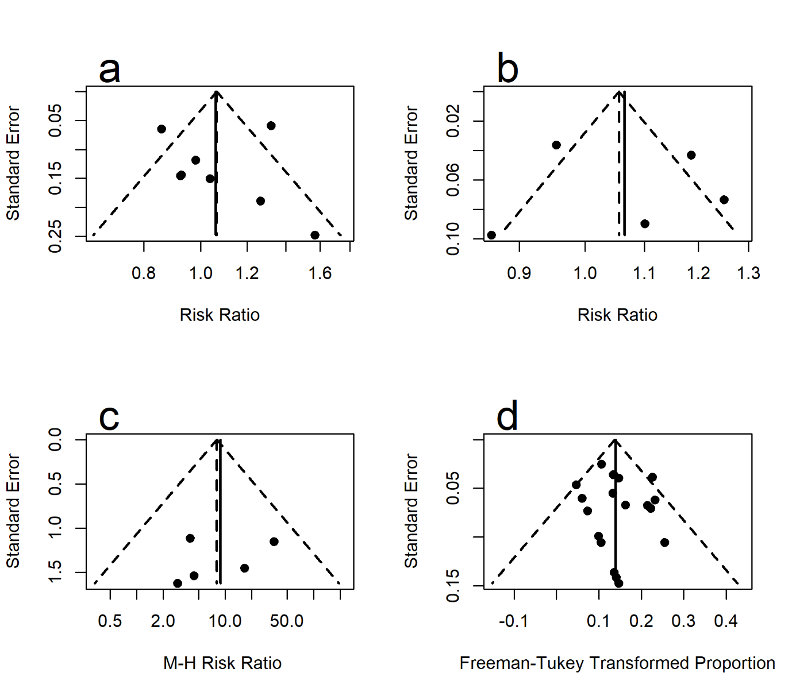
Supplemental Figure III. The unadjusted pooled risk ratio for excellent functional outcome
Supplemental Figure IV. The unadjusted overall risk ratio for favorable functional outcome
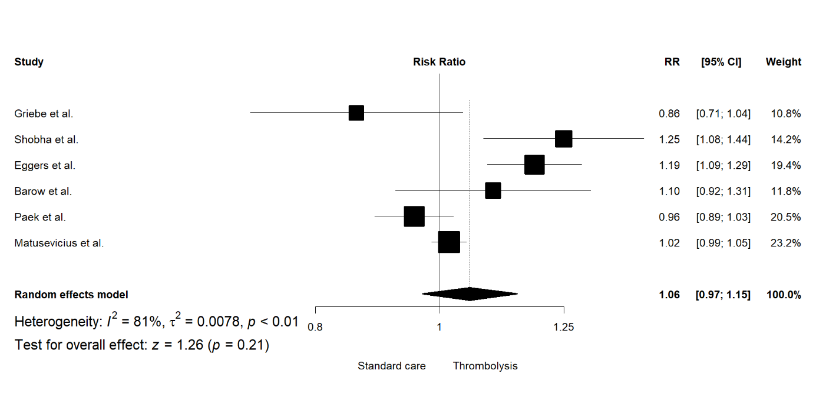

Supplemental Figure V. The unadjusted pooled risk ratio for excellent functional outcome excluding the SITS cohort

Supplemental Figure VI. The unadjusted overall risk ratio for favorable functional outcome excluding the SITS cohort

Supplemental Figure VII. The adjusted pooled odds ratio for excellent functional outcome excluding the SITS cohort

Supplemental Figure VIII. The pooled rate of sICH in trombolysed patients excluding the SITS cohort

References
1. Higgins JPT, Altman DG, Gotzsche PC, Juni P, Moher D, Oxman AD, et al. The Cochrane Collaboration’s tool for assessing risk of bias in randomised trials. BMJ. 2011;343:d5928.
2. Wells Ga, Shea B, O’Connell D, Peterson J, Welch V, Losos M, et al. The Newcastle-Ottawa Scale (NOS) for assessing the quality if nonrandomized studies in meta-analyses. http://www.ohri.ca/programs/clinical_epidemiology/oxford.htm. Accessed February 27, 2020.
3. Liberati A, Altman DG, Tetzlaff J, Mulrow C, Gøtzsche PC, Ioannidis JPA, et al. The PRISMA statement for reporting systematic reviews and meta-analyses of studies that evaluate health care interventions: explanation and elaboration. J. Clin. Epidemiol. 2009;62:e1-34.

