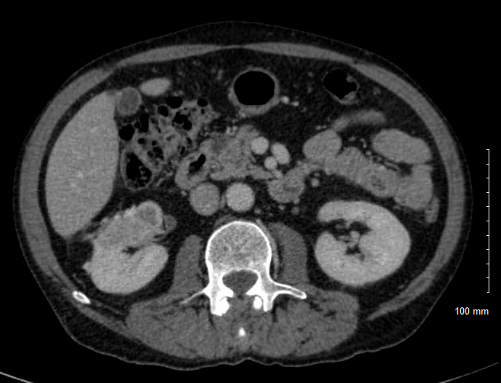

Supplemental Figure 1. Homolateral RCC recurrence 15 months after right open partial nephrectomy

