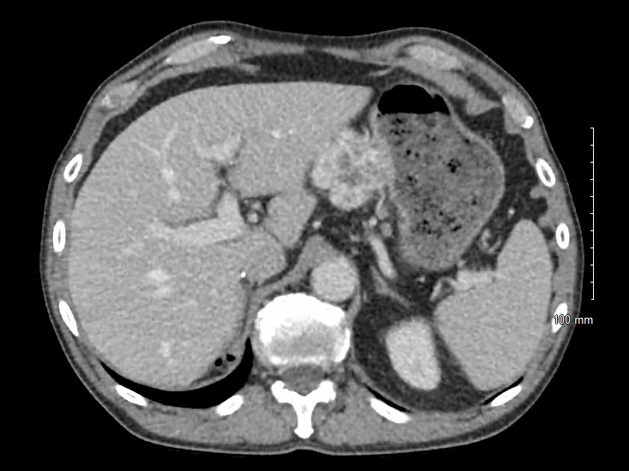
Supplemental Figure 2. Lesser curvature gastric metastases at CT scan

