Supporting Information

Contents
Search Strategy 1
Supplementary Table 1: Characteristics of individual studies 2
Supplementary Figure 1: Maps of sex-specific prevalence estimates and female:male prevalence ratio 15
Supplementary Figure 2: Subgroup analyses 17
Supplementary Figures 4-7: Sensitivity analyses, using different study selection criteria 19
Supplementary Figures 8-11: Sensitivity analyses, using different definitions of CKD 24
Supplementary Figures 12-13: Sensitivity analyses, using different definitions of CKD (Maps) 29
Supplementary Figure 14: Sensitivity analysis, restricted to advanced CKD 33
References 34

Search Strategy
Date of search January 23, 2020; and repeated on May 24, 2021
- MEDLINE (1946 to 2020; 2020 to 2021)
- EMBASE (1980 to 2020; 2020 to 2021)

- exp China/
- exp Hong Kong/
- exp Macau/
- exp Taiwan/
- exp "Democratic People's Republic of Korea"/
- exp Japan/
- exp Mongolia/
- exp "Republic of Korea"/
- exp Afghanistan/
- exp Bangladesh/
- exp Bhutan/
- exp India/
- exp Iran/
- exp Maldives
- exp Indian Ocean Islands/
- exp Nepal/
- exp Pakistan/
- exp Sri Lanka/
- exp Brunei/
- exp Cambodia/
- exp Indonesia/
- exp Laos/
- exp Malaysia/
- exp Myanmar/
- exp Philippines/
- exp Singapore/

- exp Thailand/
- exp Timor/
- exp Vietnam/
- or/1-29
- exp Renal Insufficiency, Chronic/
- (chronic kidney disease).tw
- (chronic renal failure).tw
- CKD.tw
- (end-stage kidney disease).tw
- (end-stage renal disease).tw
- exp Glomerular Filtration Rate/
- (estimated glomerular filtration rate).tw
- eGFR.tw
- GFR.tw
- exp Creatinine/
- (serum creatinine).tw
- exp Proteinuria/
- proteinuria.tw
- exp Albuminuria/
- albuminuria.tw
- (urine albumin creatinine ratio).tw
- UACR.tw
- ACR.tw
- exp Hematuria/
- Or/31-50
- 30 and 51

Supplementary Table 1: Characteristics of individual studies
Supplementary Table 1 Individual study characteristics and quality assessment.
Country | Cohort type | Study size | % females | Mean age (years) | % with diabetes | % with hypertension | Definition of CKD* | Albuminuria/proteinuria definition used† | eGFR equation | Female CKD prevalence | Male CKD prevalence | Reference | Risk of bias
East Asia
China | High-risk | 210,271 | 53.6 | 65.4 | 100.0 | - | eGFR only | - | Not specified | 11% | 8% | (1) | Low
China | Non-high-risk | 123,629 | 36.8 | 44.8 | 7.0 | 24.6 | Both | Dipstick ≥1+ | MDRD | 3% | 6% | (2) | Low
China | Non-high-risk | 95,391 | 20.1 | 52.0 | 3.2 | 12.5 | eGFR only | - | CKD-EPI | 16% | 13% | (3) | Low
China | Non-high-risk | 47,204 | 57.3 | 49.6 | 7.4 | 35.4 | eGFR only | - | CKD-EPI | 5% | 3% | (4) | Low
China | Non-high-risk | 42,350 | 63.9 | 49.6 | - | - | eGFR only | - | MDRD | 3% | 2% | (5) | Low
China | Non-high-risk | 41,862 | 31.5 | - | - | - | eGFR only | - | MDRD | 5% | 3% | (6) | Mid
China | Non-high-risk | 40,524 | 54.3 | 60.6 | 18.4 | - | eGFR only | - | CKD-EPI | 18% | 23% | (7) | Low
China | Non-high-risk | 24,002 | 28.5 | 49.9 | 11.2 | 32.3 | Both | Dipstick ≥1+ | CKD-EPI | 2% | 3% | (8) | Low
China | High-risk | 17,280 | 38.6 | 63.5 | 27.7 | 63.0 | eGFR only | - | CKD-EPI | 14% | 9% | (9) | Low
China | Non-high-risk | 13,298 | 53.7 | 50.6 | - | - | Both | Dipstick ≥1+ | MDRD | 13% | 17% | (10) | Low
China | Non-high-risk | 11,694 | 53.7 | 53.8 | 10.4 | 50.1 | eGFR only | - | CKD-EPI | 2% | 2% | (11) | Low
China | Non-high-risk | 11,578 | 53.7 | 53.8 | 10.4 | 51.1 | eGFR only | - | CKD-EPI | 2% | 2% | (12) | Low
China | Non-high-risk | 10,384 | 57.0 | 52.9 | - | - | Both | KDIGO thresholds† (A2+) | MDRD | 15% | 11% | (13) | Low
China | Non-high-risk | 8,659 | 52.4 | 61.0 | 15.2 | 41.4 | eGFR only | - | Other | 8% | 10% | (14) | Low
China | Non-high-risk | 7,798 | 53.3 | 49.3 | 11.1 | 31.1 | eGFR only | - | CKD-EPI | 10% | 6% | (15) | Low
China | Non-high-risk | 7,053 | 67.0 | 51.3 | 9.6 | 31.8 | Both | KDIGO thresholds† (A2+) | MDRD | 10% | 14% | (16) | Low
China | Non-high-risk | 6,706 | 50.4 | - | - | - | eGFR only | - | CKD-EPI | 11% | 9% | (17) | Low
China | Non-high-risk | 4,925 | 51.6 | 51.0 | 11.4 | 35.0 | eGFR only | - | MDRD | 2% | 2% | (18) | Low
China | High-risk | 4,658 | 54.0 | 67.1 | 100.0 | - | Both | KDIGO thresholds† (A2+) | CKD-EPI | 25% | 25% | (19) | Low
China | Non-high-risk | 4,242 | 36.4 | 67.1 | - | - | eGFR only | - | CKD-EPI | 20% | 28% | (20) | Mid
China | High-risk | 3,711 | 57.2 | 56.3 | 11.4 | 100.0 | eGFR only | - | CKD-EPI | 4% | 2% | (21) | Low
China | Non-high-risk | 3,678 | 57.0 | 62.0 | 22.2 | 57.8 | eGFR only | - | CKD-EPI | 22% | 15% | (22) | Low
China | Non-high-risk | 3,669 | 64.1 | 58.9 | 19.8 | 45.7 | Albuminuria/  proteinuria only | KDIGO thresholds†  (A2, A3) | N/A | 7% | 9% | (23) | Low
China | Non-high-risk | 3,610 | 47.0 | 67.0 | 38.6 | 72.4 | eGFR only | - | MDRD | 19% | 19% | (24) | Mid
China | Non-high-risk | 3,560 | 50.6 | 51.7 | 6.5 | 16.9 | Both | KDIGO thresholds†  (A2, A3)‡ | MDRD | 13% | 8% | (25) | Low
China | High-risk | 3,489 | 55.2 | 64.5 | 100.0 | -- | Albuminuria/  proteinuria only | KDIGO thresholds†  (A2, A3) | N/A | 19% | 22% | (26) | Mid
China | High-risk | 3,301 | 44.9 | 59.3 | 100.0 | 47.7 | Both | KDIGO thresholds†  (A2, A3) | MDRD | 25% | 29% | (27) | Mid
China | High-risk | 3,002 | 20.5 | 64.5 | 21.9 | 54.4 | eGFR only | - | MDRD | 26% | 14% | (28) | High
China | Non-high-risk | 2,969 | 42.0 | 44.0 | 5.3 | 12.6 | Albuminuria/  proteinuria only | KDIGO thresholds† (A2) | N/A | 8% | 9% | (29) | Low
China | High-risk | 2,862 | 27.8 | 60.5 | 31.1 | 62.0 | eGFR only | - | MDRD | 22% | 13% | (30) | Mid
China | High-risk | 2,833 | 44.4 | 58.6 | 100.0 | - | eGFR only | - | MDRD | 6% | 6% | (31) | Mid
China | Non-high-risk | 2,310 | 50.5 | - | 7.4 | 35.4 | Both | A2: 17-300 (males) and 25-300 mg/g (females)  A3: ≥300 mg/g‡ | MDRD | 13% | 13% | (32) | High
China | Non-high-risk | 2,040 | 61.1 | 51.0 | 8.5 | - | Albuminuria/  proteinuria only | KDIGO thresholds† (A2) | N/A | 23% | 18% | (33) | Low
China | Non-high-risk | 1,999 | 72.5 | - | - | - | eGFR only | - | MDRD | 13% | 13% | (34) | Mid
China | High-risk | 1,395 | 54.8 | 64.4 | 100.0 | - | eGFR only | - | Other | 4% | 3% | (35) | Mid
China | High-risk | 1,401 | 42.8 | 58.4 | 100.0 | 66.5 | Both | A2+: ≥30 mg/24h, or  Proteinuria ≥200 mg/L | CKD-EPI | 42% | 37% | (36) | Mid
China | Non-high-risk | 1,115 | 68.7 | 53.2 | - | - | eGFR only | - | MDRD | 27% | 15% | (37) | Mid
China | High-risk | 1,062 | 32.1 | 79.6 | 38.6 | 80.2 | eGFR only | - | CKD-EPI | 42% | 40% | (38) | Mid
China | High-risk | 1,014 | 44.9 | 68.6 | - | - | Both | A2: 10-25 mg/mmol, or  Proteinuria >25 mg/mmol | MDRD | 54% | 42% | (39) | Mid
China | High-risk | 1,012 | 42.3 | 62.8 | 22.9 | 57.8 | eGFR only | - | MDRD | 23% | 12% | (40) | Mid
China | High-risk | 1,002 | 82.0 | 102.8 | 9.6 | 75.5 | eGFR only | - | MDRD | 28% | 39% | (41) | High
China | High-risk | 972 | 46.8 | 68.0 | 40.2 | 67.0 | eGFR only | - | MDRD | 19% | 9% | (42) | Mid
China | High-risk | 812 | 66.6 | 86.0 | 27.5 | 63.5 | eGFR only | - | CKD-EPI | 24% | 30% | (43) | High
China | Non-high-risk | 785 | 55.4 | 66.6 | 17.0 | 40.0 | eGFR only | - | MDRD | 61% | 55% | (44) | Mid
China | Non-high-risk | 616 | 24.0 | 41.8 | 8.6 | 22.4 | Both | Dipstick ≥1+, or  Proteinuria >150 mg/24h‡ | CKD-EPI | 24% | 25% | (45) | Mid
China | High-risk | 567 | 39.2 | 67.3 | 21.2 | 77.1 | eGFR only | - | MDRD | 21% | 17% | (46) | Mid
Taiwan | Non-high-risk | 462,293 | 50.2 | 41.8 | 5.4 | 20.7 | Both | Dipstick ≥1+ | MDRD | 12% | 13% | (47) | Low
Taiwan | Non-high-risk | 106,094 | 60.3 | 47.7 | 5.2 | 13.1 | eGFR only | - | CKD-EPI | 8% | 11% | (48) | Low
Taiwan | High-risk | 52,752 | 38.6 | 69.5 | 38.9 | - | eGFR only | - | CKD-EPI | 41% | 36% | (49) | Low
Taiwan | Non-high-risk | 41,600 | 44.5 | 37.9 | - | - | eGFR only | - | MDRD | 0% | 1% | (50) | Low
Taiwan | Non-high-risk | 29,797 | 46.0 | 52.2 | 13.6 | - | eGFR only | - | MDRD | 3% | 35% | (51) | Low
Taiwan | Non-high-risk | 27,482 | 56.4 | 58.0 | - | - | eGFR only | - | MDRD | 15% | 18% | (52) | Low
Taiwan | Non-high-risk | 17,026 | 23.7 | 57.2 | 9.0 | 38.5 | eGFR only | - | MDRD | 4% | 8% | (53) | Low
Taiwan | High-risk | 16,914 | 55.5 | 74.9 | 2.9 | 8.1 | eGFR only | - | CKD-EPI | 22% | 26% | (54) | Low
Taiwan | Non-high-risk | 11,376 | 60.2 | 52.0 | - | - | eGFR only | - | MDRD | 55% | 58% | (55) | Low
Taiwan | High-risk | 7,868 | 39.1 | 72.4 | 24.6 | 63.3 | eGFR only | - | MDRD | 41% | 44% | (56) | Low
Taiwan | High-risk | 6,523 | 48.0 | 58.9 | 100.0 | 38.5 | eGFR only | - | MDRD | 14% | 12% | (57) | Low
Taiwan | Non-high-risk | 3,552 | 60.1 | 53.6 | 8.0 | 14.6 | eGFR only | - | MDRD | 5% | 7% | (58) | Low
Taiwan | Non-high-risk | 3,473 | 48.1 | 36.0 | - | - | eGFR only | - | MDRD | 1% | 2% | (59) | Mid
Taiwan | High-risk | 3,031 | 21.3 | 64.0 | 34.4 | 62.4 | eGFR only | - | CKD-EPI | 53% | 34% | (60) | High
Taiwan | Non-high-risk | 2,359 | 51.4 | 56.9 |  | 60.2 | eGFR only | - | MDRD | 3% | 5% | (61) | Low
Taiwan | Non-high-risk | 2,350 | 51.4 | - | 12.0 | - | Albuminuria/  proteinuria only | KDIGO thresholds† (A2+) | N/A | 12% | 14% | (62) | Low
Taiwan | High-risk | 1,394 | 26.3 | 64.0 | 40.5 | 58.5 | eGFR only | - | Not specified | 60% | 40% | (63) | Mid
Taiwan | High-risk | 1,133 | 33.1 | 60.7 | 31.0 | 48.1 | Both | Proteinuria >1,000 mg/day (persistent) | Other | 91% | 84% | (64) | Mid
Taiwan | Non-high-risk | 984 | 45.4 | 66.7 | 14.3 | 30.9 | eGFR only | - | MDRD | 15% | 18% | (65) | Low
Taiwan | High-risk | 929 | 32.4 | 64.7 | 36.2 | 76.2 | eGFR only | - | CKD-EPI | 37% | 40% | (66) | Mid
Taiwan | High-risk | 549 | 55.4 | 63.4 | 100.0 | 38.6 | Albuminuria/  proteinuria only | KDIGO thresholds†  (A2, A3) | N/A | 56% | 53% | (67) | Mid
South Korea | High-risk | 490,352 | 36.0 | 55.3 | 100.0 | 19.1 | Both | Dipstick ≥1+ | N/A | 1% | 4% | (68) | Mid
South Korea | Non-high-risk | 367,932 | 41.5 | 41.7 | 4.5 | 23.0 | eGFR only | - | CKD-EPI | 1% | 1% | (69) | Low
South Korea | Non-high-risk | 112,115 | 46.3 | 49.0 | 6.9 | 21.8 | eGFR only | - | MDRD | 3% | 4% | (70) | Low
South Korea | High-risk | 38,905 | 50.4 | 55.8 | 22.3 | 30.0 | eGFR only | - | MDRD | 28% | 40% | (71) | Low
South Korea | Non-high-risk | 33,276 | 57.0 | 44.4 | 7.7 | 24.3 | Both | Dipstick ≥1+ | MDRD | 6% | 5% | (72) | Low
South Korea | Non-high-risk | 20,770 | 48.4 | - | 6.9 | 22.1 | eGFR only | - | MDRD | 2% | 2% | (73) | Low
South Korea | Non-high-risk | 19,311 | 43.9 | 48.0 | - | - | Both | Dipstick ≥1+ | N/A | 8% | 13% | (74) | Low
South Korea | High-risk | 11,050 | 29.5 | 63.5 | 28.1 | 48.8 | eGFR only | - | CKD-EPI | 40% | 21% | (75) | Low
South Korea | Non-high-risk | 10,534 | 60.7 | - | 12.1 | 39.5 | Albuminuria/  proteinuria only | KDIGO thresholds†  (A2, A3) | N/A | 27% | 23% | (76) | Low
South Korea | Non-high-risk | 9,509 | 52.0 | 52.1 | 11.2 | 19.4 | Both | Dipstick ≥1+ | Other | 22% | 3% | (77) | Low
South Korea | Non-high-risk | 9,009 | 60.3 | 65.1 | 19.1 | 44.4 | eGFR only | - | CKD-EPI | 6% | 8% | (78) | Low
South Korea | High-risk | 4,738 | 28.5 | 62.6 | 31.5 | 50.0 | eGFR only | - | CKD-EPI | 41% | 18% | (79) | Low
South Korea | High-risk | 3,712 | 54.8 | 62.0 | 100.0 | 100.0 | Albuminuria  /proteinuria only | KDIGO thresholds†  (A2, A3) | N/A | 29% | 30% | (80) | Mid
South Korea | High-risk | 3,045 | 18.0 | 68.3 | 58.7 | 73.5 | eGFR only | - | MDRD | 51% | 35% | (81) | Mid
South Korea | Non-high-risk | 1,928 | 30.7 | 54.9 | 14.1 | 34.9 | eGFR only | - | MDRD | 4% | 13% | (82) | Mid
South Korea | Non-high-risk | 1,363 | 50.9 | 55.6 | 44.9 | 14.0 | eGFR only | - | MDRD | 23% | 29% | (83) | Low
South Korea | High-risk | 984 | 55.7 | 76.0 | 24.0 | 73.7 | eGFR only | - | CKD-EPI | 21% | 28% | (84) | Mid
South Korea | Non-high-risk | 724 | 49.0 | 50.0 | 9.3 | 19.6 | Both | Dipstick ≥1+ | MDRD | 8% | 12% | (85) | Low
Japan | Non-high-risk | 574,024 | 58.1 | - | - | - | eGFR only | - | Other | 2% | 2% | (86) | Low
Japan | Non-high-risk | 554,442 | 57.3 | 62.8 | 9.3 | 59.0 | Both | Dipstick ≥1+ | N/A | 15% | 23% | (87) | Low
Japan | Non-high-risk | 216,007 | 59.0 | 63.8 | 11.4 | 46.3 | Both | Dipstick ≥1+ | Not specified | 15% | 23% | (88) | Low
Japan | Non-high-risk | 154,019 | 52.0 | 49.9 | - | - | eGFR only | - | MDRD | 13% | 8% | (89) | Low
Japan | Non-high-risk | 94,602 | 58.0 | 54.7 | 3.3 | 29.9 | eGFR only | - | Other | 19% | 12% | (90) | Low
Japan | Non-high-risk | 89,547 | 66.1 | 58.6 | - | - | eGFR only | - | MDRD | 20% | 11% | (91) | Low
Japan | Non-high-risk | 41,417 | 66.3 | - | 12.2 | 35.4 | eGFR only | - | MDRD | 65% | 70% | (92) | Mid
Japan | Non-high-risk | 39,211 | 70.3 | 58.6 | 1.8 | 22.9 | Both | Dipstick ≥1+ | Not specified | 20% | 22% | (93) | Low
Japan | High-risk | 30,834 | 35.7 | 63.7 | 100.0 | - | eGFR only | - | Not specified | 33% | 31% | (94) | Mid
Japan | Non-high-risk | 11,780 | 61.2 | 53.8 | 3.7 | - | eGFR only | - | Not specified | 11% | 11% | (95) | Low
Japan | Non-high-risk | 11,030 | 68.6 | 42.6 | - | - | eGFR only | - | Other | 6% | 7% | (96) | Low
Japan | Non-high-risk | 10,471 | 55.7 | 49.2 | 3.0 | 0.0 | eGFR only | - | Other | 2% | 3% | (97) | Mid
Japan | Non-high-risk | 9,112 | 56.3 | 50.5 | 3.7 | - | eGFR only | - | Other | 13% | 11% | (98) | Low
Japan | High-risk | 8,063 | 59.2 | - | - | - | eGFR only | - | MDRD | 24% | 26% | (99) | High
Japan | Non-high-risk | 7,316 | 58.4 | 52.4 | 5.4 | 45.1 | eGFR only | - | MDRD | 8% | 5% | (100) | Low
Japan | Non-high-risk | 6,947 | 51.3 | 68.9 | 8.6 | 28.1 | eGFR only | - | Other | 15% | 18% | (101) | Low
Japan | Non-high-risk | 6,662 | 40.5 | - | 4.3 | 19.4 | Both | Dipstick ≥1+ | Other | 16% | 16% | (102) | Mid
Japan | Non-high-risk | 5,383 | 50.9 | 40.0 | 1.2 | 4.9 | Albuminuria/  proteinuria only | PCR ≥150 mg/g | N/A | 1% | 2% | (103) | Low
Japan | High-risk | 5,194 | 40.9 | 61.0 | 100.0 | 46.9 | eGFR only | - | MDRD | 15% | 16% | (104) | Low
Japan | Non-high-risk | 4,133 | 63.9 | 64.5 | 7.4 | - | eGFR only | - | Not specified | 32% | 27% | (105) | Low
Japan | Non-high-risk | 4,026 | 56.9 | 63.1 | 0.7 | 43.1 | eGFR only | - | Not specified | 17% | 19% | (106) | Low
Japan | Non-high-risk | 3,445 | 55.1 | 62.6 | 5.4 | 44.4 | Albuminuria/  proteinuria only | KDIGO thresholds† (A2+) | N/A | 14% | 16% | (107) | Low
Japan | High-risk | 3,342 | 38.8 | 64.4 | 100.0 | - | eGFR only | - | Not specified | 36% | 34% | (108) | Mid
Japan | Non-high-risk | 3,297 | 57.1 | 61.6 | 15.4 | 36.1 | Both | Dipstick ≥1+ | MDRD | 15% | 22% | (109) | Mid
Japan | High-risk | 3,231 | 38.7 | 59.1 | 100.0 | - | Both | KDIGO thresholds†  (A2, A3) | Not specified | 41% | 45% | (110) | Mid
Japan | Non-high-risk | 3,002 | 45.5 | 70.3 | 14.4 | - | eGFR only | - | MDRD | 20% | 13% | (111) | Mid
Japan | High-risk | 2,829 | 62.0 | 67.5 | 13.3 | 38.8 | eGFR only | - | Not specified | 38% | 37% | (112) | Mid
Japan | High-risk | 2,091 | 26.2 | 63.1 | 13.9 | 46.4 | eGFR only | - | Other | 19% | 8% | (113) | High
Japan | High-risk | 2,013 | 41.3 | 71.5 | 30.7 | 54.5 | eGFR only | - | MDRD | 75% | 69% | (114) | Mid
Japan | High-risk | 1,809 | 15.0 | 59.3 | 38.1 | 67.3 | eGFR only | - | Other | 7% | 20% | (115) | Mid
Japan | High-risk | 1,706 | 24.2 | 63.3 | 35.1 | 49.5 | eGFR only | - | MDRD | 45% | 40% | (116) | Mid
Japan | Non-high-risk | 1,554 | 63.1 | 62.1 | 5.5 | 26.7 | eGFR only | - | MDRD | 9% | 7% | (117) | Low
Japan | High-risk | 1,276 | 60.2 | 74.2 | 13.9 | - | eGFR only | - | Other | 52% | 46% | (118) | Mid
Japan | Non-high-risk | 1,077 | 77.2 | 63.8 | 17.4 | 27.1 | Both | Dipstick ≥1+ | Not specified | 22% | 33% | (119) | Mid
Japan | High-risk | 1,009 | 37.6 | 73.0 | 32.4 | 30.2 | eGFR only | - | Other | 86% | 73% | (120) | Mid
Japan | High-risk | 978 | 36.8 | 66.7 | 100.0 | 60.0 | Both | KDIGO thresholds†  (A2, A3) | N/A | 47% | 46% | (121) | High
Japan | High-risk | 797 | 22.1 | 64.8 | 32.0 | 57.8 | eGFR only | - | Other | 35% | 28% | (122) | Low
Japan | High-risk | 595 | 48.9 | - | 5.0 | - | eGFR only | - | Other | 68% | 69% | (123) | High
Japan | Non-high-risk | 594 | 18.9 | 67.1 | - | - | eGFR only | - | Other | 37% | 34% | (124) | Mid
Japan | High-risk | 577 | 21.3 | 64.4 | 25.8 | 56.2 | eGFR only | - | Not specified | 45% | 28% | (125) | Mid
Japan | High-risk | 572 | 28.0 | 66.4 | 36.1 | 92.7 | eGFR only | - | MDRD | 31% | 27% | (126) | Mid
Japan | High-risk | 566 | 41.3 |  | 100.0 | 55.1 | eGFR only | - | Other | 38% | 36% | (127) | High
Japan | High-risk | 525 | 50.1 | 74.1 | 18.7 | 64.8 | Both | Dipstick ≥1+ | Other | 52% | 44% | (128) | Mid
Japan | High-risk | 513 | 43.1 | 62.0 | 100.0 | 47.3 | Albuminuria/  proteinuria only | A2: ≥3.4 mg/mmol  A3: ≥34 mg/mmol | N/A | 41% | 45% | (129) | High
Southeast Asia
Indonesia | Non-high-risk | 1,496 | 63.4 | - | - | - | eGFR only | - | MDRD | 7% | 9% | (130) | Mid
Malaysia | High-risk | 6,563 | 12.2 | 55.4 | 40.3 | 60.7 | eGFR only | - | MDRD | 38% | 21% | (131) | Low
Malaysia | High-risk | 1,066 | 55.8 | - | 100.0 | - | Albuminuria/  proteinuria only | KDIGO thresholds† (A2) | N/A | 23% | 29% | (132) | Mid
Malaysia | Non-high-risk | 890 | 58.9 | 48.8 | 19.6 | 50.9 | Both | KDIGO thresholds†  (A2, A3) (persistent) | CKD-EPI | 19% | 16% | (133) | Mid
Singapore | Non-high-risk | 88,765 | 53.3 | 65.9 | 42.8 | 83.1 | Both | Dipstick ≥1+ (persistent), or PCR >0.2, or urine creatinine >30mg/g | CKD-EPI | 25% | 27% | (134) | Low
Singapore | High-risk | 5,529 | 29.0 | 62.9 | 37.6 | 56.6 | eGFR only | - | MDRD | 58% | 28% | (135) | Low
Singapore | Non-high-risk | 1,315 | 66.2 | 65.6 | 17.0 | 53.3 | eGFR only | - | MDRD | 15% | 20% | (136) | Low
Thailand | Non-high-risk | 5,099 | 60.4 | - | 12.0 | 25.6 | eGFR only | - | MDRD | 16% | 12% | (137) | Low
Thailand | High-risk | 3,748 | 64.7 | 61.4 | 100.0 | 57.4 | eGFR only | - | CKD-EPI | 26% | 22% | (138) | High
Thailand | Non-high-risk | 3,459 | 54.6 | - | 12.5 | 27.6 | Both | KDIGO thresholds† (A2)‡ | MDRD | 19% | 17% | (139) | Low
Thailand | High-risk | 1,094 | 57.1 | 61.6 | 100.0 | 81.4 | eGFR only | - | CKD-EPI | 24% | 25% | (140) | Mid
Vietnam | Non-high-risk | 8,505 | 64.8 | 57.2 | - | 30.5 | eGFR only | - | MDRD | 2% | 1% | (141) | Low
South Asia
Bangladesh | Non-high-risk | 218,888 | 43.4 | - | - | - | eGFR only | - | MDRD | 34% | 29% | (142) | Mid
Bangladesh | High-risk | 1,518 | 56.6 | 48.0 | - | - | eGFR only | - | MDRD | 9% | 8% | (143) | High
Bangladesh | High-risk | 1,317 | 45.3 | 47.0 | 100.0 | 16.7 | eGFR only | - | MDRD | 21% | 8% | (144) | Mid
Bangladesh | High-risk | 868 | 63.8 | 56.7 | 22.4 | 100.0 | Both | KDIGO thresholds†  (A2, A3) | CKD-EPI | 34% | 41% | (145) | High
India | Non-high-risk | 9,795 | 53.5 | 42.6 | 26.9 | 31.2 | Both | KDIGO thresholds† (A2+) | CKD-EPI | 8% | 8% | (146) | Mid
India | Non-high-risk | 5,588 | 44.9 | 45.2 | 18.8 | - | Both | Dipstick ≥1+ | CKD-EPI | 14% | 19% | (147) | Low
India | Non-high-risk | 5,252 | 39.9 | 38.9 | 7.3 | 31.2 | eGFR only | - | MDRD | 6% | 3% | (148) | Low
India | Non-high-risk | 3,398 | 34.0 | 35.6 | 1.5 | 13.2 | Both | KDIGO thresholds† (A2)‡ | CKD-EPI | 12% | 11% | (149) | Mid
India | Non-high-risk | 2,978 | 62.7 | - | 5.7 | 11.7 | Both | KDIGO thresholds†  (A2+) (persistent) | MDRD | 10% | 21% | (150) | Mid
India | Non-high-risk | 2,350 | 38.8 | 48.2 | 9.8 | 26.9 | Both | Dipstick ≥1+ | MDRD | 21% | 21% | (151) | High
India | Non-high-risk | 2,210 | 55.7 | 43.2 | 7.2 | 16.7 | Both | PCR >0.2, or serum creatinine >12 mg/dL | MDRD | 18% | 19% | (152) | Mid
India | Non-high-risk | 2,091 | 54.4 | 39.9 | 3.8 | 33.6 | Both | Dipstick ≥1+ | MDRD | 5% | 8% | (153) | Low
India | High-risk | 1,716 | 56.6 | 51.0 | 100.0 | 40.8 | Albuminuria/  proteinuria only | KDIGO thresholds†  (A2, A3) | N/A | 27% | 32% | (154) | Mid
India | Non-high-risk | 1,526 | 57.3 | 51.0 | - | - | eGFR only | - | MDRD | 4% | 5% | (155) | Mid
India | Non-high-risk | 645 | 39.2 | - | 14.0 | 45.6 | Both | Dipstick ≥1+ | MDRD | 50% | 44% | (156) | High
Nepal | Non-high-risk | 20,811 | 61.5 | 39.0 | - | - | eGFR only | - | MDRD | 21% | 15% | (143) | Low
Pakistan | Non-high-risk | 2,873 | 52.2 | 51.5 | 21.4 | 44.1 | Both | KDIGO thresholds† (A2+) | CKD-EPI | 13% | 12% | (157) | Low
Pakistan | Non-high-risk | 1,625 | 49.0 | - | 18.2 | - | Albuminuria/  proteinuria only | A2+: 30-300 mg/24h | N/A | 22% | 12% | (158) | Low
Pakistan | High-risk | 685 | 60.7 | 56.7 | 19.0 | 100.0 | Both | KDIGO thresholds†  (A2, A3) | CKD-EPI | 16% | 18% | (145) | High
Sri Lanka | Non-high-risk | 6,153 | 53.0 | - | 3.0 | 5.1 | Albuminuria/  proteinuria only | Dipstick ≥1+ (persistent) | N/A | 3% | 5% | (159) | Low
Sri Lanka | High-risk | 796 | 68.3 | 62.9 | 38.1 | 100.0 | Both | KDIGO thresholds†  (A2, A3) | CKD-EPI | 61% | 53% | (145) | High
Iran | Non-high-risk | 31,452 | 1.6 | 43.7 | - | - | eGFR only | - | MDRD | 14% | 6% | (160) | Low
Iran | Non-high-risk | 11,409 | 52.6 | 56.2 | - | - | eGFR only | - | MDRD | 26% | 21% | (161) | Low
Iran | Non-high-risk | 10,063 | 58.0 | 42.7 | 13.7 | 25.8 | eGFR only | - | MDRD | 23% | 13% | (162) | Low
Iran | Non-high-risk | 9,404 | 64.1 | 39.8 | - | - | eGFR only | - | MDRD | 15% | 5% | (163) | Low
Iran | Non-high-risk | 3,591 | 61.0 | 43.8 | 21.6 | 39.9 | eGFR only | - | MDRD | 5% | 4% | (164) | High
Iran | Non-high-risk | 1,285 | 59.1 | 41.9 | 7.9 | 11.4 | eGFR only | - | MDRD | 5% | 5% | (165) | Mid
Iran | Non-high-risk | 1,190 | 59.6 | 67.5 | - | 38.0 | eGFR only | - | MDRD | 41% | 17% | (166) | High
Iran | Non-high-risk | 898 | 54.8 | 48.9 | 14.0 | - | eGFR only | - | MDRD | 12% | 3% | (167) | High
Iran | Non-high-risk | 819 | 58.5 | 43.0 | 9.4 | 17.2 | eGFR only | - | CKD-EPI | 19% | 14% | (168) | Mid
*Some studies measured both eGFR and albuminuria/proteinuria but reported prevalence estimates for each of the two measures separately. In the table, we report the CKD definition that underpins the prevalence estimates used in our primary analysis.
†KDIGO thresholds: A2+ (≥30 mg/g or ≥3 mg/mmol), A2 (30-300 mg/g or 3-30 mg/mmol), A3 (>300 mg/g or >30 mg/mmol).
‡Also included an assessment of hematuria and/or leukocyturia in their definition.

Supplementary Figure 1: Maps of sex-specific prevalence estimates and female:male prevalence ratio
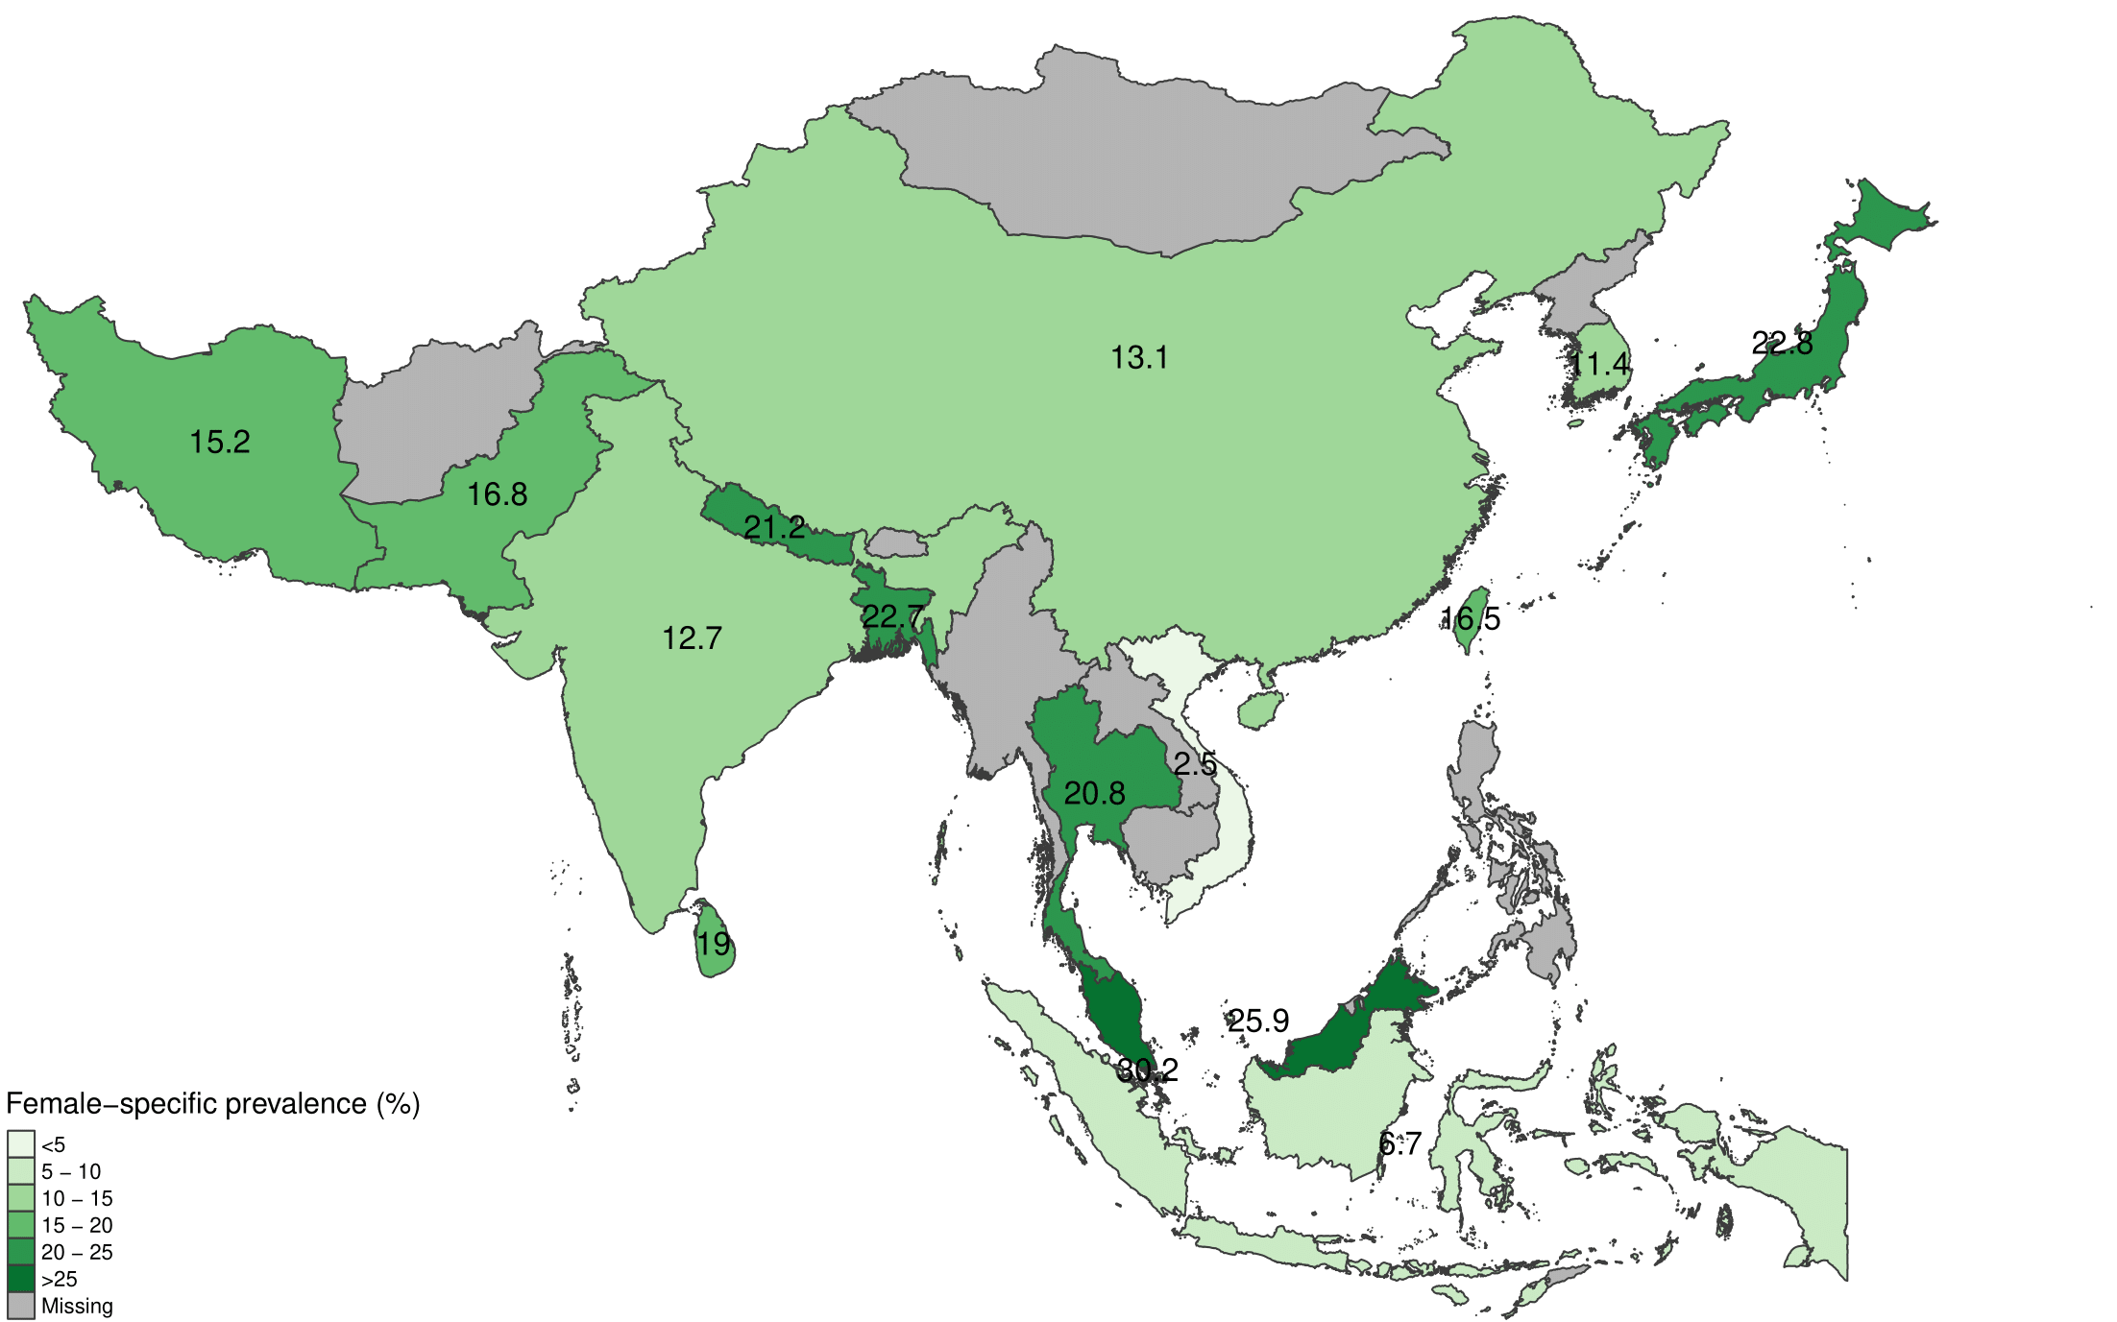

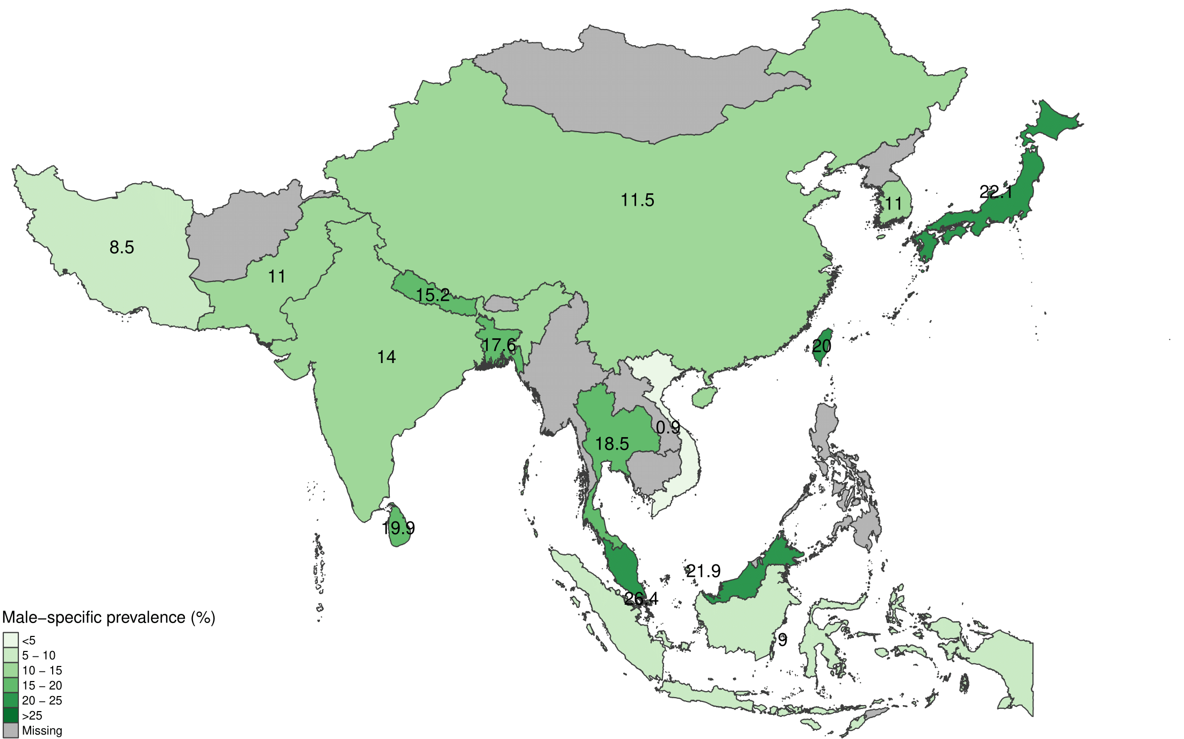

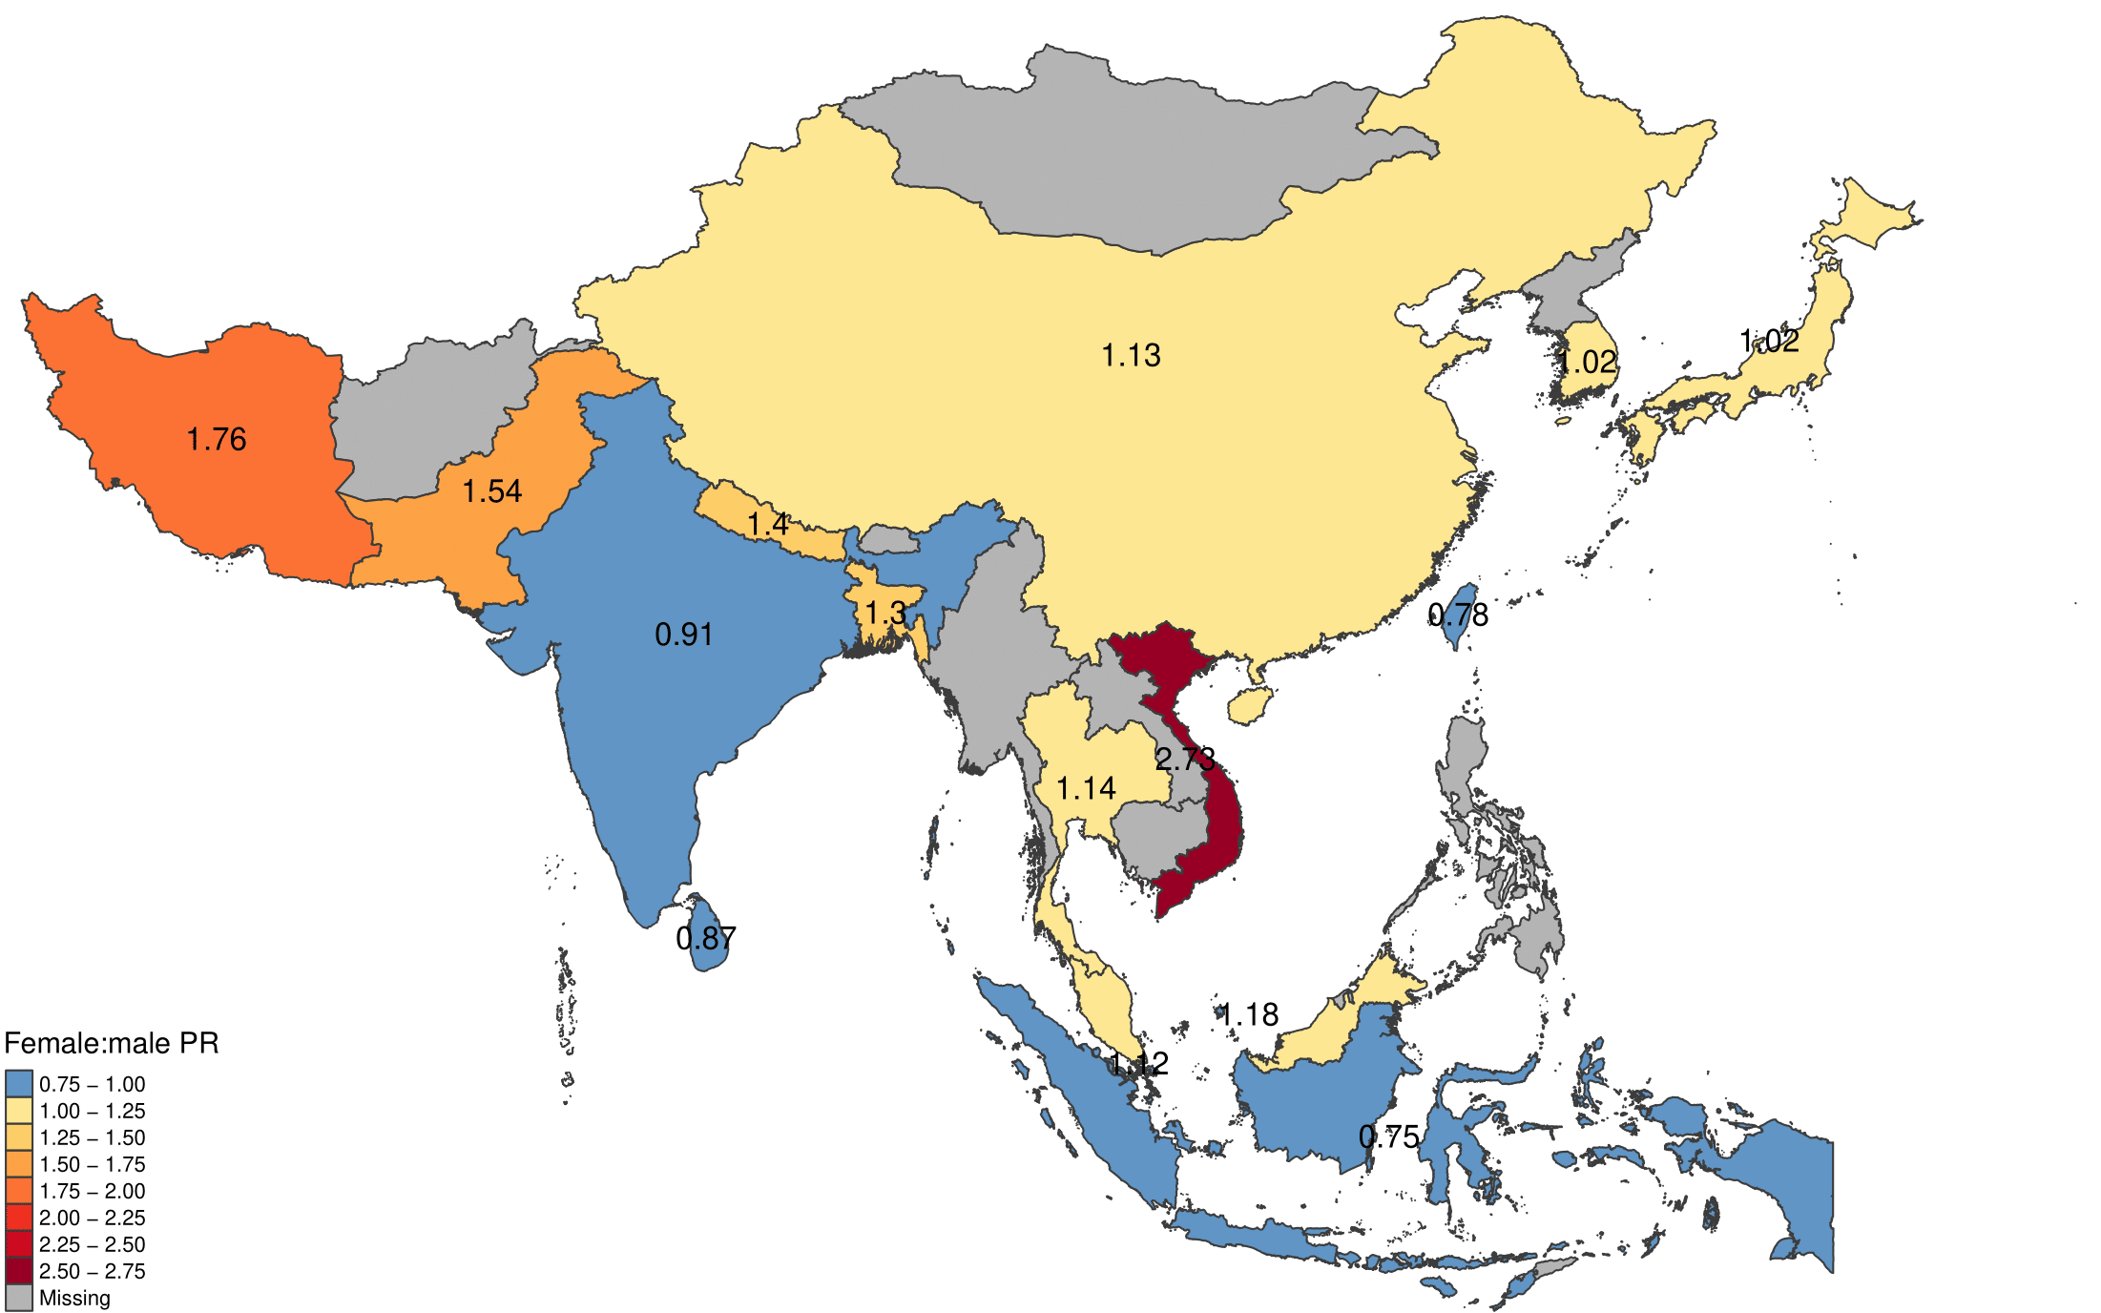

S1 Figure Maps of sex-specific CKD prevalence estimates and female:male prevalence ratio (PR), pooled by country (estimated using random effects meta-analysis).

Supplementary Figure 2: Subgroup analyses
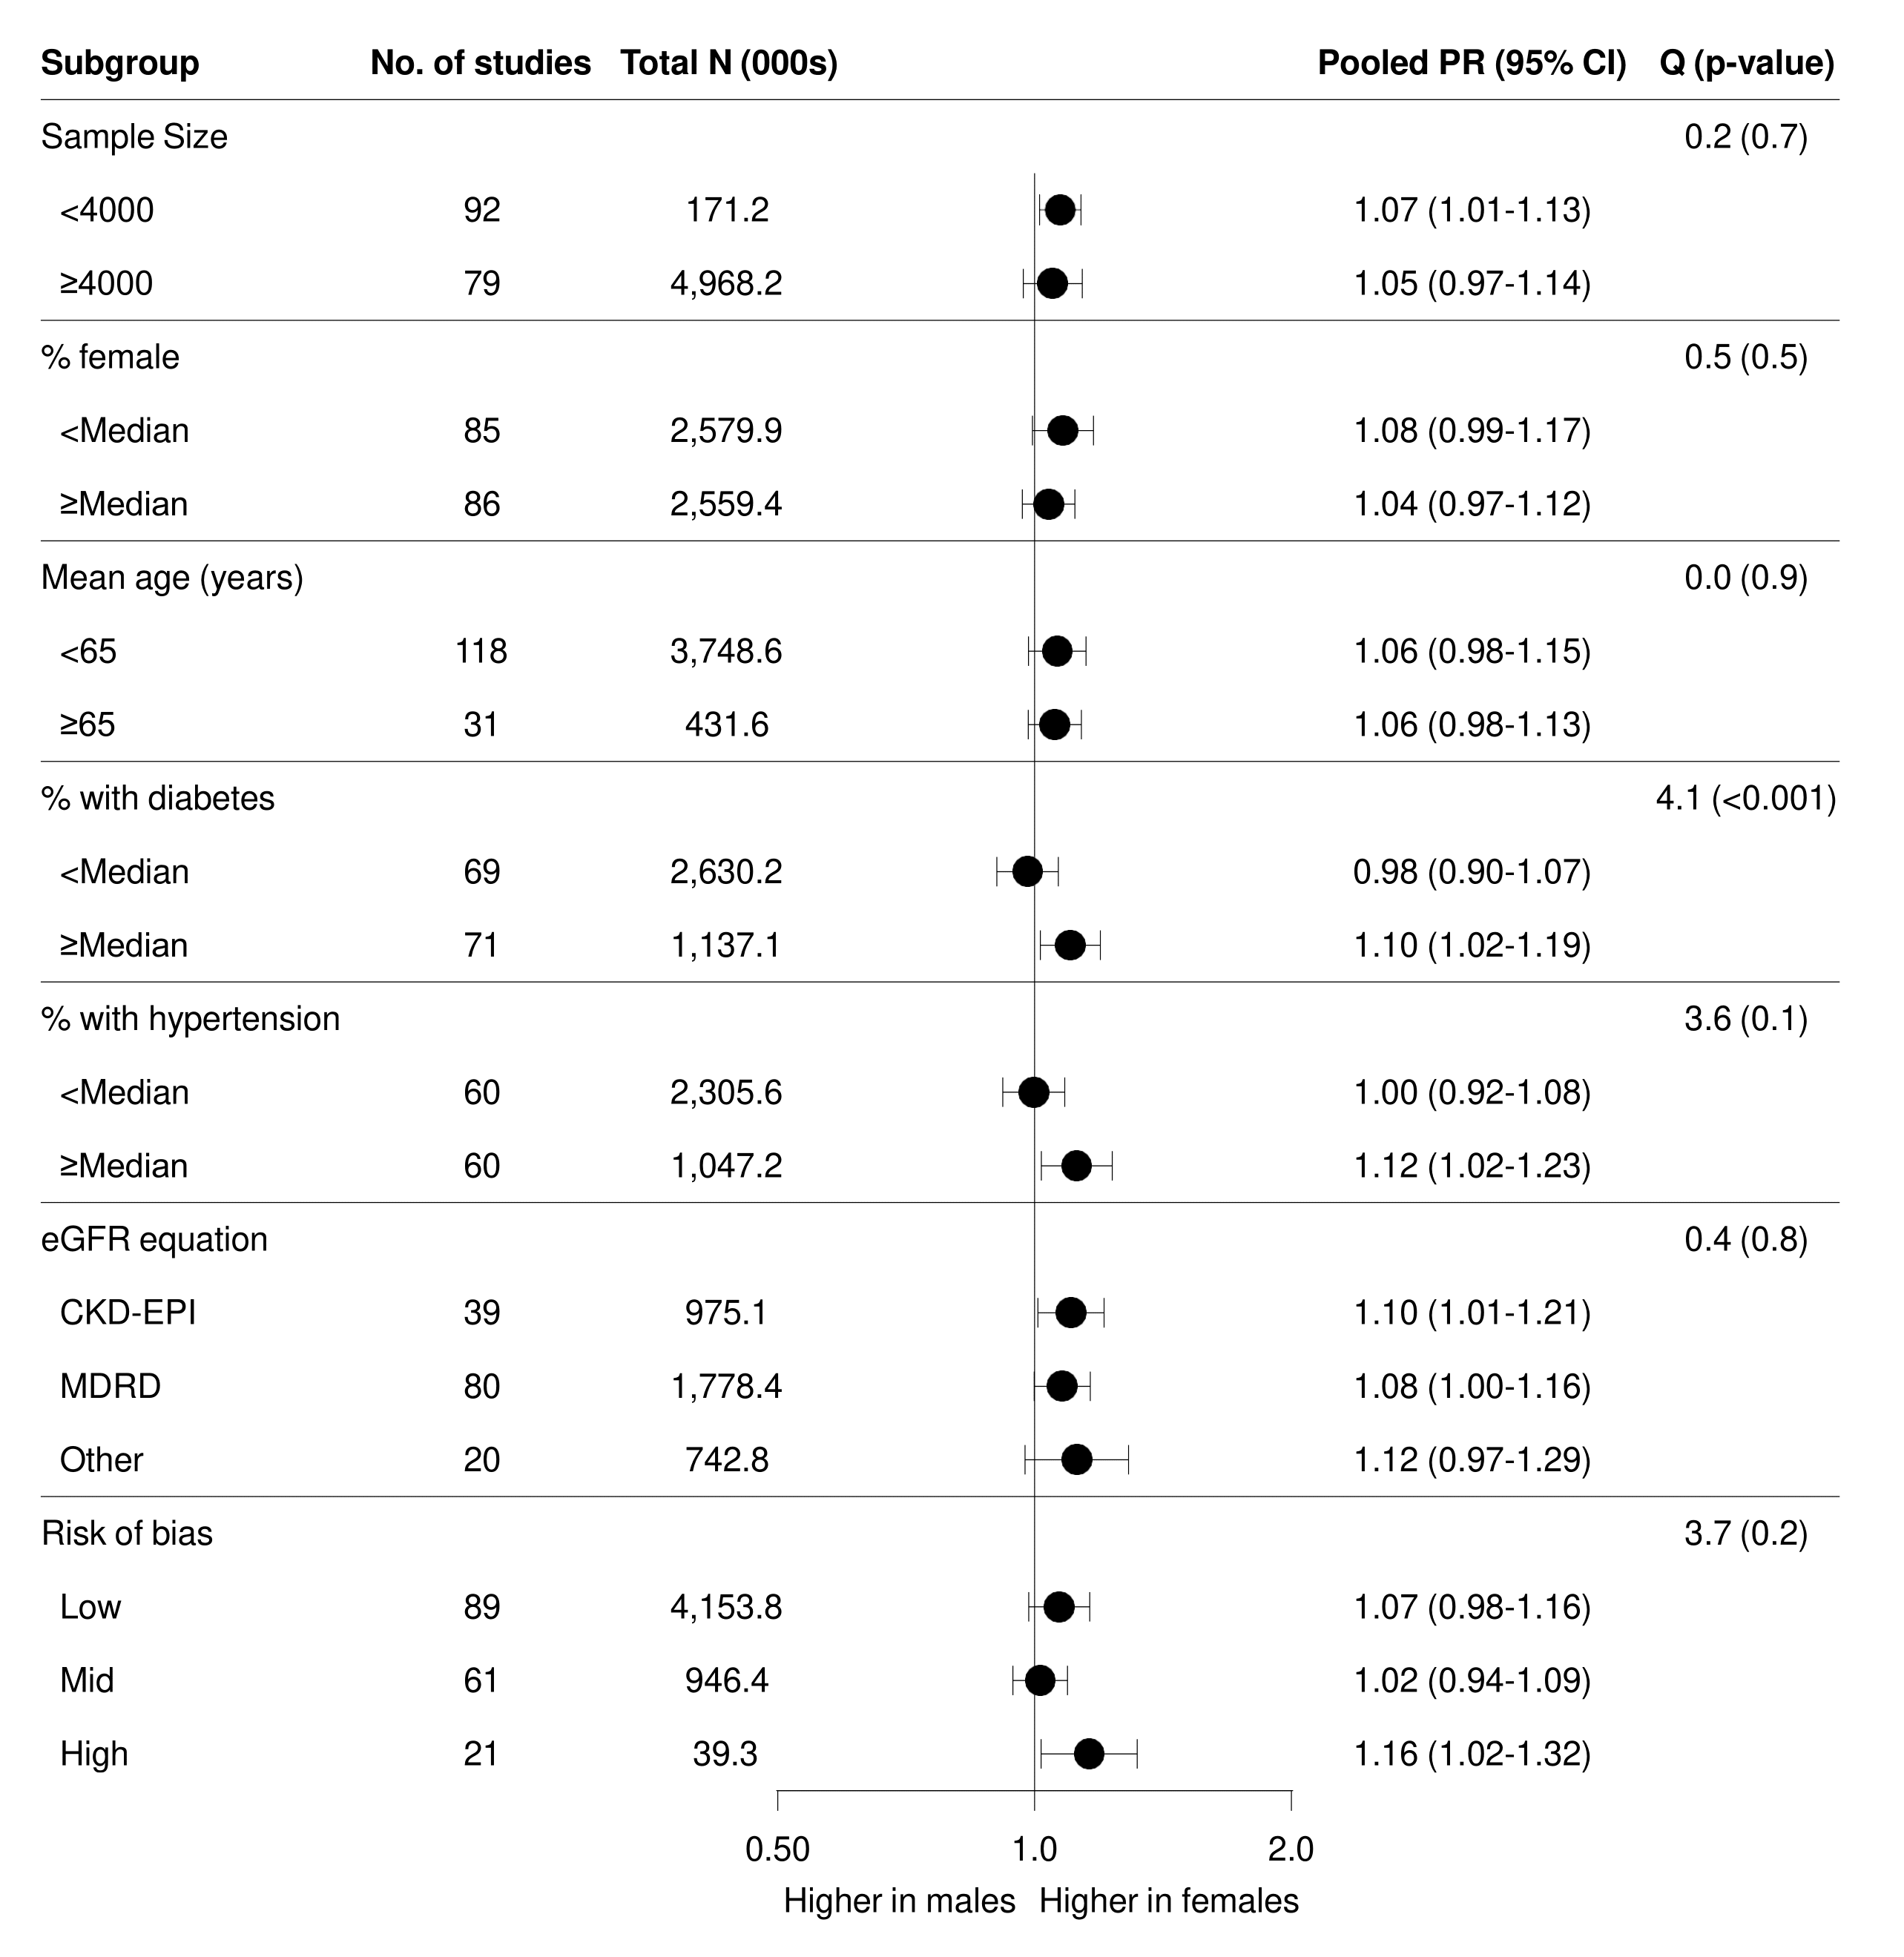
Supplementary Figure 2 Subgroup analyses of the pooled female:male prevalence ratio (PR) for Asia overall, not stratifying by country. Study characteristics of interest included: sample size, percentage of females in study cohort, mean age of study cohort, percentage of individuals with diabetes, percentage of individuals with hypertension, CKD definition used, eGFR equation and risk of bias.

Supplementary Figure 3: Sensitivity analysis, with outliers removed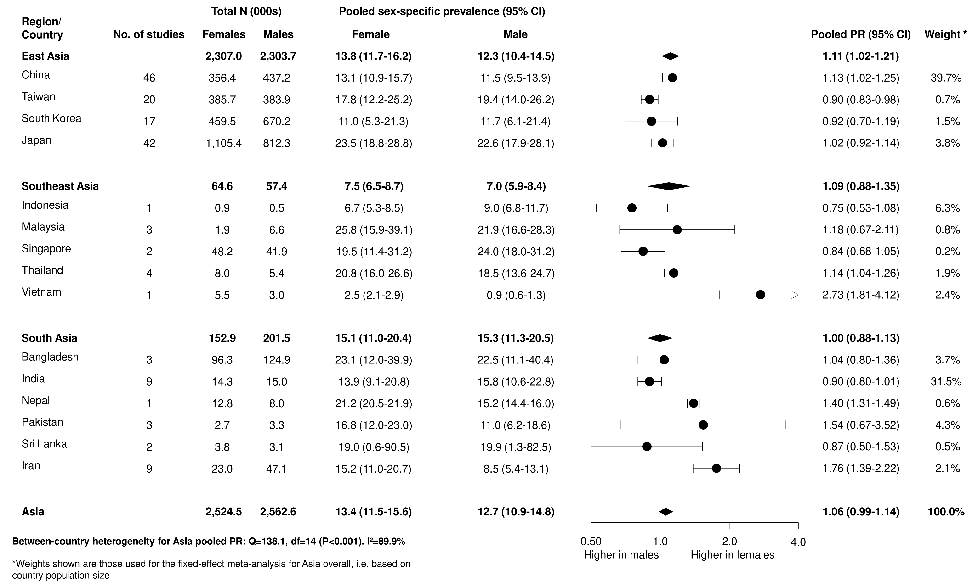
Supplementary Figure 3 Sensitivity analyses, whereby studies that had a strong influence on the country-level pooled PR estimates were removed.

Supplementary Figures 4-7: Sensitivity analyses, using different study selection criteria
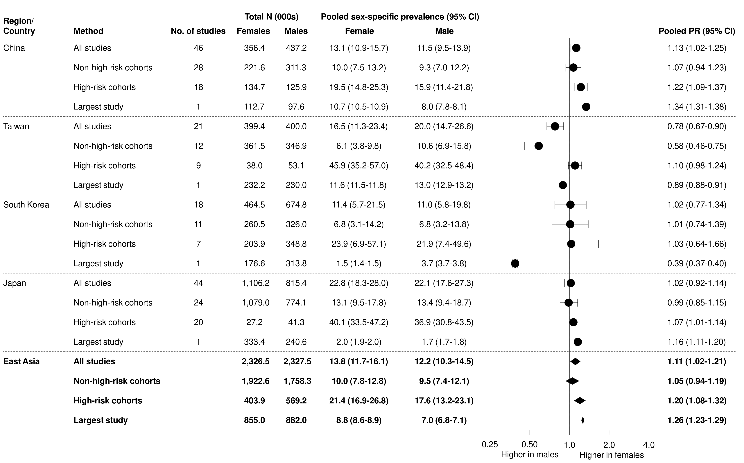
Supplementary Figure 4 Sensitivity analyses, based on different study inclusion criteria (all studies, non-high-risk cohorts only, high-risk cohorts only, largest study only) – East Asia.
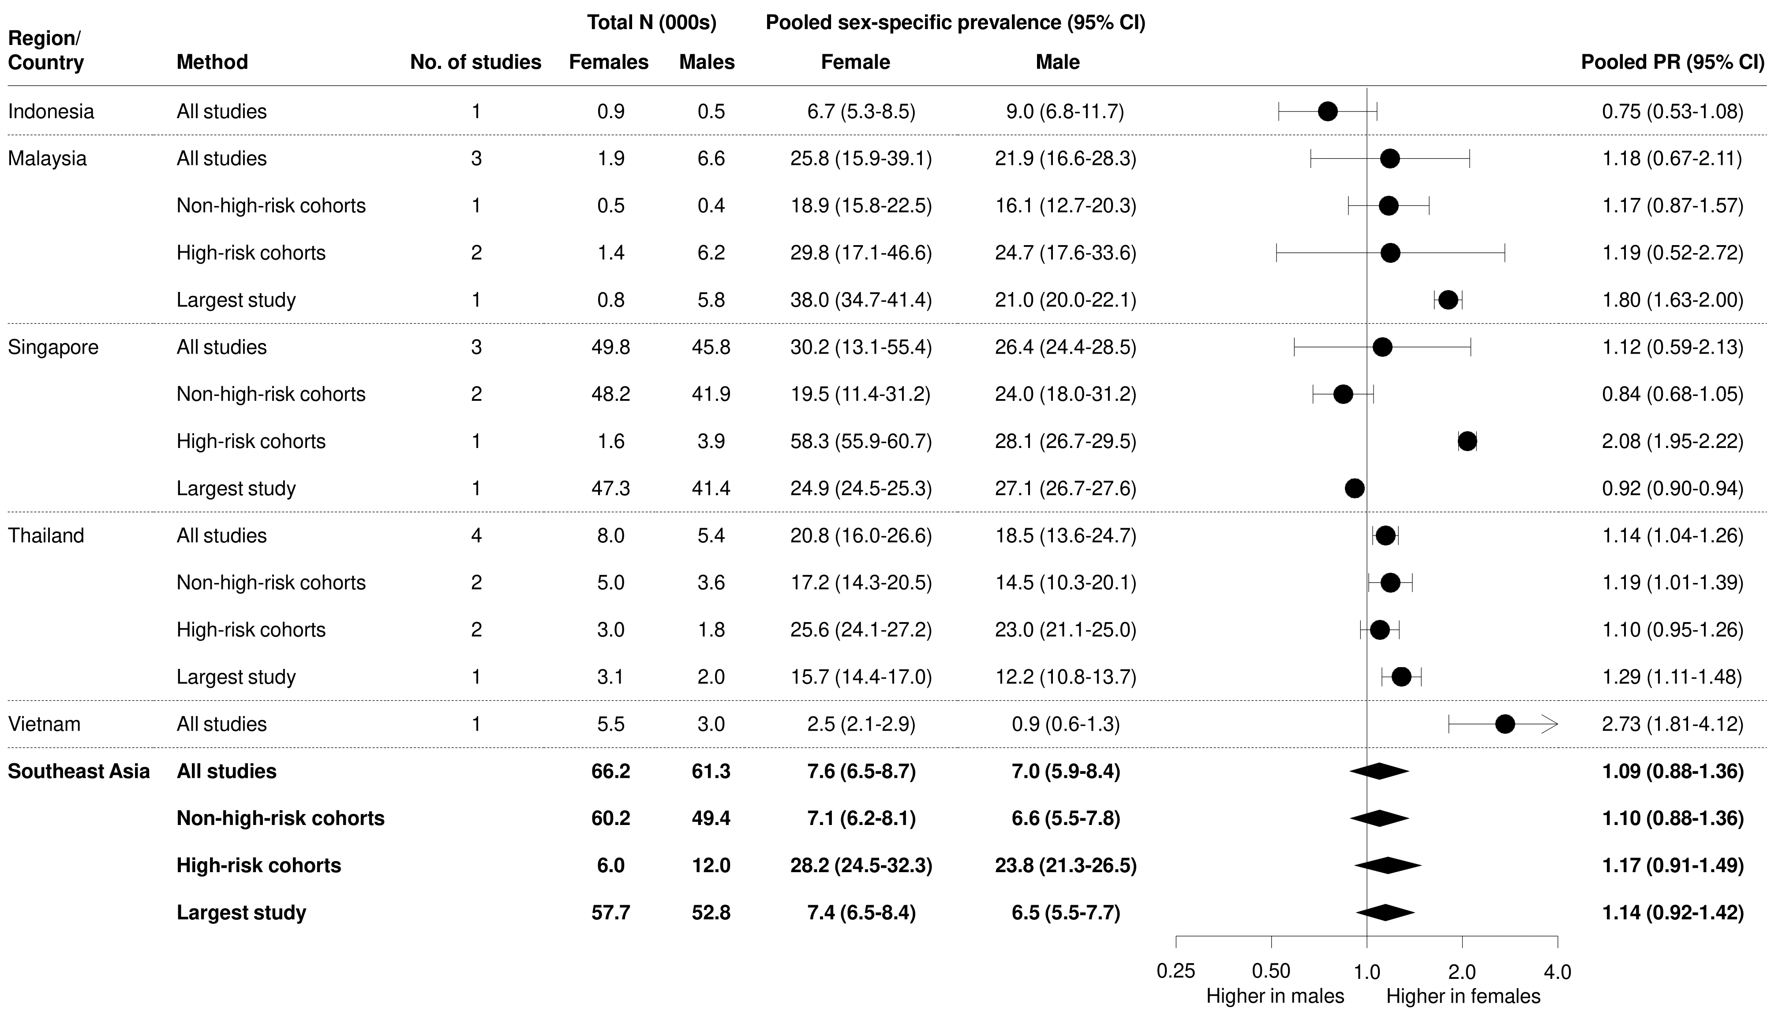
Supplementary Figure 5 Sensitivity analyses, based on different study inclusion criteria (all studies, non-high-risk cohorts only, high-risk cohorts only, largest study only) – Southeast Asia

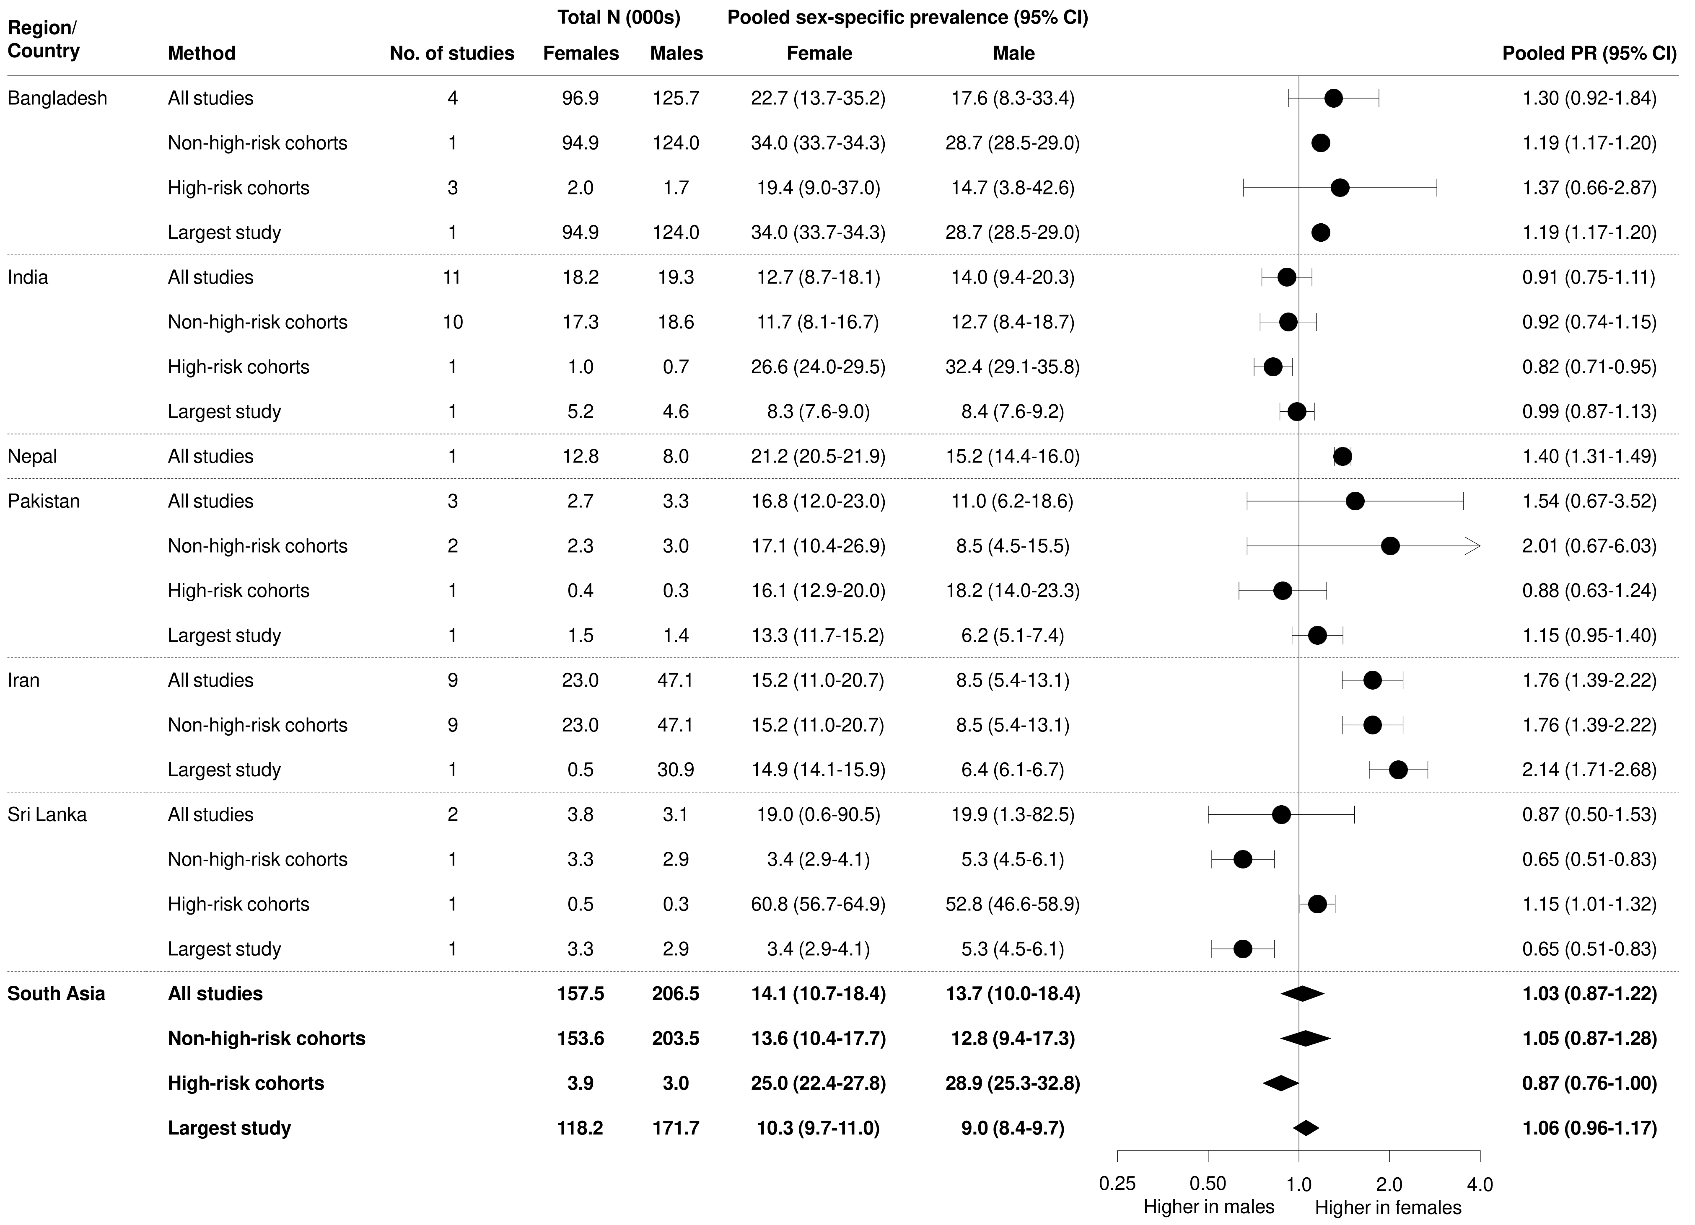
Supplementary Figure 6 Sensitivity analyses, based on different study inclusion criteria (all studies, non-high-risk cohorts only, high-risk cohorts only, largest study only) – South Asia

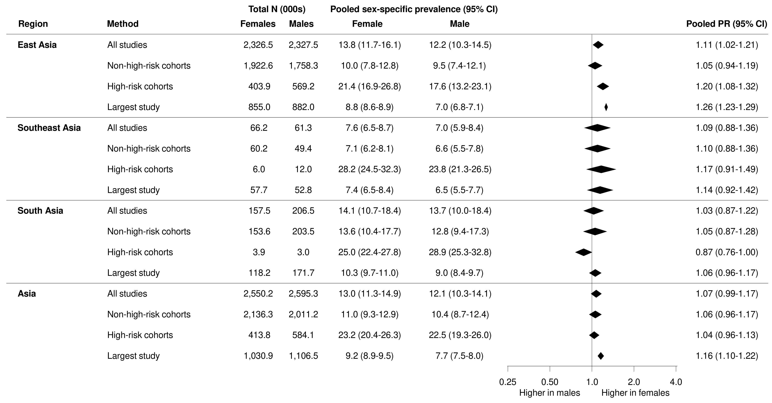

Supplementary Figure 7 Sensitivity analyses, based on different study inclusion criteria (all studies, non-high-risk cohorts only, high-risk cohorts only, largest study only) – Asia overall

Supplementary Figures 8-11: Sensitivity analyses, using different definitions of CKD
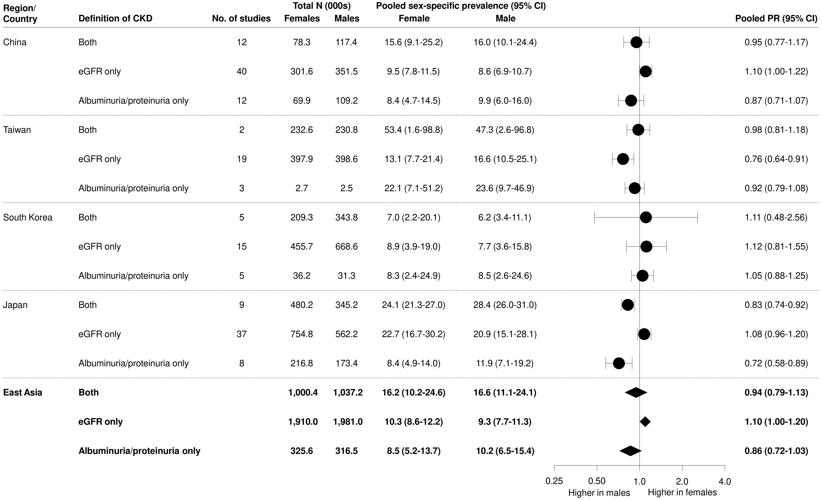
S8 Figure Sensitivity analyses, based on different definitions of CKD (reduced eGFR or albuminuria/proteinuria, reduced eGFR alone, albuminuria/proteinuria alone) – East Asia.
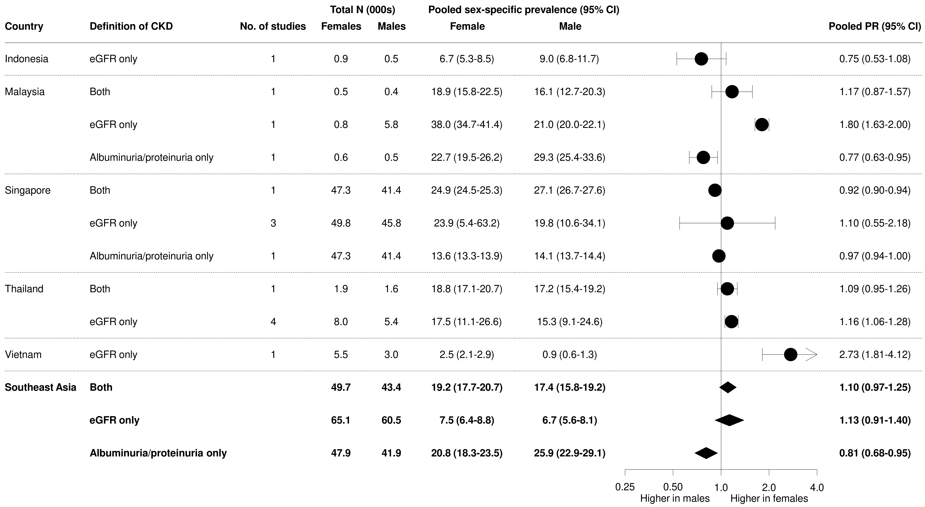
S9 Figure Sensitivity analyses, based on different definitions of CKD (reduced eGFR or albuminuria/proteinuria, reduced eGFR alone, albuminuria/proteinuria alone) – Southeast Asia.

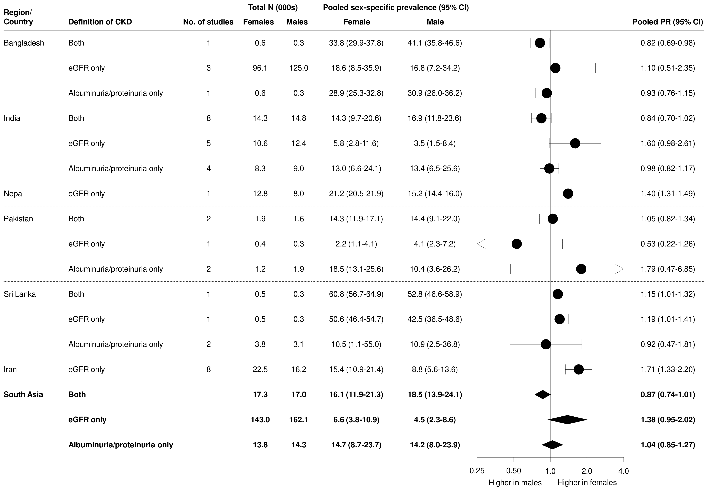

S10 Figure Sensitivity analyses, based on different definitions of CKD (reduced eGFR or albuminuria/proteinuria, reduced eGFR alone, albuminuria/proteinuria alone) – South Asia.

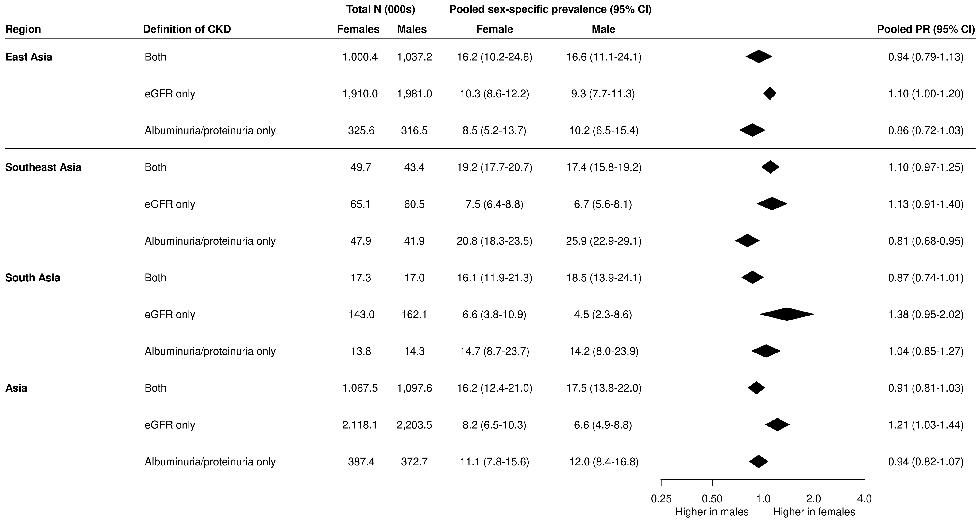
S11 Figure Sensitivity analyses, based on different study inclusion criteria (all studies, non-high-risk cohorts only, high-risk cohorts only, largest study only) – Asia overall.

Supplementary Figures 12-13: Sensitivity analyses, using different definitions of CKD (Maps)
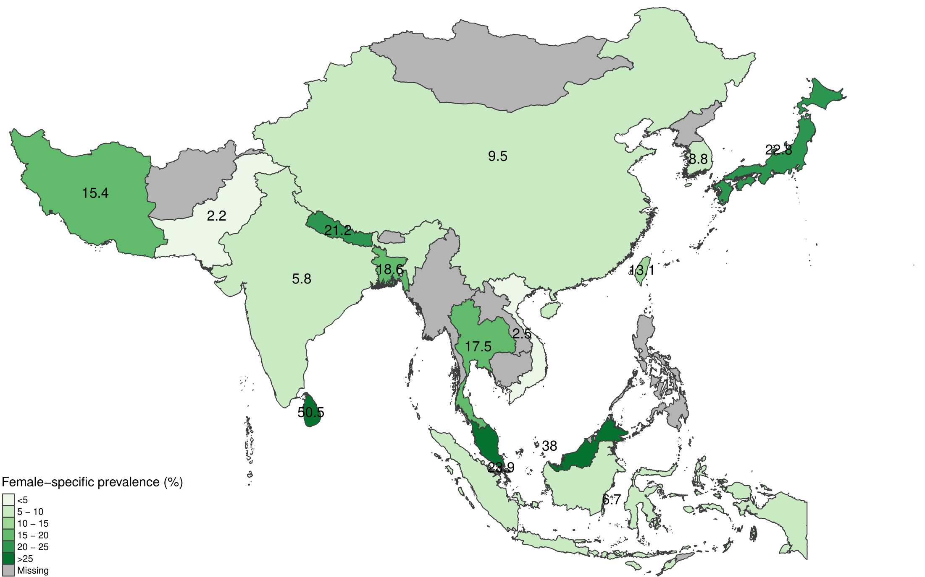
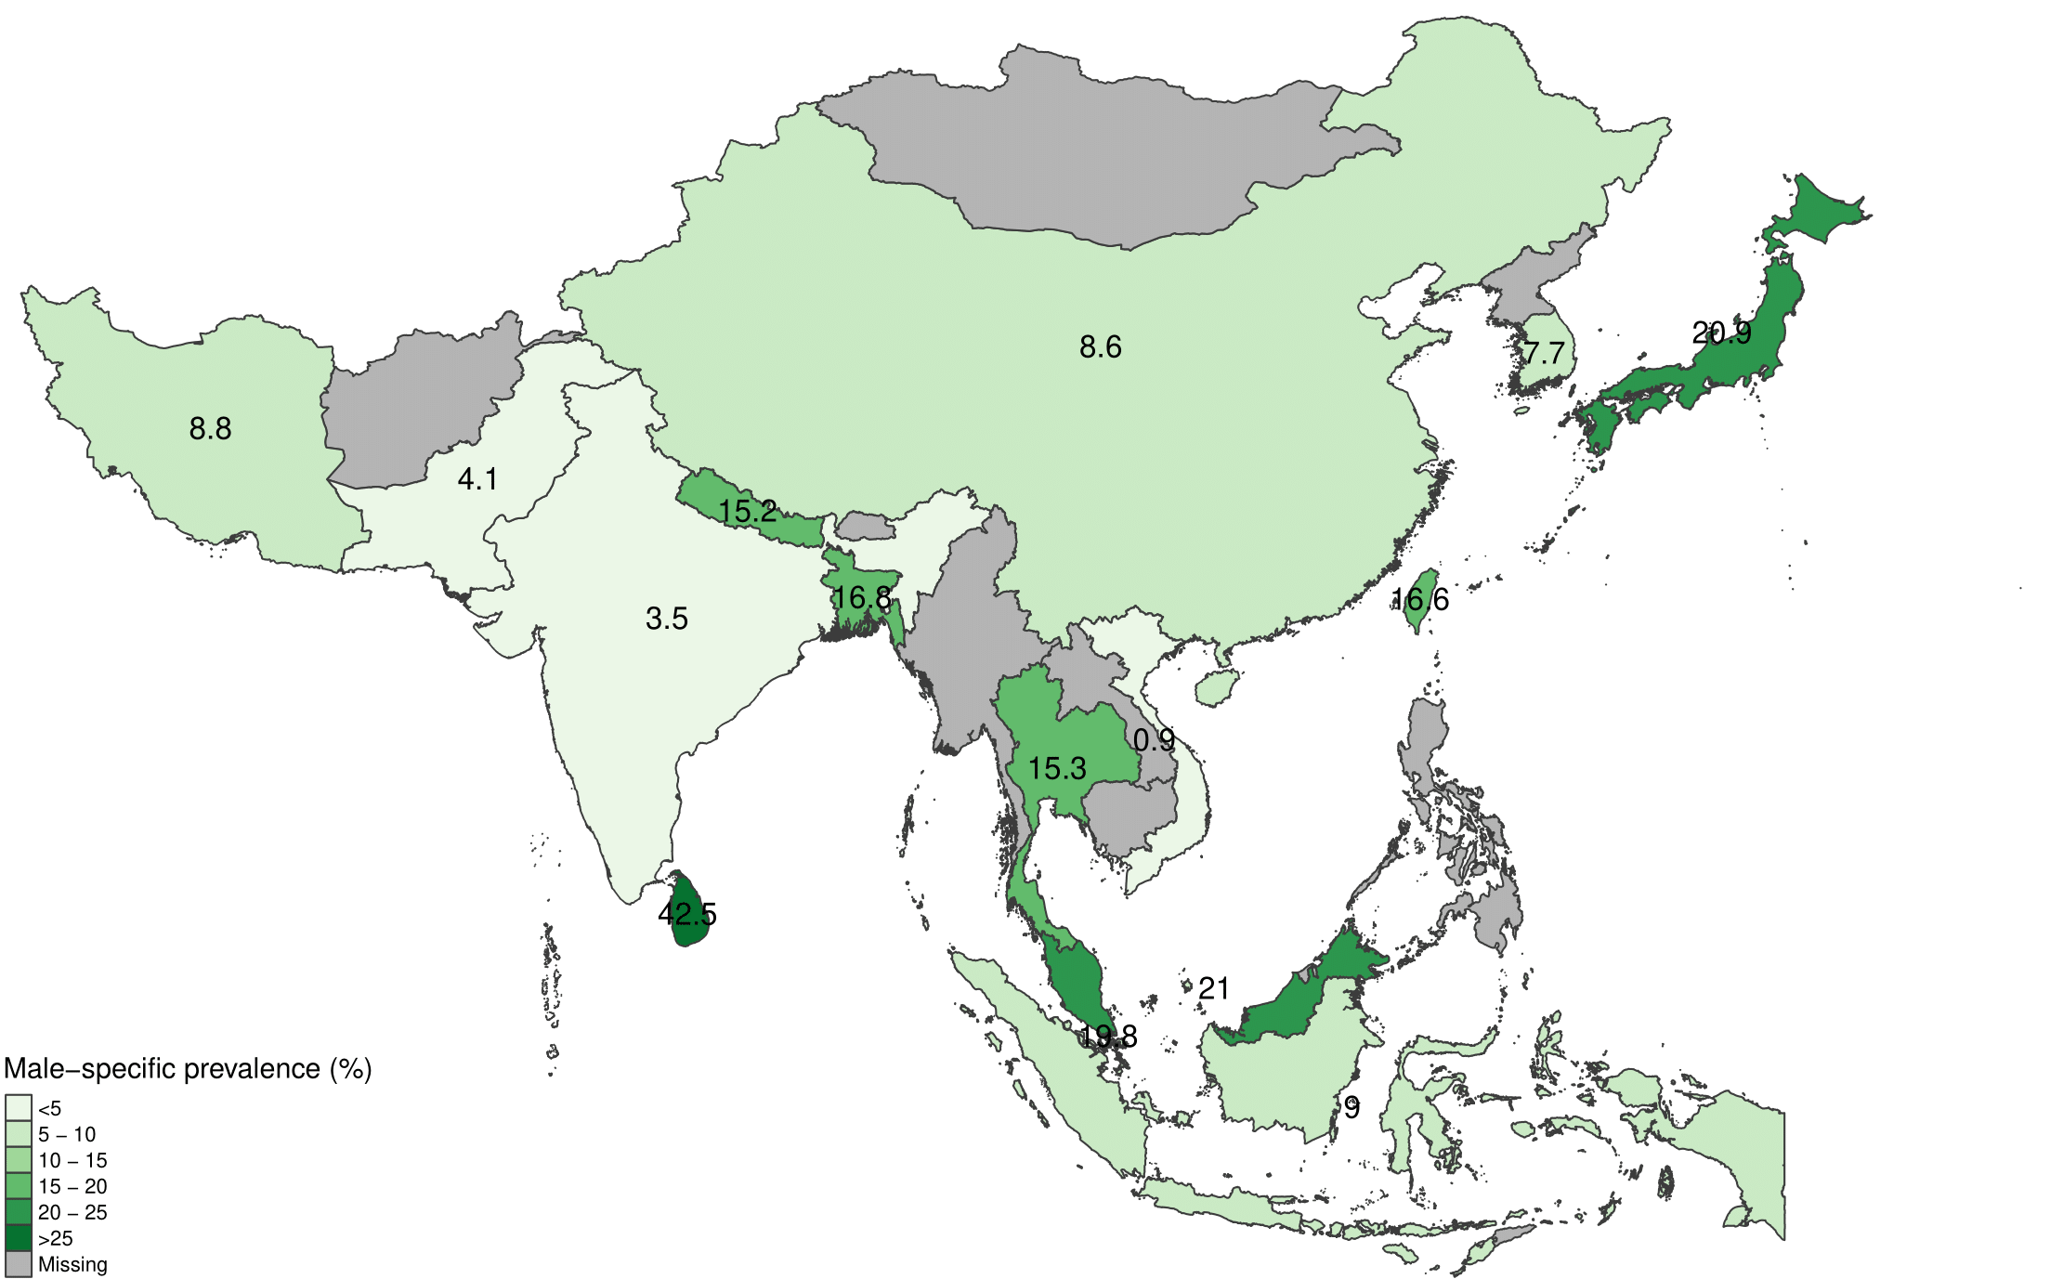
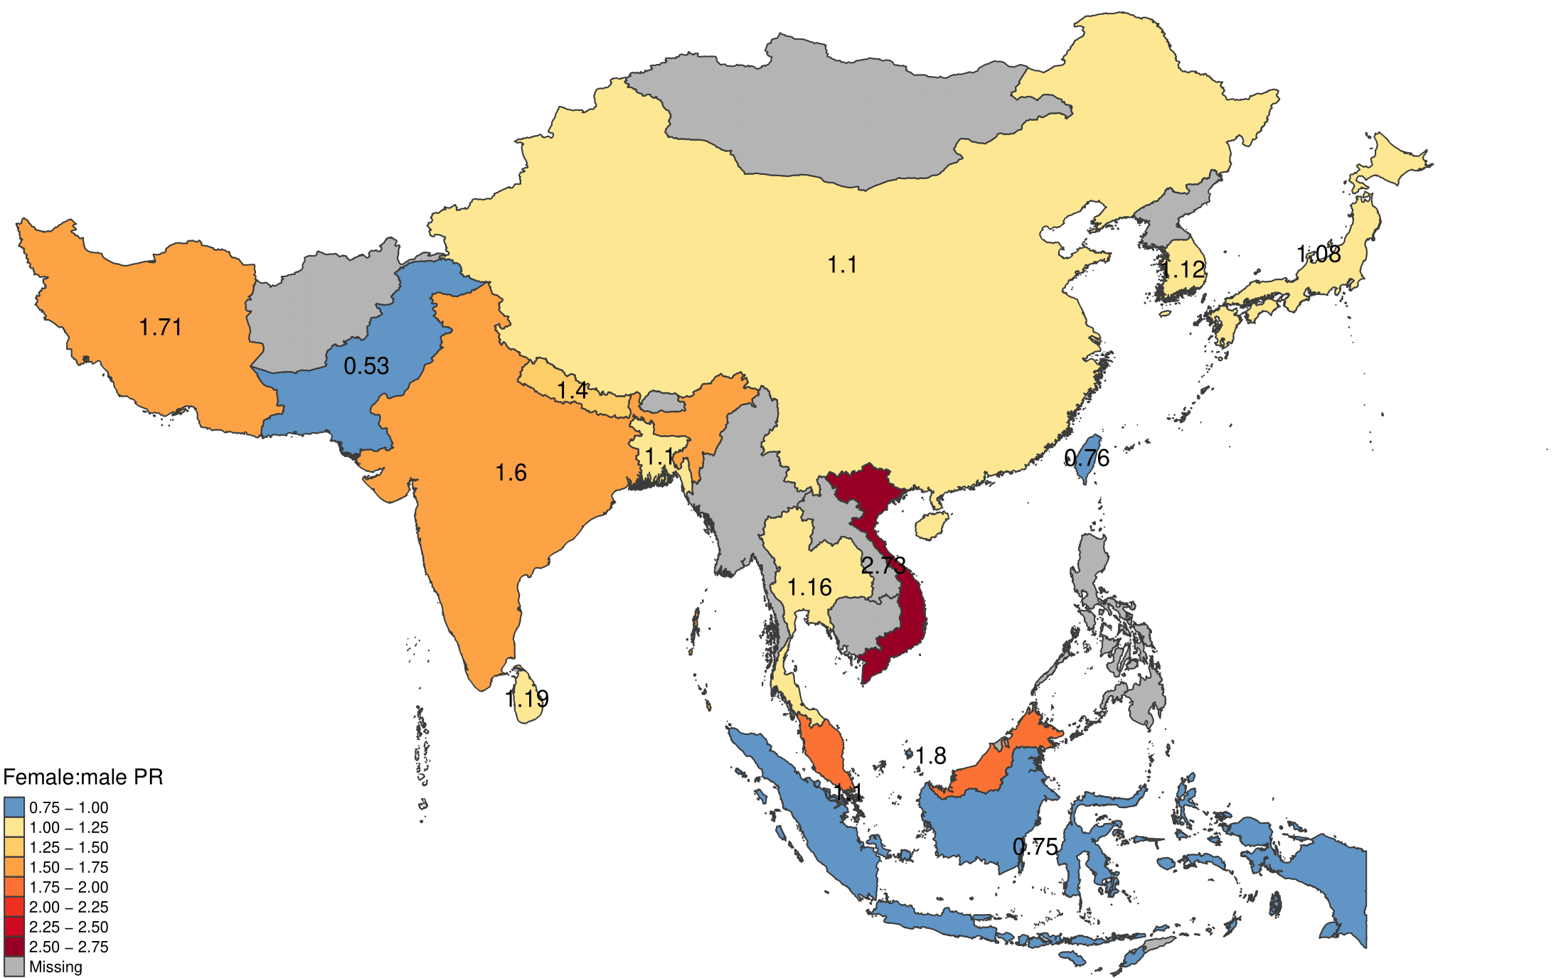
S12 Figure Maps of pooled sex-specific prevalence estimates and female:male prevalence ratio (PR) when CKD is defined based on a reduced eGFR (<60 mL/min/1.73²) alone.

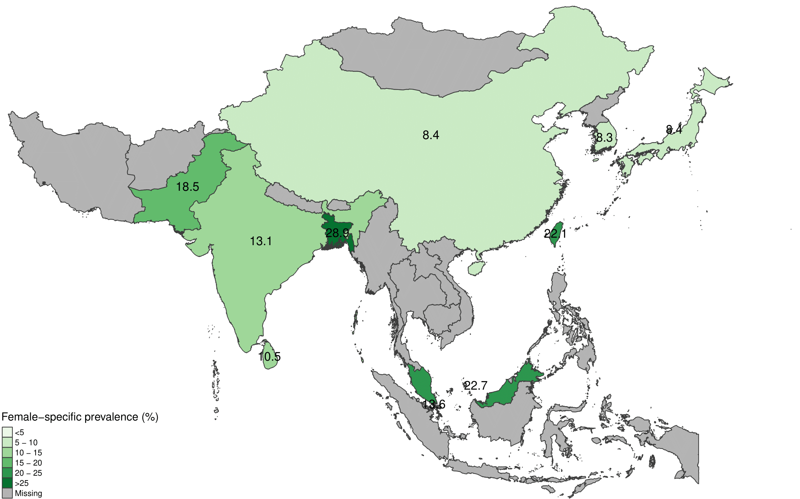
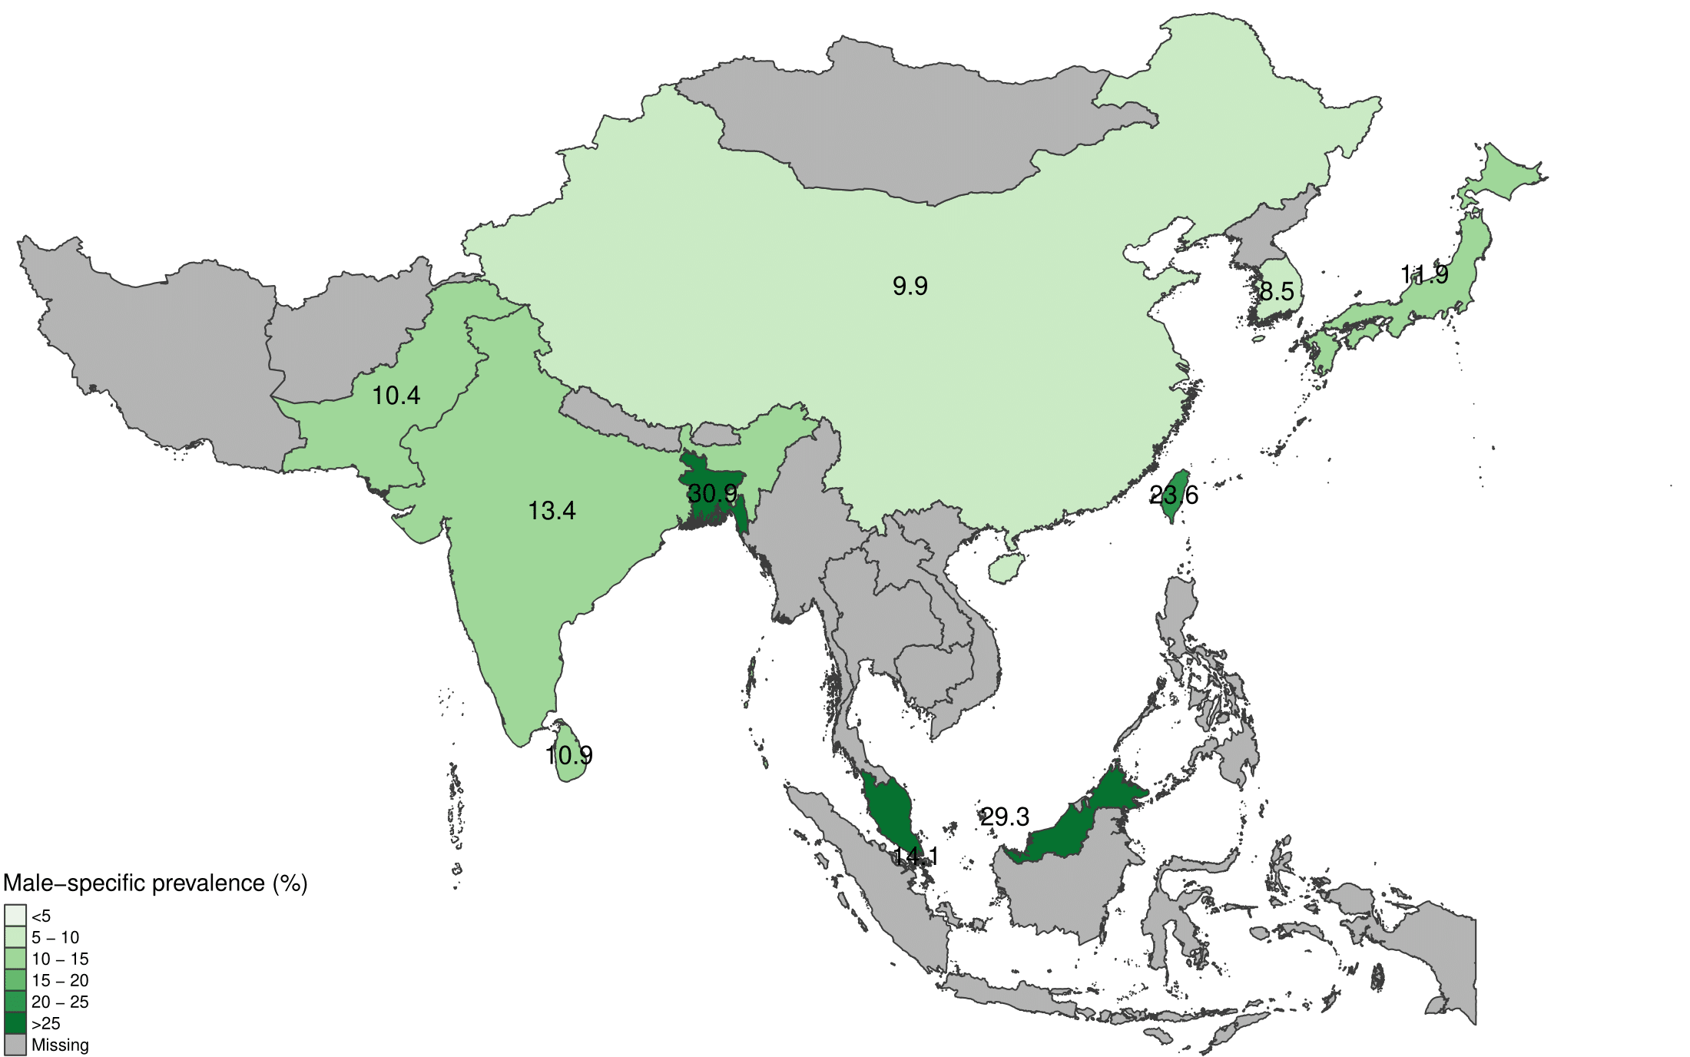
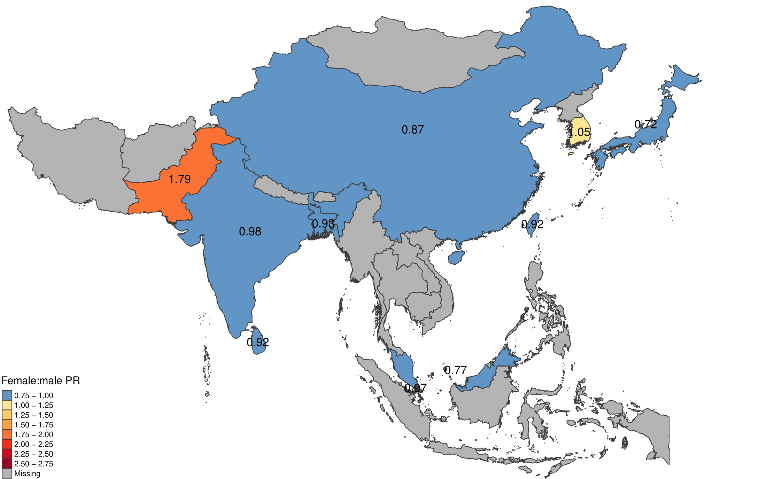
S13 Figure Maps of pooled sex-specific prevalence estimates and female:male prevalence ratio (PR) when CKD is based on albuminuria/proteinuria alone.

Supplementary Figure 14: Sensitivity analysis, restricted to advanced CKD
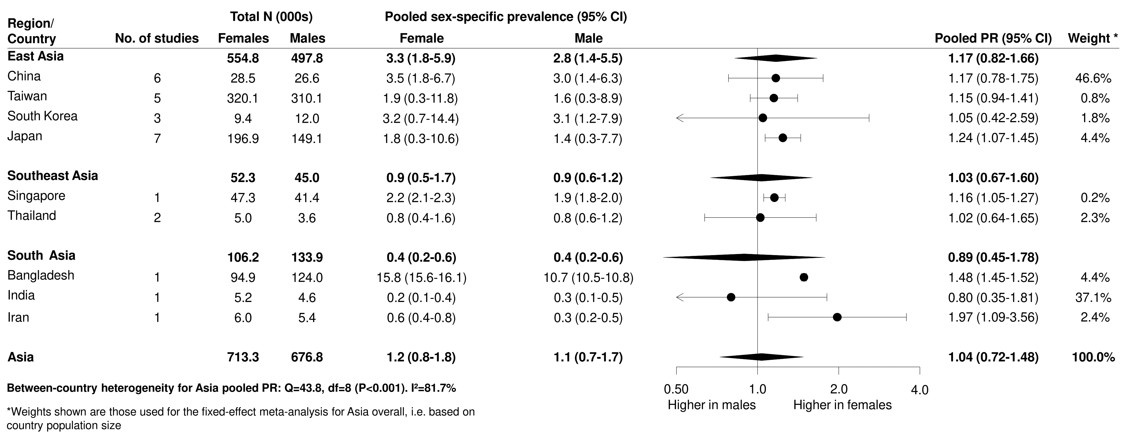
Supplementary Figure 14 Sex-specific advanced CKD (stages 4-5) prevalence estimates and female:male prevalence ratio (PR), pooled by country (estimated using random effects meta-analysis) and by region (estimated using fixed effect meta-analysis of country-stratified pooled estimates). For the fixed effect meta-analysis, country-level estimates were weighted by country population size.

References
1. Wan EYFC, W. Y.; Yu, E. Y. T.; Wong, I. C. K.; Chan, E. W. Y.; Li, S. X.; Cheung, N. K. L.; Wang, Y.; Lam, C. L. K. The Impact of Cardiovascular Disease and Chronic Kidney Disease on Life Expectancy and Direct Medical Cost in a 10-Year Diabetes Cohort Study. Diabetes Care. 2020;43(8):1750-8.
2. He Y, Li F, Wang F, Ma X, Zhao X, Zeng Q. The association of chronic kidney disease and waist circumference and waist-to-height ratio in Chinese urban adults. Medicine. 2016;95(25):e3769-e.
3. Wu J, Jia J, Li Z, Pan H, Wang A, Guo X, et al. Association of estimated glomerular filtration rate and proteinuria with all-cause mortality in community-based population in China: A Result from Kailuan Study. Scientific Reports. 2018;8(1):2157.
4. Wang J, Wang F, Liu S, Zhou M, Zhang L, Zhao M. Reduced Kidney Function, Albuminuria, and Risks for All-cause and Cardiovascular Mortality in China: A Population-based Cohort Study. BMC Nephrol. 2017;18(1):188.
5. Zhang L, Wang F, Wang L, Wang W, Liu B, Liu J, et al. Prevalence of chronic kidney disease in China: a cross-sectional survey. Lancet. 2012;379(9818):815-22.
6. Zhao Y, Zhang M, Shi CX, Zhang Y, Cai W, Zhao Q, et al. Renal Function in Chinese HIV-Positive Individuals following Initiation of Antiretroviral Therapy. PLOS ONE. 2015;10(8):e0135462.
7. Su G, Xu Y, Xu X, Xu H, Lu L, Marrone G, et al. Association between reduced renal function and cardiovascular mortality in patients hospitalized with infection: A multi-center cohort study. Eur J Intern Med. 2018;57:32-8.
8. Kong X, Tang L, Ma X, Liu W, Wang Z, Cui M, et al. Relationship between mild-to-moderate chronic kidney disease and decreased bone mineral density in Chinese adult population. Int Urol Nephrol. 2015;47(9):1547-53.
9. Luo Y, Wang X, Matsushita K, Wang C, Zhao X, Hu B, et al. Associations between estimated glomerular filtration rate and stroke outcomes in diabetic versus nondiabetic patients. Stroke. 2014;45(10):2887-93.
10. Liu BC, Wu XC, Wang YL, Wang B, Gao J, Zhang QJ, et al. Investigation of the prevalence of CKD in 13,383 Chinese hospitalised adult patients. Clin Chim Acta. 2008;387(1-2):128-32.
11. Shi WW, H.; Zhou, Y.; Sun, Y.; Chen, Y. Synergistic interaction of hyperuricemia and hypertension on reduced eGFR: insights from a general Chinese population. Postgraduate Medicine. 2020;132(3):263-9.
12. Wang H-Y, Shi W-R, Yi X, Wang S-Z, Luan S-Y, Sun Y-X. Value of reduced glomerular filtration rate assessment with cardiometabolic index: insights from a population-based Chinese cohort. BMC Nephrology. 2018;19(1):294.
13. Lin B, Shao L, Luo Q, Ou-yang L, Zhou F, Du B, et al. Prevalence of chronic kidney disease and its association with metabolic diseases: a cross-sectional survey in Zhejiang province, Eastern China. BMC Nephrology. 2014;15(1):36.
14. Wang S, Chen R, Liu Q, Shu Z, Zhan S, Li L. Prevalence, awareness and treatment of chronic kidney disease among middle-aged and elderly: The China Health and Retirement Longitudinal Study. Nephrology (Carlton). 2015;20(7):474-84.
15. Inoue Y, Howard AG, Thompson AL, Mendez MA, Herring AH, Gordon-Larsen P. The association between urbanization and reduced renal function: findings from the China Health and Nutrition Survey. BMC Nephrol. 2017;18(1):160.
16. Li Z, Liu Q, Mao H, Li Z, Dong X, Liu Y, et al. Gender difference in the association of hyperuricemia with chronic kidney disease in southern China. Kidney Blood Press Res. 2012;36(1):98-106.
17. Jin HZ, J.; Wu, C. Prevalence and health correlates of reduced kidney function among community-dwelling Chinese older adults: the China Health and Retirement Longitudinal Study. BMJ Open. 2020;10(12):e042396.
18. Fan W, Ping Y. Association of risk factors for cardiovascular disease and glomerular filtration rate: a community-based study of 4925 adults in Beijing. Heart. 2011;97(Suppl 3):A95.
19. Wan HW, Y.; Xiang, Q.; Fang, S.; Chen, Y.; Chen, C.; Zhang, W.; Zhang, H.; Xia, F.; Wang, N.; Lu, Y. Associations between abdominal obesity indices and diabetic complications: Chinese visceral adiposity index and neck circumference. Cardiovascular Diabetology. 2020;19(1):118.
20. Yang Y, Zhou W, Wang Y, Zhou R. Gender-specific association between uric acid level and chronic kidney disease in the elderly health checkup population in China. Ren Fail. 2019;41(1):197-203.
21. Zheng L, Sun Z, Zhang X, Li J, Hu D, Sun Y. The association between glomerular filtration rate and stroke in hypertensive patients in rural areas of China. J Hypertens. 2012;30(5):901-7.
22. Song XL, J.; Hua, Y.; Wang, C.; Liu, B.; Liu, C.; Zhao, Q.; Zhang, Z.; Fang, X.; Wu, J. Chronic Kidney Disease is Associated with Intracranial Artery Stenosis Distribution in the Middle-Aged and Elderly Population. Journal of Atherosclerosis & Thrombosis. 2020;27(3):245-54.
23. Jiang YF, F.; Jia, J.; He, D.; Sun, P.; Wu, Z.; Huo, Y.; Zhang, Y. Brachial-ankle pulse wave velocity is independently associated with urine albumin-to-creatinine ratio in a Chinese community-based cohort. International Urology & Nephrology. 2020;52(4):713-20.
24. Luo Y, Li X, Li J, Wang X, Xu Y, Qiao Y, et al. Peripheral arterial disease, chronic kidney disease, and mortality: the Chinese Ankle Brachial Index Cohort Study. Vasc Med. 2010;15(2):107-12.
25. Shan Y, Zhang Q, Liu Z, Hu X, Liu D. Prevalence and risk factors associated with chronic kidney disease in adults over 40 years: a population study from Central China. Nephrology (Carlton). 2010;15(3):354-61.
26. Hu YS, R.; Mo, R.; Hu, F. Nomogram for the prediction of diabetic nephropathy risk among patients with type 2 diabetes mellitus based on a questionnaire and biochemical indicators: a retrospective study. Aging. 2020;12(11):10317-36.
27. Guo K, Zhang L, Zhao F, Lu J, Pan P, Yu H, et al. Prevalence of chronic kidney disease and associated factors in Chinese individuals with type 2 diabetes: Cross-sectional study. J Diabetes Complications. 2016;30(5):803-10.
28. Peng Y, Xia TL, Huang FY, Huang BT, Liu W, Chai H, et al. Influence of Renal Insufficiency on the Prescription of Evidence-Based Medicines in Patients With Coronary Artery Disease and Its Prognostic Significance: A Retrospective Cohort Study. Medicine (Baltimore). 2016;95(6):e2740.
29. Chen B, Yang D, Chen Y, Xu W, Ye B, Ni Z. The prevalence of microalbuminuria and its relationships with the components of metabolic syndrome in the general population of China. Clin Chim Acta. 2010;411(9-10):705-9.
30. Miao Y, Yu-Jie Z, Zhi-Jian W, Dong-Mei S, Yu-Yang L, Ying-Xin Z, et al. Chronic kidney disease and the risk of stent thrombosis after percutaneous coronary intervention with drug-eluting stents. Catheter Cardiovasc Interv. 2012;80(3):361-7.
31. Luk AOY, Fu W-C, Li X, Ozaki R, Chung HHY, Wong RYM, et al. The Clinical Utility of SUDOSCAN in Chronic Kidney Disease in Chinese Patients with Type 2 Diabetes. PLOS ONE. 2015;10(8):e0134981.
32. Li ZY, Xu GB, Xia TA, Wang HY. Prevalence of chronic kidney disease in a middle and old-aged population of Beijing. Clin Chim Acta. 2006;366(1-2):209-15.
33. Fu S, Sun Y, Luo L, Ye P. Relationship of Arterial Compliance and Blood Pressure with Microalbuminuria and Mildly Decreased Glomerular Filtration Rate: A Chinese Community-Based Analysis. PLOS ONE. 2014;9(6):e101013.
34. Sharma SK, Zou H, Togtokh A, Ene-Iordache B, Carminati S, Remuzzi A, et al. Burden of CKD, proteinuria, and cardiovascular risk among Chinese, Mongolian, and Nepalese participants in the International Society of Nephrology screening programs. Am J Kidney Dis. 2010;56(5):915-27.
35. Liu S, Wang W, Tan Y, He M, Wang L, Li Y, et al. Relationship Between Renal Function and Choroidal Thickness in Type 2 Diabetic Patients Detected by Swept-Source Optical Coherence Tomography. Translational Vision Science & Technology. 2020;9(5):17-.
36. Sun X, He J, Ji XL, Zhao YM, Lou HY, Song XX, et al. Association of Chronic Kidney Disease with Coronary Heart Disease and Stroke Risks in Patients with Type 2 Diabetes Mellitus: An Observational Cross-sectional Study in Hangzhou, China. Chin Med J (Engl). 2017;130(1):57-63.
37. Yang S, Xiao F, Pan L, Zhang H, Ma Z, Liu S, et al. Association of serum irisin and body composition with chronic kidney disease in obese Chinese adults: a cross-sectional study. BMC Nephrology. 2015;16(1):16.
38. Liu W, Yu F, Wu Y, Fang X, Hu W, Chen J, et al. A retrospective analysis of kidney function and risk factors by Chronic Kidney Disease Epidemiology Collaboration (CKD-EPI) equation in elderly Chinese patients. Ren Fail. 2015;37(8):1323-8.
39. Xu J, Wang W, Shi H, Chen S, Liu Z, Li W, et al. Chronic kidney disease is prevalent in Chinese patients admitted with verified cerebrovascular lesions and predicts short-term prognosis. Nephrol Dial Transplant. 2011;26(8):2590-4.
40. Bao YS, Jia XB, Ji Y, Yang J, Zhao SL, Na SP. High prevalence and risk factors for kidney dysfunction in patients with atherosclerotic cardio-cerebrovascular disease. QJM: An International Journal of Medicine. 2014;107(6):443-9.
41. Jia WW, S.; Liu, M.; Yang, S.; Cao, W.; Han, K.; He, Y. Anemia in centenarians: prevalence and association with kidney function. Hematology. 2020;25(1):26-33.
42. Dong K, Huang X, Zhang Q, Yu Z, Ding J, Song H. A lower baseline glomerular filtration rate predicts high mortality and newly cerebrovascular accidents in acute ischemic stroke patients. Medicine (Baltimore). 2017;96(5):e5868.
43. Chan TC, Yap DY, Shea YF, Luk KH, Chan HW, Chu LW. Prevalence and associated comorbidities of moderate to severe chronic renal impairment in Chinese nursing home older adults. J Am Med Dir Assoc. 2012;13(7):630-3.
44. Xiong G, Chen X, Li X, Fang D, Zhang L, Yang L, et al. Prevalence and factors associated with baseline chronic kidney disease in China: a 10-year study of 785 upper urinary tract urothelial carcinoma patients. J Formos Med Assoc. 2014;113(8):521-6.
45. Ye W, Zhuang J, Yu Y, Li H, Leng X, Qian J, et al. Gender and chronic kidney disease in ankylosing spondylitis: a single-center retrospectively study. BMC Nephrology. 2019;20(1):457.
46. Liu D, Ding H, Liu S, Shen J. Estimated glomerular filtration rate decline in 567 patients with acute stroke. Scandinavian Journal of Urology and Nephrology. 2012;46(2):142-7.
47. Wen CP, Cheng TY, Tsai MK, Chang YC, Chan HT, Tsai SP, et al. All-cause mortality attributable to chronic kidney disease: a prospective cohort study based on 462 293 adults in Taiwan. Lancet. 2008;371(9631):2173-82.
48. Tsai MH, Hsu CY, Lin MY, Yen MF, Chen HH, Chiu YH, et al. Incidence, Prevalence, and Duration of Chronic Kidney Disease in Taiwan: Results from a Community-Based Screening Program of 106,094 Individuals. Nephron. 2018;140(3):175-84.
49. Wang IK, Liu CH, Yen TH, Jeng JS, Sung SF, Huang PH, et al. Renal function is associated with 1-month and 1-year mortality in patients with ischemic stroke. Atherosclerosis. 2018;269:288-93.
50. Li WC, Chen JY, Lee YY, Weng YM, Hsiao CT, Loke SS. Association between waist-to-height ratio and chronic kidney disease in the Taiwanese population. Intern Med J. 2014;44(7):645-52.
51. Chen PCK, W. Y.; Cheng, Y. L.; Wang, Y. J.; Hou, M. C.; Wu, J. C.; Su, C. W. The correlation between fatty liver disease and chronic kidney disease. Journal of the Formosan Medical Association. 2020;119(1 Pt 1):42-50.
52. Hsu YH, Liu WH, Chen W, Kuo YC, Hsiao CY, Hung PH, et al. Association of betel nut chewing with chronic kidney disease: a retrospective 7-year study in Taiwan. Nephrology (Carlton). 2011;16(8):751-7.
53. Cheng TY, Wen SF, Astor BC, Tao XG, Samet JM, Wen CP. Mortality risks for all causes and cardiovascular diseases and reduced GFR in a middle-aged working population in Taiwan. Am J Kidney Dis. 2008;52(6):1051-60.
54. Chang HJL, K. R.; Chang, J. L.; Lin, M. T. Risk Factors for Chronic Kidney Disease in Older Adults with Hyperlipidemia and/or Cardiovascular Diseases in Taipei City, Taiwan: A Community-Based Cross-Sectional Analysis. International Journal of Environmental Research & Public Health [Electronic Resource]. 2020;17(23):25.
55. Hsieh MHW, K. T.; Chen, Y. Y.; Yang, J. F.; Lin, W. Y.; Chang, N. C.; Lin, C. Y.; Huang, C. K.; Wang, C. L.; Chuang, H. Y.; Lin, S. C.; Hsu, Y. K.; Tsai, Y. S.; Chuang, W. L.; Yu, M. L.; Dai, C. Y. Higher NAFLD fibrosis score is associated with impaired eGFR. Journal of the Formosan Medical Association. 2020;119(1 Pt 3):496-503.
56. Lin M-Y, Hwang S-J, Mau L-W, Chen H-C, Hwang S-C, Wu L-C, et al. Impact of late-stage CKD and aging on medical utilization in the elderly population: a closed-cohort study in Taiwan. Nephrology Dialysis Transplantation. 2010;25(10):3230-5.
57. Lin C-C, Chen C-C, Kung P-T, Li C-I, Yang S-Y, Liu C-S, et al. Joint relationship between renal function and proteinuria on mortality of patients with type 2 diabetes: The Taichung Diabetes Study. Cardiovascular Diabetology. 2012;11(1):131.
58. Kang IM, Chou CY, Tseng YH, Huang CC, Ho WY, Shih CM, et al. Association between betelnut chewing and chronic kidney disease in adults. J Occup Environ Med. 2007;49(7):776-9.
59. Tsai YW, Ho CI, Chen JY, Chang KC, Weng YM, Chen SY, et al. Impact of body composition on estimated glomerular filtration rate in relatively healthy adults in Taiwan. Eur J Clin Nutr. 2015;69(1):34-9.
60. Chua SK, Lo HM, Chiu CZ, Shyu KG. Prognostic impact of renal dysfunction in patients with acute coronary syndrome-role beyond the CHA2 DS2 -VASc score: Data from Taiwan acute coronary syndrome full spectrum registry. Nephrology (Carlton). 2016;21(7):583-91.
61. Lin CC, Li CI, Liu CS, Lin WY, Lin CH, Lai MM, et al. Risks of decreased renal function and increased albuminuria for glycemic status and metabolic syndrome components: Taichung Community Health study. Biomed Res Int. 2014;2014:841497.
62. Lin WY, Pi-Sunyer FX, Liu CS, Li CI, Davidson LE, Li TC, et al. Central obesity and albuminuria: both cross-sectional and longitudinal studies in Chinese. PLoS One. 2012;7(12):e47960.
63. Lin M-J, Lee J, Chen C-Y, Huang C-C, Wu H-P. Chronic kidney disease and diabetes associated with long-term outcomes in patients receiving percutaneous coronary intervention. BMC Cardiovascular Disorders. 2017;17(1):242.
64. Wu IW, Hung MJ, Chen YC, Cherng WJ, Wu MS. High body mass index is not associated with coronary artery disease in angina patients with chronic kidney disease: a coronary angiography study. Am J Med Sci. 2008;336(4):303-8.
65. Chou CY, Lin CH, Lin CC, Huang CC, Liu CS, Lai SW. Association between waist-to-hip ratio and chronic kidney disease in the elderly. Intern Med J. 2008;38(6):402-6.
66. Hsieh CY, Lin HJ, Sung SF, Yang YH, Lai EC, Hsieh HC, et al. Does renal dysfunction modify the effect of intravenous thrombolysis for acute ischemic stroke within 4.5 hours of onset? A multicenter observational study. J Stroke Cerebrovasc Dis. 2015;24(3):673-9.
67. Tseng CH. Differential dyslipidemia associated with albuminuria in type 2 diabetic patients in Taiwan. Clin Biochem. 2009;42(10-11):1019-24.
68. Kim YTC, H. J.; Park, B. R.; Kim, Y. Y.; Lee, J. H.; Kang, D. R.; Kim, J. Y.; Lee, M. Y.; Lee, J. Y. Risk of Cardiovascular Disease and Chronic Kidney Disease According to 2017 Blood Pressure Categories in Diabetes Mellitus. Hypertension. 2020;76(3):766-75.
69. Mok Y, Matsushita K, Sang Y, Ballew SH, Grams M, Shin SY, et al. Association of Kidney Disease Measures with Cause-Specific Mortality: The Korean Heart Study. PLOS ONE. 2016;11(4):e0153429.
70. Oh SW, Baek SH, Kim YC, Goo HS, Heo NJ, Na KY, et al. Mild decrease in estimated glomerular filtration rate and proteinuria are associated with all-cause and cardiovascular mortality in the general population. Nephrol Dial Transplant. 2012;27(6):2284-90.
71. Kang MWT, N.; Kim, Y. C.; An, J. N.; Lee, J.; Li, L.; Oh, Y. K.; Kim, D. K.; Joo, K. W.; Kim, Y. S.; Lim, C. S.; Lee, J. P. An independent validation of the kidney failure risk equation in an Asian population. Scientific Reports. 2020;10(1):12920.
72. Kang HT, Lee J, Linton JA, Park BJ, Lee YJ. Trends in the prevalence of chronic kidney disease in Korean adults: the Korean National Health and Nutrition Examination Survey from 1998 to 2009. Nephrol Dial Transplant. 2013;28(4):927-36.
73. Lee DWL, J.; Kim, H. R.; Jun, K. Y.; Kang, M. Y. Long work hours and decreased glomerular filtration rate in the Korean working population. Occupational & Environmental Medicine. 2020;77(10):699-705.
74. Moon HK, H. J.; Kim, A. S. Hyperhomocysteinemia Concurrent with Metabolic Syndrome Is Independently Associated with Chronic Kidney Disease among Community-Dwelling Adults in an Urban Korean Population. International Journal of Environmental Research & Public Health [Electronic Resource]. 2020;17(18):18.
75. Choi JS, Kim CS, Bae EH, Ma SK, Ahn YK, Jeong MH, et al. Predicting outcomes after myocardial infarction by using the Chronic Kidney Disease Epidemiology Collaboration equation in comparison with the Modification of Diet in Renal Disease study equation: results from the Korea Acute Myocardial Infarction Registry. Nephrol Dial Transplant. 2012;27(10):3868-74.
76. Kweon SS, Shin MH, Choi JS, Nam HS, Lee YH, Park KS, et al. Prevalence of albuminuria and associated cardiovascular risk factors: a community cohort in Namwon City, Korea. Diabetes Res Clin Pract. 2012;97(3):492-8.
77. Kim M-J, Lim N-K, Park H-Y. Relationship between prehypertension and chronic kidney disease in middle-aged people in Korea: the Korean genome and epidemiology study. BMC Public Health. 2012;12(1):960.
78. Kim HYK, S. S.; Lee, Y. H.; Ryu, S. Y.; Nam, H. S.; Shin, M. H.; Park, K. S.; Choi, S. W. Cystatin C-based estimated GFR and albuminuria are independently associated with all-cause and CVD mortality in Korean population: The Dong-gu Study. Maturitas. 2021;143:178-83.
79. Hwang HS, Park MW, Yoon HE, Chang YK, Yang CW, Kim SY, et al. Clinical significance of chronic kidney disease and atrial fibrillation on morbidity and mortality in patients with acute myocardial infarction. Am J Nephrol. 2014;40(4):345-52.
80. Yang CW, Park JT, Kim YS, Kim YL, Lee YS, Oh YS, et al. Prevalence of diabetic nephropathy in primary care type 2 diabetic patients with hypertension: data from the Korean Epidemiology Study on Hypertension III (KEY III study). Nephrol Dial Transplant. 2011;26(10):3249-55.
81. Kim JP, T. K.; Choi, K. H.; Choi, D.; Ko, Y. G.; Lee, J. H.; Yoon, C. H.; Chae, I. H.; Yu, C. W.; Min, P. K.; Lee, S. W.; Lee, S. R.; Koh, Y. S.; Choi, S. H.; Korean Vascular Intervention Society Endovascular therapy in Lower Limb Artery diseases Registry, Investigators. Different association between renal dysfunction and clinical outcomes according to the presence of diabetes in patients undergoing endovascular treatment for peripheral artery disease. Journal of Vascular Surgery. 2020;71(1):132-40.e1.
82. Kim SH, Lee SE, Hong SK, Jeong CW, Park YH, Kim YJ, et al. Incidence and risk factors of chronic kidney disease in korean patients with t1a renal cell carcinoma before and after radical or partial nephrectomy. Jpn J Clin Oncol. 2013;43(12):1243-8.
83. Shin HS, Jung YS, Rim H. Relationship of serum bilirubin concentration to kidney function and 24-hour urine protein in Korean adults. BMC Nephrology. 2011;12(1):29.
84. Ahn SY, Ryu J, Baek SH, Kim S, Na KY, Kim KW, et al. Incident chronic kidney disease and newly developed complications related to renal dysfunction in an elderly population during 5 years: a community-based elderly population cohort study. PLoS One. 2013;8(12):e84467.
85. Kim HJ, Kim Y, Kim S, Chin HJ, Lee H, Lee JP, et al. Age, sex, and the association of chronic kidney disease with all-cause mortality in Buddhist priests: An analysis of the standardized mortality ratio from the Korean Buddhist priests cohort. Medicine (Baltimore). 2018;97(45):e13099.
86. Imai E, Horio M, Watanabe T, Iseki K, Yamagata K, Hara S, et al. Prevalence of chronic kidney disease in the Japanese general population. Clin Exp Nephrol. 2009;13(6):621-30.
87. Otaki YW, T.; Konta, T.; Watanabe, M.; Asahi, K.; Yamagata, K.; Fujimoto, S.; Tsuruya, K.; Narita, I.; Kasahara, M.; Shibagaki, Y.; Iseki, K.; Moriyama, T.; Kondo, M.; Watanabe, T. Impact of Chronic Kidney Disease on Aortic Disease-related Mortality: A Four-year Community-Based Cohort Study. Internal Medicine. 2021;60(5):689-97.
88. Tsuruya K, Yoshida H, Nagata M, Kitazono T, Hirakata H, Iseki K, et al. Association of the triglycerides to high-density lipoprotein cholesterol ratio with the risk of chronic kidney disease: analysis in a large Japanese population. Atherosclerosis. 2014;233(1):260-7.
89. Iseki K, Kohagura K, Sakima A, Iseki C, Kinjo K, Ikemiya Y, et al. Changes in the demographics and prevalence of chronic kidney disease in Okinawa, Japan (1993 to 2003). Hypertens Res. 2007;30(1):55-62.
90. Kohagura K, Tomiyama N, Kinjo K, Takishita S, Iseki K. Prevalence of anemia according to stage of chronic kidney disease in a large screening cohort of Japanese. Clin Exp Nephrol. 2009;13(6):614-20.
91. Nagai K, Sairenchi T, Irie F, Watanabe H, Ota H, Yamagata K. Relationship between Estimated Glomerular Filtration Rate and Cardiovascular Mortality in a Japanese Cohort with Long-Term Follow-Up. PLoS One. 2016;11(6):e0156792.
92. Iguchi Y, Kimura K, Kobayashi K, Aoki J, Terasawa Y, Sakai K, et al. Relation of atrial fibrillation to glomerular filtration rate. Am J Cardiol. 2008;102(8):1056-9.
93. Ohno Y, Ishimura E, Naganuma T, Kondo K, Fukushima W, Mui K, et al. Prevalence of and factors associated with chronic kidney disease (CKD) in Japanese subjects without notable chronic diseases, undergoing an annual health checkup. Kidney Blood Press Res. 2012;36(1):139-48.
94. Yokomichi H, Nagai A, Hirata M, Kiyohara Y, Muto K, Ninomiya T, et al. Survival of macrovascular disease, chronic kidney disease, chronic respiratory disease, cancer and smoking in patients with type 2 diabetes: BioBank Japan cohort. J Epidemiol. 2017;27(3s):S98-s106.
95. Shimizu Y, Maeda K, Imano H, Ohira T, Kitamura A, Kiyama M, et al. Chronic kidney disease and drinking status in relation to risks of stroke and its subtypes: the Circulatory Risk in Communities Study (CIRCS). Stroke. 2011;42(9):2531-7.
96. Miyatake N, Shikata K, Makino H, Numata T. The relation between estimated glomerular filtration rate and proteinuria in Okayama Prefecture, Japan. Environ Health Prev Med. 2011;16(3):191-5.
97. Kuwabara M, Hisatome I, Niwa K, Hara S, Roncal-Jimenez CA, Bjornstad P, et al. Uric Acid Is a Strong Risk Marker for Developing Hypertension From Prehypertension: A 5-Year Japanese Cohort Study. Hypertension. 2018;71(1):78-86.
98. Segawa HK, K.; Kadota, A.; Yamauchi, H.; Ohno, S.; Tanaka-Mizuno, S.; Okuda, N.; Miyagawa, N.; Arima, H.; Okamura, T.; Miura, K.; Okayama, A.; Ueshima, H.; The Nippon Data Research, Group. Association of Red Meat Intake with the Risk of Cardiovascular Mortality in General Japanese Stratified by Kidney Function: NIPPON DATA80. Nutrients. 2020;12(12):30.
99. Yamada M, Arai H, Nishiguchi S, Kajiwara Y, Yoshimura K, Sonoda T, et al. Chronic kidney disease (CKD) is an independent risk factor for long-term care insurance (LTCI) need certification among older Japanese adults: a two-year prospective cohort study. Arch Gerontol Geriatr. 2013;57(3):328-32.
100. Nakamura K, Okamura T, Hayakawa T, Kadowaki T, Kita Y, Ohnishi H, et al. Chronic kidney disease is a risk factor for cardiovascular death in a community-based population in Japan: NIPPON DATA90. Circ J. 2006;70(8):954-9.
101. Kabasawa KT, J.; Nakamura, K.; Ito, Y.; Yoshida, K.; Takachi, R.; Sawada, N.; Tsugane, S.; Narita, I. Study Design and Baseline Profiles of Participants in the Uonuma CKD Cohort Study in Niigata, Japan. Journal of Epidemiology. 2020;30(4):170-6.
102. Noborisaka Y, Ishizaki M, Yamada Y, Honda R, Yokoyama H, Miyao M, et al. Distribution of and factors contributing to chronic kidney disease in a middle-aged working population. Environ Health Prev Med. 2013;18(6):466-76.
103. Usui TY, Y.; Nishi, H.; Yanagimoto, S.; Matsuyama, Y.; Nangaku, M. Diagnostic accuracy of urine dipstick for proteinuria category in Japanese workers. Clinical & Experimental Nephrology. 2020;24(2):151-6.
104. Shikata KK, R.; Utsunomiya, K.; Koya, D.; Nishimura, R.; Miyamoto, S.; Tajima, N.; Jdcp study group. Prevalence of albuminuria and renal dysfunction, and related clinical factors in Japanese patients with diabetes: The Japan Diabetes Complication and its Prevention prospective study 5. Journal of Diabetes Investigation. 2020;11(2):325-32.
105. Shimizu Y, Sato S, Koyamatsu J, Yamanashi H, Tamai M, Kadota K, et al. Subclinical carotid atherosclerosis and hyperuricemia in relation to renal impairment in a rural Japanese population: the Nagasaki Islands study. Atherosclerosis. 2014;233(2):525-9.
106. Higashiyama A, Okamura T, Watanabe M, Murakami Y, Otsuki H, Adachi N, et al. Effect of chronic kidney disease on individual and population medical expenditures in the Japanese population. Hypertens Res. 2009;32(6):450-4.
107. Konta T, Kudo K, Sato H, Ichikawa K, Ikeda A, Suzuki K, et al. Albuminuria is an independent predictor of all-cause and cardiovascular mortality in the Japanese population: the Takahata study. Clin Exp Nephrol. 2013;17(6):805-10.
108. Hirose TO, M.; Matsuhisa, M.; Koshida, R.; Senda, M.; Tanaka, Y.; Terauchi, Y. Risk of hypoglycemia in Japanese people with type 2 diabetes mellitus who initiated or switched to insulin glargine 300 U/mL: A subgroup analysis of 12-month post-marketing surveillance study (X-STAR study). Diabetes Research & Clinical Practice. 2021;172:108647.
109. Nagata M, Ninomiya T, Doi Y, Yonemoto K, Kubo M, Hata J, et al. Trends in the prevalence of chronic kidney disease and its risk factors in a general Japanese population: the Hisayama Study. Nephrol Dial Transplant. 2010;25(8):2557-64.
110. Tanaka N, Babazono T, Takagi M, Yoshida N, Toya K, Nyumura I, et al. Albuminuria and reduced glomerular filtration rate for predicting the renal outcomes in type 2 diabetic patients. Nephrology (Carlton). 2015;20(8):531-8.
111. Miyake KI, M.; Ohtake, T.; Moriya, H.; Kume, N.; Murata, T.; Nishida, T.; Mochida, Y.; Isogai, N.; Ishioka, K.; Shimoyama, R.; Hidaka, S.; Kashiwagi, H.; Kawachi, J.; Ogino, H.; Kobayashi, S. Association of pre-operative chronic kidney disease and acute kidney injury with in-hospital outcomes of emergency colorectal surgery: a cohort study. World Journal Of Emergency Surgery. 2020;15(1):22.
112. Tsuyuki Y, Yamashita Y, Morimoto T, Amano H, Takase T, Hiramori S, et al. Renal dysfunction and long-term clinical outcomes in patients with venous thromboembolism: From the COMMAND VTE Registry. Thrombosis Research. 2020;187:39-47.
113. Yanagisawa S, Inden Y, Fujii A, Ando M, Funabiki J, Murase Y, et al. Renal function and risk of stroke and bleeding in patients undergoing catheter ablation for atrial fibrillation: Comparison between uninterrupted direct oral anticoagulants and warfarin administration. Heart Rhythm. 2018;15(3):348-54.
114. Hamaguchi S, Tsuchihashi-Makaya M, Kinugawa S, Yokota T, Ide T, Takeshita A, et al. Chronic kidney disease as an independent risk for long-term adverse outcomes in patients hospitalized with heart failure in Japan. Report from the Japanese Cardiac Registry of Heart Failure in Cardiology (JCARE-CARD). Circ J. 2009;73(8):1442-7.
115. Konishi H, Kasai T, Miyauchi K, Kajimoto K, Kubota N, Dohi T, et al. Association of low glomerular filtration rate with the incidence of stroke in patients following complete coronary revascularization. Circ J. 2011;75(10):2372-8.
116. Koganei H, Kasanuki H, Ogawa H, Tsurumi Y. Association of glomerular filtration rate with unsuccessful primary percutaneous coronary intervention and subsequent mortality in patients with acute myocardial infarction: from the HIJAMI registry. Circ J. 2008;72(2):179-85.
117. Takamatsu N, Abe H, Tominaga T, Nakahara K, Ito Y, Okumoto Y, et al. Risk factors for chronic kidney disease in Japan: a community-based study. BMC Nephrology. 2009;10(1):34.
118. Yano Y, Bakris GL, Matsushita K, Hoshide S, Shimada K, Kario K. Both chronic kidney disease and nocturnal blood pressure associate with strokes in the elderly. Am J Nephrol. 2013;38(3):195-203.
119. Tokoroyama T, Ando M, Setoguchi K, Tsuchiya K, Nitta K. Prevalence, incidence and prognosis of chronic kidney disease classified according to current guidelines: a large retrospective cohort study of rheumatoid arthritis patients. Nephrol Dial Transplant. 2017;32(12):2035-42.
120. Otaki YW, T.; Konta, T.; Tamura, H.; Kato, S.; Nishiyama, S.; Takahashi, H.; Arimoto, T.; Shishido, T.; Watanabe, M. The impact of kidney dysfunction categorized by urinary to serum creatinine ratio on clinical outcomes in patients with heart failure. Heart & Vessels. 2020;35(2):187-96.
121. Takamatsu K. Renal status in elderly patients with type 2 diabetes. Clinical & Experimental Nephrology. 2020;24(1):53-62.
122. Nakamura M, Yamashita T, Yajima J, Oikawa Y, Ogasawara K, Kirigaya H, et al. Impact of reduced renal function on prognosis in Japanese patients with coronary artery disease: a prospective cohort of Shinken Database 2007. Hypertens Res. 2009;32(10):920-6.
123. Takata Y, Ansai T, Yoshihara A, Miyazaki H. Glomerular filtration rate and 10-year mortality in a 70-year-old community-dwelling Japanese population. Aging Clin Exp Res. 2011;23(3):223-30.
124. Matsumoto A, Nakagawa T, Kanatani A, Ikeda M, Kawai T, Miyakawa J, et al. Preoperative chronic kidney disease is predictive of oncological outcome of radical cystectomy for bladder cancer. World J Urol. 2018;36(2):249-56.
125. Nakahashi H, Kosuge M, Sakamaki K, Kiyokuni M, Ebina T, Hibi K, et al. Combined impact of chronic kidney disease and contrast-induced nephropathy on long-term outcomes in patients with ST-segment elevation acute myocardial infarction who undergo primary percutaneous coronary intervention. Heart Vessels. 2017;32(1):22-9.
126. Kiyosue A, Hirata Y, Ando J, Fujita H, Morita T, Takahashi M, et al. Relationship between renal dysfunction and severity of coronary artery disease in Japanese patients. Circ J. 2010;74(4):786-91.
127. Okada HT, M.; Yasuda, T.; Okada, Y.; Norikae, H.; Fujita, T.; Nishi, T.; Oyamada, H.; Yamane, T.; Fukui, M. Peripheral perfusion, measured by perfusion index, is a novel indicator for renal events in patients with type 2 diabetes mellitus. Scientific Reports. 2020;10(1):6054.
128. Kudo K, Konta T, Degawa N, Saito S, Kondo R, Kayama T, et al. Relationship between kidney damage and stroke types in Japanese patients. Clin Exp Nephrol. 2012;16(4):564-9.
129. Furukawa S, Saito I, Yamamoto S, Miyake T, Ueda T, Niiya T, et al. Nocturnal intermittent hypoxia as an associated risk factor for microalbuminuria in Japanese patients with type 2 diabetes mellitus. Eur J Endocrinol. 2013;169(2):239-46.
130. Prodjosudjadi W, Suhardjono, Suwitra K, Pranawa, Widiana IG, Loekman JS, et al. Detection and prevention of chronic kidney disease in Indonesia: initial community screening. Nephrology (Carlton). 2009;14(7):669-74.
131. Ismail MD, Jalalonmuhali M, Azhari Z, Mariapun J, Lee ZV, Zainal Abidin I, et al. Outcomes of STEMI patients with chronic kidney disease treated with percutaneous coronary intervention: the Malaysian National Cardiovascular Disease Database - Percutaneous Coronary Intervention (NCVD-PCI) registry data from 2007 to 2014. BMC Cardiovasc Disord. 2018;18(1):184.
132. Abougalambou SS, Abougalambou AS. Prevalence and risk factors of microalbuminuria in type 2 diabetes mellitus outpatients at University Sains Malaysia Hospital. Diabetes Metab Syndr. 2013;7(2):64-7.
133. Saminathan TA, Hooi LS, Mohd Yusoff MF, Ong LM, Bavanandan S, Rodzlan Hasani WS, et al. Prevalence of chronic kidney disease and its associated factors in Malaysia; findings from a nationwide population-based cross-sectional study. BMC Nephrology. 2020;21(1):344.
134. Lew QLJ, Allen JC, Nguyen F, Tan NC, Jafar TH. Factors Associated with Chronic Kidney Disease and Their Clinical Utility in Primary Care Clinics in a Multi-Ethnic Southeast Asian Population. Nephron. 2018;138(3):202-13.
135. Tay EL, Chan M, Tan V, Sim LL, Tan HC, Lim YT, et al. Relation between combining evidence-based medications on mortality following myocardial infarction in patients with and without renal impairment. Acta Cardiol. 2010;65(2):211-6.
136. Feng L, Yap KB, Yeoh LY, Ng TP. Kidney function and cognitive and functional decline in elderly adults: findings from the Singapore longitudinal aging study. J Am Geriatr Soc. 2012;60(7):1208-14.
137. Perkovic V, Cass A, Patel AA, Suriyawongpaisal P, Barzi F, Chadban S, et al. High prevalence of chronic kidney disease in Thailand. Kidney Int. 2008;73(4):473-9.
138. Zaman SB, Karim MA, Hossain N, Al Kibria GM, Islam SMS. Plasma triglycerides as a risk factor for chronic kidney disease in type 2 diabetes mellitus: Evidence from northeastern Thailand. Diabetes Res Clin Pract. 2018;138:238-45.
139. Ingsathit A, Thakkinstian A, Chaiprasert A, Sangthawan P, Gojaseni P, Kiattisunthorn K, et al. Prevalence and risk factors of chronic kidney disease in the Thai adult population: Thai SEEK study. Nephrol Dial Transplant. 2010;25(5):1567-75.
140. Jitraknatee J, Ruengorn C, Nochaiwong S. Prevalence and Risk Factors of Chronic Kidney Disease among Type 2 Diabetes Patients: A Cross-Sectional Study in Primary Care Practice. Scientific Reports. 2020;10(1):6205.
141. Ito J, Dung DT, Vuong MT, Tuyen do G, Vinh le D, Huong NT, et al. Impact and perspective on chronic kidney disease in an Asian developing country: a large-scale survey in North Vietnam. Nephron Clin Pract. 2008;109(1):c25-32.
142. Das SK, Afsana SM, Elahi SB, Chisti MJ, Das J, Mamun AA, et al. Renal insufficiency among urban populations in Bangladesh: A decade of laboratory-based observations. PLoS One. 2019;14(4):e0214568.
143. Cravedi P, Sharma SK, Bravo RF, Islam N, Tchokhonelidze I, Ghimire M, et al. Preventing renal and cardiovascular risk by renal function assessment: insights from a cross-sectional study in low-income countries and the USA. BMJ Open. 2012;2(5):e001357.
144. Khanam P, Sayeed M, Islam A, Begum T, Habib S, Nahar N, et al. Hospital-based prevalence of chronic kidney disease among the newly registered patients with diabetes. Journal of Diabetology. 2016;7(3):2-.
145. Feng L, de Silva HA, Jehan I, Naheed A, Kasturiratne A, Himani G, et al. Regional variation in chronic kidney disease and associated factors in hypertensive individuals in rural South Asia: findings from control of blood pressure and risk attenuation-Bangladesh, Pakistan and Sri Lanka. Nephrol Dial Transplant. 2019;34(10):1723-30.
146. Anand S, Shivashankar R, Ali MK, Kondal D, Binukumar B, Montez-Rath ME, et al. Prevalence of chronic kidney disease in two major Indian cities and projections for associated cardiovascular disease. Kidney Int. 2015;88(1):178-85.
147. Singh AK, Farag YMK, Mittal BV, Subramanian KK, Reddy SRK, Acharya VN, et al. Epidemiology and risk factors of chronic kidney disease in India – results from the SEEK (Screening and Early Evaluation of Kidney Disease) study. BMC Nephrology. 2013;14(1):114.
148. Singh NP, Ingle GK, Saini VK, Jami A, Beniwal P, Lal M, et al. Prevalence of low glomerular filtration rate, proteinuria and associated risk factors in North India using Cockcroft-Gault and Modification of Diet in Renal Disease equation: an observational, cross-sectional study. BMC Nephrol. 2009;10:4.
149. Varma PP, Raman DK, Ramakrishnan TS, Singh P, Varma A. Prevalence of early stages of chronic kidney disease in apparently healthy central government employees in India. Nephrol Dial Transplant. 2010;25(9):3011-7.
150. Mohanty NK, Sahoo KC, Pati S, Sahu AK, Mohanty R. Prevalence of Chronic Kidney Disease in Cuttack District of Odisha, India. Int J Environ Res Public Health. 2020;17(2).
151. Trivedi H, Vanikar A, Patel H, Kanodia K, Kute V, Nigam L, et al. High prevalence of chronic kidney disease in a semi-urban population of Western India. Clinical Kidney Journal. 2016;9(3):438-43.
152. Tatapudi RR, Rentala S, Gullipalli P, Komarraju AL, Singh AK, Tatapudi VS, et al. High Prevalence of CKD of Unknown Etiology in Uddanam, India. Kidney Int Rep. 2019;4(3):380-9.
153. Anupama YJ, Uma G. Prevalence of chronic kidney disease among adults in a rural community in South India: Results from the kidney disease screening (KIDS) project. Indian J Nephrol. 2014;24(4):214-21.
154. Unnikrishnan RI, Rema M, Pradeepa R, Deepa M, Shanthirani CS, Deepa R, et al. Prevalence and risk factors of diabetic nephropathy in an urban South Indian population: the Chennai Urban Rural Epidemiology Study (CURES 45). Diabetes Care. 2007;30(8):2019-24.
155. Gallieni M, Ene-Iordache B, Aiello A, Tucci B, Sala V, Brahmochary Mandal SK, et al. Hypertension and kidney function in an adult population of West Bengal, India: role of body weight, waist circumference, proteinuria and rural area living. Nephrology (Carlton). 2013;18(12):798-807.
156. Rai P, Rai P, Bedi S. Prevalence and risk factors of chronic kidney disease: a single day screening on World kidney day for four consecutive years in Varanasi. Urol Nephrol Open Access J. 2018;6(6):167-71.
157. Jessani S, Bux R, Jafar TH. Prevalence, determinants, and management of chronic kidney disease in Karachi, Pakistan - a community based cross-sectional study. BMC Nephrology. 2014;15(1):90.
158. Ishtiaque I, Shafique K, Ul-Haq Z, Shaikh AR, Khan NA, Memon AR, et al. Water-Pipe Smoking and Albuminuria: New Dog with Old Tricks. PLOS ONE. 2014;9(1):e85652.
159. Athuraliya NT, Abeysekera TD, Amerasinghe PH, Kumarasiri R, Bandara P, Karunaratne U, et al. Uncertain etiologies of proteinuric-chronic kidney disease in rural Sri Lanka. Kidney Int. 2011;80(11):1212-21.
160. Mahdavi-Mazdeh M, Saeed Hashemi Nazri S, Hajghasemi E, Nozari B, Zinat Nadia H, Mahdavi A. Screening for decreased renal function in taxi drivers in Tehran, Iran. Ren Fail. 2010;32(1):62-8.
161. Sepanlou SG, Barahimi H, Najafi I, Kamangar F, Poustchi H, Shakeri R, et al. Prevalence and determinants of chronic kidney disease in northeast of Iran: Results of the Golestan cohort study. PLoS One. 2017;12(5):e0176540.
162. Hosseinpanah F, Kasraei F, Nassiri AA, Azizi F. High prevalence of chronic kidney disease in Iran: a large population-based study. BMC Public Health. 2009;9:44.
163. Khajehdehi P, Malekmakan L, Pakfetrat M, Roozbeh J, Sayadi M. Prevalence of chronic kidney disease and its contributing risk factors in southern Iran: a cross-sectional adult population-based study. Iran J Kidney Dis. 2014;8(2):109-15.
164. Najafi I, Attari F, Islami F, Shakeri R, Malekzadeh F, Salahi R, et al. Renal Function and Risk Factors of Moderate to Severe Chronic Kidney Disease in Golestan Province, Northeast of Iran. PLOS ONE. 2010;5(12):e14216.
165. Naghibi M, Mojahedi MJ, Jarrahi L, Emadzadeh A, Ahmadi R, Emadzadeh M, et al. Prevalence of chronic kidney disease and its risk factors in Gonabad, Iran. Iran J Kidney Dis. 2015;9(6):449-53.
166. Malekmakan L, Khajehdehi P, Pakfetrat M, Malekmakan A, Mahdaviazad H, Roozbeh J. Prevalence of chronic kidney disease and its related risk factors in elderly of southern iran: a population-based study. ISRN Nephrol. 2013;2013:427230.
167. Mahmoodpoor F, Ardalan M-R, Somi M, Faramarzi E, Zununi Vahed S, Ghaoyr Nahand M. Chronic kidney disease among the Iranian-Azari population; a report from pilot phase of AZAR cohort study. J Renal Inj Prev. 2018;7(3):124-8.
168. Bakhshayeshkaram M, Roozbeh J, Heydari ST, Honarvar B, Dabbaghmanesh MH, Ghoreyshi M, et al. A Population-Based Study on the Prevalence and Risk Factors of Chronic Kidney Disease in the Adult Population of Shiraz, Southern Iran. Galen Med J. 2019;8:e935.

