Supplementary appendix 3 Transitivity test
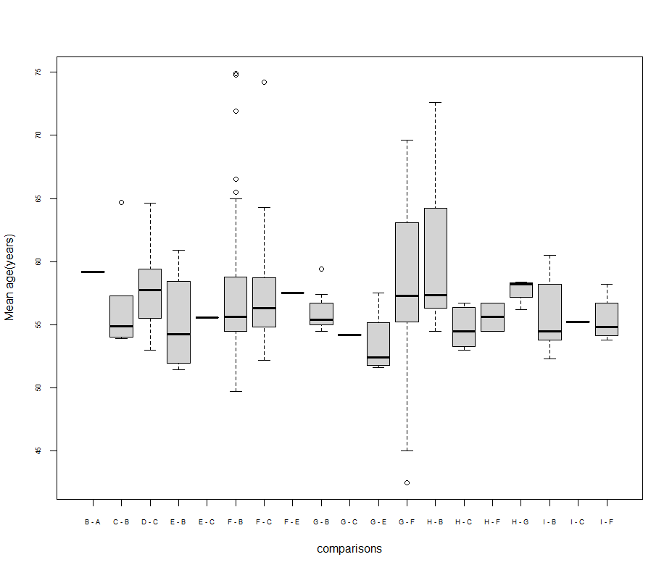
Figure 1 Box plot for baseline age by comparisons (years)
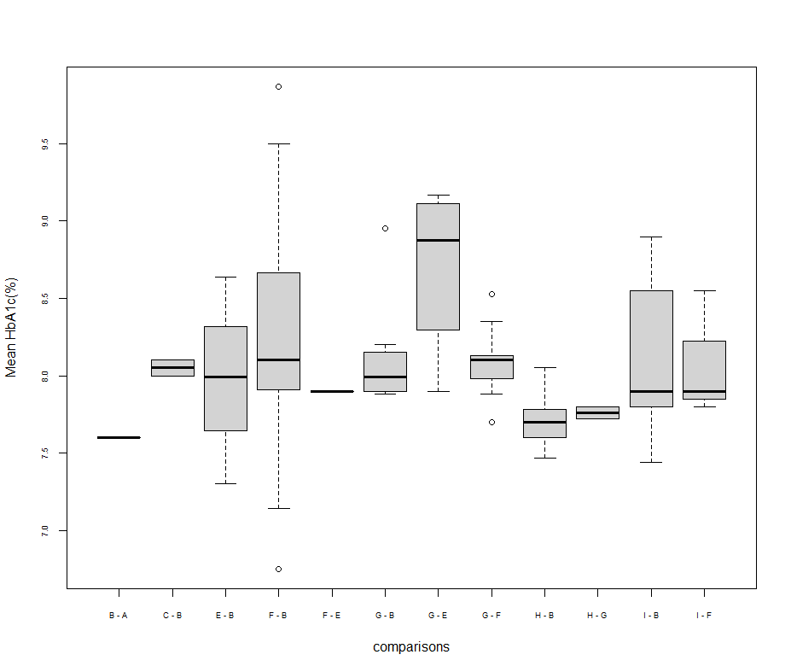
Figure 2 Box plot for baseline HbA1c by comparisons (%)

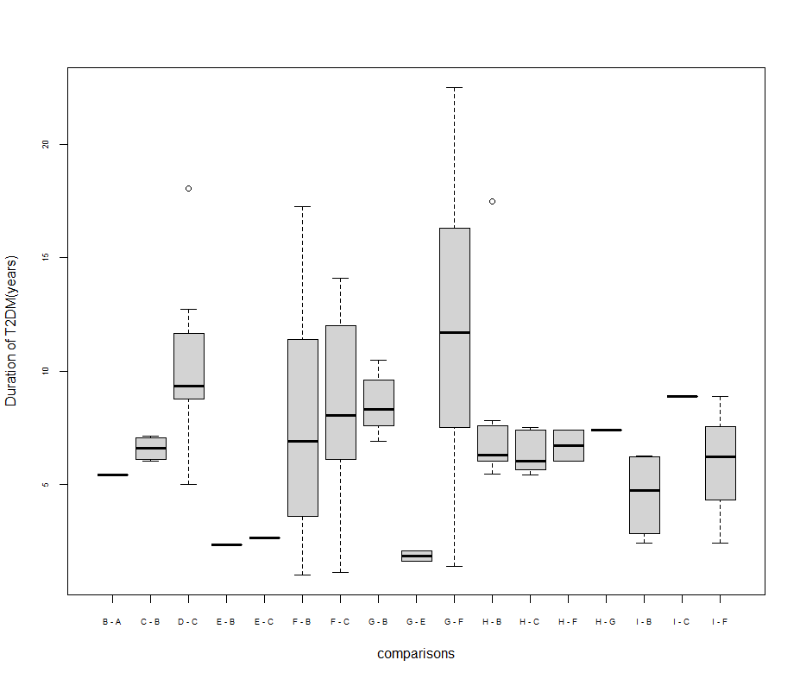
Figure 3 Box plot for baseline duration of T2DM by comparisons (years)

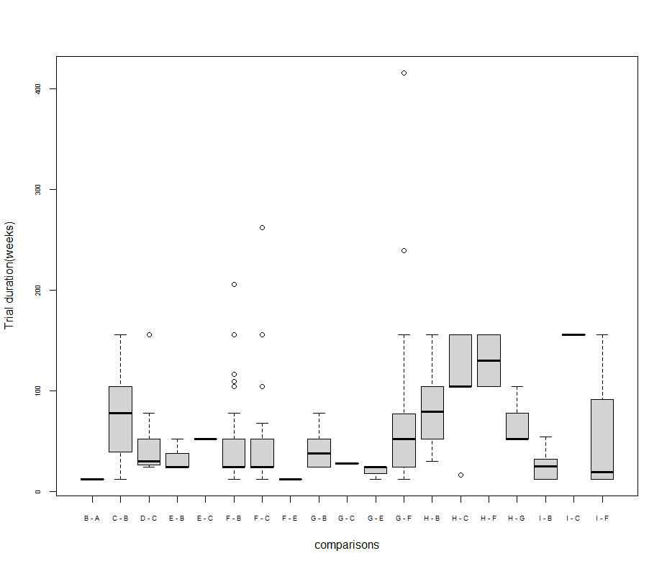
Figure 4 Box plot for trial duration by comparisons (weeks)

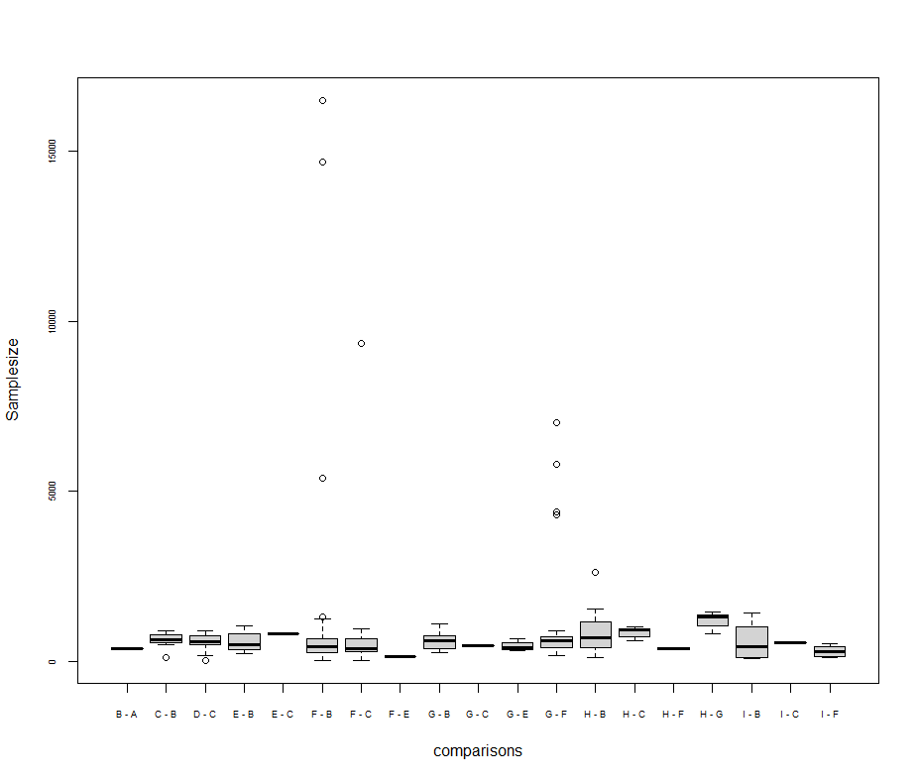
Figure 5 Box plot for sample size by comparisons

