Supplementary appendix 7 Evaluation of the inconsistency and heterogeneity for all closed loops
in the network
Global inconsistency test
In the process of network meta-analysis by STATA Version.14.0, we used the total fracture data to fit the inconsistent model, the result shows: Chi-square=10.01, P=0.9680 > 0.05, so the overall inconsistency of this data was considered to be insignificant, that is, consistent model can be chosen for analysis.

Local inconsistency test
We test Local inconsistency by node-splitting test, the result was as shown in Table 1. All P values were greater than 0.05, and the local inconsistency was not significant.

Table 1 The result of node-splitting test

Side | Direct |  | Indirect |  | Difference
 | Coef. | Std. Err. | Coef. | Std. Err. | Coef. | Std. Err. | P>|z|
A B * | -1.598884 | 1.558891 | 0.1591882 | 26.29808 | -1.758072 | 26.34425 | 0.947
B C | -0.0795706 | 0.4864503 | -0.2203933 | 0.2462001 | 0.1408227 | 0.5434338 | 0.796
B E | -0.0219658 | 0.8215412 | 0.6564787 | 0.7520952 | -0.6784444 | 1.113871 | 0.542
B F | 0.0839273 | 0.4954104 | -0.0300787 | 0.1705226 | 0.1140061 | 0.5245606 | 0.828
B G | -0.3331494 | 0.2604409 | -0.0359033 | 0.4356381 | -0.2972462 | 0.5077431 | 0.558
B H | -0.2896966 | 0.6729517 | -0.0123011 | 0.9554214 | -0.2773954 | 1.1521 | 0.81
B I | 0.0669423 | 0.1234997 | -0.1054915 | 0.3173231 | 0.1724337 | 0.3466494 | 0.619
C D * | 0.0459283 | 0.3392778 | 3.837173 | 173.4811 | -3.791245 | 173.4814 | 0.983
C E | -0.402678 | 1.640235 | 0.6787881 | 0.6206992 | -1.081466 | 1.75375 | 0.537
C F | -1.115896 | 1.641005 | 0.2056442 | 0.2381293 | -1.32154 | 1.658193 | 0.425
C G | 0.1130114 | 0.4553176 | -0.1676666 | 0.349903 | 0.280678 | 0.5763769 | 0.626
C H | -0.0219307 | 1.166628 | 0.0017264 | 0.6672269 | -0.0236571 | 1.343957 | 0.986
C I | 0.3472824 | 0.1792859 | -0.0402215 | 0.363013 | 0.3875039 | 0.4056553 | 0.339
E F | -1.038913 | 0.8908883 | 0.0965549 | 0.7336 | -1.135468 | 1.17061 | 0.332
E I | -1.515657 | 1.597759 | -0.1188464 | 0.6022245 | -1.396811 | 1.732332 | 0.42
F G | 0.4948189 | 0.7266976 | -0.3429515 | 0.2755359 | 0.8377704 | 0.7771828 | 0.281
F I | 0.0308126 | 0.1427218 | 0.334088 | 0.4418297 | -0.3032754 | 0.4628735 | 0.512
G I | 0.6576462 | 0.8943837 | 0.2673375 | 0.2411947 | 0.3903087 | 0.9315708 | 0.675
H I | -0.1899864 | 0.8786051 | 0.5988325 | 0.7974583 | -0.7888189 | 1.245844 | 0.527
( A : AGI; B: DPP-4i; C: GLP-1 RAs; D: Insulin; E: Metformin; F: SGLT-2i; G: Sulfonylurea; H: TZD; I: placebo)
* all the evidence about these contrasts comes from the trials which directly compare them.

Loop inconsistency test
As can be seen in Figure 1, all confidence intervals includes 0, and the inconsistency based on loop was not significant.
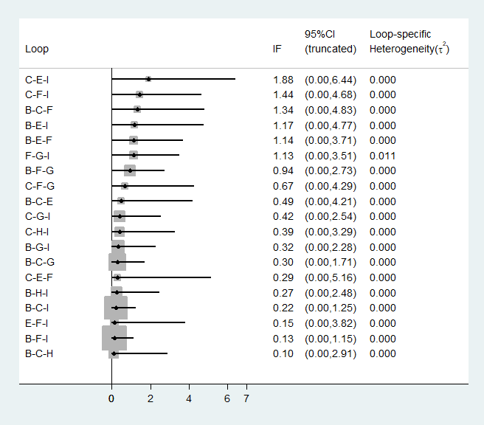
*( A : AGI; B: DPP-4i; C: GLP-1 RAs; D: Insulin; E: Metformin; F: SGLT-2i; G: Sulfonylurea; H: TZD; I: placebo)
Figure 1 The result of loop inconsistency test

Heterogeneity test
As can be seen in Figure 2, there are a total of 9 interventions involved in the study, among which the results of comparing any two interventions, there is no significant difference between 95% CIs and the predictive intervals, so the heterogeneity in the study can be considered not significant.
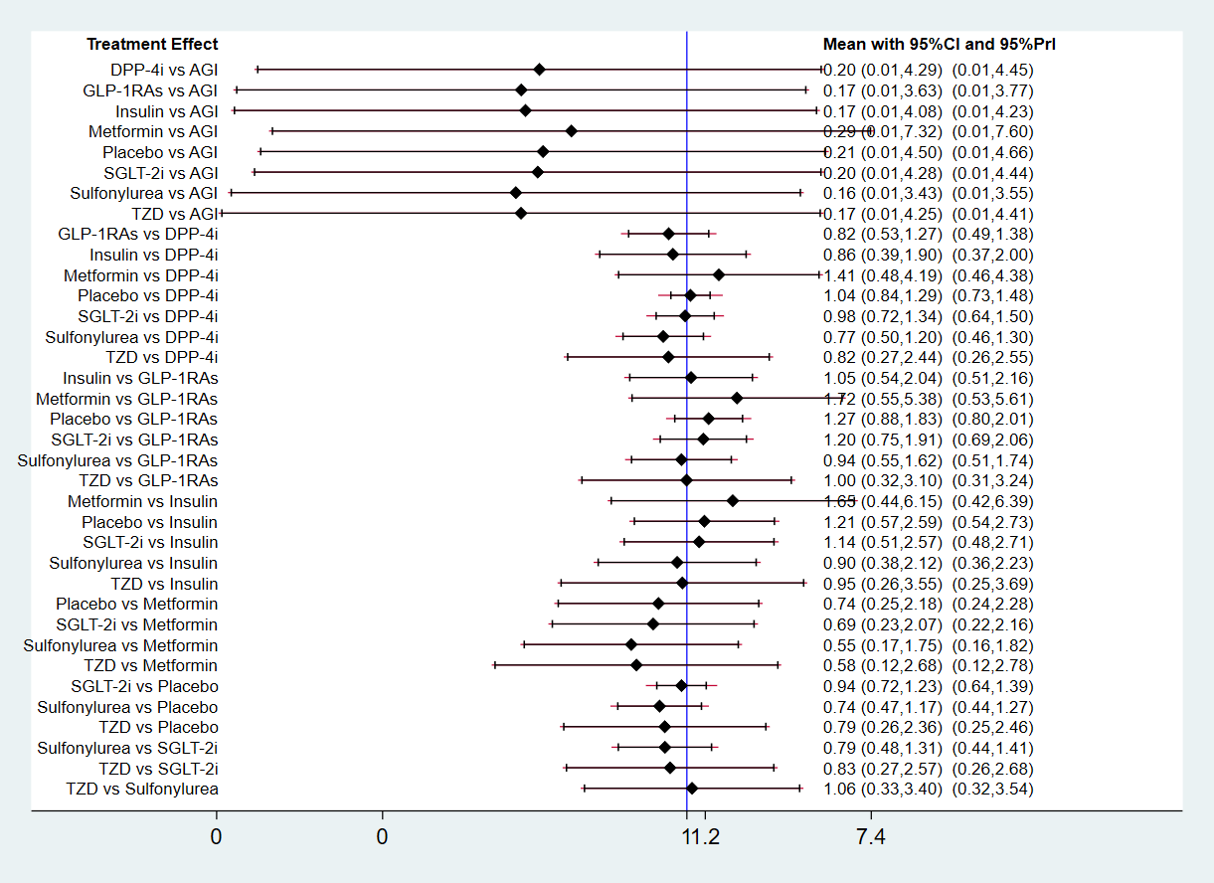
Figure 2 Forest plot with predictive interval

