Supplementary appendix 8 Funnel plots based on fractures in different parts of the body

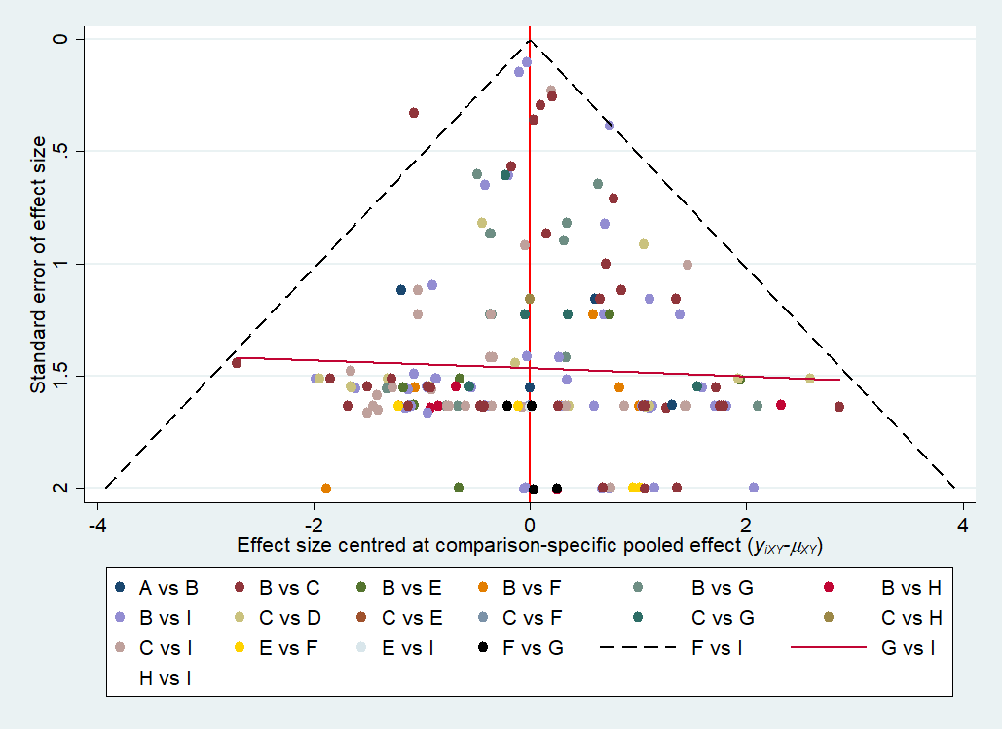
*( A : AGI; B: DPP-4i; C: GLP-1 RAs; D: Insulin; E: Metformin; F: SGLT-2i; G: Sulfonylurea; H: TZD; I: placebo)
Figure 1 Funnel plot for total fracture

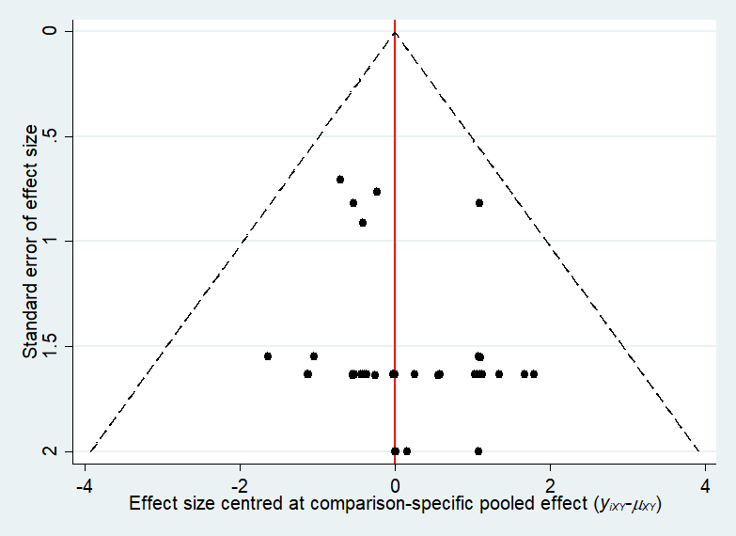
Figure 2 Funnel plot for spinal fracture
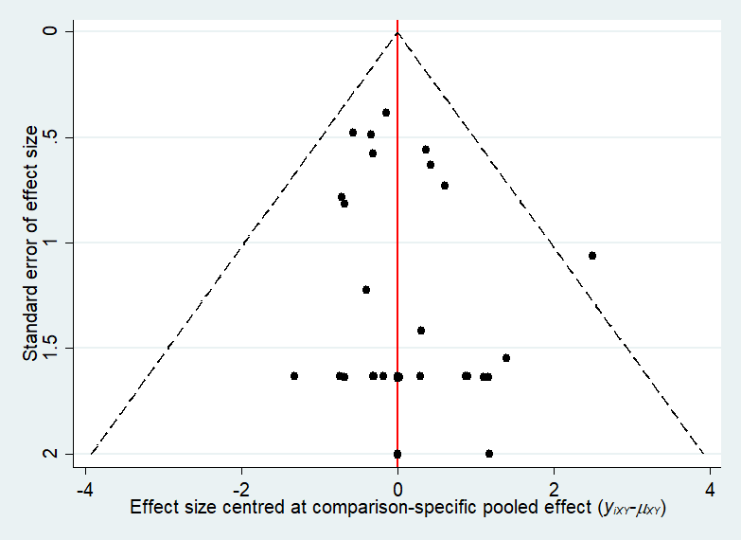
Figure 3 Funnel plot for hip fracture
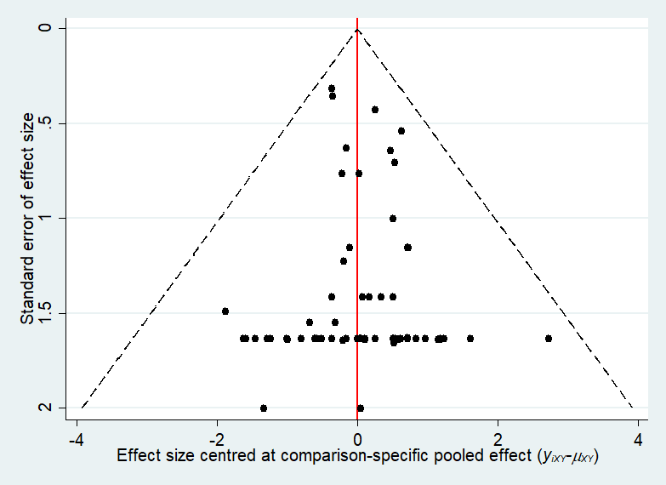
Figure 4 Funnel plot for upper limb fracture
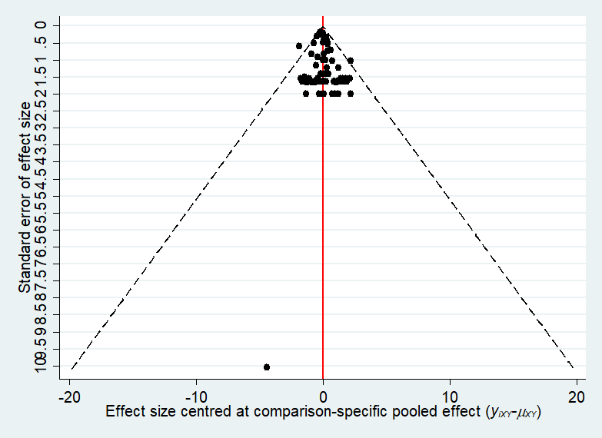
Figure 5 Funnel plot for lower limb fracture
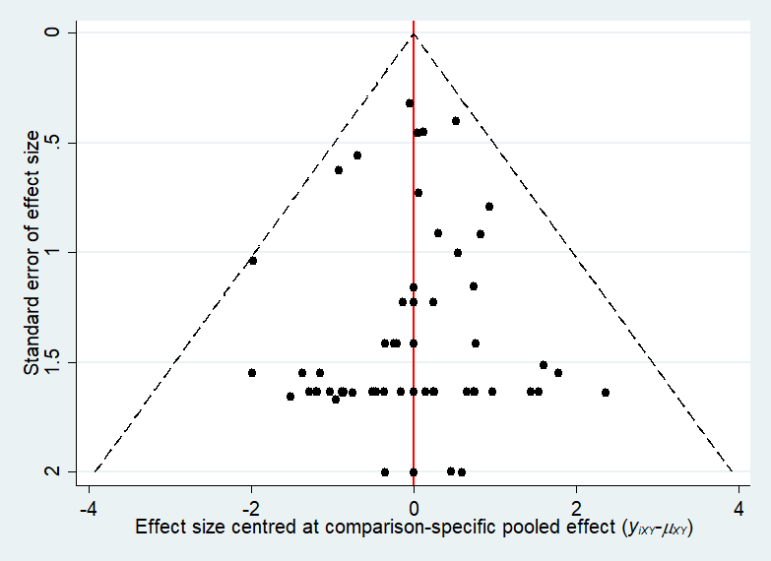
Figure 6 Funnel plot for other fracture

