Supplementary appendix 9 Evidence level assessment by GRADE
The Grading of Recommendations, Assessment, Development and Evaluation (GRADE) system was used to assess the quality of the evidence. The CINeMA (https://cinema.ispm.unibe.ch/) was used to complete the whole process.
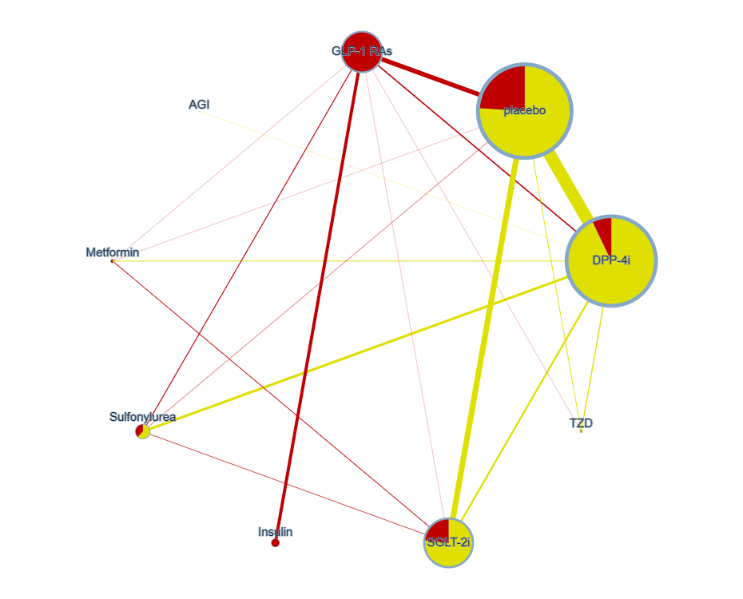
Figure 1 CINeMA netplot with risk of bias

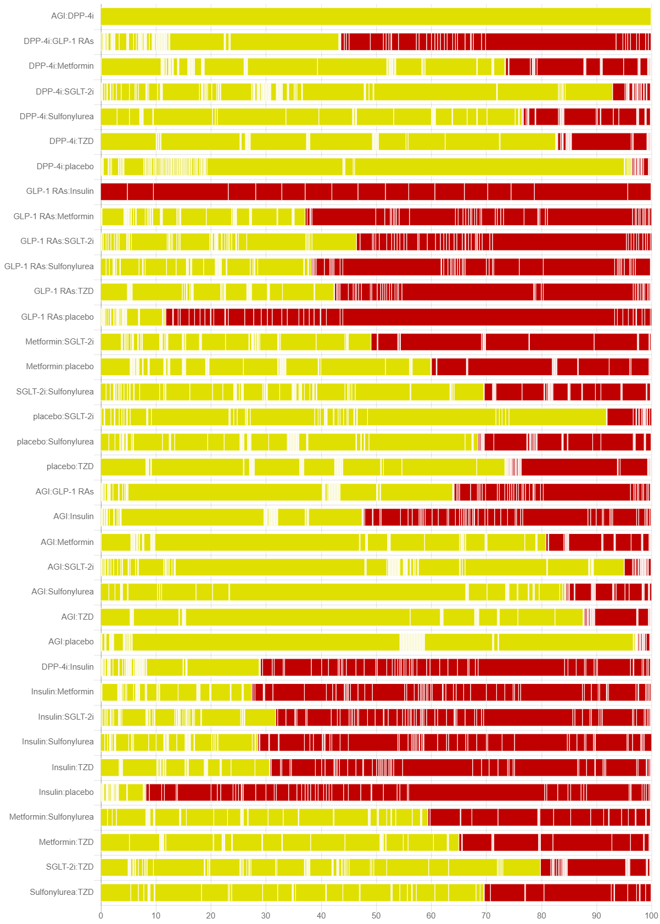
Figure 2 CINeMA risk of bias chart

Table 1 CINEMA report
Comparison | Number of studies | Within-study bias | Reporting bias | Indirectness | Imprecision | Heterogeneity | Incoherence | Confidence rating
Mixed evidence
AGI:DPP-4i | 1 | Some concerns | Undetected | No concerns | Major concerns | No concerns | No concerns | Moderate
DPP-4i:GLP-1 RAs | 7 | Major concerns | Undetected | No concerns | Major concerns | No concerns | No concerns | Moderate
DPP-4i:Metformin | 4 | Some concerns | Undetected | No concerns | Major concerns | No concerns | No concerns | Moderate
DPP-4i:SGLT-2i | 10 | Some concerns | Undetected | No concerns | Major concerns | No concerns | No concerns | Moderate
DPP-4i:Sulfonylurea | 14 | Some concerns | Undetected | No concerns | Major concerns | No concerns | No concerns | Moderate
DPP-4i:TZD | 6 | Some concerns | Undetected | No concerns | Major concerns | No concerns | No concerns | Moderate
DPP-4i:placebo | 67 | Some concerns | Undetected | No concerns | Major concerns | No concerns | No concerns | Moderate
GLP-1 RAs:Insulin | 17 | Major concerns | Undetected | No concerns | Major concerns | No concerns | No concerns | Moderate
GLP-1 RAs:Metformin | 1 | Major concerns | Undetected | No concerns | Major concerns | No concerns | No concerns | Moderate
GLP-1 RAs:SGLT-2i | 1 | Major concerns | Undetected | No concerns | Major concerns | No concerns | No concerns | Moderate
GLP-1 RAs:Sulfonylurea | 5 | Major concerns | Undetected | No concerns | Major concerns | No concerns | No concerns | Moderate
GLP-1 RAs:TZD | 1 | Major concerns | Undetected | No concerns | Major concerns | No concerns | No concerns | Moderate
GLP-1 RAs:placebo | 25 | Major concerns | Undetected | No concerns | Major concerns | No concerns | No concerns | Moderate
Metformin:SGLT-2i | 4 | Major concerns | Undetected | No concerns | Major concerns | No concerns | No concerns | Moderate
Metformin:placebo | 1 | Some concerns | Undetected | No concerns | Major concerns | No concerns | No concerns | Moderate
SGLT-2i:Sulfonylurea | 3 | Some concerns | Undetected | No concerns | Major concerns | No concerns | No concerns | Moderate
placebo:SGLT-2i | 31 | Some concerns | Undetected | No concerns | Major concerns | No concerns | No concerns | Moderate
placebo:Sulfonylurea | 2 | Some concerns | Undetected | No concerns | Major concerns | No concerns | No concerns | Moderate
placebo:TZD | 4 | Some concerns | Undetected | No concerns | Major concerns | No concerns | No concerns | Moderate
Indirect evidence
AGI:GLP-1 RAs | 0 | Some concerns | Undetected | No concerns | Major concerns | No concerns | No concerns | Moderate
AGI:Insulin | 0 | Major concerns | Undetected | No concerns | Major concerns | No concerns | No concerns | Moderate
AGI:Metformin | 0 | Some concerns | Undetected | No concerns | Major concerns | No concerns | No concerns | Moderate
AGI:SGLT-2i | 0 | Some concerns | Undetected | No concerns | Major concerns | No concerns | No concerns | Moderate
AGI:Sulfonylurea | 0 | Some concerns | Undetected | No concerns | Major concerns | No concerns | No concerns | Moderate
AGI:TZD | 0 | Some concerns | Undetected | No concerns | Major concerns | No concerns | No concerns | Moderate
AGI:placebo | 0 | Some concerns | Undetected | No concerns | Major concerns | No concerns | No concerns | Moderate
DPP-4i:Insulin | 0 | Major concerns | Undetected | No concerns | Major concerns | No concerns | No concerns | Moderate
Insulin:Metformin | 0 | Major concerns | Undetected | No concerns | Major concerns | No concerns | No concerns | Moderate
Insulin:SGLT-2i | 0 | Major concerns | Undetected | No concerns | Major concerns | No concerns | No concerns | Moderate
Insulin:Sulfonylurea | 0 | Major concerns | Undetected | No concerns | Major concerns | No concerns | No concerns | Moderate
Insulin:TZD | 0 | Major concerns | Undetected | No concerns | Major concerns | No concerns | No concerns | Moderate
Insulin:placebo | 0 | Major concerns | Undetected | No concerns | Major concerns | No concerns | No concerns | Moderate
Metformin:Sulfonylurea | 0 | Some concerns | Undetected | No concerns | Major concerns | No concerns | No concerns | Moderate
Metformin:TZD | 0 | Some concerns | Undetected | No concerns | Major concerns | No concerns | No concerns | Moderate
SGLT-2i:TZD | 0 | Some concerns | Undetected | No concerns | Major concerns | No concerns | No concerns | Moderate
Sulfonylurea:TZD | 0 | Some concerns | Undetected | No concerns | Major concerns | No concerns | No concerns | Moderate
As shown in Table 1, the quality of most studies was moderate. The quality of evidence in total fracture was rated as moderate

